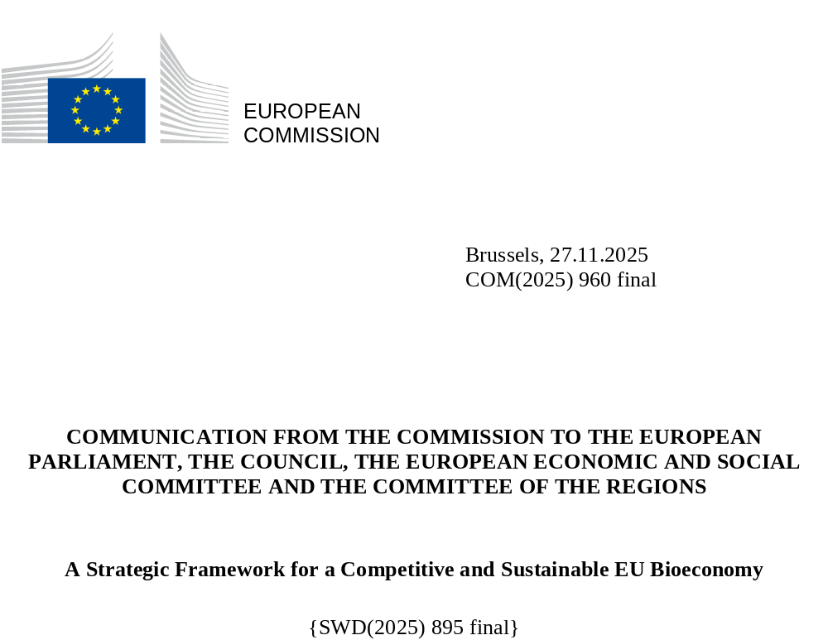

Introduction
The bioeconomy represents a strategic opportunity of the 21st century - a driver of green growth, competitiveness and resilience. It makes better use of Europe’s biological resources, scientific excellence and industrial base to decarbonise our economy and replace fossil-based materials and products. It develops practical solutions that support economic prosperity, and strong rural and coastal communities, while helping industry shift to more circular production models. It contributes to the EU’s strategic autonomy by reducing reliance on imported fossil-based products and can contribute significantly to climate and environmental goals such as resource efficiency, greenhouse gas emissions reduction, water resilience, zero pollution and biodiversity.
The bioeconomy is defined as the activities that deliver sustainable solutions based on biological resources to create added value. These include products, services, science and technologies benefiting sectors ranging from agriculture, forestry, fisheries and aquaculture to value chains based on biomass processing, biomanufacturing and biotechnologies such as in food, health, energy, industry, ecosystem and other services. Biological resources include genetic resources, as well as primary and secondary biomass, such as by-products and residues, and biogenic carbon captured through innovative technologies.
Europe’s bioeconomy has strong foundations: world-class science, cutting-edge technologies, a competitive industrial base, a single market of 26 million companies and 450 million consumers and significant biomass production managed by EU farmers, foresters and fishers.
With a value of up to EUR 2.7 trillion in 2023, the EU’s bioeconomy is a dynamic driver for competitiveness and is of strategic importance for a wide range of economic sectors. In 2023, biomass producing and converting activities employed in the EU 17,1 million people (8% of EU jobs) and generated EUR 863 billion in value added (5% of EU GDP). R&D investment in bioeconomy-related sectors reached EUR 23.2 billion (9% of all R&D investments) in 2023, while patents in these fields accounted for 5% of all patents filed in EU between 2008 and 2020. Over the past decade, bioeconomy sectors have grown faster than the overall economy. Estimates suggest that for every job, which is created in the European bioeconomy industry, an additional 2.9 indirect jobs are created in the EU.
Figure 1 – Evolution of value added in the biomass producing and converting sectors (EU27)
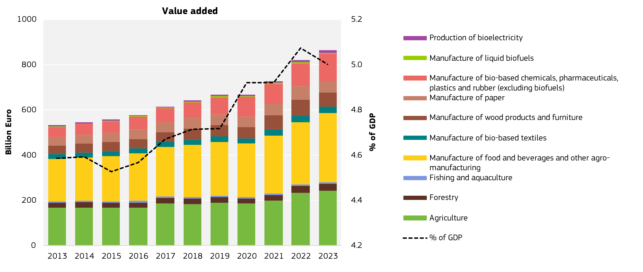
Source: Lasarte-López, J., M’barek, R. (2025). The EU bioeconomy at a glance: Focus on economic value added,
employment and innovation. European Commission, Seville, 2025. JRC143759

The bioeconomy still has a huge untapped potential. This is notably due to a lack of investments: The European Investment Bank Group (EIBG) has mapped investment needs in nine bioeconomy sectors, identifying where the EU must act to close financing gaps and accelerate sustainable transformation. Their analysis shows sizeable financing gaps across the value chain, particularly for scaling biomanufacturing, advanced bio-based materials and circular bioeconomy infrastructure, which currently prevent promising innovations from reaching the market.
At the same time, the bioeconomy is constrained by planetary boundaries, impacts of climate change and the sustainability of biomass . Responsible and efficient use of biomass remains key for long-term competitiveness, supply stability and eco-system health.
Based on extensive input from several consultations this strategy charts a way forward to build a sustainable and a nature-positive bioeconomy by:
- scaling innovation and investments;
- building new lead markets for bio-based materials and technologies;
- ensuring sustainable biomass supply across value chains and
- harnessing global opportunities.

It builds on the 2012 Bioeconomy Strategy and the reviews carried out in 2018 and 2022, shifting the focus towards industrial deployment, market scale-up, competitiveness and resilience. The strategy responds to the 2023 and 2024 Council Conclusions, and the strategic agenda for 2024–2029. It also considers the European Parliament’s resolution on the future of the EU biotechnology and biomanufacturing from July 2025.
Vision: The European Bioeconomy in 2040
By 2040, sustainable bio-based materials and products such as construction materials, biochemicals, textiles, fertilisers and plant protection products and plastics are widely deployed in the EU. They provide fossil-free alternatives and create new, stable income streams in rural, coastal and industrial regions across Europe. Sustainable yield improvements support resilient farming and food systems grounded in knowledge-based management. Integrated biorefineries and advanced fermentation facilities operate across the continent, turning diverse feedstocks into high-value products.

Europe’s bioeconomy reaches this scale because biotechnology, boosted by the Biotech Acts, becomes the engine that makes bio-based solutions affordable, competitive, and deployable at industrial scale.

Breakthroughs in biotechnology and biomanufacturing make bio-based solutions cost-competitive and scalable. Skills, investment certainty, and reliable biomass supply underpin industrial deployment.

The Bioeconomy enables Europe to mobilise its own strengths – productive farmlands, sustainably managed forests and healthy oceans – to deliver prosperity, economic and food security and resilience. Farming and forestry, combined with smarter use of marine resources, ensure that Europe meets most of its biomass needs through sustainable domestic production. The strategic use of by-products and residues makes resource use more efficient, while boosting the EU’s position in global markets.

Globally, Europe acts as a leading partner, and exporter of sustainable bio-based technologies, materials, and know-how. Through fair and sustainable strategic partnerships and trade agreements, the EU taps into new markets. The EU works actively in international fora such as the UN Food and Agriculture Organisation (FAO) and the World Trade Organisation (WTO), championing a fair and rules-based global bioeconomy.

Scaling Up Innovation and Investments: from Lab to Deployment
The past decade has shown the potential of bioeconomy innovation at scale. Value added from novel bio-based materials is rising fast in sectors like chemicals, pharmaceuticals, plastics, construction and textiles. However, international competition, notably from the United States and China, as well as persistent barriers in the single market are slowing deployment and risk diverting innovation to non-EU markets.
To accelerate the move from potential to deployment, we need to remove existing barriers and scale up investment and support to the use of these technologies, promising highest value added from the limited resources.

Removing Barriers
Streamlining Requirements and Facilitating Market Entry
Regulatory complexity remains a major challenge for the bioeconomy. Bioeconomy market entry is often delayed because of uncertainty about how to classify novel bio-based products that do not clearly fit within existing legally recognised categories . Aggravated by divergent national rules and interpretations from one Member State to another, this complexity results in market fragmentation that increases the cost of doing business, especially for SMEs.
To ensure that the EU offers a predictable and enabling environment for bio-based innovation while safeguarding EU safety standards, the Commission intends to simplify regulatory requirements and accelerate product authorisations through the EU Biotech Acts. The Biotech Acts will introduce sectoral and horizontal enablers, for example regulatory sandboxes, fast-track authorisation procedures for microbial solutions for industrial use in the bioeconomy and streamlined permitting for biomanufacturing projects.
Swift and proportionate risk assessments of novel bio-based solutions are crucial. Today, such assessments are carried out by the European Food Safety Authority, the European Chemicals Agency, and the European Medicines Agency. Their expertise is indispensable, and yet innovators often face fragmented and lengthy procedures, particularly when novel bio-based solutions do not fit neatly within existing regulatory categories.
The Commission will establish a European Bioeconomy Regulators and Innovators’ Forum as a structured space for exchanging best practices related to risk assessments of novel bio-based solutions, monitor progress, and engage in early discussions with firms developing novel bio-based solutions. It will coordinate national and EU actions to fast-track authorisations for new entrants and remove barriers.
Beyond the Forum, there is a need to make approvals faster, clearer and simpler. The Commission will provide guidance on how to classify new bio-based products and create a single online entry point so that companies only need to submit information once. Risk assessments will be better coordinated across EU agencies to avoid duplication and reduce waiting times.
The Commission will make technical support available for SMEs scaling innovative bio-based products to accelerate authorisations while maintaining high safety standards. In particular, the Commission will support SMEs developing innovative products based on advanced fermentation, including for food and feed.
To increase regulatory agility and allow bioeconomy innovators to develop and test new ideas, gather evidence and make sure regulation remain supportive of innovation, the Commission will promote the use of test environments such as regulatory sandboxes in the bioeconomy, including in the context of the upcoming EU Innovation Act.
Biotechnology and biomanufacturing will also benefit from clearer and more consistent standards that support market uptake. To remain competitive in these complex and rapidly evolving fields, the Commission will accelerate the development of bioeconomy standards and metrology. It will strengthen its investments under the current MFF in pre-normative activities by developing, testing and validating strategic pre-standards, including on data, in real-world setting.
Under the Construction Products Regulation, essential characteristics related to reaction to fire and resistance to fire already apply to all construction products where relevant, and manufacturers must declare performance accordingly. Until now, divergent national practices continue to create duplication for those bio-based construction products which are not yet harmonised. To address these inconsistencies, the Commission will work with Member States, industry and standardisation bodies to prioritise the development and revision of relevant harmonised standards within the CPR framework (by adopting standardisation requests for doors and windows, structural timber products/elements and ancillaries, wood-based panels and elements, thermal insulation products in 2026). This work will ensure that existing EU test methods and classification approaches can be applied in a harmonised manner to timber and other bio-based products, while fully respecting that building-level fire safety requirements remain a national competence.

Non-regulatory barriers
Compared to fossil-based alternatives, bio-based products can deliver environmental benefits that are not always visible to consumers. The ongoing review of the Product Environmental Footprint (PEF) methods will improve how bio-based materials, chemicals and products are assessed and compared. This includes strengthening biogenic carbon accounting, adding indicators on biodiversity and microplastics, and refining circularity assessment methods. It will also provide higher-quality data to support transparent and credible assessments.

1.2 Stimulating Innovation and Investments
Bio-based technologies and industrial biotechnology are capital-intensive, requiring substantial upfront investments in R&I, demonstration, and manufacturing infrastructure. Despite support from EU funds and instruments to de-risk innovation and investment, funding opportunities remain insufficient for bioeconomy start-ups and scale-ups on the path from laboratory discovery to market deployment. They face two ‘valleys of death’:
The first occurs between demonstration and first commercial production, when technologies must prove their technical and economic viability. High capital needs and perceived market risks can deter private financing at this stage. The second ‘valley of death’ arises after initial market entry, when companies seek to scale up to industrial production. Here, the challenge is moving to industrial scale, requiring substantial growth capital and long-term offtake certainty.
Figure 2: Two valleys of death in scaling bioeconomy in Europe
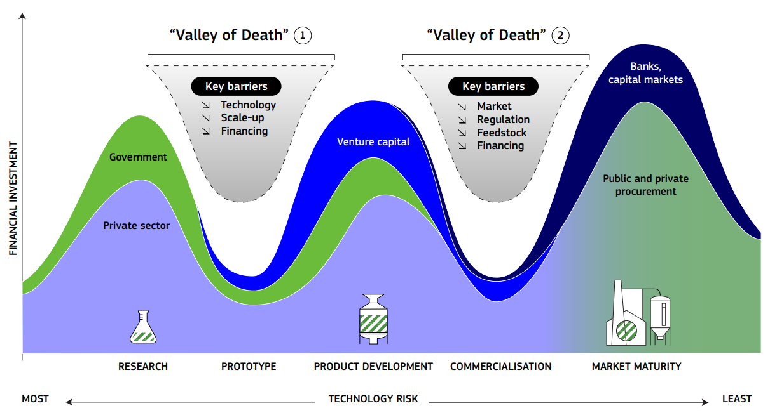
Source: European Commission graph based on the public consultation results and own analysis
The Strategy for European Life Sciences and the EU Start-up and Scale-up Strategy provide the framework to accelerate innovation, improve market access and support scale-up, ensuring that sustainability and competitiveness advance together. This should be complemented by a number of measures specifically targeted at investment and innovation in the bioeconomy, focussing particularly on the later stages of the scale up journey.
De-risking investments to scale up innovation
In order to enable companies to finance scale up of innovation, it is critical to reduce investment risks, mobilise blended finance, and strengthen the financial viability of breakthrough solutions. Access to both early- and late-stage venture finance should be facilitated at both EU and national level, with specific focus on attracting bioeconomy-focused investors and impact-driven funds that can support long-term, capital-heavy projects, in line with applicable State Aid rules. Specific attention should be paid to tailor financing suitable to the needs of SMEs, and to address technology readiness levels.
The Commission’s proposal for the next Multiannual Financial Framework (MFF 2028-2034) increases the funding for the bioeconomy through the European Competitiveness Fund (ECF), and the Horizon Europe Framework Programme policy window on health, biotech, agriculture, and the bioeconomy. This will mobilise research and innovation funding, large-scale investment along the full value chain, including sustainable land management, and de-risk industrial deployment, bridging the gaps between research, innovation, and market upscale.
In the meantime, programmes under the current MFF remain available to address the needs of the bioeconomy. These must be fully implemented, taking also into account the recommendations from the EIB Group, which include developing a bioeconomy booster programme, leveraging the Circular Bio-Based Europe Joint Undertaking (CBE-JU) flagship grant applications, and increasing flexibility in project support (e.g. high-risk investments in early-stage ventures). The Common Agricultural Policy (CAP) offers various models for cooperative investments in bottom-up processing and marketing of new value chains, creating value from untapped biomass, and in bridging primary production with industrial investments, thereby contributing to rural growth and employment. HERA Invest supports SMEs and startups investing in MCMs for health risk reduction and prevention solutions which, where relevant, could make use of bio-based resources and biotechnology. The InvestEU Blue Economy, a blended finance instrument, supports venture capital and private investment in the blue bioeconomy.
Starting in 2026, the Commission will improve access to finance and related services for startups and scale-ups in the bioeconomy via the Scale-up Europe Fund and other European Innovation Council instruments, in close cooperation with the EIB, other financial actors and with national and regional stakeholders.
From 2026, the Commission will work with industry and stakeholders to review the CBE-JU and determine the most effective collaboration format for the next MFF, ensuring impact and value for money.
To attract private investors, the Commission will identify financial tools to build on successful practices such as the European Circular Bioeconomy Fund (ECBF), through the EIB, and national promotional banks. The Commission will also work to ensure that sustainable biomanufacturing and other bio-based activities are appropriately recognised in the upcoming revisions of the EU Taxonomy Delegated Acts, to improve investment certainty.
To bring all these instruments together the Commission will convene a Bioeconomy Investment Deployment Group on finance and investment, combining research, demonstration and scale-up financing across EU and national levels. This group, bringing together the Commission, the EIB Group, national promotional banks and private investors, will create a pipeline of bankable projects, share risk more effectively, and crowd in private capital. This coordinated approach should help mobilise public and private investment over the coming decade, particularly for first-of-a-kind biorefineries, advanced fermentation facilities and bio-based materials manufacturing.
Support for the dissemination of technologies, pilots and demonstrations
Limited access to piloting and upscaling infrastructure is another important bottleneck for bioeconomy start-ups and scale-ups. The Commission will support improved access to such infrastructures, building on existing synergies between EU programmes, such as the partnerships between Green Assist and the Enterprise Europe Network.
The Commission is working with Member States to align investment priorities in the bioeconomy and guide coordination of EU support mechanisms with national projects, including in relation to Important Projects of Common European Interest (IPCEIs). The Joint European Forum for IPCEI (JEF-IPCEI) is examining the biotechnology and biomanufacturing value chain to identify potential projects. Member States may design aid measures to support IPCEIs for research and development of major innovation and the first industrial deployment of technologies crucial for the clean transition, or important infrastructure projects.

Developing Lead Markets for Materials and Technologies
Identifying and strengthening lead markets, where bio-based solutions have predictable demand conditions, can unlock private investment, and enable scale-up. Priority should be given to sectors where bio-based solutions deliver the highest added-value and are close to market deployment or already industrially mature, building on existing value chains to ensure further resource efficiency, faster uptake and visible economic impact, making the most of Europe’s biomass resources as a basis for bioeconomy markets. In 2022, biomass in Europe was used primarily for: animal feed (38%), energy (29%), materials (24%) and food (9%). Over the last ten years, biomass use for energy increased by 14%, while material use grew by 11% . Bioenergy continues to play a role in energy security, particularly where it uses residues, does not increase water and air pollution, and complements other renewables.

Efficient Use of Biomass
Efficient use of biomass means directing it toward higher-value applications and reducing pressures on ecosystems, while reflecting local conditions and market realities:
- food and nutrition security while maintaining and improving ecosystem services;
- where feasible, biomass should be used for higher-value products and materials that store carbon longer and substitute fossil-based materials;
- residual and secondary streams can be used for energy, particularly where no alternative decarbonisation solutions exist, or where it ensures energy security and energy affordability.

When assessing the most efficient use pathway in policy and investment decisions, relevant factors include biomass quality; feedstock type (primary vs. secondary); biomass availability over time; alternative ways to supply the same service considering, sustainability, environmental impacts and circularity; infrastructure and processing capacity; and the local context.
Going forward, CAP Strategic Plans, National Energy and Climate Plans, Cohesion Policy and national or regional bioeconomy strategies should support efficient and appropriate biomass use. This approach is fully in line with the Clean Industrial Deal State Aid Framework, which encourages Member States to ensure that projects and activities supported by State aid contribute to the circular economy to the largest extent possible. To support Member States and market actors, the Commission will improve the transparency of biomass flows under the existing reporting and monitoring mechanisms and share practical examples and approaches through the Knowledge Centre for Bioeconomy. This work will include a consistent and comprehensive assessment of environmental impacts and trade-offs from a life cycle perspective, and economic potential in a system-wide approach, e.g. through economic modelling.
In 2026, the Commission will design the Energy Union package for the decade ahead and take into account the experience gained by the implementation of the Renewable Energy Directive (RED), including its sustainability and greenhouse gas emissions saving criteria, and technological developments in energy from renewable sources. In addition, by 2027, the Commission will publish a report, in line with Article 3(3) RED, on the impact of Member States’ support schemes for biomass, including on biodiversity, climate and the environment, and on possible market distortions.
Biofuels will continue to play a role in the decarbonisation of the transport sector, notably in aviation and maritime, as well as for long-haul heavy duty transport in the transition to electrification. Demand is expected to rise from 2025, driven in part by ReFuelEU Aviation and FuelEU Maritime. However, the availability of sustainable biomass remains finite, and its use is most effective in hard-to-abate sectors. As outlined in the Sustainable Transport Investment Plan, this Strategy will support a coherent, circular and sustainable value chain for these purposes.

Enablers for bioeconomy lead markets across sectors: Public procurement and voluntary industry alliances
Public procurement can help create early demand for innovative materials and solutions. The forthcoming revision of the Public Procurement Directives will, among others, seek to further promote and facilitate the public procurement of biobased solutions. In addition, the Commission will support public buyers who wish to consider bio-based solutions in relevant procurement processes.
Voluntary industry initiatives can help create clearer demand signals and reduce investment uncertainty, especially for first-of-a-kind production facilities. They complement regulatory simplification and financing tools by aligning market expectations and improving coordination across the value chain.
The Commission will develop a pilot project on Bioeconomy under the Competitiveness Coordination Tool (CCT), in line with the Competitiveness Compass. This CCT project aims to create the necessary demand that will accelerate the industrial readiness of biobased materials, while taking into account the role of primary biomass producers in the value chain and ensuring that startups have access to the necessary demonstration facilities to test their new products. For that purpose, this project will support the creation of the ‘Bio-based Europe Alliance’ (BEA), a voluntary alliance of corporations that could ensure a reliable and predictable demand of biobased materials and products, reassuring private investors on their investments in CAPEX-intensive facilities as well as guaranteeing the needed offtake agreements. The CCT Pilot on the Bioeconomy would also foster the creation of new biomanufacturing demonstration infrastructure facilities (Technological Readiness Level 5-7), allowing start-ups and innovative companies to test the viability of new prototypes and products. The Bio-based Europe Alliance (BEA) will bring together EU companies committed to collectively purchasing bio-based materials, products and applications worth EUR 10 billion by 2030. By developing practical blended finance instruments, tailored to the specificities of the different bioeconomy sectors, the EU can help improve investor confidence in scale-up stages, including for SMEs and regional producers.
The Commission’s guidelines on horizontal cooperation agreements provide general principles and concrete examples of how sustainability agreements can comply with EU competition rules. Where companies seek clarity on cooperation models, the Commission can provide additional tailored guidance according to the conditions specified in the Notice on Informal Guidance.

Lead markets for materials
Bio-based materials often struggle to reach economies of scale resulting in higher production costs, leading to lower demand, which in turn limits growth and investment. Similar challenges are experienced across most of the markets for biomaterials and technologies: cost competition with fossil-based alternatives, feedstock supply risks, weak market demand, low economies of scale and longer authorisation timelines.
The following lead markets were identified as having a high potential to overcome these challenges through targeted initiatives and to scale-up the bioeconomy.
Bio-based plastics and polymers, as well as bio-based fibre-packaging materials, can replace fossil-based materials with alternatives made from renewable biomass sources (e.g. starch, lignin or algae). They are increasingly used in packaging, automotive components and industrial applications, with performance improving through ongoing research and innovation, including digital and AI-assisted material design.
Benefits:
- lower carbon footprint compared to conventional plastics (polymer dependent);
- potential to reduce import dependency for key chemical feedstocks;
- supports revalue creation when using locally sourced biomass;
- develop new applications for biodegradable plastics.

Measures to support demand and investment:
Under the Packaging and Packaging Waste Regulation, the Commission will:
- support the recognition and uptake of bio-based plastics and novel materials, in complementarity with recycled content targets, ensuring a coherent approach across applications;
- assess whether EU-wide definitions could support certification and scaling of bio-based polymers.

Textiles from bio-based fibres and fabrics include natural fibres, (cotton, flax, hemp, and wool) and man-made cellulosic fibres (MMCFs) from sustainably managed forests, can provide a reliable and traceable source of cellulose for these fibres, supporting regional value chains.

Benefits:
- renewable feedstocks with established European production capacity;
- can support traceable and regionally rooted supply chains;
- avoid micro-plastic release into the environment;
- rising demand for lower-impact textile fibres;
- potential for higher value retention, including in rural regions.
Measures to support demand and investment:

- The Ecodesign for Sustainable Products Regulation (ESPR) will set performance and durability requirements for textiles, including those made from bio-based fibres.
- The revision of the Product Environmental Footprint (PEF) methods will consider indicators relevant to fibre performance, microfibre release and environmental footprint, thereby facilitating customer understanding for the benefits of materials such as bio-based textiles.
- A CAP Network focus group will explore how to strengthen EU wool processing capacity and farmer income diversification.

Bio-based chemicals are derived from renewable biological resources, such as plants, wood, algae, and agricultural residues, and are used across sectors, including pharmaceuticals, food and beverages, textiles, personal care products, and industrial applications.
Benefits:
- 30–50% lower process emissions (depending on pathway);
- microbial and enzymatic processes can support lower-energy production;
- opportunities to replace petrochemical inputs and reduce import dependency.

Measures to support demand and investment:
The Commission will:

- support the scale-up of industrial biotechnology for the production of bio-based chemicals;
- stimulate demand for and production of bio-based chemicals, such as the possible introduction of bio-based content requirements for certain products placed on the EU single market.
Bio-based construction products include wood and other renewable materials such as hemp, straw, mycelium and fibre-based composites. The construction sector is responsible for over 35% of the EU’s waste generation and 5-12% of total national GHG emissions . The use of bio-based products can help reduce embodied carbon and the energy demand in buildings by about 40% .
Benefits:
- lower embodied carbon and energy demand;
- long-term carbon storage in buildings;
- diversification of material supply chains;
- supports regional processing ecosystems.

Measures to support demand and investment:
Under the revised Construction Products Regulation (CPR), the Commission will:

- continue standardisation work for bio-based construction products and ensure standards to allow fair comparison between conventional and innovative materials, opening and expanding the EU market for bio-based construction products;
- for new bio-based construction products not yet harmonised, future standards will ensure that their performance, including fire behaviour, can be directly compared with similar products made of different materials, thereby improving their competitiveness and circulation within the single market.

To stimulate market uptake, the Commission will:

- support industrialised and modular construction using durable bio-based materials, by contributing to standardisation work, public procurement models, and reference projects under the Strategy for Construction (2026);
- support the whole-life-cycle assessment of buildings’ greenhouse gas emissions under the Energy Performance of Buildings Directive;
- develop a methodology for certification of long-lasting biogenic carbon storage in buildings under the Carbon Removal and Carbon Farming Certification Framework (CRCF).

The New European Bauhaus (NEB) will continue to:
- support demonstration projects (e.g. school renovations, social housing, public interiors);
- link designers, architects, manufacturers, builders, cities and authorities managing EU, national and regional funds;
- improve market acceptance and visibility.

The NEB Academy will:
- support training and skills development for bio- and nature-based construction;
- provide targeted support for SMEs and innovation ecosystems;
- support research and innovation.

Bio-based fertilisers and plant protection products. Bio-based fertilising products include microorganisms, recycled nutrients and bio-based compounds that improve soil fertility and nutrient availability. Bio-based plant protection products include microorganisms and natural substances (such as plant extracts, and other bio-based substances) that help manage plant health. Bio-based fertilisers can lower import dependence and the carbon footprint while turning agricultural residues and local organic waste into economic value.
Benefits:
- reduce reliance on synthetic inputs;
- support soil function and resource efficiency;
- enable circular value chains by using agricultural and processing by-products;
- reduce import dependency for key agricultural inputs; and
- provide practical and adaptable options for farms of different scales.

Measures to support demand and investment:
With clearer authorisation pathways and improved market visibility, uptake could expand significantly by 2040.

The simplification omnibus for chemicals will streamline the assessment procedures for certain microorganisms in fertilising products. And in the upcoming Food and Feed Safety simplification package, the Commission will propose measures to accelerate market access for bio-pesticides.

When evaluating the Fertilising Products Regulation (due by July 2026), the Commission will examine whether the Regulation is delivering on its objective to promote the use of organic and recovered materials. Based on the evaluation, the Commission could propose targeted measures (e.g. dedicated guidance, common data platforms, or streamlined risk assessments for microbial strains).

Through the EU CAP Network, the Commission will support knowledge exchanges and circular nutrient use; and increase familiarity and practical uptake among farmers and advisers. Moreover, the Delegated Act on RENURE (Recovered Nitrogen from Manure) provides an option for using processed manure under defined conditions.

2.4 Lead markets for technologies
Bio-based technologies are central to scaling up the bioeconomy and expanding Europe’s industrial base. They enable the conversion of primary and secondary biomass into materials, chemicals, fuels and other high-value applications.
Biorefineries convert biomass— including woody biomass, agricultural residues, bio-waste and processing side-streams – into a range of products such as food ingredients, feed, biofuels, biochemicals and biomaterials. Biorefineries can also produce alternatives to critical raw materials, such as bio-based anodes used in batteries. They often require significant capital investment and coordinated planning for feedstock and infrastructure. Enhanced industrial symbiosis can optimise use of feedstocks across sectors, stabilise input supplies, reduce waste and production costs and support industrial clusters.
Advanced fermentation uses innovative, high-performance micro-organisms to convert carbon-sources such as sugar residues and other secondary biomass into high-value compounds.

Developing permanent storage of biogenic carbon can support European leadership in net-zero industrial technologies; complement the bio-based materials value chain by storing carbon long-term; and provide CO₂ feedstock for industrial processes where carbon is required.

Measures to support demand and investment:

The Commission and the EIB Group will continue using blended-finance instruments to accelerate first-of-a-kind biorefineries and will strengthen de-risking approaches to attract more private capital. To support the emergence of strong regional clusters, the Commission will facilitate the development of Industrial Symbiosis Valleys that coordinate feedstocks, infrastructure and investment planning at territorial level.

To help fermentation-based businesses scale, the Commission will improve access for SMEs and scale-ups to pilot and demonstration infrastructure and will enhance coordination on authorisation processes where relevant.

On capture, use and storage of biogenic carbon, the EU ETS review will explore potential pathways to recognise biogenic permanent removals certified under the CRCF, while the Innovation Fund will continue supporting scalable Bio-CCUS projects.

Securing Long-Term Prospects for the Bioeconomy: Sustainably Sourced Biomass
The EU is largely self-sufficient in biomass supply (around 90%). It has the means to remain so, provided that coherent long-term measures are implemented that maintain productive capacity, ecosystem health, and resource resilience over time.

Reducing the need for primary biomass: relying on secondary feedstocks and circularity
Circularity must become a core principle of the European bioeconomy. By keeping materials in productive use for longer and making better use of residues and by-products, the EU can support resource efficiency and reduce pressure on primary production systems. With a circularity rate of 11.8% since 2015, greater uptake of secondary biomass streams presents opportunities for new circular business models. A more circular bioeconomy starts locally. When by-products and residues are turned into new resources, they create value close to where they arise and help communities become more self-reliant. Many regions already show how businesses and industries, including SMEs and primary producers to turn waste into feedstock, heat or fertilisers. But a well-functioning EU single market for secondary biomass is essential. Clearer market signals and processing capacity can improve competitiveness of secondary streams. The lead markets measures that the Commission will adopt under the Ecodesign for Sustainable Products Regulation (ESPR) for textiles and furniture (see section 2) will also set performance and information requirements to increase longevity, reusability and recyclability, including for products made from biological resources. A similar approach will be taken with regard to the EU Ecolabel.
Bio-waste remains under-used. The Commission will support its collection and valorisation, including through the upcoming Circular Economy Act, the production of biogas and biomethane, and the use of digestate as a bio-based fertiliser, through a Tripartite Agreement. Where relevant, biogenic CO₂ capture and use will be encouraged to improve resource efficiency.
Closing the nutrient cycle is essential for environmental and economic resilience. Circular manure use, including through RENURE, can reduce dependence on synthetic fertilisers. The Commission will promote nitrogen efficiency in bioeconomy systems and work towards minimum recycling and reuse targets for phosphorus recovered from wastewater and sludge.

Towards resilient and sustainable ecosystems and value chains
The strength of Europe’s bioeconomy depends on the health and resilience of its natural environment.
Understanding how much biomass can be produced and extracted while restoring ecosystems and maintaining a resilient land sector carbon sink helps ensure that any growth stays within planetary boundaries, and takes into account LULUCF goals. The Commission will continue to draw on scientific evidence, practical experience and dialogue with producers and communities to support a balance between production, restoration and protection. A clearer picture of sustainable biomass potential is needed. The Commission will therefore strengthen modelling and data via the Knowledge Centre for Bioeconomy and use this evidence to guide demand side measures.
Many regions already combine economic use and ecological care — rewetting drained lands, reducing fire risks, or turning low-value wood into new products. Sharing these experiences across borders helps everyone learn faster. Because many sectors draw on shared feedstocks, the Commission will convene producers, processors and industrial users to discuss supply outlooks, including dual-use flexible crops, and facilitate scaling up approaches that combine production with restoration, including paludiculture in wetlands or valorisation of low-value wood to create new income sources and prevent forest fires. The Commission will also build consensus through voluntary, bottom-up approaches, including a voluntary benchmarking system for on-farm sustainability assessments and cooperation with Member States and partners such as Forest Europe, FAO and IFAD to strengthen sustainable forest management in a way that recognises regional diversity and long-standing practices. Consensus building will be supported through continued cooperation with Member States, researchers, and stakeholders, including through the pan-European Forest Europe process. The bioeconomy will also rely on foresight. Better monitoring, anticipation of climate and market risks, and a readiness to adapt will help Europe’s value chains stay stable even in uncertain times. To enhance resilience, the Commission will conduct a risk analysis of biomass supply chains and support the use of Copernicus open monitoring data for biomass supply assessment.

Primary biomass supply

Primary production is where the bioeconomy begins, and sustainability and competitiveness can go hand in hand. Farmers, foresters and fishers manage Europe’s living resources, balancing productivity with care for land and water. Their daily work underpins food security, renewable materials and rural livelihoods.

In forests, locally adapted sustainable management can provide long-term supply to industry while maintaining a resilient carbon sink.

In agriculture, circular and sustainable approaches strengthen soil fertility and reduce costs. The current and future CAP will support farmers who adopt bioeconomy innovation as well as sustainable and regenerative practices, diversify income sources, and cooperate in emerging value chains.

Aquatic resources can also contribute to a more diverse and resilient biomass supply while protecting vulnerable ecosystems. The EU Aquaculture Guidelines and the EU Algae Initiative support the production and valorisation of algae and bivalves, while the Ocean Pact will launch an EU blue bioeconomy innovation initiative to unlock under-used aquatic biomass side streams and develop marine value chains, including through the valorisation of side streams such as fish trimmings or shells.

Water resilience is essential to the bioeconomy. Integrated water management, efficiency measures and climate-risk assessments should be embedded in investment decisions, following the approach set out in the Water Resilience Strategy. Healthy soils and balanced water cycles are the quiet foundations of long-term productivity and climate stability.

Nature itself can become part of Europe’s competitiveness. Emerging markets for carbon and biodiversity credits can reward those who restore and protect natural capital, giving new income to rural areas. To this end, the Commission is adopting carbon farming methodologies and is establishing an EU registry under the CRCF Regulation. Moreover, the Commission is implementing the Nature Credits Roadmap to guide voluntary, high-integrity markets that complement carbon farming. To create predictable demand for results-based schemes and stimulate private investment, it will establish an EU Buyers’ Club, ensuring fair opportunities and competitiveness for producers. This voluntary initiative will provide a clear demand signal for carbon farming and permanent carbon removals under the CRCF Regulation. By pooling voluntary demand from private companies, it will help generate new revenue streams for European farmers and foresters, support resilient biomass value chains, and underpin corporate commitments. To further simplify the participation of farmers and forests in the voluntary carbon farming market, the Commission will establish an EU carbon farming database of models, emission factors, remote sensing products and benchmarking datasets that will reduce monitoring and administrative costs.

Finally, knowledge remains the bridge between science, policy and practice. The Commission will create an EU-wide knowledge repository offering practical, locally adapted guidance for farmers, foresters and land managers to improve productivity, resilience and the delivery of ecosystem services.

Harnessing Global Partnerships and Opportunities
Across the world, the bioeconomy is gaining momentum. Over 50 countries have adopted bioeconomy strategies. In a context of climate change, increasing pressure on natural resources, and intensifying competition for biomass, global alignment on what constitutes a sustainable bioeconomy is important. Strategic partnerships should also foster open and predictable market access for EU bio-based products, supported by cooperation on standards and reducing unnecessary trade barriers. The EU intends to enter into strategic partnerships regarding the bioeconomy, including with main global suppliers of biomass. The aim is to support continued trade in sustainable biomass, materials and bio-based solutions, in a way that is predictable for operators and respectful of local conditions.

Facilitate wider access to global markets for the EU’s bio-based technologies, innovations, biomaterials and applications
​Europe can scale up exports of bio-based technologies, materials, products, applications, and circular innovations. To this end, EU industry needs fair market access conditions, and, in parallel, exports need to be monitored to avoid biomass scarcity and negative impacts on ecosystems. The EU is competing globally for sustainable biomass. Diversifying sources, while maintaining strong domestic supply, will be important to avoid over-reliance on single suppliers and exposure to volatility.
Trade agreements, partnerships and regulatory dialogues will be used to support balanced market access for bio-based products and technologies. At the same time, growing demand for biomass and the expansion of global markets for bio-based products should be managed to avoid negative environmental or social impacts abroad. Trade in biomass and bio-based products should be consistent with broader environmental and developmental objectives. These are to be reinforced by consistent and transparent information systems that support traceability and market confidence, such as under the European deforestation legislation.

The Global Gateway strategy offers a framework to link investment in resilient supply chains with knowledge exchange and innovation cooperation to help them develop strong and sustainable bioeconomy sectors of their own and improve their access to global markets as potential suppliers. Partnerships will focus on building local value addition, skills, and resilient supply systems in partner countries. In Africa, where the EAC Circular Economy Action Plan and the EAC Regional Bioeconomy Strategy were recently adopted, the Global Gateway already supports projects building local capacity, creating jobs and promoting responsible use of resources. Platforms such as the International Bioeconomy Forum (IBF) and the African Union- European Union (AU-EU) High Level Policy Dialogue on Science, Technology and Innovation will continue to support exchange and cooperation on research and innovation. The EU will support the development of bio-based value chains globally, including in selected African countries, in a manner adapted to local conditions.

4.2. Shaping the global sustainable bioeconomy agenda
A common understanding between the EU and its main international and trading partners is important to facilitate private investment, dialogues at an early stage, cooperation on research and innovation, regulatory convergence, and sustainability goals, for instance on sustainable agriculture, fisheries, aquaculture and forestry. The EU will continue to engage in main international fora where the international playing field for the bioeconomy is developed and continue advocating for and working to achieve the related goals and targets in the 2030 Agenda for Sustainable Development, the Kunming-Montreal Biodiversity Framework, the Paris Agreement and other multilateral environmental agreements.
The EU will strengthen its partnership role in shaping the international bioeconomy agenda, including through engagement with international organisations (such as FAO). The EU will build stronger partnerships with non-EU countries to discuss the benefits and trade-offs, work towards interoperability and facilitate common projects. The EU will build on existing work such as the G20 High-Level Principles on Bioeconomy, developed during the G20 Presidency of Brazil, or the Aspirational Principles and Criteria for a Sustainable Bioeconomy, developed within FAO, to work with partners towards convergence on data, best practices, parameters and standards to promote sustainable trade.
EU candidate countries and immediate neighbours are partners of strategic importance for the EU, and their integration into EU bio-based value chains contributes to establishing regional bioeconomy hubs, diminishing reliance on external raw materials, and enhancing EU's strategic autonomy.
The EU will launch a research and innovation initiative to develop and deploy sustainable bioeconomy solutions in regions with high biomass potential, including in BIOEAST countries, Moldova, Ukraine and the Western Balkans. This initiative will mobilise capital and strengthen industrial ecosystems beyond EU borders for the benefit of Member States and EU accession countries and ensure that all efforts are underpinned by robust environmental and social safeguards.

Joining Forces for Delivery: Member States, Industry, Investors and Civil Society
Member States and stakeholders are key partners in translating the EU bioeconomy strategy into action and in creating synergies with regional and national strategies. Regions and municipalities are central to implementation, as many bioeconomy solutions scale through local value chains and municipal procurement. Farmers, foresters, fishers, industry, investors – both private and public – public authorities at regional and local level, and civil society will be closely associated to the implementation of this strategy.
The development of the EU’s bioeconomy must build on Europe’s existing strength in this sector and recognise regional differences. Member States differ widely in biomass availability, ecosystem health, industrial capacity, innovation ecosystems, and market maturity. Member States will also be encouraged to define national bioeconomy strategic profiles, for example as primary biomass producers, high-value processors, blue bioeconomy frontrunners, or bio-based innovation hubs and to integrate them into their National and Regional Partnership Plans and their National Energy and Climate Plans. The EU bioeconomy dialogues with Member States will be building on the European Bioeconomy Policy Forum, supported from 2027 by a Bioeconomy Policy Support Hub and contributions from the European Board for Agriculture and Food (EBAF).
To train their work force for the bioeconomy and align labour market needs with emerging opportunities, Member States and regions are encouraged to promote bioeconomy-related education, training, and re-/up-skilling programmes for workers and job seekers alike. The Circular Economy Stakeholders Platform and the future Bioeconomy Stakeholder Network will join forces to bring together primary producers, industry, investors and civil society and to nurture links to initiatives such as the Trusted Investors Network of the European Innovation Council and the youth dialogue through the EU Bioeconomy Youth Ambassadors programme. In addition, the links will be strengthened across specific EU education initiatives relevant to the bioeconomy, such as European Bioeconomy University, BIOEAST Uninet, the Global Bioeconomy Alliance, and Global Bioeconomy Youth Champions.
The European Commission will continue to improve monitoring of the EU bioeconomy through its EU Bioeconomy Monitoring System, and cooperate with countries and regions within the EU and internationally.

Conclusion
Europe has the knowledge, the industrial base and the people to lead the global shift towards a sustainable and competitive bioeconomy. By reducing strategic dependencies on fossil-based and imported raw materials, and by diversifying supply chains built on renewable and circular resources, the bioeconomy will also reinforce Europe’s economic and resource security in a more uncertain world.

Delivering this vision will require coordinated action at EU, national and regional level. By working together, we can turn Europe’s biological resources into engines of growth and resilience, support strategic autonomy, and build a fair transition that leaves no region behind. The Commission will report on the delivery of the strategy by 2028.

A strong European bioeconomy is not only an environmental imperative; it is a strategic investment in Europe’s long-term prosperity, resilience and security.

ANNEX: Key Actions and Timeline

Scaling Up Innovation and Investments: from Lab to Deployment
Actions | Timeline
Adopt Biotech Acts | 2025  3Q 2026
Establish a European Bioeconomy Regulators and Innovators’ Forum | 1Q2026
Adopt standardisation requests for doors & windows, structural timber products/elements and ancillaries, wood-based panels and elements, thermal insulation products under the Construction Products Regulation | 2026
Support co-operation of primary producers to drive joint investments in innovative bio-based value chains through CAP investment support, sectoral interventions and the European Innovation Partnership | 2026
Launch of a European Bioeconomy Investment Deployment Group | 2026-2028
Review the current CBE JU partnership arrangement, and identify the most effective and impactful future collaboration options under the next Multi-Annual Financial Framework | 2026-2028
Ensure that sustainable biomanufacturing and other bio-based economic activities are appropriately recognised in the upcoming revisions of the EU Taxonomy Delegated Acts | 2026-2028
Revise the Recommendation on the use of Environmental Footprint (EF) methods and provision of data | 4Q2026

Developing Lead Markets for Materials and Technologies
Actions | Timeline
Analysis and exchange of best practices on cascading use with a community of practitioners within the EC Knowledge Centre for Bioeconomy | 2026-2027
The Energy Union package for the decade ahead will take into account the experience gained by the implementation of the RED Directive including its sustainability and greenhouse gas emissions saving criteria, and technological developments in energy from renewable sources. | 2026
Publish a report, in line with Article 3(3) RED, on the impact of Member States’ support schemes for biomass, including on biodiversity, climate and the environment, and on possible market distortions. | 2027
Adoption of criteria and targets for bio-based plastics under the Packaging and Packaging Waste Regulation | 2027
ESPR delegated acts on eco-design requirements for textiles and furniture, as announced in the first ESPR working plan | 2027-2028
Continue standardisation work for bio-based construction products under the Construction Products Regulation | 2026
Support the development of industrial symbiosis valleys and bioeconomy hubs | As of 2026
Launch the Competitiveness Coordination Tool including voluntary ‘Bio-based Europe’ Alliance | 4Q2026
Certification methodology for long-lasting carbon storage in buildings under the Carbon Removals and Carbon Farming (CRCF) Regulation | 2026
Improve green public procurement requirements and create lead markets for bio-based materials and clean strategic technologies through the revision of the EU public procurement legislation | Rolling

Securing Long-Term Prospects for the Bioeconomy: Sustainably Sourced Biomass
Actions | Timeline
Exchange good practices for local circular uses of animal by-products supported under the CAP network | 2027
Support biogas and biomethane production valorising bio-waste and residues and enabling the use of the co-produced digestate as bio based fertilising products through a tripartite agreement | 2026
Assess best bioeconomy practices and innovations to increase nitrogen use efficiencies in bioeconomy systems and value networks | As of 2026
Issue guidance on circular business models | 2027
Improve data and modelling for monitoring biomass availability (relying on the Commission’s Knowledge Centre for Bioeconomy) | As of 2026
Launch of the blue bioeconomy innovation initiative and related Horizon Europe funding | 2026-2027
Incentivise data-driven approaches to the development of a sustainable bioeconomy: integration of Earth Observation (EO) data to monitor sustainable biomass availability and related land-use changes and biodiversity concerns. | 2027
Develop an EU-wide repository of knowledge with practical, locally adapted guidance to support farmers, foresters, and land managers in improving biomass productivity, resilience to extreme weather, and the delivery of ecosystem services, including under the Mission Soil | By 2030

Harnessing Global Partnerships and Opportunities
Actions | Timeline
Use the EU free trade agreements and other partnerships and international fora to advance cooperation on expanding market access for sustainable bioeconomy solutions. Identify and address regulatory and technical trade barriers to support investment in bio-based sectors | Rolling
Work with selected partner countries to promote European innovation and build strategic partnerships and facilitate investments, including through Clean Trade and Investment Partnerships and Global Gateway. | 2026-27
Advance global cooperation and streamline global governance on sustainable and circular bioeconomy, | Rolling

Joining Forces for Delivery: Member States, Industry, Investors and Civil Society
Actions | Timeline
EU bioeconomy dialogues with Member States on the implementation of the EU bioeconomy strategy, mobilisation of the Circular Economy and Bioeconomy Stakeholder Platforms, the European Board for Agriculture and Food (EBAF) and EU Bioeconomy Youth Ambassadors Programme. | As of Q12026
Monitoring of the EU bioeconomy through the EU Bioeconomy Monitoring System economic and environmental aspects. | As of 2026

Food is a key part of the bioeconomy and at the heart of the Vision for Agriculture and Food. While it is not the primary focus of this strategy, several of its actions benefit food innovation and complement EU policies related to sustainable food systems.
The strategy uses the following terms: (1) ‘Biological resources’ includes genetic resources, organisms or parts thereof, populations, or any other biotic component of ecosystems with actual or potential use or value for humanity (Convention on Biodiversity). (2) Biological resources encompass also “Biomass”: “‘biomass’ means the biodegradable fraction of products, waste and residues from biological origin from agriculture, including vegetal and animal substances, from forestry and related industries, including fisheries and aquaculture, as well as the biodegradable fraction of waste, including industrial and municipal waste of biological origin.” (recital 24 of the Renewable Energy Directive) (3) “bio-based = derived from biomass. Biomass can have undergone physical, chemical or biological treatment(s).” (European Committee for Standardization (point 2.1))
This strategy uses the term defossilisation to acknowledge that materials consist of carbon.
COM (2025) 500 final, A strategy for making the Single Market simple, seamless and strong
Mubareka, S.B. and Renner A. (editors), EU Biomass supply, uses, governance and regenerative actions - 10-year anniversary edition, Publications Office of the European Union, Luxembourg, 2025
Lasarte-López, J., M’barek, R. (2025). The EU bioeconomy at a glance: Focus on economic value added, employment and innovation. European Commission, Seville, 2025. JRC143759
When considering also service activities, the size of all bioeconomy-relevant sectors is substantially increased. According to JRC estimates, the bioeconomy-relevant sectors created between 42 and 60 million jobs in 2023 (19-28% of total employment), and generated a value added between EUR 1.9-2.7 trillion (around 11-16% of EU’s GDP).
According to IRP, Global Resources Outlook, 2024, the overall demand for biomass rose from 12.6 billion tonnes in 1970 to 24.8 billion tonnes in 2020
Based on Lasarte-López, M’barek (2025)bioeconomy_infographic_update_updated with 2019 numbers-2
Based on Lasarte-López, M’barek (2025)
Grassano, N., M'Barek, R. and Gonzales Hermoso, H., Patenting in the Bioeconomy: An Analysis of Trends and Patterns in the EU, Publications Office of the European Union, Luxembourg, 2025
Lasarte-López, J., M’barek, R. (2025). The EU bioeconomy at a glance: Focus on economic value added, employment and innovation. European Commission, Seville, 2025. JRC143759
Amsterdam Data Collective, 2025, The Value of Biosolutions: Growth and Prosperity to 2035 – Europe edition
JRC, 2025 The EU bioeconomy at a glance: Focus on economic value added, employment and innovation
EIBG, Investment gaps to achieve sustainable targets in the bioeconomy, 2025.
EEA, The European Biomass Puzzle, 2023, The European Biomass Puzzle | Publications | European Environment Agency (EEA)
EEA, Europe’s Environment 2025 – Main Report: Europe’s Environment and Climate: knowledge for resilience, prosperity and sustainability.
Staff Working Document – Stakeholders consultation’s synopsis report and the public Consultation results on the EU Have your Say portal
COM (2012) 060 final Innovating for Sustainable Growth: A Bioeconomy for Europe
COM (2018) 673 final A sustainable bioeconomy for Europe: strengthening the connection between economy, society and the environment. Updated EU Bioeconomy Strategy.
COM (2022) 283 final European bioeconomy policy – Stocktaking and future developments
Council of the European Union, Conclusions on the opportunities of the bioeconomy in the light of current challenges with special emphasis on rural areas, 2023
Official Journal as OJ C 2024 400 I, p. 1
European Parliament, Resolution on the future of the EU biotechnology and biomanufacturing sector: leveraging research, boosting innovation and enhancing competitiveness, 2025. The Committee of the Regions and the European Economic and Social Committee also issued opinions on the bioeconomy.
Lasarte-López, J., M’barek, R. (2025). The EU bioeconomy at a glance: Focus on economic value added, employment and innovation. European Commission, Seville, 2025. JRC143759
European Chemicals Agency (ECHA), Bio-Based Chemicals in REACH, 2023.
EIBG, Scaling up Europe’s Bio-based industries, 2025
Medical Countermeasures (MCMs)
JRC policy brief, Biomass supply and demand in the EU 2012-2022
SINKKO, T., CASONATO, C., VALENZANO, A., WIERZGALA, P. and LISTORTI, G., Substituting conventional products with bioeconomy innovations: analysis of potential environmental impacts using a Life Cycle Assessment perspective, Publications Office of the European Union, Luxembourg, 2025, JRC142832
Towards a circular economy: biopolymers by machine learning, retrieved: 18.10.2025
Buildings and construction - Internal Market, Industry, Entrepreneurship and SMEs
BIOBUILD Project - Thermal Solutions for Green Buildings
Paving the way for lowering embodied carbon emissions in the building and construction sector | Clean Technologies and Environmental Policy
EU biorefinery outlook to 2030 - Publications Office of the EU
JRC, EU Biomass supply, uses, governance and regenerative actions, 2025
Monitoring framework - Circular economy - Eurostat
Secondary biomass includes biomass from by-products or side streams from product manufacturing processes, bio-waste, livestock waste, recovered post-consumer wood, paper and cardboard and any other biomass recovered from end-of-life bio-based products.
Gardossi et al, Bioeconomy national strategies in the G20 and OECD countries: Sharing experiences and comparing existing policies, 2023
https://au.int/sites/default/files/documents/45336-doc-GIZ-AU_Continental_Circular_Action_V11.pdf
Final-Summary-EAC-BIOECONOMY-STRATEGY.pdf
For example, at FAO, the EU has launched together with Brazil a Group of Friends of the Bioeconomy, on 17 October 2025.
https://openknowledge.fao.org/server/api/core/bitstreams/92d6ae7c-2257-427f-a5a1-1f1223c89a47/content
European Bioeconomy Policy Forum - Research and innovation
The Bioeconomy Policy Support Hub will kick-start in 2027 based on Horizon Work Programme in 2026.
Homepage | European Circular Economy Stakeholder Platform
Bioeconomy Youth Ambassadors - Research and innovation
Trends in the EU bioeconomy - update 2024. JRC Publications Repository - Trends in the EU bioeconomy - update 2024

