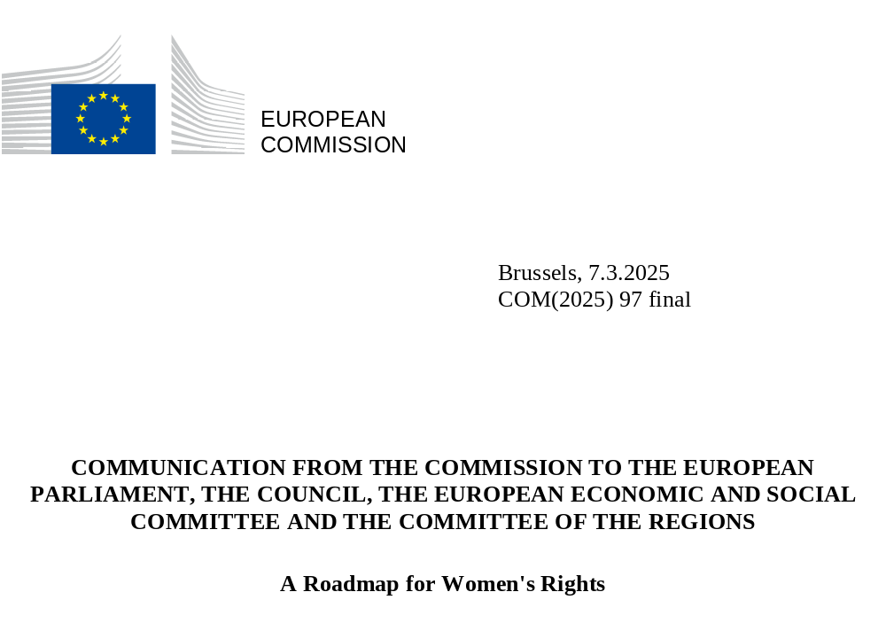

INTRODUCTION

Equality between women and men is a fundamental right and a founding value enshrined in EU law since the 1957 Treaty of Rome. The European Union is proud to defend this core value and to have achieved numerous milestones on women’s rights and gender equality. The EU is home to some of the most gender-equal societies in the world, setting a global benchmark for equality and inclusion.
Over the decades of the European project, the pursuit of gender equality has become a cornerstone of the EU’s social and economic policies, targeting inter alia gender inequalities in the labour market, in social security, in access to goods and services, and in pay. At the same time, the EU has promoted better work-life balance, women’s equal representation in corporate decision-making, entrepreneurship and research, and combated violence against women. The EU has also taken important steps towards strengthening the care economy, and thereby promoted women’s participation in the labour market, by supporting children’s access to quality early childhood education and care and by improving access to affordable and high-quality long-term care.
The Gender Equality Strategy 2020-2025, under the vision of building a Union of Equality, where all women and girls, men and boys can thrive, lead and be free from violence, has delivered on a series of key policy actions. The Commission has advanced its gender mainstreaming efforts through the Taskforce on Equality, working to integrate gender considerations in all policy areas.
At the same time, the EU has leveraged its global influence to advocate for women’s rights, ensuring these issues remain integral to the global development agenda. It has proven itself a pivotal force in the global push for gender equality and commitment to fostering inclusive, equitable societies worldwide. In line with international commitments, the EU has consistently worked towards implementing the Sustainable Development Goals (SDGs), notably SDG5 on achieving gender equality and empowering all women and girls.
The 2024 Gender Equality Index - scoring the EU with 71 points out of 100, representing an improvement of 7.9 points since 2010 - shows that action matters and that the EU is making steady, albeit modest, progress towards a gender-equal society.
The start of the Commission’s new mandate and political priorities as stated by President von der Leyen in her Political Guidelines for 2024−2029 are an opportunity to re-affirm EU’s values, engagement and continuity when it comes to advancing women’s rights. Gender equality and women’s rights ensure and contribute towards social justice, strong democracies, robust competitive economies and security for all; it is about the potential of the whole population and for the benefit of the whole society.
Worrying trends against women’s rights can be observed across the world, questioning existing gender equality legislation, and political discourse too often falling into sexism and gender stereotypes.
There is, therefore, an urgent need to reiterate, reaffirm and reinforce the commitment to gender equality and women’s rights. The declaration annexed to this Communication confirms the Commission’s strong commitment to advance in this area. It sets out principles and objectives on women’s rights which will guide future strategies and actions, in particular in the Gender Equality Strategy post-2025. The declaration aims to drive forward and steer the gender equality policy agenda in the longer term, becoming the guiding EU policy framework towards greater gender equality in all aspects of society and the economy.
The Commission invites other European institutions, in particular the European Parliament and the Council, as well as Member States, social partners, civil society organisations and other relevant stakeholders to adhere to this commitment. Stakeholders are invited to work together towards devising the measures to be put forward at the appropriate level, including at the EU and national level, to realise the principles and objectives set out in this Roadmap.
The 30th anniversary of the Beijing Declaration and its Platform for Action, gives the EU the opportunity to reconfirm its adherence to this key framework. A fundamental EU value and a long-held commitment, equality between women and men is at the core of the European way of life.

GENDER EQUALITY: AN IMPERATIVE FOR COMPETITIVENESS, DEMOCRACY, AND SOCIAL FAIRNESS
The bedrock of a strong EU, its competitiveness, democracy and social fairness, is its people, with women making up half of the EU’s population. Acknowledging and harnessing the potential of all women as workers, entrepreneurs, and leaders is imperative for the EU’s growth and stability. Empowering women to fully engage in the workforce and decision-making processes catalyses economic growth, spurring innovation and enhancing the quality of life for all citizens.
Projections show that improved gender equality could elevate the EU GDP per capita by 6.1 to 9.6% by 2050, equating to a remarkable 1.95 to 3.15 trillion euros. Thus, advancing women’s rights is not just a moral imperative but a strategic investment in the EU’s economic growth and competitiveness.
Ensuring women’s full, equal and meaningful participation, and their representation and leadership, also fosters more stable and resilient democracies. Democracies that advance women’s rights incorporate a wider range of perspectives and experiences into decision-making processes, leading to policies that are more comprehensive and attuned to the needs of all citizens. In the corporate sphere, gender equality translates into a competitive edge, with firms exhibiting higher profits and better stock market performance when women occupy leadership roles.
Promoting gender equality can help address pressing challenges, including labour force shortages, the demographic transition, inequalities and poverty, climate change, hybrid threats and security concerns. It thus constructs a healthier, more prosperous future while making our societies fairer, more democratic, stable, healthy and cohesive, and our economies more innovative and competitive on the global stage.
However, the findings of the 2024 Report on Gender Equality in the EU are clear: despite the many achievements made in promoting gender equality and the gradual strengthening of the EU’s related policy framework, significant challenges remain in the domains of violence, health, time, money, work, education and knowledge, power and institutional mechanisms, as evidenced by the Gender Equality Index. In the absence of reinforced action, it would take another 60 years to achieve full gender equality in the EU.
One in three women in the EU have experienced physical and/or sexual violence, one in five women have faced physical or sexual violence from their partner, a relative, and one in eight women have experienced sexual violence in the EU. At the same time, women are particularly targeted by new forms of violence specific to the digital sphere. The cost of violence against women in the EU is estimated at €289 billion euros per year.
On gender aspects of health, women and men are confronted with gender-specific health risks and diseases. Women in the EU also continue to face a lack of comprehensive information on and accessibility of healthcare services and products related to sexual and reproductive health, where provided under national law.
While gender employment and pay gaps are narrowing (10.2 p.p. and 12% respectively), progress is slow and structural barriers, such as discriminatory social norms, remain. Progress made by women in key areas, such as education (10.9 p.p. more women than men completed tertiary education), is not fully reflected in women’s positions on the labour market and in decision-making bodies and processes. Women are overrepresented in low-paid and undervalued (albeit essential) jobs and face higher risks of threats and violence limiting their participation in public life: women in the EU hold just 33% of parliamentary seats and 34.8% of local government seats. More women than men suffer poverty in old age, with the gender pension gap at 25.4%.
Women in the EU continue to be time-poor compared to men on average, as they shoulder a disproportionate share of household duties and care responsibilities. This is exacerbated by the low uptake of family leaves by fathers, limited flexibility at work and difficulty in accessing quality care services.
Gender segregation in education and training in the EU is evident in the underrepresentation of women in science, technology, engineering and mathematics and the underrepresentation of men in sectors like education, health, and welfare. Women account for only 19.4 % of ICT specialists, and men represent only around 15% of primary school teachers.
Furthermore, recent crises such as the COVID-19 pandemic, war in the EU’s neighbourhood and rising energy costs had adverse impacts on women. This is because women often have lower incomes, are more likely to be lone parents, take more of the responsibility for the household and care than men, and are more exposed to gender-based and domestic violence.
These challenges require continued attention and commitment to gender equality action at all levels, by all relevant actors, across the Union and beyond.

THE ROADMAP FOR WOMEN’S RIGHTS: A COMMITMENT TO GREATER GENDER EQUALITY
The Roadmap annexed to this Communication has the ambition to drive future efforts to ensure that women’s rights and gender equality are at the core of EU policies and actions. It takes into account what has already been achieved on gender equality and looks ahead to the challenges in the coming years. It reaffirms the need for a dual approach: mainstreaming of a gender perspective in all policies, on the one hand, and preventing and eliminating gender inequalities, on the other hand. It reflects the contributions received in the course of its preparations, including from Member States, social partners, civil society and international organisations.
The Roadmap is based on fundamental rights and values, which are either already laid down in the EU treaties and legislation, or which may require further action at the competent level to be fully operational. It must, therefore, be read in tandem with existing EU legal acts and instruments and is without prejudice to them. The effective implementation of recently adopted legislation will be essential to make the Roadmap’s principles and objectives a reality.
The Roadmap sets out long-term policy objectives for upholding and advancing the following key principles of women’s rights and gender equality: (1) freedom from gender-based violence; (2) the highest standards of health; (3) equal pay and economic empowerment; (4) work-life balance and care; (5) equal employment opportunities and adequate working conditions; (6) quality and inclusive education; (7) political participation and equal representation; (8) institutional mechanisms that deliver on women’s rights.
These principles relate to the remaining key gender equality challenges in the domains of violence, health, time, money, work, education and knowledge, power and institutional mechanisms. The upcoming Gender Equality Strategy post-2025 will present concrete policy measures to be taken to address these challenges. A related open public consultation will be launched in spring 2025, calling for an active involvement and input of all relevant stakeholders in the design of actions to be put forward in the Strategy. The continued implementation of the Gender Equality Strategy 2020-2025 in parallel contributes to advancing women’s rights in the EU.
The Commission commits to continue gender mainstreaming in all its policies and actions. This includes mainstreaming gender in the EU budget and aligning relevant upcoming policy initiatives with the goals of the Roadmap. For instance, to foster competitiveness and further tap into women’s workforce potential, the Commission proposes to add a strong gender equality perspective to initiatives such as the Quality Jobs Roadmap, the Women in Farming Platform, and the EU Start-up and Scale-up Strategy. The Roadmap for Women’s Rights is adopted at the same time as the Union of Skills, setting out measures to support education and training, up-skilling and reskilling from a gender sensitive perspective. Moreover, as part of the work on a strategy on financial literacy that aims to empower retail investors to take informed financial decisions and increase their participation in capital markets on fairer terms, specific attention will be given to women.
The Commission will pursue gender mainstreaming in initiatives such as the EU Anti-Poverty Strategy, the European Affordable Housing Plan, the Apply AI Strategy and the EU-wide inquiry on the broader impacts of social media on well-being, which will contribute to foster social fairness and tackle the social inequalities faced by women and girls. The Commission will also put forward proposals for gender mainstreaming in the context of the revision of the 2013 Council Recommendation on health-enhancing physical activity across sectors and in working to strengthen the European Sport Model.
As gender equality is also key to democratic participation and societal resilience, the Commission intends to integrate a gender dimension into the Preparedness Union Strategy and the action plan against cyberbullying. Moreover, the European Democracy Shield will contribute to empowering and supporting women in politics, with dedicated measures on the safety of political candidates and elected representatives.

A GUIDE FOR EU EXTERNAL ACTION
Going beyond the EU’s internal action, this Roadmap reaffirms the strong commitment to women’s rights, on the 30th anniversary of the Beijing Declaration and Platform for Action in 2025 and beyond.
Striving for internal-external policy coherence, the Roadmap confirms the principles, objectives and targets of the EU Gender Action Plan (GAP III) for the promotion of gender equality and women’s and girls’ empowerment in EU external action, including humanitarian interventions, through multilateral and multi-stakeholder initiatives and partnerships, political dialogue and financial support, including through global investments, such as Global Gateway. It also confirms the EU Strategic Approach to Women, Peace and Security (WPS) as a framework that emphasises women’s leadership, rights, and agency in all areas of peace and security, integrating gender perspectives into EU policies and actions to prevent conflicts. The EU is also committed to addressing the specific situation of women and girls in humanitarian action and integrates gender considerations, including protection strategies against sexual and gender-based violence, in its humanitarian response.
Applying a human rights-based approach, the EU works with partners worldwide, through the European External Action Service and the 145 EU delegations, to tackle the underlying causes of gender inequalities, which are rooted in discriminatory social structures, institutions, legal norms and practices. The Roadmap will thus serve as a guide to inform external initiatives and pave the way towards the next EU Gender Action Plan in external relations (2028 – 2034).
The overall objective is to reaffirm, promote and solidify the full validity of the existing EU and international acquis on gender equality, WPS, the full enjoyment of all human rights by all women and girls, and their empowerment. This requires strong political will, leadership and prioritisation of gender equality at the highest levels, including in the context of upholding a rules-based global order with multilateralism as its key principle and the United Nations at its core.
Rollback on the progress we have achieved over the past 30 years is not acceptable. The Commission will firmly oppose any action or proposal that seeks to undermine the existing international commitments and standards and will strive to enhance them further, wherever possible.

THE WAY FORWARD: COOPERATION AND INSTITUTIONAL NEEDS
The success of the Roadmap depends on the commitment and contribution of all relevant actors. The Commission invites all interested parties, especially the European Parliament and the Council of the European Union, social partners, civil society actors and other relevant organisations, to endorse the declaration on women’s rights annexed to this Communication in the course of 2025.
Furthermore, the Commission invites all interested parties to take an active role in contributing to realising the objectives set out in the Roadmap. These objectives will guide the development of the new Gender Equality Strategy post-2025.
To be effective, the Roadmap must be underpinned by strengthened institutional mechanisms and strategies that promote gender equality. In the Commission, this includes the work of the Taskforce on Equality that promotes equality mainstreaming, including gender mainstreaming, in all policy areas through a network of equality coordinators in all Commission services. The Commission will also continue to lead by example, striving for gender parity in management, pursuing the work to identify and assess impact on gender equality in impact assessment and evaluations within the better regulation framework, and promoting gender equality through its own public procurement.
The EU budget will continue to support gender equality. The EU financial Regulation (recast) requires that all EU budget programmes and activities, where feasible and appropriate in accordance with the relevant sector-specific rules, are implemented taking into account the principle of gender equality in accordance with an appropriate gender mainstreaming methodology. In addition, where appropriate, data collected in relation to indicators shall be broken down by gender.
The full realisation of the aspirations set out in this Roadmap goes beyond the EU’s competences and needs to rely on the actions at national level. This can happen only with the proper structures in place, endowed with sufficient resources to ensure their capacity.
The success of the Roadmap also requires a reinforced cooperation and closer partnership with Member States, for instance in the context of the European Semester (the EU’s economic and employment coordination process) and with all relevant actors.
The Commission furthermore invites the other EU institutions, Member States, and stakeholders, including social partners, civil society, to take the Roadmap presented in the annex to this Communication into account in the further development of EU, international, national, regional and sectoral policies.

Council Directive 79/7/EEC of 19 December 1978, Directive 2004/113/EC of 13 December 2004, Directive (EU) 2023/970 of 10 May 2023
Directive (EU) 2019/1158 of 20 June 2019, Directive (EU) 2022/2381 of 23 November 2022, Regulation (EU) 2021/695 of 28 April 2021, Directive (EU) 2024/1385 of 14 May 2024. See also the EU’s accession to the Istanbul Convention (OJ L 143I, 2.6.2023)
OJ C 484, 20.12.2022, p. 1–12, OJ C 476, 15.12.2022, p. 1–11
Communication from the Commission to the European Parliament, the Council, the European Economic and Social Committee and the Committee of the Regions, A Union of Equality: Gender Equality Strategy 2020-2025, COM(2020) 152 final.
Available online at Gender Equality Index | European Institute for Gender Equality.
European Commission: Directorate-General for Communication and Leyen, U., Europe’s choice – Political guidelines for the next European Commission 2024−2029, Publications Office of the European Union, 2024. Available online.
Available online at: Beijing Declaration and Platform for Action.
Economic Benefits of Gender Equality in the European Union | European Institute for Gender Equality.
See e.g. S&P Global. (2020). When Women Lead, Firms Win: How Gender Diversity in the C-suite and Boardroom Drives Financial Performance.
For more background and references to the topics and figures presented in this Communication, please see the annual report, SWD(2025) 67 final.
See also Gender equality benefits everyone – but it's still 60 years away | European Institute for Gender Equality.
See EU Gender-based Violence Survey | European Institute for Gender Equality.
See Cyber violence against women | European Institute for Gender Equality.
See Costs of gender-based violence in the European Union | European Institute for Gender Equality.
Franklin, P., Mambra, C. and Albani, V. (2021). Gender equality and health in the EU. Available online: DS0320880ENN-en.pdf
Employment and activity by sex and age - annual data [lfsi_emp_a]
Gender pay gap statistics - Statistics Explained.
The 'tertiary education attainment' indicator is defined as the proportion of men aged 30-34 years that have attained tertiary education minus that of women. In 2023, this gender gap was -10.9 percentage points (pp) in the EU. See Population by educational attainment level, sex and age (%) - main indicators [edat_lfse_03].
International Labour Organization (2018), The gender gap in employment: What's holding women back? - InfoStories.
Indicator: National parliaments: presidents and members | Gender Statistics Database | European Institute for Gender Equality
Gender pension gap by age group [ilc_pnp13].
Employed ICT specialists by sex Employed ICT specialists by sex Statistics | Eurostat.
Classroom teachers and academic staff by education level, programme orientation, sex and age groups [educ_uoe_perp01]
https://commission.europa.eu/strategy-and-policy/priorities-2019-2024/stronger-europe-world/global-gateway_en
OJ L, 2024/2509, 26.9.2024

