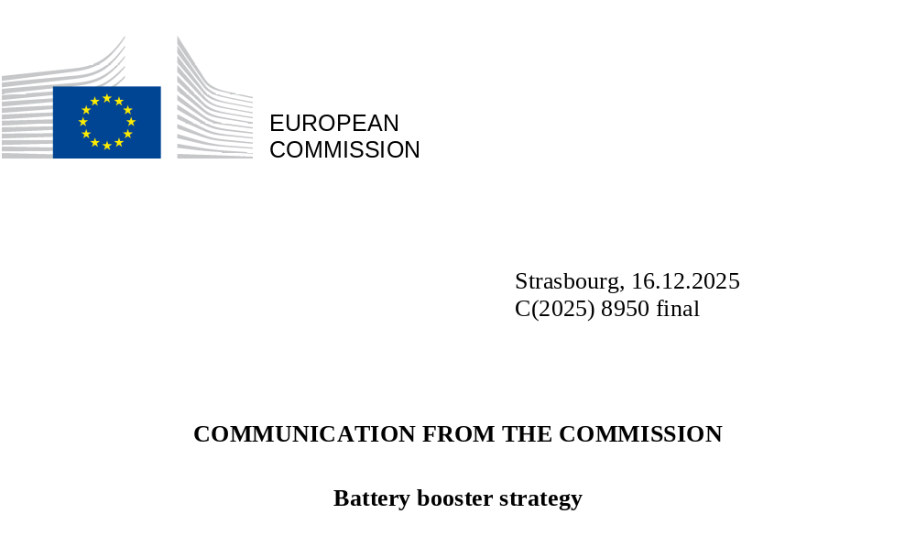

COMMUNICATION FROM THE COMMISSION
Battery booster strategy
The European battery industry is central to the EU’s efforts to meet its climate goals and to boost its economic resilience, energy security and defence capabilities. Demand for batteries in Europe is projected to surge over the coming years, driven by electrification across multiple sectors, including electric vehicles and in emerging markets such as electric aviation and maritime transport. Batteries also play a crucial role in grid-scale energy storage to build energy system resilience and in defence applications, underscoring their strategic importance. In combination with the continued decarbonisation of the power sector, this will reduce the energy import bill and our geopolitical dependence on imported fossil fuels.
Over the past decade, EU action to build up the battery manufacturing value chain has unlocked substantial investment, driven by rapid growth in the sector. Spurred by the European Battery Alliance launched in 2017 and dedicated Important Projects of Common European Interest (IPCEIs), battery cell manufacturing capacity increased from just 1 GWh in 2017 to over 200 GWh today, translating into investments of around EUR 33 billion in battery factories alone by 2025. Midstream segments have also expanded significantly, with increased production of critical components such as cathode and anode active materials, electrolytes, separators and binders.
However, the conditions that initially fuelled this growth have shifted in recent years. A combination of structural and external challenges is jeopardising the ability of the EU’s battery ecosystem to properly develop, and they risk aggravating strategic dependence on non-EU technologies. These conditions also pose economic security risks. The resultant downturn is reflected in many projects being cancelled, downsized and delayed.
One of the challenges is global overcapacity across the battery value chain, which has triggered an intense price-driven competition. In 2025, global battery manufacturing reached over 4 000 GWh while global demand was below 2 000 GWh. This poses a structural challenge for the European battery value chain, as achieving competitiveness requires scale. Scale can only be reached after a costly ramp-up phase, during which production costs are significantly higher than the production costs for mature producers. The situation has created a barrier to scale.
In addition, global competition does not take place in a level playing field environment, which undermines the European battery ecosystem. Many non-EU competitors are heavily supported by state subsidies, enabling them to cut costs and expand aggressively both domestically and internationally. In contrast to the foreign subsidies that are predominantly aimed at supporting manufacturing, Europe’s strategy has not focused enough on effective battery supply measures in the single market while insufficiently addressing the development of a competitive domestic supply chain. This leaves European manufacturers at a disadvantage. Currently, many competitors benefit from double subsidies – supported at home on the production side and again in the EU on the demand side. This is no longer acceptable.
Despite significant efforts to build a homegrown battery value chain, the EU has become a net importer of batteries, with the battery industry heavily concentrated in certain markets. In 2024, the EU imported around EUR 28 billion worth of batteries, of which EUR 22 billion from China alone. Currently China dominates global battery production, accounting for roughly 83% of global capacity in 2024, far exceeding its domestic demand. Its grip on the midstream and upstream battery supply chain is even stronger. China has a systemic dominance on the whole battery value chain, creating critical dependencies and supply-chain bottlenecks on critical upstream components and technologies. This enables China to inflate input costs, which could further erode the competitiveness of EU manufacturers, and to set export restrictions, as it has done for its advance battery technologies. The risk is that dependence on foreign battery technologies not only impairs the EU’s industrial competitiveness but also results in the EU lagging behind in critical defence and energy security applications.
China’s assertive industrial strategy leverages foreign direct investment to expand its market domination. In recent years, foreign firms have acquired critical projects and set up assembly-only operations. As a result, strategic dependencies on external suppliers increase, leaving Europe more vulnerable to price manipulation, supply disruptions and geopolitical shocks. Europe cannot afford to repeat the strategic mistakes of past energy dependencies. Batteries are one of the key technologies identified in the EU’s economic security strategy. Safeguarding technological sovereignty in this sector that forms the cornerstone of electrification is not optional; it is imperative.
These challenges call for urgent action across the entire EU battery value chain, anchored in a robust industrial strategy that makes best use and develops the value chain throughout the EU territory. With the automotive industry transitioning to zero-emission vehicles, the EU faces a reduction in added value across the value chain. In an internal combustion engine vehicle, the EU content is above 80%. In battery-electric vehicles, the vehicle’s battery accounts for 30-40% of the cost, reducing the EU content in most battery-electric vehicles to currently below 50%. In a growing market estimated to reach EUR 250 billion a year by 2030 (equivalent to the GDP of Greece), we stand by the objective set in the Automotive Action Plan to achieve a European added value of more than 50% along the value chain by 2030.
This is why the Commission is making a new business case for manufacturing of batteries in Europe, from securing raw materials to scaling production, ensuring offtake and the level playing field. Building on previous initiatives such as the Batteries Regulation, the Net-Zero Industry Act, the automotive action plan and the strategic action plan for batteries, the battery booster initiative is built on six pillars. It is designed to: (1) unlock investment; (2) develop a resilient upstream value chain; (3) align foreign investments with Europe’s strategic interests; (4) stimulate demand for EU-made batteries; (5) accelerate research, innovation and skills for the battery value chain; and (6) coordinating action to maximise impact across Europe.

Figure 1. The six pillars of the Battery Booster
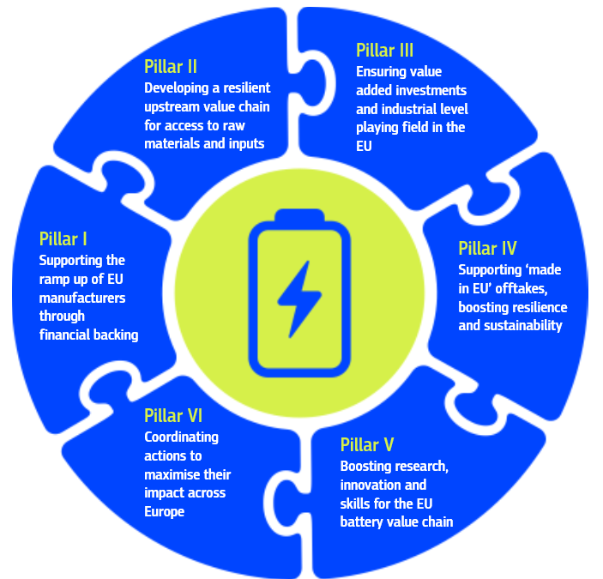

Pillar I: Supporting the ramp up of EU manufacturers through financial backing
There is a critical need to support battery production in the EU in response to the pressing international challenges and the difficulties the industry faces in scaling up production. Battery cell manufacturing requires substantial capex investments due to the need for large-scale industrial infrastructure, advanced equipment, and stringent quality and safety standards. Additionally, the ramp-up phase tends to feature high costs and low revenues due to high scrap rates, the time needed to start production and low outputs. The ramp-up phase involves a steep learning curve to master and refine the manufacturing process. In order to secure the current pipeline of projects, encourage further private-sector investment and boost the security of supply of the automotive and energy storage industries, the Commission is committed to implementing targeted financial support measures.
The European Commission put forward in December 2024 EUR 1 billion in grants to support electric vehicle battery cell manufacturing projects via the Innovation Fund. In addition, it has provided a top-up of EUR 200 million (in the form of guarantees for loans) to the InvestEU programme from the EU Innovation Fund, to support innovative projects along the European battery manufacturing value chain. Under the clean tech manufacturing topic of the ongoing Net-zero technologies call with a budget of EUR 1 billion, support is also available for the upstream battery value chain such as cathode active material (CAM) and anode active material (AAM), as well as battery recycling. Those two materials are essential components of lithium-ion batteries. Moreover, the Interregional Innovation Investment (I3) instrument supports the scale-up of mature interregional innovation projects along strategic European value chains, such as the battery industry.
Building on these initial steps, the European Commission is setting up the Battery Booster Facility to mobilise EUR 1.5 billion from the Innovation Fund in financing to support European battery cell producers during the ramp-up phase. Support will be provided through interest-free loans. These will be provided in instalments and will be performance-based, linked to the achievement of specific milestones based on progress in implementing the business plan until the projects successfully reach large scale production and higher levels of commercial viability. Compliance with Regulation (EU, Euratom) 2024/2509, as well as compliance with Directive 2003/87 and Delegated Regulation 2019/856, will be ensured in the design and in the implementation of the Facility. The overarching goal is to ensure that public support catalyses private-sector investment, speeds up industrial deployment and strengthens Europe’s position on the global battery market.
As regards further Member States involvement, the Commission has already acknowledged the specific situation of clean technology manufacturers like battery producers in the Clean Industrial State Aid Framework (CISAF), especially as regards unfair global competition, unexpected costs overruns, or uncertainties on future demand. It has further clarified that Member States may provide funding, including in the form of equity and quasi-equity instruments, on market terms, alongside private operators, which may help to address the issue identified above on the limited shock absorption capacity of EU-based suppliers due to small balance sheets. The Commission invites Member States to make use of these existing possibilities which can help to address the acute issues of the industry, while also providing the possibility of returns to the taxpayer once production levels allow for profitable manufacturing.
In the medium term, under the EU’s next multiannual budget from 2028, the proposal for a European Competitiveness Fund (ECF) includes support for ‘production ramp-up actions’, including in the cleantech sector such as the battery industry. In the meantime, the Battery Booster Facility will provide a bridging solution for the industry, providing immediate support until the ECF framework is fully operational.
This recognises the urgent need for swift action to upgrade the EU’s battery production capabilities to reach and maintain a competitive edge in the global market.

Figure 2. Financial support
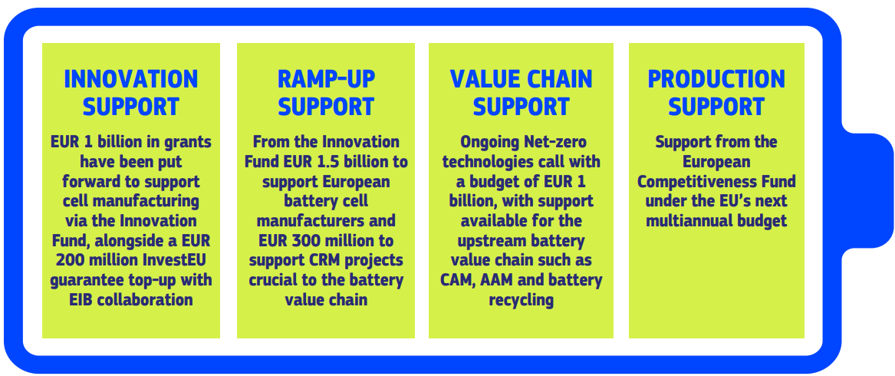

With regards to strengthening the circular economy, Member States are also invited to make full use of the existing State aid possibilities provided by the Climate, Energy and Environmental State Aid Guidelines to encourage resource efficiency and the transition towards a circular economy.
Flagship actions
- EUR 1 billion in grants were put forward in December 2024 to support electric vehicle battery cell manufacturing projects via the Innovation Fund. In addition, the Commission is working with the EIB to ensure full use of the EUR 200 million top-up of guarantees for loans under InvestEU from the Innovation Fund.

- EUR 1.5 billion from the Innovation Fund for the Battery Booster Facility in the form of interest-free loans, the first instalment of support is aimed at reaching selected companies in 2026

- Support from the European Competitiveness Fund under the EU’s next multiannual budget.
Pillar II: Developing a resilient upstream value chain for access to raw materials and inputs
The EU battery industry is grappling with supply-chain challenges due to geopolitical tensions and reliance on a few non-EU suppliers, including for critical raw materials (CRM). This dependency creates the risk of supply disruptions and higher costs, hindering efforts to build a secure value chain.
The European Commission has taken significant steps to support the development of strategic raw material projects related to battery production. Earlier this year, it designated 32 projects in the EU focusing on battery raw materials such as lithium, nickel and graphite and 10 projects outside of the EU, all as strategic projects under the Critical Raw Materials Act. These projects will be eligible for simplified permitting and coordinated funding. The Commission has launched a second call for strategic projects, inviting project promoters to apply by 15 January 2026.

Figure 3. Battery related CRM Strategic Projects
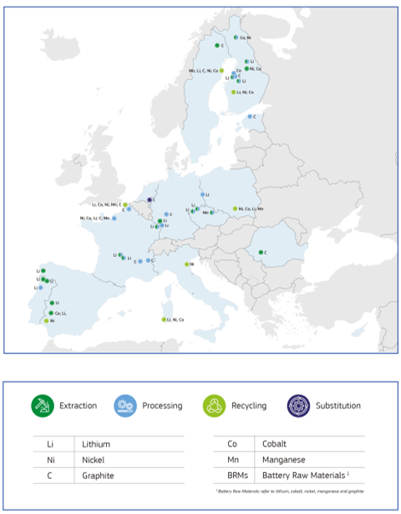

To accelerate diversified sourcing of battery raw materials, the Commission has also adopted the RESourceEU Action Plan, which will mobilise EUR 3 billion of EU funds within the next 12 months to provide direct support to the CRM value chain.
The recent agreement between the Council and the European Parliament on enhancing the InvestEU programme increases the EU guarantee by EUR 2.9 billion, with aims to unlock nearly EUR 55 billion in additional public and private-sector investment. This can support, among others, projects in critical raw materials, including all stages of development from support to start-ups, to the scale-up stage and deployment. Altogether, the Commission expects to mobilise investment under the InvestEU facility of around EUR 6 billion by 2027, of which at least EUR 2 billion in 2026-2027, in critical raw material-related investment. It will boost the project pipeline via the InvestEU Advisory Hub.
The Commission has identified relevant projects to reduce EU raw material dependencies on a single country of origin by 30% to 50% by 2029 or earlier. The Commission will closely track progress in finalising financing needs and in accelerating toward market readiness, with the CRM Financing Hub and the CRM Centre, which will be set up in 2026. In addition, in March 2026, the Commission will launch the first round of the Raw Materials Mechanism on the EU Energy and Raw Materials Platform. The first round in March 2026 will target immediately available and soon-to-be-available rare earths, battery and defence raw materials value chains.
It is equally important to recycle the resources available in Europe to strengthen the EU battery value chain. This is why, building on the recent announcement in RESourceEU and the Batteries Regulation’s Implementing Act on labelling, the Commission will take action to make it easier to recover and recycle battery raw materials. For batteries, recycling also requires access to black mass as well as sufficient refining capacity, which remains a challenge for the European industry.
As decided in March 2025, waste lithium-ion batteries and black mass will be classified as hazardous waste as of December 2026. This means that exports to non-OECD countries will be prohibited after that date. The Commission will work to implement this ban effectively, with no circumvention, and if needed it will present additional measures to further restrict exports of black mass.
There is also critical need to recover lithium, cobalt and nickel from black mass within the EU. Recycling facilities to extract materials from black mass are advancing but represent only a small portion of future European demand and have to mature further. These challenges require substantial investments in battery recycling facilities and ramping up financial support for battery recycling.
On the back of this ambitious agenda announced in RESourceEU, with the Battery Booster, we take a further step to develop the upstream value chain of the battery sector. Up to EUR 300 million will be used to support CRM projects crucial to the battery value chain, notably lithium, cobalt, nickel, manganese and graphite. This support will address a severe market gap as a lot of project promoters of battery raw materials projects face large upfront costs to scale up production while having only a small balance sheet to leverage against. The Commission will also adopt a Circular Economy Act in Q3/2026, which will accelerate the circular transition, strengthening the sustainability, resilience and competitiveness of the Union by leveraging the single market. The Act will deliver simpler, harmonised rules and lower costs for cross-border circular activities and will create a single market for waste and secondary raw materials.

Flagship actions
- Implementing the RESourceEU action plan to accelerate the roll-out of projects along the battery raw materials supply chain.

- Funding up to EUR 300 million from the Innovation Fund in critical raw materials projects in the battery value chain.

- Launching the second call for strategic projects under the CRMA, deadline 15 January 2026.

- Launching the first round of the Raw Materials Mechanism on the EU Energy and Raw Materials Platform in March 2026.

Pillar III: Ensuring value added investments and industrial level playing field in the EU
European battery manufacturers are navigating geopolitical headwinds and fierce foreign competition on a market that lacks a genuine level playing field for trade and investment. This situation allows imports from unfair competition into the EU battery ecosystem. There is increasing interest from foreign players in investing in the battery sector, but the EU currently lacks clear conditions to ensure that investments bring added value. Without strong safeguards, the EU remains exposed to concentrated foreign ownership, external technological control and limited integration into European supply chains.
That is why the Commission is considering proposing a new set of conditions to ensure that foreign direct investments, including those in the battery value chain, deliver clear benefits for Europe’s competitiveness and resilience. Projects in strategic segments from material processing to cell manufacturing and recycling, should bring value-creation to the EU economy and therefore may need to respect some conditions covering governance, maximum foreign ownership, technology transfer, research and development, workforce development, supply-chain integration.
In line with the objectives of the Clean Industrial Deal and the automotive action plan, the EU must continue to build strategic partnerships to boost the resilience of our supply chain. The Memorandum of Understanding on batteries between European and Japanese industry associations signed in September 2025 will lead to stronger cooperation in key aspects including recycling and circularity, data sharing and skills. We will continue to develop, de-risk and diversify supply chains with international partner countries to strengthen the EU´s manufacturing capacity.
In parallel, the Commission will continue to make use of its tools to ensure a level playing in the Single Market, including by investigating under the Foreign Subsidies Regulation, where appropriate, potential distortions of competition in the battery value chain caused by foreign subsidies, promoting fair competition throughout member states. Additionally, the Commission will actively monitor developments related to Economic Security and Trade Defence Instruments for batteries. This vigilance is essential for maintaining market stability and ensuring fair trading conditions across all sectors.
Flagship actions
- FDI Conditionalities to ensure that foreign direct investments bring value added by respecting some conditions including for example technology transfer and supply-chain integration
- ‘Battery diplomacy’ – outreach with global partners to strengthen and diversify supply chains.
Pillar IV: Supporting ‘made in EU’ offtakes, boosting resilience and sustainability
To support the emergence of a resilient European battery value chain and to boost demand, the Commission will stimulate the creation of lead markets for EU-made batteries, components and materials by leveraging the size and predictability of the EU’s battery needs.
Under the Industrial Accelerator Act, the Commission will propose EU content requirements for batteries and their components, in line with the EU’s international legal commitments and applicable State aid rules. Those requirements will be designed to ensure that public funds are channelled to EU manufacturing and employment to help EU battery manufacturers scale up and flatten the steep industrial learning curve. They will also be designed to unlock and attract private capital into the most strategic segments of the battery value chain.
EU content requirements will help ensure the full use of existing manufacturing capacities for key battery components, whenever EU or MS support is provided, and provide support so that planned, announced and on-hold projects can be implemented successfully. By anchoring more stages of the battery value chain in Europe. It will not only reduce the EU’s battery industry exposure to geopolitical risks but also ensure that public funding is used to create European industrial resilience and long-term competitiveness. The requirements may also have a positive effect on the extraction and processing of critical raw materials, where creating strong and predictable demand is essential to de-risk investments.
The Commission will also explore how drone production in Europe for the defence industry can play a greater role in de-risking the process of ramping up the battery value chain.
This will complement the requirements already applicable under the Net-zero Industry Act, which mandate Member States to include resilience criteria in all new or updated electric vehicle subsidy schemes as of January 2026. The Commission issues today a communication providing guidance on how these provisions should be implemented in practice.
In parallel, the work underway to implement the Battery Regulation is advancing to strengthen the European single market for batteries. Greater transparency and having more information available through labelling, including information on the carbon footprint, will also improve sustainability throughout the value chain.
Initiatives and technologies should be pursued to meet the effective needs of drivers, while avoiding unnecessary oversizing, and to more easily and cheaply repair and recycle them, for example through standardisation.

Flagship actions
- As part of the IAA, propose new EU content requirements in EV batteries and in BESS.

- Under Article 28 of the NZIA, EV support schemes created or updated as of 1 January 2026 should promote the purchase of zero-emission vehicles with an electric propulsion system whose components – including the battery pack – come from diversified sources of supply. This will contribute to reducing the EU’s dependency on Chinese vehicles and batteries.

Pillar V: Boosting research, innovation and skills for the EU battery value chain
The battery industry is still a nascent industry with huge potential for innovation and growth. The EU must ensure that its battery ecosystem grows, keeps pace with global technological advancements and remains at the forefront of battery technology. To stay competitive in both the production of batteries and technology development, the EU must invest more in research and development (R&D) to develop new battery technologies, improve battery recycling, and close critical gaps in the value chain.
This is not a new journey; the EU has developed and strengthened its battery R&D ecosystem for many years, but we need to accelerate and scale it up. In the period 2021-2027, the EU aims to provide up to EUR 925 million in support to the Horizon Europe Batt4EU partnership. This strategic initiative underpins the development of differentiating technologies in battery materials, cell design, manufacturing and battery recycling, leveraging synergies between transport and electricity storage battery applications. Between 2025 and 2027, the partnership will support research and innovation (R&I) projects across the whole value chain for a total value of EUR 382 million. The Smart Specialisation Partnership on Advanced Material for Batteries for Electro-mobility and Stationary Energy Storage enables regions to align their innovation priorities and collaborate on such projects. In addition, in September 2025, Batt4EU signed, together with the other two partnerships relevant for the automotive sector under Horizon Europe (2Zero and CCAM), a Memorandum of Understanding with the European Commission to align strategic priorities to boost the competitiveness of the EU automotive industry and develop a joint Strategic Research and Innovation Agenda. The Commission will at the same time explore additional possibilities to finance research and innovation activities for improved battery cell technologies. In addition, the EIC will fund start-ups and SMEs developing advanced materials for energy storage via a specific call for proposals under the Accelerator funding programme, to be launched in 2026.
In future, aligning and de-fragmenting public and private research initiatives will be a key success factor for a competitive EU batteries value chain. Under the revamped Strategic Energy Technology (SET) plan, which is now anchored in the Net-Zero Industry Act, the Implementation Working Group on Battery Technologies (led by Member States with the European Commission and supported by the private sector and academia) will deliver a common investment and implementation plan in 2026.
The plan will map the available resources and set out Member State and stakeholder implementation and investment commitments to meet joint public-private European R&I priorities and objectives. It will focus on next-generation high-performance battery chemistries, including those relevant to military applications, while tackling gaps in early-offtake, low-volume production lines. This plan will lay the ground for a new coordinated R&I programming which, building on the initiatives funded under Pillar II of this strategy, will be designed to boost competitiveness in battery technologies to improve the battery manufacturing and recycling process, develop EU-made machinery for battery production, new battery concepts and materials across all applications. This will support the work under the Competitiveness Coordination Tool (Pillar VI).
Given the rapid technological evolution, equally ensuring that the battery industry has a workforce with the right skills requires constant focus on skills development, up- and reskilling. The Skills Intelligence Observatory, set up under the Union of Skills, will play a key role in identifying the skills needs and continuously monitoring the demand. It will provide input to the European Semester process, thus enhancing policy attention and leveraging the necessary funding. Adjusting the supply of skills to the demand will need investment from both public (EU funds, EU-supported projects) and private sources, available over a stable period, due to the growing evolution of the sector
Strengthening the EU battery manufacturing capacity requires a sizeable skilled workforce. Further action should build on the lessons learnt from the Net-Zero Industry Academies, including the European Battery Alliance Academy. Through the Net-Zero Industry Academies, the Commission supports education and training on battery upskilling and reskilling across the EU. This requires mobilisation of European actors, from industry, Member States authorities (including at regional and local level), education and training providers, and social partners.
The Commission will also explore additional practical ways to support European battery manufacturing innovation, taking into account existing frameworks and tools. This may include providing, as needed, guidance on scope for closer cooperation between battery industry players to work jointly on new R&I projects.
Flagship actions
- Support through Horizon Europe the development of new battery concepts and materials and cell manufacturing technologies along with a full European battery value chain.

- Integration and better alignment of related Member States R&I programmes with European R&I via the SET plan.

Pillar VI: Coordinating action to maximise impact across Europe
The battery booster embodies Europe’s overarching industrial strategy for the entire battery value chain. Support must be coordinated and implementation consistent across the ecosystem – this is essential for success. The Commission and Member States must take joint action, alongside financial institutions and market operators, to deliver a coherent and effective push.
The Commission plans to bring in a new Competitiveness Coordination Tool, designed to coordinate action at European level with action taken at national level, and to achieve coherence across Member States’ shared competitiveness priorities in key areas and projects of strategic significance and common European interest. For the battery sector, the primary purpose will be to align cross-border and EU-wide action to achieve greater economic impact across Europe.
Figure 4. EU battery related projects based on industry announcements
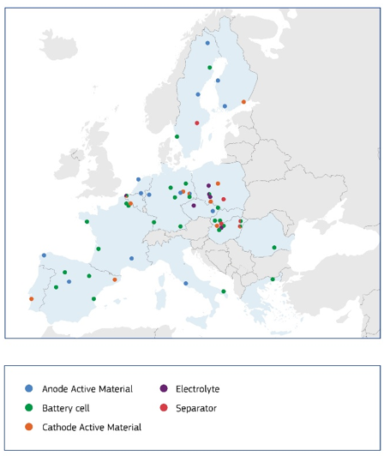

A CCT pilot will be set up for the battery sector, to support the successful implementation of the measures announced under the battery booster. The aim of the pilot will be to:
- exchange information on skills, finance, research and innovation, in particular on upskilling, reskilling and training schemes;
- align investments across the European battery value chain, between EU and national funding instruments, together with private investors;
- align and strengthen Member States’ commitments to rolling out demand-side measures, for example ‘made in Europe’ requirements.
Flagship actions
- Develop a pilot competitiveness coordination tool to promote strategic alignment between the EU, the Member States and the regions, to foster a robust and competitive battery ecosystem within Europe.

Conclusion – next steps
The European Battery value chain is at a turning point. Time is of essence. The Battery Booster Strategy aims to accelerate the delivery of the EU battery strategy by tackling all chokepoints in the value chain and by supporting the whole ecosystem to enable its fast development.
The battery booster provides an immediate opportunity to deploy a new business case for manufacturing batteries in the European Union and across its territories. Fast implementation is of paramount importance to provide EU operators the tools they need to scale up, build resilience, be competitive and remain at the forefront of innovation.
The Commission will immediately proceed with setting up the Battery Booster Facility so as to accelerate the successful ramp up of European battery cell manufacturers. The Commission aims at launching a related call for proposals in the first quarter of 2026 with the first instalment of support aimed at reaching selected companies in 2026.
Next month, the Commission will propose the Industrial Accelerator Act to support lead markets for European-made batteries and their components and to secure value added foreign investments in the EU. The measures are essential for the EU’s battery industry to boost its competitiveness in an increasingly fast-paced global ecosystem. In the interim, as from January 2026 Member States must begin applying the resilience and sustainability criteria of the Net Zero Industry Act in new or updated public support schemes, and the Commission further encourages Member States to make full use of foreign investment screening tools.

In 2019 and 2021, the Commission approved two IPCEIs in the battery ecosystem involving support to 59 companies in 12 Member States of up to EUR 6.1 billion in State aid aiming to trigger more than EUR 13.8 billion of additional private investment. The IPCEIs support ambitious research and development activities to deliver innovations across the batteries value chain, including mining and processing of raw materials, development of advanced chemical materials, design of battery cells and integration into applications such as electric vehicles, and recycling of used batteries.
BloombergNEF.
Bruegel Clean Tech Tracker.
BloombergNEF.
An example is the BATMASS project, which develops a circular European battery value chain and investment-ready solutions for recycling and reuse.
Advanced Materials for Batteries for Electro-mobility and Stationary Energy Storage, https://ec.europa.eu/regional_policy/policy/communities-and-networks/s3-community-of-practice/partnership_industrial_mod_advanced_materials_en
European Commission (2025), Communication from the Commission to the European Parliament, the European Council, the Council, the European Economic and Social Committee and the Committee of the Regions, ‘A Competitiveness Compass for the EU’, COM (2025) 30 final, Brussels, 29 January 2025.

