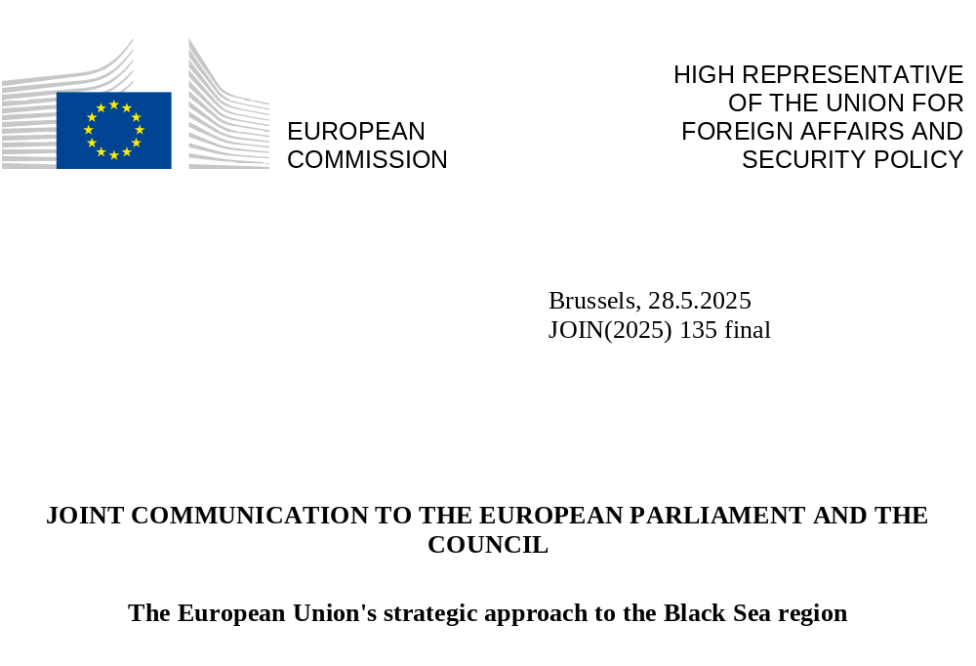

the geostrategic importance of the Black Sea region
The Black Sea is an area of significant geostrategic importance, bridging Europe to Asia, with untapped potential for economic development, strategic transit routes especially for access to energy resources and critical raw materials.

Its critical importance is underscored by Russia’s war of aggression against Ukraine that has shaken the foundations of the rules-based international order and exposed the vulnerabilities of European and regional security. It has plunged regional security to its lowest point since the Cold War and calls for a robust, coordinated EU response. In this evolving geopolitical landscape, with the Black Sea region at its core, the EU is stepping up with a comprehensive approach with the aim of supporting the democratic resilience of a region vital to Europe's stability and prosperity and asserting our interests.

The EU is committed to supporting Ukraine and its neighbours, by upholding their independence, sovereignty and territorial integrity, fostering peace and dialogue, providing security guarantees and contributing to recovery and reconstruction. The security in the Black Sea region will equally need to be at the heart of a just, comprehensive and lasting peace.
A number of countries in the region are on the path towards accession or closer alignment with the EU. The enlargement process, the gradual integration of candidate countries into the internal market and integrated partnerships in the region will unlock economic potential, strengthen the rule of law, and accelerate reforms. Peace and security are at the foundations of this renewed approach.
Beyond its immediate neighbourhood, the Black Sea’s importance is global. As a critical connector between Europe, the Southern Caucasus, Central Asia and the Eastern Mediterranean, the Black Sea region plays a strategic role for European and overall global security, international trade, energy and food security (notably grain). With its population of almost 174 million people the States surrounding the Black Sea (excluding Russia) generate a GDP of approximately EUR 2 trillion. The EU is the largest trade partner for most of the countries in the Black Sea region with the overall trade volume of EUR 310 billion and the second largest trading partner for Central Asia. Strengthening our cooperation and fostering enhanced economic links will contribute to the competitiveness of the region and of the EU itself.
Next to its geopolitical and economic significance, the Black Sea is a dynamic hub of innovation and culture. The environmental challenges of the Black Sea equally demand stronger regional cooperation – to protect marine ecosystems, develop the blue economy, and increase climate resilience among coastal communities. A safe and secure Black Sea is essential to ensure freedom of navigation, maritime safety and security. Furthermore, we must swiftly address hybrid threats, such as cyber-attacks, disinformation campaigns and foreign information manipulation and interference (FIMI).
The EU Strategic Approach: a hub of security, stability and prosperity
At the heart of this strategy lies a political project: to advance peace and security, economic development, and democratic consolidation in a region increasingly under geopolitical pressure. The EU’s vision is for the Black Sea region to be a secure, interconnected and prosperous space – anchored in shared values and regional cooperation. The EU’s strategy recognises the Black Sea as a pivotal gateway linking Europe to the South Caucasus, Central Asia, and beyond – underpinned by targeted investments in transport, energy and digital infrastructure, to increase connectivity and trade. Increased intra-regional and inter-regional connectivity will be a key enabler to accelerate energy independence, integration of renewables and ensure energy system stability and resilience. Regional challenges will be addressed through mutually beneficial partnerships to promote long-term security, prosperity, stability and resilience.
This strategy brings together internal and external EU instruments under a single framework. Under the Global Gateway the EU aims to mobilise strategic investments, deepen partnerships, and deliver tangible benefits in a Team Europe approach – reinforcing Europe’s role as a reliable geopolitical actor. In response to the evolving geopolitical context, the new EU strategic approach for the Black Sea region outlined in this Joint Communication proposes multiple avenues to forge closer cooperation with Ukraine, the Republic of Moldova, Georgia, Türkiye, Armenia and Azerbaijan, and with relevant partners and organisations.
The EU’s role and responsibility in the Black Sea region is increasing, particularly with the opening of accession negotiations with Ukraine, the Republic of Moldova; and with Georgia, should the country revert to the EU path. The EU enlargement process is a strategic investment to enhance regional security and resilience. The EU aims to support interested partners in EU integration by strengthening the rule of law, democracy, and climate resilience. Gradual integration of candidate countries and their involvement in EU initiatives will offer tangible benefits to citizen and address challenges already prior to accession. The EU will work closely with partners to align with its Common Foreign and Security Policy, including sanctions and defence policy. Particular focus will be on enforcement of the EU restrictive measures on Russia and Belarus, notably tackling sanctions circumvention.
In the Black Sea region, the EU focuses on peace and international law to unlock potential for economic growth, sustainable investments and enhanced regional connectivity. In this respect. supporting Ukraine's overall resilience, security, and reconstruction is central, alongside peace and stability in the South Caucasus, particularly normalisation of Armenia-Azerbaijan relations, including the swift signature of the peace treaty, as well as normalisation of Armenia-Türkiye relations.
A coordinated approach with Türkiye, an EU partner of strategic importance and a candidate country is also important. Re-engagement remains key in line with the November 2023 Joint Communication and relevant European Council conclusions. This is a common responsibility towards peace and stability in the region, based on the UN Charter and international law. Türkiye and the EU share the objective of ending Russia’s war of aggression against Ukraine, respecting Ukraine’s territorial integrity and sovereignty, and ensuring security in the region. Türkiye’s engagement in diplomatic efforts, such as facilitating the Black Sea Grain Initiative and prisoner exchanges, underscores its importance as a security and economic actor. Furthermore, Türkiye can play a constructive role on countering Russia’s shadow fleet, and contributing to efforts to enhance maritime safety, energy security and connectivity in line with international law and relevant conventions. Türkiye and the EU are in a Customs Union and are important trade partners for each other.

Three pillars for future EU-Black Sea cooperation
Future cooperation with the Black Sea region will be structured under three major pillars:
- enhancing security, stability, and resilience;
- fostering sustainable growth and prosperity;
- promoting environmental protection, climate change resilience and preparedness, civil protection.

To increase the desired impact of joint actions, flagship initiatives will be implemented under each of these pillars. The initiatives will address the immediate challenges of conflict and security and unlock the region’s potential for growth.
The way forward for EU engagement
The EU strategic approach is a forward-looking policy framework, combining short-term and longer-term measures.
To leverage the potential of the Black Sea region, the EU will engage in:
- Deepening partnerships: Strengthen bilateral ties with Black Sea countries to foster regional security and prosperity, while ensuring interconnections with the EU and boosting cross-regional cooperation, including cooperation with Baltic Sea.
- Security and conflict resolution: Support peace and conflict resolution, including by enhancing mediation and dialogue facilitation and stepping up cooperation on capability development, military mobility and demining. This also concerns supporting the negotiation and monitoring of ceasefires and facilitating inclusive peace-building efforts.
- Upholding the rule of law and democracy: Strengthen societal resilience, notably through the independence and efficiency of the judiciary as well as through addressing corruption, organised crime, cybersecurity, FIMI and disinformation and advancing fundamental rights and gender equality.
- Energy market integration: Advance policy reforms to enable more energy trading across borders, facilitate the roll-out of renewable generation capacity, diversify energy supplies to reduce dependency on Russia, improve industrial competitiveness, increase access to affordable energy for households and ultimately enhance energy security.
- Energy efficiency and decarbonisation: Promote energy efficiency measures to reduce energy consumption and greenhouse gas emissions in line with the EU’s decarbonisation trajectory and international commitments and support the region's transition to a low-emission economy.
- Infrastructure development: Improve connectivity by developing transport, energy and digital infrastructure aligned with Trans-European Networks, linking Europe, Asia, and the Mediterranean.
- Trade: Maximise mutual economic benefits by improving trade relations, fostering investments with private sector involvement, ensuring further economic integration. This includes access to critical raw materials in Central Asia via the Trans-Caspian Transport Corridor linked to a stable and secure Black Sea region.
- Preparedness and resilience: Strengthen collaboration and exchange of good practices to anticipate, detect, prevent and manage threats and incidents, particularly with a view to shared challenges in the Baltic Sea, including to counter information manipulation, and improve the protection of critical infrastructure – including all types of energy infrastructure – against hybrid threats. Enhance ability to recover.
- Environmental protection and climate change: Enhance regional cooperation on environmental protection and restoration work to preserve the potential of the blue economy and increase the resilience of coastal communities, while addressing the broader environmental threats and the impacts of climate change and environmental degradation, and fostering sustainable practices.
- Education, skills and research: Strengthen links between the research sector and academia and promote quality and cooperation in education. Promote skills development and employment policies across the region, in line with the objectives of the Union of Skills.
- Defence industry: Cooperate on developing defence related industrial assets in the region.
- Culture: Strengthen cultural exchanges and cooperation to unlock growth potential, foster societal resilience, promote shared values and mutual understanding.

Implementation will build on a range of partnerships and cooperation frameworks with the countries of the Black Sea region, notably the Association Agreements/Deep and Comprehensive Free Trade Areas (DCFTA) with Ukraine, the Republic of Moldova - and their respective Negotiating frameworks with the EU - and Georgia, the Association Agreement with Türkiye, the November 2023 HRVP-European Commission Joint Communication on the state of play of EU-Türkiye political, economic and trade relations and in line with European Council conclusions, the Comprehensive and Enhanced Partnership Agreement with Armenia, and the Partnership and Cooperation Agreement with Azerbaijan, as well the as regional cooperation frameworks of the Black Sea Synergy, the Common Maritime Agenda for the Black Sea the Strategic Research and Innovation Agenda (SRIA), the Interreg NEXT Black Sea Basin programme, and the EU-Ukraine Solidarity Lanes.
In particular, the Eastern Partnership has been instrumental in supporting critical reforms, promoting cooperation and investments, engaging with young people and civil society, and fostering closer ties between the EU and interested partners, and regional cooperation. The Black Sea region is central to the reinvigorated Eastern Partnership framework in the heart of which will be a dedicated regional connectivity agenda.
The Global Gateway - the EU’s strategy for promoting sustainable and high-quality infrastructure development worldwide - will be a primary framework for mobilising investments in connectivity and for fostering stronger business ties between the EU and the wider Black Sea region, in line with the implementation of the Trans European Network policy. The Global Gateway strategy is already being actively implemented in Ukraine, Moldova, South Caucasus and Central Asia. The Black Sea serves as a crucial connection between the EU and Central Asia, playing a pivotal role in enhancing connectivity and promoting trade. With strategic focus on the region, significant investments are underway to strengthen transport, energy and digital infrastructure to further improve trans-continental links between Europe and Asia and security of global supply chains.
1. Security, stability and resilience
Security in the Black Sea region and in Europe is closely interlinked with Ukraine’s security. The EU will take forward actions to contribute to security guarantees to Ukraine including in the maritime domain. Black Sea maritime security is essential to re-assuring regional partners and unleashing the untaped potential of the Black Sea region.
The EU should step up and support and coordinate Member States and partners’ efforts to build up maritime capacities and enablers regarding sea monitoring, including for observation of a possible maritime ceasefire, mine cleaning efforts, protection of critical infrastructure, patrolling of commercial sea lines, countering hybrid threats, with the aim of deterring future aggressions in the region and, when conditions allow, to consolidate peace.
The EU will support its Member States and like-minded Black Sea partner countries to build-up their defence and get the needed capabilities to face growing and multi-faceted threats, including through the Defence package recently agreed and backed by the funding foreseen by the ReArm Europe Plan/Readiness 2030. The integration of the Ukrainian defence industry into the European Defence Technological and Industrial Base (EDTIB) and by investing more into new technologies will contribute to the strengthening of maritime capabilities in the Black Sea.
The EU is enhancing its engagement with the countries of the Black Sea region through security and defence dialogues, capacity building, de-mining action, deploying EU CSDP missions and providing European Peace Facility (EPF) support. The adoption of several security initiatives, for instance the Revised EU Maritime Security Strategy or to counter hybrid threats and strengthen the security of critical maritime infrastructure offer new possibilities to enhance security in the region. The EU’s strategic partnership with NATO and the established staff-level formats and areas of cooperation can be further leveraged.
Flagship 1: Black Sea Maritime Security
In a short-term and with a sense of priority due to the Russian war of aggression, the Commission and the High Representative propose to establish a Black Sea Maritime Security Hub, leveraging EU and Black Sea states’ contributions to strengthen maritime security and safety, protect critical maritime infrastructure and the marine environment.
The Hub will enhance maritime situational awareness and information sharing on the Black Sea, real-time monitoring from space to seabed, and early warning of potential threats and malicious activities. It will include the following services:
- information exchange in real time on security situation, with more integrated and interoperable systems, including through the European Maritime Safety Agency, and by opening EU information sharing platforms and providing services by EU agencies to Ukraine and like-minded littoral States whenever possible.
- monitoring of critical maritime infrastructure, including submarine cables, offshore installations, gas and wind energy operations off the Romanian and Bulgarian shores, and related maritime capabilities, using existing and new technologies such as underwater sensors, unmanned/remotely piloted vessels and surveillance drones programmes (air, surface, underwater). It will enable taking preventive actions when necessary.
- input for decisions to activate, accelerate or adapt ongoing and planned cooperative projects (including in PESCO and EDF frameworks) that support work to develop maritime assets and/or capabilities to monitor and protect critical maritime infrastructure, including through supporting the assets and services based on satellite observation and satellite telecomunications. It will capitalise on the capabilities offered by the EU Space Programme, in particular the Copernicus Maritime Surveillance service.
- a mechanism for broadening coast-guard cooperation in the Black Sea basin, modelled on existing mechanisms
By end of summer, the Commission and the High Representative will map specific needs and present operational options, including regarding CFSP and CSDP tools and European Maritime Security Strategy.

1.1 Support regional cooperation on demining and maritime safety, defence and security
A key challenge in the Black Sea is the danger posed by mined areas in the littoral States waters, drifting mines and other unexploded ordnance (UXO), creating serious risks to maritime security, safety, blue economy activities, and the marine environment. Building on and coordinating with the existing trilateral demining initiative by Bulgaria, Romania and Türkiye for the Black Sea, the EU will work towards Black Sea shores and the region becoming mine-free, which is essential for the development of transport corridors supporting trade.
Key actions include:
- Engaging and seeking synergies with like-minded partner countries and organisations on demining in the region in a long-term perspective.
- Using EU programmes and projects under the European Maritime, Fisheries and Aquaculture Fund (EMFAF), HORIZON and Interreg to map and assess the state of UXO.
- Leverage the SAFE instrument and European Defence Industry Programme (EDIP) for collaborative opportunities to invest into new defence technologies.
- Addressing the tangible risks posed by the shadow fleet used by Russia to maritime safety and the environment in the Black Sea.
- Seeking partnerships with the private sector and the shipping industry in developing best practices to prevent incidents and to ensure the protection and resilience of critical undersea infrastructure.
- Full implementation of the International Ship and Port Facility Security Code (ISPS) and of the EU maritime security acquis across EU Member States and candidate countries.
- Continued outreach and dialogue with concerned third countries and work with international partners, including with the International Maritime Organization (IMO) to establish and uphold stringent maritime safety and security standards.

1.2 Enhancing military mobility and dual use infrastructure
A key strand of action is linked to the need to enhance military mobility in and around the Black Sea and to facilitate dual-use infrastructure projects in EU Member States, also connecting neighbouring countries, in land, sea, and air domains. While bringing clear added value to the security of the EU, enhanced military mobility in the region will provide additional benefits to EU’s security and Ukraine’s security and reconstruction.
At the heart of military mobility is the need to urgently upgrade the dual use transport infrastructure along the existing military mobility network – comprising multi-modal transport routes connected by logistical hubs – so that it is capable of handling potentially heavy and large-scale military transport. EU Black Sea and EU Danube ports of embarkation and debarkation, as well as the connecting rail and road infrastructure, are crucial for enabling military mobility. The ability to rapidly move military equipment and troops to Ukraine will serve as additional security guarantees to deter against future aggression.
Key actions include:
- Upgrading transport infrastructure to enable its preparedness for dual use.
- Equipping a sufficient number of sea and river ports and airports in the region, particularly on the military mobility corridors, with the specialised infrastructure necessary to onload/offload oversized and overweight military equipment and materiel and providing for sufficient storage space to allow smooth inland forwarding of shipments.
- Protection of the critical infrastructure, including military mobility corridors and economic and energy platforms.
- Working with partners on mechanisms to ensure that the ownership and management of ports and critical maritime infrastructure is transparent, reliable, including through the implementation of the Foreign Direct Investment screening mechanism in the EU.

1.3 Countering hybrid threats
Countries in the Black Sea region, their societies and infrastructure are targets of hybrid threats, including cyber threats, disinformation campaigns and FIMI. The EU and the Black Sea region will benefit from closer cooperation in these areas, especially with Baltic Sea region, to foster greater shared understanding of the threat picture, actors and their methods, as well as by exchanging policy approaches, responses and best practices. The EU offers the use of instruments, such as the EU Hybrid Toolbox and EU Cyber Diplomacy Toolbox to address these specific threats and boost the region's resilience.
Key actions include:
- Establishing a network for joint response mechanisms that reduce the space for FIMI and disinformation campaigns, including in rural and border areas.
- Increasing capacity, cooperation and information sharing on hybrid and cyber threats, including for critical infrastructure, across the region by building on the dedicated CSDP Missions in the region and leveraging EU projects and frameworks, such as the Hybrid Risk Survey, and the EU Hybrid Rapid Response Teams or in coordination with NATO and other like-minded.
- Engaging in coordinated actions to impose costs on malign actors through demarches, statements, attribution or sanctions, making full use of the EU’s Hybrid, Cyber and FIMI Toolboxes.
- Enhancing partner countries’ ability to use innovative technology and artificial intelligence as tools to counter disinformation and FIMI, combined with tailored actions to promote media literacy and critical thinking across the population, fostering a culture of democratic engagement.
- Strengthening cooperation between regional networks of fact-checkers, building on EU Democracy Action Plan and Defence of Democracy Package.
- Enhancing multi-stakeholder processes to mitigate risks on online platforms, safeguarding fundamental rights online, in line with international human rights standards.

1.4 Fighting organised crime and trafficking
In line with ProtectEU - the European Internal Security Strategy, the EU actively supports its neighbours in addressing emerging threats, fostering deeper operational collaboration, facilitating information exchange, and building capacities aligned with EU standards. The European Commission, the EMPACT firearms and Europol have highlighted concerns regarding the potential proliferation of firearms and explosives stemming from the military hostilities against Ukraine. The EU will reinforce cooperation in the fight against organised crime, with particular focus on the fight against human trafficking, firearms and drug smuggling.
Key actions include:
- Encouraging the participation of partner countries in the European Multidisciplinary Platform Against Criminal Threats (EMPACT) to fight organised crime and to take leadership or co-leadership positions in operational actions plans to tackle regional priority areas.
- Strengthening partnerships between law enforcement agencies and border and customs authorities in the Black Sea region and Frontex, Eurojust, Europol and CEPOL.
- Put in place a programme for enhancing expert co-operation in preventing and combating corruption notably in ports, with a focus on restricting the influence of organised crime groups.
- Stepping up judicial cooperation through mutual legal assistance with focus on asset recovery and cooperation with EU agencies.
- Improving data-driven insights to track corruption, money laundering, sanctions circumvention, organised crime, trafficking and smuggling of goods.

2. Growth and prosperity
The Black Sea region is a strategic economic zone. The EU will continue diversifying transport corridors and developing alternative, resilient and secure digital and energy connectivity networks. Challenges and opportunities related to connectivity expand beyond the Black Sea. This calls for a regional Connectivity Agenda, aligned with the extended Trans-European Networks, embracing all core partners from the EU, the Black Sea region, the South Caucasus and Central Asia. In line with the EU’s decarbonisation trajectory and international commitments, the Connectivity Agenda will boost value chains, competitiveness and economic growth in the region.
Flagship 2: Connectivity Agenda
The EU will develop a Connectivity Agenda linking Europe with Central Asia through the South Caucasus.
Transport corridors: The agenda will complement the newly established Baltic Sea-Black Sea-Aegean Sea and the Rhine-Danube European Transport Corridors. In line with the EU’s Trans European Network Regulations, the Connectivity Agenda will be implemented through partnerships with participating countries and regions.
Green energy links: Strategic investments will facilitate energy trading across the region, advance market integration and build a larger Energy Union. This will enable higher integration of intermittent renewable sources into energy systems, and ultimately enhance energy security and affordability. Options to deploy new submarine cables in the Black Sea will be considered.
Black Sea digital links: Secure, high-capacity internet connections will be created in the region, when conditions allow, to contribute to safe and secure data flows and step up cooperation on digital skills, privacy and innovation as key drivers of competitiveness. Digital links will also help strengthen the digital resilience of the EU and its partners and underpin regional digital integration.
The Eastern Partnership, as a strategic and ambitious policy framework based on common values, mutual interest and shared ownership, will be instrumental in developing the Connectivity Agenda based on existing partnerships and governance mechanisms in trade, energy, transport and digital sectors. Aligning rules and standards in the region rooted in shared interests in the context of the Eastern Partnership will improve the business and trade environment and unlock investment opportunities within the Black Sea region and beyond.
The EU will leverage the full potential of the existing network of trade agreements between the EU and its Black Sea partners (the Customs Union and Deep and Comprehensive Free Trade Areas currently in force), which is a solid foundation for developing cross-border value chains and further regional trade integration and has already led to a significant increase in trade volumes in the region.
The Ukraine Facility, the Reform and Growth Facility for the Republic of Moldova, the EU’s Resilience and Growth Plan for Armenia and investments in Azerbaijan under the Global Gateway will create additional opportunities in this regard. Moreover, harnessing the potential of progressively integrating candidate countries into the EU single market combined with reforms in all the partner countries of the Black Sea region in the areas of rule of law, justice and anti-corruption, will attract new investments and business opportunities.
As a clear enabler of regional connectivity and catalyst for innovation and growth, support to digitalisation will be mainstreamed through all activities of the EU’s strategic approach. The full power of digital tools will be leveraged to secure critical transport and energy infrastructure.
Cooperation on the digital transition, greening the economy, education, culture, research, science and innovation will provide the human dimension to the EU’s new approach in the Black Sea region.
2.1 Boosting connectivity and energy security
Russia’s war of aggression has a significant negative impact on trade dynamics in the Black Sea region and globally. The disruption of Ukrainian grain exports initially has contributed to rising global food prices and global food insecurity. In response, the EU-Ukraine Solidarity Lanes established new transport routes, providing a lifeline to the Ukrainian economy. Even more important, the Solidarity Lanes continue providing vital new transport routes, including for non-agricultural Ukrainian export to the EU as well as for EU exports to Ukraine. The total value of trade via the Solidarity Lanes since May 2022 is around EUR 213 billion, including around EUR 150 billion imports to Ukraine. Over EUR 2 billion has been mobilised to scale up the Solidarity Lanes, including contributions by the Commission, the European Investment Bank, the European Bank for Reconstruction and Development, and the World Bank. Ukraine’s successful establishment of a new maritime corridor has helped restore exports of grain from its Black Sea ports, a development further supported by the sustained capacity offered by Ukrainian Danube ports that link directly to Black Sea or EU seaports.
Despite these successful efforts, Russia’s regular and targeted attacks continue to impede transport and overall investment in regional projects and infrastructure and lead to high insurance costs. Substantial investments will be needed not only to reconstruct the transport infrastructure in the Black Sea and Danube region, which has suffered extensive damage due to repeated attacks, negatively impacting trade, raising costs and undermining reliability of transport, but also to upgrade and modernise the outdated infrastructure, logistics systems and border control equipment to meet EU standards.
As a direct response to the adverse consequences on trade dynamics in the Black Sea region and globally caused by Russia’s war of aggression, the Trans-Caspian Transport Corridor (TCTC) has seen trade volumes doubling in 2022, with a surge in demand leading to significant increase in container traffic. Effectively tackling bottlenecks and capacity shortages would create an economically viable alternative for private sector operators seeking to diversify trade routes, as well as shrinking the current estimated transit time of 14-45 days.
Cooperation with regional partners, particularly Azerbaijan, is one among the essential actions to support the EU’s efforts to phase out remaining Russian energy imports and accelerate energy diversification, as outlined in the RePowerEU Roadmap, thereby strengthening EU’s energy security. As host of COP29 Azerbaijan furthermore committed itself to decarbonisation and the multilateral process, which is a core priority for the EU.
The Black Sea region holds a vast and diverse renewable energy potential and scope to unlock energy efficiency gains, which can be leveraged to decarbonise economies in line with the countries’ international commitments. This makes the region an important energy partner for the EU and beyond. The acceleration of the deployment of renewable fuels will be essential to reduce external dependence to fossil fuels. Technical and financial cooperation has strengthened energy security and accelerated the energy transition. At the same time, energy cooperation in the Black Sea region should be strengthened to address common challenges, reduce import dependency and streamline the diverse regulatory environments that hinder the interconnections and energy market integration. By investing in and deepening cross-border energy interconnections and renewable energy projects, the EU and partner countries will be laying the groundwork for truly integrated regional energy markets that support decarbonisation, boost resilience, and unlock new investment opportunities for clean technology deployment. The EU will work closely together with regional partners to develop a common way forward. Several infrastructure projects are being discussed already, including a Black Sea electricity connection. The EU stands ready to assess them for possible EU support as a Project of Mutual Interest and to look into ways to support broader green energy links across the region also through Global Gateway or with the European Investment Bank.
In terms of nuclear safety, nuclear power plants around the Black Sea region are also exposed to multiple risks, including risks related to natural hazards and armed conflict. Countries that have opted to use nuclear energy must uphold the highest standards of nuclear safety, security and non-proliferation.
Key actions include:
- Coordinating investment planning and developing strategic cross-border customs and transport infrastructure on the extended TEN-T network and leveraging enhanced multimodal transport links, including rail, road and waterway connections to key Black Sea ports and links to the Danube region, will strengthen the region's position as a vital trade hub and its key role in the Trans-Caspian Transport Corridor.
- Transition to cleaner, safer, energy efficient and decarbonised maritime transport and port system. Tackling gaps in regulatory frameworks, increasing the efficiency of the maritime administrations and encouraging the exchange of good practices and institution building will enable the transition towards a cleaner, safer, more energy-efficient and decarbonised maritime transport and port system.
- Energy efficiency measures and a higher uptake of renewable energy sources can be achieved by enhancing the planning for grid development, convergence of regulatory frameworks and network codes, potential cross-border renewable energy projects, pilot projects such as floating offshore wind farms or enhanced geothermal systems. These actions can help decarbonise heating, industry and transport by supporting electrification and clean hydrogen.
- Critical raw materials. Deepen cooperation on critical raw materials aimed at ensuring sustainable and diversified supply chains and mutual prosperity, including as part of the follow up to the EU-Central Asia Summit.
- Bolster energy security and infrastructure protection. Energy security and infrastructure protection will be strengthened by improving physical security, optimising energy flows with smart grids, and ensuring existing submarine cables in the Black Sea are safeguarded against security threats, in line with the EU Action Plan on Cable Security.
- Supporting energy links between the countries around the Black Sea, and in particular the creation of a green energy corridor linking clean energy production in the Caucasian region and EU markets through - for example - submarine electricity interconnectors under the Black Sea.
- Ensure the highest level of nuclear safety through cooperation with regional partners will continue in the areas of nuclear safety, security and safeguards.
- Creating digital links and a trustworthy digital environment is necessary to ensure secure cooperation of law enforcement agencies, the digitalisation of customs procedures, single window initiatives and cross-border interoperability of digital services, actions to digitalise businesses and promote digital skills, innovation and research.

2.2 Integrated development for a competitive Black Sea region
Next to connectivity, modernising and decarbonising the core sectors of the economy, including the blue economy and agriculture, will boost economic growth and competitiveness in the region. In this process, cohesion and balanced development should be prioritised to create a more prosperous and resilient economy, where all regions and communities can benefit from sustainable growth and development.
The blue economy in the Black Sea region has seen concrete progress thanks to the Common Maritime Agenda for the Black Sea (CMA), supported by the EU, in marine pollution management, blue economy entrepreneurship, coastal tourism, innovation, and environmental protection. Within the framework of the General Fisheries Commission for the Mediterranean (GFCM), sustainable Black Sea fisheries and aquaculture will remain a key area of shared interest, substantial long-term benefits that extend beyond the fisheries and aquaculture sector.
Agriculture is another critical focus area for integrated regional development. Export of staple foods like wheat, maize and sunflower oil, in particular towards global partners, plays crucial role in ensuring global food security. Maintaining these traditional export routes, which have been disrupted by Russia’s war of aggression, is crucial and supports the stability of global food supplies. To unlock the region’s full potential, a multifaceted approach to agricultural development should focus on enhancing standards applied to agricultural production, trade capacity including food logistics and promotion of sustainable farming practices that minimise the sector's ecological footprint and exposure to climate change. Cooperation among partners to adress critical dependencies will be explored.
Education, skills, research and innovation are key drivers of competitiveness and economic growth. The EU will build on its existing partnerships with its counterparts in the Black Sea region, including those established through the Erasmus+ programme, to assess the skills needs, enhance the quality of education and provide citizens with the skills needed to equip them for changing society and job market and to drive future growth.
The Black Sea region can also benefit from increased research and innovation linkages with the EU’s innovation and startups ecosystem enabling the commercialisation of research outcomes driving productivity and economic gains for the whole region. Scientific cooperation can build bridges in the region and beyond. Most partners in the region are already associated with the EU framework programmes for research and innovation and can access training and capacity building support provided by the European Commission’s Joint Research Centre. Participation of the region in framework programmes is increasing. Initiatives like the Danube and Black Sea lighthouse of the EU Mission ‘Restore our Ocean and Waters by 2030’ supports freshwater and marine research and innovation, bringing together community and sectoral stakeholders in the region. The Sustainable Blue Economy partnership also focuses on the Black Sea. BIOEAST initiative plans to extend its activities towards Ukraine, the Republic of Moldova and the Western Balkans in knowledge-based agriculture, forestry and aquaculture in the bioeconomy.
The EU support for territorial cohesion through the Interreg NEXT Black Sea Basin programme will help reduce the gaps in development opportunities between different areas and make the Black Sea region a more appealing place to live, work, and invest. This includes support to strengthen regional governance structures and to build administrative and investment capacity in local and regional projects, especially for countries on the path to EU accession. The EU and its partners will also continue cooperation to enhance gender equality, including closing gender gaps and pay gaps as well as to enhance access to high quality affordable care services for those in need, including for children and for older people, to facilitate active participation in the labor market, crucial for further development of communities and overall prosperity of the region.
Key actions include:
- Prioritising investment in the blue economy. The EU will mobilise investments in blue economy projects, including sustainable aquaculture and coastal and maritime tourism, by strengthening local community and regional stakeholder engagement. Strengthening their capacity building notably regarding the priorities of the forthcoming European Ocean Pact.
- Mobilising private sector investment for the blue economy. Facilitating access to funding mechanisms for innovative SMEs, mobilising the private sector and leveraging funding mechanisms that can secure larger-scale investments in the blue economy, including under the EU cohesion policy funds will strengthen the competitiveness and decarbonisation of key blue economy sectors as well as their capacity to innovate.
- Sustainable use of marine resources. Enhancing maritime spatial planning in the sea basin, effective fisheries management and sustainable aquaculture to ensure a balanced and sustainable use of the marine space and marine living resources.
- Preserving traditional trade routes to global partners, while boosting production standards and sustainable farming. The EU will facilitate and preserve established trade routes, in particular towards global partners, including transportation and storage of food products combined with improvement of production standards and sustainable farming practices, including energy and water efficiency.
- Smart specialisation across borders. The EU will step up cooperation with Black Sea partners smart specialisation across borders to foster regional economic integration.
- Supporting cooperation on territorial cohesion and development, including on enhanced access to services notably high quality care services for those in need in society.
- Investors and business dialogues. The EU will step up private sector involvement through dedicated and tailored business dialogues and outreach facilitating business partnerships between EU companies, including SMEs, and those of partner countries; using financial instruments to de-risk innovative investments with growth potential, both in civil and defence industry domains, including for a protection of the marine enviroment.
- Strengthening cooperation and synergies with regional frameworks and initiatives beyond the Black Sea region towards other Sea Basins, such as the Caspian Sea, the Baltic Sea, the Western Mediterranean, the Atlantic and the Greater North Sea, as well as with macro-regional strategies, such as the Danube macro-regional strategy. Macro-regional partnerships will be deployed in thematic areas such as (blue) bioeconomy, biomass, food and water nexus.
- Implementation of the Black Sea Strategic Research and Innovation Agenda (SRIA) which defines common regional priorities, including the blue economy and research infrastructures, as well as education and capacity building. We will build on the work of the Operational Network of Funders, facilitate joint priority setting and the development of potential targeted funding calls that address the region's specific needs.
- The EU will build on Erasmus + programme, promoting partnerships, enhance cooperation, modernise curricula and increase mobility between education and training institutions in the Black Sea region and EU Member States, including in Vocational Education and Training (VET) and Higher Education, to equip workers and job seekers with the necessary skills and to nurture talents by re- and upskilling people in line with the objectives of the Union of Skills.
- Science diplomacy. Closer links will be established between the European Research Area and Black Sea partners will enable greater mobility for researchers, enhance their capacity to conduct free research and promote research security.
- Culture Diplomacy. Building on the Creative Europe programme, the EU will promote cooperation in cultural and creative sectorswith partners in the Black Sea region.
- Enhancing digital connectivity between Black Sea countries’ universities and academia and organising exchanges with the Mediterranean to build relevant experience. This will involve leveraging the opportunities provided by Horizon Europe cooperation projects as well as under the newly established European Digital Innovation Hubs in the region.
- Preparing for a ‘Black Sea Digital Twin’ linked to the EU Digital Twin of the Ocean to support resilience, monitor pollution, contribute to biodiversity protection, improve vessel traffic coordination, and maritime security aspects and facilitate cross-border data sharing.

- environmental protection, climate change resilience and preparedness, civil protection
The Black Sea region has a highly complex disaster profile. It is exposed to a wide range of disaster risks, from earthquakes, floods, landslides, forest and ground fires to extreme temperature fluctuations. Climate change impacts are stronger here than in the rest of Europe: the sea surface temperature increases twice as fast as in the North Sea marine litter is almost twice as high as in the Mediterranean Sea, while many pollutant concentrations exceed toxicity thresholds. The region is susceptible to sea-level rise and vulnerable to industrial, chemical, biological, radiological and nuclear risks, with significant threats to countries’ economies and livelihoods.
In the marine environment, environmental degradation is further amplified by Russia’s actions in its war against Ukraine, as illustrated by the destruction of the Nova Kakhovka dam, the use of drifting mines and other explosives. The risks of marine disasters persist due to possible accidents with tankers, as well as pollution reaching the sea via rivers.
The “source-to-sea” approach, which recognises the links between inland waters and marine pollution, is particularly relevant for the Black Sea with its large catchment area and potential for aquaculture growth. The EU will support this approach in the region in line with the forthcoming EU water resilience strategy, the European Ocean Pact, the EU Marine Strategy Framework Directive and the EU Water Framework Directive.
The EU enlargement countries of the Black Sea, including Ukraine, the Republic of Moldova, Georgia, and Türkiye (within the framework of EU enlargement), as well as Armenia as an associated partner, have committed to the EU water and marine environment legislation and achieving global goals on oceans protection, including restoring 30% of all degraded ecosystems and conservation of land, waters and seas by 2030.
FLAGSHIP 3: Reinforcing preparedness of coastal communities and blue economy sectors
Improve preparedness to anticipate, manage and respond to the climate change related risks, building on Black Sea countries’ policies on climate change adaptation and drawing from EU best practices. Special emphasis will be on cooperation with local authorities, civil society organisations, and other stakeholders on the ground, including youth.

Key actions include:
- Tackling environmental damages from Russia’s war of aggression against Ukraine, with special attention to reducing contamination, preventing oil spills and restoring affected ecosystems and protected areas.
- Tackling environmental challenges in the region by leveraging new technologies, including in the domains of defence and space.
- The EU will enable Black Sea partners to join the European Flood Awareness System, the European Forest Fire Information System and the European Drought Observatory.
- Forging scientific cooperation in conjunction with the Copernicus Emergency Management Service.
- Expanding joint monitoring, data exchange, and assessment of environmental quality and pollution and climate risks, based on, among others, the Black Sea Environmental Data Platform. Connecting relevant data systems with the European Marine Observation and Data Network and with the Copernicus Marine Environment Monitoring Service, in particular its Black Sea Monitoring and Forecasting Centre, will be gradually ensured.
- Strengthening regional environmental cooperation and governance, including through the EU accession to the Bucharest Convention for the protection of the Black Sea.
- Engaging in policy dialogue, and putting forward joint initiatives to improve environmental and climate change resilience, including water resilience; strengthening the role of civil society and promoting dialogue with private sector bodies.
- Advancing regional cooperation on preparedness by a common understanding of crises and their implications; minimum criteria for preparedness related to environment, climate, and natural hazards; and improving communication networks.
- Associating the Black Sea countries, where feasible, with relevant EU preparedness initiatives in line with the European Preparedness Union Strategy and the crisis management framework. This will build on cooperation related to the Union Civil Protection Mechanism and other frameworks.
- Setting up “Black Sea Resilience” as a multi-stakeholder platform for preparedness and crisis response to maritime incidents. Focus on reinforcing disaster management systems through improving emergency plans and early warning systems, harmonised standard operating procedures, updating national disaster risk assessments and conducting additional full-scale exercises when relevant.

CONCLUSION

This strategic approach for the Black Sea region will govern the EU initiatives and policies furthering security and democratic resilience, inclusive and sustainable growth, and improved connectivity for the EU and its Black Sea partners through mutually-beneficial partnerships.

In this context, the EU will continue its efforts to promote democracy, human rights, good governance, rule of law, conflict resolution and inclusive peacebuilding with respect for the international order based on international law. This vision aims to ensure long-term economic growth, resilience, environmental protection and restoration, and enhanced cooperation, while supporting the region’s integration with the EU through strategic initiatives and partnerships.

The EU will implement the new strategic approach to the Black Sea in synergy with the enlargement process and the Eastern Partnership policy, which provides a well-established framework for cooperation. Engagement and collaboration with strategic partners in the Black Sea region will be reinforced by leveraging the Eastern Partnership actions across all key areas, including people-to-people exchanges and civil society engagement, alongside cooperation on education, culture, youth and gender equality that will provide an important human dimension to the EU’s approach.

This strategic approach also amplifies the EU’s links to the Caucasus and Central Asia. It builds on the Joint Roadmap for Deepening Ties between the EU and Central Asia and the outcomes of the Central Asia - EU Summit in April 2025, with progress in this area guided by a regional Connectivity Agenda to increase trade and focus on the key sectors of transport, energy and digital connectivity across key sectors such as transport, energy and digital connectivity.
The EU will continue its action to promote regional prosperity and economic stability through investments under the Global Gateway, complemented by financing from EU Member States, development and financial institutions (DFIs) and the European Investment Bank (EIB), respecting the EU agreed framework of cooperation with each partner, in a Team Europe approach. Furthermore, the EU will also seek to maximise the potential for synergies through investments and reforms undertaken under the Ukraine Plan, the Growth Plan for the Republic of Moldova, the Resilience and Growth Package for Armenia and investments in Azerbaijan and the overall region under Global Gateway.
The implementation of activities outlined in this document will depend on the evolving security situation in the Black Sea. Activities may be implemented through existing financing instruments and budgetary availability over the course of the 2021-27 Multiannual Financial Framework, including through the Neighbourhood, Development and International Cooperation Instrument (NDICI), the Instrument for Pre-Accession Assistance (IPA III), the Connecting Europe Facility, Horizon Europe, European Defence Fund (EDF) and EU Defence Innovation Scheme (EUDIS), the Cohesion policy (ERDF), the Digital Europe Programme, InvestEU, the LIFE programme, Erasmus+, the ReArm Europe Plan, the European Peace Facility, and the Ukraine Facility.

The Commission and the High Representative propose the organisation of a dedicated EU ministerial meeting with partner countries in the Black Sea region to develop and advance different aspects of cooperation under the new EU approach to the Black Sea region based on a jointly agreed way forward. Follow-up ministerial meetings could be organised as appropriate to monitor and evaluate progress of specific actions agreed in this context.

The Commission and the High Representative invite the European Parliament and the Council to endorse the approach set out in this Joint Communication and to work together on its implementation and review.
The Commission and the High Representative will provide a first report on the implementation of this strategic approach to the Black Sea region after one year of implementation.

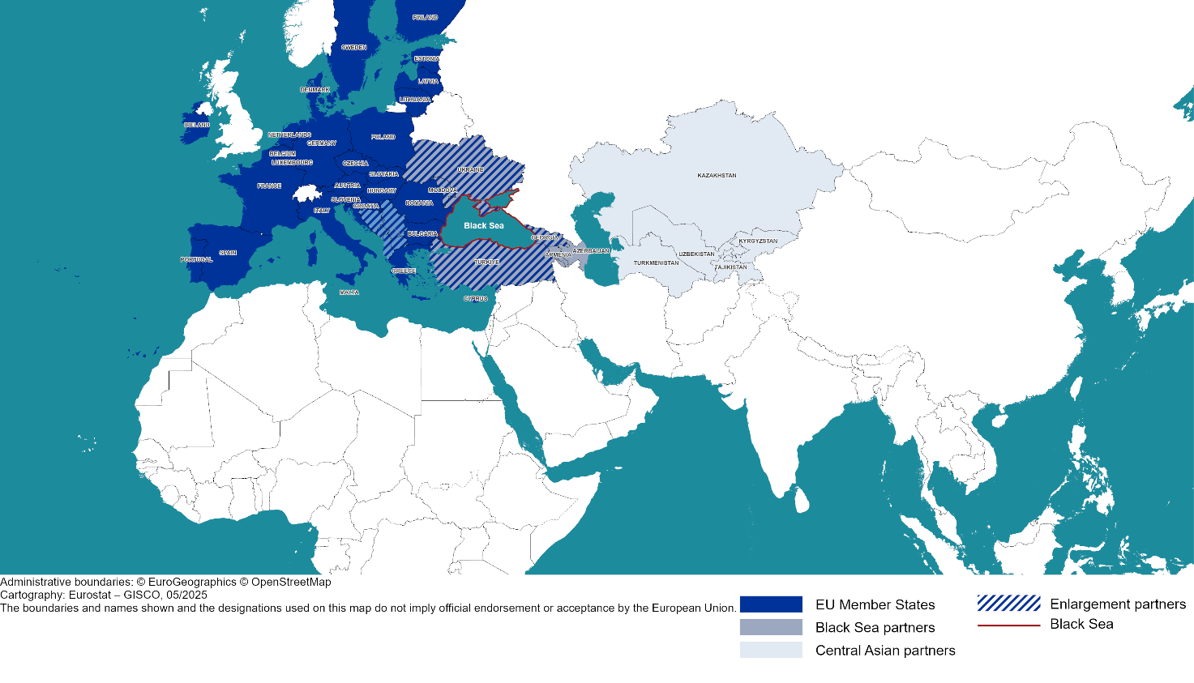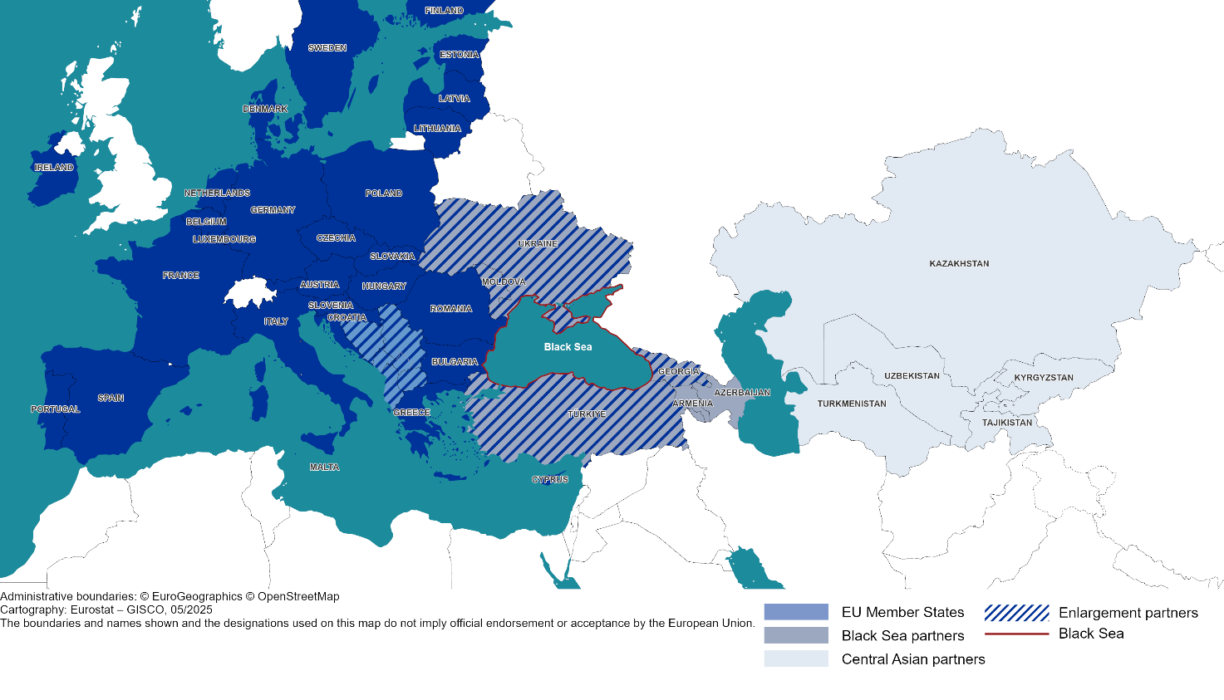

IMF April 2025 World Economic Outlook.
Armenia, Azerbaijan, Georgia, the Republic of Moldova, Ukraine, Türkiye, together with EU Member States Bulgaria, Greece and Romania – without Russia.
EUROSTAT data 2023 https://ec.europa.eu/eurostat/data/database
Source: IMF, WTO, UNCTAD
https://www.consilium.europa.eu/en/meetings/international-summit/2025/04/04/
Joint Communication to the European Council, State of play of EU-Türkiye political, economic and trade relations JOIN(2023) 50 final
In line with Council Conclusions from June 2021 and April 2024
Initiative on the Safe Transportation of Grain and Foodstuffs from Ukrainian ports launched in Türkiye on 22 July 2022. https://www.consilium.europa.eu/en/infographics/ukrainian-grain-exports-explained
OJ L 161 p. 3 of 29.5.2014
OJ L 260 p. 4 of 30.8.2014
OJ L 261 p. 4 of 30.8.2014
Agreement establishing an Association between the European Economic Community and Turkey, OJ L 361 p. 29 of 31.12.1977
https://eur-lex.europa.eu/legal-content/EN/ALL/?uri=celex:52023JC0050
OJ L 23 p. 4 of 26.1.2018
OJ L 246 p. 3 of 17.9.1999
Established in 2007, the Black Sea Synergy has successfully delivered on its objectives, facilitating a sea basin strategy and driving meaningful cooperation among regional stakeholders in areas such as maritime cooperation, marine research and innovation and investments in the blue economy.
https://black-sea-maritime-agenda.ec.europa.eu/
European Commission: Directorate-General for Research and Innovation and EOSC Executive Board, Strategic Research and Innovation Agenda (SRIA) of the European Open Science Cloud (EOSC), Publications Office of the European Union, 2022, https://data.europa.eu/doi/10.2777/935288
Transnational cooperation programme involving eight countries in the Black Sea region: Romania, Bulgaria, Greece, Armenia, Georgia, the Republic of Moldova, Türkiye, Ukraine https://www.blacksea-cbc.net/
https://commission.europa.eu/topics/eu-solidarity-ukraine/eu-assistance-ukraine/eu-ukraine-solidarity-lanes_en
Joint Communication: Eastern Partnership policy beyond 2020: Reinforcing Resilience – an Eastern Partnership that delivers for all, JOIN(2020) 7
Joint Communication to the European Parliament, the Council, the European Economic and Social Committee, the Committee of the Regions and the European Investment Bank The Global Gateway JOIN(2021) 30 final
White Paper for European Defence Readiness 2030, 30b50d2c-49aa-4250-9ca6-27a0347cf009_en proposal for a Security Action for Europe (SAFE) new instrument, and Communication on activating the National Escape Clause of the SGP.
JOINT WHITE PAPER for European Defence Readiness 2030 JOIN/2025/120 final
Council conclusions of 24 October 2023 on the Revised EU Maritime Security Strategy (EUMSS) and its Action Plan
2024 guiding framework for the establishment of the EU Hybrid Rapid Response Teams
2025 Joint Communication on the EU Action Plan on Cable Security JOIN(2025) 9 final
(Permanent structured cooperation) designed to enable EU Member States to develop joint defence projects, enhance military capabilities, and improve defence cooperation in all operational domains.
The European Defence Fund (EDF) is a financial tool designed to support the development of cutting-edge defence technologies and foster collaboration between EU Member States on joint defence projects. It aims to strengthen Europe's strategic autonomy and enhance its defence capabilities.
Copernicus Maritime Surveillance - EMSA - European Maritime Safety Agency
Mediterranean Coast Guard Functions Forum (MCGFF) | European Cooperation on Coast Guard Functions
JOIN/2023/8 dated 10 March 2023
https://www.imo.org/en/OurWork/Security/Pages/SOLAS-XI-2%20ISPS%20Code.aspx
EU regulation 2019/452
COM(2025) 148 final
The Deep and Comprehensive Free Trade Area (DCFTA) between the EU and Ukraine is the trade part of the Association Agreement, which has been fully in force since 1 September 2017. The Priority Action Plan for enhanced implementation of the EU-Ukraine DCFTA, which was first created in 2021, has been further extended and its latest version covers 2025-2026. Similarly, DCFTAs for Georgia and Moldova are part of the respective Association Agreements, both of which have fully entered into force on 1 July 2016. The Comprehensive and Enhanced Partnership Agreement (CEPA) between the EU and Armenia formally entered into force on 1 March 2021. The CEPA is a non-preferential agreement and aims to further improve EU-Armenia trade by enhancing the regulatory environment for businesses and facilitating trade in services. The Partnership and Cooperation Agreement (PCA) between the EU and Azerbaijan is in force since July 1999. In the area of trade, the PCA is a non-preferential agreement, and envisages progressive regulatory approximation of Azerbaijan’s legislation and procedures to the most important EU and international trade related laws and standards.
Ukraine Facility - European Commission
Commission adopts €1.8 billion support package to underpin the Republic of Moldova's economic growth plan on its path to the EU - European Commission
Press statement by President von der Leyen on a Resilience and Growth Plan for Armenia - European Commission
https://commission.europa.eu/topics/eu-solidarity-ukraine/eu-assistance-ukraine/eu-ukraine-solidarity-lanes_en
EU-Ukraine Solidarity Lanes - European Commission
Sustainable transport connections between Europe and Central Asia’, European Bank for Reconstruction and Development, 2023
cf. Memorandum of Understanding on a Strategic Partnership in the Field of Energy signed on 18 July 2022
Communication from the Commission to the European Parliament, the Council, the European Economic and Social Committee and the Committee of the regions roadmap towards ending Russian energy imports com/2025/440 final/2
The membership of Georgia, the Republic of Moldova and Ukraine in the Energy Community has been instrumental in advancing sectoral reform and aligning with EU acquis. Similarly, the Central and South-Eastern Europe Energy Connectivity (CESEC) initiative, fosters dialogue between the Republic of Moldova and Ukraine with counterparts from Western Balkan countries to address shared energy challenges.
JOIN(2025) 9 final of 21.02.2025
European Commission, Common Maritime Agenda for the Black Sea, 21 May 2019
Including in the framework of the General Fisheries Commission for the Mediterranean,
European sea surface temperature | European Environment Agency's home page
Based on the findings of the joint EU-UNDP project “Improving Environmental Monitoring in the Black Sea”. https://www.undp.org/ukraine/press-releases/black-sea-twice-polluted-marine-litter-mediterranean-sea-eu-projects-survey
https://emblasproject.org/wp-content/uploads/2022/03/EMBLAS_Scientific-Report_ISBN-978-617-8111-01-4-web.pdf
Belis, C., Petrosian, A., Turos, O., Maremuhka, T., Morhulova, V., Kona, A., Djatkov, D., Caudullo, G., Ceccherini, G., Beck, P.S.A., San-Miguel, J., Arias Navarro, C., Wojda, P., Jones, A., Hanke, G., Mariani, G. And Carravieri, A., Status of Environment and Climate in Ukraine, Publications Office of the EU, Luxembourg, 2025, https://data.europa.eu/doi/10.2760/6292177, JRC141480.
United Nations Environment Programme (2023). Rapid Environmental Assessment of Kakhovka Dam Breach; Ukraine, 2023. Nairobi, Kenya. https://wedocs.unep.org/20.500.11822/43696
OJ L 164, 25.6.2008, p. 19–40
OJ L 327, 22.12.2000, p. 1–73
Bulgaria, Georgia, Romania, and Ukraine are part of the EFAS network.
All the countries in the region are part of the Expert Group on Forest Fires.
https://blackseadb.org/
https://emodnet.ec.europa.eu/en
Black Sea – Monitoring Forecasting Centre (BS MFC) | CMEMS
JOIN/2025/130 final
https://data.consilium.europa.eu/doc/document/ST-14587-2023-INIT/en/pdf

