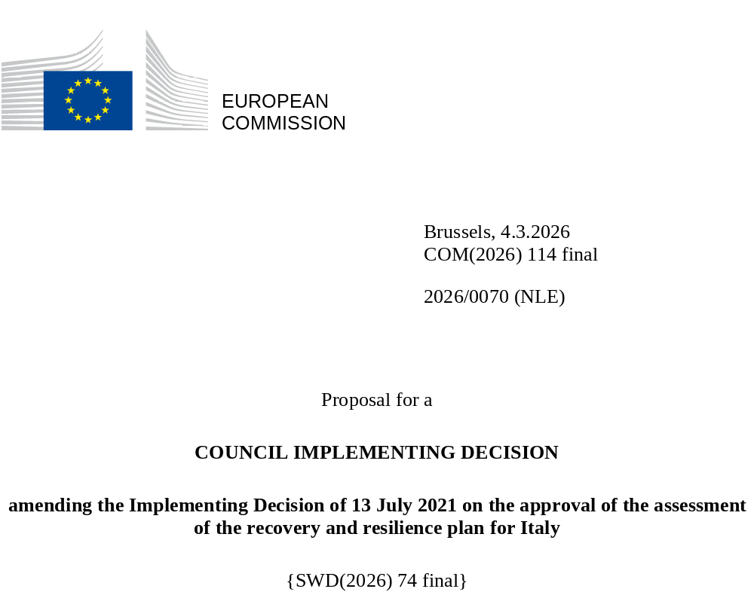

2026/0070 (NLE)
Proposal for a
COUNCIL IMPLEMENTING DECISION
amending the Implementing Decision of 13 July 2021 on the approval of the assessment of the recovery and resilience plan for Italy
THE COUNCIL OF THE EUROPEAN UNION,
Having regard to the Treaty on the Functioning of the European Union,
Having regard to Regulation (EU) 2021/241 of the European Parliament and of the Council of 12 February 2021 establishing the Recovery and Resilience Facility, and in particular Article 20(1) thereof,
Having regard to the proposal from the European Commission,
Whereas:
(1) Following the submission of the national recovery and resilience plan (‘RRP’) by Italy on 30 April 2021, the Commission proposed its positive assessment to the Council. On 13 July 2021, the Council approved the positive assessment by means of an implementing decision (‘the Council Implementing Decision of 13 July 2021’). The Council Implementing Decision of 13 July 2021 was amended by Council Implementing Decisions of 19 September 2023, of 8 December 2023, of 14 May 2024, of 18 November 2024, 20 June 2025, and of 27 November 2025.
(2) On 23 February 2026, Italy made a reasoned request to the Commission to make a proposal to amend the Council Implementing Decision of 13 July 2021 in accordance with Article 21(1) of Regulation (EU) 2021/241 on the grounds that the RRP is partially no longer achievable because of objective circumstances. On that basis, Italy has submitted an amended RRP.
Amendments based on Article 21 of Regulation (EU) 2021/241
(3) The amendments to the RRP submitted by Italy because of objective circumstances concern 40 measures.
(4) Italy has explained that 13 measures are partially no longer achievable in the timeline provided under the Annex to the Council Implementing Decision of 13 July 2021. This concerns: M2C3-6 under Investment 1.1 (Construction of new schools through building replacement); M2C3-8 under Investment 1.2 (Requalification of public real estate assets partly or wholly used by the administration of justice); M2C3-10 under Investment 3.1 (Promotion of efficient district heating); M2C4-23 under Investment 3.3 (Re-naturification of Po area); M2C4-25 under Investment 3.4 (Remediation of “orphan-sites soil”); M2C4-38 under Investment 4.4 (Investments in sewerage and purification); M3C1-5 under Investment 1.1 (High-speed railway connections to the South for passengers and freight); M5C2-6 under Investment 1 (Supporting vulnerable people and preventing institutionalization); M5C2-8 under Investment 2 (Autonomy patterns for people with disabilities); M5C2-10 under Investment 3 (Housing First and Post Stations); M5C2-20 under Investment 6 (Innovation Programme for Housing Quality); M6C1-9 under Investment 1.2 (Home as the first place of care and telemedicine); and M7-3 under Reform 1 (Streamlining permitting procedures for renewable energy). On this basis, Italy has requested that this measure be amended. The Council Implementing Decision of 13 July 2021 should be amended accordingly.
(5) Italy has explained that seven measures have been amended to implement better alternatives in order to achieve the original ambition of the measure. This concerns M1C1-49 and M1C1-50 under Investment 1.8 (Recruitment procedures for administrative courts); M1C1-72quinquies and M1C1-72sexies under Reform 1.11 (Reduction of late payments by public administrations and health authorities) and the related measure description; M1C1-144 under Investment 1.4 (Digital services and citizen experience); M1C1-24 under Investment 1.7 (Basic digital skills) and the related measure description; measure description under Investment 1.4 (Development of bio-methane, according to criteria for promoting the circular economy) under M2C2; M6C2-17 under Investment 2.2 (Development of technical-professional, digital and managerial skills of professionals in the healthcare system) and the related measure description; and M7-5 under Reform 2 (Reduction of Environmental Harmful Subsidies). On this basis, Italy has requested to amend the aforementioned measures. The Council Implementing Decision of 13 July 2021 should be amended accordingly.
(6) Italy has explained that 20 measures have been amended to implement better alternatives that allow the administrative burden to be reduced and simplify the Council Implementing Decision of 13 July 2021, while still achieving the objectives of those measures. This concerns M1C1-96 under Reform 1.10 (Reform of the public procurement legislative framework); M1C2-5 under Investment 6 (Investment in the Industrial Property System) and the related measure description; M1C2-14 under Reform 2 (Annual Competition Laws) and the related measure description; M1C3-9bis under Investment 4.1 (Digital Tourism Hub); M1C3-18 under Investment 2.3 (Programmes to enhance the identity of places, parks and historic gardens) and the related measure description; M1C3-28 under Investment 4.2 (Funds for the competitiveness of tourism enterprises); measure description of Investment 4 (Agri-Solar Park Facility) under M2C1; M2C4-32 under Investment 4.2 (Reduction of losses in water distribution networks, including digitization and monitoring of networks) and the related measure description; measure description of Investment 1.4 (Extraordinary intervention aimed at the reduction of territorial gaps in I and II cycles of secondary school and at tackling school drop-out) under M4C1; M4C1-13 under Investment 2.1 (Integrated digital teaching and training on the digital transformation for school staff); M4C2-2bis under Investment 2.2 (Innovation Agreements); M5C1-4 under Reform 1 (ALMPs and Vocational Training); measure description of Investment 1 (Strengthening Public Employment Services (PES)) under M5C1; M5C1-10 under Reform 2 (National Plan tackling undeclared work); M5C1-19bis and M5C1-20 under Investment 5 (Creation of women’s enterprises) and the related measure description; M6C2-8 under Investment 1.1 (Digital update of hospitals’ technological equipment); measure description of Investment 1.3 (Strengthening of the technological infrastructure and of the tools for data collection, data processing, data analysis and simulation) under M6C2; measure description of Investment 2.2 (Development of technical-professional, digital and managerial skills of professionals in the healthcare system) under M6C2; M7-10 under Reform 5 (Plan for new Skills – Transitions); and M7-26 under Investment 8 (Sustainable, circular and secure supply of Critical Raw Materials) and the related measure description. On this basis, Italy has requested to amend the aforementioned measures. The Council Implementing Decision of 13 July 2021 should be amended accordingly.
Distribution of milestones and targets
(7) The distribution of milestones and targets in instalments should be amended to take into account the amendments to the RRP and the indicative timeline presented by Italy.
Corrections of clerical errors
(8) Ten clerical errors have been identified in the text of the Council Implementing Decision of 13 July 2021, affecting ten milestones and targets and ten measures under three components. The Council Implementing Decision of 13 July 2021 should be amended to correct these clerical errors. Those clerical errors relate to M2C4-40 of Investment 4.5 (Grant scheme for investments on water infrastructure); M4C1-14bis of Reform 2.1 (Teachers’ recruitment); M4C1-31 of Investment 5 (Student housing fund); M7-6 of Reform 3 (Reduction of the costs of connection to the gas network of biomethane); M7-13 of Investment 3 (Scale up measure: Production of hydrogen in brownfield sites (hydrogen valleys)); M7-22 of Investment 7 (Smart national transmission grid); M7-30 of Investment 10 (Pilot projects on skills and “Crescere green”); M7-37 of Investment 13 (Adriatic line phase 1 (Sulmona compressor station and Sestino-Minerbio gas pipeline); M7-39 of Investment 14 (Cross-border gas export infrastructure); and M7-42 of Investment 15 (Transizione 5.0). Those corrections do not affect the implementation of the measures concerned.
Commission’s assessment
(9) The Commission has assessed the amended RRP against the assessment criteria laid down in Article 19(3) of Regulation (EU) 2021/241.
Contribution to the green transition including biodiversity
(10) In accordance with Article 19(3), point (e), of and Annex V, criterion 2.5, to Regulation (EU) 2021/241, the amended RRP contains measures that contribute to a large extent (rating A) to the green transition, including biodiversity, or to addressing the challenges resulting therefrom. The measures supporting climate objectives account for an amount which represents 37.1 % of the amended RRP’s total allocation and 74.8 % of the total estimated costs of measures in the REPowerEU chapter calculated in accordance with the methodology set out in Annex VI to Regulation (EU) 2021/241. In accordance with Article 17 of Regulation (EU) 2021/241, the amended RRP is consistent with the information included in the National Energy and Climate Plan 2021-2030.
Contribution to the digital transition
(11) In accordance with Article 19(3), point (f), of and Annex V, criterion 2.6, to Regulation (EU) 2021/241, the amended RRP contains measures that contribute to a large extent (rating A) to the digital transition or to addressing the challenges resulting from it. The measures supporting digital objectives account for an amount which represents 26.5 % of the amended RRP’s total allocation calculated in accordance with the methodology set out in Annex VII to that Regulation.
Any other assessment criteria
(12) The Commission considers that the amendments put forward by Italy do not affect the positive assessment of the RRP set out in the Council Implementing Decision of 13 July 2021 on the approval of the assessment of the RRP for Italy regarding the relevance, effectiveness, efficiency and coherence of the RRP against the assessment criteria laid down in Article 19(3), points (a), (b), (c), (d), (da), (db), (g), (h), (i), (j) and (k).
Positive assessment
(13) Following the positive assessment by the Commission of the amended RRP, with the finding that the RRP satisfactorily complies with the criteria for assessment set out in Regulation (EU) 2021/241, in accordance with Article 20(2) of and Annex V to that Regulation, the reforms and investment projects necessary for the implementation of the amended RRP, the relevant milestones, targets and indicators, and the amount made available from the Union for the implementation of the amended RRP should be set out.
Financial contribution
(14) The estimated total costs of Italy’s amended RRP is EUR 194 435 381 164. As the amount of the estimated total cost of the amended RRP is higher than the updated maximum financial contribution available for Italy, the financial contribution determined in accordance with Article 4a of Regulation (EU) 2021/1755 of the European Parliament and of the Council, and with Article 20(4) and Article 21a(6) of Regulation (EU) 2021/241 that is allocated for Italy’s amended RRP should be equal to EUR 71 779 623 788. Therefore, the financial contribution made available to Italy remains unchanged.
Loans
(15) The loan support made available to Italy amounting to EUR 122 601 810 400 remains unchanged.
(16) The Council Implementing Decision of 13 July 2021 should therefore be amended accordingly. For the sake of clarity, the Annex to the Council Implementing Decision of 13 July 2021 should be replaced entirely.
(17) This Decision should be without prejudice to the outcome of any procedures relating to the award of Union funds under any Union programme other than the Facility or to procedures relating to distortions of the operation of the internal market that may be undertaken, in particular under Articles 107 and 108 of the Treaty. It does not override the requirement for Member States to notify instances of potential State aid to the Commission under Article 108 of the Treaty,
HAS ADOPTED THIS DECISION:
Article 1
Approval of the assessment of the RRP
The assessment of the amended RRP of Italy on the basis of the criteria provided for in Article 19(3) of Regulation (EU) 2021/241 is approved.
Article 2
Amendments
The Council Implementing Decision of 13 July 2021 on the approval of the assessment of the recovery and resilience plan for Italy is amended as follows:
the Annex is replaced by the text set out in the Annex to this Decision.
Article 3
Addressee
This Decision is addressed to the Italian Republic.
Done at Brussels,
For the Council
The President

OJ L 57, 18.2.2021, p. 17, ELI: https://eur-lex.europa.eu/eli/reg/2021/241/oj
See documents ST 10160/21 INIT; ST 10160/21 ADD 1 REV 2 at http://register.consilium.europa.eu
ST 12259/23 INIT.
ST 16051/23 INIT; ST 16051/23 ADD 1; ST 16051/23 ADD 1 REV 1 (ga).
ST 9399/24 INIT; ST 9399/24 ADD 1.
ST 15114/24 INIT; ST 15114 ADD 1 REV 1.
ST 9587/25 INIT; ST 9587/25 ADD 1.
ST 15106/25 INIT: ST 15106/25 ADD 1; ST 15106/25 COR 1.
Regulation (EU) 2021/1755 of the European Parliament and of the Council of 6 October 2021 establishing the Brexit Adjustment Reserve (OJ L 357, 8.10.2021, p. 1, ELI: http://data.europa.eu/eli/reg/2021/1755/oj).

