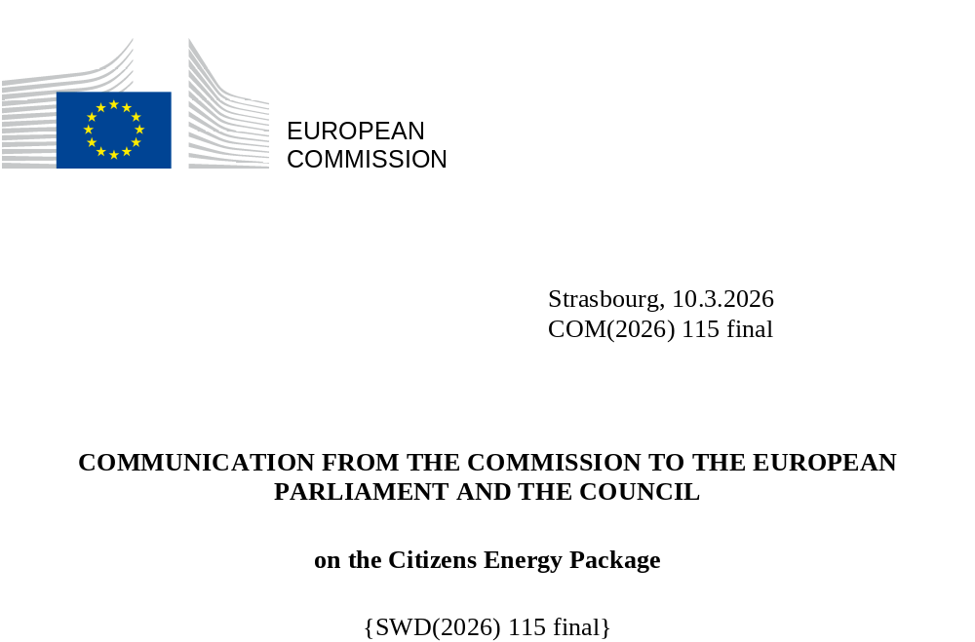

The Citizens Energy Package – Affordable energy for all
All Europeans should have access to affordable, clean energy in comfortable and resilient homes. Affordable energy is an essential condition for a safe, decent quality of life, free of poverty, and key to ensuring fairness and inclusion, in particular for groups in situations of vulnerability and of all generations. If energy prices are too high, the entire economy suffers – consumption drops and businesses slow down. This is what the Citizens Energy Package intends to address.
The safest way to obtain affordable energy is to rely on clean energy that Europe can produce for itself. This is why Europeans need to be empowered to switch from gas to cleaner alternatives based on electricity. Electrification will bring lower and more stable prices over time while increasing European independence, sustainability and competitiveness. Member States have a role to play here by setting the right targeted incentives – for instance, making the use of electricity more attractive through tax incentives and lower levies.
Flexibility allows homes with smart meters to use energy when electricity is abundant and cheaper. Smart and bidirectional charging of electric vehicles can further support this flexibility. For this to work, citizens need access to reliable information and advice adapted to different needs (including disabilities), affordable technologies, and services that reward users for shifting their electricity consumption from peak times to cheaper periods – with special attention paid to groups facing digital exclusion. A recent Eurobarometer survey indicates the EU energy consumers want better protection of vulnerable consumers and those in energy poverty, and more clarity and transparency of energy bills.
Citizens – for instance, farmers, rural inhabitants , small-business owners or kindergartens – should be able to team up and produce and share their self-produced energy. This takes pressure off local energy grids and prevents unnecessary investments in energy infrastructure. The financial and technical requirements to set up energy communities should be clear and simple. Empowering consumers is also beneficial for European manufacturers of clean technologies and electricity suppliers as increased demand for innovative products (such as heat pumps) and services (such as social leasing, heat-as-a-service) will provide investment certainty and help bring growth to these job markets. These innovative technologies will also improve the energy-water nexus, especially during droughts and heatwaves, and thereby help lowering energy bills.
The Citizens Energy Package aims as well to tackle energy poverty – a serious situation currently faced by too many citizens in the EU, and disproportionally affecting groups in situations of vulnerability, and in rural or remote areas, outermost regions and islands. In 2024, almost 10% of European citizens could not adequately heat their homes in winter, and many face rising cooling needs in summer. Improving the energy performance of buildings and switching to cheaper electrical heating and cooling or district systems based on renewable energy is essential in order to reduce energy poverty and housing expenditure.
A strong set of EU laws is already in place for all this, but its implementation remains uneven. Ensuring effective enforcement of EU laws is key to ensuring that citizens can fully benefit from their rights. Local authorities are key for supporting citizens in the energy transition through administrative, technical and financial advice, in particular when it comes to dealing with energy poverty and reaching groups with specific needs. With the aim of stepping up joint efforts across all levels of government and deliver for European citizens, this communication, complementing other Commissions initiatives on affordable energy, sets outs concrete actions to: (i) lower energy bills for households; (ii) protect and empower consumers; (iii) tackle energy poverty; and (iv) implement the existing EU laws effectively.
Pillar I: Lowering energy bills for households
High energy prices hurt Europe’s economy and its citizens. Household electricity prices rose sharply during the crisis and remain elevated today, disproportionately harming groups in situations of vulnerability. Retail electricity prices faced by EU households are 36% above their 2014-2020 average with retail gas prices 68% higher compared to the average in the same period. As a reference, inflation over the same period was of 26%, meaning that prices have increased by 10% once corrected with inflation.
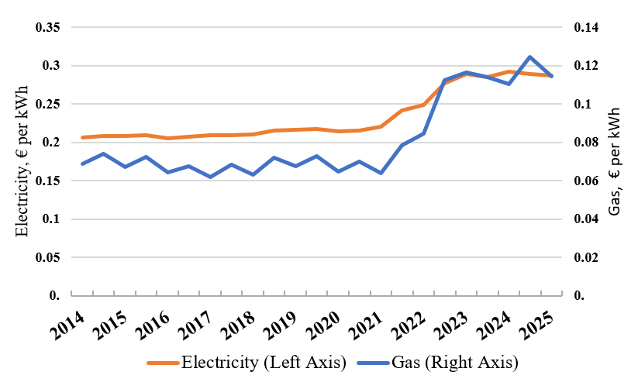
Figure 1. Average bi-annual electricity and gas prices in the EU for households. Source: Eurostat household energy prices (bands DC for electricity and D2 for gas). Prices include all taxes and levies. Gas prices are converted to EUR/kWh

The energy bills citizens pay are influenced by network charges, national taxes and levies, the wholesale energy price and the level of individual consumption. National energy taxes, and the calculation of network charges are mainly under the responsibility of the Member States and their regulatory authorities, giving them tools to make energy bills more affordable. The Commission is therefore proposing four concrete actions in this respect.
Action 1: Lowering taxes and levies on electricity for households to the EU minimum
Electricity taxes and levies account, on average, for 25 % of the price for households and 15% of the price for businesses. Member States can lower national energy taxes and levies, including additional taxes or levies with no connection to energy (e.g. public broadcasting charges added to electricity bills). Removing unrelated costs benefits everyone’s electricity bill, notably vulnerable households.
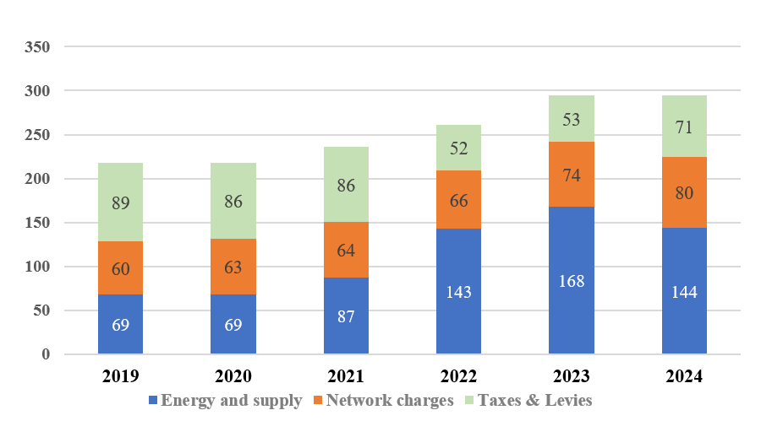
Figure 2. Electricity price components for average EU Households (2019 – 2024). Source: Eurostat.

Some Member States lowered, or are in the process of lowering, the tax rate for energy-intensive industries. Lowering taxation also proved effective in containing energy bills temporarily during the energy crisis, particularly where the electricity retail price was significantly higher than for gas. Under the existing Energy Taxation Directive and VAT Directive, Member States have the flexibility to lower minimum excise duty rates and VAT on electricity prices. This would have an immediate effect on electricity prices and contribute also to faster electrification of end-uses.

Goal | Lowering consumer electricity bills and supporting electrification
Result | Citizens’ bills could be lowered by 14% or an average of EUR 200 per year.
How | Member States to contribute to lower electricity bills for households by carrying out tax reviews and making full use of the flexibilities in EU legislation, and considering full or partial targeted reductions of excise duty rates regarding electricity, e.g., for energy poor and vulnerable households

Action 2: Lowering network costs for local consumers
Consumers pay network tariffs to cover the cost of transporting energy to their homes. This makes up between a quarter and a third of electricity prices and is key to energy affordability. EU legislation protects consumers by requiring that network operators only pass on costs which are cost-reflective, transparent, take into account the need for network security and flexibility and reflect actual costs incurred. Tariffs, and the costs associated with them, are subject to approval by independent national regulatory authorities.
Energy communities producing energy for their own consumption or sharing energy with neighbours can help reduce the use of local grids and help avoid investments in additional infrastructure. Flexibility rewards in grid tariffs, which lower the energy bill for energy communities and citizens sharing their energy, would provide incentives for the local production and consumption of energy and provide benefits for all network users.
In 2025, the Commission published guidance on network tariffs to help national regulatory authorities keep network charges, and therefore consumers bills, low. Swift implementation of this guidance will help to lower network charges for all consumers. The Commission encourages regulatory authorities to apply a rigorous approach when assessing the costs/revenues and take full account of the potential flexibility and demand response to replace expensive infrastructural investments. Following up on the guidance on network tariffs, the Commission will work with national regulatory authorities on accelerating the energy transition including by rewarding the positive effects of energy communities and energy sharing.
Goal | Lowering network tariffs for consumers
Result | Flexible consumption and flexible local electricity production and consumption supporting lower grid investment needs and more efficient operation.
How | National regulatory authorities are encouraged to consider targeted incentives in grid tariffs for flexible local consumption which would reduce overall grid costs, e.g. energy communities and citizens sharing their energy; and to assess flexibility potential, in particular from energy communities and energy sharing when designing network charges. The Commission will cooperate closely with ACER and national regulatory authorities on the swift implementation of the Commission guidance on network charge design.
Action 3: Boosting the use of clean and energy-efficient technologies.
In 2023 the main use of energy by EU households was for heating homes (62.5% of final energy consumption in the residential sector), followed by water heating (15.1%). EU energy labels already display saving potentials and give consumers useful advice, for example in purchase decisions on appliances for their homes. Home energy management systems and modern energy smart appliances have the capacity to lower energy bills. The transition to electric mobility offers additional opportunities to reduce energy costs through smart and bidirectional charging of electric vehicles, enabling households to optimise electricity use. Yet, they are often perceived as too costly, mainly due to the high upfront payments. To tackle this, some Member States have set up innovative financing models, including social leasing. Companies in some markets offer customers clean heating systems (including maintenance) by allowing consumers to pay the costs in flexible monthly instalments. Beyond-grant schemes are being developed but have in most cases not yet been widely rolled out.
The Commission urges Member States and companies to go beyond a grant-only approach and to develop innovative energy services and financing solutions – for example, schemes combining social leasing with potential to cover upfront capital costs, offering heat as a service, or flexible tariffs for heat pumps and maintenance costs. This will give EU citizens greater access to clean and energy- and water-efficient technologies, improving quality of life through, for example, reduced pollution, better indoor comfort and health, and lowering energy bills. Properly designed schemes combining public and private funding that prioritise people in energy poverty and other groups in situations of vulnerability will have a positive effect on lower- and middle-income households, whose energy costs can make up a disproportionate share of their overall household income. Similarly, investment should be supported to deploy clean or energy efficient solutions in off-grid situations. With the forthcoming Clean Energy Investment Strategy, the Commission aims to unlock private investments in energy efficiency.
Goal | Increasing access to clean, efficient technologies with innovative solutions
Result | Improved energy performance of buildings, lower energy bills.
How | The Commission will work with Member States and stakeholders, within the European Energy Efficiency Financing Coalition, on devising practical and innovative energy service models and financing solutions and also beyond-grant approaches, including sharing best practices on reaching vulnerable households, increasing uptake of home and buildings energy management systems and energy smart appliances and improving households’ access to electrified, flexible, and efficient energy services and technologies (Q4 2026).

Action 4: Empower consumers to have the cheapest offer and to switch supplier quickly
EU legislation gives citizens the right to switch to alternative energy providers; yet it is estimated that citizens lose on average EUR 152 per year by not doing so. One reason is the lack of transparency; not all existing comparison tools may be sufficient in this regard, and while intermediary platforms can facilitate switching, their business models are not always clear, which can compromise transparency and accountability.
The Commission calls on Member States to ensure that energy suppliers provide their customers with ‘best tariff advice’ on the basis of their specific energy usage at least once a year, and put in place an ‘early warning system’ if there is a risk that a customer’s energy consumption will greatly exceed the level assumed when the contract was concluded and whenever a cheaper offer becomes available. Such services, which reflect those provided in other sectors, would allow consumers to react promptly and change contract (e.g. from flexible to fixed), with a positive impact on their bills.
Citizens should have access to clear information about their contracts; a concise summary should be provided in good time before a contract is concluded or extended. To ensure that vulnerable consumers, including those lacking digital tools or skills, can effectively exercise their rights, suppliers should provide this summary free of charge in accessible formats and through multiple channels. The Commission will provide guidance on key contractual terms and conditions and encourage suppliers to provide a standardised summary.
There are also unnecessary technical hurdles to switching suppliers. To address them, the Commission will lay down technical rules for suppliers to ensure that back-office switching operations across the EU can be completed within 24 hours. Furthermore, a full roll-out of smart meters by Member States is key – to exercise their rights, or to benefit from flexibility services (see action 6), citizens need to have a clear view of the energy they consume.

Goal | Improving the transparency and comparability of energy supply offers; enabling technical switching of suppliers within 24 hours.
Result | By switching, estimated savings of up to EUR 152 per year.
How | The Commission will adopt technical rules on supplier switching (Q1 2026); adopt a recommendation on the summary of the key terms and conditions of energy contracts (Q1 2026); and consider a recommendation on standardised templates for energy bills (2027).

Pillar II: Protecting and empowering consumers
Action 5: Boosting energy self-production and energy sharing among citizens
Citizens can decide to join forces and set up an energy community to manage joint investments and produce and consume renewable energy, for example through solar panels, wind turbines, and district heating systems. This is a right guaranteed by EU law. While more than 8000 energy communities are currently active in Europe, the untapped potential is huge, particularly in rural areas, for example by producing renewable energy, including biogas and biomethane, local waste management. Collective benefits can also be achieved by sharing energy. This allows a larger group of people such as tenants, low-income households, and those without suitable space to benefit directly from home-grown renewable energy. Self-production and energy sharing mean greater autonomy and stable access to affordable and more stable prices and make the energy system more efficient.
By 2030, over 16 million households and 630.000 SMEs could produce their own renewable energy. There is potential to increase the installed renewable energy capacity of communities of households by up to tenfold. Individual households producing and consuming their own solar energy can achieve savings of EUR 260-550 per year. For communities of households with a mix of wind and solar energy, it could be EUR 440-930 per year.
To achieve this potential, energy communities need to be empowered to share electricity without being subject to excessive supplier fees, sell surplus energy and tap into their potential to balance high or low market demand. Administrative requirements must be reduced to a minimum. Targeted support should be provided to ensure accessibility for energy poor and vulnerable households. To support Member States in this endeavour, the Commission will issue an energy communities action plan.
Goal | Tapping into the potential of energy communities to increase their installed renewable energy capacity by up to tenfold by 2030 in the EU, enabling the production of renewable power for 25–30 million households.
Result | Potential savings of EUR 260-550 per year for individual households and potential financial benefit of EUR 440-930 per year for communities.
How | The Commission will provide guidance to Member States on how to unleash the potential energy communities and energy self-consumption, including sharing good practices. on the basis of an assessment of potential and existing barriers (Q1 2026); adopt an implementing regulation on data interoperability to ensure that energy sharing is easy to use and fully automated for consumers (2027); and issue a series of practical, step-by-step guides on how to set up and manage community energy projects for households and other stakeholders, including SMEs, farmers and public authorities (2026-2027).

Action 6: Promoting flexibility through retail contracts
Consumers with flexible retail contracts can make significant savings. In some cases, electricity bills can be up to 40% lower, when shifting heating demand to times with low electricity prices. This is one of the reasons why demand flexibility should be actively promoted across the EU. The benefits include reduced electricity generation and lower network costs, as well as lower need for capacity support measures, with potential annual savings estimated at EUR 2.7 billion by 2030.
Realising these benefits means ensuring that flexible retail contracts are widely available; that consumers have access to transparent pricing and reliable information, and targeted advice on how to choose the supply contract best suited to their needs; and that the necessary technical tools are in place. Smart metering systems are key – they provide the data needed for flexibility to work. Efficient access to relevant data further facilitates greater automation, therefore improving consumer experience, while ensuring strong data protection.
Promoting flexibility also means removing barriers to flexibility services providers – companies that reward their customers for shifting their electricity usage from peak times to cheaper periods, reducing strain on local grids. The Commission will provide guidance to help remove these barriers, such as disincentives or unsuitable price signals.
Outside the EU, Australia’s Solar Sharer Offer provides households with zero-cost electricity during times of high solar generation. Inside the EU suppliers have also been developing offers with zero-cost electricity. Member States may wish to explore similar mechanisms adapted to the EU regulatory framework, which enable direct citizen benefits from the clean transition by lowering bills without requiring upfront investment in rooftop solar, that encourage demand-side flexibility, align consumption with periods of high renewable output, improve grid efficiency and strengthen public support for decarbonisation, by making the advantages of the energy transition visible and tangible.
Goal | Enabling citizens to confidently benefit from flexible retail contracts and smart energy devices that optimise energy use.
Result | Lower consumer bills and system costs, with potential savings of up to 40%.
How | The Commission will provide guidance to promote the remuneration of flexibility in retail contracts (Q1 2026); improve access to the data required for flexibility with an Implementing Regulation on interoperability requirements and procedures (2027); and promote the potential of flexibility and efficiency in relevant projects under the new Partnerships for Better Homes (2026).
Action 7: Strengthening consumer trust
Energy consumers face aggressive telemarketing practices or find it sometimes difficult to navigate the energy markets. This results in a lack of trust in the market and restricts opportunities to benefit from cheaper alternatives or more innovative services.
To improve the quality of energy services for customers, the Commission will engage with consumers associations, energy suppliers and regulators to develop a new code of service for energy suppliers, as a first step towards countering unfair marketing practices. The code will give energy suppliers the opportunity to voluntarily commit to go beyond existing requirements to provide efficient complaint handling and prevent disconnections of vulnerable consumers – such as those living in rural areas – through longer notice periods, tailored payment plans, minimum supply, and to offer ‘best tariff advice’ and ‘early warning’ systems (see action 4). The code will serve as a trust mark by which energy suppliers signal to consumers that they can expect transparent and fair services. Some Member States are already successfully applying and enforcing such a code. It will remain at the discretion of the Member States to decide if and how such a code will be enforced at national level.
While AI and digitalisation will bring many benefits, including energy savings and energy bill reductions, it also presents new challenges. The Commission will therefore assess if the current rules are fit for purpose in this regard.
Trust in the market suffers if energy suppliers do not protect themselves against volatile prices. When energy suppliers fail, customers can lose any advance payments and may be forced into less favourable contracts. To prevent this, the Commission will provide guidance to national regulators on how they can ensure that energy suppliers devise appropriate risk-management and hedging strategies, to help keep the retail electricity market stable and reliable.

Goal | Strengthen trust; tackle aggressive and misleading (tele)marketing; protect citizens from the consequences of market failures.
Result | Increased consumer trust and higher quality of service. Greater market transparency leading to competitive pricing and improved service efficiency.
How | The Commission will unlock consumers benefits by proposing an easily understandable code of service on consumer rights to energy suppliers, who can commit voluntarily to high consumer protection standards based on transparency, fairness, mutual trust and accountability (Q4 2026); publish new guidance to support national regulatory authorities in preventing supplier failures by improving risk management (Q1 2026); and assess the need to adopt a new post-2029 EU consumer energy rights legal proposal to ensure consumer rights also in new innovative contracts and address aggressive or misleading (tele-)marketing practices (2028).

Pillar III: Tackling energy poverty and vulnerability
Fairness and equality are at the heart of the energy transition. The protection of vulnerable consumers and those in energy poverty is the number one priority for Europeans, according to the latest Eurobarometer survey. Energy poverty, unaffordable housing and limited access to social housing can lead to growing risks of vulnerabilities. The EU is developing the first EU Anti-Poverty Strategy to help people access essential protection and services, address the root causes of poverty, and contribute to poverty eradication by 2050. Allowing everyone to have access to energy as an essential service will reduce vulnerability and poverty in the EU.
Action 8: Joining forces to reduce energy poverty
In 2024, around 42 million Europeans (9.2% of the EU population) were unable to adequately heat their homes. This is a serious and unacceptable situation for too many citizens in the EU, with disproportionate impacts on families and population groups at risk of poverty or of discrimination.
The EU legal framework requires Member States to address energy poverty and to protect vulnerable consumers through policy measures and concrete actions. However, the Commission’s assessment of the updated national energy and climate plans shows that these rules are unevenly implemented across the EU. This is, in part, due to the difficulty of identifying and reaching vulnerable households and people facing energy poverty, and of effectively translating needs into efficient support measures – since energy poverty and vulnerability are multifaceted. To help Member States make their national plans more ambitious and reduce energy poverty, the Commission will provide additional guidance and share good and replicable practices. These will focus on successful national and local approaches to address energy poverty and split incentives, while ensuring that incentives for energy savings and efficiency are maintained even for households receiving social benefits to cover their energy bills. In line with the Energy Performance of Buildings Directive (EU) 2024/1275, the Commission will also help Member States draw up their national building renovation plans by the end of 2026 to identify the worst performing buildings, where the most vulnerable citizens reside, and design tailor-made policies that help them reduce their energy bills and live more comfortably in their homes, in winter and in summer. The plans also aim to mainstream accessibility for older persons and persons with disabilities in the context of renovations.
In addition to energy poverty projects under the Social Climate Fund, Cohesion Policy Funds or other support provided at local level through the Energy Poverty Advisory Hub (EPAH), the Commission will launch a new call for proposals under the LIFE programme to fund projects that support national, regional and local authorities in tackling energy poverty, building on 10 projects already underway. This will empower additional actors to design and upscale targeted measures providing households in energy poverty with durable solutions for affordable energy and improved living conditions. Moreover, the Commission will provide guidance on ways to protect vulnerable households and people in energy poverty during the decommissioning of natural gas networks.

Goal | Help national and local authorities take concrete actions to reduce the number of people in energy poverty and protect vulnerable consumers to ensure a fair and just energy transition.
Result | More consistent and targeted policies for vulnerable households in or at risk of energy poverty; faster, fairer and more affordable access to structural solutions (e.g. renovations); progressive and measurable reduction of energy poverty and related health and social issues across the EU.
How | The Commission will:  - update its Recommendation on energy poverty to provide additional analysis and share good and replicable practices. It will include practices which successfully address energy poverty and remove split incentives, utilise digital tools, simplify outreach to vulnerable citizens, implement cross-sectoral measures to protect citizens from heat waves, promote innovative financing tools for energy efficiency measures and showcase how energy sharing and energy communities can effectively alleviate energy poverty (Q4 2026);  - continue providing technical assistance and additional guidance to national, regional and local authorities to effectively target vulnerable citizens through policies and measures (2026-2028); and  - help national, regional and local authorities reach out to citizens facing energy poverty with efficient measures by funding new projects under the LIFE programme which address energy poverty. It will take tailored communication and information actions to inform vulnerable and energy-poor citizens on cost effective energy saving opportunities (2026-2027).

Action 9: Protecting vulnerable citizens from disconnections
For many EU citizens, including those already facing energy poverty, the inability to pay energy bills is an additional pressing concern. The risk of being disconnected from their electricity and gas supply, seriously impacting their quality of life and health, including mental health. In 2024, around 31 million Europeans were late on their utility bills.
The Commission will engage with Member States, national regulatory authorities, energy suppliers, consumer organisations and other relevant stakeholders to set up systems at national level to identify early warning signs when households have difficulty paying their energy bills. The aim is to help energy companies step in and offer support to such households before the problem gets worse. In addition, the Commission will promote good practices on the prevention and protection from disconnections, including debt-management schemes.

Goal | Better protection for vulnerable and energy-poor citizens at risk of energy disconnections, through early-warning and debt management schemes.
Result | Fewer disconnections; consistent protection for vulnerable consumers across the EU; reduced vulnerability; improved social justice, health and well-being.
How | The Commission will produce support guidelines and organise training courses for national and local authorities on designing and implementing disconnection safeguards, and promote best practices via targeted workshops, events and publications (Q2-Q3 2026); and will inform about available support with dedicated communication actions (throughout 2026).

Pillar IV: Implementing the existing EU laws
European citizens benefit from strong consumer protection thanks to EU laws – however, implementation remains uneven. Without strong implementation on the ground, the gap between the EU ambition and people’s lived experience will persist. Local authorities have a key role in supporting and engaging with citizens, but they are often insufficiently involved in policy development and lack the powers and means to deliver measures to citizens.
The Commission will work with Member States and the relevant stakeholders to help implement and enforce EU laws – in particular, by adopting guidance and technical analysis on energy communities and self-consumption including an action plan on energy communities; protection of vulnerable customers and customers in energy poverty from energy disconnection and during gas phase-out; the summary of the key contractual conditions; supplier risk management; market-based retail prices; remuneration of flexibility in retail contracts; technical rules for supplier switching.
Implementation cannot, of course, happen without taking into account all the different stakeholders. That is why, in order to achieve all the objectives set out in this communication, it is essential to have strong interaction and engagement between the Commission, Member States and citizens themselves, as well as with civil society, regulators, industry and academia. To this end, the Commission will streamline existing initiatives and increase the visibility of existing support tools – such as the Citizens Energy Advisory Hub, the Energy Poverty Advisory Hub, the Covenant of Mayors, the EU Islands Initiative, the Coal Regions in Transition Initiative and the Energy Behaviour Forum – upgrading the existing Citizens Energy Forum to a focal point for sharing best practices and tracking progress on implementation. The Commission will also issue guidance for Member States to empower cities, supporting them to unlock the full potential of local authorities in delivering the clean energy transition. Through national consumer organisations, the Commission will give particular attention to citizen engagement, ensuring consumers are informed of their rights and the opportunities available within the EU energy market.

Flash Eurobarometer 566 ‘Consumer behaviour in the energy transition’, December 2025.
European Water Resilience Strategy, COM/2025/280 final.
Namely, the Clean Industrial Deal, the Affordable Energy Action Plan, the Affordable Housing Plan, the Grids Package, the Agenda for Cities, as well as the forthcoming Electrification Strategy, the Heating and Cooling Strategy or the Strategic Roadmap for Digitalisation in the Energy Sector.
Greece, Italy and Portugal add charges related to public broadcasting to electricity bills.
Germany, France.
Directive (EU) 2019/944 of the European Parliament and of the Council of 5 June 2019 on common rules for the internal market for electricity and amending Directive 2012/27/EU (recast).
Notice on Guidelines on future proof network charges for reduced system costs, C(2025) 4010 final.
Eurostat, ‘Energy consumption in households’, June 2025.
‘Europeans attitudes towards energy policies’ – September 2024 – Eurobarometer survey. More than three quarters of respondents had used the EU energy label during the past five years.
For example, France has launched the second edition of the social leasing system for electric vehicles. In Latvia, a state-owned company provides companies and households with access to financial resources, through loans, guarantees and investments in venture capital funds.
Good practices provided in the Annex of Commission Recommendation on unlocking private investment in energy efficiency. COM(2026)1526, Recommendation
A business model that allows customers to pay for the heat they use rather for the infrastructure or fuel.
COM(2026) 116, Clean Energy Investment Strategy.
Directive (EU) 2019/944 of the European Parliament and of the Council of 5 June 2019 on common rules for the internal market for electricity and amending Directive 2012/27/EU (recast), Arts. 4,12.
ACER 2021 Annual Report on the Results of Monitoring the Internal Electricity and Natural Gas Markets
See also action 7.
In telecoms, providers should give customers best tariff advice at least annually, which could encourage them to change their contract option.
Article 16 of Directive (EU) 2019/944 and Article 22 of Directive (EU) 2018/2001.
Estimate based on a broad interpretation of the concept, not limited to the EU definitions alone.
EnTEC study on the potential of citizen energy (forthcoming).
Community energy could contribute up to 90 GW, accounting for 8% of total renewable electricity generation in the EU by 2030. See EnTEC study on the potential of citizen energy (forthcoming).
Cost savings are calculated based on wholesale and retail market prices in 2020 and 2022. Where electricity is self-consumed using the grid, all network tariffs and taxes apply.
On the basis of data from the ACER 2025 market monitoring report and the Commission’s own calculations.
Demand-side Flexibility: Quantification of benefits in the EU; DNV for smartEn, September 2022.
On the basis of data from ACER 2025 market monitoring report (Rewarding Flexibility: How retail contract choice can help unlock consumer flexibility) and the Commission’s own calculations, electricity consumers could achieve savings of up to 40% if they switch to a dynamic price contract and actively manage their consumption.
The Eurobarometer flags unfair commercial practices as an area for improvement. 82% of respondents would trust an energy provider more if they committed to an officially certified code of practice on consumer rights.
For instance, Ireland, the Netherlands and France.
Flash Eurobarometer 566 ‘Consumer behaviour in the energy transition’, December 2025.
Eurostat ‘Population unable to keep home adequately warm by poverty status’, February 2026.
SWD(2025) 140 final.
Split incentives happen when landlords lack motivation to improve housing as tenants gain most of the benefits but cannot make the changes themselves.
Between 2026 and 2032, the Social Climate Fund will provide up to EUR 86.7 billion to help vulnerable people and small businesses who are most affected by rising energy and transport costs.
The Regulation on the modernisation of Cohesion Policy incentivizes Member States to increase funding to affordable and sustainable housing, with a focus on households affected by energy poverty.
LIFE Multiannual Work Programme 2025-2027
EUR-LEX 32023H2407
Eurostat, ‘Arrears on utility bills’, February 2026.

