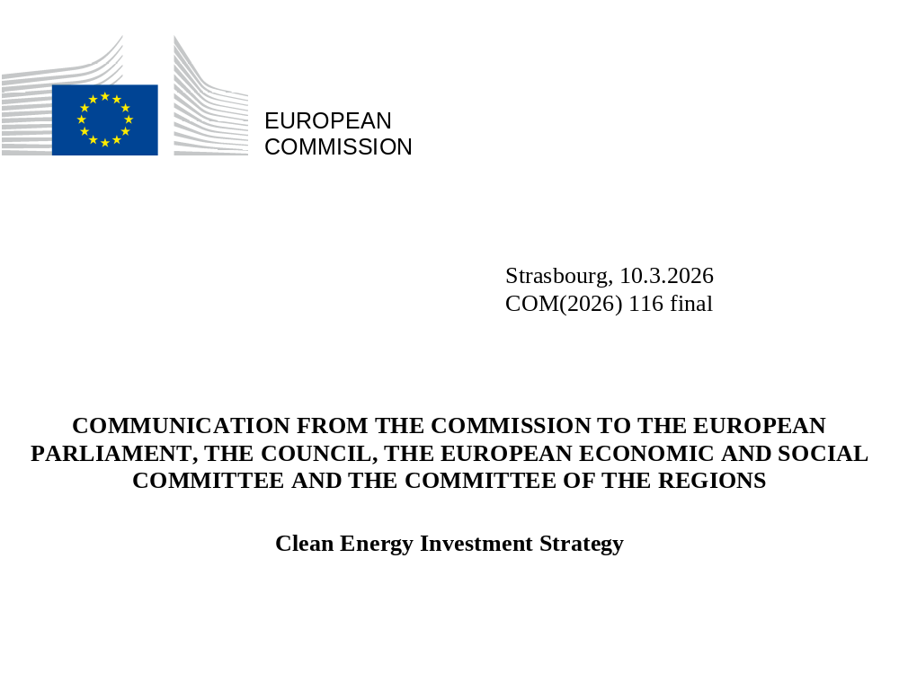

Introduction
The clean energy transition is vital for Europe’s strategic autonomy, competitiveness, and sustainable prosperity. Decarbonisation is an opportunity for economic growth and employment across Europe. As the Draghi report highlights, turning our ambitions into reality requires unprecedented levels of investment and in particular a more integrated approach to mobilising public and private capital.
The Commission estimates that to achieve our energy transition objectives and secure affordable, efficient, and clean energy for all Europeans, investment levels in the energy sector must reach approximately EUR 660 billion annually between 2026 and 2030, rising to EUR 695 billion annually from 2031 to 2040. This is a substantial increase compared to the EUR 240 billion annual average observed between 2011 and 2021. These investments need to include supply side (generation), demand (energy efficiency), and infrastructure (grids).
The European Investment Bank (EIB) Group is a cornerstone financier of Europe’s clean energy transition, combining lending, guarantees, investment and advisory support to accelerate the shift to a secure, competitive and low-carbon energy system. In this context, the Group intends to deliver more than EUR 75 billion of financing over the next 3 years in support of the objectives of the energy transition and this Clean Energy Investment Strategy, drawing on the full range of financial products and advisory services at its disposal.
Moreover, European initiatives such as Connecting Europe Facility-Energy (CEF), the Recovery and Resilience Facility (RRF) and REPowerEU chapters have helped accelerate investments. However, there are still barriers to the pace and scale of private capital mobilisation across clean energy segments. While Europe delivers regulatory predictability and policy stability for long-term institutional capital mobilisation, lengthy permitting and grid connection processes slow deployment and increase risks. Fragmented markets - with divergent rules, standards, and planning practices - raise transaction costs and hinder scaling up. In many areas, the full system value of clean energy investments is not reflected, thus reducing their attractiveness to private investors. Recent evidence suggests that in certain sectors the investment growth is slowing and even reversing.
Private capital is available and must be mobilised
However, the scale of the investment needed for the energy transition far exceeds public funding capacity from national budgets, the Multi-Annual Financial Framework (MFF) and the EIB Group. Public funds must be deployed not as a primary funding source, but as a strategic lever to crowd in this broader mix of banking and capital market finance, ultimately lowering the overall cost of the transition. This is particularly important in an energy system increasingly driven by upfront capital expenditure. Moreover, public support can help spread the costs of the transition over the lifetime of assets, preventing short-term price peaks.
Meeting the scale and scope of investment needs is dependent upon diversifying funding sources to fully mobilise institutional capital, venture capital and private equity, as well as more traditional sources. Looking ahead, the success of the Savings and Investments Union will be essential for establishing the deep and liquid capital markets necessary to this effect.
This strategy aims to facilitate the mobilisation of private investment in the energy sector by improving the link between available private capital and Europe’s pipeline of energy projects. An estimated EUR 33.7 trillion in assets are under private management in Europe . Institutional investors (e.g. insurers and pension funds) control over EUR 12 trillion of assets in Europe and seek the long-term stable returns that energy projects can provide with an appropriate framework in place.
The Clean Energy Investment Strategy complements EU initiatives, as well as Member States’ actions aimed to reduce risk and uncertainty, and create stable, attractive investment conditions, thereby reinforcing Europe’s competitiveness and energy security.

Unlocking private capital at the scale needed to deliver the energy transition
This Clean Energy Investment Strategy is therefore designed to promote the mobilisation of private capital, targeted de-risking of investments, and a structured cooperation with the financial community.

SUPPORTING ACCESS TO CAPITAL MARKETS FOR ENERGY INFRASTRUCTURE
Increased and accelerated investments into grids and networks, the backbone of the energy system, is essential for European competitiveness and security. The Draghi report warns that simply investing in clean electricity generation is not enough; parallel efforts to strengthen and modernise network infrastructure and system integration, including through innovative and digital solutions, are essential to ensure a successful energy transition. Yet, current financing mechanisms fail to mobilise capital at the required scale and speed.
To bridge these gaps, complementing the recent European Grids Package, the Commission, in close coordination with the EIB Group, will implement a targeted approach to transform the financial rights to future cashflows associated with energy assets into liquid, investment-grade securities.
Furthermore, legislative programmes, as well as other reforms to the prudential framework for insurers undertaken under the review of the Solvency II Delegated Regulation, will play a central role in unlocking private capital. By reducing the cost of long-term equity investments and securitisations and recognising the risk-reducing effect of EU or national guarantees in capital requirements, these reforms can encourage investments in clean energy. Insurers will be required to integrate forward-looking climate scenarios into their risk management, which should further support a gradual shift of investments towards clean energy.

Action 1: Strengthening Grid Operator Balance Sheets
To ensure operators (DSOs and TSOs) can finance massive infrastructure upgrades while maintaining high credit ratings, a suite of facilities tailored to different operator needs will be deployed:
a) Strategic Infrastructure Investment Fund (SII Fund)
Many crucial energy transition projects fail to reach financial closure due to equity gaps that specialized funds, or private investors cannot cover alone. To address this, the Strategic Infrastructure Investment Fund (SII Fund) will act as an Equity Platform facilitating targeted Co-Investment alongside infrastructure funds.
The EIB Group will make a commitment with an indicative amount of up to EUR 500 million, providing the necessary anchor capital to invest in specific energy infrastructure projects. This collaborative model allows private managers to leverage the EIB’s long-term investment horizon and technical expertise, ensuring that large-scale private equity is mobilised into the most critical segments of the European energy network.
Co-investments allow for targeted support to those projects or companies that lack funding or struggle to raise sufficient capital to complete their investment plans. This ensures the maximisation of the EIB Group’s impact, through targeted strategies addressing clearly defined policy priority areas, which would be difficult to equal through the traditional generalist strategies available in the market.

b) The Operator Securitisation Facility
Building upon the EIB Group’s established role in financing European energy infrastructure, the Commission and the EIB Group intend to collaborate on an Operator Securitisation Facility (OSF). This initiative would aim to complement existing EIB instruments by evaluating off-balance sheet financing structures that could convert future regulated revenue streams into immediate liquidity. The primary objective is to assess how institutional capital can be effectively mobilized while ensuring that physical assets remain under public ownership. By aligning financing durations with the long lifecycle of grid assets, the OSF could help mitigate refinancing risks and lower the total cost of capital, supporting grid development without placing undue pressure on energy tariffs. To accommodate diverse market needs and operator profiles, the proposed framework remains flexible. While large-scale grid operators may utilize standalone issuances, the facility is also open to exploring pooling together different grid operators as one potential option among others, particularly for smaller entities.

c) Hybrid Bonds
The EIB supports investments by regulated utilities through the purchase of hybrid bonds. The participation of the EIB Group as anchor investor provides a positive signal to other investors and boosts interest in the fundraising process. It also strengthens the financial position of operators because the instruments used are treated as equity, which is beneficial for their balance sheets.

Action 2: Supporting access to finance for operators via the loan securitisation and intermediated lending for small operators
The Commission will explore with the EIB how to better support access to finance for grid operators by freeing up banks’ lending capacity, allowing banks to grant new loans to grid operators without direct reliance on public subsidies or state budgets, while crowding‐in private institutional capital.
The goal is to incentivise commercial banks to grant new loans to grid operators, including by providing support to promote securitisation of existing loan portfolios, in compliance with the EU securitisation framework, so that the participant banks use the freed-up balance sheet capacity to extend new loans to grid operators. The EIB Group could contribute to the initiative via its existing products, including securitisation – contingent on demonstrated demand.
Additionally, recognising that the EU DSO landscape consists of a large, diverse number of operators with different sizes, legal environments and regulatory regimes, regional and local commercial banks can play an important role to overcome the fragmentation of the sector and support project aggregation for small operators. Following the recent announcement of the first Growth for Energy operation, the EIB will scale up this initiative, based on the specificities and needs of each Member State. This initiative will strengthen local banking networks’ capacity to lend to small operators.

De-risking via strategic Use of Public Funds
Public capital has a vital role to play in lowering risks and mobilising private finance for the clean energy transition. The MFF has been a key tool for de-risking clean energy investments, providing crucial public funding, including through the InvestEU programme, the flagship investment programme of the European Union. InvestEU supports clean energy investments in a transversal manner through guarantees, enabling investment in projects and enterprises targeting all stages of development, including start-ups to scale-up stage as well as deployment. So far, InvestEU has mobilised more than EUR 57 billion in energy related investments.
The Commission proposal for the next MFF reaffirms continued support for clean-tech manufacturing and its supply chain and energy transition projects, including at the R&I stage, amongst others by strengthening financial instruments to mobilise private investment. Financing for investments in energy is available notably under the NRPPs, the ECF, Horizon Europe and under the Connecting Europe Facility (CEF) – Energy the budget of which has been increased fivefold to c.a. EUR 30 billion. The Euratom Research and Training Programme will continue to be a key instrument to support nuclear research and innovation.
In June 2025, the Commission adopted the Clean Industrial Deal State Aid Framework (CISAF). setting the criteria the Commission will apply for assessing Member States aid proposals for financial support to achieve the Clean Industrial Deal objectives and net-zero transition. CISAF will enable swift aid granting for projects. It contributes to EU resilience by accelerating independence from fossil fuels imports, industry decarbonisation and new clean tech manufacturing investments, while preserving Single market integrity.
The Commission encourages Member States to make use of CISAF to accelerate clean energy, non-fossil flexibility measures and capacity mechanisms, industrial decarbonisation measures, and contribute to de-risk investment in these priority areas via dedicated investment funds. The Commission estimates that CISAF could mobilise investments within the range of three-digit billions if Member States continue to put in place similar schemes as those set up under the Temporary Crisis and Transition Framework (TCTF).
As part of the Clean Industrial Deal, the Commission has also set out a Recommendation for designing cost-effective, simple and timely tax measures that stimulate investment in clean technologies and industrial decarbonisation.

Action 3: De-risking innovative clean energy generation technologies and long-duration storage
The International Energy Agency estimates that around 35% of the emission reductions required by 2050 will rely on technologies that are not yet available on the market. Success of the transition is structurally dependent on innovation — on bringing forward a new generation of clean energy technologies capable of delivering affordable, reliable and decarbonised energy at scale. The Commission proposes the following actions to support innovation:
- Bring next generation of clean energy technologies to commercialisation
The Commission in cooperation with the EIB Group will step up support to private investments in innovative clean, energy technologies (e.g. long-duration energy storage (LDES), floating wind, floating solar, ocean energy (wave and tidal), and airborne wind energy; novel forms of renewables deployment like agrivoltaics, advanced bio-based renewable solutions, carbon capture and storage (CCS) and carbon capture utilisation and storage (CCUS)) and for the expansion of established technologies into new markets with specific development risks (e.g. geophysical uncertainties for geothermal projects). This could include strengthening or extending existing mechanisms, such as venture debt and equity operations that can be eligible for support from the InvestEU programme. It will also explore investing in funds focused on clean energy technologies, including LDES.
Furthermore, the de-risking of clean technologies, especially where we depend on high-risk third country providers, such as for solar inverters, needs to be reinforced at national and EU level. It is essential to perform a thorough analysis of cybersecurity risks for all deployments considered for financing, and define appropriate risk mitigation measures, when needed.
The strengthened and extended Emissions Trading System will increase economic incentives for clean energy technologies thus reducing financial support requirements. The Horizon Europe programme and the Innovation Fund will continue to provide relevant grant support. For instance, under the work programme 2026-27 of Horizon Europe, the Commission is launching a EUR 600 million flagship Call to support the Clean Industrial Deal and accelerate the technological maturity and market-readiness of advanced cleantech and industrial decarbonisation demonstrators. Furthermore, under the upcoming Strategic Roadmap for Digitalisation and AI in Energy, the Commission will launch an action on digitalisation of permitting to support the development of a pilot digital permitting portal with GenAI tools.
- Small Modular Reactors / Advanced Modular Reactors (SMRs/AMRs)
Several SMR concepts, including advanced modular and Generation IV designs, are progressing towards demonstration within this decade. The Commission is adopting today a Strategy for the development and deployment of SMRs in Europe. If these technologies are to reach the stage of commercialisation in the early 2030s, we must address the financing challenges due to higher technology and deployment risks.
The EIB Group will support, through venture debt and other financial products, the de-risking of investments in line with the SMR strategy, and the associated fuel cycle facilities and supply chain, which can be eligible for support also under the InvestEU programme.
- Support scale up of new clean energy technologies through the Scale Up Europe Fund
As part of the EU Startup and Scaleup Strategy published in May 2025, the Commission launched a privately managed and co-financed Scaleup Europe Fund to bridge the financing gap for deep-tech and disruptive scale-up companies. Energy corporate venture funds and other potential interested investors in innovative clean energy can already join the existing Trusted Investors Network in view of becoming investment partners in the European Innovation Council, which the Scale Up Europe Fund will complement.
- Strengthen energy efficiency financing
The Commission together with the EIB Group is working on strengthening the InvestEU Sustainability Guarantee Product, managed by the EIF. This increased capacity, together with the introduction of new opportunities through co-investments, will consequently allow for further access to the product for the decarbonisation and energy efficiency of SMEs.
In line with the Affordable Energy Action Plan, the Commission and the EIB Group will launch in 2026 a pilot scheme aiming at leveraging EUR 500 million of financing to also accelerate the offer and uptake of “energy efficiency as a service” models, alongside specialised investment funds and with the potential support of the InvestEU Advisory Hub. This will complement the current EIB Group support to energy services, and to decarbonisation solutions for SMEs.
In the next MFF, strengthening energy efficiency is to be supported under the new European Competitiveness Fund. An energy efficiency Accelerator instrument could use ECF tools (e.g. combination of grants, repayable support, advisory services like project development assistance). It will support aggregation of investment projects, including for heating and cooling, to increase their access to capital markets, facilitating the development of a tradable energy efficiency market.
The EIB Group can play a key role by proposing a consolidated offer of funding (e.g. loans, guarantees and grants), including through its own resources.
Union support could be channelled through the ECF InvestEU instrument and instruments such as the Energy Efficiency for SMEs Initiative, and could take the form of repayable support, advisory support and grants.
- Ensuring synergies and maximising effective public funding for the clean energy transition
Member States also use national funds to derisk clean energy investments; however, the lack of coordination amongst them can lead to inefficiencies. Harnessing existing frameworks like the Energy Union Task Force and the Energy Transition Investment Council (see Action 4), the Commission will facilitate the exchange of information and cooperation among Member States regarding the deployment of their national public financing schemes (e.g. via national promotional banks). The aim is to provide political guidance on common priorities and optimise resource uses, prevent duplication in research and development and cross-border projects and encourage cross-border cooperation, best practices sharing and pilot projects.

An Upgraded Investment Dialogue & Strategic Funding

Action 4: Establish an Energy Transition Investment Council
The Commission will establish the Energy Transition Investment Council, comprising representatives from investment (including institutional investors) and other financial institutions, Member States and high-level Commission officials. It will serve as a dedicated energy-focused platform for strategic feedback, helping to ensure that EU policies and funding align with investor needs and support long-term private investment in the energy sector, building on the experience of the Investors Dialogue on Energy established in 2022. It will ensure its activities proceed without overlapping or impinging upon the future governance structures of the ECF. It will also encompass an innovation and market uptake dimension in coordination with the SET Plan and explore potential synergies with the T-Med Investment Platform.
The Energy Transition Investment Council will have a sub-group made up representatives of the EIB Group, International Financial Institutions (IFIs), National Promotional Banks and Institutions (NBPIs) and other national public banks to discuss the role of these institutions in strengthening the financing flows for energy projects and enhancing mobilisation of private capital.

Conclusions and way forward
Investing in the clean energy transition means investing in our security, competitiveness and sustainability. This Strategy and its target actions aim to help mobilise large-scale institutional private capital, based on the recognition that additional private investment in the clean energy transition is needed for European competitiveness, security and decarbonisation.
The Strategy builds upon the existing policy and financial framework. The European Union has a robust and predictable legal framework, and its policy agenda is clearly set. The forthcoming energy and climate framework for the decade ahead will further clarify the scope and nature of the necessary investments. The Commission will present an Energy-System Needs Assessment for the Clean Transition (ENACT) and the post-2030 legislative package in Q4 2026, that will be based on a comprehensive impact assessment, to update the size and nature of the investment needs and provide further granularity and insights to support the decision making of investors and public administrations.
Future National Energy and Climate Plans should distinguish clearly the contribution of public funding and the opportunity for private investments. This will help improve the understanding of public funding opportunities and private investment across Member States, ensuring targeted resource use. The MFF 2028-2034 and national public support schemes will be critical as a lever to unlock private finance.
The successful implementation of the Clean Energy Investment Strategy necessitates the strategic alignment of EU funds and enabling policies, alongside collective engagement of EU institutions, Member States, institutional capital and private financial entities. The EIB Group is a key partner in the implementation of this Strategy intending to make an overall commitment of EUR 75 billion of financing over the next three years in support of the objectives of the energy transition and the strategy. The InvestEU programme will amplify the firepower of the EIB Group and other implementing partners regarding high-risk operations.
The Strategy can truly deliver when it is fully and effectively implemented. The Commission will execute and monitor progress toward the Strategy goals through the Energy Transition Investment Council which provides a structured partnership with the investment community. The first meeting of the Energy Transition Investment Council will be convened by the European Commission in Q2 2026. Progress will also be monitored within the context of the Energy Union Task Force.
The scale of the investment challenge is significant. But so is the private capital available that could be mobilised for the energy transition. Accelerating the investment pace is paramount for the EU to increase its competitiveness and deliver on the Clean Industrial Deal and the Affordable Energy Action Plan.

https://commission.europa.eu/topics/eu-competitiveness/draghi-report_en .
All figures related to investment needs in this document, unless stated otherwise, are based on the modelling for the 2040 Impact Assessment (SWD/2024/63 final).
EFAMA Asset Management in Europe (16th Edition, 2024) & EFAMA: Our Industry in Numbers (Live Data Page)
EIOPA: EIOPA and the EU Institutions - European Insurance and Occupational Pensions Authority
Hybrid bonds are treated in part as equity, allowing operators to increase their debt capacity, and therefore investment capacity, without breaching credit limits or diluting existing ownership and control.
In this operation, the EIB covers a percentage of the commercial bank risk exposure to loans for eligible energy projects at the municipal utility level, allowing the bank to allocate less capital to each sub-loan, increasing its lending capacity, see https://www.eib.org/en/press/all/2025-469-eib-and-commerzbank-join-forces-for-eur1-2-billion-energy
In line with the Net-Zero Industry Act and Critical Raw Materials Act Regulations
For further background see: https://competition-policy.ec.europa.eu/about/contribution-clean-just-and-competitive-transition/clean-industrial-deal-state-aid-framework-cisaf_en.
Commission Staff Working Document accompanying the Clean Industrial Deal State aid Framework, (SWD(2025) 850 final, 4.11.2025), p.22.
Commission Recommendation of 2.7.2025 on tax incentives to support the Clean Industrial Deal and in light of the Clean Industrial Deal State aid Framework (C(2025 4319 final)
International Energy Agency, Net Zero by 2050 – A Roadmap for the Global Energy Sector, 2021.
Commission Communication “Future development and deployment of small modular reactors (SMRs) in Europe”, COM(2026) 117.
The InvestEU guarantee cannot be used for operations focussing on the decommissioning, operation, adaptation or construction of nuclear power stations.

