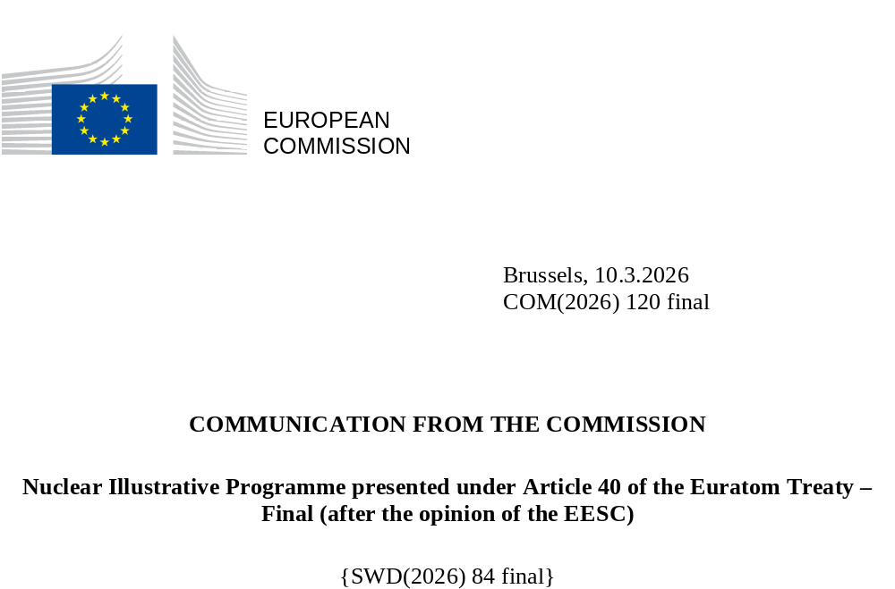

Introduction
Homegrown, affordable and clean energy supports our decarbonisation, competitiveness and resilience objectives as indicated in the Clean Industrial Deal () and Action Plan for Affordable Energy ().
For some EU Member States, nuclear energy is an important component of decarbonisation, industrial competitiveness, and security of supply strategies. The updated National Energy and Climate Plans (NECPs) indicate that installed nuclear capacity is anticipated to increase. Nuclear power plants supply clean power, suitable for low-carbon baseload electricity, also enhancing system integration and providing flexibility facilitating further roll-out of other clean technologies. These benefits accrue to the whole EU energy system.
As outlined in Commission’s 2040 climate target impact assessment (), all zero- and low-carbon energy solutions are needed to decarbonise the energy system. Projections show that zero- and low-carbon energy sources will generate over 90% of electricity in the EU in 2040, primarily from renewables, complemented by nuclear energy. Delivering Member States’ plans regarding nuclear energy will require significant investments until 2050, both for lifetime extensions of existing reactors and the construction of new large-scale reactors. Additional investments are needed for Small Modular Reactors (SMRs) and Advanced Modular Reactors (AMRs) and in fusion for the longer-term future.
The choice of the energy sources in the energy mix, including the decision to use or not use nuclear energy, remains within the remit of each Member State in accordance with the EU Treaties (). Some EU countries are setting nuclear programmes extending operating life of existing reactors and announcing new builds. Finally, some are considering including nuclear in their energy mix for the first time. The outlook of nuclear energy share in the EU electricity production depends on long-term operations of existing reactors.
The EU industrial leadership in nuclear energy has firm roots in fundamental commitments: mastering of the entire fuel cycle, fostering innovative start-ups ecosystems and conducting leading-edge research, all while ensuring the highest standards of nuclear safety, security and safeguards, of safe and responsible management of radioactive waste, high-class education and training, as well as promoting transparency and public engagement. Further developing essential infrastructure for spent fuel and radioactive waste management, such as deep geological disposal facilities, as well as integrating circular economy principles are therefore critical components in all nuclear programmes. Future industrial planning and investments in nuclear capacity and research infrastructure must be closely aligned with advances in these areas.
Diversification is key at the EU level; scenarios incorporating varying levels of nuclear energy deployment, based on Member States decisions, may support the transformation of our energy system to accomplish both the decarbonisation of our economy and the strategic energy independence of our continent. In order to foster economic security of the EU, the Commission has presented the Roadmap towards ending Russian energy imports outlining measures to diversify energy supplies and reduce dependence on external sources ().
This nuclear illustrative programme of the Commission () provides quantitative and qualitative information on the scope of investment needs across the nuclear energy life-cycle, pinpointing areas where Member States’ action should be prioritised. As illustrated below, achieving the objectives set out by some Member States will require significant investment, blending public and private financing. Clear policy frameworks to de-risk projects will be crucial in mobilising the necessary resources.
The European Economic and Social Committee (EESC) issued its Opinion on 4 December 2025 () on this nuclear illustrative programme (), in line with the Euratom Treaty. Adopted by a large majority, the Opinion affirms that nuclear energy plays and will continue to play a crucial role in decarbonising the European continent, especially given that the EU needs to consolidate its strategic autonomy in energy and technology.
The EESC Opinion calls on the Commission to set out regulatory and financial measures supporting the planned investments in Member States. Furthermore, the EESC has recommended a technology-neutral approach across all instruments supporting investments in clean technologies, as well as speeding up investments through specific measures, such as a streamlined State aid process, fiscal measures, licensing processes, and faster decisions at the EU and national levels (including a commitment to open up access to EU cohesion funds when Member States choose to do so and long-term financing). Moreover, the EESC has expressed recommendations pertaining to hydrogen, the role of nuclear energy in system integration, and SMRs.
The Commission welcomes the Opinion and recommendations, which align with the Commission’s recent and upcoming policy initiatives. In 2025, the Commission adopted a new State aid framework accompanying the Clean Industrial Deal (CISAF), part of which streamlines State aid supporting manufacturing capacity in clean technologies, including nuclear technologies. In addition, the Commission provided guidance to Member States on the design of effective Contracts for Difference and Power Purchase Agreements, in line with a technology-neutral approach. The Commission also adopted the delegated act setting the methodology for accounting of greenhouse gas emission of low-carbon fuels, thus further paving the way for hydrogen production using nuclear energy.
Furthermore, the Commission will prepare an energy system needs assessment for the clean transition which will update the investment needs in the energy sector in the period 2031-2040, looking at the energy system holistically and in a technology-neutral way. As part of the Energy Package of March 2026, including this nuclear illustrative programme and the SMR Strategy, the Commission also presents a Clean Energy Investment Strategy aiming at mobilising private investments at scale for all clean energy technologies, including nuclear. Furthermore and building on the work of the European SMR Industrial Alliance, the Commission’s SMR strategy supports the acceleration of the development and deployment of such reactors in the EU in early 2030s in view of reinforcing the EU’s industrial competitiveness. The upcoming EU fusion strategy will lay out a comprehensive set of strategic actions to guide European public and private sector activities in the coming years and will confirm ITER as a cornerstone of the EU’s efforts to accelerate fusion energy commercialisation.

Nuclear energy in the current context
At the end of 2024, there were 101 nuclear power reactors operating across 12 Member States (). Their installed net capacity totalled about 98 Gigawatt electric (GWe). In 2023, nuclear energy provided 23% of the EU’s electricity generation (). The reactor fleet in the EU includes three new units recently connected to the grid and three more under construction ().
For comparison, on a global scale, there were 410 power reactors in operation in over 30 countries in 2023. 63 additional reactors were under construction, three quarters of which in emerging economies and half in China alone ().
Resilient supply chain and competitive European nuclear industry are essential for maintaining EU leadership in this sector. Across the life-cycle of nuclear fuel and nuclear installations, there are vulnerabilities and dependencies requiring coordinated intervention of Member States and the Commission, the Roadmap towards ending Russian energy imports () will contribute to phasing out Russian nuclear dependencies. Moreover, engaging new talents and supporting start-ups, retraining the existing workforce and maintaining and reinforcing skills in nuclear technologies will be crucial to support the EU strategic leadership.
Innovative nuclear technologies are emerging and maturing. The willingness of several Member States and the European industry to develop Small Modular Reactors (SMRs) and Advanced Modular Reactors (AMRs), including designs based on Generation IV technologies, has led to the establishment of a European Industrial Alliance (). Looking ahead, development and commercialisation of nuclear fusion technologies would require an EU strategic approach to contribute significantly to meeting and sustaining the ambitious EU climate, energy and industrial targets in the second half of this century.
Beyond the energy sector, modern healthcare is interlinked with the nuclear value chain supplying radioisotopes for medical diagnostics and treatment. Maintaining the sectoral EU competitiveness is key to ensure patients’ access to vital medical procedures and therapies ().

The EU engagement on highest safety standards
The fundamental commitments on ensuring highest possible standards in nuclear safety across three pillars is the foundation of the EU strategic leadership in this sector.

Strong and independent regulatory framework
Strong and independent national regulatory authorities are instrumental to achieving high levels of nuclear safety. Endowing the national regulators with sufficient resources – both human and financial – to carry out their tasks of regulating, monitoring, and enforcing nuclear safety rules is an essential component of regulatory independence. The Euratom legislation, particularly through the Nuclear Safety Directive () and the Radioactive Waste Directive (), addresses the aspects of adequacy of regulators’ financial resources and human capacity.
At the same time, the environmental acquis must be implemented, through assessments such as those stemming from relevant Directives ().
Different national circumstances, such as size of the nuclear programme, characteristics of the national legal and regulatory framework, and structure of the safety authority, translated into domestic and systematic approaches to estimate regulatory resources needs.
The European Nuclear Safety Regulators Group (ENSREG) has contributed to share information on staffing plans at national level to maintain and reinforce regulatory capacities in view of Member States’ plans. Compared to the 2024 baseline figures, planned additional positions range from a 10% to 50% staff increase up to doubling the number of staff, depending on national circumstances. Adequate staffing of regulators is indispensable for the safe and effective rollout of national plans.
Cross-border cooperation between national regulatory authorities can facilitate and speed up the licencing of new installations, possibly reducing administrative burden on individual regulators. The Commission recommends Member States planning to use nuclear energy to consider forming a “regulatory coalition of willing countries”, as part of which they might converge their regulations or agree to mutually recognise their licensing decisions.

Transparent and open public engagement process
Engaging civil society and public at large through transparent and open dialogue in all stages of the nuclear projects development (strategic and policy decisions, siting, construction, operation, decommissioning, spent fuel and radioactive waste management) is pivotal for their success.
Member States should consider investment needs also in this sector, supporting civil society representatives and increased education or communication.

Effective decommissioning, responsible waste management and circular economy
Effective decommissioning and responsible management of radioactive waste and spent fuel are key to ensuring safety and continued public support to the use of nuclear energy.
Alongside any nuclear expansion plans, Member States are encouraged to set out policies incentivising progress in decommissioning and to advance the realisation of the needed infrastructure for the management of radioactive waste, including deep geological disposal facilities. This requires governmental commitment and adequate funding from waste generators in line with secondary Euratom legislation (¹⁴). The Taxonomy Regulation establishes technical screening criteria for classifying certain nuclear activities as sustainable ().
In the EU, about 40,000 m³ of radioactive waste and around 1,000 tonnes of heavy metal () of spent nuclear fuel are generated each year against a supply of 620 TWh of electricity taking year 2023 as reference ().
The EU nuclear industry is well equipped to deliver radioactive waste management activities (both for operations and decommissioning), and nuclear decommissioning works, applying circular economy principles, maximising recycling and reuse of materials/equipment. As an example, more than 95% of materials resulting from the dismantling of the Bohunice V1 reactors in Slovakia was recycled. The unit cost for the overall decommissioning of that plant may be estimated at EUR 8.33 per supplied MWh (), including all waste management operations except the geological disposal of high-level waste.
While cost assessments are steadily getting more accurate based on experience, further improvements should be pursued to increase transparency and security of funding. Significant funding is needed to complete the radioactive waste management infrastructure, including geological disposal facilities. In the latest report published by the Commission (), the overall EU cost estimate for the management of all radioactive waste, i.e. including waste generated from past activities, all waste expected from ongoing and future activities, and decommissioning of operational activities, was around EUR 300 billion ().
In line with circular economy principles, there is a need to explore further multiple recycling of used fuel by manufacturing a new fuel (MOX) for nuclear reactors.

Outlook for nuclear energy in the EU electricity system
Looking back at the previously published PINC in 2017 () (), the prospected scenario for nuclear energy in the EU-27 had been set around 80 GWe in 2025. The current capacity is slightly below 100 GWe, mostly due to a higher number of existing installations continuing long-term operations than projected at the time of the previous PINC.
The analysis presented in the accompanying staff working document provides a deployment scenario for large-scale nuclear reactors including sensitivity analyses, prospects for roll out of Small Modular Reactors along with gap analyses covering the nuclear fuel cycle market and facilities, and the industrial supply chain.

Nuclear power generation capacity until 2050
Based primarily on updated National Energy and Climate Plans (NECPs) () and investment projects notified to the Commission under Article 41 of the Euratom Treaty, a ‘base case’ scenario of 109 GWe of net electricity generation capacity from large-scale nuclear reactors in 2050 derives from the assumptions that: (i) at least some of the existing reactors extend their service life beyond 60 years; and (ii) planned reactor new build projects are delivered on time. As lifetime extensions are subject to verification that standards for nuclear safety, safeguards, and security are met, there is uncertainty around the availability of all such reactors in 2050. Uncertainty also exists around the delivery of new-builds as planned (on schedule and according to planned budget). These uncertainties were assessed and resulted in a range of outcomes spanning around the ‘base case’ scenario (Figure 1).
Figure 1 – ‘Base case’ scenario capacity evolution and uncertainty range.
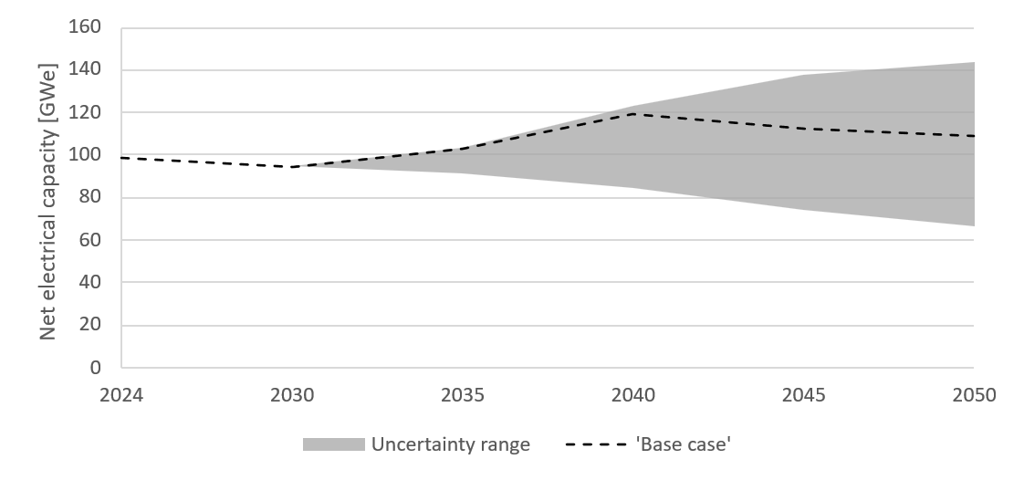
Power plants undergoing lifetime extensions are set to contribute a significant share of the nuclear installed capacity in 2050 (cf. light blue bars in Figure 2). In one scenario, the installed capacity could drop to less than 70 GWe by 2050. Conversely, if existing reactors extended their service life to 70 or even 80 years and all planned new build projects got delivered on time, the installed capacity could reach 144 GWe in 2050 (). The rate of achievement of lifetime extensions will be the main driver behind a wide range of outcomes.
Figure 2 – ‘Base case’ scenario of large-scale power generation capacities in the EU, 2024 - 2050. LTO denotes long-term operation (lifetime extensions).
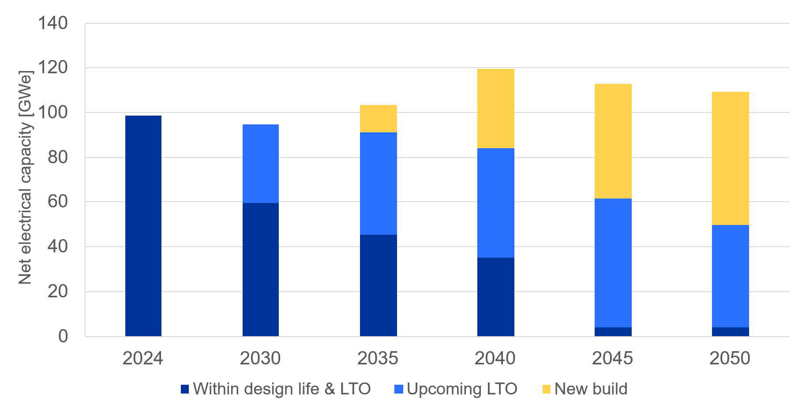
In addition to traditional large-scale reactors, the scenario may be supplemented with SMRs. The European SMR Industrial Alliance is setting out a strategic plan to achieve first SMRs in commercial operation in the early years of the next decade. In 2023, in the preparatory phase of the European SMRs Industrial Alliance, a preliminary evaluation by the sector organisations resulted in projections of SMR capacity ranging from 17 GW to 53 GW by 2050 (). Such projections are consistent with other more recent reports () ().
Building on the work of the European SMR Industrial Alliance, the Commission’s strategy for SMRs () seeks to support the acceleration of the development and deployment of such reactors in the EU in early 2030s.
The ‘base case’ scenario requires investments of around EUR 241 billion in present value terms (), with new-build of large-scale reactors accounting for EUR 205 billion and lifetime extensions accounting for EUR 36 billion. Thus, while actual lifetime extensions will determine the installed capacity by 2050, they account only for a minor share of investment needs. On the other hand, building new large-scale reactors on schedule and in accordance with planned budget is an important component for total investment needs. The following quantitative example shows that if new-build projects get delayed by five years, installed capacity in 2050 would decrease by almost 9 GWe, while the required investments would increase by more than EUR 45 billion (), i.e. spending more for less capacity (Figure 3). With delays leading to further costs, investment needs incurred until 2050 stay well above EUR 200 billion, even though the available capacity decreases.
Figure 3 – Investment needs for new build capacity until 2050 for delayed new-build deployment scenarios.
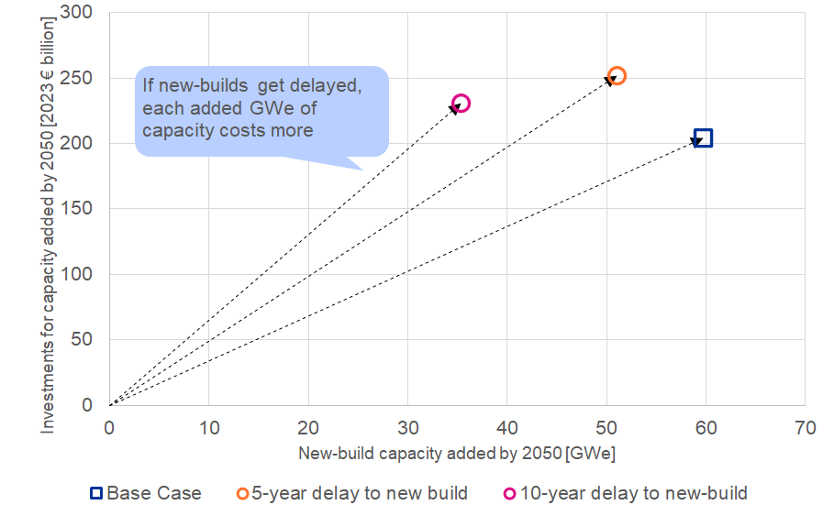

Energy system effects
By supplying clean, reliable baseload as well as flexible power nuclear energy may contribute to support system integration providing flexibility and inertia for grid stability. High upfront capital costs of nuclear energy may be mitigated by systemic savings lowering investment needs for transmission, distribution, and storage infrastructure.
Flexibility requirements are to increase across all timescales (daily, weekly, and seasonal). Where utilised, nuclear energy may primarily support the weekly and longer-term monthly flexibility needs (Figure 4).
Nuclear energy can contribute to support total system integration domestically and across the borders. Electricity trade data show that Member States with nuclear energy are net exporters (9 out of 10 net exporters in 2023 had nuclear capacity) ().
While taking into account its costs, nuclear energy can also contribute alongside other cost-efficient solutions (including flexibility, storage, grids, and interconnections) to reduce total system costs by complementing renewables (like wind and solar) with firm, low-carbon capacity that supports grid stability, integration, and storage needs (). This should be aligned to minimise the cost of decarbonisation in line with EU’s climate objectives.
Figure 4 – Contribution of nuclear energy to daily, weekly, and monthly flexibility needs in energy volume in the EU and selected Member States in 2030.
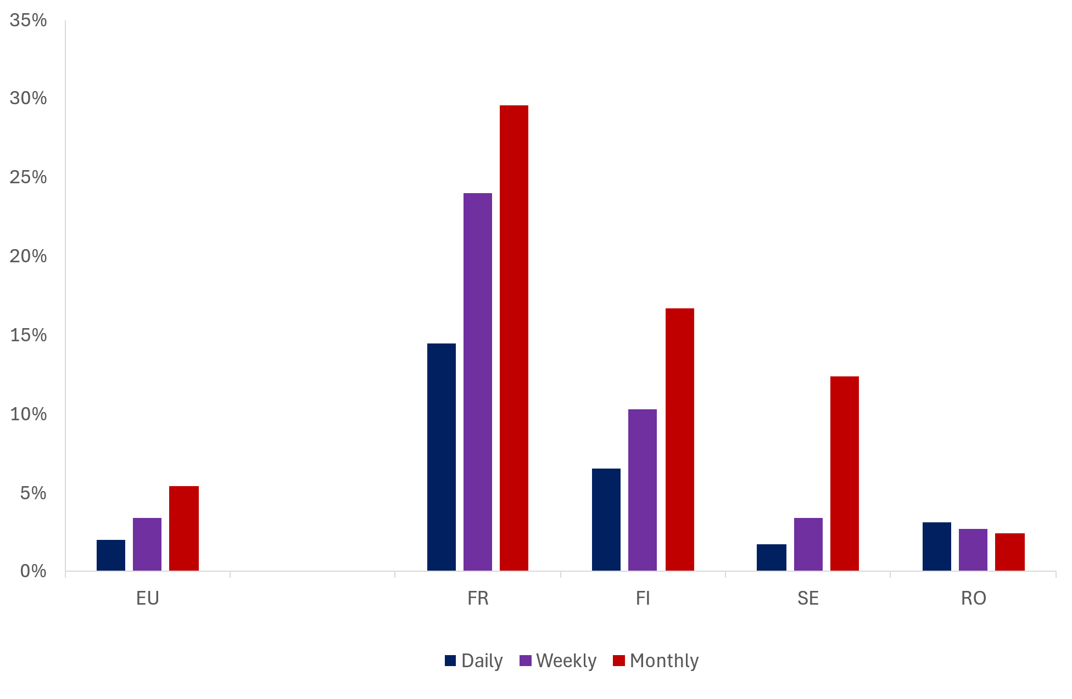

Emerging innovative technologies
There is a growing interest in the development of the industry of small and advanced modular reactors (SMRs and AMRs) as well as microreactors worldwide. Although not competitors of large-scale reactors on the energy market, their designs are conceived for faster and more efficient deployment than large-scale reactors, as factory-built modules benefit from competitive effects of in-series manufacturing. SMRs and AMRs are not competing with large-scale reactors as they may serve different energy needs.
Though numerous start-up projects exist in the EU, demonstration throughout the realisation of first-of-a-kind plants is needed. In the EU, the market size in individual countries does not match the necessary production volumes for series economies to materialise. Therefore, a coordinated approach across Member States is needed, for instance increased cooperation in relation to regulatory requirements by national competent authorities. In this respect, the Commission announced the launch of the design phase of a new potential Important Project of Common European Interest (IPCEI) candidate on innovative nuclear technologies. Interested EU countries will develop its scope and structure with support of the new IPCEI Design Support Hub.
The comparatively small land footprint, reduced cooling water usage, combined utilisation of heat and most importantly the expected reduced construction costs make these reactors a potentially more appealing option for private investors. A prominent example is the substantive amounts of capital being invested by high-tech companies to supply low-emission and reliable energy to data centres and the increased uptake of artificial intelligence (in 2020 the consumption of data centres globally stood at more than 10% of the EU electricity consumption).
Furthermore, SMRs and AMRs may form a component of future hybrid energy systems, serving as a reliable source of heat for urban districts and specific hard-to-abate industries, including low-carbon hydrogen production. SMRs can effectively support grid load balancing, owing to their typically greater operational flexibility compared to large-scale nuclear reactors. Due to their size, such reactors can be placed in a wide variety of locations; on the one hand this feature may help optimising the use of existing infrastructures and facilitate the integration of diverse and complementary energy sources within a given region; on the other hand, however it poses peculiar safety, security, and safeguards challenges to be tackled. On a general level, when selecting locations, Member States should perform a screening for climate risks next to the general risk assessment for the planned infrastructure and take into account which areas are more conducive to reduce the identified risks to acceptable levels.
Microreactors are designed as transportable, including via air. Thus, in spite of a high levelized cost of electricity (projected around 140 USD/MWh), they are attracting interest for use in defence applications, in difficult to access markets, such as remote mining sites where energy costs are high, in oil and gas industry both on- and off-shore, and in maritime transport.

Financing models
For national plans to materialise, Member States, who have decided to deploy nuclear energy should consider investing early and developing policies to maintain a sustainable industrial ecosystem for nuclear energy.
The Commission identified instances of lacking market-based instruments for private actors to implement their desired risk allocation, as well as challenges of “hold-up” risk (), i.e. the perceived risk that applicable laws and regulations change after private parties have sunk capital in a project.
Therefore, a combination of diverse sources of financing complemented by de-risking instruments may be the response, where public intervention addresses the above challenges taking also into account the benefits, e.g. the potential to increase system integration and supply of flexibility.
The instruments set out in the revised Electricity Market Design enable Member States to support project developers through re-allocating electricity market and construction risks. Projects’ financing may rely also on Power Purchase Agreements (PPAs); in those cases, Member States may design support instruments targeting the producer in the given PPA. Other jurisdictions, e.g. the US and the UK, are testing other innovative instruments to further manage construction risk, e.g. by adapting the regulated asset base model, an option which some Member States have recently considered as well.
The Commission provided guidance to Member States on how to design Contracts for Difference (CfD) for energy-related projects (), including their potential combination with Power Purchase Agreements (PPAs), in line with the state aid rules, as indicated in Draghi’s report and announced in the Clean Industrial Deal. In line with the approach in the Electricity Market Design, the Commission is engaged with the EIB to promote PPAs, including cross-border PPAs, in a technology-neutral way.
When designing features of public support, Member States should retain incentives to ensure beneficiaries’ efficient behaviour, e.g. delivering construction on time and within budget and dispatching capacity based on market signals.

Beyond electricity generation
Both the existing nuclear reactor fleet and new projected investments at EU and global level are largely focused on electricity supply. However, nuclear technologies can also provide a source of low-carbon heat for households and various industrial applications and are also instrumental in producing medical radioisotopes.

Heat supply
Many industrial processes require high-temperature heat, traditionally generated using fossil fuels. Currently, the demand for industrial heat in the EU is around 1900 TWh, with approximately 960 TWh needed at temperature levels between 500°C and 1000°C. In line with the projected electrification of demand sectors, studies () see the demand of high temperature heat dropping by 40% to about 620 TWh in 2050.
Heat from nuclear power plants has already been used or considered for district heating, the chemical industry or water desalination. Besides, SMR developers see a place for such technologies in the high temperature heat market, as they can contribute either supplying heat directly for hard-to-abate processes or via hydrogen production (Figure 5).
Supplying district heating is one of the potential use cases for SMRs. For instance, the CityHeat project, which was selected by the European Industrial Alliance on SMRs, explores this use case.
Figure 5 – SMRs deployment scenarios with shares of heat/hydrogen supply.
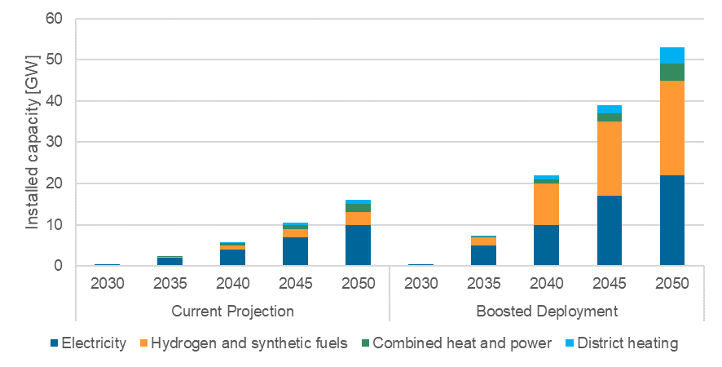

Medical radioisotopes
Nuclear research reactors play a crucial role in the production of radioisotopes, which are essential for both healthcare and various industrial applications.
In the medical sector, radioisotopes are indispensable for diagnosis of diseases, such as cancer, cardiac, pulmonary and neurological ones, and they are increasingly important for cancer therapy. Projections show that the number of patients eligible for radiopharmaceutical / radioligand therapies in the EU will triple until 2035 (). Therefore, secure and long-term supply of medical radioisotopes in the EU is vital for all citizens.
The EU is a global leader in this market, consistently providing more than 65% of the global irradiation services, with a strong export position. However, there are vulnerabilities upon which to act timely, such as specific foreign dependencies (e.g. supply of high-assay low enriched uranium – HALEU) and ageing of EU research reactors. While two research reactors are being built to produce radioisotopes for medical use and are scheduled to be ready in the early 2030s, innovation should also be pursued to diversify production means and increase the system resilience.
To date, other western countries, namely the US and the UK, have already invested substantial amounts for domestic supply of HALEU in the order of USD 1.2 billion and GBP 300 million (). Member States should catch up with similar investments in securing source materials and developing new industrial capacities.
Under the Strategic Agenda for Medical Ionising Radiation Applications (SAMIRA) Action Plan (), the Commission started a process towards establishing the “European Radioisotope Valley Initiative” (ERVI) to secure EU supply of medical radioisotopes ().

Strategic independence and diversification
The EU’s strategic independence is linked to the strengths and vulnerabilities of the supply chain. In view of national plans including nuclear energy to decarbonise the energy system and maintain energy security, there is a need to nurture a competitive EU nuclear industry ecosystem.

Control of the fuel cycle supply chain
Ensuring security of supply from ore to nuclear fuel should remain a strategic objective of the Member States with nuclear energy programmes including elimination of current dependencies and avoidance of dependence in the future. All Member States should also consider the strategic importance of security of supply of radioisotopes.
Russia’s unjustified military aggression against Ukraine has disrupted the global supply system for all sources of energy. It has affected the EU market across the entire nuclear fuel supply chain: in particular conversion, enrichment, and fuel fabrication services are to be strategically handled; to a lesser extent uranium mining requires attention, too.
EU’s strategic independence is vulnerable insofar as conversion and enrichment services (both in homeland and in like-minded partners) are not sufficient to ensure adequate supplies in view of projected nuclear expansion scenarios. In the ‘base case’ scenario EU conversion supply capacity barely matches foreseen demand until 2050, while EU enrichment supply capacity is forecasted to be marginally sufficient with a definite lack in relation to HALEU, especially needed for certain SMRs.
Uranium conversion and enrichment prices almost tripled from February 2022 to December 2023. Conversion and enrichment capacities in the EU must increase to meet demand and avoid dependence on any single or unreliable supplier. While investments into new enrichment capacities have been announced (), investments into conversion capacities are lagging, see Figure 6. Both conversion and enrichment service providers need long-term commitments to underwrite these investments.
Figure 6 – Global demand for conversion services vs supply capacity projections. (tU as UF₆ per year).
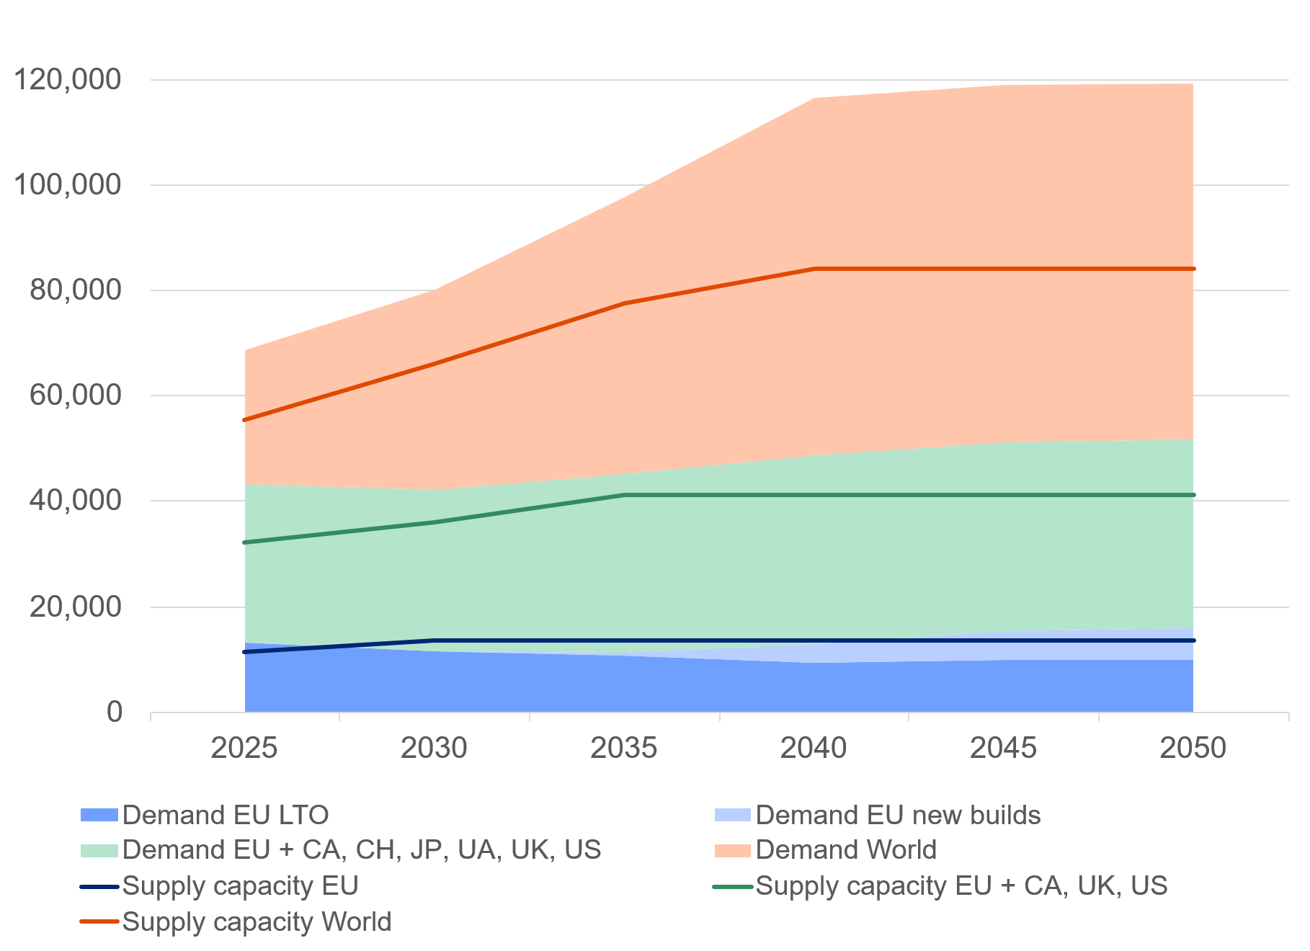
Most EU utilities can purchase nuclear fuel from at least two alternative suppliers. As an exception, dependence on a single design and supplier of fuel was the case for Russian design nuclear reactors operating in the EU (VVER) and became a vulnerability for the security of supply (). Almost all concerned EU operators have taken action to diversify nuclear fuel supply; alternative VVER fuel supplies are expected to become fully available by 2027, pending regulatory approval.
Uranium mining in the EU has significantly declined over the past decades, leading to a heavy reliance on imports from five countries to meet the region’s nuclear energy needs. The global uranium market is facing challenges due to Russia’s unjustified military aggression against Ukraine, the coup d’état in Niger, production issues, difficulties in transportation, and stronger demand, which influenced supply and demand forecast setting upward pressure on uranium prices.
Phasing out supplies from unreliable partners is a necessity to ensure economic security of the EU. The prerequisite would be to ensure that safe and open markets could make up for the Russian capacity. Increased cooperation between the EU and reliable international partners is crucial in this context. The EU and several countries should coordinate to ensure a resilient nuclear supply chain to achieve the goals which the Commission presented in the Roadmap towards ending Russian energy imports ().

Capacity of the industrial life-cycle supply chain
The nuclear energy supply chain in the EU has a pronounced domestic character and should be able to address possible upcoming disruptions that are due to geopolitical, raw materials availability, or climate change. Maintaining a robust, reliable and interlinked supply chain is essential to materialise the forecast demand for nuclear capacity in the EU. In the recent decades, the EU’s nuclear supply chain was marked by both contraction and reorientation trends towards maintenance and upgrades rather than new construction activities.
Current plans for new builds in the EU imply that the supply chain needs to ramp up to larger capacities to produce all needed components for a nuclear power plant. To achieve 60 GWe of new large-scale nuclear power capacity by 2050, Member States and industry would have to engage in multiple construction projects at the same time. This implies that because of the long construction period of large-scale nuclear plants, over the next 25 years, the equivalent of c. 20 GWe, representing about 15 large nuclear reactors, would have to be built simultaneously. The Commission’s analysis identified critical manufacturing processes, such as heavy forging, that require immediate intervention (). Making the nuclear energy supply chain in the EU more resilient would also enable further diversification of nuclear technologies and their related fuel cycle.
Availability of workforce and skills
A high demand for skilled workers spans across all facets of the nuclear ecosystem, including nuclear engineers and scientists, power plant operators, technicians, and regulatory staff. Impending workforce bottlenecks, exacerbated by an ageing workforce and an insufficient inflow of younger professionals, due to low attractiveness of the sector and a deficit in science, technology, engineering and mathematics (STEM) education, create various challenges to the EU nuclear authorities and industry.
A study () provided estimates on the EU nuclear sector needs in terms of jobs. Additional 180 000 – 250 000 new professionals will have to be engaged until 2050, in addition to replacing retiring employees. Approximately 100 000 – 150 000 professionals may be required to cover the construction phase of planned new nuclear power plants. Another 40 000 to almost 65 000 professionals are necessary to operate and maintain the planned nuclear power plants. Lastly, the decommissioning sector may require a further 40 000 professionals. Even under a no-growth scenario (equivalent to the ‘base case’ scenario), around 100 000 people would still need to be recruited to replace retiring workers. Particular attention is also required in the fusion sector to maintain the EU leading role.
A multi-tiered response comprising of mapping workforce needs, enhancing education and training, improving communications, offering better working conditions, and supporting workers’ mobility (from adjacent industries or from third countries), and access to nuclear research infrastructures may address this challenge.
If no action is undertaken, Europe will suffer a skills and workforce shortage in the nuclear sector, including for certain regulatory bodies. This gap may be even starker in cutting-edge technologies such as SMRs. The workforce needs replenishment, rejuvenation, and a transfer of skills and experiences to the next generation. Whereas the nuclear sector must take the initiative to attract new talent, the Commission and Member States can support this process, e.g. through Net-Zero Industry Academies and by reinforcing further Euratom Research and Training Programme-funded action in support to the assessment, maintenance and development of the necessary strategic competences at EU level.
The SKILLS4NUCLEAR project (), launched in 2025 with an Euratom funding of EUR 1.5 million, aims to strengthen capacity-building in nuclear safety, decommissioning, waste management, radiation protection, and medical applications while fostering industry-driven workforce development. Additionally, the project will establish a European forum for nuclear workforce and skills to update training programmes based on emerging developments and to develop reskilling and upskilling initiatives for workers.
The need for robust European nuclear research infrastructure has a vital significance as it supports cutting-edge research, fosters innovation, and enhances collaborative efforts among Member States. This includes the development and maintenance of experimental facilities, data-sharing platforms, and integrated research networks that enable scientists and engineers to conduct comprehensive studies in nuclear safety, safeguards, waste management, fusion energy, and the development of next-generation reactor technologies. It also ensures that Europe remains at the forefront of nuclear science and technology, maintaining Europe's competitive edge in the global research landscape and in meeting future energy and environmental challenges.

Strategic international cooperation
The Euratom’s external relations framework is instrumental to promote the highest nuclear safety standards, facilitating knowledge and technology exchange, as well as support the EU competitive nuclear supply chain, via forward looking partnerships and trade and commercial cooperation ().
In view of bolstering EU’s strategic autonomy, reviewing existing cooperation agreements or entering in new ones is essential. They may also help strengthening compliance with the international nuclear standards and facilitate incorporating emerging and innovative technologies, such as SMRs and fusion energy.
Most importantly, increased cooperation between the EU and reliable partners will enhance security of supply for uranium and nuclear fuel cycle services and will facilitate access to markets for the EU supply chain to nurture its industrial capabilities.
To enhance cooperation between the EU and reliable partners, the Euratom Community should embark in either renewing (e.g. with Canada or Kazakhstan) or negotiating new Nuclear Cooperation Agreements and Memoranda of Understanding.

Leadership in research and training
Public and private research at national level contribute significantly to the EU’s leadership in nuclear technologies. Research efforts contribute to ensuring the highest standards for nuclear safety and safeguards when building new nuclear power plants or when extending the lifetime of existing ones. Euratom’s task is to complement Member States’ contributions by means of the Euratom Research and Training Programme. The 2021-2025 Programme supported the development of essential knowledge () for those Member States who plan to use nuclear energy, and for those who need reassurance that nuclear power plants in neighbouring countries meet the highest safety standards. The public also stands to benefit from Euratom funded research on other applications of ionising radiation, in particular in medicine. The Commission proposal for 2028-2032 Euratom Programme () aims at increased funding for research on safe, innovative nuclear technologies for a prosperous, resilient and sustainable EU.

Preparing for a future with nuclear fusion energy
The EU’s flagship project ITER, based in France, is the world’s largest fusion experiment aimed at demonstrating the scientific and technological feasibility of fusion. As a major driver of innovation ITER is bringing the knowledge and industrial base which are essential for the development of the first demonstration fusion power plant in the EU.
It is very important to anchor further investments in ITER and fusion in general in a broader European action aimed at mastering fusion not just as a research topic, but also as a tool for long-term energy independence, decarbonisation as well as nearer-term European industrial competitiveness. Public-private partnerships can accelerate commercialisation of fusion energy by leveraging the strengths of both sectors. Continued spending on the development of a fuel cycle for fusion technologies and on closing the technology gaps will be needed in parallel with the definition and implementation, if necessary, of a differentiated and proportionate regulatory framework for fusion installations.
In line with Draghi’s report and as announced in the Action Plan for Affordable Energy, the Commission is preparing a comprehensive EU fusion strategy, whereby ITER is confirmed as a cornerstone, with a view to accelerating the long-term development of fusion energy.
Such developments are supported by research and technology development carried out by the Euratom co-funded European Partnership EUROfusion () and Fusion for Energy (F4E). The commercial deployment of fusion energy should be accelerated by strengthening the large fusion community brought together in the Fusion Expert Group, the European Fusion Stakeholder Platform, the launching of a Public Private Partnership with industry, and the support to the fusion startups.

Conclusions
As several EU countries have chosen to rely on nuclear energy, it will continue to play an important role in the EU’s diversified energy system. Therefore, it is essential to ensure its safe, efficient and sustainable integration and to reap all benefits nuclear energy may bring, including system integration.
All investment projects in the EU nuclear industry need to comply with the highest standards of nuclear safety, radiation protection, radioactive waste management, and safeguards applicable in the EU. New nuclear projects must adhere to highest safety objectives, ensuring that innovative reactor designs meet these stringent requirements. Member States should intensify their efforts to provide long-term solutions for the management of high-level radioactive waste and spent fuel.
In 2050, a wide range of outcomes is anticipated for the actual installed capacity. Lifetime extensions carried out under strict safety conditions and new plants will be critical as well as the ability of the industry to deliver on time and on budget.
Substantial investments are implied across the entire nuclear life-cycle until 2050. Compared to the previously published PINC, the Commission has not observed a significant change in envisaged investment amounts, however plans are more articulated and diversified, looking at innovative technologies and the full industrial ecosystem. Specific attention is needed for SMRs development and actual deployment, to enhancing the resilience of the supply chain, guaranteeing sufficient, diversified and sovereign EU capacity for conversion and enrichment, regulatory capacity, research, the workforce, and delivering a secure supply of medical radioisotopes.
To thrive, the EU nuclear supply chain needs stable long-term commitments, greater standardisation levels and enhanced cooperation. Investing in the competitiveness of the EU nuclear industry and strengthening its supply chain is essential, with the ambition to operate worldwide.

() COM(2025) 85 final.
() COM(2025) 79 final.
() COM(2024) 63 final.
() Article 194 of the Treaty on Functioning of the European Union (TFEU).
() COM(2025) 440 final/2, EUR-Lex - 52025DC0440R(01) - EN - EUR-Lex.
() The nuclear illustrative programme of the Commission, or Programme Illustrative Nucléaire Communautaire (PINC) is an obligation of the Commission under Article 40 of the Euratom Treaty.
() TEN/856-EESC-2025
() COM(2025) 315 final
() Belgium, Bulgaria, Czech Republic, Spain, France, Hungary, Netherlands, Romania, Slovenia (Croatia), Slovakia, Finland, and Sweden.
() Slight increase in nuclear power production in 2023 - News articles - Eurostat.
() Mochovce 3 in Slovakia was connected to the grid in January 2023, Olkiluoto 3 in Finland started commercial operation in May 2023, and Flamanville 3 in France was connected to the grid in December 2024. One reactor in Slovakia (Mochovce 4) and two others in Hungary (Paks II) are under construction.
() IEA (2025), The Path to a New Era for Nuclear Energy, IEA, Paris https://www.iea.org/reports/the-path-to-a-new-era-for-nuclear-energy, Licence: CC BY 4.0.
() COM(2025) 440 final/2, EUR-Lex - 52025DC0440R(01) - EN - EUR-Lex.
() European Industrial Alliance on Small Modular Reactors - European Commission (europa.eu).
() COM(2025) 440 final/2, EUR-Lex - 52025DC0440R(01) - EN - EUR-Lex – Action 7
() Council Directive 2009/71/Euratom as amended by Council Directive 2014/87/Euratom.
() Council Directive 2011/70/Euratom.
() In particular Directive 2011/92/EU on the assessment of the effects of certain public and private projects on the environment, Directive 2001/42/EC on the assessment of the effects of certain plans and programmes on the environment, Directive 92/43/EEC on the conservation of natural habitats and of wild fauna and flora, and Directive 2000/60/EC establishing a framework for Community action in the field of water policy.
() Regulation (EU) 2020/852, OJ L 198, 22.6.2020, p. 13–43; Commission Delegated Regulation (EU) 2022/1214, OJ L 188, 15.7.2022, p. 1–45.
() Tonnes of heavy metal, abbreviated as tHM, is a unit of mass used to quantify uranium, plutonium, thorium, and mixtures of these elements.
() Shedding light on energy in Europe – 2025 edition, ESTAT, ISBN 978-92-68-22424-3.
() The figure of EUR 8.33 per MWh represents a ratio, where: (i) the numerator is sum of incurred expenditures for decommissioning and all waste management operations except the geological disposal; and (ii) the denominator is the electric energy generated during the plant’s operational life.
() COM(2024) 197 final, Report from the Commission to the Council and the European Parliament on progress of implementation of Council Directive 2011/70/EURATOM and an inventory of radioactive waste and spent fuel present in the Community's territory and the future prospects - THIRD REPORT.
() This figure represents the sum of Member States’ individual estimates. However, Member States’ estimates vary widely in terms of methodology, assumptions, completeness of data, scope and time frames. Individual Member States’ figures may or may not represent a present value figure.
() COM(2017) 237 final.
() Adjusting also for Brexit.
() COM(2025) 274 final.
() In 2023, the Finnish Government granted the Loviisa nuclear power plant a new operating license until the end of 2050, at which point it will have completed more than 70 years of operation. These presented scenarios reflect only potential LTOs of currently operational nuclear power plants. They do not consider the potential re-start of already shutdown plants, which could add further capacity if realised.
() European SMR pre-Partnership - nucleareurope, Note that this scenario include power for electricity generation and heat supply.
() The Path to a New Era for Nuclear Energy, IEA, 2025, The Path to a New Era for Nuclear Energy. Considering large-scale reactors and SMRs jointly, the IEA projected global installed nuclear generation capacity to increase from 416 GWe in 2023 to between 650 GWe, 870 GWe, and more than 1,000 GWe by 2050 across three scenarios.
() Pathways to 2050: the role of nuclear in a low-carbon Europe, Compass Lexecon, 2024, Pathways to 2050 - nucleareurope.
() COM(2026)117.
() The Commission calculated the present value using a discount rate of 7.5%. The investment needs indicated include new build and lifetime extensions. Section 3.3 covers investment needs for decommissioning and management of radioactive waste and spent fuel separately.
() The quantitative example assumes that construction costs increase proportionally with construction time.
() Accompanying Staff Working Document, Sections 2.2.2 and 2.2.3.
() IEA (2025), The Path to a New Era for Nuclear Energy, IEA, Paris https://www.iea.org/reports/the-path-to-a-new-era-for-nuclear-energy, Licence: CC BY 4.0
() Commission Decision (EU) 2015/658 of 8 October 2014 on the aid measure SA.34947 (2013/C) (ex 2013/N) which the United Kingdom is planning to implement for support to the Hinkley Point C nuclear power station.
() C(2025) 8479 final.
() Accompanying Staff Working Document, Section 3.1.2.
() Accompanying Staff Working Document, Section 3.2.1.
() Accompanying Staff Working Document, Box Supply of High-assay low-enriched uranium (HALEU).
() SAMIRA Action Plan - European Commission.
() COM(2025) 440 final/2, EUR-Lex - 52025DC0440R(01) - EN - EUR-Lex – Action 7
() France: EIB and Orano sign a loan agreement for €400 million relating to the project to extend the Georges Besse 2 uranium enrichment plant, European Investment Bank, 10 March 2025.
() Fuel to those reactors has been originally delivered from TVEL (RU), subsidiary of Rosatom within bundled contracts offering uranium and all related services including production of fuel assemblies.
() COM(2025) 440 final/2, EUR-Lex - 52025DC0440R(01) - EN - EUR-Lex.
() Accompanying Staff Working Document, Section 4.3.2.
() Report on the European nuclear ecosystem, prepared by Deloitte for DG ENER, in preparation for publication.
() https://cordis.europa.eu/project/id/101213280
() In addition. the European Instrument for International Nuclear Safety Cooperation (INSC) is a key tool for strengthening the adoption of the highest international nuclear safety standards globally.
() See interim evaluation, COM(2025)61
() COM(2025)594
() https://cordis.europa.eu/project/id/101052200

