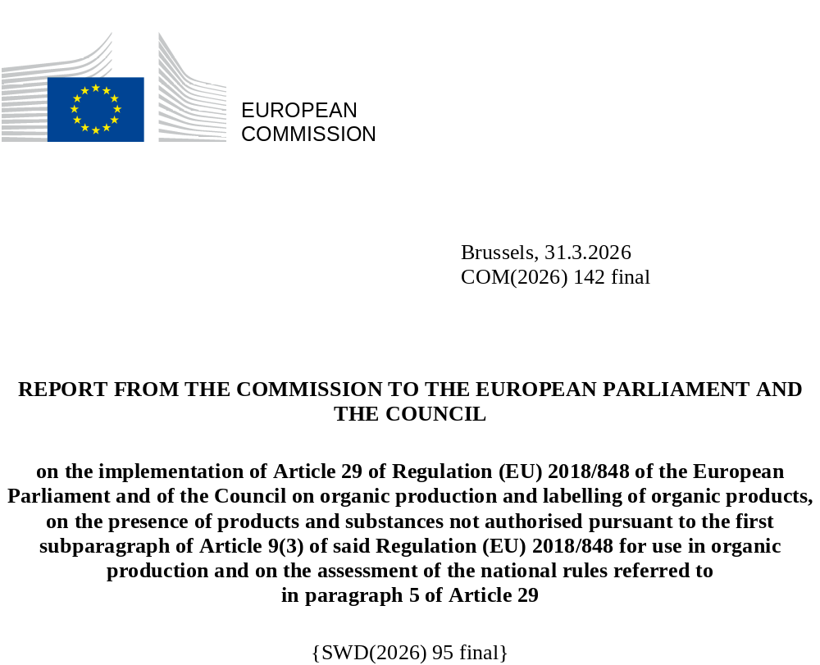

REPORT FROM THE COMMISSION TO THE EUROPEAN PARLIAMENT AND THE COUNCIL
on the implementation of Article 29 of Regulation (EU) 2018/848 of the European Parliament and of the Council on organic production and labelling of organic products, on the presence of products and substances not authorised pursuant to the first subparagraph of Article 9(3) of said Regulation (EU) 2018/848 for use in organic production and on the assessment of the national rules referred to
in paragraph 5 of Article 29

Abbreviation | Explanation
CA/(s) | competent authority/(ies)
CB/(s) | control body/(ies)
CtrlA/(s) | control authority/(ies)
EFSA | European Food Safety Authority
EU | European Union
MRL | maximum residue level
MU | measurement uncertainty
OFIS | Organic Farming Information System
PF | processing factor
LOQ | limit of quantification
LOD | limit of determination
TC | third country

- INTRODUCTION
Organic farming is a key element of the EU’s Common Agricultural Policy. The proportion of land farmed organically has been growing steadily to reach 11% today and consumers increasingly purchase organic food, which is recognisable through an EU logo. The production and labelling of organic products are governed by Regulation (EU) 2018/848 of the European Parliament and of the Council (hereafter the ‘Organic Regulation’), applicable since January 2022, as well as by the delegated and implementing Regulations that have been adopted on its basis and lay down the detailed rules underpinning organic production.
Pursuant to Article 29(4) of the Organic Regulation, the Commission must present ‘by 31 December 2025, a report to the European Parliament and the Council on the implementation of measures taken in the event of the presence of products and substances not authorised for use in organic production and on the assessment of the national rules referred to in Article 29(5) of the Organic Regulation. That report may be accompanied, where appropriate, by a legislative proposal for further harmonisation’.
Organic and in-conversion products are subject to the specific rules, in particular concerning the active substances authorised for use in organic production as set out Annex I to Commission Implementing Regulation (EU) 2021/1165 whereas the presence at any stage of the supply chain of residues of products or substances not authorised for use in organic production must be duly investigated with the view to ensure the integrity of organic products.
Furthermore, to ensure consumer safety, Regulations of the European Parliament and of the Council (EC) No 396/2005 and (EU) 2017/625 govern official controls and residues of pesticides in food and feed. These provisions also apply to organic products.
Every year, the EFSA publishes results on the presence of residues in food, including organic products. In 2023, out of the 7 074 samples labelled as organic, 80% did not contain quantifiable residues, 19% contained residues below or at the MRL (of which 94.6% were copper-based substances) and in only 0.9% of the samples contained residues above the MRL.
This report from the Commission to the European Parliament and the Council builds on the one hand on contamination reports submitted over the last three years by Member States on their official investigations into contamination of organic and in-conversion products and on the other hand on the conclusions of a dedicated study by the EFSA on 21 substances not authorised for use in organic production notified in the OFIS in 2021 and 2022 as occurring most frequently in organic products. For each substance, the EFSA examined relevant information with a view to identifying potential sources of contamination, such as soil residues, irrigation water, spray drift from conventional farming, biocides and others. The study provides a useful scientific background for understanding the possible causes and sources of these substances when they are present in products labelled as organic.
The EFSA study shows that pesticide residues are less likely in organic products than in the corresponding conventional goods; the likelihood of the 21 examined substances non-authorised for use in organic production occurring in products labelled as organic ranged from 0.04 to 3.95%, compared with 0.18 to 17.5% for non-organic goods. It also highlights the need to systematically open investigations on the possible active use of substances not authorised for use in organic production and recommends that additional tests be conducted (e.g. soil, water or other analyses) depending on the detected substance.
The accompanying Commission staff working document lists the overall findings from contamination reports on those 21 substances.

- OFFICIAL INVESTIGATIONS
Article 29(1) of the Organic Regulation sets out the measures to be taken if non-authorised products or substances for use in organic production are present in organic or in-conversion products. This provision requires that an official investigation be carried out immediately when a CA, or, where appropriate, a CtrlA or CB (i) has received substantiated information about the presence of products or substances that are not authorised for use in organic production; (ii) has been informed by an operator that a suspicion has been substantiated or could not be eliminated; or (iii) itself detects non-authorised products or substances in an organic or an in-conversion product.
While the notion of substantiated information may have been interpreted differently across Member States, the results of laboratory tests tend to be the starting point for launching official investigations.
Technical issues on analytical results
Interpreting laboratory test results on the presence of residues relies on a comprehensive set of legally binding rules set in Regulation (EC) No 396/2005 – to ensure the safety of feed and food products. The EU pesticide database serves as a reference information source along with the relevant technical guidelines available at EU level.
Multi-residue methods are available for analysing residues of most active substances used in pesticides according to the pesticide residue definition set in Regulation (EC) No 396/2005. Many of the available methods have a LOQ as low as 0.001 mg/kg. Furthermore, in the absence of a specific MRL, a default value of 0.01 mg/kg is applied, except for certain combinations of active substances and food products for which specific LOQs are set.
It is essential that analytical quality control and method validation procedures for pesticide residues analysis in food and feed are followed by laboratories and that the laboratory test results on residues of pesticides are accompanied with the corresponding MU.
For certain organic products that have been subject to processing, such as drying or distillation, a PF may be used to adjust the laboratory residue results. PFs are specific to the process, product and active substance concerned. Since October 2018, the EFSA has been publishing a comprehensive list of PFs with indicative values for many pesticide/commodity/process combinations. An information note on Article 20 of Regulation (EC) No 396/2005 as regards PFs, processed and composite food and feed is also available.
Launching official investigations
Where a CA or, where appropriate, CtrlA or CB concludes, after completing the relevant procedures, that substantiated information exists about the presence of substances non authorised for use in organic production in an organic or in-conversion product, it must immediately carry out an official investigation with a view to determining the source and the cause of such presence.
Even for substances non authorised for use in organic production that can occur naturally, natural occurrence cannot be presupposed as the reason for their presence and an investigation is required with a view to ruling out the possibility of intentional active use. The same approach is applied to non-naturally occurring substances whose presence may be due to background contamination, drift, long-range aerial transport, irrigation, industrial emissions or other reasons. Thus, environmental background contamination cannot be presupposed as the source and an official investigation is therefore required. In cases where previous investigations concluded that repeated identical contaminations were unrelated to an intentional active use, and if the operator took the precautionary measures to avoid such contamination, additional investigations may not be needed for future occurrences.

III: IMPLEMENTATION OF ARTICLE 29 OF THE ORGANIC REGULATION
This Chapter is based on Member State responses to a questionnaire gathering information on the implementation of Article 29 of the Organic Regulation, as well as on elements of the EFSA study.
Timing for triggering official investigations
Most Member States confirmed that official investigations are carried out immediately when substantiated information is received, with intervals ranging from ‘within the day’
to ‘within seven days’ depending on the prevailing circumstances, such as the availability of staff, workload or completeness of available information.
A few Member States indicated that they prioritise fresh products, products with a shorter shelf life and products that are already on the market when initiating an investigation.
Identifying the source and the cause of the contamination
Member States reported that the outcomes of investigations vary, but most estimated that more than half of all official investigations (ranging from 60% to 80%, depending on the substance concerned) identify the source and the cause of the contamination. A few Member States reported extreme rates well below or above those ranges.
A few Member States reported that the cause and source of the contamination can usually be identified for domestic primary production, while the success rate diminishes further down the supply chain. They highlighted that for products originating in TCs, drift is often claimed to be the cause of the contamination.
Duration of the official investigation
The duration of official investigations varies significantly. More than half of the Member States responded that the average duration of an official investigation ranges from 20 to 30 days, while others reported an average duration ranging from 40 to 90 days. Only one Member State reported that investigations take on average between 2 and 5 days. Article 29(1), point (a), of the Organic Regulation provides that the time needed to complete the investigation should consider the durability of the product.
The following factors were mentioned by Member States as reasons for requiring more time to complete official investigations: (i) the need for additional sampling; (ii) incomplete reports; (iii) the complexity of the supply chain (type and number of operators involved); (iv) the need for cooperation between different authorities; and (v) other reasons.
Status of the products during an official investigation
Member States responded that, in accordance with Article 29(1), point (b), of the Organic Regulation, the products concerned are normally prohibited from being placed on the market as organic or in-conversion products pending the results of the investigation. A few Member States responded that it can be problematic to implement that provision for fresh organic or in-conversion products with a short shelf life.
A few Member States also indicated that in the case of very low levels of substances not authorised for use in organic production well below the set MRL for pesticides, or in the case of substances that could be naturally occurring, the CA, CtrlA or CB might consider not provisionally prohibiting the placing of the products concerned on the market as organic products. These practices may require further investigation.

Once the investigation is concluded
Member States have put in place various systems adapted to their own administrative and control structures to inform other control bodies and CAs, as well as downstream operators, of their decision after the conclusion of the investigation.
Opportunity for the operators concerned to comment
All Member States confirmed that operators are systematically given the opportunity to comment on the results of official investigations and are informed about the deadlines to request a second expert opinion according to the rules set out in in Article 35 of Regulation (EU) 2017/625.
Record keeping
All Member States responded that, in accordance with Article 29(3) of Regulation (EU) 2018/848, their relevant CAs, or, where appropriate, CtrlAs or CBs keep records of the official investigations carried out.
Corrective measures to avoid future contamination
Member States indicated, based on annual checks of follow-up inspections, that in more than 90% of the cases operators took corrective measures to avoid future contamination. When no corrective actions were taken, Member States indicated that in the case of critical non-compliances, CtrlAs or CBs suspend or withdraw the certificate according to the uniform arrangements set out in Annex I of Commission implementing Regulation (EU) 2021/279.
National rules under Article 29(5) and (7)
Article 29(5) of the Organic Regulation allows Member States that, under Council Regulation (EC) No 834/2007 set levels for substances non authorised for use in organic production above which products cannot be marketed as organic, to continue to apply those rules as long as they do not impede the placing on the market of products from other Member States produced in compliance with the Organic Regulation.
Four Member States (Belgium, Italy, Romania and Slovenia) reported having kept such national levels and confirmed that they do not apply them to organic or in-conversion products from other Member States. They also confirmed that investigations are systematically triggered in all cases.
- Belgium (only Wallonia) informed applying a threshold set at 1.5 times the existing LOD of Regulation (EC) No 396/2005 to products produced or processed in Wallonia only or imported from TCs. An official investigation is always launched when substances non-authorised for use in organic production are detected and downgrading (i.e. no authorisation to market the product as organic) occurs when the findings are above the national threshold.

- Italy informed applying a general threshold of 0.01 mg/kg for substances non authorised for use in organic production (except for phosphonic acid, for which a higher threshold is temporarily allowed). Products exceeding that threshold cannot be marketed as organic, regardless of whether the contamination was intentional.

- Romania informed applying a 0.01 mg/kg national threshold for substances non authorised for use in organic production. All positive detections are investigated.

- Slovenia informed using the LOQ of the analytical method but taking MU into consideration. An official investigation is triggered when this national threshold is exceeded. Where the contamination was intentional, the certificate is withdrawn for all the products of the operator. Where the contamination was accidental or the presence of such substances was unintended, the operator must take appropriate preventive and precautionary measures to avoid repeated contamination in the future.

Similarly, Article 29(7) of the Organic Regulation allows Member States to take appropriate measures on their territory to avoid the unintended presence of substances not authorised for use in organic production in organic or in-conversion products. They may do so if such measures do not impede the placing on the market of products from other Member States produced in compliance with the Organic Regulation and if they inform the Commission and the other Member States that they are making use of Article 29(7). The above-mentioned four Member States informed the Commission that they take such measures on their respective territories.

IV SUMMARY OF THE RESULTS OF OFFICIAL INVESTIGATIONS AND BEST PRACTICES
Official contamination reports
In accordance with Article 29(9) of the Organic Regulation, Member States must report to the Commission by 31 March each year the results of official investigations into cases detected during the previous year of contamination with products or substances not authorised for use in organic production.
27 MS responded for 2022 and 2023 and 25 for 2024. The Commission focused its analysis of those contamination reports on the same 21 substances examined in the EFSA study mentioned in Section I. The Commission staff working document accompanying this report contains a summary table, as well as individual tables for each of those 21 substances, indicating: (i) the categories of product in which the product or substance non authorised for use in organic production was most commonly detected; (ii) the relevant stage in the supply chain; (iii) the identified source and cause of the contamination; and (iv) the measures taken in relation to the marketing of the investigated products.
In relation to the stage of the supply chain at which the substances were detected, the consolidated average results are as follows: 66.2% of the substances were detected at production, 10.2% at preparation, 9.5% at storage,
5.9% at distribution, 3.3% at import, 2.5% at the placement on the market (e.g. retail) and 0.1% at export.
As regards the causes of contamination, spray drift was established as the main cause, accounting on average for 24.1% of the cases. In 16.7% of the cases, the operator did not take the precautionary measures referred to in Article 28(1) of the Organic Regulation, in 15.9% the operator used products or substances not authorised in organic production, while in 10.6% the contamination had occurred at the previous stage of the supply chain. In 1.6% of the cases, commingling of organic or in-conversion products with non-organic products was established as the cause and in 0.6% it was lack of traceability. Finally, other sources and causes were established in 14.8% of the cases and in 14.9% the source and cause of the contamination could not be identified.
Despite considerable differences across the substances, it is worth highlighting some common patterns in relation to the source and cause of contamination. In nearly all cases where investigations concluded that the contamination was due either to the active use of the substance by the operator or to the lack of precautionary measures, the product was not allowed to be marketed as organic, as provided for in Article 29(2) of the Organic Regulation. In the other cases, the situation was more varied.
Best practices
In accordance with Article 29(6) of the Organic Regulation, most Member States provided feedback on best practices. A key best practice remains highlighting to operators the importance of strict compliance with precautionary measures, including: (i) separating organic and non-organic products, at both the production and processing stages; (ii) using adequate buffer zones and intercropping; and (iii) being careful to prevent contamination by cleaning equipment and separating organic, in-conversion and non-organic products. An appropriate risk assessment, based on the characteristics of the products and the production methods as well as on information on the previous performance of operators, is also needed to identify best sampling operations (number of products, number of operators, stage of production, etc.).
Member States highlighted the importance of making it easier to implement precautionary measures and quality controls (performed by the operators themselves), as well as the role of action plans in correcting and preventing recurrent cases of non-compliance.
Some Member States stressed the need to assist operators by developing informative documents and providing continuous training for the stakeholders along the supply chain, including training CBs. This can involve research projects and surveys to promote harmonised approaches among CAs and, where appropriate, CtrlAs and CBs.
Member States also use surveys to identify differences in approaches by control bodies, which can lead to suggestions for improvement. Overall, simplifying communication at all levels is highlighted as an important practice to ensure that issues within the organic control system are quickly detected, dealt with and learnt from.

V CONCLUSIONS
Organic and in-conversion products undergo a comprehensive set of checks and certification procedures to verify their compliance with the Organic Regulation and the corresponding secondary legislation. The organic control system has proven its reliability and is one of the cornerstones of the success of the organic sector in the EU where citizens expect organic products not to carry traces of substances non authorised for use in organic production.
The Organic Regulation lays down rules for handling cases where substantiated information (typically the result of laboratory tests) indicates the presence of substances not authorised for use in organic production. In such cases, an official investigation must be opened immediately to identify the source and cause of the presence of the substance non authorised for use in organic production with the view to ensure the integrity of the products. National CAs or, where appropriate, CtrlAs and CBs operate the system in conformity with a harmonised methodology set down in Article 2 of Commission Implementing Regulation (EU) 2021/279.
The EFSA study reported a large variety of possible sources and causes of the presence of substances non authorised for use in organic production in relation to the 21 pesticide substances analysed, but also stressed that, without a proper investigation, it is not possible to rule out intentional use or a lack of the necessary preventive measures. The study also showed that the occurrence of residues is far less likely in organic than in the respective conventional products. These findings confirm the high level of assurance provided by the EU organic control system, the need to maintain strict control and sampling protocols and the pertinence of systematic official investigations.
This report acknowledges that CAs and, where appropriate, CtrlAs and CBs, face some operational challenges when determining the source and cause of contamination, especially when it takes place at a downstream stage of the supply chain where the number of inconclusive investigations remains a matter of concern. It also confirms that the rules on systematic official investigations in case of substantiated non-compliances are necessary to ensure the integrity of the organic products.
Some operators have criticised the time required to start and conclude investigations, the complexity of these procedures, the diverging approaches across national CAs, CtrlAs and CBs, the additional costs, as well as possible impacts on supply chains.
The Commission is ready to foster a more harmonised implementation of Article 29 by engaging actively with CAs and, where appropriate, CtrlAs and CBs through dedicated workshops to exchange experiences and best practices with the view to reduce burdens for operators in the organic supply chain.
At the same time, this report provides evidence that official investigations are, overall, initiated rapidly and often concluded within a reasonable time span. Similarly, measures to avoid the undue marketing as organic of products under investigation appear to work satisfactorily, although challenges remain with fresh products with a short shelf life.
In conclusion, the Commission is of the view that the current system is working reasonably well, with no adjustment being needed at this early stage of implementation. Building on the various actors’ learning curve, the Commission expects to see further improvements in the operation of the system and stands ready to underpin this process by fostering further dialogue and exchange of experiences among all the stakeholders.

. Regulation (EU) 2018/848 of the European Parliament and of the Council of 30 May 2018 on organic production and labelling of organic products and repealing Council Regulation (EC) No 834/2007 (OJ L 150, 14.6.2018, p. 1, ELI: http://data.europa.eu/eli/reg/2018/848/2025-03-25).
.Commission Implementing Regulation (EU) 2021/1165 of 15 July 2021 authorising certain products and substances for use in organic production and establishing their lists (OJ L 253, 16.7.2021, p. 13, ELI: http://data.europa.eu/eli/reg_impl/2021/1165/oj).
. Regulation (EC) No 396/2005 of the European Parliament and of the Council of 23 February 2005 on MRLs of pesticides in or on food and feed of plant and animal origin and amending Council Directive 91/414/EEC (OJ L 70, 16.3.2005, p. 1, ELI: http://data.europa.eu/eli/reg/2005/396/oj).
. Regulation (EU) 2017/625 of the European Parliament and of the Council of 15 March 2017 on official controls and other official activities performed to ensure the application of food and feed law, rules on animal health and welfare, plant health and plant protection products amending Regulations (EC) No 999/2001, (EC) No 396/2005, (EC) No 1069/2009, (EC) No 1107/2009, (EU) No 1151/2012, (EU) No 652/2014, (EU) 2016/429 and (EU) 2016/2031 of the European Parliament and of the Council, Council Regulations (EC) No 1/2005 and (EC) No 1099/2009 and Council Directives 98/58/EC, 1999/74/EC, 2007/43/EC, 2008/119/EC and 2008/120/EC, and repealing Regulations (EC) No 854/2004 and (EC) No 882/2004 of the European Parliament and of the Council, Council Directives 89/608/EEC, 89/662/EEC, 90/425/EEC, 91/496/EEC, 96/23/EC, 96/93/EC and 97/78/EC and Council Decision 92/438/EEC (Official Controls Regulation) (OJ L 95, 7.4.2017, p. 1, ELI: http://data.europa.eu/eli/reg/2017/625/oj).
. The 2023 EU report on pesticide residues in food https://www.efsa.europa.eu/en/efsajournal/pub/9398.
. Pursuant to Article 29(9) of the Organic Regulation and based on the template set out in Commission Implementation Regulation (EU) 2023/1195 of 20 June 2023 laying down rules for the details and the format of the information to be made available by Member States on the results of official investigations concerning cases of contamination with products or substances not authorised for use in organic production (OJ L 158, 21.6.2023, p. 65, ELI: http://data.europa.eu/eli/reg_impl/2023/1195/oj).
. ‘Findings of not authorised substances in food and feed certified as organic’, EFSA Supporting publication 2025: EN-9524: https://www.efsa.europa.eu/en/supporting/pub/en-9524.
. EU Pesticide database.
. https://webgate.ec.europa.eu/dyna2/pgd/.
. LOQ is a synonym of LOD for which a definition is set in the Article 3(2), point (f), of that Regulation as follows: ‘(f) ‘limit of determination’ (LOD) means the validated lowest residue concentration which can be quantified and reported by routine monitoring with validated control methods;’.
Analytical quality control and method validation procedures for pesticide residues analysis in Food and Feed -SANTE 11312/2021 v2026
. European database of processing factors for pesticides residues in food.
. https://food.ec.europa.eu/document/download/071dce96-d916-4615-87fa-148f1491bfc8_en?filename=pesticides_mrl_guidelines_proc_imp_sante-2021-10704.pdf.
. Commission Implementing Regulation (EU) 2021/279 of 22 February 2021 laying down detailed rules for the implementation of Regulation (EU) 2018/848 of the European Parliament and of the Council on controls and other measures ensuring traceability and compliance in organic production and the labelling of organic products (OJ L 62, 23.2.2021, p. 6, ELI: http://data.europa.eu/eli/reg_impl/2021/279/oj).
. Council Regulation (EC) No 834/2007 of 28 June 2007 on organic production and labelling of organic products and repealing Regulation (EEC) No 2092/91 (OJ L 189, 20.7.2007, p. 1, ELI: http://data.europa.eu/eli/reg/2007/834/oj).
Page 49 of the accompanying Commission staff working document.

