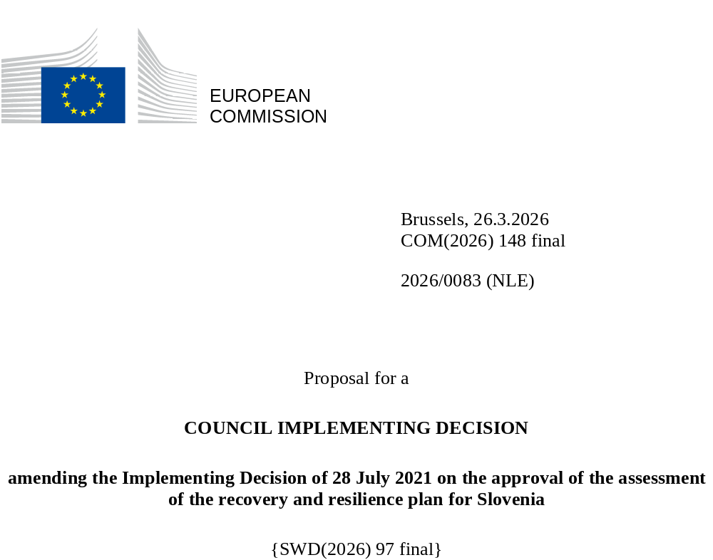

2026/0083 (NLE)
Proposal for a
COUNCIL IMPLEMENTING DECISION
amending the Implementing Decision of 28 July 2021 on the approval of the assessment of the recovery and resilience plan for Slovenia
THE COUNCIL OF THE EUROPEAN UNION,
Having regard to the Treaty on the Functioning of the European Union,
Having regard to Regulation (EU) 2021/241 of the European Parliament and of the Council of 12 February 2021 establishing the Recovery and Resilience Facility, and in particular Article 20(1) thereof,
Having regard to the proposal from the European Commission,
Whereas:
(1) Following the submission of the national recovery and resilience plan (‘RRP’) by Slovenia on 30 April 2021, the Commission proposed its positive assessment to the Council. On 28 July 2021, the Council approved the positive assessment by means of an implementing decision (‘the Council Implementing Decision of 28 July 2021’). The Council Implementing Decision of 28 July 2021 was amended by the Council Implementing Decisions of 17 October 2023, 10 December 2024, 20 June 2025 and 12 December 2025.
(2) On 13 March 2026, Slovenia made a reasoned request to the Commission to make a proposal to amend the Council Implementing Decision of 28 July 2021 in accordance with Article 21(1) of Regulation (EU) 2021/241 on the grounds that the RRP is partially no longer achievable because of objective circumstances. On that basis, Slovenia has submitted an amended RRP.
Amendments based on Article 21 of Regulation (EU) 2021/241
(3) The amendments to the RRP submitted by Slovenia because of objective circumstances concern 21 measures.
(4) Slovenia has explained that one measure is no longer partially achievable because of implementation delays due to unforeseen circumstances beyond the control of the Member State. This concerns measure C1-IFL (Strengthening the electricity distribution network (low-voltage network)). On this basis, Slovenia has requested that this measure be amended. The Council Implementing Decision of 28 July 2021 should be amended accordingly.
(5) Slovenia has explained that one measure is no longer partially achieavable because of an insufficient number of participants in the trainings. This concerns measure C3-IE (Social and economic resilience to climate-related disasters in the Republic of Slovenia). On this basis, Slovenia has requested that this measure be amended. The Council Implementing Decision of 28 July 2021 should be amended accordingly.
(6) Slovenia has explained that one measure is no longer partially achievable because of issues with the purchase of the premises beyond the control of the Member State. This concerns measure C3-IF (Reducing flood risks and and reducing the risk to other climate-related disasters). On this basis, Slovenia has requested that this measure be amended. The Council Implementing Decision of 28 July 2021 should be amended accordingly.
(7) Slovenia has explained that three measures are no longer partially achievable because of delays in the tendering process beyond the control of the Member State. This concerns measures C3-IFL (Further reducing flood risks and reducing the risk to other climate-related disasters), C4-IE (Promoting alternative fuels infrastructure in transport) and C4-ICL (Further increasing railway infrastructure capacity). On this basis, Slovenia has requested that this measure be amended. The Council Implementing Decision of 28 July 2021 should be amended accordingly.
(8) Slovenia has explained that one measures is no longer partially achievable because of cost increases. This concerns measure C12-IHL (Further greening education infrastructure in Slovenia). On this basis, Slovenia has requested that this measure be amended. The Council Implementing Decision of 28 July 2021 should be amended accordingly.
(9) Slovenia has explained that one measure is no longer partially achievable because of delays in the evaluation of the implemented pilot projects beyond the control of the Member State. This concerns measure C12-IF (Pilot projects for higher education reform for a green and resilient transition). On this basis, Slovenia has requested that this measure be amended. The Council Implementing Decision of 28 July 2021 should be amended accordingly.
(10) Slovenia has explained that one measure is no longer partially achievable because of the cancellation of a related call for proposals, leading to the reduction in the allocation and a change of the unit costs. This concerns measure C17-ID (Energy efficiency and decarbonisation of the economy). On this basis, Slovenia has requested that this measure be amended. The Council Implementing Decision of 28 July 2021 should be amended accordingly.
(11) Slovenia has explained that two measures have been amended to implement better alternatives in order to achieve their original ambition. This concerns C10-RA (Structural measures to strengthen the resilience of the labour market) and C14-ID (Accessibility of the health system). On this basis, Slovenia has requested that those measures be amended. The Council Implementing Decision of 28 July 2021 should be amended accordingly.
(12) Slovenia has explained that eight measures have been amended to implement better alternatives that allow the administrative burden to be reduced and simplify the Council Implementing Decision, while still achieving the objectives of those measures. This concerns C3-IG (Centre for seeds, nurseries and forest protection), C3-IHL (Further projects for the discharge, treatment and re-use of urban waste water), C5-IB (Integrated strategic project to decarbonise Slovenia through the transition to a circular economy), C7-IJ (Digitalisation of education and science), C12-RA (Renovating the education system for the green and digital transitions), C12-IH (Greening education infrastructure in Slovenia), C14-IB (Strengthening the competence of health personnel to ensure quality of care) and C14-IE (Effective treatment of communicable and chronic diseases). On this basis, Slovenia has requested that those measures be amended. The Council Implementing Decision of 28 July 2021 should be amended accordingly.
(13) Following the decrease in the level of implementation of measures in accordance with Article 21 of Regulation (EU) 2021/241, Slovenia has requested to use the resources freed up by the decrease in the level of their implementation to increase the level of implementation of three measures. This concerns C17-IC (Strengthening the electricity distribution network (medium-voltage network and low-voltage network) and C17-IE (Promoting alternative fuels infrastructure in transport (scaled-up)). On this basis, Slovenia has requested that the level of implementation of two measures be increased. The Council Implementing Decision of 28 July 2021 should be amended accordingly.
Distribution of milestones and targets
(14) The distribution of milestones and targets in instalments should be amended to take into account the amendments to the RRP and the indicative timeline presented by Slovenia.
Commission’s assessment
(15) The Commission has assessed the amended RRP against the assessment criteria laid down in Article 19(3) of Regulation (EU) 2021/241.
Do no significant harm
(16) In accordance with Article 19(3), point (d), of, and criterion 2.4 of Annex V to, Regulation (EU) 2021/241, the amended RRP is expected to ensure that no measure (rating A) for the implementation of reforms and investments projects included in the RRP does significant harm to environmental objectives within the meaning of Article 17 of Regulation (EU) 2020/852 of the European Parliament and of the Council (the principle of ‘do no significant harm’).
(17) The modified plan assesses compliance with the ‘do no significant harm’ principle following the methodology set out in the Commission’s technical guidance on the application of ‘do no significant harm’ under the Recovery and Resilience Facility Regulation (2021/C58/01). Changes introduced in measures through the modification of the plan do not affect the assessment carried out for the original version of the RRP. Based on the information provided, it can be concluded that no measure in the modified plan does significant harm to environmental objectives within the meaning of Article 17 of Regulation (EU) 2020/852.
Contribution to the REPowerEU objectives
(18) In accordance with Article 19(3), point (da), of, and criterion 2.12 of Annex V to, Regulation (EU) 2021/241, the REPowerEU chapter is expected to effectively contribute to a large extent (rating A) to energy security, the diversification of the Union’s energy supply, an increase in the uptake of renewables and in energy efficiency, an increase of energy storage capacities or the necessary reduction of dependence on fossil fuels before 2030.
(19) Despite Slovenia’s request to decrease the level of its implementation of one measure, the REPowerEU chapter is still coherent with Slovenia’s policy framework aimed at reducing greenhouse gas emissions and increasing the share of renewable energy sources. The measures also reinforce those included in the original RRP on promoting energy efficiency and zero-emission transport, and on increasing the share of renewables.
Contribution to the green transition including biodiversity
(20) In accordance with Article 19(3), point (e), of, and criterion 2.5 of Annex V to, Regulation (EU) 2021/241, the amended RRP contains measures that contribute to a large extent (rating A) to the green transition, including biodiversity, or to addressing the challenges resulting therefrom. The measures supporting climate objectives account for an amount which represents 44.69% of the amended RRP’s total allocation and 91.69% of the total estimated costs of measures in the REPowerEU chapter calculated in accordance with the methodology set out in Annex VI to Regulation (EU) 2021/241. In accordance with Article 17 of Regulation (EU) 2021/241, the amended RRP is consistent with the information included in the National Energy and Climate Plan 2021-2030.
(21) Despite a reduction by 0.34%, the downscaled measures do not impact the overall ambition of the RRP regarding the green transition, including biodiversity. The REPowerEU chapter continues to provide additional support to the green transition of Slovenia, since the reform of the promotion of renewable energy sources in Slovenia and all the investments contribute integrally to accelerating the uptake of renewables, thereby reducing the reliance on fossil fuels and reducing air pollution, as well as to increasing energy efficiency and energy savings. The measures in the RRP are still expected to reduce the greenhouse gas emissions, facilitate the uptake of renewable energy, further increase the railway infrastructure capacity and ensure the reduction of flood risks in Slovenia, thereby contributing to the attainment of the 2030-2050 climate targets, including to the objective of EU climate neutrality by 2050.
Contribution to the digital transition
(22) In accordance with Article 19(3), point (f), of, and criterion 2.6 of Annex V to, Regulation (EU) 2021/241, the amended RRP contains measures that contribute to a large extent (rating A) to the digital transition or to addressing the challenges resulting from it. The measures supporting digital objectives account for an amount which represents 24.46% of the amended RRP’s total allocation calculated in accordance with the methodology set out in Annex VII to that Regulation.
(23) The amendments of the measures do not impact the overall ambition of the RRP regarding the digital transition. The amended RRP continues to significantly contribute to the digital transition of the public administration and businesses, including by developing necessary infrastructure (building up connectivity, developing cloud and improving cybersecurity), by deploying advanced and user-friendly digital solutions and services, and by transforming business processes and closing the digital gap for more traditional companies.
Costing
(24) In accordance with Article 19(3), point (i), of, and criterion 2.9 of Annex V to, Regulation (EU) 2021/241, the justification provided in the amended RRP on the amount of the estimated total cost of the RRP is to a medium extent (rating B) reasonable and plausible, is in line with the principle of cost efficiency and is commensurate to the expected national economic and social impact.
(25) According to the information provided, the assessment of the cost estimates for the revised investments show that most of the costs are reasonable and plausible. The changes to the plan were not extensive enough to affect the existing rating (B) of the plan. Slovenia proposed to make allocation changes between loans and grants, reducing the overall amount of loans. Additional resources were allocated to well-performing measures while allocations were reduced in those cases where the measures faced risks. Slovenia provided sufficient explanations, which include mainly the results of tenders and calls for proposals launched for the purposes of the RRP. The changes in the cost estimates for amended measures were justified and proportional and as such the reasonability and plausibility of those cost estimates were not altered compared to the original RRP. Slovenia has provided sufficient information and evidence that the amount of the estimated total cost is not covered by other existing or planned Union financing. Finally, the amount of the estimated total cost of the RRP is in line with the principle of cost-efficiency and commensurate with the expected national economic and social impact.
Any other assessment criteria
(26) The Commission considers that the amendments put forward by Slovenia do not affect the positive assessment of the RRP set out in the Council Implementing Decision of 28 July 2021 on the approval of the assessment of the RRP for Slovenia regarding the relevance, effectiveness, efficiency and coherence of the RRP against the assessment criteria laid down in Article 19(3), points (a), (b), (c), (g), (h), (j) and (k).
Measures supporting investment operations contributing to the objectives of the Strategic Technologies for Europe Platform (STEP)
(27) In accordance with Article 4(4) of Regulation (EU) 2024/795 of the European Parliament and of the Council, Slovenia considered as a matter of priority projects that have been awarded a Sovereignty Seal pursuant to Article 4(1) of Regulation (EU) 2024/795. However, Slovenia considered that no project having been awarded a Sovereignty Seal was to be included in the amended RRP because those projects do not cover the areas that have been upscaled with this revision.
Positive assessment
(28) Following the positive assessment by the Commission of the amended RRP, with the finding that the RRP satisfactorily complies with the criteria for assessment set out in Regulation (EU) 2021/241, in accordance with Article 20(2) of and Annex V to that Regulation, the reforms and investment projects necessary for the implementation of the amended RRP, the relevant milestones, targets and indicators, and the amount made available from the Union for the implementation of the amended RRP should be set out.
Financial contribution
(29) The estimated total costs of Slovenia’s amended RRP is EUR 2 082 352 849. As the amount of the estimated total cost of the amended RRP is higher than the updated maximum financial contribution available for Slovenia, the financial contribution determined in accordance with Article 4a of Regulation (EU) 2021/1755 of the European Parliament and of the Council, and with Article 20(4) and Article 21a(6) of Regulation (EU) 2021/241 that is allocated for Slovenia’s amended RRP should be equal to EUR 1 612 948 340. Therefore, the financial contribution made available to Slovenia remains unchanged.
Loans
(30) In order to support additional reforms and investments, a total loan support of EUR 525 585 704 was made available to Slovenia by means of Council Implementing Decision of 28 July 2021. Following the decrease in the level of implementation of C1-IFL (Strengthening the electricity distribution network (low-voltage network)) and C4-ICL (Further increasing railway infrastructure capacity) under Article 21 of Regulation 2021/241, Slovenia has not requested to use the freed-up loan resources to support new measures or to increase the level of implementation of existing measures within the RRP. The amount of the estimated total costs of the RRP is lower than the combined financial contribution available for Slovenia and the loan support that had been made available to Slovenia by means of Council Implementing Decision of 28 July 2021. Therefore, the total loan support made available to Slovenia should be reduced to EUR 468 836 849.
(31) The Council Implementing Decision of 28 July 2021 should therefore be amended accordingly. For the sake of clarity, the Annex to the Council Implementing Decision of 28 July 2021 should be replaced entirely.
(32) This Decision should be without prejudice to the outcome of any procedures relating to the award of Union funds under any Union programme other than the Facility or to procedures relating to distortions of the operation of the internal market that may be undertaken, in particular under Articles 107 and 108 of the Treaty. It does not override the requirement for Member States to notify instances of potential State aid to the Commission under Article 108 of the Treaty,
HAS ADOPTED THIS DECISION:
Article 1
Approval of the assessment of the RRP
The assessment of the amended RRP for Slovenia on the basis of the criteria provided for in Article 19(3) of Regulation (EU) 2021/241 is approved.
Article 2
Amendments
The Council Implementing Decision of 28 July 2021 on the approval of the assessment of the recovery and resilience plan for Slovenia is amended as follows:
(1) in Article 3, paragraph 1 is replaced by the following:
“1. The Union shall make available to Slovenia a loan amounting to a maximum of EUR 468 836 849.”;
(2) the Annex is replaced by the text set out in the Annex to this Decision.
Article 3
Addressee
This Decision is addressed to the Republic of Slovenia.
Done at Brussels,
For the Council
The President

OJ L 57, 18.2.2021, p. 17, ELI: https://eur-lex.europa.eu/eli/reg/2021/241/oj.
See documents ST 10612/21 INIT and ST 10612/21 ADD 1 at http://register.consilium.europa.eu.
See documents ST 13615/23 INIT, ST 13615/23 REV 1 (en) and ST 13615/23 ADD 1 REV 1 at http://register.consilium.europa.eu.
See documents ST 15989/24 INIT, ST 15989/24 ADD 1 and ST 15989/24 COR 1 (ga) at http://register.consilium.europa.eu.
See documents ST 9591/25 INIT and ST 9591/25 ADD 1 at http://register.consilium.europa.eu.
See documents ST 15797/25 INIT, ST 15797/25 ADD 1 and ST 15797/25 COR 1 (lv) at http://register.consilium.europa.eu.
Regulation (EU) 2020/852 of the European Parliament and of the Council of 18 June 2020 on the establishment of a framework to facilitate sustainable investment, and amending Regulation (EU) 2019/2088 (OJ L 198, 22.6.2020, p. 13, ELI: https://eur-lex.europa.eu/eli/reg/2020/852/oj/eng).
Regulation (EU) 2024/795 of the European Parliament and of the Council of 29 February 2024 establishing the Strategic Technologies for Europe Platform (STEP), and amending Directive 2003/87/EC and Regulations (EU) 2021/1058, (EU) 2021/1056, (EU) 2021/1057, (EU) No 1303/2013, (EU) No 223/2014, (EU) 2021/1060, (EU) 2021/523, (EU) 2021/695, (EU) 2021/697 and (EU) 2021/241 (OJ L, 2024/795, 29.2.2024, ELI: http://data.europa.eu/eli/reg/2024/795/oj).
Regulation (EU) 2021/1755 of the European Parliament and of the Council of 6 October 2021 establishing the Brexit Adjustment Reserve (OJ L 357, 8.10.2021, p. 1, ELI: http://data.europa.eu/eli/reg/2021/1755/oj).

