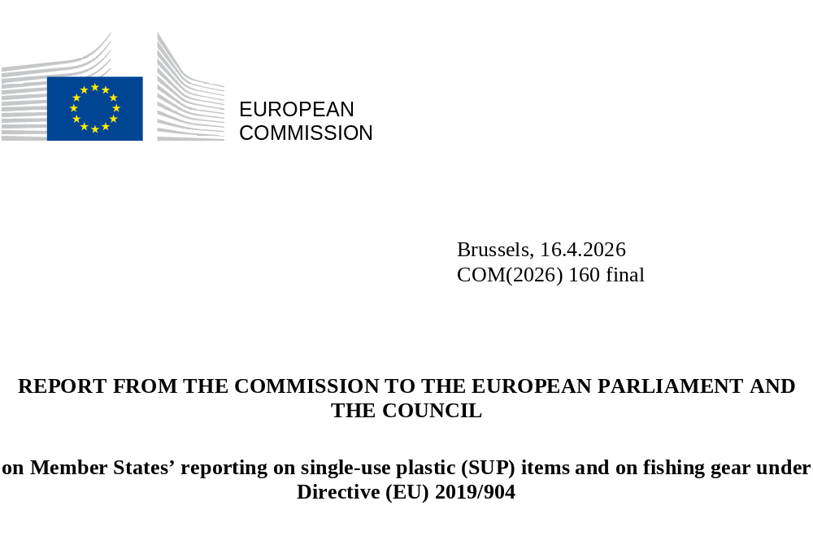

Review of the data and information reported in accordance with Article 13(3) of Directive (EU) 2019/904 of the European Parliament and of the Council of 5 June 2019 on the reduction of the impact of certain plastic products on the environment

Contents
1. Background and purpose of the report 1
2. Results of the reporting 1
Overview by item 3
Item A: Amounts placed on the market of cups for beverages and food containers 3
Item B: Consumption reduction measures for cups for beverages and food containers 7
Item C: Separate collection of SUP beverage bottles 8
Item D: Amounts placed on market and collected as waste of fishing gear containing plastic 10
3. Organisation of data collection and data quality 12
Organisation of data collection 12
Data quality 12
Data sources and methodologies 12
Completeness 13
Reliability 13
Timeliness 14
Consistency 14
4. Recommendations for improvement 15
5. Conclusions 15
6. Annexes 17
Annex 1: Consumption reduction measures by category and sub-category (item b) 17
Annex 2: Measures setting quantitative targets for SUP cups for beverages and food containers’ consumption reduction (item b) 20
Annex 3: SUP bottles separate collection rate (item c) and deposit-refund schemes in place 22
Annex 4: SUP beverage bottles placed on the market and separately collected, absolute and per capita values (item c) 23
Annex 5: Data reported broken down by material and fishing gear type (item d) 24
Annex 6: Fishing gear placed on the market and waste fishing gear collected (item d) relative to the fishing fleet tonnage by country 27
Annex 7: Institutions responsible for the SUP Directive reporting and reporting dates 28
Annex 8: Summary of the results of the survey carried out to reporting countries 29
Annex 9: Data sources and methodologies 32
Annex 10: Verification methods and accuracy issues identified 34

Background and purpose of the report
Directive 2019/904 of the European Union and the Council of 5 June 2019 on the reduction of the impact of certain plastic products on the environment (‘the Single Use Plastics (SUP) Directive’) has three aims: (i) to prevent and reduce the negative impact of certain plastic products on the environment and human health; (ii) to promote a circular economy; and (iii) to contribute to a well-functioning internal market.
Under Article 13 of the SUP Directive, Member States are required to report the information outlined in Table 1 within 18 months of the end of the respective reference year, together with a quality-check report describing, among other things, the methods used for the calculations and for data verification and control. The Commission has adopted a series of implementing decisions laying down the methodologies and formats for both the data reporting and the quality-check reports.
This report provides an assessment of the information reported for the reference year 2022, as required by Article 13(3) of the SUP Directive, the text of which is set out below.
The Commission shall review the data and information reported in accordance with this (13) Article and publish a report on the results of its review. The report shall assess the organisation of the collection of the data and information, the sources of data and information and the methodology used in Member States as well as the completeness, reliability, timeliness and consistency of that data and information. The assessment may include specific recommendations for improvement. The report shall be drawn up after the first reporting of the data and information by the Member States and thereafter at the intervals envisaged in Article 12(3c) of Directive 94/62/EC.
The report also:
- provides an overview of the reported data and information;
- assesses the quality of the data in view of the criteria listed in Article 13(3);
- offers recommendations on how to improve the reporting in subsequent years.
The analysis underpinning this report was supported by the European Environment Agency. More detailed analyses can be found in the extended report (EEA, 2025). In addition to the EU Member States (MS), this report also covers data and information submitted by European Free Trade Association (EFTA) states belonging to the European Economic Area (Iceland, Liechtenstein and Norway).

Results of the reporting
This section presents the reported data by reporting item (from item (a) to item (d) as indicated in Table 1), supplemented by additional calculations of per capita and total values. The complete set of reported data and information is available here.
The presented information should be considered with caution due to both different methodologies that were used by different countries and accuracy issues (see Chapter 3 on data quality). Therefore, comparisons across countries (e.g. of per capita values) may not be especially meaningful. Nonetheless, per capita and total values have been calculated for the countries that reported on the respective item to give a better overview of the current picture.

Table 1: Reporting obligations according to the SUP Directive.
Data and information | Referred in this report as | Legal basis for reporting | Reference year | First reporting by MS due | Target / objectives
Amounts placed on market for:  - cups for beverages  - food containers | Item (a) | SUP Directive Article 13(a): Data on single-use plastic products listed in Part A of the Annex that have been placed on the market of the Member State each year, to demonstrate the consumption reduction in accordance with Article 4(1).  Commission Implementing Decision (EU) 2022/162. | 2022 | End June-2024 | Ambitious and sustained reduction (2022-2026).  In addition, the reported data will feed into the evaluation of the SUP Directive, which will include an assessment of the possibility of introducing binding consumption-reduction targets for cups for beverages and food containers.
Measures taken to reduce consumption of:  - cups for beverages  - food containers | Item (b) | SUP Directive Article 13(b): Information on the measures taken by the Member State for the purposes of Article 4(1).  Commission Implementing Decision (EU) 2022/162. | 2022 | End June-2024
Separate collection of SUP beverage bottles | Item (c) | SUP Directive Article 13(c): Data on single-use plastic products listed in Part F of the Annex that have been separately collected in the Member State each year, to demonstrate the attainment of the targets in accordance with Article 9(1).  Commission Implementing Decision (EU) 2021/1752. | 2022 | End June-2024 | By 2025, 77%.  By 2029, 90%.  (all by weight)
Fishing gear containing plastic:  - amounts placed on market  - amounts collected as waste | Item (d) | SUP Directive Article 13(d): Data on fishing gear containing plastic placed on the market and on waste fishing gear collected in the Member State each year.  Commission Implementing Decision (EU) 2021/958. | 2022 | End June-2024 | No targets, but Member States that have marine waters are required to set their annual national collection rates for waste fishing gear containing plastic for recycling as of 1 January 2025. In addition, the data reported in 2024 (for 2022) will provide the basis for an assessment of possible further measures under the evaluation of the SUP Directive, including potentially setting binding collection rates for waste fishing gear.
Recycled content in SUP beverage bottles | Item (e) | SUP Directive Article 13(e): Information on recycled content in beverage bottles listed in Part F of the Annex to demonstrate the attainment of the targets laid down in Article 6(5).  Commission Implementing Decision (EU) 2023/2683. | 2023 | End June-2025 | By 2025, 25% for SUP beverage bottles made of PET.  By 2030, 30% for all SUP beverage bottles.
Post-consumption waste from filters for tobacco products | Item (f) | SUP Directive Article 13(f): Data on the post-consumption waste of single-use plastic products listed in Section III of Part E of the Annex that has been collected in accordance with Article 8(3).  Commission Implementing Decision (EU) 2021/2267. | 2023 | End June-2025 | -

Overview by item
29 countries reported data and information under the SUP Directive for 2022 (all EU MS and 2 EEA-EFTA countries). The main results are set out in Table 2.
Table 2: Summary results by reporting items for EU MS for 2022.
 | Placed on the market  (item (a)) | Measures to reduce consumption  (item (b))
Cups for beverages (‘CfBs’) and food containers (‘FCs’)  (items (a) and (b)) | Based on weight (data from 20 EU MS):  - 152 037 tonnes of plastics from CfBs (0.46 kg per capita)  - 524 003 tonnes from FCs (1.60 kg per capita)  Based on the number of products (data from 11 EU MS):  - 17 billion CfBs (97 per capita)  - 111 billion FCs (636 per capita) | - Economic instruments (27 EU MS)  - Awareness raising (25 EU MS)  - Promotion of sustainable alternatives (25 EU MS)  - Quantitative targets for reducing CfBs and FCs placed on the market (14 MS)
 | Placed on the market | Separate collection
Beverage bottles  (item c) | 2.54 million tonnes (5.7 kg per capita) (data from 27 EU MS) | 1.8 million tonnes, which amounts to a total separate collection rate of 71% (data from 26 EU MS; 2025-target: 77%)
Fishing gear (item d) | 22 900 tonnes (data from 23 EU MS ) | 7 500 tonnes, which amounts to a total collection rate of 32,7% (data from 20 EU MS)

Item A: Amounts placed on the market of cups for beverages (CfBs) and food containers (FCs)
Out of the 27 countries (25 EU MS and 2 EEA-EFTA countries) that reported the amounts of CfBs and FCs placed on the market, 15 reported only by weight, 6 only by number of products and 6 reported both. No country used the option to adjust these quantities for movements to and from other Member States or non-EU countries.
The values reported are highly variable across countries by product, metric (weight of plastic in items and total weight of items) and reporting modality (by weight or by number of products). For values based on weight (Figure 1(a)), a total of 526 482 tonnes (524 003 tonnes of which were from EU MS) of plastic from FCs and 152 290 tonnes (152 037 from EU MS) of CfBs were reported as placed on the market in 2022. This corresponds to per capita values of 1.60 kg of plastic from FCs and 0.46 kg from CfBs (these values also apply to the subset including only EU MS). The total weight, including non-plastic components, was 637 456 tonnes (634 744 of which were from EU MS) from FCs and 218 469 tonnes (218 092 of which were from EU MS) from CfBs. For items partly made of plastic, the average plastic content (averaged across EU and EEA/EFTA countries) was 27.8% of the total weight for CfBs and close to 30% for FCs (these values are almost the same for the subset including only EU MS). The values for FCs were highly influenced by a small number of countries reporting very high figures (see Figure 2 and Figure 3). Altogether, the amounts reported represent 7.9% of the volume of plastic packaging waste generated in the same countries.
By number of products (Figure 1(b)), 17.3 billion (17 billion of which were from EU MS) CfBs and 111.1 billion (111.06 from EU MS) FCs were reported as placed on the market in 2022. These total figures correspond to 95.9 (97 for EU MS) CfBs and 616.7 (636 for EU MS) FCs per capita. 88.5% (88.8% for EU MS) of the total number were products wholly made of plastic.
Figure 1: SUP CfBs and FCs placed on the market in the EU in 2022, total absolute values based on weight (a) and based on the number of products (b).
(a)

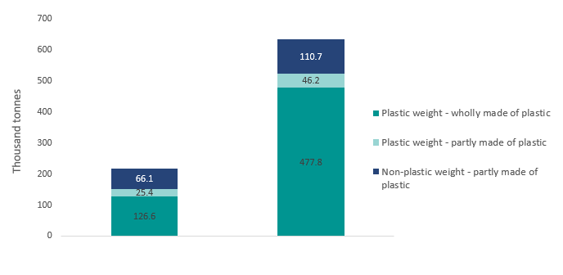
(b)

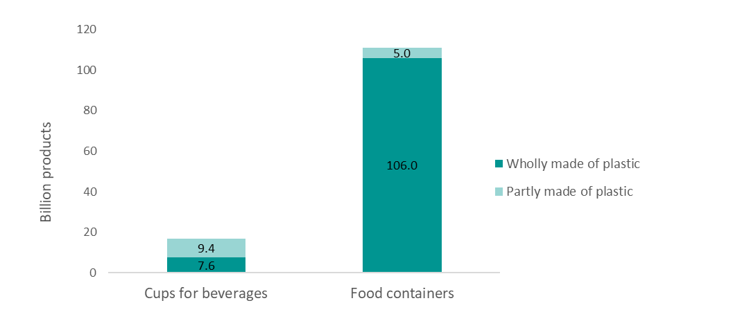
Note: Figure 1(a) is based on data from 20 EU MS. Figure 1(b) is based on data from 11 EU MS. See country breakdown in Figure 2.
Figure 2: SUP cups for beverages (CfBs) and food containers (FCs) placed on the market in 2022 (for EU MS and EEA-EFTA countries), absolute values by country based on weight (a) and per capita values (b). Countries missing in the graph did not report data based on this approach.
Figure 2(a) shows the data reported by countries and Figure 2(b) per capita values, with significant variation across countries.

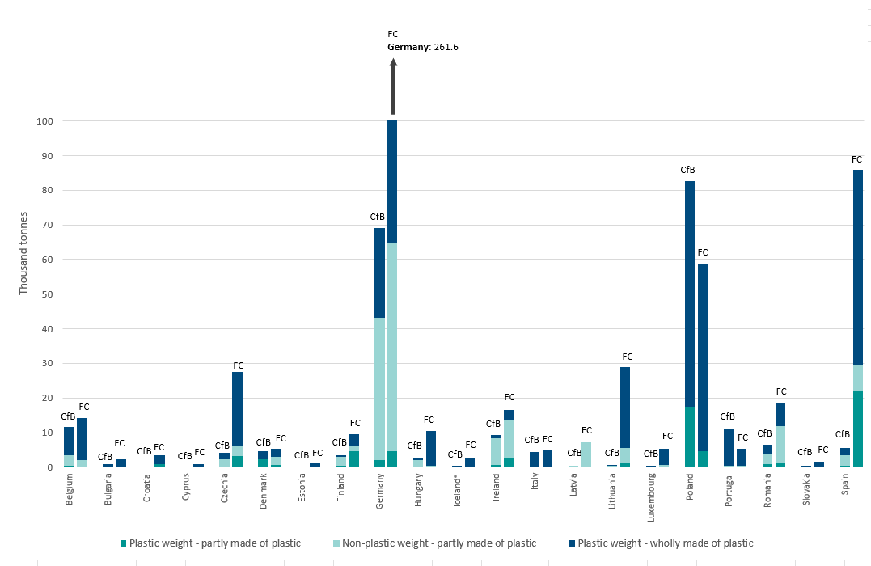
(b)

(a)

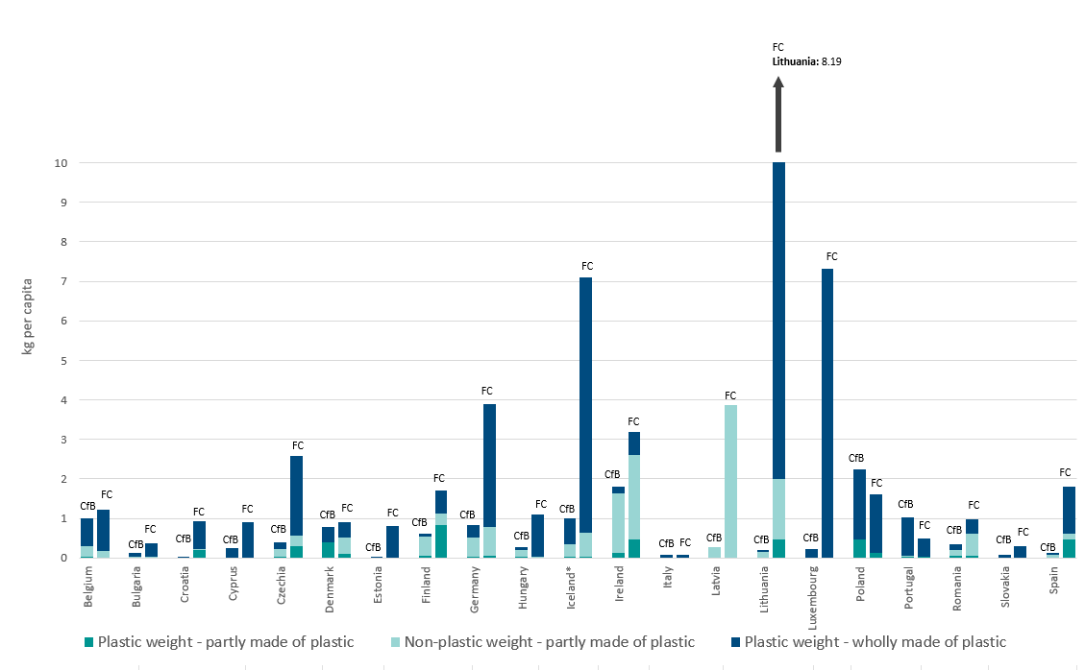
Note: * EEA-EFTA countries.
Figure 3: SUP cups for beverages (CfBs) and food containers (FCs) placed on the market in 2022 (EU MS and EEA-EFTA countries), absolute values by country based on the number of products (a) and per capita values (b). Countries missing in the graph did not report data based on this approach.
Figure 3 shows data reported based on the number of products, in absolute amounts (a) and per capita values (b).
(a)

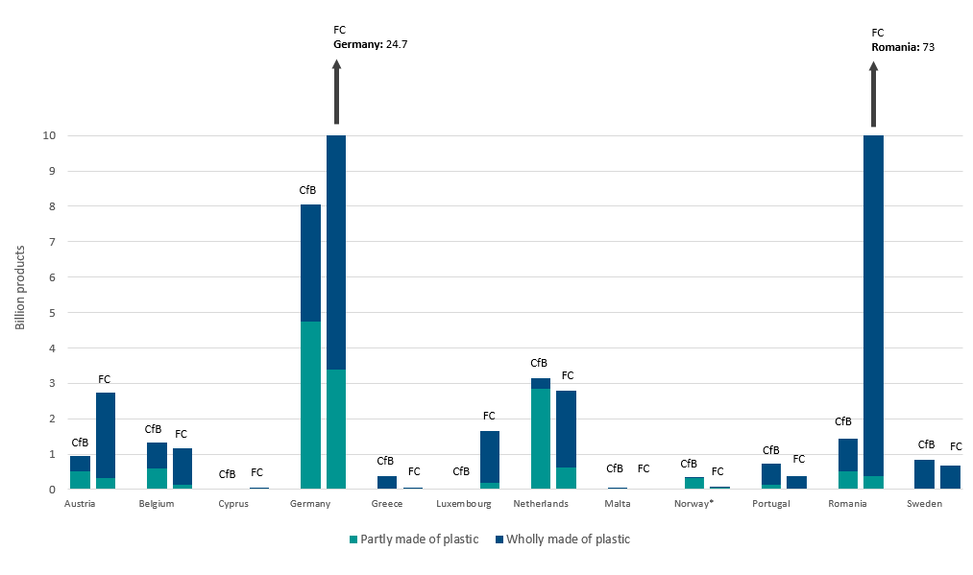
(b)

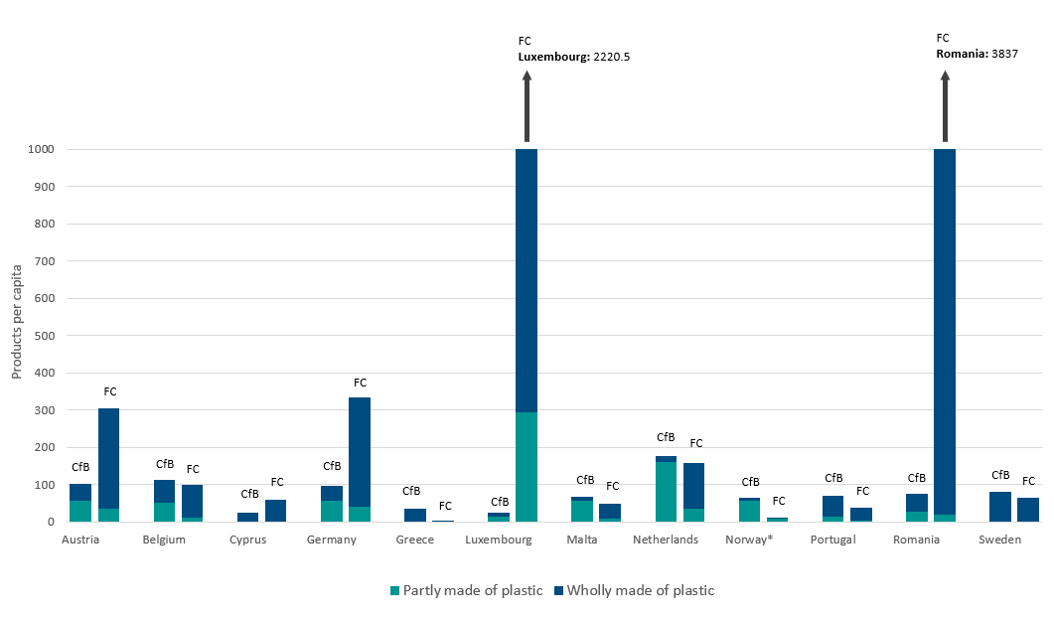
Note: * EEA-EFTA countries.

Item B: Consumption-reduction measures for cups for beverages and food containers
The reporting template provided a list of measures classified by category and sub-category, and the countries were asked to note which of these measures they applied. All countries declared to have used economic instruments, and most said that they had taken measures to raise awareness and promote sustainable alternatives (Figure 4). For most countries, the measures reported for cups for beverages and food containers were the same.
Figure 4: Number of countries with consumption-reduction measures in force for SUP CfBs and FCs in 2022 (EU MS and EEA-EFTA countries).

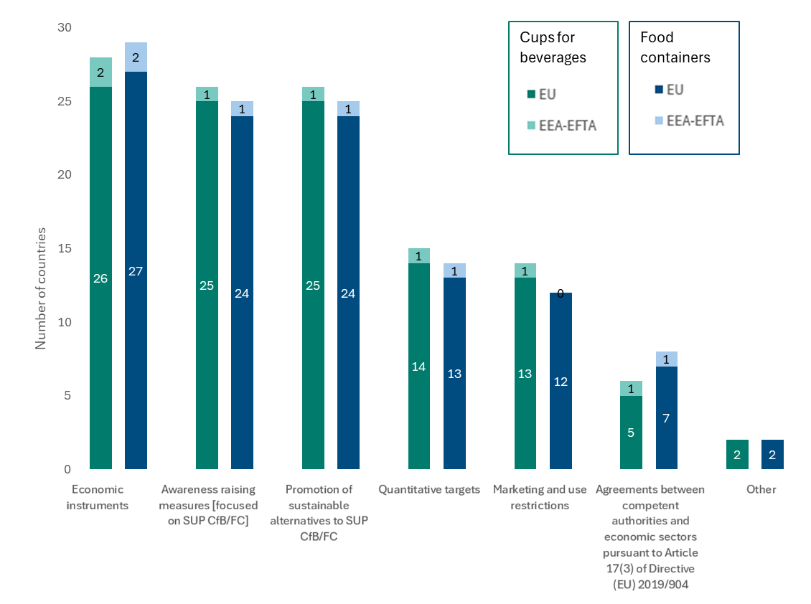
Measures are often linked to policies on packaging or to the implementation of the SUP Directive. Some reported measures will enter into force later and are not yet reflected in this report.
The sub-categories of measures that were frequently reported were: (i) extended producer responsibility obligations (20 EU MS); (ii) campaigns to raise awareness of negative environmental impacts (21 EU MS); (iii) promotion of sustainable alternatives to these SUP products (e.g. reusable food containers) (19 EU MS); (iv) obligations or incentives for businesses to provide sustainable alternatives to the SUP products at the point of sale to the final consumer (17 EU MS); and (v) the promotion of free public sources of drinking water encouraging people to bring a refillable cup or drink from the tap (14 EU MS). 14 EU MS said they had introduced quantitative targets for reducing the amount of SUP CfBs and FCs placed on the market. See Annex 1 for the full set of measures by category and sub-category and Annex 2 for details on the quantitative targets.
The total number of measures in force varied among countries (Figure 5). It is noteworthy that countries very often referred to the same policy instrument under different categories and sub-categories of measures. Some countries listed more than one policy as a reference for a specific sub-category.
Figure 5: Consumption-reduction measures in force for SUP CfBs and FCs in 2022 (EU MS and EEA-EFTA countries).
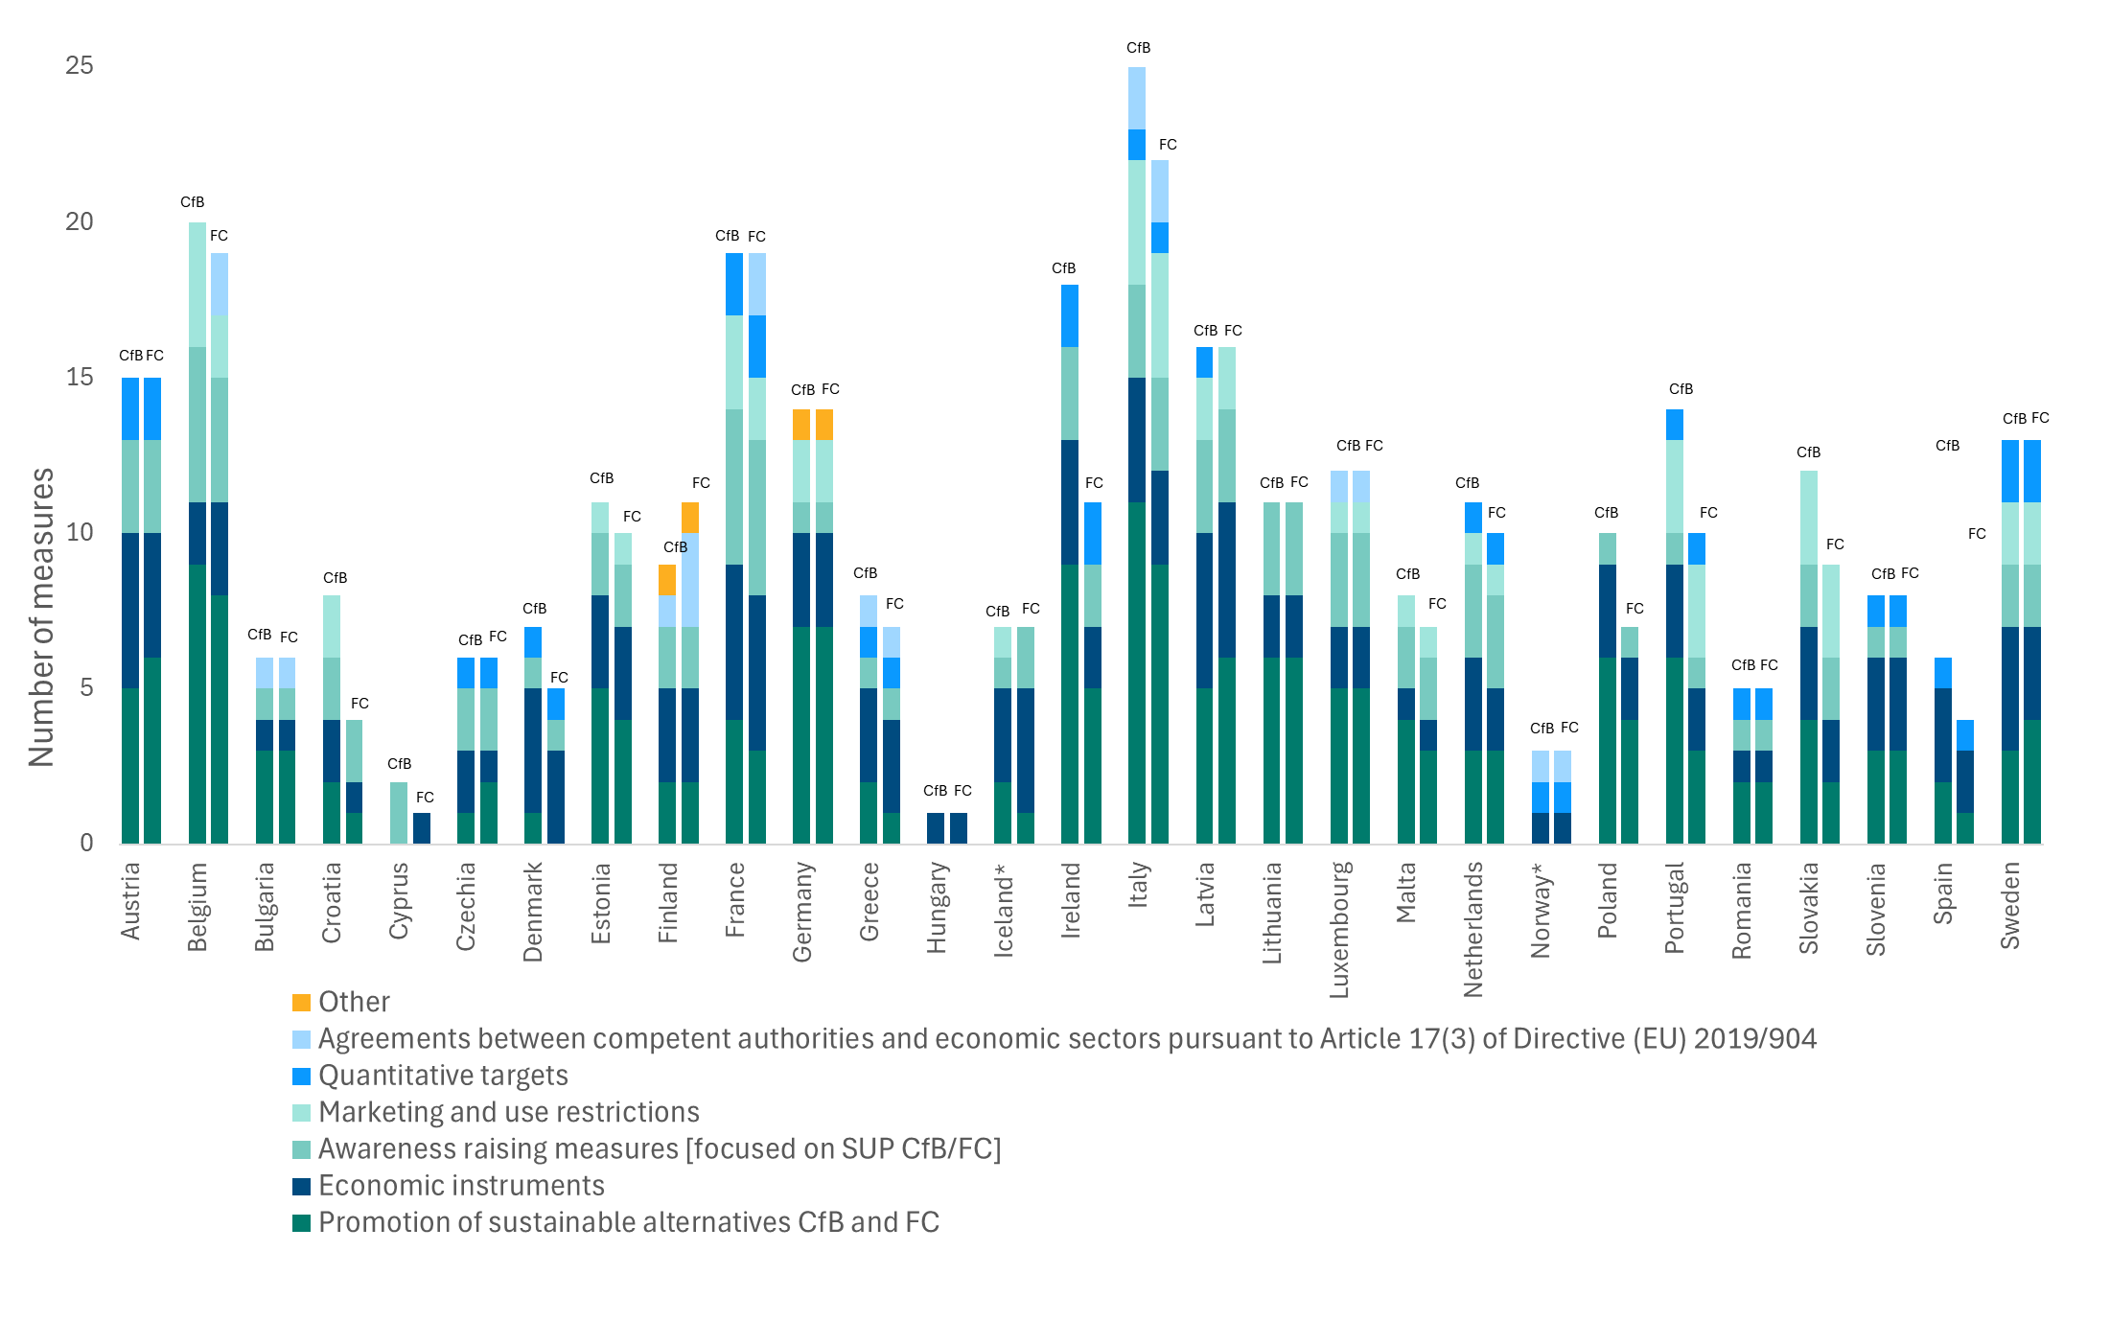
Note: * EEA-EFTA countries.
These figures do not give any indication of the degree of enforcement and level of implementation of the measures referred to. In addition, it is not possible to assess whether the reported measures are proportionate and non-discriminatory.

Item C: Separate collection of SUP beverage bottles
All 29 countries (27 EU and 2 EEA-EFTA) reported data on the weight of SUP beverage bottles placed on the market. Some countries mentioned the impact of movements of these bottles between EU countries and exports/imports from non-EU countries in the reported data, but these countries did not report separate figures for either of these phenomena. Four EU MS used the option given in Commission Implementing Decision (EU) 2021/1752 to estimate the amounts of bottles placed on the market as the weight of waste generated from this product. In this case, countries were required to report amounts based on four waste flows: (i) waste collected separately according to the requirements laid down in the SUP Directive; (ii) waste separately collected but not in accordance with the requirements of the SUP Directive; (iii) mixed municipal waste; and (iv) littered waste. Data were provided on all flows except (ii).
A total of 2.56 million tonnes (2.54 million of which were from EU MS) of SUP beverage bottles were reported as placed on the market in 2022, corresponding to 5.7 kg per capita (also applicable to the subset of EU MS). 1.83 million tonnes (1.8 million of which were from EU MS) were reported as separately collected according to the requirements laid down in the SUP Directive, which equates to a total separate collection rate of 71% for the EU MS (71.2% when also taking into account the EEA-EFTA countries) (Figure 6). 12 (10 EU MS) of the 26 reporting countries reported separate collection rates above the 2025 target of 77% set by the SUP Directive, while 6 EU MS even reported separate collection rates above the 2029 target of 90% (Figure 7).
Figure 6: SUP beverage bottles placed on the market and separately collected (EU MS), total values in 2022.

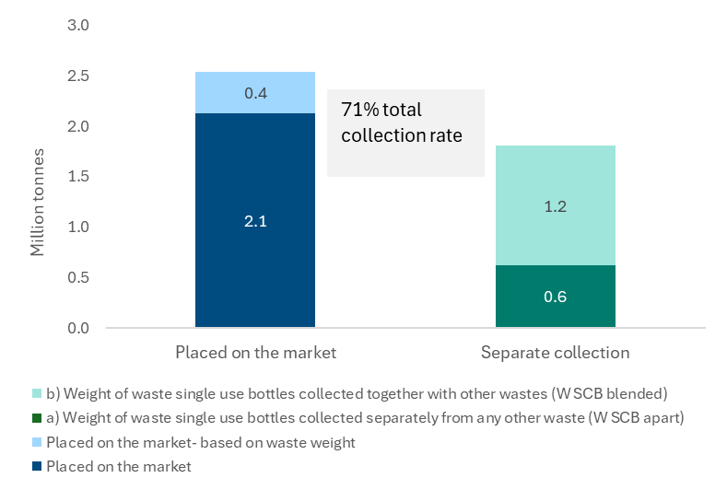
Figure 7: Separate collection rate for SUP beverage bottles by country in 2022 (EU MS and EEA-EFTA countries).
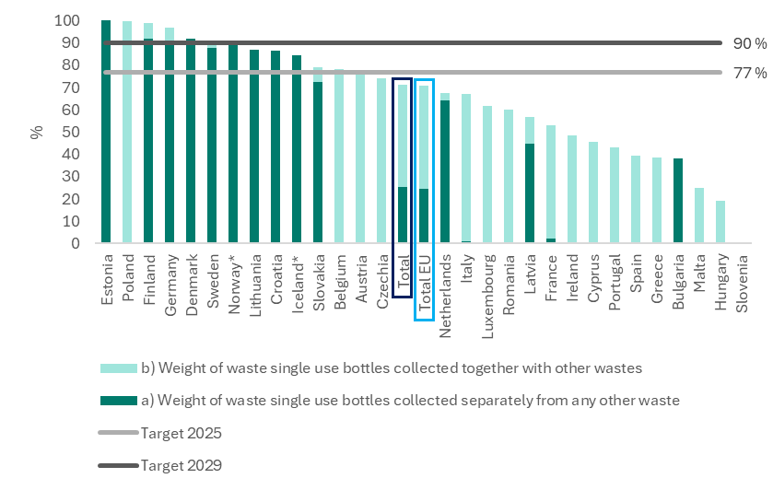
Note: Countries are ordered according to the separate collection rate. Slovenia did not report data.
Notably, 10 out of the 12 countries that already reached the 2025 target in 2022 have deposit-refund schemes (DRS) in place for SUP beverage bottles. This shows the effectiveness of DRS, which Member States will have to introduce under the new Packaging and Packaging Waste Regulation. Many countries are already setting up these types of schemes or planning to do so soon (see Annex 3 for more details).
The amounts of SUP beverage bottles placed on the market varied significantly across countries in 2022 (see absolute and per capita values in Annex 4). As expected, the countries with the largest populations reported the highest absolute amounts (Germany, Italy, France, Poland and Spain). Malta and Cyprus however, reported the highest per capita values. On separate collection, 23 (22 EU MS) countries reported separately collected SUP bottles that were collected together with other waste streams. 18 countries reported amounts on SUP bottles separately collected from any other waste stream, mostly via DRS. The remaining countries did not report values other than zero, due to either: (i) a lack of systems in place for separate collection from any other waste stream; (ii) bottle collection happening together with other dry waste streams; or (iii) some countries being unsure whether their systems are able to collect bottles fully separated from any other waste streams.

Item D: Amounts of fishing gear containing plastic placed on market and collected as waste
A total of 25 countries (23 EU MS and 2 EEA-EFTA countries) reported data on fishing gear containing plastic placed on the market, and 22 of these countries (20 EU MS and 2 EEA-EFTA countries) reported data on waste fishing gear collected. Most countries reported only the mandatory data, i.e. total amounts of fishing gear without any further breakdown. However, 6 countries (5 EU MS) provided a further data breakdown, either by type of fishing gear or by material (plastic, metal, rubber) (see Annex 5 for the broken-down data).
For 2022, a total of 67 000 tonnes (22 900 of which were from EU MS) of fishing gear were reported as placed on the market, and 24 700 tonnes (7 500 of which were from EU MS) as waste fishing gear collected. This means a total collection rate of 32.7% for EU MS (36.8% when also including the EEA-EFTA countries) (Figure 8). Collection rates ranged across countries from 0% to values above 100% (Figure 9) (the latter being generally for countries with an extensive coastline). Overall, landlocked countries declared 0% values for both amounts placed on the market and collected, even though fishing gear could possibly be placed on their market. Although the SUP Directive does not lay down quantitative binding collection targets, Member States with marine waters are required to set annual national collection rates for waste fishing gear containing plastic for recycling as of 1 January 2025. The data reported this year will provide the basis for assessing the feasibility of setting binding collection targets following the evaluation of the SUP Directive in 2027.
The amounts of fishing gear placed on the market and collected varied greatly across countries (Figure 10), with a strong correlation between: (i) amounts placed on the market and amounts collected; and (ii) those values and the tonnage of the fishing fleet in each country (see Annex 6 for data relative to the size of the fishing fleet). Country values ranged from a few tonnes to more than 42 000 tonnes placed on the market and to up to 15 000 tonnes of waste fishing gear collected. The highest amounts placed on the market were reported by Norway, Lithuania, France and Portugal. This seems to partly reflect differing situations in different countries, but it also partly reflects differences in data gathering efforts (see section ‘Data sources and methodologies’), as countries often declared difficulties reporting accurate data (see section ‘Reliability’).
Figure 8: Fishing gear placed on the market and waste fishing gear collected, total values for 2022 (EU MS and EEA-EFTA countries).
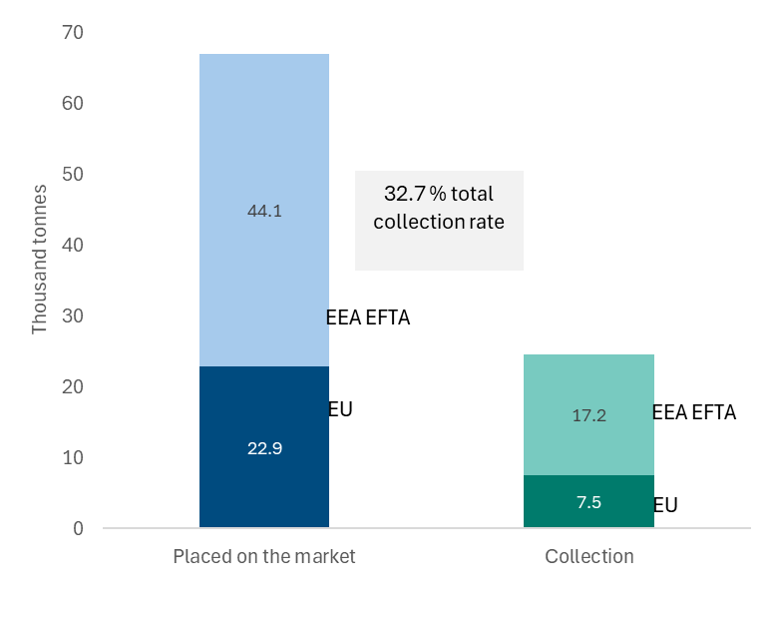
Note: Data requested to remain confidential is excluded from the figure.
Figure 9: Waste fishing gear collection rate by country, 2022 (EU MS and EEA-EFTA countries). Source: own calculation based on the reported data, as the amounts placed on the market divided by the amounts collected.
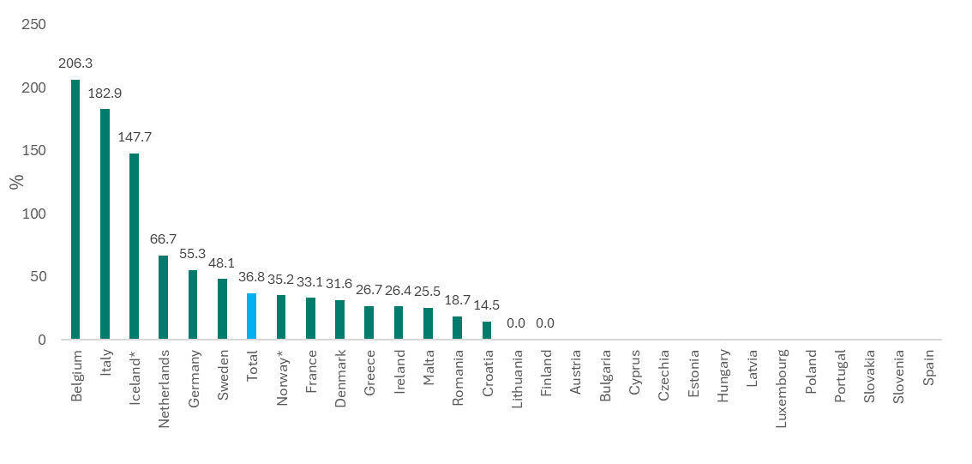
Note: Countries that reported data are ordered according to their collection rate.
Figure 10: Fishing gear placed on the market and waste fishing gear collected reported under item (d), absolute values by country, 2022 (EU MS and EEA-EFTA countries).
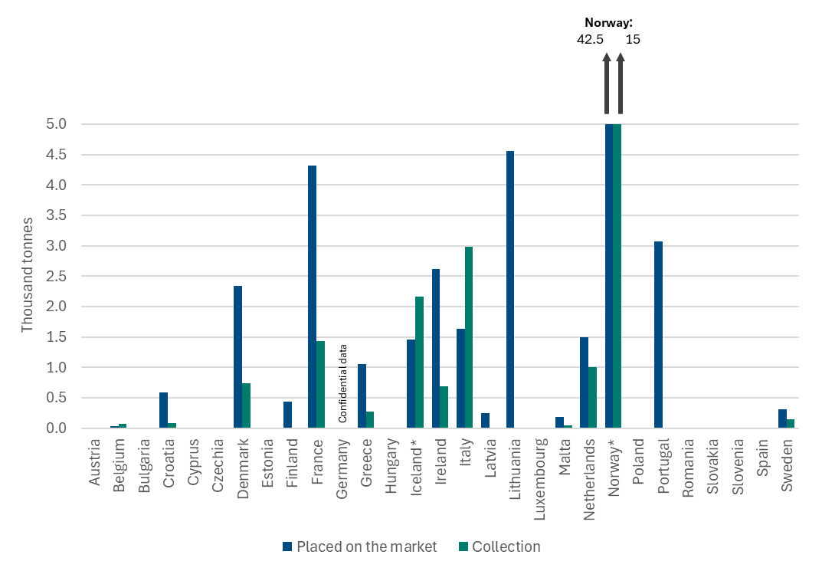

Organisation of data collection and data quality

Organisation of data collection
The nomination of lead reporters took between 1 and 8 months, with delays due to staffing shortages or institutional restructuring in some countries. The most frequent institutions involved were ministries dealing with environmental responsibilities and national environment agencies (see Annex 7 for the list of national reporters’ institutions).
As of Q1 2024, the European Environmental Agency developed and tested, on behalf of and in close collaboration with the Commission, reporting templates. The Agency also created supporting materials, including a manual for reporters, and held three webinars to clarify the process. The Agency developed a website to inform countries about the legal framework and provide access to templates supporting materials. Continuous support was provided via a helpdesk.
The European Environmental Agency thoroughly revised, on behalf of and in close collaboration with the Commission, reported data and information upon arrival and improved them together with the national reporters to ensure that elements were reported correctly, mandatory fields were filled and explanations in the quality-check report were fully understandable. After the data collection phase, countries were asked for feedback via a questionnaire. Replies showed a high level of satisfaction with the process and pointed to data challenges for 2025 reporting (see Annex 8 for details).

Data quality
Countries used different data sources and methodologies, and often highlighted accuracy issues. The quality assurance process also spotted frequent consistency issues, which were corrected as much as possible by providing streamlined guidance to reporters. Nonetheless, national reporters may have interpreted the requirements on data and information differently, for instance when choosing the most relevant measures to reduce consumption of SUPs under item (b). Because it was not mandatory to fill in important fields that were necessary to understand certain features and limitations of the data, the quality assurance process may not have identified all relevant data limitations. Therefore, the results from this first-year reporting exercise should be considered with caution. In particular, it is important to refrain from making comparisons of reported data across countries.

Data sources and methodologies
Countries based their data on a variety of sources, often more than one, and some countries reported their data sources using a different classification than the one provided by the reporting format. Many countries highlighted data quality issues and said that they expected to provide better estimates next year. In some cases, countries provided figures for years other than 2022, due to the lack of data for 2022.
For item (a), extended producer responsibility (EPR) systems and dedicated surveys were the main source (see Annex 9). Only one country (Lithuania) used data from DRS (for cups for beverages). In most cases, countries used the same data sources and methodologies for cups for beverages as for food containers, and countries often relied on waste management data. Most countries that used data from EPR systems reported based on weight. The reporting format for item (b) did not ask reporters to specify the methodology followed for the reporting of this item. The diversity of measures reported indicates rather varied methodologies across countries. For item (c) (SUP beverage bottles placed on the market and separately collected), DRS and EPR systems and waste statistics were the most frequently cited data sources (see Annex 9).
For item (d) (fishing gear placed on the market and waste fishing gear collected), the most frequently used sources, and the sources used by the countries reporting the highest amounts, were surveys of gear producers and port operators as well as trade statistics (see Annex 9). Four countries said that they used data from EPR schemes. No country said that they had used conversion factors to derive the data.

Completeness
A total of 29 countries reported the data and information to fulfil their 2024 reporting obligations - all EU MS and 2 EEA-EFTA countries (Iceland and Norway). All of these countries reported data for items (b) and (c), while 27 countries reported data for item (a) and 25 reported data for item (d). Most countries reported only the mandatory data. Overall, no data were provided by any country that would make it possible to assess the impact of movements, trade, free riders, online sales or de minimis rules. For item (b), mandatory data were very limited, which made it difficult to identify and understand the measures in force. For the reporting of item (a), some mandatory data fields were missing in the country reports, often due to either: (i) limited data on items partly made of plastic; or (ii) statistics that did not distinguish between items wholly made of plastic and items partly made of plastic. For item (c), zero or no values were reported for waste which was separately collected in a way that was not in accordance with the SUP Directive requirements. For item (d): (i) not all countries reported the amounts of waste fishing gear collected, and these amounts are needed to calculate the collection rate; and (ii) only a few countries provided voluntary data broken down by material and fishing gear type.
Countries often said that they expected to improve the completeness of reporting in the following years, especially thanks to EPR systems that are due to be set up starting on 1 January 2025.

Reliability
Countries often referred to data limitations and accuracy issues. Data verification methods were used only by a limited number of countries (17 for item (a), 22 for item (b) and 9 for item (d)), with the most frequently used methods being data completeness checks and cross-checks. Several accuracy issues were identified (see Annex 10), especially for the data on CfBs and FCs, with sampling and coverage the issues declared most frequently. Data limitations and accuracy issues warrant caution in the interpretation of the data.
Comparing the reported data across countries also helps when assessing the reliability of data. For instance, per capita values showed great variety, which suggests either: (i) possible underreporting (for example due to limited data-gathering efforts); or (ii) overreporting by some countries (for example, data covering a broader scope than the SUP Directive intends to monitor). Data reported on fishing gear also showed extremely different values across countries, many of which declared significant data limitations for this first year of reporting.
Although the scope of reporting and plastic-packaging statistics reported under the SUP Directive partly differ, comparing the reported values with the statistics on plastic packaging waste (for items (a) and (c)) can make it possible to assess the reliability of the figures.
Differences between the two data sets may point to potential accuracy issues. For example, while the total plastic weight of CfBs and FCs reported under item (a) represents on average close to 8% of the volume of plastic packaging waste generated in the same set of countries, country values ranged between 2% and 23%. Similarly, the total amounts of SUP bottles placed on the market represent 19% of the volume of plastic packaging waste generated on average across all countries (with values for each country typically closer to values for that country’s plastic packaging placed on the market), but values for this metric still vary from 0% to 69%.
For item (b), the information reported should be considered as a first attempt for an overview of which type of measures are being put in place by countries, since the approach across countries was rather varied, with limited information that would make it possible to assess the measures reported.
The accuracy issues declared for item (d), where generally only big players/ports were targeted, point to the potential underestimation of the actual values.

Timeliness
The reporting deadline was 30 June 2024, with 18 countries reporting by this deadline (16 EU and 2 EEA-EFTA countries) (Annex 7). Three more countries reported with a small delay (less than a month), and the remaining reports arrived later, with the last country submitting its files in late November 2024. One country did not fully conclude the quality assurance process.
Due to reporting delays in some countries, different steps of the process had to be run in parallel for different subsets of countries. Many countries said that the process of gathering data for specific items, such as fishing gear, delayed their reporting.

Consistency
Several consistency issues appeared during the reporting process, for instance: (i) different interpretations of the content to be reported; (ii) values reported as zero that were in fact missing values; or (iii) the use of units other than those indicated in the reporting templates. These issues were corrected as much as possible during the quality assurance process. However, the resulting reports still present some degree of variation.
Consistency over time will be assessed for next year’s reporting. It is expected that data quality will improve, based on the experience gained this year.

Recommendations for improvement
Reporters greatly appreciated the support offered during the reporting process by the European Environmental Agency in close collaboration with the Commission (see Annex 8). Nevertheless, a few aspects could be improved for future reporting, five of which are set out in the bullet points below.
- Nomination of lead reporters. Countries should ensure process continuity, keep the Commission informed of changes in reporting teams, and ensure timely reporting, given the significant delays this year.
- Data gathering by countries. Generally, countries reported only the mandatory data. Aspects such as movements, trade flows, free riders, etc. were not reported, despite their relevance in some countries. The description of the measures taken by countries to reduce consumption (item (b)) was also rather poor overall, making a proper assessment impossible. Moreover, results from the survey carried out at the end of the reporting period this year (see Annex 8) show that: (i) most countries do not expect data from the EPR systems set up under the SUP Directive to be available for the 2025 reporting (reference year 2023); and (ii) only a few countries have already identified data sources for the two additional reporting obligations for 2025 (i.e. items (e) and (f) in Table 1). Improving the reporting of the mandatory and voluntary data, for all items due in 2025 is therefore encouraged. Exchanges between countries on best practices and closer collaboration within countries among colleagues working on industry and waste statistics are recommended.
- Filling in the reporting templates. Taking full advantage of the support provided to reporters by the Commission is fully encouraged in order to both: (i) increase the consistency and clarity of the data and information reported; and (ii) reduce the burden on the quality assurance process. Particular attention should be paid to both fields that presented more challenges during the first-year reporting and the new reporting obligations on items (e) and (f).
- Streamlining the reporting format. Given the Commission’s aim of reducing reporting burden, the templates of the quality-check reports could be simplified. Using the same structure to report data sources/methodologies, verification methods and accuracy issues would increase consistency across different data flows and countries.
- Comparison over time. The data sources and methodologies used to report some of the data covered this year are expected to change in the future. It will be important for countries to report the changes in data sources and methodologies in a fully transparent manner, and explain the differences in detail, distinguishing between the potential impact of measures in force and changes in the underlying data sources and methodologies.

Conclusions
This first reporting for the reference year of 2022 provides initial insights into consumption levels and separate collection rates across countries of the three SUP items covered (CfBs, FCs and beverage bottles) and of fishing gear containing plastic.
According to the SUP Directive, this first round of reporting is meant to set a baseline to measure the consumption of SUP CfBs and FCs, with a view to the possible introduction of binding consumption-reduction targets at EU level. This first round of reporting is also meant to provide a basis for assessing possible additional measures for fishing gear containing plastic following the evaluation of the SUP Directive (in 2027), including potentially setting binding collection rates for waste fishing gear. The assessment of the data and information provided in this report shows some key elements that should be factored in when considering these baseline data, such as considerable variability in the methodologies across countries and frequent accuracy issues.
Next year’s data will provide the first data points that will make it possible to monitor trends. This will make it easier to understand whether consumption reduction is taking place with a high level of ambition for CfBs and FCs, as specified by the SUP Directive. It will also make it possible to monitor which consumption-reduction measures are still in force, and any new measures, especially those related to the SUP Directive. More dedicated analysis will be needed to understand the linkage between the trends in observed consumption and the measures put in place, as these trends cannot be assessed based solely on the information provided by reporters under the current reporting formats.
On the separate collection of SUP beverage bottles, results show that many countries are well placed to reach the 2025 target. Next year’s data will make it possible to further monitor countries’ progress. Data will also make it possible to: (i) assess the trends for the collection of waste fishing gear; and (ii) better understand the actual strengths and challenges of the data coming from the newly set up EPR systems.
Finally, the information gained from this first reporting and reporting in the coming years will provide relevant information for the evaluation of the SUP Directive (due in July 2027).

Annexes

Annex 1: Consumption-reduction measures by category and sub-category (item (b))
Economic measures in force included the following.
- EPR obligations (21 countries), mostly related to the implementation of the mandatory provisions of the SUP Directive.
- Green public procurement (GPP) (14 countries), linked to mandatory systems, voluntary systems and wider national GPP policies. In the country reports, it was not always fully clear what the specific GPP provisions were for SUP CfBs and FCs.
- Instruments to ensure discounts for consumers using reusable alternatives (12 instruments for CfBs and 7 instruments for FCs). These measures were often voluntary, and in some cases applied at sub-national level.
- Levies on businesses placing this type of item in the market (11 countries), which were generally mandatory and applied at national level.
- Subsidies/reduced levies for operators with reusable alternatives (5 countries had these for CfBs and 6 countries had these for FCs).
The most frequent measures for awareness raising were:
- campaigns to raise awareness of the negative environmental impacts of SUP CfBs/FCs (21 and 20 countries, respectively);
- Promotion of sustainable alternatives to SUP FCs (e.g. reusable food containers) (20 countries had these in place for cups and 18 countries had these in place for food containers).
The most frequent measures for the promotion of sustainable alternatives were:
- the promotion of free public sources of drinking water encouraging people to bring a refillable cup or drink from the tap (16 countries);
- measures promoting reusable alternatives to SUP CfBs/FCs in public administrations (16 countries had these in place for CfBs and 15 countries had these in place for FCs);
- the promotion of business models that provide reusable alternatives to SUP CfBs/FCs (14 countries had these in place for CfBs and 13 countries had these in place for FCs);
- measures laying down obligations or incentives for businesses to: (i) provide sustainable alternative CfBs/FCs at the point of sale to the final consumer (17 countries had these in place for CfBs and 16 countries had these in place for FCs); or (ii) make reusable alternatives to SUP CfBs/FCs available to consumers at large public events (13 countries).
Other types of measures that stood out were:
- quantitative targets for reducing the share of SUP CfBs placed on the market and made available to consumers (15 countries had these in place for cups and 14 countries had these in place for food containers, see Box 1 for an overview);
- restrictions on the use of SUP when serving drinks or providing food to consumers (10 countries had these in place for CfBs and 9 countries had these in place for FCs).
Other measures reported, which did not fully fit into any of the given categories included:
- government financial support for technology improvement and capacity building for alternatives to SUP products subject to marketing restrictions;
- strategic planning and guidance documents;
- the setting up of round tables.
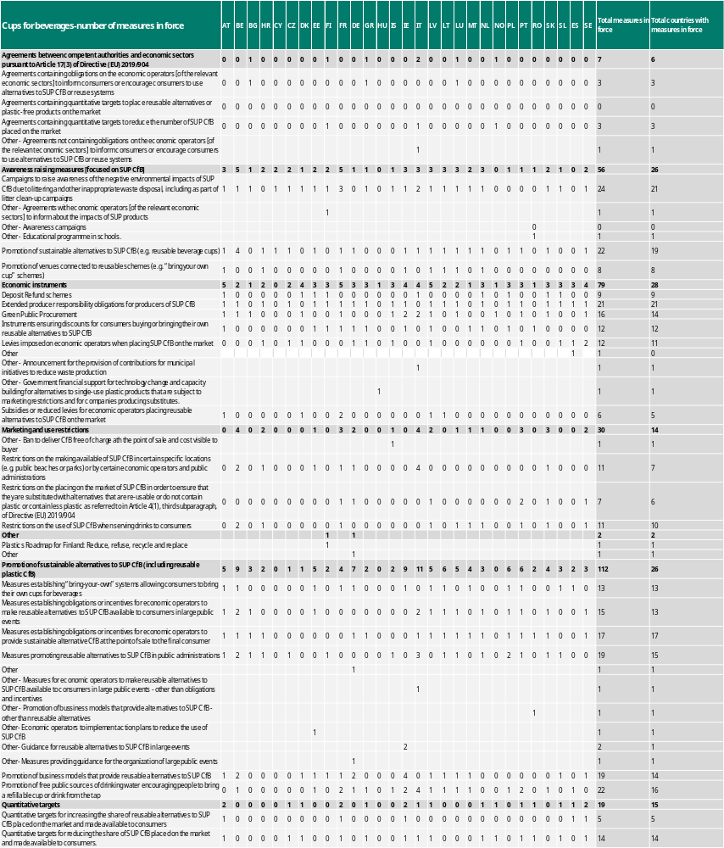
See the tables below for a full overview of measures in force by category and sub-category:
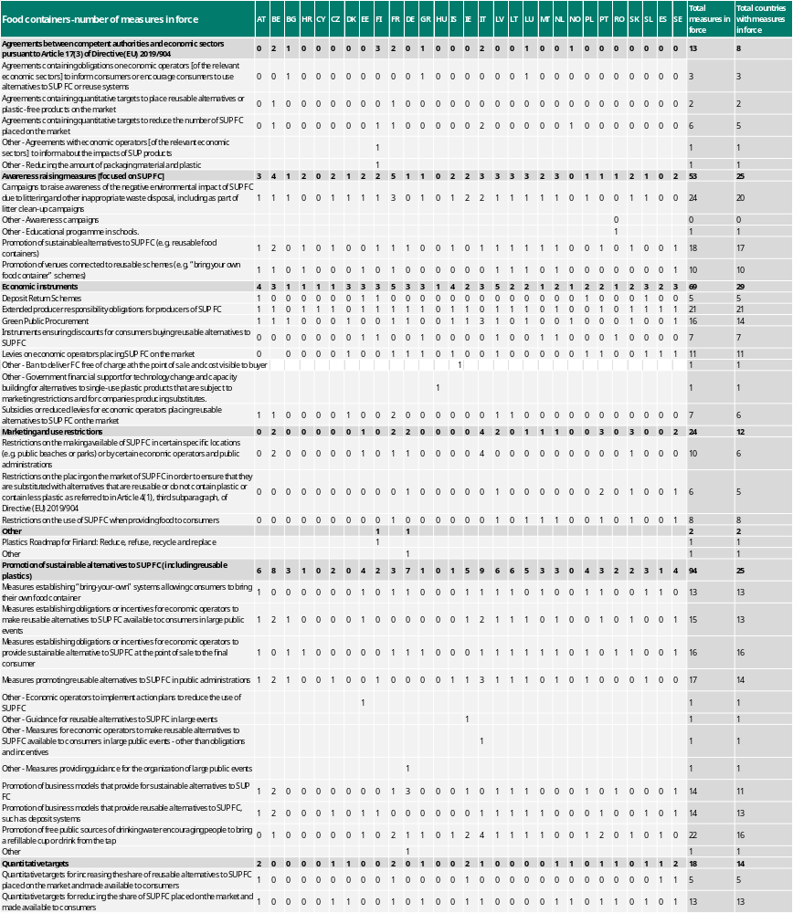

Annex 2: Measures setting quantitative targets to reduce the consumption of SUP CfBs and FCs (item (b))
The SUP Directive does not include quantitative targets for the reduction of consumption of SUP CfBs and FCs, but it calls on countries to make an ‘ambitious and sustained reduction’ of consumption of these categories between 2022 and 2026.
According to the data reported this year, 15 countries have already set quantitative targets for reducing SUP CfBs placed on the market and 14 countries have already set quantitative targets for reducing FCs placed on the market (Latvia’s targets only cover CfBs). The following table gives an overview of the quantitative targets and policy references indicated by countries in the reporting files, which is in some cases incomplete. This is because the fields to describe measures (e.g. description of the measure, URL of the policy reference, year of entry into force, geographical level, etc.) were voluntary according to the reporting format and therefore not filled in by all countries.
Country | Target | Reference/URL
Austria | 20% reduction for SUP packaging placed on the market in 2025-2018 | https://www.ris.bka.gv.at/GeltendeFassung.wxe?Abfrage=Bundesnormen&Gesetzesnummer=20002086.
Czechia | Lower numbers in 2026 | National waste management plan
Denmark | 50% reduction by 2026 | https://mim.dk/media/ouwjnpp5/aftaletekst-ofoelgning-paa-aftale-om-klimaplan-for-en-groen-affaldssektor.pdf.
France | 15% reduction as of 1 January 2022 and 8% reduction as of 1 January 2024. | https://www.legifrance.gouv.fr/jorf/id/JORFTEXT000044205692.
Greece | 30% reduction in 2024-2022 and 60% in 2026-2022 | Law 4736/2020
Ireland | - | Circular economy strategy, as required under the Circular Economy Act, the circular economy strategy must include reuse targets for various sectors including packaging. Strategy is being updated.
Italy | - | Aggiornamento 2021-2026 del Piano regionale di Gestione dei Rifiuti e delle Bonifiche 2015
Latvia | - | Law on the Reduction of Consumption of Products Containing Plastic, https://likumi.lv/ta/en/en/id/323733-law-on-the-reduction-of-consumption-of-products-containing-plastic.
Netherlands | At least 40% reduction in 2026-2022. | https://open.overheid.nl/documenten/ronl-9b1cda6564e27b4ef7267c9a13aff00e46cba6e1/pdf.
Norway | 50% reduction by 2026. | National target for consumption reduction of CfBs and FCs. See point 4 in this agreement: https://www.regjeringen.no/contentassets/e83f4f1084b740c48bcbe79d8c6de05a/2024-04-02-signert-plastpartnerskap-med-vedlegg.pdf.
Portugal | 80% reduction in 2026-2022;  90% reduction in 2030-2022 | National objectives to reduce the consumption of single-use products: cups for beverages and food containers for immediate consumption, https://diariodarepublica.pt/dr/detalhe/decreto-lei/78-2021-171871496  Article 5 of Decree-Law no.78/2021 (as currently worded)
Romania | 5% reduction for 2023, 10% for 2024, 15% for 2025 and 20% for 2026, compared with the 2022 baseline | Government Ordinance No. 6/2021 on reducing the impact of certain plastic products on the environment: https://www.mmediu.ro/articol/ordonanta-6-2021-privind-reducerea-impactului-anumitor-produse-din-plastic-asupra-mediului-directiva-904-2019-a-parlamentului-european-si-a-consiliului-privind-reducerea-impactului-anumitor-produse-din-plastic-asupra-mediului/3122; https://www.afm.ro/legislatie_declaratii_produse_plastic_unica_folosinta.php.
Slovenia | 20% reduction in 2026-2022 | Decree on the reduction of the impact of certain plastic products on the environment (Of.J. 132/22 and 49/24, Article 4, paragraph 1).
Spain | 50% reduction by weight in 2026-2022  70% reduction by weight in 2022-2030 | Article 5 https://www.boe.es/eli/es/l/2022/04/08/7/con.
Sweden | 50% reduction in 2026-2022 | -

The reporting next year will shed light on both: (i) the progress that countries are making in moving towards these quantitative targets; and (ii) the overarching objective of the SUP Directive of reducing consumption significantly and sustainably. Some challenges can be already anticipated. For instance: (i) the fact that some countries with targets for recent years did not report data on the amounts placed on the market (France and Slovenia); (ii) the fact that some countries with a declared high level of ambition did not declare having especially ambitious measures in place (Denmark, the Netherlands, Norway and Portugal); or (iii) the fact that some countries considered as a reference year a different year than the one considered by the SUP Directive (2022) (Austria, France).

Annex 3: Separate collection rate for SUP bottles (item (c)) and deposit-refund schemes in place
Country | SUP beverage bottles separate collection | Use of DRS data as source for separate collection of SUP beverage bottles  (as indicated in quality-check report on SUP Directive reporting) | Existence of DRS for plastic beverage bottles  (EEA, 2025 and EEA, 2024)
Estonia | 100.66 | DRS | DRS in place
Poland | 100.00 | No | DRS in 2025
Finland | 98.83 | DRS | DRS in place
Germany | 97.11 | DRS | DRS in place
Denmark | 91.94 | Not specified | DRS in place
Sweden | 90.33 | DRS | DRS in place
Norway* | 89.74 | DRS | DRS in place
Lithuania | 86.94 | Not specified | DRS in place
Croatia | 86.62 | Not specified | DRS in place
Iceland* | 84.31 | DRS | DRS in place
Slovakia | 78.98 | DRS | DRS in place
Belgium | 78.21 | No (EPR) | No
Austria | 75.98 | Not specified | DRS to be established in 2025
Czechia | 74.20 | No (EPR) | DRS to be established in 2026
Netherlands | 67.73 | DRS | DRS in place
Italy | 67.03 | No (EPR) | No
Luxembourg | 61.63 | Not specified | No
Romania | 60.07 | No data | No
Latvia | 56.84 | No (EPR) | DRS expanded in 2023
France | 53.28 | No (EPR) | DRS under discussion
Ireland | 48.66 | No DRS | DRS established in 2024
Cyprus | 45.62 | No (EPR) | DRS being set up
Portugal | 43.12 | Not specified | DRS established in 2024
Spain | 39.52 | No | No
Greece | 38.68 | No | DRS planned but postponed to 2025
Bulgaria | 38.21 | Not specified | No
Malta | 24.96 | No | DRS planned
Hungary | 19.17 | No | DRS started 2024
Slovenia | - | Not specified | No

Notes: DPR = deposit-refund scheme. Countries are ordered according to their separate collection values for SUP bottles, based on the data reported. Countries meeting the 2025 separate collection target are highlighted in bold.
Source: Own elaboration based on the values reported and EEA (2025) and ‘Country profiles on waste management’ for EU countries and EEA (2024) for EEA-EFTA countries.

Annex 4: SUP beverage bottles placed on the market and separately collected, absolute and per capita values (item (c))
Figure 11: SUP beverage bottles placed on the market and separately collected, absolute values by country.
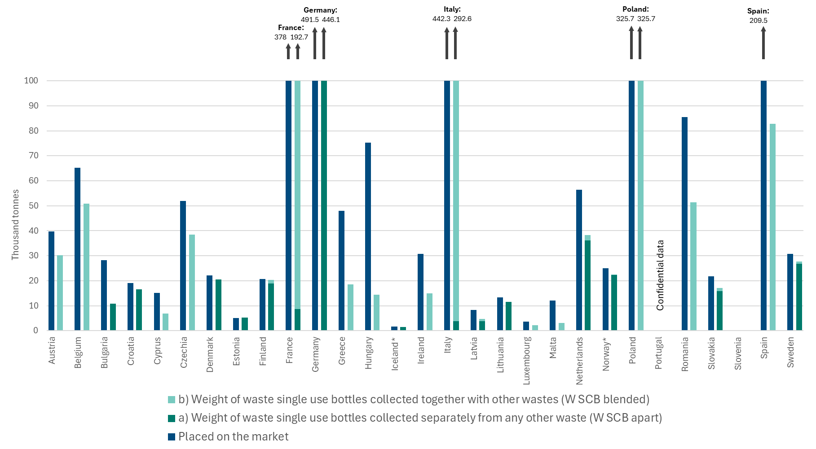

Figure 12: SUP beverage bottles placed on the market and separately collected, per capita values by country.
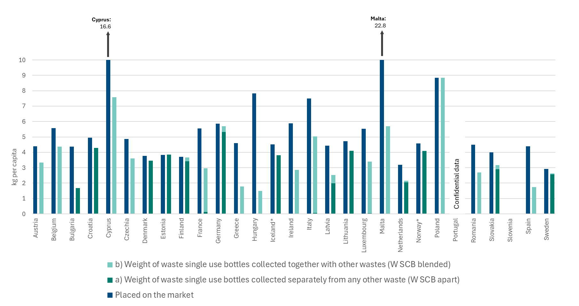
Note: Country per capita values have been calculated as the amounts reported divided by the country population (average country population for year 2022, Eurostat (2024a)).

Annex 5: Data reported broken down by material and type of fishing gear (item (d))
The reporting format laid down by Commission Implementing Decision (EU) 2021/958 gives countries the possibility of reporting data broken down by material and by type of fishing gear. There was 1 country (France) that provided a full breakdown of the data, and 5 other countries provided some partial breakdown of the data, especially for the amounts placed on the market and for the plastic content. The reported values are presented in the tables below.
Fishing gear placed on the market
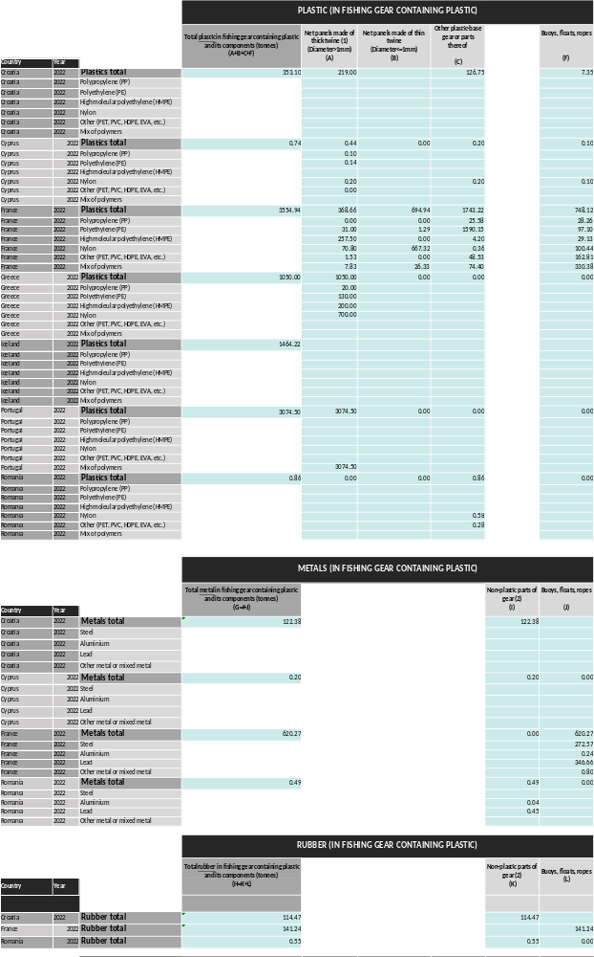
Waste fishing gear collected
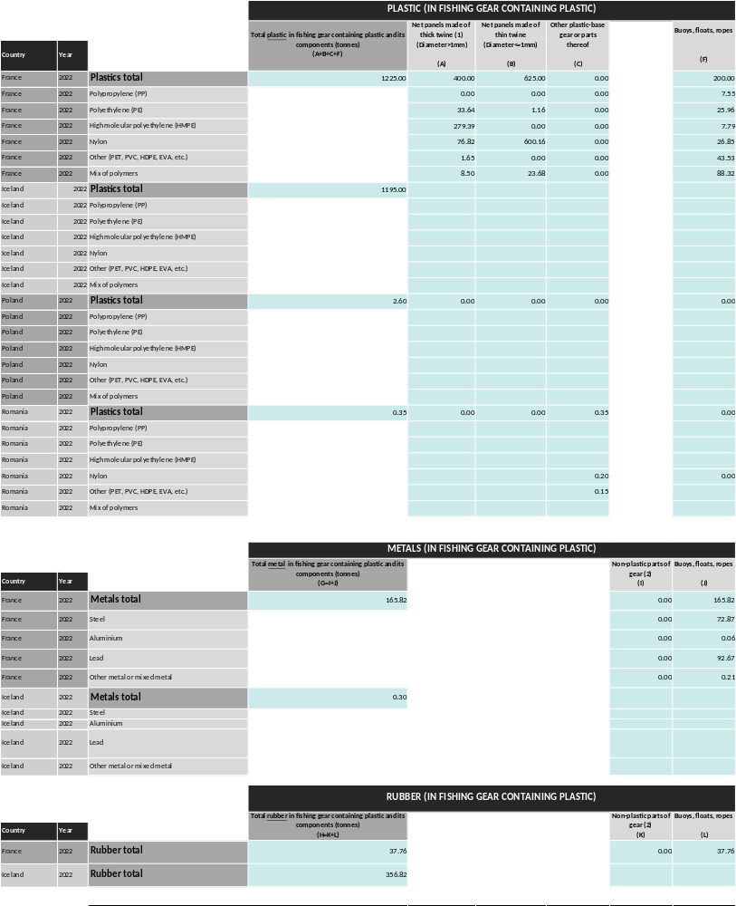

Annex 6: Fishing gear placed on the market and waste fishing gear collected (item (d)) relative to fishing fleet tonnage by country
Figure 13: Fishing gear placed on the market and waste fishing gear collected reported under item (d), values relative to fishing fleet tonnage by country.
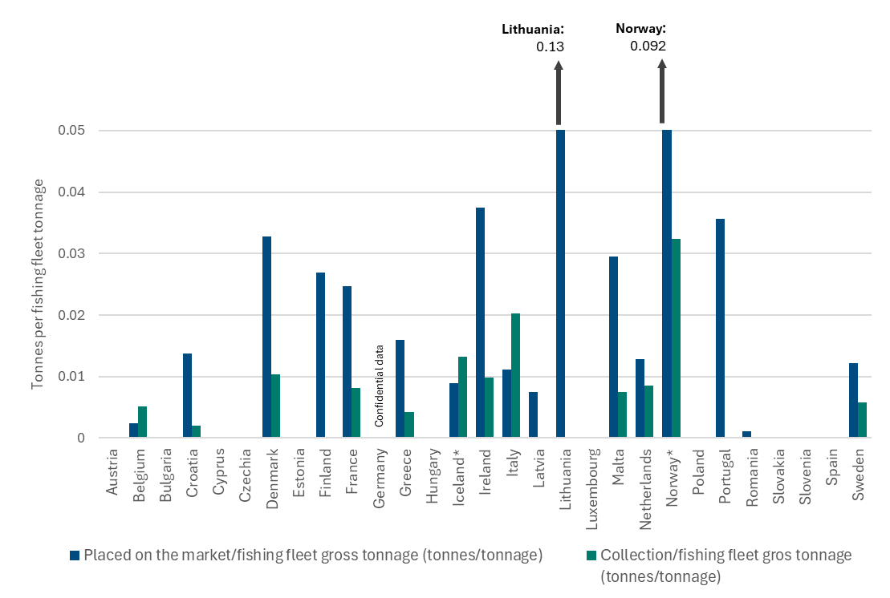
Note: Data displayed are the ratio between the amounts placed on the market or collected in each country on one hand, and the tonnage of each country’s fishing fleet in 2022 on the other hand, i.e. the total size of their fishing fleet, taken from Eurostat (2024b).

Annex 7: Institutions responsible for SUP Directive reporting and reporting dates
Country | Institution responsible | Reporting date
Austria | Federal Ministry for Climate Action | 15/07/2024
Belgium | Federal Public Service (FPS) Health, Food Chain Safety and Environment (Environment - Product policy)  OVAM (public Flemish waste company (Flanders region)) - support | 03/07/2024
Bulgaria | Ministry of Environment and Water of Bulgaria | 28/08/2024 (quality assurance process not concluded)
Croatia | Ministry of Economy and Sustainable Development, Institute for Environment and Nature | 25/06/2024
Cyprus | Ministry of Agriculture, Rural Development & the Environment, Department of Environment | 30/09/2024
Czechia | Ministry of Environment | 11/09/2024
Denmark | Environmental Protection Agency | 28/06/2024
Estonia | Environment Agency | 28/06/2024
Finland | Centre for Economic Development, Transport and the Environment for Pirkanmaa | 27/06/2024
France | Ministry of Ecological Transition and Territorial Cohesion | 28/06/2024
Germany | Environment Agency (Umweltbundesamt, UBA)  Federal Statistical Office of Germany (Statistisches Bundesamt, Destatis) - support | 28/06/2024
Greece | Ministry of Environment and Energy, General Secretariat of Waste Management Coordination, Directorate of Waste Management Department of Waste Registry, Licensing and Statistics  Hellenic Recycling Agency - support | 01/10/2024
Hungary | Ministry of Energy | 28/06/2024
Iceland* | Icelandic Recycling Fund  Environment Agency - support | 28/06/2024
Ireland | Environmental Protection Agency | 28/06/2024
Italy | Institute for Environmental Protection and Research (ISPRA) | 28/06/2024
Latvia | Ministry of Environmental Protection and Regional Development | 28/06/2024
Lithuania | Environmental Protection Agency, Waste Licensing Division | 30/06/2024
Luxembourg | Environment Agency | 27/06/2024
Malta | Environment & Resources Authority | 28/10/2024
Netherlands | Directorate-General for Public Works and Water Management | 28/06/2024
Norway* | Norwegian Environment Agency | 25/06/2024
Poland | Ministry of Climate and Environment, Department of Waste Management | 25/07/2024
Portugal | Environment Agency | 28/06/2024
Romania | Ministry of the Environment, Waters and Forests  Ministry of Economy, Entrepreneurship and Tourism  National Agency for Fisheries and Aquaculture – reporting on item (d) (fishing gear) | 28/06/2024
Slovakia | Environment Agency | 10/10/2024
Slovenia | Environmental Agency (ARSO) | 14/08/2024
Spain | Ministry for the Ecological Transition and the Demographic Challenge | 21/11/2024
Sweden | Swedish Environmental Protection Agency | 27/06/2024
* EEA-EFTA countries.

Annex 8: Summary of the results of the survey carried out to reporting countries
Overview
The survey collected feedback from 12 countries on their experience with the SUP Directive reporting process in 2024 and on their views for the next reporting round. Reporters rated the countries’ satisfaction with the process, shared the challenges they faced, and made suggestions for improving the process. Below are the key findings.
Satisfaction with the reporting process
Satisfaction scores ranged from 4 to 10, with the majority rating between 7 and 9. The average satisfaction score was approximately 7.7, indicating overall positive feedback with room for improvement.
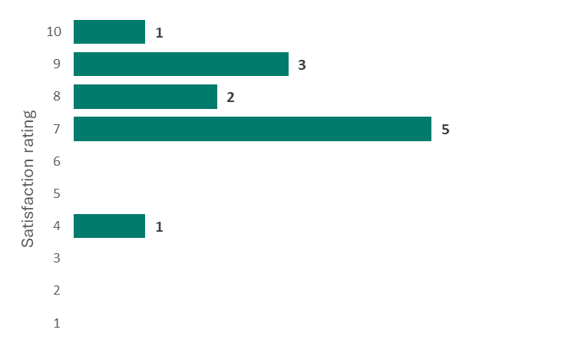
Most useful support elements
Reporters identified the following support elements as most helpful:
- the manual for reporters: frequently mentioned as an essential resource for guidance;
- helpdesk support: praised for its responsiveness;
- webinars: valued for clarifying complex requirements and sharing best practices;
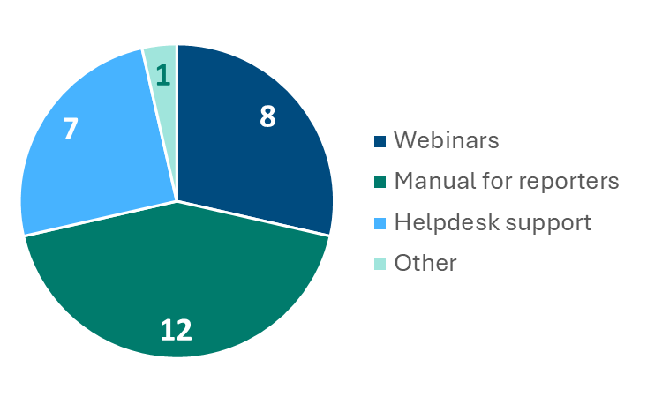
Main challenges faced
Countries highlighted several challenges:
- data collection issues: many countries struggled with gathering complete and accurate data;
- complex reporting formats: a few countries found the Excel-based reporting format to be cumbersome;
- timing constraints: delays in the publication of the implementing acts, which were essential for data collection, and which delayed the development of national legislation to make dedicated data collection possible.

Suggestions for improvement
Reporters proposed some improvements such as: (i) simplification of the reporting templates and alignment with practical data-collection capabilities; (ii) the introduction of modular forms that expand based on initial inputs to reduce complexity; and (iii) the provision of additional guidance and examples, potentially replacing webinars with more comprehensive manuals for those unable to attend.
Future expectations
Most countries indicated that they planned to complete mandatory and voluntary fields that were omitted this year.
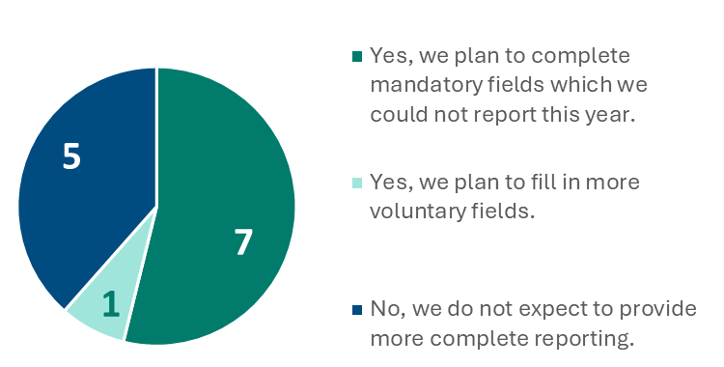
Interest in a 2025 webinar to review results of this first-year reporting and discuss improvements was strong, with over half expressing support.
Data for 2025 reporting of items (a), (b), (c) and (d), and EPR scheme readiness
Identified data sources for reporting next year include national regulatory acts, producer reports, and EPR schemes, although some data sources remain incomplete. Several countries noted delays in implementing EPR schemes, impacting data availability for the SUP reporting next year.

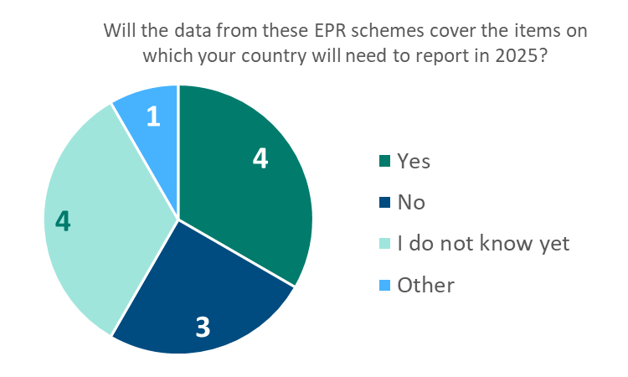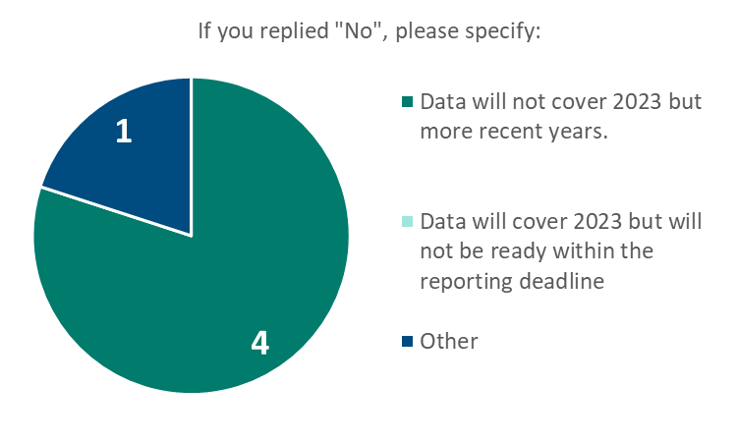
Data for the two additional reporting obligations in 2025
When asked about the identification of data sources for the two additional reporting obligations for next year (filters for tobacco products and recycled content in SUP beverage bottles), the responses indicate a mix of preparedness, with some uncertainty among reporters.
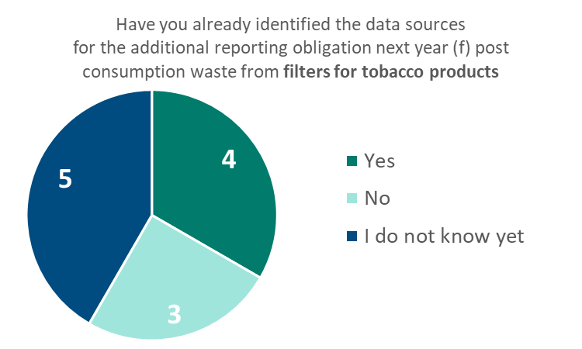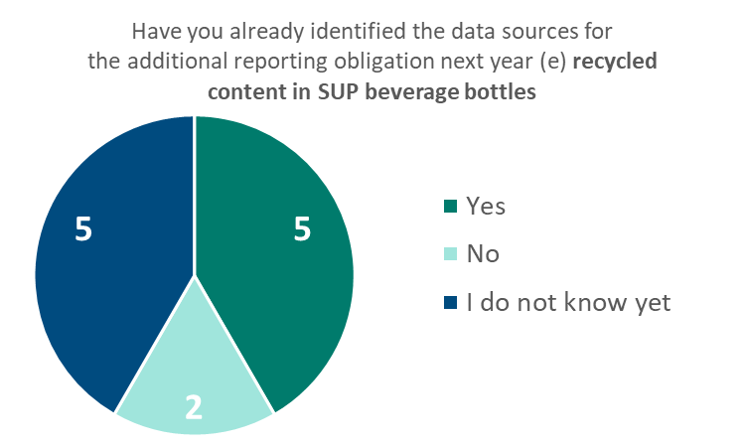

Conclusion
While satisfaction with the reporting process was generally positive, there are clear opportunities to streamline data collection and reporting formats. Better guidance and simplified forms are key recommendations to improve the process for the next reporting cycle.

Annex 9: Data sources and methodologies
The Commission guidelines on single-use plastic products, in accordance with the SUP Directive (2021/C 216/01), provide clarifications about the items under the scope of the SUP Directive, including the items covered by reporting obligations. The guidelines clarify, among other aspects, what can be considered single use and what is considered as plastic under the SUP Directive. The guidelines also give specifications to better identify products and their caps/covers/lids. For fishing gear, further details to support the reporting of data are provided in the 2020 ‘Study to support the implementation of obligations set out in the Single Use Plastics and Port Reception Facilities Directives’, which gives specifications about the reporting scope, possible data sources, types of fishing gear, etc.
Apart from these guidance documents, each Commission implementing decision provides details about the reporting format for all items under the reporting obligation. This also includes the format for reporting the data sources and methodologies used. For item (a), Commission Implementing Decision (EU) 2022/162, and for item (d), Commission Implementing Decision (EU) 2021/958), ask countries to declare the data sources/methodologies used for reporting, with a list of possible sources and methodologies set out in their annexes. For item (b), the reporting relies on countries’ awareness of the measures, and Commission Implementing Decision (EU) 2022/162 does not lay down any criteria that the measures need to fulfil to be reported. For item (c), countries are asked in the guidelines to provide details, some on a voluntary and some on a mandatory basis, about specific elements of the data, but the guidelines do not provide a specific reference list of data sources from which countries can choose. In the figures below, details cover the data sources/methodologies used by countries for each SUP reporting item. We refer to data sources and methodologies jointly, since this is how this information is referred to in the Commission implementing decisions.
The figures below give an overview of the data sources/methodologies reported by countries, for the items for which the reporting format provides built-in categories that reporters could indicate (item (a) and item (d)):
Figure 14: Data sources/methodologies used by countries for reporting item (a). Source: Quality-check reports.
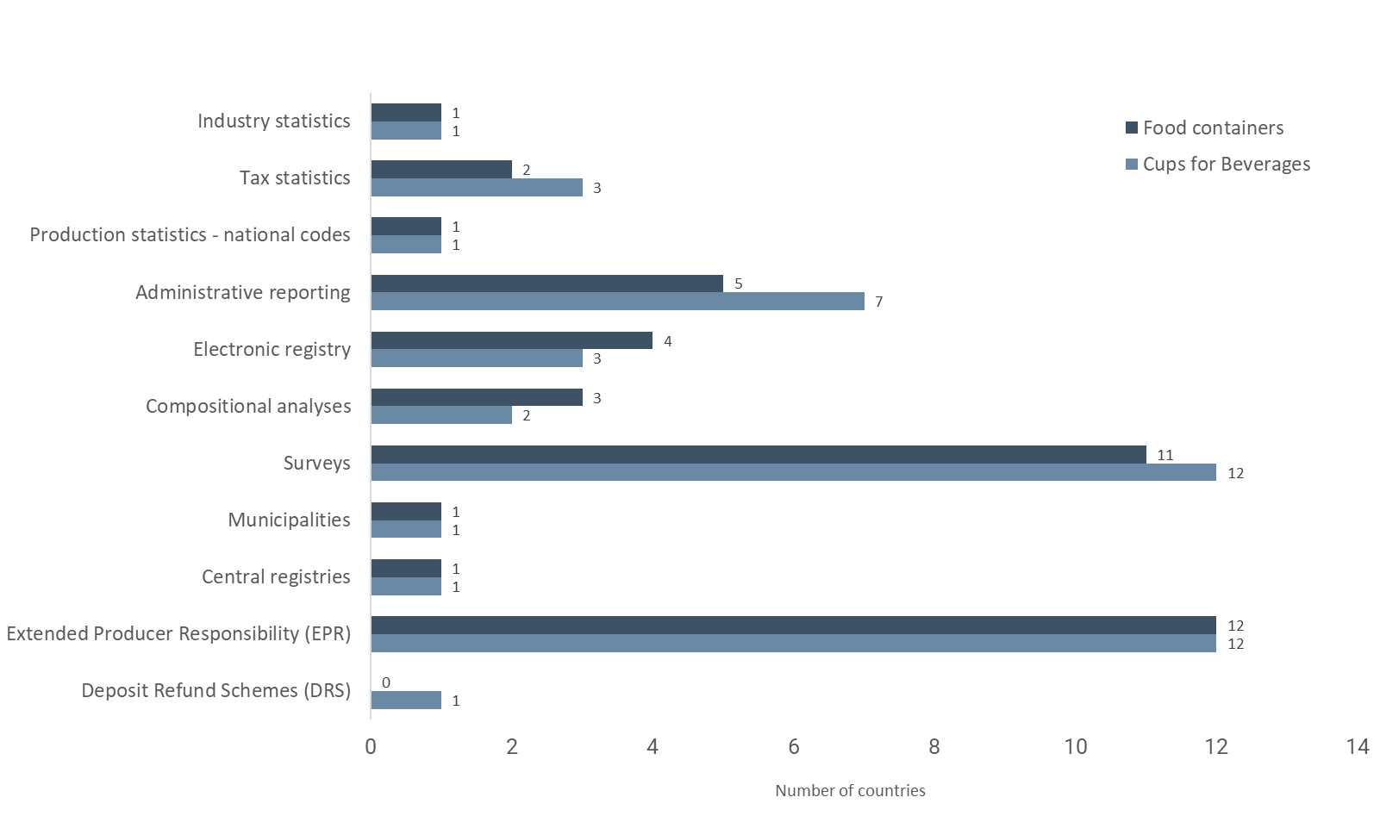
Figure 15: Data sources/methodologies used by countries for reporting item (d). Source: Quality-check reports.
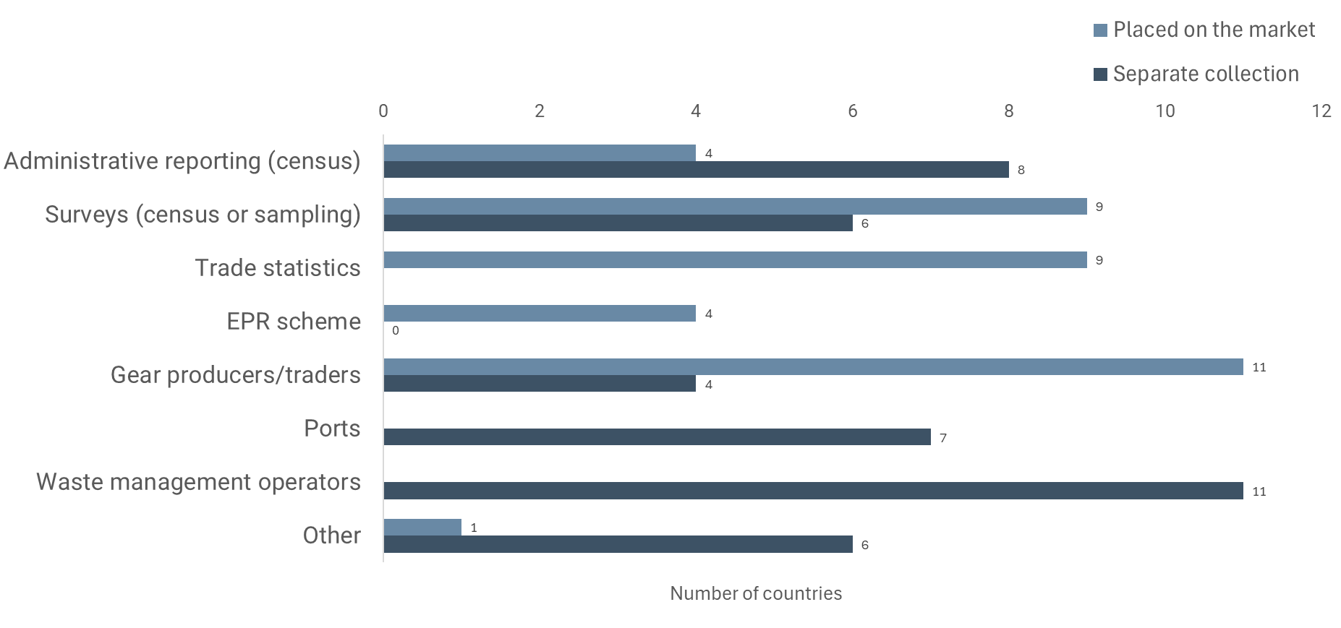

Annex 10: Verification methods and accuracy issues identified
Figure 16: Verification methods (left) and accuracy issues (right) identified for the reporting of item a. Source: Quality-check reports.

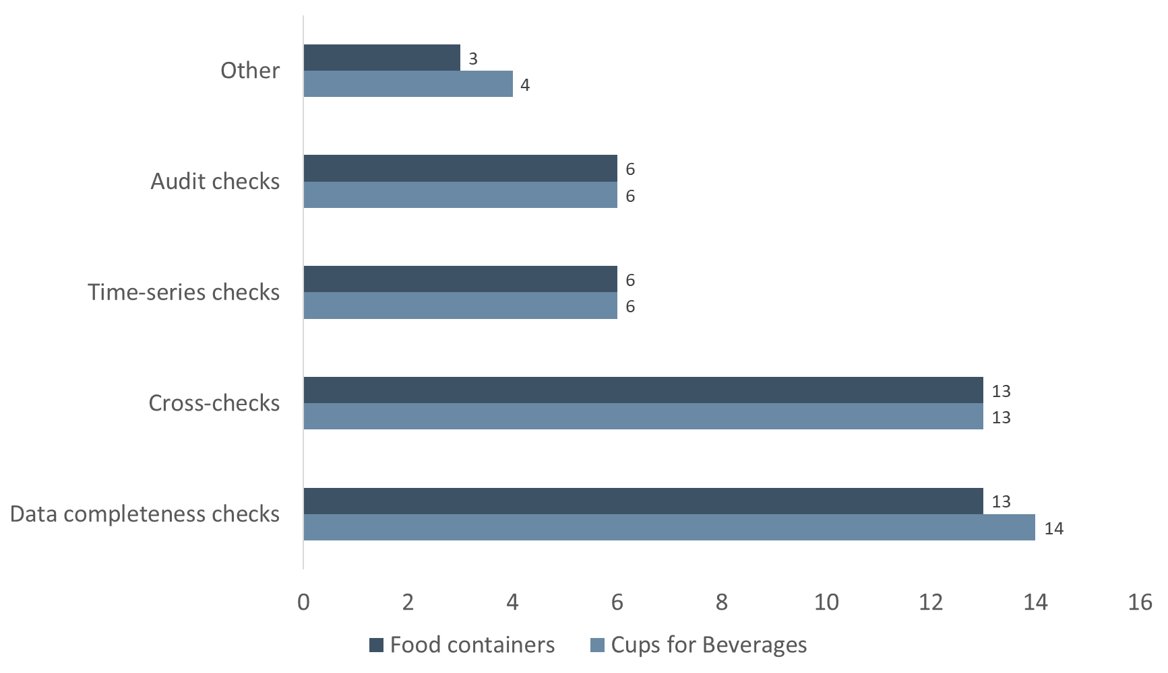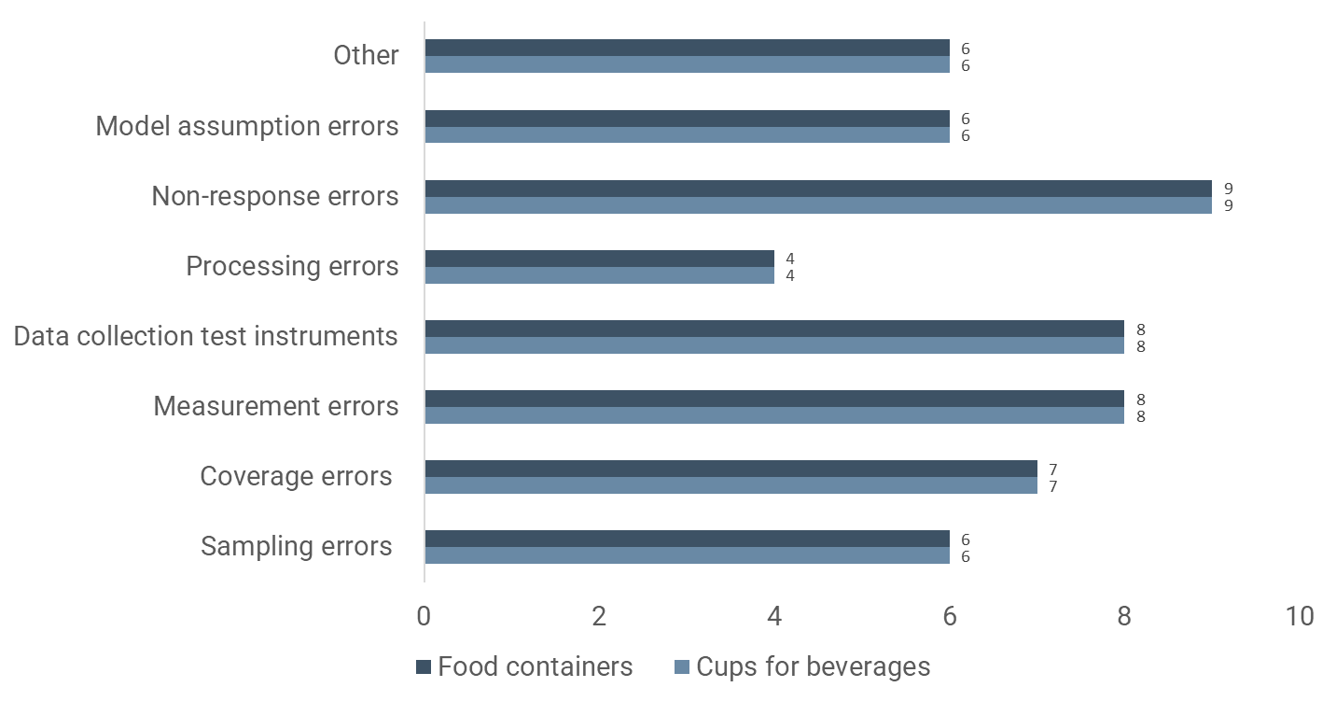
Figure 17: Verification methods and accuracy issues identified for the reporting of item (c). Source: Quality-check reports.
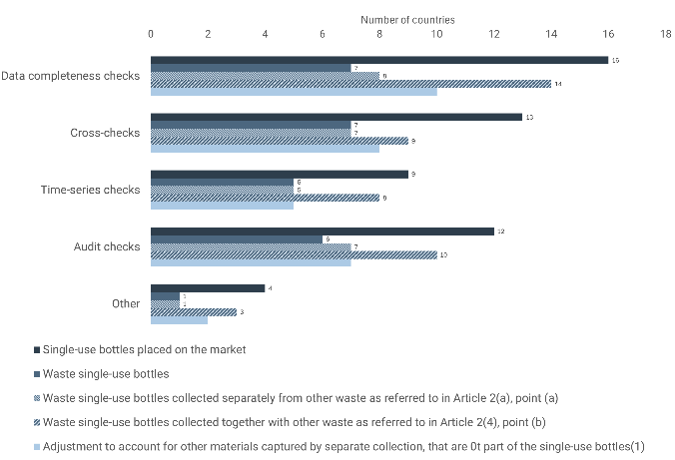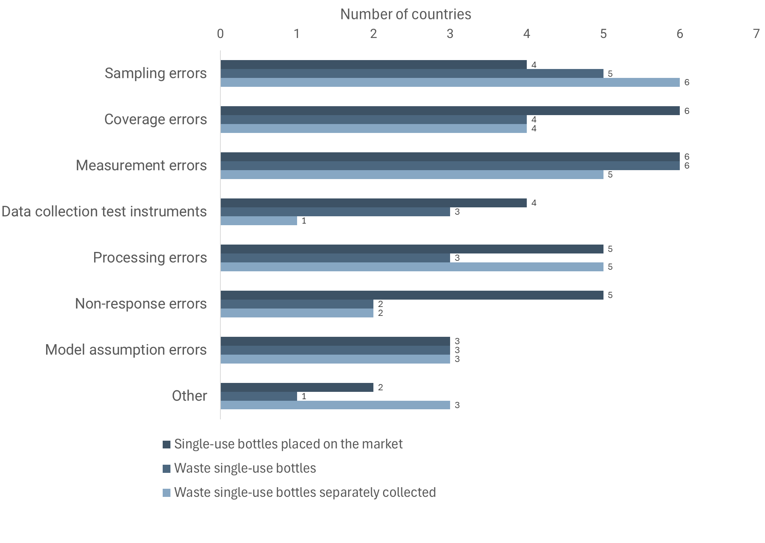
Figure 18: Verification methods and accuracy issues identified for the reporting of item (d). Source: Quality-check reports.
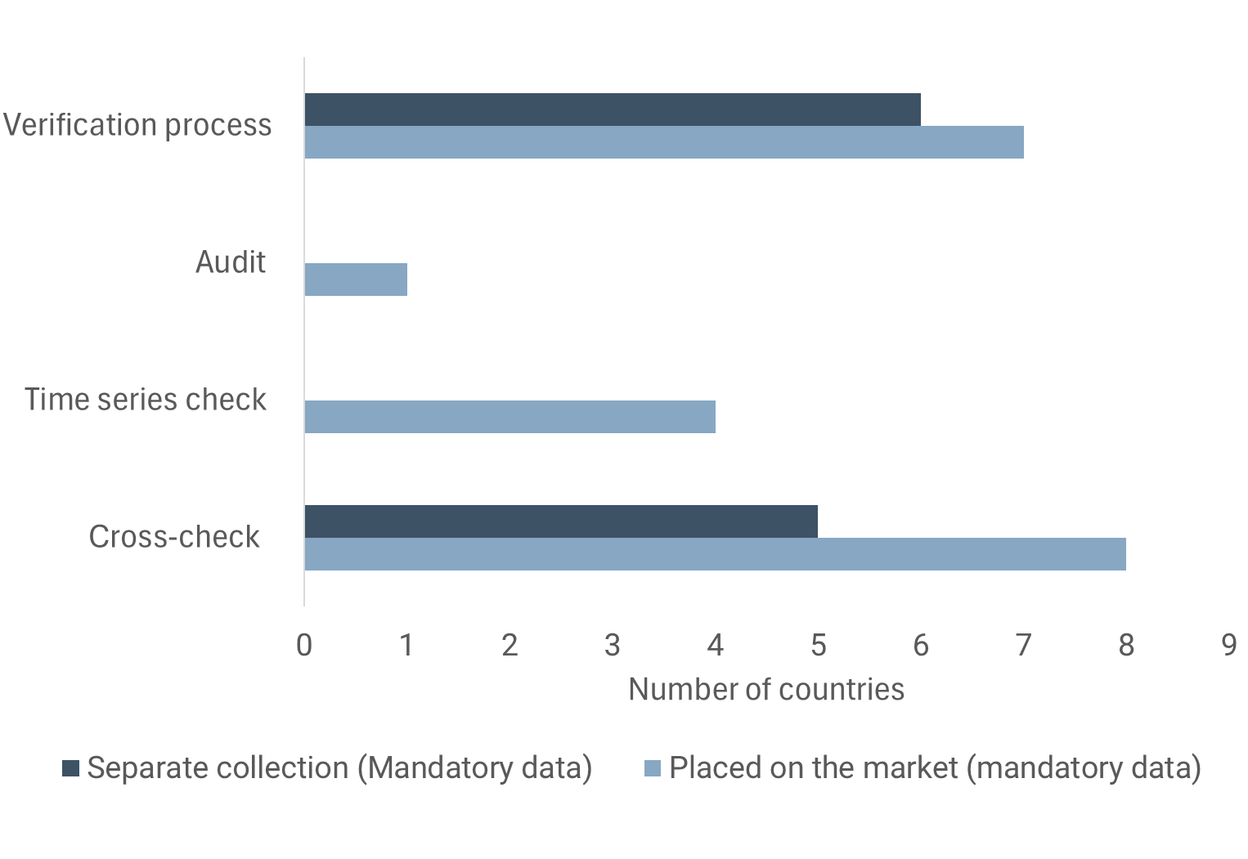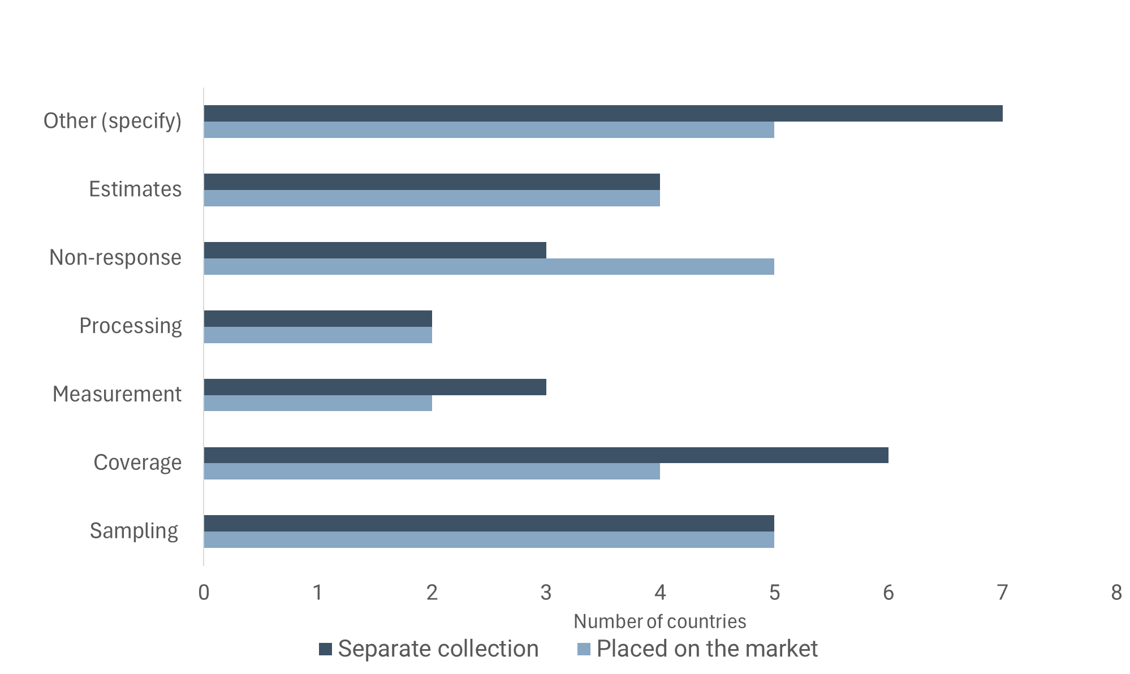

Throughout the report, per capita values have been calculated as the ratio between the sum of the weight divided by the total population in the countries reporting. Population data come from Eurostat (average country population for year 2022, Eurostat (2024a)).
Calculated ad hoc for this assessment, as the division of the plastic weight of both products covered under item (a) and the packaging waste generated, considering the subset of countries that reported this item. The plastic weight of the item considers the weight of items wholly made of plastic and the plastic content of items partly made of plastic. Plastic packaging waste generated is taken from Eurostat statistics ‘Packaging waste by waste management operations’. This comparison should be taken only as a limited proxy. Plastic packaging waste might still be underestimated in some countries, as the early warning assessments (EEA, 2022) found out.
For instance, Estonia mentioned inflows from neighbouring countries as a reason for having higher figures for separate collection than for placed on the market, and Malta stated the importance of accounting for inflows from other countries during the summer season.
Only Spain reported values of zero based on the assumption that flows in and out balanced out.
Where either of the following conditions is fulfilled: (a) the waste single-use bottles have been collected separately for recycling from any other waste; (b) the waste single-use bottles have been collected together with other waste packaging fractions of municipal waste or with other non-packaging plastic, metal, paper or glass fractions of municipal waste collected separately for recycling, and: (i) the collection system does not collect waste likely to contain hazardous substances; (ii) the collection of waste and the subsequent sorting are designed and carried out in such a way as to minimise the contamination of collected waste single-use bottles from waste plastics not originating from such bottles and other waste; and (iii) quality assurance systems are set up by the waste operators in order to verify that the conditions set out in points (i) and (ii) are fulfilled.
Data requested to remain confidential is excluded from the figure and total values.
As an example, Hungary referred to issues with the EPR data in their quality-check report for item (a), even though EPR systems were not indicated as data sources underpinning the reporting.
For instance, with different levels of ambition, actors and sectors targeted and geographical scale.
Four countries only filled in the compulsory information, i.e. specifying (yes/no) whether they had each type of measure in force in the country. The other countries also provided at least some voluntary information that made it possible to identify the specific measure (URL / policy document reference) or the year of entry into force. 20 countries also completed additional voluntary information fields, i.e. the geographical scope of the measure, actors targeted, mandatory/voluntary nature of the measure, etc. Nevertheless, information was generally provided with frequent gaps.
Items that are not single use fall under the scope of the packaging waste data but are therefore not covered by the SUP Directive, and vice versa. For instance, reusable packaging is not covered by the SUP Directive but it is considered packaging. Similarly, SUP cups for beverages and SUP food containers sold empty with no intention of being filled at the point of sale are SUP products but they are not considered packaging.
Eurostat statistics ‘Packaging waste by waste management operations’. It is also to be noted that: (i) plastic packaging waste might still be underestimated in some countries, as the early warning assessments (EEA, 2022) found out, based on data until 2019; and (ii) plastic packaging waste has been steadily increasing since 2009.
The sum of the weight for items wholly made of plastic plus the plastic content for items partly made of plastic.
For instance, the different data fields for the reporting of item (a), the classification of measures for item (b), the reporting of data sources/methodologies for item (c) or the breakdown and conversion factors for the reporting of item (d).
Based on the mass of plastic contained in the product.

