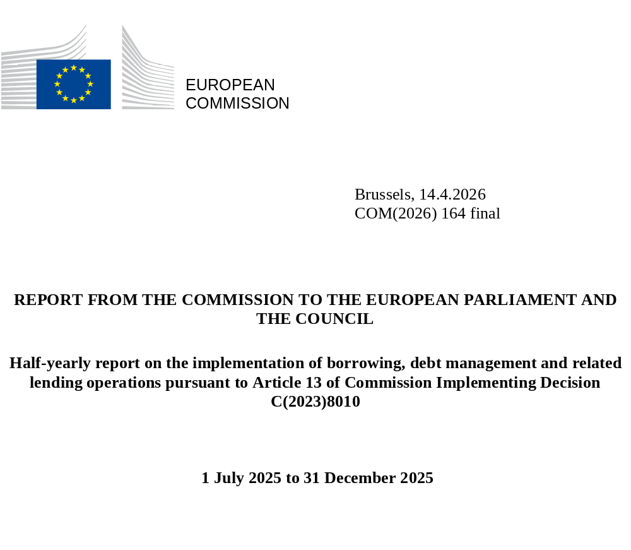

Table of Contents
1. Summary 3
2. Introduction 4
3. Implementation of borrowing operations in the second half of 2025 5
4. Cost of funding and liquidity management costs 8
5. Other milestones in the second half of 2025 11
6. Issuance outlook for the first half of 2026 11

FUNDING RAISED IN THE SECOND HALF OF 2025
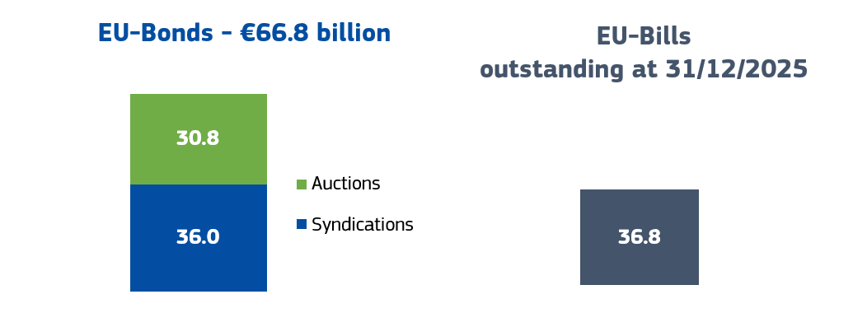
EU-Bills
outstanding at 31/12/2025
USE OF BORROWING PROCEEDS IN THE SECOND HALF OF 2025
Other programmes
NGEU financed through borrowing
Total NGEU €78.4 billion

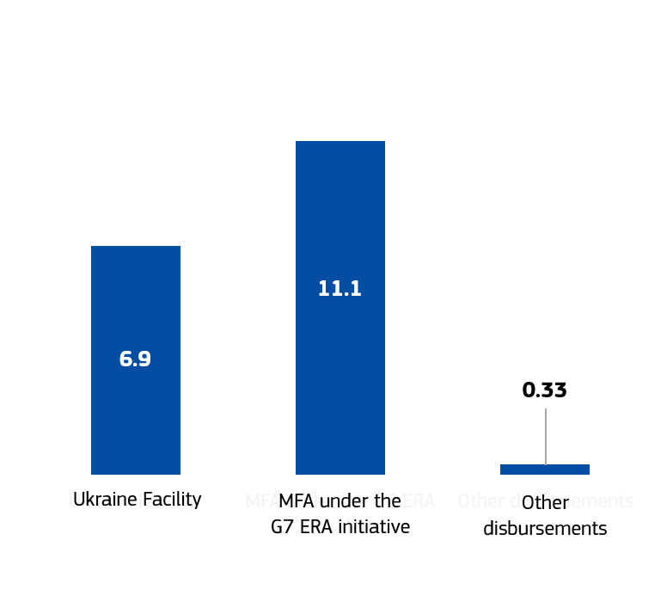
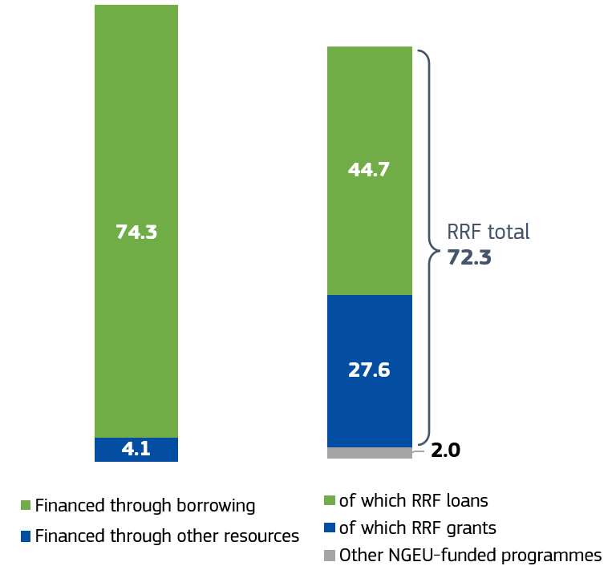
All amounts in billion EUR

OUTSTANDING EU-BONDS
on 31/12/2025
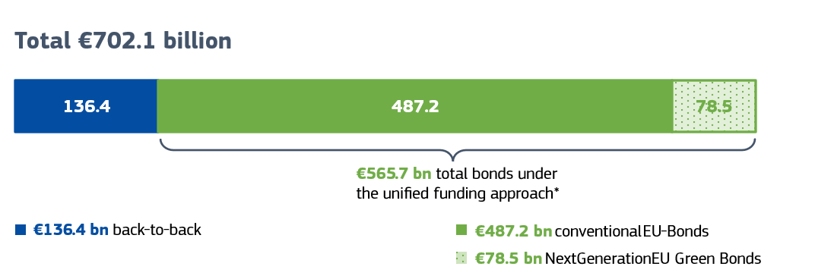
* This includes proceeds from the early repayment for the EFSM.
GRANTS AND OUTSTANDING LOANS FINANCED THROUGH BORROWING
on 31/12/2025
Other outstanding loans

NGEU financed through borrowing
Total NGEU €469.3 billion

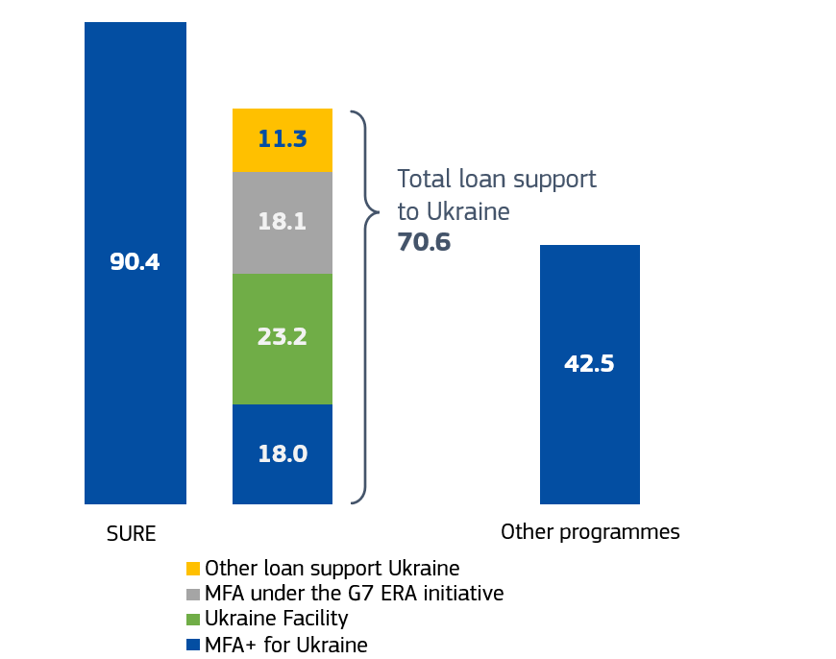
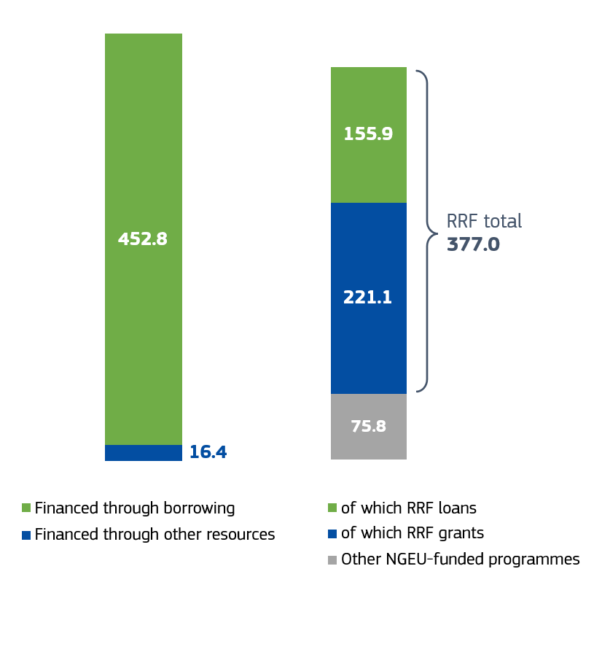
All amounts in billion EUR

KEY FACTS about H2 2025
- Four syndications and six auctions raised EUR 66.8 billion, with an average maturity of around 12 years.
- Most of the funds were used for NextGenerationEU (EUR 74.3 billion) and to support Ukraine (EUR 18.0 billion), with additional disbursements under the macro-financial assistance (MFA) programme for Jordan (EUR 250 million), the Western Balkans Reform and Growth Facility (EUR 65.8 million), and the Reform and Growth Facility for Moldova (EUR 18.9 million).
- The cost of funding was:
For NextGenerationEU: 3.32% in the second half of 2025 compared with 3.24% in the first half of 2025.
For the Western Balkans Reform and Growth Facility: 2.72% compared with 2.85% in the first half of 2025.
For the other programmes (without time compartments): 2.76% for the Ukraine Facility, 2.54% for the MFA loan under the G7 Extraordinary Revenue Acceleration (ERA) loans initiative, 2.73% for the Reform and Growth Facility for Moldova, and 2.79% for the MFA loan to Jordan.

Summary
In the second half of 2025, the EU raised EUR 66.8 billion in long-term funding through four syndications and six auctions. EUR 3.4 billion of this amount was raised through NextGenerationEU Green Bonds. At the end of 2025, the EU had EUR 702.1 billion outstanding in EU-Bonds (with an average remaining maturity of about 12 years), of which EUR 78.5 billion NextGenerationEU Green Bonds. EU-Bills outstanding at the end of 2025 stood at EUR 36.8 billion, up from EUR 33.3 billion on 30 June 2025.
In 2025 the Commission raised a total of EUR 152.6 billion in EU-Bonds, including the EUR 85.8 billion raised in the first half of the year. This is the highest annual EU issuance to date, following on from a steady increase in previous years (from EUR 120 billion in 2023 to EUR 140 billion in 2024).
Bonds issued by the EU continued to benefit from strong investor demand, while yields on EU-Bonds tightened versus most European government bonds (EGB). In a context of volatile market conditions affecting all issuers, the EU’s average cost of funding increased slightly to 3.32% compared to 3.17% in the first half of 2025.
EUR 74.3 billion of the issuance proceeds was disbursed to implement NextGenerationEU investments and reforms in the second half of 2025, a substantial increase from the EUR 12.8 billion disbursed in the first half of 2025. Ukraine received a total of EUR 18.0 billion under the Ukraine Facility and the MFA programme under the G7’s ERA initiative. Furthermore, borrowing proceeds were used to finance a EUR 250 million loan under the MFA programme for Jordan, a EUR 18.9 million loan under the Reform and Growth Facility for Moldova and EUR 65.8 million in loans to Albania, North Macedonia, and Montenegro under the Western Balkans Reform and Growth Facility.
The second half of 2025 also saw repayments of outstanding loans. Latvia repaid EUR 200 million under the Balance of Payments (BoP) Facility and nine Member States repaid EUR 8 billion under the SURE programme. In addition to these regular repayments, Portugal made an early repayment of EUR 2.5 billion under the European Financial Stabilisation Mechanism (EFSM).
2025 ended with an increase in liquidity holdings to EUR 65.2 billion to prepare for the high-volume of disbursements foreseen in 2026 to finance NextGenerationEU and the new Security Action for Europe (SAFE) instrument. These cash balances resulted in liquidity management costs of around EUR 295 million due to their long-term funding profile. The Commission actively manages these temporary cash balances to minimise holding costs, thus reducing the annual costs by about EUR 85 million.
Any accumulation of cash balances is temporary. Large funding volumes require a regular and predictable issuance schedule, and the Commission therefore spreads out its issuance to the markets over time to achieve the most advantageous funding conditions. At the same time disbursements depend on the implementation specificities of each supported programme, which can sometimes lead to a concentration of disbursement needs at certain times of the year and thus to liquidity temporarily accumulating in the Commission's liquidity buffer. As we approach the 2026 end date for NextGenerationEU disbursements, funding inflows and outflows will converge.
As in previous years, the Commission presented in December 2025 its funding plan for the first half of 2026. Taking into account expected disbursements under NextGenerationEU, SAFE, and other programmes, the Commission announced a target of up to EUR 90 billion in bond issuances in the first half of 2026.
Subsequently, at its meeting of 18-19 December 2025, the European Council agreed a EUR 90 billion loan programme for Ukraine, to be financed through EU borrowing in 2026 and 2027. To meet these new funding needs, the Commission will use the full range of funding instruments available to the Commission under the unified funding approach in a prudent and market-friendly way.
In December 2025 the Commission also published the 2025 edition of the annual NextGenerationEU Green Bonds Allocation and Impact report which provides updated information on the allocation of proceeds from the issuance of NGEU Green Bonds and on their estimated actual and expected climate impacts. The report highlights an increase in the issuance of NGEU Green Bonds for which outstanding debt has reached EUR 78.5 billion. It also estimates that this financing has allowed a prevention of greenhouse gas emissions in the order of 14 million tonnes of CO₂ per year, a substantial improvement compared to previous years.

Introduction
The Commission has been borrowing funds on behalf of the EU for over 40 years. The past six years have seen a marked increase in bond issuance by the EU, as it relies on capital markets to finance large programmes such as SURE, NextGenerationEU and financial support for Ukraine (MFA+, the Ukraine Facility, and the MFA loan as part of the G7 ERA initiative).
This half-yearly report reviews the implementation of borrowing operations between 1 July 2025 and 31 December 2025. The report also provides an outlook for EU-Bond issuance in the first half of 2026. It does not evaluate how the proceeds from EU-Bond issuances are used, including for green expenditure, as this is covered by separate reports under the regulations governing each individual instrument.
In line with the recommendation of the European Court of Auditors of June 2023, the Annex to this report presents indicators for monitoring the implementation of the overarching debt management strategy guiding the Commission’s unified funding approach.

Implementation of borrowing operations in the second half of 2025
The following sections present key aspects of the Commission’s borrowing and lending operations in the second half of 2025. Further indicators used to monitor the implementation of the Commission’s funding strategy are set out in the Annex.

Execution of funding operations in the second half of 2025
The Commission raised a total of EUR 66.8 billion in EU-Bonds, including EUR 3.4 billion in NGEU Green Bonds, in the second half of 2025. The average maturity was around 12 years, which is similar to the average maturity of funding raised in the first half of 2025.
The Commission used four syndications (54% of the amount raised) and six auctions (46% of the amount raised). EU-Bonds were issued regularly over the six-month period, taking market liquidity conditions into account while ensuring a regular market presence.
On 31 December 2025, the EU’s total outstanding debt was EUR 738.9 billion. Outstanding EU-Bonds stood at a total of EUR 702.1 billion, of which EUR 565.7 billion issued under the unified funding approach. The total value of outstanding NGEU Green Bonds was EUR 78.5 billion. In addition, at the end of December 2025, the EU had EUR 36.8 billion in credit outstanding through EU-Bills.

Chart 2: Amounts of EU-Bonds issued under the unified funding approach (in billion EUR)

* The first two NextGenerationEU transactions took place in June 2021, but these have been included in the figure for H2 2021 as they were part of the same funding plan as the transactions that took place in H2 2021.
All amounts in billion EUR

Disbursements
In the second half of 2025, the Commission used its borrowing proceeds to disburse a total of EUR 92.6 billion for all policies combined. EUR 74.3 billion went to NextGenerationEU, of which EUR 72.3 billion was used to finance Member States’ national recovery and resilience plans under the RRF. This can be broken down into EUR 27.6 billion in grants to 17 Member States and EUR 44.7 billion in loans to eight Member States. These funds for the RRF were paid out within six working days on average. The remaining EUR 2.0 billion was used to finance EU-managed programmes supported by NextGenerationEU .
The Commission also disbursed EUR 18.0 billion to Ukraine during the second half of 2025, of which EUR 6.9 billion under the Ukraine Facility and EUR 11.1 billion under the MFA programme for Ukraine as part of the G7 ERA initiative.
During the second half of 2025, EU-Bond issuance also financed a EUR 250 million MFA loan to Jordan, a EUR 18.9 million Reform and Growth Facility loan to Moldova and EUR 65.8 million in loans to Albania, North Macedonia, and Montenegro under the Western Balkans Reform and Growth Facility.

repayments
In October 2025, Latvia repaid the final EUR 200 million instalment of the of Balance of Payments (BoP) support it received in 2009-2010.
Member States made their first principal repayments under the SURE programme in November 2025. Nine Member States repaid in total EUR 8 billion. Final repayments are scheduled for 2050.
In December 2025, Portugal made a EUR 2.5 billion early repayment of the EFSM loan that it received in 2011-2014. This did not affect the bonds issued to finance the EFSM loan disbursements, as the repayment was made in cash to cover the Commission’s corresponding liabilities. The funds received were thus added to the Commission's funding pool under the unified funding approach to be used for other financial support programmes. EUR 19.8 billion in EFSM loans (for Portugal and Ireland) remains currently outstanding, with the final repayment currently scheduled for 2042.

Investor demand and secondary market liquidity
EU-Bond issuances continued to enjoy demand from a balanced and diversified global investor base.
Chart 3: Investors in syndicated transactions executed in H2 2025 by investor type

In the second half of 2025, 38% of the EU-Bonds issued through syndication were purchased by investors that typically have longer investment horizons (i.e. fund managers, insurance companies and pension funds). Central banks and official institutions, which usually prefer to invest in bonds with maturities of up to 10 years, accounted for about 27% of syndicated EU-Bond issuances and were also the largest single source of demand. Compared to the first half of 2025, the share of central banks and official institutions increased slightly, while that of insurance and pension funds decreased somewhat, most likely due to the slightly shorter tenors of bonds issued in the second half of 2025.
Chart 4: Investors in syndicated transactions executed in H2 2025 by country / region

In the second half of 2025, investors located in the EU accounted for 55% of investments in EU-Bond syndications, compared to 66% in the first half of 2025. The increase in investors from outside the EU can be mainly attributed to international investors from Asia (9% in H2 2025 versus 5% in H1 2025) and the Middle East and Africa (6% in H2 2025 versus 2% in H1 2025). The percentage of international investors operating from the UK remained stable at around 20%. The remainder came from non-EU European countries such as Norway and Switzerland.
Despite the turbulent market environment, the new issue premium (NIP), that investors demand as a concession when the EU issues bonds through syndication, remained subdued in the second half of 2025 with an average of around 1.65 basis points. This was in line with the average NIP of 1.6 basis points in the first half of 2025 and with that of other issuers on comparable transactions (measured by size and maturity).
The secondary market liquidity of EU-Bonds improved further, supported by a quoting arrangements system (in place since November 2023) where EU primary dealers are encouraged to post reliable EU-Bond prices on the leading electronic bond trading platforms. In the second half of 2025, the absolute turnover of EU-Bonds was EUR 1531 billion, compared to EUR 833 billion in the second half of 2024.
The Commission’s market approach of tapping existing lines while regularly creating new ones, strengthened the liquidity of the EU-Bond curve. New 5, 7, 15 and 30-year lines were launched in the second half of 2025. As a result, the average amount outstanding per EU-Bond stood at around EUR 16 billion at the end of 2025.
Chart 5: Quarterly secondary market turnover of EU-Bonds and European government bonds (% of outstanding volume)

Source: European Commission, based on data from the Economic and Financial Committee’s Subcommittee on EU Sovereign Debt Markets (ESDM).
Note: In this chart the European government bond (EGB) market comprises bonds issued by euro-area sovereigns, the European Financial Stability Fund and the European Stability Mechanism. Data are not yet available for Q3 and Q4 2025.

Cost of funding and liquidity management costs

Cost of funding
The cost allocation methodology under the diversified funding strategy links the costs of funding charged to beneficiaries (the EU budget or loan beneficiaries) to the conditions obtained in the market when the disbursements were financed. In addition, borrowing costs are allocated on a programme-related basis under this methodology.
The cost of funding for NextGenerationEU payments in the June to December 2025 time compartment (‘TC9’ in the table below) is estimated at 3.32%, up from 3.24% for the previous six-month time compartment. At the end of December 2025, the cost of funding for disbursements under other programmes was between 2.70% and 2.80%, except for the MFA+ loan and the MFA loan to Ukraine as part of the G7 ERA initiative which had a cost of funding of respectively 3.15% and 2.54%.
Differences in funding costs between programme compartments reflect programme characteristics, such as differences in the average maturities of borrowing instruments.

Chart 6: Cost of funding
NextGenerationEU | TC1 | TC2 | TC3 | TC4 | TC5 | TC6 | TC7 | TC8 | TC9
NextGenerationEU | 0.15% | 1.57% | 2.68% | 3.24% | 3.58% | 3.19% | 3.05% | 3.24% | 3.32%

Western Balkans Reform and Growth Facility | TC1 | TC2
Western Balkans Reform and Growth Facility | 2.85% | 2.72%

Ukraine | Ukraine Facility | MFA+ | MFA Ukraine  (G7 ERA)
Ukraine | 2.76% | 3.15% | 2.54%

Other Countries | MFA Egypt | MFA Jordan | Reform and Growth Facility for Moldova
Other Countries | 2.76% | 2.79% | 2.73%

Changes in the cost of funding also reflect the prevailing market conditions, which change over time and impact the borrowing cost for EU issuances. During the second half of 2025, interest rates were volatile because of economic and financial uncertainties. The interest rate on 10-year EU-Bonds varied between 3.00% and 3.27% during the six-month period, ending at 3.20%. Yield spreads between the EU and most EGB issuers tightened, with the 10-year interest rate spread between EU-Bonds and a 50/50 basket of German/French sovereign bonds decreasing from around 5 basis points at the start of the six-month period to -1 basis points in December 2025.
Chart 7: Yields on 10-year EU-Bonds

Liquidity management Costs
Liquidity holdings stood at EUR 77.4 billion on average in the second half of 2025, up from EUR 71.1 billion in the first half of the year. Outflows peaked in the summer with EUR 46 billion outflows in August, reducing the liquidity holdings to EUR 54.0 billion at the end of August, and at the end of the year with EUR 23 billion in outflows in December, bringing the cash balance to EUR 65.2 billion on 31 December 2025.
This increase in average liquidity holdings reflected a need to maintain high overall borrowing to meet sizeable funding requirements in the final year of NextGenerationEU - with disbursements following a more backloaded profile than initially forecast – in addition to expected disbursements under SAFE. A regular and predictable issuance schedule is key to ensure the best market conditions and predictability for investors.
The Commission invested on average around 75% of the free cash balance in term deposits and reverse repurchase (repo) transactions to reduce the negative carry associated with the cash balance. This created an additional return of 20 - 25 basis points, corresponding to EUR 85 million annually, of which about EUR 70 million in the second half of 2025. Overall, the net liquidity management cost in the second half of 2025 was around EUR 295 million, compared to a net cost of EUR 195 million on liquidity holdings in the first half of 2025.

Other milestones in the second half of 2025
2025 NGEU Green Bonds Allocation and Impact Report
On 9 December 2025, the Commission published the fourth annual NextGenerationEU Green Bonds Allocation and Impact Report of its flagship NGEU Green Bond programme.
The report, which provides an annual update on the use of proceeds and the climate impacts of NGEU Green Bond financed investments, estimates that these investments helped prevent 14 million tonnes of CO₂ emissions per year. This represents an exponential increase in actual prevention in greenhouse gas emissions compared to previous years (up from 1.5 million tonnes of CO₂ equivalent per year in 2024 and 224,143 tonnes of CO₂ equivalent per year in 2023). This also reflects the extended lifespan of project implementation under the RRF.
The report also provides updated information on the allocation of proceeds and on the EU Taxonomy alignment of measures financed through NGEU Green Bonds. For the first time, it also includes information on how NGEU Green Bonds align with corresponding NACE categories. New graphics help make the results accessible to a wider public.
With 2026 marking the last year of disbursements under the NGEU programme, the report also underlines that any further issuance of NGEU Green Bonds (which currently stand at EUR 78.5 billion) will depend on how Member States progress in implementing and reporting climate-related recovery plan expenditure. The Commission may continue to issue NGEU Green Bonds after 2026, during the planned refinancing phase of the NextGenerationEU programme, but this is conditional on the timely and satisfactory reporting of expenditure by Member States.

Issuance outlook for the first half of 2026
2026 will see exceptionally high aggregate amounts paid out under the various policies funded by
the EU debt issuance programme.
Among other things, 2026 marks the final year of disbursements to EU Member States under NextGenerationEU. EUR 469.3 billion has already been disbursed under the programme (mostly financed through borrowing), but uptake of the remaining funds will depend on timely implementation of Member States’ national Recovery and Resilience Plans, with 30 September 2026 being the deadline for submitting the final payment requests.
At the same time, disbursements under the new SAFE programme are set to begin, starting with prefinancing of up to 15%. In addition, financing from borrowing operations will be needed to support the EU’s neighbourhood and for the refinancing of maturing outstanding bonds to ensure smooth debt management. Borrowing proceeds in 2026 will also be used to finance the new EUR 90 billion Ukraine Support Loan (to be disbursed in 2026-2027), for which legislative approval is pending after political agreement was reached at the European Council on 18 December 2025.
The high volume of funding needs for 2026 is reflected in the Commission’s funding plan for the first half of 2026, with a combination of long and short-term funding. For the first half of 2026, EU-Bond issuance of EUR 90 billion is planned. This planning is subject to calibration once the disbursements under the new loan programme for Ukraine are confirmed.

Annex: Implementation indicators on the use of the means for delivering against the Commission’s overarching debt-management strategy’s efficiency and effectiveness objectives
Means |  | Indicator | Value in H2 2025 (unless otherwise indicated) | Comments on execution in H2 2025
Implementation of the EU-Bond programme | - Regular issuances across the curve  Regular EU-Bond (and NextGenerationEU Green Bond) issuances in all maturities across the curve (up to 30 years) to provide different types of investors with investment opportunities as a way to maintain strong investor demand and with it the flexibility to determine issuance volumes and maturities for individual transactions based on market conditions. | - Maturity split of issuance programme | 1-4 years: 15%  4-8 years: 39%  8-12 years: 11%  12-17 years: 13%  17-23 years: 10%  23-31 years: 12% | In H2 2025, the Commission conducted regular bond issuances across different tenors to provide the EU curve with liquidity on all segments. Funding transactions were spread over the six-month period to ensure a regular presence in the market. There were fewer transactions than in H1 2025, as the H2 2025 funding target of up to EUR 70 billion was lower than the H1 2025 funding target of EUR 90 billion. The number of transactions and the sequencing were similar to H2 2024, when the funding target was EUR 65 billion.  Green bond issuance was lower than in the first half of 2025, reflecting the calibration of green bond issuances to green expenditures reported by the Member States.
Implementation of the EU-Bond programme |  | - Timely distribution of issuances | Four syndications and six bond auctions, resulting in at least one issuance per month.
Implementation of the EU-Bond programme |  | - Green Bond issuances | EUR 3.4 billion, by tapping EU 2033 and EU 2048 bonds.
Implementation of the EU-Bond programme | - Achieving a proper balance of auctions and syndications  Use of different funding techniques with a proper balance, depending on total issuance volumes and market conditions, in order to manage execution risks, improve secondary market liquidity and improve borrowing costs. | - Auction / syndication split as % | 46% of bond issuances via auction. | In H2 2025, the Commission issued 46% of the EU-Bonds via auction, a higher proportion than in H1 2025 (41%) and H2 2024 (42%)
Implementation of the EU-Bond programme | - Establishment of large and liquid benchmark bonds  Tapping of EU-Bonds to bring the outstanding volume of different lines to levels commensurate with large and liquid benchmark lines. | - Issuances via new bonds vs volume issued via taps | - EUR 22 billion via new bonds  - EUR 45 billion via taps | the Commission used its transactions to tap existing funding lines, with two thirds (67%) of the funding volume mobilised via taps to support the liquidity of EU securities.  New funding lines were launched to provide the market with new benchmark lines where needed on the curve and based on the recommendations of EU primary dealers. New 5-year, 7-year, 15-year and 30-year bonds were launched in the second half of 2025.  The average outstanding amount per bond remained at around EUR 16 billion by the end of December 2025, ensuring consistent liquidity of the bonds.
Implementation of the EU-Bond programme |  | - Speed of tapping of new bonds | Approximately three months
Implementation of the EU-Bond programme |  | - Average size of outstanding bonds | Around EUR 16 billion
Implementation of the EU-Bond programme |  | - Turnover relative to issuance volume | Approximately 218% in H2 2025 vs 162% in H1 2025 and 144% in H2 2024
Implementation of the EU-Bond programme |  | - Absolute turnover | EUR 1 531 billion in H2 2025 vs EUR 833 billion in H2 2024
 | - Management of the maturity profile of EU-Bond issuances with due regard to:  - the temporary additional headroom (for NextGenerationEU-related borrowing) and permanent headroom (for MFA+) under the EU budget  - the future redemption of disbursements in any given year  - stable future roll-over needs  - the need to protect the EU’s rating to ensure low borrowing costs in the long run and strong demand from its core investor base. | - Average maturity of issuance | Around 12 years | In H2 2025, EU-Bond issuances had an average maturity of 12 years. This reflects the need to spread the redemption profile over time while, at the same time, attracting investors to EU primary market transactions. The average maturity remained below the maximum average maturity of 17 years set out in the annual borrowing decision for 2025.  The weighted average time to maturity of outstanding debt declined slightly (closer to 11 years after falling below 11.5 years in the first half of 2025) driven by the issuance profile and roll down of existing debt.  The short-term refinancing profile increased from less than 10% to less than 12%, while the medium-term refinancing profile remained stable at around 37%, reflecting past issuances and the redemption profile.
 |  | - Average time to maturity of outstanding debt | Around 11 years
 |  | - Refinancing in the short term, i.e. percentage of outstanding stock of bonds and bills maturing in the next 12 months | Less than 12%
 |  | - Refinancing in the medium term, i.e. percentage of outstanding stock of bonds and bills maturing in the next five years | Around 37%.
Implementation of the EU-Bill- programme | Regular issuance of EU-Bills with maturities of up to one year via auction to attract additional investors (or additional portfolios of existing investors) and support liquidity management. | - Outstanding volume of EU-Bills | Around EUR 37 billion | Outstanding debt under the EU-Bill programme increased from around EUR 30 billion to around EUR 37 billion over the period. This increase supplements EU-Bond issuances in providing additional flexibility at peak disbursement periods.
Implementation of the EU-Bill- programme |  | - Number of EU-Bill auctions | 10
Liquidity management | Management of a liquidity pool based on payment obligations, disbursement needs and the costs of cash holding, with due regard to prevailing market conditions. | - Number of payment failures due to lack of liquidity | None | The Commission met all disbursement needs and there were no settlement failures during the second half of 2025.
Primary dealer network | Attracting a wide range of financial institutions with a strong commitment to supporting EU issuances. | - Number of institutions that signed underwriting commitments for transactions over the past six months | 16 (compared with 19 in H1 2025) | EU primary dealers continued to support the Commission and rotation at the syndications helped the Commission make the best use of all banks eligible to be part of a syndicate.
Communication with diverse market stakeholders and peer issuers | Maintaining and building the trust of the investor base, market participants and peer issuers to support demand for EU debt and improve the EU’s understanding of market dynamics and investor needs. | - Deviations from the pre-announced timings for the publication of funding plans | None | The Commission maintained regular and predictable communication with the markets, in line with previous announcements.  During the first half of 2025 allocations were reduced by around EUR 3 billion reflecting financing conditions in bond auctions and final financing needs.  The Commission regularly published investor statistics, and its diversified investor base continued to grow.
 |  | - Deviation from the volumes announced in the funding plan | Around EUR 3 billion or less than 5% (similar to H1 2025).
 |  | - Investor distribution statistics | Per type:  central banks / official institutions 27%, fund managers 24%, bank treasuries 36%, insurance and pension funds 14%, banks 7%, hedge funds 2%  Per country/region: UK 20%, Nordics 13%, France 8%, Benelux 8%, Italy 8%, Asia-Pacific 9%, Germany 8%, Iberia 9%, other EU 6%, other Europe, non-EU 3%, Americas 2%, Middle East and Africa 6%

Based on the cost allocation methodology set out in Commission Implementing Decision (EU) 2024/1974.
The European instrument for temporary support to mitigate unemployment risks in an emergency (SURE).
Drawn up under Article 13 of Commission Implementing Decision C(2023)8010 on the arrangements for implementing the unified funding approach for borrowing and debt management operations.
See, for example, the annual reports for the Recovery and Resilience Facility and Macro-Financial Assistance and the NextGenerationEU Green Bonds Allocation and Impact Report.
Special report 16/2023: NGEU debt management at the Commission and Replies of the Commission
The overarching debt management strategy is described in the half-yearly report on the execution of the EU borrowing and lending operations from 1 January 2023 to 30 June 2023.
For all programmes before NextGenerationEU the Commission used a back-to-back funding approach, issuing bonds and transferring the proceeds directly to beneficiary countries on the same terms it received (so the same interest rate and maturity). When the Commission set up NextGenerationEU in 2021, the Commission adopted a diversified funding strategy of the type used by the largest euro-area sovereign issuers, using different funding instruments (EU-Bonds and EU-Bills) and funding techniques (syndications and auctions) for long-term and short-term funding needs. In December 2022, the Parliament and the Council amended Article 220a of the Financial Regulation to allow the Commission to extend its diversified funding strategy to other EU borrowing programmes, creating a unified funding approach for all EU borrowing and lending programmes under which the EU issues single-branded ‘EU-Bonds’, rather than separately denominated bonds for individual programmes such as NextGenerationEU, SURE and MFA.
In line with previous semesters, the difference compared to the funding plan target (EUR 70 billion in H2 2025) is due to the Commission’s under-allocation in the final amounts raised through bond auctions in order to secure the most attractive financing conditions for these transactions given the prevailing bidding.
These include the Strategic Technologies for Europe Platform (STEP), Horizon Europe, the InvestEU Fund, ReactEU, the EU Civil Protection Mechanism (RescEU), the European Agricultural Fund for Rural Development (EAFRD), and the Just Transition Fund.
Since mid-2021, the Commission has disbursed EUR 469.3 billion to support NextGenerationEU. This comprises, EUR 237.5 billion in grants and EUR 155.9 billion in loans to Member States under the RRF, and EUR 75.8 billion for EU-managed NextGenerationEU programmes. Of the total EUR 469.3 billion in support for NextGenerationEU, EUR 452.8 billion was financed by issuing debt. An additional EUR 16.4 billion in NextGenerationEU expenditures was financed from other sources (i.e. the Emission Trading Scheme (ETS) and the Brexit adjustment reserve (BAR)).
The NIP is a premium that the issuer pays in order to persuade investors to buy its bonds in the primary market rather than in the secondary market.
Under NextGenerationEU, interest costs incurred are allocated to the EU budget and to the Member States receiving loans in accordance with the methodology set out in Commission Implementing Decision (EU) 2021/1095 and its successor Commission Implementing Decisions (EU) 2022/9701 and (EU) 2024/1974. This methodology distinguishes between three different cost categories: (i) the cost of funding to finance non-reimbursable support and loan disbursements calculated for six-month time compartments, (ii) the cost of holding and managing liquidity, and (iii) administrative costs. Compartmentalisation per programme has been possible since Commission Implementing Decision (EU, Euratom) 2024/1974 entered into force in the second half of 2024. To avoid any retroactive effect, programmes that were funded and disbursed before this methodology was implemented (such as MFA+ loans to Ukraine and exceptional bridge-financing under the Ukraine Facility) remain pooled with NextGenerationEU borrowing and lending operations under the unified funding approach.
For instance, NextGenerationEU currently has a longer average maturity of funding than other programmes, due to the structure of the specific temporary ‘own resources’ ceiling that covers NextGenerationEU’s repayment profile. Bonds issued to finance NextGenerationEU grants typically have a longer maturity to allow the budgetary assets that will be used to repay NextGenerationEU grants to be spread out over time.
Some short-term investments will mature in H1 2026. In line with the relevant standards, the amount of approximately EUR 295 million does not take into account any proceeds on these holdings but does include earnings invested in H1 2025 which matured in H2 2025. On an accrual basis, the net liquidity management cost for H2 2025 is estimated to be approximately EUR 385 million.
Statistical classification of economic activities in Europe.
The Commission also provides regular updates through the online NGEU Green Bond Dashboard.
Additional information on NextGenerationEU Green Bonds: NGEU Green Bond Dashboard
Based on the average number of months between new issuance and first tap when considering the new lines tapped during H1 2025.
Outstanding bonds over number of bonds as at the end of H2 2024, based on bonds issued under the diversified funding strategy.

