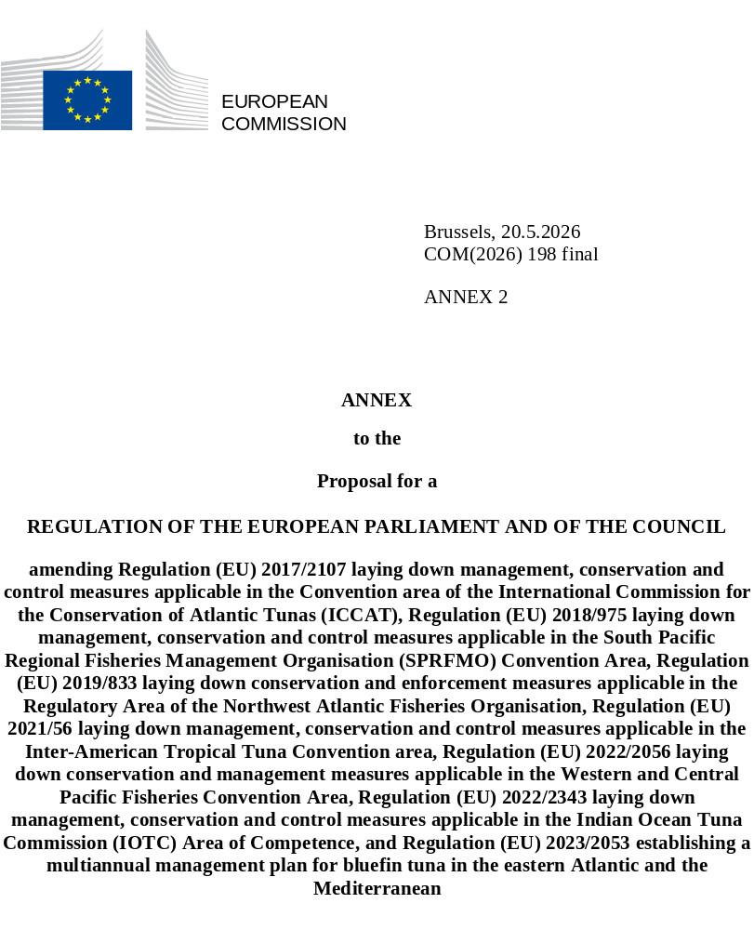

Annex II

- Annexes 12 and 13 are added to Regulation (EU) 2022/2343 as follows:
"ANNEX 12
Schematic diagram of a shark line

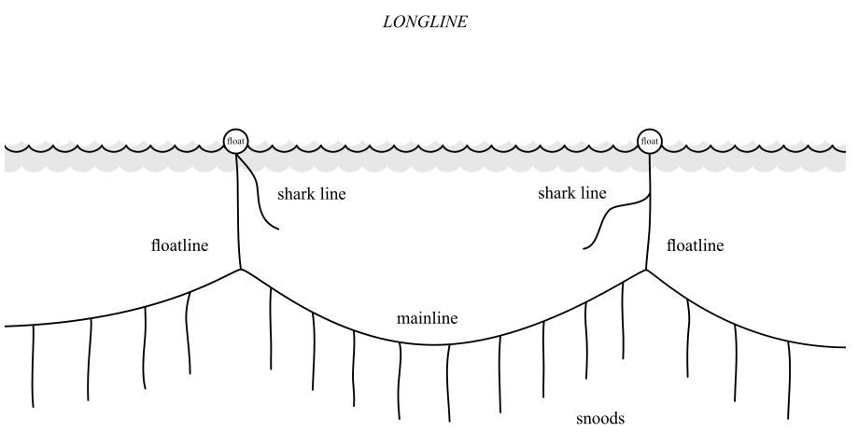
ANNEX 13
Minimum standards for safe handling and live release procedures
To maximise the efficacy and utility of adopted Best Handling and Release Practices (BHRPs), Member States shall have crew are educated and trained by qualified staff on these practices regularly. Illustrated best handling and release practices shall be available on the vessels.
Safety first: These minimum standards shall be considered in light of safety and practicability for crew. Crew safety shallalways come first. At a minimum, crew shall wear suitable gloves and avoid working around the mouths of sharks.
Be prepared: Tools shall be prepared in advance (e.g. canvas or net slings, stretchers for carrying or lifting, large mesh net or grid to cover hatches/hoppers in purse seine fisheries, long handled cutters and dehookers in longline fisheries, etc., listed at the end of this document).
General recommendations for all fisheries:
• if operationally safe to do so, stop the vessel or substantially reduce its speed.
• when entangled (in netting, fishing line, etc.), if safe to do so, carefully cut the net/line free from the animal and release to the sea as quickly as possible with no entanglements attached.
• where feasible, and while keeping the shark in the water, try to measure the length of the shark.
• to prevent bites, place an object, such as a fish or big stick / wooden pole, in the jaw.
• if, for whatever reason, a shark must be brought on the deck, then minimise the time it takes to return it to the water to increase survival and reduce risks to the crew.
• bring the shark as close to the vessel as possible without putting too much tension on the branch line to avoid that a released hook or branch line break could shoot hook, weights and other parts toward the vessels and crew at high speed.
• secure the far side of the longline mainline to the boat to avoid that any remaining gear in the water pulls on the line and the animal.
• if hooked, and the hook is visible in the body or mouth, use a dehooking device or long-handled bolt cutter to remove the hook barb, and then remove the hook.
• if it is not possible to remove the hook or the hook cannot be seen, cut the line of the trace (or snood, leader) as close to the hook as possible (ideally leaving as little line and/or leader material as possible and no weights attached to the animal).
• if in purse seine net: Scan the net as far ahead as possible to spot the sharks early to react quickly. Avoid lifting them up in the net towards the power block. Reduce vessel speed to slacken the tension of the net and allow the entangled animal to be removed from the net. If necessary, use clippers to cut the net.
• if in brail or on deck: Use a purpose-built large-mesh cargo net or canvas sling or similar device. If the vessel layout allows, these sharks could also be released by emptying the brail directly on a hopper and release ramp held up at an angle that connects to an opening on the top deck railing, without need to be lifted or handled by the crew.
Do not (all fisheries):
• to the greatest extent practicable, lift sharks from the water using the branch line, especially if hooked unless it is necessary to lift sharks for species identification.
• lift sharks using thin wires or cables, or by the tail alone.
• strike a shark against any surface to remove the animal from the line.
• attempt to dislodge a hook that is deeply ingested and not visible.
• try to remove a hook by pulling sharply on the branch line.
• cut the tail or any other body part.
• cut or punch holes through the shark.
• gaff or kick a shark, or insert hands into the gill slits.
• expose the shark to the sun for extended periods.
• wrap your fingers, hands or arms in the line when bringing a shark or ray to the boat (may result in serious injury).
Useful tools for safe handling and release:
• gloves (shark skin is rough; ensures safe handling of shark and protects crew’s hands from bites)
• towel or cloth (a towel or cloth soaked in seawater can be placed on the eyes of the shark; used to calm sharks down)
• dehooking devices (e.g., pig tail dehooker, bolt or plier cutters)
• shark harness or stretcher (if needed)
• tail rope (to secure a hooked shark if it needs to be removed from the water)
• saltwater hose (If anticipated that it may require more than 5 minutes to release a shark, then place a hose into its mouth so seawater is moderately flowing into it. Make sure deck pump has been running several minutes before placing it in a sharks mouth)
• measuring device (e.g., mark a pole, leader and float, or a measuring tape)
• data sheet for recording all catch.
• tagging gear (if applicable)."

