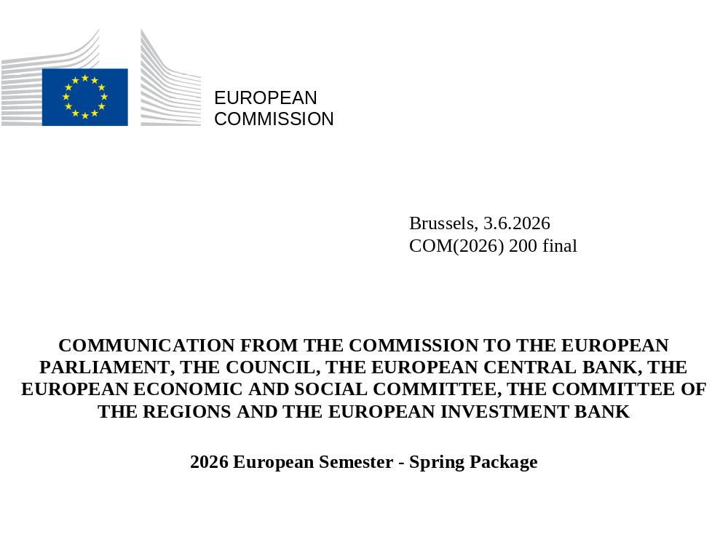

- INTRODUCTION
At a time of major geopolitical shifts and tensions, the EU needs to continue strengthening its competitiveness and strategic autonomy to sustain its economic and social resilience and cohesion. The economic environment is marked by profound geopolitical uncertainty and intensifying global competition, persistent global tensions, heightened security risks, and increasingly severe climate change impacts. In addition, persistent energy price volatility and rising global tariffs continue to elevate the cost of living, strain supply chains and increase operational costs, affecting in particular small and medium-sized enterprises (SMEs). These developments expose several weaknesses and compound Europe’s long-standing challenges linked to subdued productivity growth and innovation. However, the EU has also shown resilience by navigating multiple crises. It is implementing an ambitious competitiveness agenda and is making progress on digital innovation, decarbonisation goals, and economic security.
The 2026 European Semester Spring Package aims to build on the EU’s strengths through coordinated action to boost competitiveness, secure strategic autonomy, increase resilience, and strengthen preparedness while maintaining fiscal sustainability. The Competitiveness Compass () remains the guiding framework for this European Semester cycle. It builds on the vast potential of the single market, fosters macroeconomic and fiscal stability and aligns structural reforms and investments with the EU’s strategic priorities of closing the innovation gap, decarbonising our economy, reducing strategic dependencies, promoting skills and quality jobs, ensuring social fairness and cohesion, and simplifying the business environment. These are also some of the core ambitions of the “One Europe, One Market” roadmap, the swift implementation of which remains crucial. The EU is pursuing these objectives while upholding its commitment to implementing the European Pillar of Social Rights and the UN Sustainable Development Goals.
The 2026 European Semester provides a comprehensive framework to align national and regional reforms and investments with EU priorities. Building on the progress achieved through the Recovery and Resilience Facility (RRF), which has boosted reform and investment implementation, and the mid-term review of cohesion policy, the 2026 European Semester will continue to provide a key analytical basis to identify and prioritise reform and investment needs across a broad range of policy areas including measures to address economic, social and territorial disparities. Taking into account this analysis, the EU, Member States and other stakeholders need to coordinate investments and reforms to improve the EU’s economic security and strengthen strategic EU-wide value chains within shared competitiveness priorities. In this Spring Package, the Commission places a strong emphasis on assessing the progress made in implementing the comprehensive set of 2025 country-specific recommendations (CSRs). Coherence and synergies between the European Semester and other governance frameworks, such as the Digital Decade and the CAP recommendations, will be ensured.
The Commission calls on the European Council to endorse and on the Council of the EU to adopt the Commission recommendations for the 2026 CSRs. It also calls on all Member States to implement the CSRs fully and in a timely manner, in close dialogue with their social partners, civil society organisations and other stakeholders.

- KEY POLICY CHALLENGES AND RECOMMENDATIONS
Responding to emerging threats
Addressing the energy crisis
Fossil fuels are at the core of the current energy crisis, which highlights the urgent need for a decisive European response to ensure clean, homegrown and affordable energy, and security of energy supply, and to safeguard EU industrial competitiveness. The energy transition remains the most effective strategy for achieving Europe’s strategic autonomy, strengthening resilience, structurally lowering energy prices, and delivering the clean, abundant and homegrown energy needed to power the economy of the future. REPowerEU, which was launched in May 2022 to respond to Russia’s full-scale invasion of Ukraine has already demonstrated that joint action can effectively reduce energy demand and imports, stabilise energy markets, strengthen resilience and boost electrification. Thanks to energy investments supported by several EU funds, the EU is significantly better placed than before to withstand energy market volatility. In particular, the Connecting Europe Facility helped finance critical cross-border energy infrastructure, thereby strengthening interconnections and supporting the development of an integrated and sustainable European energy market, and a genuine Energy Union.
Through the Accelerate EU initiative (), the Commission has proposed a coordinated approach to bring immediate relief to vulnerable households and companies facing energy price spikes, and to make the energy system more resilient. To ensure security of supply, greater EU coordination, including for the refilling of gas storage facilities for the winter and the collective release of oil reserves is essential. It will be equally important to ensure the availability of critical fuels, such as jet fuel and diesel, and avoid disruptions to cross-border transport and the single market. At the same time, Member States need to ensure that emergency measures taken to reduce the economic and social impact of the energy crisis on households and businesses are temporary, targeted, timely, proportionate, and fiscally sustainable, and that they do not increase the demand for fossil fuels. With the Middle East crisis Temporary State aid Framework (), the Commission adopted targeted and temporary rules to facilitate support for the most exposed sectors of the economy. Finally, the EU needs to speed up the energy transition to continue reducing its reliance on fossil fuels – the only way to ensure our true energy independence. The EU, Member States, industry and all other relevant stakeholders must continue their joint efforts to improve energy infrastructure across Europe, including by advancing the Energy Highways set out in the European Grids Package. The upcoming electrification action plan will set an ambitious electrification target and measures to address barriers in the industrial, transport, and building sectors. The Commission will also present a legislative proposal on network charges and taxation, ensuring that electricity is taxed less than natural gas, among other things. The Commission will coordinate an EU exercise (AccelerateEU investment chapter) to assist Member States to make maximum use of and reallocate available EU funding, e.g. cohesion policy funds, where feasible and in line with Member States’ and regions’ preferences. In parallel, the Circular Economy Act will support industries in replacing virgin fossil materials with circular and bio-based ones. These efforts should go hand in hand with accelerated and full implementation of the REPowerEU plan and energy-related CSRs to provide clean and affordable energy, circular solutions, enhance energy security, and strengthen resilience to external price shocks. It should also be in line with other initiatives, such as RESourceEU, that prevent the weaponisation of the EU’s excessive dependencies on raw materials.
Bolstering economic security
Economic security remains a pressing priority for the EU amid persistent geopolitical tensions, supply chain vulnerabilities, and strategic dependencies. Member States continue to face risks stemming from strategic dependencies, particularly in energy, critical raw materials, fertilisers and key technologies, which expose economies to price volatility, risks to food security, disruptions, and external pressure. While progress has been made in diversifying energy sources, reducing dependence on single suppliers, and accelerating the clean and digital transitions, challenges persist. Energy-intensive industries remain vulnerable to high energy prices, and delays in renewable deployment, grid resilience, and storage investments hinder long-term energy security. Critical raw material dependencies, often concentrated in non-EU suppliers, threaten strategic sectors essential for the digital and clean transitions, underscoring the need for circular economy advancements, domestic production, and supply chain diversification. To strengthen economic security, Member States must deepen Single Market integration, fast-track strategic investments in clean technologies manufacturing capacity, technological sovereignty and cybersecurity, infrastructure resilience, and crisis preparedness. The proposed Industrial Accelerator Act aims to promote Europe’s economic security by strengthening industrial capacities in key sectors while keeping on track with the transition to decarbonised manufacturing.
Enhancing the EU’s defence readiness
Member States continue to strengthen their defence readiness and capabilities as called for in the 2025 CSRs. Member States have made progress in strengthening their defence readiness and capabilities, in particular thanks to the additional fiscal space of up to 1.5% of GDP in 2025-2028 linked to the activation of the national escape clause in 17 Member States. These efforts should be sustained, including through investments to ramp up and modernise production capacity to meet the demand surge. Joint procurement initiatives, which offer demand visibility to industry, reduce market fragmentation and can lower unit costs, must be continued. Progress on these fronts is necessary and in line with the Commission’s European Defence Readiness 2030 objectives. To this end, the Security Action for Europe (SAFE) initiative is providing up to EUR 150 billion in competitively priced, long-maturity loans to Member States requesting financial assistance for the procurement of defence capabilities. The Commission has already endorsed 18 out of the 19 national defence investment plans submitted by Member States to request SAFE loans, to provide EUR 130 billion of financial support. Additionally, cohesion policy has redirected EUR 11.9 billion towards defence and dual-use investment under the medium-term review. Looking ahead, there is a critical need for sustained, long-term investment in civil preparedness, including to enhance national cybersecurity and space assets, which is a strategic enabler of defence readiness. This need is underscored by developments in the eastern regions bordering Russia, Belarus, and Ukraine.
Ensuring macroeconomic stability
Member States need to sustain medium-term fiscal sustainability against a background of competing needs for public finances. Member States face growing demands on public spending driven by the urgent need to bolster defence spending and boost competitiveness, while also confronting the long-term fiscal costs of demographic change () and the rising costs of climate change impacts, in a context of already high public debt. In parallel, the EU’s external environment has become more uncertain, which compounds the challenges for the economies and the policy making of the Member States and the EU. As part of the European Semester, the Commission has assessed Member States’ compliance with the requirements stemming from the European economic governance framework, which is built around Member States’ medium-term fiscal structural plans (see Box 1).
Measures that strengthen the structural resilience of the European energy system and accelerate the transition away from fossil fuels may benefit from the existing flexibility within the fiscal framework. In order to preserve Europe’s long-term energy security and mitigate the economic implications associated with the conflict in the Middle East, Member States will be faced with substantial fiscal costs in the short run. Upon request by the Member States, the scope of the current National Escape Clause for defence spending could be broadened to accommodate the measures undertaken since February 2026 to reduce the dependence on imported fossil fuels and thereby contribute to Europe’s security and defence. Measures which could be considered would include support for households and firms to reduce their dependency on fossil fuels and promote decarbonisation, measures that accelerate electrification of end use sectors, investments in electricity grids, storage of electricity (e.g. batteries), energy saving and capacity expansion of clean energy sources.
Fiscal sustainability safeguards would remain fully in place. The existing cap on the flexibility, of up to 1.5% of GDP in additional expenditure, under the National Escape Clause for defence would remain unchanged. Therefore, while the scope of the flexibility may be broadened the risk to fiscal sustainability would remain contained. Within the existing cap (1.5% of GDP), a dedicated annual cap of 0.3% of GDP would apply specifically to the energy support measures and be available for 2026-2028 (), with a cumulative cap of 0.6% of GDP over that same period. These limits are consistent with the purpose of addressing unavoidable short-term fiscal costs and ensure a balance between the flexibility provided for energy-related supports and those available for defence expenditure. The expenditure exceeding the cap would remain subject to the standard compliance assessments under the fiscal framework. Member States should continue to use the period until 2028 to make the necessary budgetary adjustments to accommodate the higher level of defence spending in the future.
Member States will have the opportunity to request the expansion in the scope of their existing National Escape Clause over the coming months. Member States that have not yet requested the activation of the National Escape Clause for defence may do so at any time. The Commission will assess all requests received to ensure that the extension or activation of the clause does not endanger fiscal sustainability over the medium term. The Commission will provide in due time further clarity to Member States around the procedural and operational requirements, including the reporting by Member States of sufficiently granular data and information to monitor and assess eligibility of the proposed measures in support of strengthening the structural resilience of the European energy system and accelerating the transition away from fossil fuels, and conduct fiscal surveillance.
Over the past year, macro-financial vulnerabilities have evolved diversely across Member States, having narrowed in some cases, while uncertainty has augmented very recently. Some Member States face particular challenges to their macroeconomic stability, which in some cases have cross-border relevance, thereby are a concern for the euro area and the EU as a whole. Under the macroeconomic imbalance procedure, the Commission has identified macroeconomic imbalances or excessive imbalances in four Member States (see Box 2 and Appendix 4).
Box 1: Fiscal surveillance under the Stability and Growth Pact

In spring 2026, the Commission’s assessment of Member States’ compliance with the relevant Council recommendations covers both 2025 and 2026. The assessment for 2026, based on the Commission Spring 2026 Forecast, will be followed up by a further assessment in autumn, and another assessment will take place in spring 2027 based on outturn data for 2026. The core of the Commission’s assessment consists in comparing outturn data and the Commission’s projections for net expenditure () growth with the maximum growth rates of net expenditure as recommended by the Council (see Appendix 5 and the Fiscal Statistical Tables (). For Member States for which the national escape clause for defence spending () has been activated (), the assessment of compliance takes this flexibility into account ().
For the ten Member States currently under excessive deficit procedure (EDP)(), the Commission assessed the action taken in response to the Council recommendations under the EDP. For Malta, the Commission is today recommending to the Council to close the excessive deficit procedure, as the general government deficit was successfully reduced to below 3% of GDP in 2025 – in advance of the deadline that the Council established – and is projected to remain below 3% of GDP in 2026 and 2027. At the same time, the Commission notes that, for Malta, the net expenditure growth is above the ceilings recommended by the Council in both 2025 and 2026, with the corresponding deviations in cumulative terms being above 0.6% of GDP. For the nine other Member States under EDP (Belgium, France, Hungary, Italy, Austria, Poland, Romania, Slovakia and Finland), and after accounting for the flexibility from the national escape clause where relevant, the Commission considers that effective action has been taken at this stage and that the procedure should be kept in abeyance. For Italy, the net expenditure growth in 2025 was above the recommended ceilings. However, in cumulative terms, the net expenditure growth over 2024-2025 was only marginally above the recommended ceilings, and Italy is projected to correct the excessive deficit in 2026, in line with the deadline set by the Council (). At the same time, the Commission assesses France to be at risk of non-compliance with the recommended annual growth rate of net expenditure in 2026 by a small margin, while it is projected to be compliant with the cumulative growth rate. Hungary is assessed to be at risk of material non-compliance in 2026. Therefore, on current projections, an overall assessment of action taken may be needed at a later stage. In case these assessments would point to a lack of effective action, this could then require a stepping-up of the EDP (). Also, the Commission stresses that the fiscal situation in Romania remains fragile with the largest 2025 deficit ratio in the Union and where there are serious implementation risks which require a strong and persistent focus on fiscal adjustment in 2026 and subsequent years.
For the Member States not currently in EDP, the Commission assessed progress with the implementation of the medium-term plans and compliance with the relevant Council recommendations. Among these, in 2025, and after accounting for the flexibility from the national escape clause where relevant:
- Czechia, Denmark, Germany, Estonia, Greece, Spain, Latvia and Sweden are assessed as compliant, as the net expenditure growth is below the maxima recommended by the Council or the cumulated deviation is within the flexibility provided by the national escape clause.
- Ireland, Cyprus and Portugal are deemed to be compliant with the budgetary policy obligations of the Stability and Growth Pact thanks to their budgetary position in surplus, thus contributing to a reduction in their government debt-to-GDP ratios. At the same time, the Commission notes that Portugal exceeds the recommended maximum growth of net expenditure, while Cyprus and Ireland materially exceed the recommended maximum growth of net expenditure.
- Lithuania and Slovenia are assessed as non-compliant since the net expenditure growth is above the ceilings recommended by the Council, but the corresponding deviations remain below the 0.6% of GDP (in cumulative terms) threshold. However, the Commission notes that for Lithuania the general government deficit and public debt are projected below the 3% and 60% of GDP reference values.
- Luxembourg, the Netherlands, Bulgaria and Croatia are assessed as materially non-compliant with the recommended net expenditure ceilings, with the corresponding deviations above the 0.3% of GDP (in annual terms) and/or 0.6% of GDP (in cumulative terms) thresholds. At the same time, the Commission notes that for Luxembourg and the Netherlands the government deficit and public debt are below the 3% and 60% of GDP reference values in 2025.
In 2026, again after accounting for the flexibility from the national escape clause where relevant:
- Czechia, Denmark, Estonia, Germany, Ireland, Greece, Latvia are projected to be compliant, as the net expenditure growth is below the maxima recommended by the Council or the cumulated deviation is within the flexibility provided by the national escape clause.
- As in 2025, Cyprus and Portugal are projected to be compliant with the budgetary policy obligations of the Stability and Growth Pact thanks to their budgetary position projected to stay in surplus or close to balance in 2026. At the same time, the Commission notes that Portugal risks to exceed the recommended maximum growth of net expenditure and Cyprus is at risk of materially exceeding the recommended maximum growth of net expenditure.
- Spain, Luxembourg and the Netherlands are found at risk of non-compliance. However, for Luxembourg and the Netherlands the Commission notes that the general government deficit and public debt are projected below 3% of GDP and 60% of GDP respectively in 2026.
- Lithuania and Slovenia, and, as in 2025, Bulgaria and Croatia, are assessed at risk of material non-compliance in 2026. At the same time, the Commission notes that, for Lithuania and Croatia, the general government deficit and public debt are projected below the 3% and 60% of GDP reference values. Finally, for Slovenia, a confirmation of the material non-compliance based on outturn data for 2026 could trigger a report under Article 126(3) TFEU for the assessment of compliance with the debt criterion.
- Sweden is assessed at risk of material non-compliance with the recommended annual growth rate of net expenditure in 2026, while it is projected to be compliant with the cumulative growth rate. At the same time, the Commission notes that for Sweden the general government deficit and public debt are projected below the 3% and 60% of GDP reference values.
In the assessment of implementation of the medium-term plans, the Commission also considered the set of investments and reforms underpinning an extension of the respective fiscal adjustment periods. This concerns eight Member States (), for which the fiscal adjustment period in these plans had been extended from four to seven years. For these Member States, the Commission has assessed the implementation of the key steps of those reforms and investments, taking into account the information provided in the Annual Progress Reports. In the light of its assessment, the Commission considers that, overall, all the concerned Member States have complied with their commitments in terms of reforms and investments in a satisfactory manner (see Appendix 5).
Finally, the Commission has assessed compliance with the deficit criterion for five Member States (), to decide whether there is case to recommend to the Council new decisions on the existence of an excessive deficit. The assessment leads to the conclusion that at this stage there is no case to open an excessive deficit procedure for Germany, Estonia and Slovenia. For Latvia, overall, the deficit criterion is assessed as fulfilled. Instead, for Bulgaria, taking into account the Opinion of the Economic and Financial Committee on its report, the Commission will consider proposing to open an excessive deficit procedure.
Given the recent developments in the energy markets since the outbreak of the war in the Middle East in February 2026, many Member States have adopted fiscal policy measures to mitigate the social and economic impact of high energy prices on households and businesses. The Commission Spring 2026 Forecast incorporates the budgetary cost of such new measures of EUR 14.5 bn (0.07% of the EU GDP) in 2026 for the EU as a whole. This estimate assumes that the measures will come to an end in accordance with the expiring dates stated in the respective laws at the cut-off date of the forecast. If these measures were to be extended until end-2026, their fiscal cost would increase to EUR 38.6 bn (0.2% of the EU GDP) in 2026. Three-quarters of the support is being spent in a non-targeted manner, with the remaining quarter being targeted at vulnerable households or energy-intensive firms. Moreover, more than two-thirds of the estimated budgetary cost corresponds to measures that aim at directly impacting the marginal cost of energy consumption, such as cuts to excise duties. The remaining one-third corresponds to measures that provide temporary income support to households or (non-price) compensations to firms.

Box 2: Macroeconomic imbalances in the Member States
The Commission has assessed the existence of macroeconomic imbalances for the seven Member States selected for in-depth reviews in the 2026 Alert Mechanism Report. All those Member States had been identified with imbalances or excessive imbalances in the previous cycle of surveillance under the macroeconomic imbalance procedure (MIP). Like in the past two MIP annual cycles, the 2026 in-depth reviews were presented to the Member States before the publication of the Spring Package to enable more in-depth multilateral discussions in the Council Committees before the country-specific recommendations were formulated ().
The classification of imbalances is based on three criteria: (i) the gravity of imbalances; (ii) their evolution and prospects; and (iii) policy responses. These criteria are considered within the forward-looking orientation of the MIP applied since the economic governance review concluded in 2024. Specifically, under the forward-looking approach, those three criteria remain in place, but more emphasis is placed on the evolution and prospects of imbalances and the policy responses by the national authorities to overcome those imbalances or the risks they present.
Over the past year, vulnerabilities have evolved diversely across Member States but have narrowed in several cases, while uncertainty has augmented recently. Inflation fell further in most of the euro area and the EU, though at different speeds, current accounts improved, and high debts declined in various cases, while the banking sectors have remained healthy. On the contrary, house prices accelerated in several countries. Nonetheless, this annual cycle of MIP implementation ends against a backdrop of higher uncertainty, as the conflict in the Middle East has raised concerns about energy prices, higher and more volatile inflation, tighter financing conditions, and slower economic growth. Predicting how risks will evolve and how they will affect the macroeconomic stability of the EU, the euro area, and of the individual Member States, has become more challenging.
The Commission took several decisions under the MIP. Vulnerabilities are receding in a few of the Member States subject to an in-depth review and in some cases leading to a finding of no imbalances under the MIP. Relevant challenges remain in the other Member States for which an in-depth review was undertaken. In particular:
- Greece is assessed as no longer experiencing imbalances. Vulnerabilities related to government and external debt have receded over recent years, supported by steady GDP growth, with budgetary surpluses further contributing to decreases in government debt; banks’ non-performing loans have declined and balance sheets have improved; the current account deficit remains sizeable but its favourable financing mitigates external sustainability risks; Greece has implemented relevant reforms to reduce its long-standing vulnerabilities.
- The Netherlands is assessed as no longer experiencing imbalances. Vulnerabilities related to high levels of household debt, the housing market, and the large current account surplus have been present over the years but have lessened recently.
- Sweden is assessed as no longer experiencing imbalances. Vulnerabilities related to its real estate market and high levels of private debt remain but their gravity has lessened recently.
- Italy continues to experience imbalances as vulnerabilities related to high government debt and weak productivity growth, which have cross-border relevance, persist, and continued and effective implementation of growth-enhancing reforms and investments, together with a prudent fiscal stance, remains crucial to reduce those vulnerabilities.
- Hungary continues to experience imbalances as vulnerabilities related to competitiveness, government financing needs, and house prices persist, and policies have continued compounding those vulnerabilities.
- Slovakia continues to experience imbalances as vulnerabilities related to the external and government balances, competitiveness, the housing market, and household debt persist, with policy action remaining limited.
- Romania continues to experience excessive imbalances; vulnerabilities related to fiscal and current account deficits have diminished somewhat recently but remain very significant, while cost competitiveness continues deteriorating albeit less than before. The Commission will continue monitoring the progress of relevant policy action to overcome those excessive imbalances.
Appendix 4 details the country-specific aspects for the seven Member States concerned.

Against this backdrop, and in light of the persistently high debt ratios in a number of Member States, enhancing the quality of public finances and the efficiency of spending is critical to delivering real value for taxpayers and ensuring fiscal sustainability. This requires a strong prioritisation of spending and making it more efficient and effective, including through spending reviews. In parallel, modernising and streamlining taxation systems can help generate the necessary revenues while fostering economic resilience. To support credible and growth-friendly fiscal policies, several countries have reformed their overall fiscal governance. Some countries have strengthened independent fiscal institutions, made public finance reporting more transparent and improved the management of public investments. The 2026 CSRs call on Member States to enhance the quality of public spending by making health care and long-term care systems more sustainable and by stepping up the use of spending reviews for example in Poland, Slovenia, and Spain. This is particularly relevant in Member States where public revenue as a share of GDP is already high. Some Member States are also recommended to improve the sustainability of their pension systems. For instance, Austria, Germany, Italy, Luxembourg and Poland are recommended to apply measures that encourage a higher effective retirement age. Meanwhile, Cyprus, Czechia, Lithuania, Malta, and Portugal – as well as Austria, Germany, and Luxembourg – should support retirement income by strengthening their supplementary pension schemes, which also supply long-term capital to their economies.
A number of Member States have taken action to strengthen tax compliance and modernise revenue collection. Among the Member States that had received a CSR related to taxation policy in 2025, examples of positive developments include enhanced digitalisation of tax administrations – such as Greece’s digital tax reporting system and related e-invoicing reforms and Portugal’s steps to improve compliance by streamlining and digitalising tax procedures. Several Member States are making efforts towards broadening their tax bases and rebalancing their tax mix. Additionally, some efforts to combat tax evasion and avoidance have progressed. By comparison, less progress has been made on the long-standing need to tackle aggressive tax planning and the significant challenges posed by tax gaps. European governments forego more than EUR 100 billion in revenue every year due to tax non-compliance. Furthermore, there are several thousand tax expenditure provisions, which can be costly and do not always have a good rationale. Such complexity in taxation hinders fair and efficient revenue mobilisation. The proposed 2026 CSRs call for reducing these gaps to safeguard tax fairness and revenue sustainability, while further improving the tax mix to support sustainable competitiveness. For instance, Ireland, Poland, Bulgaria and Estonia are recommended to broaden tax bases, including by tapping into revenue from tax sources less detrimental to growth. Continued modernisation and digitalisation of tax administrations can help achieve these objectives.
Strengthening the EU’s competitiveness
Channelling savings towards productive investments to boost competitiveness
In 2025-2026, Member States made modest progress in improving access to finance, and disparities persist across Member States. Positive developments include robust banking and insurance sectors and continued financial stability. However, challenges endure, including persistent financing gaps, especially for scaleups, but in some Member States also start-ups and SMEs; inefficient insolvency frameworks in several Member States; and still under-developed and fragmented capital markets that fail to sufficiently complement debt finance provided by banks.
With the proposed 2026 CSRs, the Commission calls for national measures to build the Savings and Investments Union (). The Commission calls on several Member States to expand their financing sources by incentivising institutional and retail investor participation in capital markets, notably equity markets. In many Member States, supplementary pension funds have the potential to both improve individuals’ living standards in old age and channel long-term savings into productive investment, thereby helping to improve access to finance and strengthen Member States’ competitiveness.
At EU level, several initiatives launched under the Savings and Investments Union strategy also aim to improve the flow of savings into investment. The Recommendation on increasing the availability of savings and investment accounts with simplified and advantageous tax treatment () and the Communication on a financial literacy strategy for the EU () map out a clear strategy to promote greater retail investor participation in capital markets. The Communication on enhancing the capacity of the EU supplementary pension sector to improve retirement income and supply long-term capital to the EU economy () aims to mobilising Europe’s pension funds’ assets to expand financing options for all firms. Lastly, the market integration and supervision package () adopted in December 2025 seeks to create a more integrated, efficient and competitive capital market giving people better options for growing their wealth and helping businesses access funding.
Closing the innovation gap
Some Member States took steps to boost research and innovation, as called for by the 2025 CSRs. However, progress remains limited and uneven across EU Member States and regions. With R&D spending stagnating at 2.2% of GDP in 2024, the EU lags behind global leaders in R&D intensity such as the US (3.4% of GDP), Japan (3.4%) or South Korea (5.0%) and, since 2020, it has been overtaken by China (2.6%). Still, positive developments were recorded in improving financing conditions for start-ups and scale-ups, for example in Austria, and Greece. Progress was also made in facilitating technology transfer and providing incentives for innovation and research in Czechia and Germany. Regarding scientific excellence, Ireland took measures to strengthen public R&D funding, although sustained increases are needed, while Estonia enhanced public support for applied research.
As significant shortfalls persist, the 2026 CSRs prioritise closing Europe’s innovation gap and boosting R&D investment. They highlight the need to: foster public and private R&D investment; strengthen innovation systems by improving business-academia cooperation, the efficiency of public support to business innovation and access to finance; and enhance access to innovation, including, where relevant, in regions lagging behind. Czechia, Spain, France and Poland are advised to deepen knowledge transfer, support innovation uptake, and provide an innovation-friendly environment for startups and scaleups. Among innovation frontrunners, Denmark is encouraged to further strengthen SME innovation, technology diffusion, and access to growth financing. In addition to fostering the digitalisation of businesses, shortages in some science, technology, engineering and mathematics (STEM) fields and of information and communications technology specialists in strategic technological domains should be further addressed, including by incentivising female enrolment in these disciplines.
EU-level initiatives aim to further support efforts to close the innovation gap. These initiatives include the Startup and Scaleup Strategy (), including the launch of a EUR 5 billion Scaleup Europe Fund, and the envisaged European Research Area Act, which aims to strengthen () the free circulation of knowledge, researchers and technology, as well as the upcoming European Innovation Act, which aims to boost deployment and commercialisation of innovation (). As part of the next MFF, the proposed European Competitiveness Fund will mobilise private capital at scale. Through a close connection with Horizon Europe, it will support investment at all stages from research and innovation, through scale up and industrial deployment, to manufacturing. Member States should accelerate the uptake of artificial intelligence and other cutting-edge technologies such as quantum, cloud, high-performance computing, in line with the Apply AI () and the AI Continent Action Plan (). Together with the deployment of AI Factories and AI Gigafactories, the forthcoming Chips Act 2 and the Cloud and AI Development Act, will mobilise critical computing, data and infrastructure capacity and talent to secure Europe’s leadership in artificial intelligence and frontier technologies. Finally, Important Projects of Common European Interest (IPCEIs) are a powerful State aid instrument for cross-border projects driving innovation and fostering European competitiveness.
Delivering simple and digital public services
Modest progress has been made in reducing administrative burdens and modernising public administration. Some positive developments include streamlined permitting procedures and improved regulatory impact assessments. Digitalisation and modernisation of public services, including justice systems, has advanced in several Member States, while progress has stalled in others, for example due to project delays (e.g. in Cyprus). Reforms of public administration were also undertaken in several Member States, for instance Greece’s civil service digital upskilling programmes.
Therefore, the proposed 2026 CSRs call on Member States to increase administrative efficiency, reduce administrative burdens, and foster digital public services. Belgium, Croatia and Spain, for example, are called upon to speed up the issuing of construction, environmental and business permits. Addressing overlapping competencies, pursuing regulatory simplification at national, regional and local level and improving coordination across those levels would reduce administrative burdens on people, businesses and administration, thereby fostering competitiveness and innovation. Digitalising public administration requires not only improving the provision and interoperability of digital public services, e.g. in Germany and Bulgaria and guarantee equal digital access to the justice system and other public services across regions and investing in the digital skills of civil servants. To increase civil service capacity, there is also a need to improve governance and coordination including at local level, for example Croatia. The quality of law-making can be improved by strengthening impact assessments, ensuring stakeholder consultations and reducing the use of emergency ordinances, for example in Romania.
At EU level, the Commission has set out measures to ensure that new EU initiatives avoid regulatory complexity and fragmentation. The ‘simplicity by design’ principles outlined in its Communication on a simpler, clearer and better enforced EU rulebook () are particularly noteworthy. At the same time, the Commission continues to tackle duplications and inconsistencies in the existing body of legislation, including through the Action Plan on Regulatory Deep Cleaning. This dual-track approach, together with the underlying principles and measures, also provides useful guidance for equally ambitious action at national, regional, and local level. In 2025, the Commission tabled ten omnibus and other proposals, bringing administrative cost savings of EUR 15 billion annually and approximately EUR 6 billion in one-off cost savings. Additionally, the proposal for an EU Inc. corporate legal framework which would provide businesses with a unified set of rules across the EU calls on Member States to prioritise the digitalisation and cross-border availability of key business procedures under the single digital gateway ().
Making the most of the single market
There has been some progress in reducing single market barriers and strengthening institutional quality, though progress remains limited and uneven across Member States. Progress in reducing single market barriers and ensuring effective competition remains limited; some measures have been taken to strengthen sectoral regulation, reduce entry barriers and improve coordination, for example in Italy and Spain. Late payments are distorting the Single Market, hampering SMEs’ growth and eroding supply chains’ competitiveness by reducing access to finance, and stifling innovation. Cyprus has made some advancement in improving the governance of state-owned enterprises by adopting an action plan aligned with international recommendations. In public procurement, despite several implemented measures, a number of, Member States e.g. Poland and Bulgaria, continue to face challenges related to limited competition and efficiency of procedures, in particular for smaller tenders where bidder participation remains low. Some measures have been taken to improve the efficiency of the justice system, as part of the recovery and resilience plans, for example in Italy, Spain and Greece, through organisational reforms, improved digital capabilities and training.
Deepening the single market, including by reducing gold-plating of EU legislation, is a top priority for the EU, and the European Semester has a role to play. This year’s CSR proposals include more references to country-specific barriers to the single market, complementing existing single market enforcement and monitoring instruments. The aim is to identify, based on available evidence, concrete, country-specific obstacles with a cross-border dimension that affect market entry, the free movement of goods and services, and the overall business environment. The Commission will further deepen its analysis of single market barriers and gold-plating that increase the regulatory burden and compliance costs for businesses and hamper intra-EU business dynamics ().
The 2026 CSRs are geared to lifting restrictions to the single market, strengthening the rule of law, and ensuring an effective institutional framework. Regulatory restrictions on certain professions and on services markets continue to create barriers to the cross-border provision of services, for example in Luxembourg and Austria. Measures are also called for to simplify regulatory frameworks, reduce gold-plating, and lower administrative burdens affecting market entry and cross-border activity. Further action on regulatory simplification and reducing compliance costs is called for in Bulgaria, Spain, Croatia, Slovakia, Austria, Germany, and Cyprus among others. Ensuring a predictable and fair regulatory framework, strengthening anti-corruption measures and fostering a dynamic and innovative business environment are key priorities for Hungary, Bulgaria and Slovakia. In parallel, several Member States including Croatia, Cyprus, Malta and Italy, are recommended to improve the effectiveness of justice systems, notably by reducing case backlog and shortening the length of court proceedings.
The EU is taking action to further strengthen the single market. Examples include the One Europe, One Market roadmap, which sets specific targets for legislative proposals, for example the upcoming European Product Act to modernise product rules while ensuring stronger compliance across borders. The forthcoming Fair Labour Mobility Package will include the Skills Portability Initiative and a European Social Security Pass and will strengthen the European Labour Authority to better enforce the rules. Further examples include the proposal for an EU Inc. corporate legal framework, covering the entire lifecycle of a company, and the Digital Networks Act, designed to modernise and harmonise telecommunications rules and strengthen Europe’s digital resilience. The ongoing reform of the EU public procurement directives further simplifies the legal framework for public procurement. Completing the trans-European transport network (TEN-T) and its European Transport Corridors is essential to ensure the free movement of people and goods within the single market, foster the EU's industrial competitiveness and enhance military mobility.
Accelerating an affordable clean energy transition and decarbonisation
On decarbonisation, energy, environment and climate adaptation, progress has been uneven but, in some cases, notable progress has been made in aligning with EU objectives. Positive developments include accelerated renewable energy deployment, such as Ireland’s offshore wind auctions and Lithuania’s solar capacity expansion. Heating decarbonisation has progressed; for example, subsidies for installing fossil fuel boilers have been ended across the EU. The Dutch Energy Act enables more flexible grid use in the Netherlands, while sustainable agriculture initiatives have begun addressing greenhouse gas emissions, pollution, biodiversity loss and ecosystem degradation. In transport, electrification and alternative fuels are gaining traction, with support for electric transport and Germany’s rail infrastructure investments. Positive steps on water and resource management were taken, including Spain’s adoption of drought resilience plans, Greece’s implementation of the water service providers’ reform, and Portugal’s adoption of a circular economy action plan.
The 2026 CSRs aim to accelerate the clean energy transition to make energy more affordable, enhance security, support competitiveness, and align with the 2030 climate and energy targets. Member States in which fossil fuels still represent a significant part of the electricity generation mix, for instance, Czechia, Bulgaria and Hungary, need to scale up clean energy, particularly wind. For these and other Member States there is a need to accelerate and streamline grid permitting procedures and to upgrade grid infrastructure including cross-border connections and supporting the transition of regions highly dependent on fossil fuels. Several Member States including Croatia, Malta and Portugal are encouraged to prioritise energy efficiency and phase out fossil fuel subsidies that neither tackle energy poverty in a targeted way nor address genuine energy security concerns, that hinder electrification and that are not crucial for industrial competitiveness. Several Member States such as Germany, France, Spain, Portugal, Ireland, Cyprus and Latvia need to invest in energy system flexibility, grid capacity, and energy storage. Rolling out smart meters is an important prerequisite to fostering demand side flexibility and should be prioritised in several countries, for example Croatia and Germany. Several Member States, including Slovakia, Greece and Poland would benefit from reducing the relatively high taxation of electricity compared with fossil fuels, in order to incentivise electrification effectively, while France is encouraged to accelerate electrification in high-emitting sectors. Support should be provided to regions that are facing industrial transition challenges, including in Austria and Poland.
Transport decarbonisation requires electrification, including the roll-out of recharging infrastructure, and a modal shift, in particular by strengthening public and rail transport. In particular, coordinated action between the EU, Member States and industry is encouraged to accelerate the deployment of truck charging infrastructure at locations along the two heavily used TEN-T corridors of the North Sea-Baltic and Scandinavian-Mediterranean. Member States also need to encourage and support the decarbonisation of manufacturing, in particular in energy-intensive sectors. For example, Germany and Croatia are asked to improve permitting related to clean industry facilities. Poland needs to decarbonise transport, Bulgaria is encouraged to promote the roll-out of clean transport, and Romania is asked to increase public transport connectivity of remote and rural areas.
Regarding water resilience and resource management, Member States including the Netherlands, and Malta are called upon to improve water quality and prevent excessive water use. France is encouraged to strengthen water management to address competing demands between water-intensive sectors and safeguard water quality. Others, including Spain, Lithuania, Greece, and Denmark are recommended to strengthen waste management and promote a circular economy. Several Member States including Spain, Slovenia, Slovakia, and Cyprus are advised to implement their climate adaptation measures, including nature-based solutions and strengthened governance systems. It is recommended that Spain improve the management of its forests, while Portugal, Malta and Romania need to increase the resilience of their infrastructure. In addition, social equity must be addressed by taking further measures to tackle energy poverty and support vulnerable households, for example in Slovakia and Bulgaria. Romania and Italy are encouraged to accelerate investments in environmental infrastructure, in particular in the less developed regions.
Major EU initiatives strengthen climate resilience and support the energy transition to preserve the competitiveness of the European economy across sectors. As part of the European Grids Package (), the Commission is addressing the most urgent energy infrastructure needs, including interconnectors, via the Energy Highways initiative. The forthcoming European Integrated Framework for Climate Resilience should support the ability of Member States to tackle the growing impacts of climate change and strengthen the preparedness and risk management. The Communication on Integrated Wildfire Risk Management () specifically focuses on wildfire prevention, preparedness, responses and recovery. The Circular Economy Act, in line with the EU Bioeconomy Strategy (), will support industries in replacing virgin fossil materials with circular and bio-based ones. Supporting the fisheries and aquaculture sectors through the Energy Transition Partnership will be key to enhancing the sector‘s resilience. Building on the EU Strategy on Small Modular Reactors (SMRs), interested Member States are encouraged to contribute to creating the enabling conditions for SMRs development in the EU and facilitate deployment in the early 2030s.
Promoting skills, education and quality jobs
There has been some improvement in the functioning of labour markets and boosting human capital development, but further action is needed to strengthen Europe’s competitiveness and productivity. Progress has been made, for instance, in improving employment opportunities by strengthening active labour market policies (ALMP) in some Member States. In Croatia, the Job+ Programme supports labour market integration of groups in situations of vulnerability, and Slovenia has adopted an effective framework for active employment policy measures. Incentives to work have been strengthened by changes to the tax and benefit framework. For example, in Belgium, the duration of unemployment benefits has been limited to two years for most jobseekers, while strengthening ALMP and providing support to vulnerable groups. Vocational education and training (VET) programmes have been expanded, for instance in Bulgaria and Spain. Initiatives to boost STEM education and adult learning were launched, such as Finland’s digital continuous learning initiatives for adults. Access to early childhood education and care services has been improved in several Member States, also with the support of EU funds.
The 2026 CSRs call on Member States to promote quality employment, improve the functioning of labour markets and foster skills development, including the development of digital skills, through quality education and training, with a view to increasing productivity and fostering a resilient social market economy. Improving educational outcomes and better aligning people’s skills with labour market needs remain key priorities, also to address labour and skills shortages which are particularly acute in strategic sectors such as cybersecurity, quantum, artificial intelligence and semiconductors. For several Member States, it is key to boost skills levels, for instance, by strengthening basic skills and tackling early school leaving (Spain), promoting enrolment in STEM and improving the labour market relevance of training (France), and expanding upskilling and reskilling opportunities for low-skilled and older adults (Estonia and Latvia). Some Member States are called to improve their VET systems or leverage skills intelligence tools to future-proof their education and training systems. Several Member States, for example Greece, Sweden, Lithuania, Romania, Croatia and Slovenia, are encouraged to tackle labour shortages, including by strengthening ALMP; supporting the labour market integration of underrepresented groups, such as persons with disabilities, younger and older people, people with a migrant background and Roma; or, where relevant, by better attracting and retaining talent from outside the EU. Addressing labour market segmentation remains important in Poland and the Netherlands. Expanding the provision of quality early childhood education and care, for example across all regions in Austria, remains important to foster equal opportunities for children and women’s participation in the labour market. The participation of older workers needs to be enhanced for instance in Luxembourg and Germany, with a view to increasing the effective retirement age. Social dialogue and collective bargaining, as recommended for instance to Hungary and Italy remain key tools for addressing labour market challenges and fostering economic and social resilience.
Various key initiatives at EU level aim to support Member States in fostering quality jobs and skills development. The Quality Jobs Roadmap () and the forthcoming Quality Jobs Act guide Member States in ensuring that quality employment can act as an enabler for a competitive social market economy. As announced in the Union of Skills (), the Commission will present a European VET Strategy in 2026 to help VET systems respond to changing market needs. The STEM Education Strategic Plan () reinforces this ambition by supporting participation in STEM studies, especially among girls and women. The Council recommendation on human capital in the EU () calls on Member States to strengthen basic skills as a solid foundation for skills development, prioritise STEM at all levels of education, boost public and private investment and make better use of skills intelligence, with a view to tackling skills shortages. Building also on the Action Plan on Basic Skills, the forthcoming Education Package will help struggling learners improve basic skills, support schools and teachers, and boost cross-border school cooperation. Through the Digital Europe Programme (), the EU is significantly investing in building advanced digital skills in all Member States.
Social fairness
The implementation of the 2025 CSRs shows some progress in areas such as pensions and healthcare, among others. Social protection and inclusion policies have progressed in several areas, including the extension of coverage to all workers and self-employed people, pension reforms to improve adequacy and sustainability, healthcare digitalisation, and investment in long-term care. Adjustments to the minimum wage in Slovenia have improved income fairness, while pension system changes in Belgium have strengthened sustainability and those in Croatia have improved its adequacy, though further progress is often still needed.
The 2026 CSRs call on Member States to address existing and emerging challenges in the area of social fairness, including as identified through the Social Convergence Framework (see box 3). In several Member States, boosting social inclusion and reducing poverty requires stronger pathways to the labour market as well as better outreach, targeting and adequacy of minimum income schemes, including for older people. Improving access to social services is equally essential, both to support those experiencing poverty and to prevent others from falling into it. These services also play a key role in guiding people towards education, training, healthcare, and other essential services, including energy. Several Member States, including Spain, Romania and Greece, need to improve the effectiveness of social protection, for instance by revisiting its coverage. Improving access to and affordability of healthcare and long-term care remains a priority in, for example, Czechia, Estonia and Romania and in depopulating and rural regions of some Member States. Addressing persistent access and affordability challenges while maintaining cost-effectiveness and fiscal sustainability requires tackling workforce shortages and addressing territorial disparities in several Member States, such as Spain and Portugal.
EU initiatives have established a comprehensive framework to improve social fairness, support poverty reduction, and strengthen social inclusion across the EU. With the EU Anti-Poverty Strategy (), the Commission supports eradication of poverty in the EU by 2050 through a comprehensive approach. The strategy is complemented by measures to strengthen the European Child Guarantee () to break the cycle of child poverty. Through robust equality and non-discrimination policies, the EU promotes social fairness and leaves no one behind, in line with the Union of Equality Strategies ().
Increasing the affordability of housing
To tackle the ongoing crisis in housing affordability, ambitious reforms at the appropriate levels of government are crucial for increasing housing supply, streamlining administrative procedures, and tackling capacity constraints in residential construction. There has been progress in implementing the 2025 CSRs on housing, but it remains limited. Positive developments include increasing housing construction in several Member States and tackling capacity constraints. Some Member States have expanded in particular the supply of social and affordable housing, with initiatives including Denmark’s comprehensive housing package, and Ireland’s plans to expand social housing supply. However, significant challenges persist across Member States, including the need to simplify and speed up planning and permitting procedures, severe housing shortages particularly in urban areas and touristic regions, rising homelessness and declining affordability, constraints on labour and educational mobility, and increasing inequalities.
Recognising the scale of the challenge and seeking to boost access to affordable, sustainable and quality housing, including social housing, the Commission is proposing several additional CSRs. Easing housing supply constraints requires reforms in many Member States to simplify rules and procedures for example to facilitate and accelerate permitting, for instance in the Netherlands and Germany. Action is also needed to bring public land into use, boost the construction and renovation of affordable, energy-efficient and sustainable homes, and strengthen coordination across various levels of governance, for instance in Poland. Improving affordability also requires making taxation frameworks more effective, for example in Sweden, as well as repurposing underutilised stock, for instance in Portugal. Social housing needs should be addressed through adequate investments, for instance in Spain and Lithuania. Without decisive action, housing shortages and inequalities will further undermine economic competitiveness and social cohesion, in particular in regions and cities most acutely affected.
Coordinated EU-level action, with full regard for the subsidiarity principle, can play a supporting role in addressing the housing crisis. The European Affordable Housing Plan (), adopted in December 2025, and related initiatives such as the European Strategy for Housing Construction (), the New European Bauhaus (), the revision of State aid rules on housing and the proposal for a Council Recommendation on fighting housing exclusion (), provide a framework for joint action. Additional initiatives and measures, including the forthcoming Affordable Housing Act, a simplification package on housing in 2027, and a pan-European investment platform involving major financial institutions, aim to scale up investment and address market challenges such as the mismatch between housing supply and demand. Member States are encouraged to implement ambitious and comprehensive reforms to enhance housing affordability, including by facilitating construction and renovation, making full use of the data-sharing, mutual-learning and technical assistance opportunities available at EU level, including within the European Housing Alliance. At least EUR 43 billion is mobilised under the current Multiannual Financial Framework, to support affordable and sustainable housing efforts with an additional EUR 3.3 billion in cohesion policy resources re-programmed towards this objective as part of the mid-term review, complemented also by support from the Social Climate Fund notably for vulnerable households and small businesses. Under the Strategy for Housing Construction (), the EU, Member States and industry are encouraged to continue working hand in hand to identify and implement key investment and reform measures needed to scale-up the EU-wide offsite housing construction industry.
Economic, social and territorial cohesion
The implementation of the 2025 CSRs on cohesion shows partial progress in reducing territorial disparities and strengthening regional and local administration governance. Sub-national governance reforms have advanced in some Member States, improving service delivery, while local public services have been strengthened, also through further digitalisation. However, persistent challenges, such as the still unequal access to infrastructures and services, further deepen economic and social disparities across regions and between urban and rural areas. Insufficient administrative capacity, insufficient coordination across administrative levels and slow digital uptake in local governments further hinder efficient delivery of public services, which undermines economic, social and territorial cohesion.
The 2026 CSRs focus on regional competitiveness, strengthening sub-national governance, and ensuring access to key services. Sub-national governance in certain Member States would benefit from better coordination across levels of government and from advancing the digitalisation of public administration at local level. For instance, stronger coordination between central and local administrations would be warranted in areas such as climate resilience and housing to ensure effective implementation of policy actions for example in Poland, Spain and Czechia. Reducing the urban-rural divide also demands better access to public services, for example in Ireland and Lithuania, as well as improved connectivity of remote regions (e.g. Bulgaria). Finally, in the area of innovation it is particularly important to take into account regional specificities (Croatia, the Netherlands, Poland, Romania).
The EU is taking action to tackle key challenges specific to certain territories to ensure the right to stay. The EU Agenda for Cities () is strengthening multilevel governance through more regular dialogues with local authorities to better integrate their needs into EU policymaking, while the Vision for Agriculture and Food () focuses on improving the living standards in rural areas. Estonia, Latvia, Lithuania, Poland and Finland are recommended to address the unique socio-economic, security and civil preparedness challenges faced by the regions on the EU’s external eastern border, in line with the Commission’s recently adopted Strategy for Eastern border regions (). The specific challenges and pressures affecting livelihoods and the socio-economic fabric in outermost regions, as well as islands and coastal areas will be further addressed in dedicated strategies and supported by the European Ocean Pact (). The upcoming EU Sustainable Tourism Strategy will focus on tackling unbalanced tourism, promoting sustainable practices and strengthening the sector’s global competitiveness, encouraging action at national and sub-national level. Finally, the Commission will also put forward a strategy to ensure that all Europeans have the right to stay in their home region, focusing on the key challenges underlying the growing demographic decline of some European regions.

Box 3: Analysis of upward social convergence in line with the Social Convergence Framework

The Commission has assessed the existence of challenges to upward social convergence in nine Member States in line with the Social Convergence Framework (SCF), which entails a two-stage country-specific analysis of risks and challenges to upward social convergence (). In the first-stage analysis, presented in the 2026 Joint Employment Report (), labour market, skills and social policies were analysed for all Member States. A total of nine Member States were identified as facing potential risks to upward social convergence. A second-stage analysis for these nine countries was published on 21 April 2026 (). This analysis examined in more detail the available quantitative and qualitative evidence and the key factors driving the challenges, taking into account policy developments. A major challenge in all Member States is reducing poverty and social exclusion, in particular enhancing the effectiveness of social transfers in reducing poverty. Many Member States are struggling with high shares of young people not in employment, education or training, low levels of adult learning and basic digital skills, and high rates of early school leaving. Further efforts are needed to better integrate underrepresented groups into education and training, as well as the labour market. Overall, the second-stage analysis identified challenges to upward social convergence in six Member States.
The analysis of upward social convergence points to cross-cutting challenges in all three policy areas. While labour markets remain strong overall, the analysis highlights the need to foster quality job creation and transitions, including by integrating inactive people into the labour market more effectively. The analysis also points to further measures to boost quality education and skills acquisition to address skills gaps and mismatches. At the same time, income inequality and poverty risks require very close policy attention, also against the background of demographic and fiscal challenges, while keeping to efficient, adequate and sustainable social protection and inclusion systems.
The findings of the social convergence analysis are reflected in the country reports and inform the 2026 European Semester. This analysis has fed into the multilateral surveillance reviews in the relevant committees of the Council.

Box 4: RRF closure: a turning point for EU funding, powered by reforms
The RRF, the centrepiece of the NextGenerationEU response to the COVID-19 pandemic, mobilised a substantial volume of EU financing tied to complementary reforms and investments that respond both to national-specific challenges and common EU priorities. With payments linked to fulfilling milestones and targets that track progress with those reforms and investments, the RRF design has reshaped the effectiveness and synergies of EU funding instruments, and policy coordination, including notably under the European Semester.
Across the EU, the facility has supported ambitious reform agendas, often addressing long-standing structural challenges in a wide variety of areas. These include:
- labour market and skills reforms, such as modernising employment protection frameworks, strengthening active labour market policies, and improving education and training systems to foster quality and inclusiveness and ensure that people have the skills needed for the labour market (e.g. Italy, Greece, Luxembourg, Romania)
- pension and social protection reforms, to enhance sustainability and adequacy (e.g. Belgium, Greece, Romania, Slovenia, Croatia)
- reforms strengthening health and long-term care systems to improve primary healthcare and prevention, and address the needs of an ageing population (e.g. Slovakia, Lithuania, Austria, Estonia)
- public administration and justice reforms, including the digitalisation of public services and measures to improve judicial efficiency (e.g. Italy, Croatia, Slovakia, Greece, Spain, Bulgaria, Romania)
- business environment reforms, such as reducing administrative burdens, improving insolvency frameworks, and facilitating access to finance (e.g. Portugal, Cyprus, Latvia
- research and innovation reforms, such as strengthening the public research landscape, revising R&D tax incentives for companies, and reforming R&I governance (e.g. Spain, Croatia, Slovakia, Lithuania)
- tax and fiscal-structural reforms, broadening or shifting tax bases, tackling tax evasion, and strengthening public financial management (e.g. Italy, Spain, Bulgaria)
- energy market, climate mitigation and environmentally friendly reforms, including through REPowerEU, supporting the deployment of renewables, improving energy efficiency, and reducing dependence on fossil fuels (e.g. Germany, Czechia, Poland, Latvia, Finland, Luxembourg); and
- housing reforms, strengthening affordability by facilitating permitting procedures for construction, creating the conditions for energy renovations and creating support schemes for social housing (e.g. Poland, Slovenia, Ireland, Spain)

APPENDIX 1 – OVERVIEW OF THEMATIC AREAS COVERED IN THE COUNTRY-SPECIFIC RECOMMENDATIONS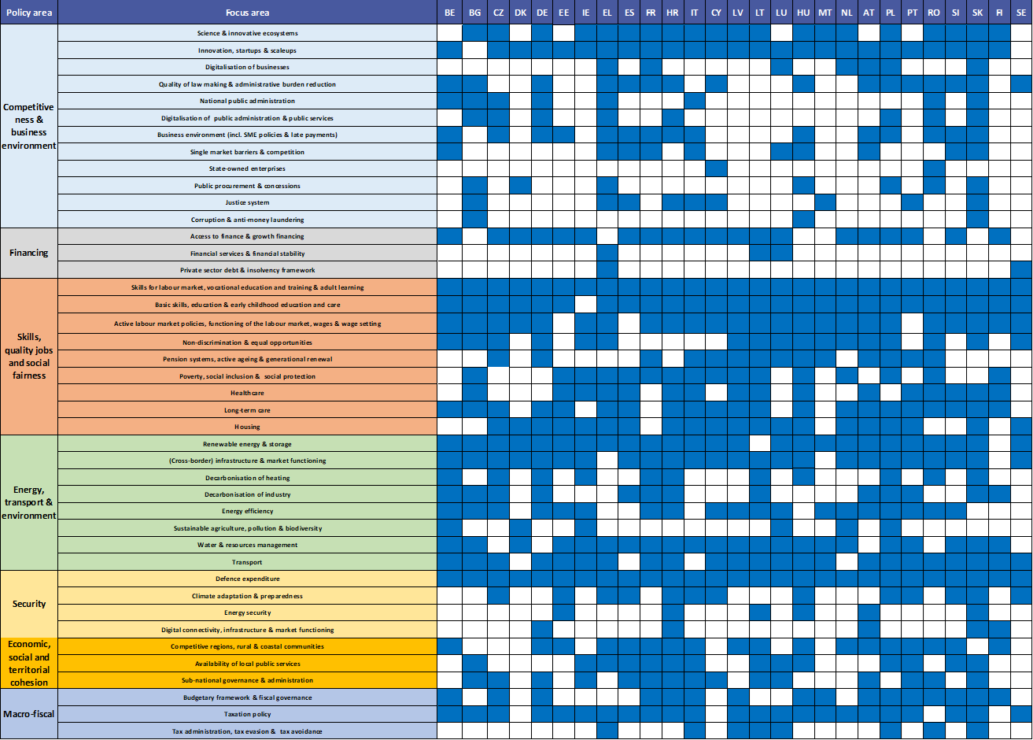

APPENDIX 2 - PROGRESS ON CSR IMPLEMENTATION
The 2026 European Semester takes stock of the Member States’ policy action to address structural challenges identified in the country-specific recommendations (CSRs) adopted in 2025. The 2026 assessment of CSRs implementation considers the policy action taken by the Member States to date (). It takes into account in particular the measures taken as part of the implementation of the RRF, commitments undertaken in the RRPs as well as the medium-term fiscal structural plans, depending on their degree of implementation. The assessment reflects the current stage of implementation, rather than the level of progress that could be achieved assuming full implementation of the plans (). The 2026 CSR assessment covers the assessment of 2025 CSRs (annual assessment)().
Figure 1: Current level of implementation of 2025 CSRs | Figure 2: Implementation of 2019-2025 CSRs: annual assessment in each consecutive year
 | 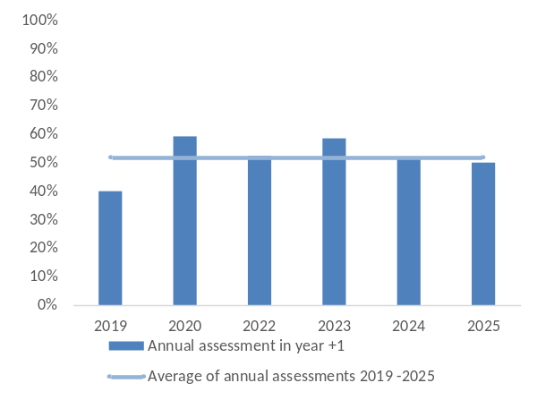
Note: The annual assessment in Figure 1 shows the progress recorded in the first year after CSRs adoption. To be noted that 2021 CSRs only relate to fiscal policy.

Overall, there has been good progress in the implementation of CSRs adopted in 2025. Member States have made at least “some progress” in 50% of the recommendations addressed to them in July 2025 (Figure 1). This represents a broadly stable level compared to the annual progress achieved in June 2025 on the CSRs adopted in October 2024. Considering the policy areas under which a significant number of Member States received a recommendation in 2025, progress has been achieved in particular on private sector debt and insolvency framework, on budgetary framework and fiscal governance, followed by digital connectivity, infrastructures and market functioning and wage setting. By contrast, less progress has been made in addressing recommendations on financial services and financial stability, quality of law making and state-owned enterprises.
The results of the 2025 CSR assessment, together with those of previous years, is available on the Commission website.

APPENDIX 3 – EU-WIDE PROGRESS ON SDG IMPLEMENTATION
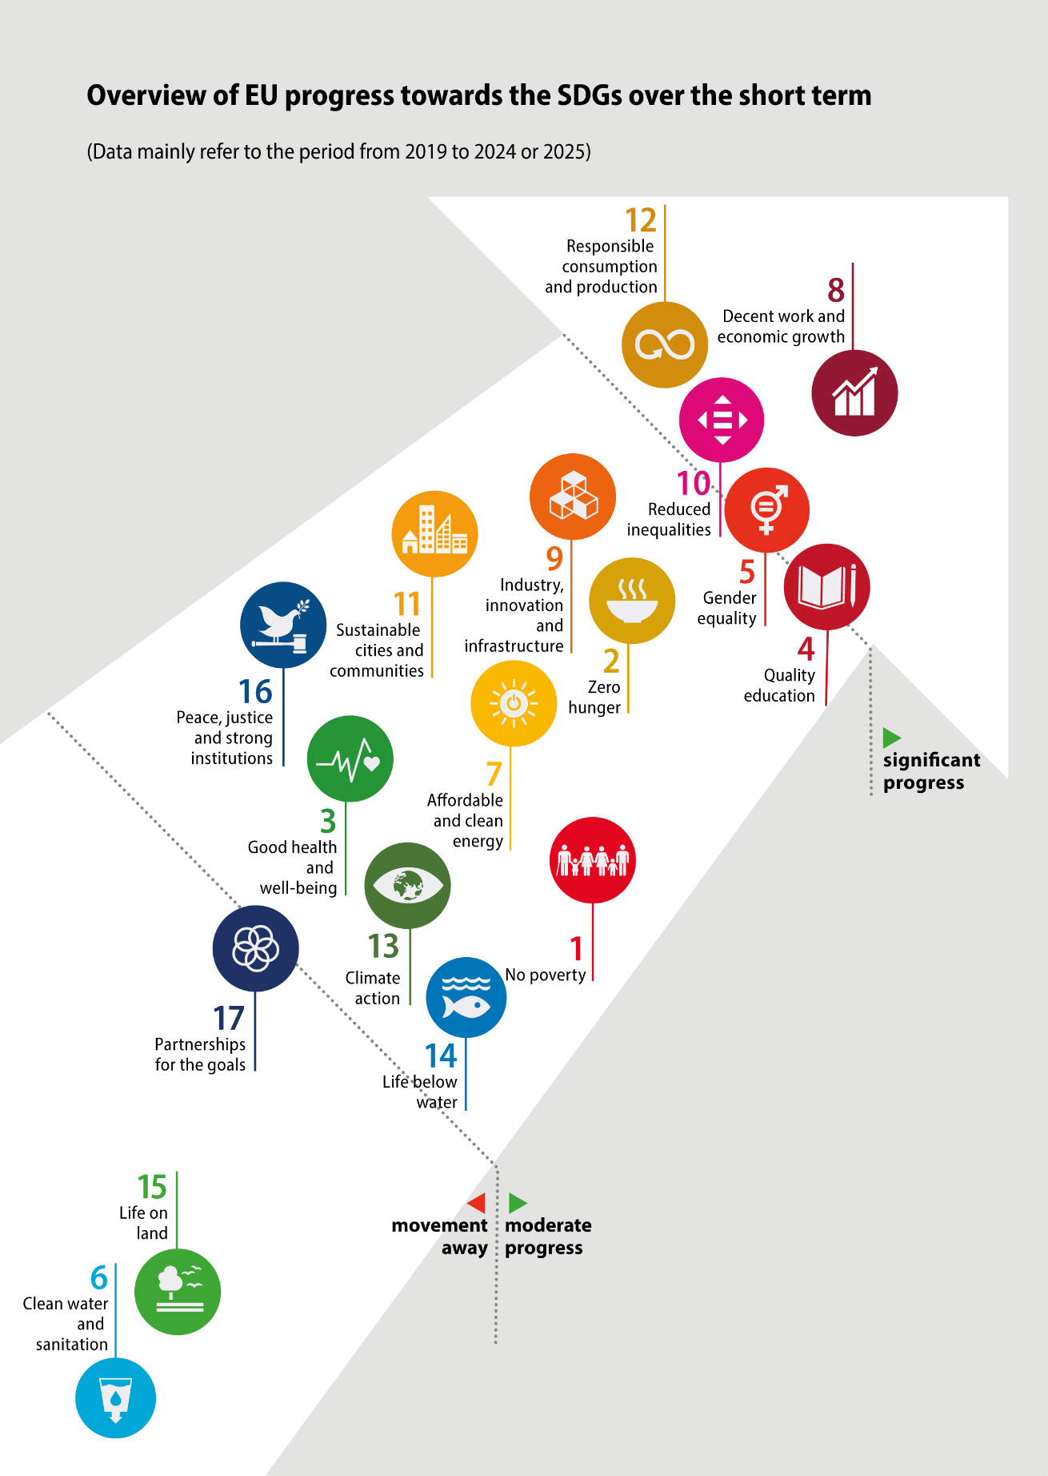
Note: The figure above shows the pace at which the EU has progressed towards each of the 17 goals over the most recent 5-or 6-year period of available data, avoiding 2020 as a base year due to COVID-related outliers. The method for assessing indicators and aggregating them at the goal-level, as well as more detailed analyses are available on the Eurostat website: Overview - Sustainable development indicators - Eurostat (europa.eu)
How has the EU progressed towards the SDGs?
The overview arrow visually summarises the EU progress towards each of the 17 goals. Over the short-term period, the EU has made significant progress towards five SDGs: ‘Decent work and economic growth’ (SDG 8), ‘Responsible consumption and production’ (SDG 12), ‘Reduced inequalities’ (SDG 10), ‘Gender equality’ (SDG 5) and ‘Quality education’ (SDG 4). The EU has also progressed towards nine other SDGs, but at a moderate pace. Among these goals, the EU has performed best for ‘Industry, innovation and infrastructure’ (SDG 9) and ‘Zero hunger’ (SDG 2). By contrast, no progress was observed for ‘Partnerships for the goals’ (SDG 17). Moreover, the EU has moved away from the sustainable development objectives of ’Life on land’ (SDG 15) and ’Clean water and sanitation’ (SDG 6) due to biodiversity loss, water scarcity and deteriorating water quality. In summary, the EU has made progress towards most SDGs, at varying paces and despite remaining challenges, while it has stagnated on SDG 17 and fallen back on SDG 6 and SDG 15.

APPENDIX 4 - MIP - FINDINGS OF IN-DEPTH REVIEWS OF MACROECONOMIC IMBALANCES IN MEMBER STATES
Imbalances or excessive imbalances have been identified in four out of the seven Member States for which an in-depth review was carried out. The in-depth review analysis looked at the gravity of the vulnerabilities, their recent evolution and prospects, and related policy responses, which are the three criteria for the classification of macroeconomic imbalances.
The paragraphs below review the most relevant vulnerabilities at this juncture, with a focus first on cross-country developments and then in the seven Member States subject to an in-depth review this year.
Inflation has declined further across most of the euro area and the EU, but significant inflation differentials persist in several Member States and increases in energy prices are now contributing to a resurgence of inflation. While inflation slowed further in 2025 and early 2026, some countries, both within and outside the euro area, have continued to record markedly above-average inflation. However, even after accounting for the fact that part of those differentials reflects rises in indirect taxation, inflation divergences have widened, including where the economic activity has been subdued. Looking ahead, the disinflation process appears increasingly at risk, and a further widening of inflation differentials cannot be excluded. At the same time, unit labour cost growth moderated in the past year, in some cases significantly, owing to slower wage growth and amid limited productivity gains. It however remains elevated relative to peers in several countries. Persistent divergences in costs and prices may undermine competitiveness, particularly in countries that have already experienced larger cost and price competitiveness losses and record more fragile external positions. Moreover, entrenched inflation differentials risk weakening the effectiveness of the common monetary policy.
Current account positions improved in 2025, but concerns persist over large deficits, and latest rises in energy price can worsen current accounts. Somewhat stronger exports growth, together with falls in energy prices, helped in narrowing the large current account deficits in 2025. Yet, some countries still have current account deficits significantly higher than what the fundamentals of their economies would justify. In some of the Member States subject to an IDR, large government deficits account for much of the economy’s external financing needs, while in others domestic demand buoyancy is the main cause. Meanwhile, significant current account surpluses have shrunk somewhat, even if remaining elevated, thanks to faster domestic demand growth compared to the rest of the euro area. Looking ahead, higher energy prices could hamper or even reverse improvements in external accounts. Trade growth is also expected to slow down compared to 2025, limiting further gains in trade balances and making them more dependent on shifts in domestic demand.
The more negative net international investment positions often improved further in 2025, but by less than before and that progress may soon reverse as current account deficits keep accumulating. Despite the significant current account deficits, most of those positions improved further in 2025 on account of nominal GDP growth – even if those denominator effects were somewhat milder than in earlier years – and accelerating capital transfers. However, if those very large current account deficits remain, negative net international investment positions could worsen. Large positive positions declined in 2025, largely reflecting adverse valuation effects but are set to rise if large surpluses persist.
House prices accelerated further in 2025 after a small rebound in 2024. Demand has been boosted by increases in household real income and more supportive financing conditions, while supply has remained constrained or even shrunk in some areas. Overvaluation risks grew in various countries. Dysfunctional rental markets have not changed much, and certain policies, including taxation policies incentivising debt-financed home buying, continue fuelling demand in some countries. House prices are expected to keep rising, as housing shortages are increasing amid slow progress in addressing supply bottlenecks.
Borrowing by households and non-financial corporations has picked up with lower interest rates, whereas high debt ratios declined less than in previous years. Denominator effects became less significant on account of lower nominal GDP growth which led to more limited falls in debt ratios than in earlier years. In the Member States with high private debt ratios, the slowdown in deleveraging has been often more pronounced in the case of households. The recent tightening of financing conditions may dampen borrowing and increase debt service burdens especially where variable-rates loans are widespread.
Government debt ratios have evolved diversely, sometimes declining but often increasing depending on budget balances, while interest rates are now increasing everywhere. High government debt ratios decreased in one country subject to an in-depth review but edged up in other cases. Lower growth weakened debt dynamics too. Looking forward, sizeable, even if declining, large deficits are forecast to continue adding to debt ratios in a number of cases. In 2025, borrowing conditions improved for euro area government debts, but long-term interest rates were much unchanged for non-euro area Members, where borrowing in foreign currencies is significant too. Since this March, however, government bond yields have risen across various maturities.
The banking sector has remained healthy. Capital ratios have increased slightly further in 2025. Bank profitability has remained elevated despite the decreasing contribution of the net interest income. Non-performing loans have been broadly stable and close to historical lows on aggregate, with limited further reductions in Member States where they used to be elevated and some marginal increases in some cases. At the same time, non-performing loans held by servicers outside the banking sector remain large in some Member States and their workout remains slow. Commercial real estate remains a source of vulnerability in some cases, but financing pressures have eased. Banks continue to hold large exposures to domestic sovereign debt in some Member States, which have increased further in some cases.
Table 1: MEMBER STATES CLASSIFICATION UNDER THE MIP
 | 2025 outcomes | 2026 outcomes
No imbalances | CY, DE, EE | EL, NL, SE
Imbalances | EL, HU, IT, NL, SE, SK | HU, IT, SK
Excessive imbalances | RO | RO
p.m.: No IDR | AT, BE, BG, CZ, DK, ES, FI, FR, HR, IE, LT, LU, LV, MT, PL, PT, SI | AT, BE, BG, CY, CZ, DE, DK, EE, ES, FI, FR, HR, IE, LT, LU, LV, MT, PL, PT, SI
Note: Member States with classification changed between 2025 and 2026 are marked in bold in both columns.

Member States no longer experiencing imbalances
Greece is no longer experiencing imbalances. Vulnerabilities related to government and external debt have receded over recent years, supported by steady GDP growth, with budgetary surpluses further contributing to decreases in government debt; banks’ non-performing loans have declined and balance sheets have improved; the current account deficit remains sizeable but its favourable financing mitigates external sustainability risks; Greece has implemented relevant reforms to reduce its long-standing vulnerabilities. While remaining high, the government debt-to-GDP ratio has continued to decrease due to prudent fiscal policy and GDP growth, which has also supported an improvement of the negative net international investment position. Both government debt and external debt ratios are expected to fall further. The current account deficit has remained elevated and is not expected to improve this year, but EU financing and private non-debt-generating financing are expected to cover a large share of it. The labour market has improved, with the unemployment rate decreasing further. Over the past years, banks have cleaned up their balance sheets. The workout of non-performing loans held by servicers outside the banking sector remains slow though. Overall policy progress has been strong and addressing the main vulnerabilities, with the government taking a broad range of measures to improve the business environment, the labour market, and tax administration. Looking ahead, sticking to sound fiscal policies would help further reductions in government debt and while structural challenges related to labour productivity remain, the European Semester will provide the framework for monitoring progress in structural reforms.
The Netherlands is no longer experiencing imbalances. Vulnerabilities related to high levels of household debt, the housing market, and the large current account surplus have been present over the years but have lessened recently. The large current account surplus dipped somewhat lately and part of it is structural, as the Netherlands acts as a key European trade hub and hosts many multinational enterprises. In parallel, from a savings-investment perspective, the fall in the surplus reflects that domestic demand has been the main contributor to recent real GDP growth and demand has grown faster than in the rest of the euro area, albeit from lower levels. The current account surplus is not forecast to grow this year or next. House prices continue to grow visibly amid reduced housing supply. Household debt as a share of GDP fell again in 2025, though more slowly than before, as borrowing increased with lower interest rates. The household debt may stabilise in the coming years, and the risks related to high household debt are partly mitigated by the prevalence of fixed-rate mortgages. Some policy measures have been taken to increase housing supply, and the latest government investment agenda, including in housing, could help reduce the current account surplus over the medium term. Looking ahead, effectively increasing housing supply and tackling tax incentives favouring debt-financed house buying could help dampen house prices and reduce household debt in a lasting way while boosting domestic investment would help further narrow the current account surplus. The European Semester will provide the framework for monitoring progress on housing reforms.
Sweden is no longer experiencing imbalances. Vulnerabilities related to its real estate market and high levels of private debt remain but their gravity has lessened recently. While the Swedish economy is highly sensitive to interest rates due to the widespread use of variable-rate mortgages, it proved resilient to the higher interest rates in 2022 and 2023, which caused house prices to drop. Since then, house prices have been stable and seem less overvalued than before. The large commercial real estate sector showed signs of improved refinancing capacity as interest rates eased and capital market access improved. Household debt as a share of GDP, which had been falling since the pandemic, levelled off in 2025 and is expected to stay steady. Going forward, housing shortages, coupled with looser borrower requirements, could push house prices and household debt up. Banks remain strong, profitable, and with low non-performing loans. Some measures have recently been taken aimed at making the rental market more flexible, and the regulatory framework for building permits was tweaked in late 2025. Looking ahead, effectively increasing housing supply and tackling tax incentives favouring debt-financed house buying, together with judicious use of macroprudential measures, would help further dampen house price growth and reduce household debt in a lasting way. The European Semester will provide the framework for monitoring progress on housing reforms.
Member States experiencing imbalances
Italy continues to experience imbalances. Vulnerabilities related to high government debt and weak productivity growth, which have cross-border relevance, persist, and continued and effective implementation of growth-enhancing reforms and investments, together with a prudent fiscal stance, remains crucial to reduce those vulnerabilities. Government debt as a share of GDP fell after the pandemic but increased in 2024 and again in 2025, on account of the slowdown in nominal GDP growth, the lagged impact of the tax credits for housing renovations of earlier years, and the still sizeable government deficits. The government debt ratio is expected to continue increasing in 2026 and 2027. Productivity has declined recently and is forecast to stagnate, limiting potential GDP growth and hence hampering reductions in the government debt ratio. Banks have significantly strengthened their asset quality and profitability and reduced their non-performing loans, but the high sovereign-banks nexus is still a concern, as banks’ holdings of domestic government debt as a share of their assets is high, especially for less significant institutions and cooperative banks. The labour market has continued to improve, but the labour potential does not seem to be fully exploited. Measures have been taken to address the long-standing vulnerabilities but, despite the recent extensive reform action, significant productivity gains have yet to materialise. Looking ahead, continued and effective implementation of growth-enhancing reforms and investments, together with a prudent fiscal stance, remains crucial to improve productivity growth and reduce the government debt-to-GDP ratio.
Hungary continues to experience imbalances. Vulnerabilities related to competitiveness, government financing needs, and house prices persist, and policies have continued compounding those vulnerabilities. Inflation and unit labour costs growth have been among the highest in the EU despite stagnating economic activity. Price and cost pressures are expected to ease only gradually, while remaining much higher than in the euro area and EU. Government deficits have been elevated in the past years and are not forecast to improve. Government financing needs and debt servicing costs remain high, although the government debt-to-GDP ratio has risen only marginally thanks to the high nominal GDP growth in the context of still elevated inflation. Banks continue to hold large sovereign exposures, partly reflecting tax incentives. House prices have continued to increase strongly and risks of overvaluation have risen. The current account has remained in surplus, but Hungary’s high reliance on energy imports makes it vulnerable to higher and more volatile energy prices. Policies have not improved and have compounded some of the vulnerabilities. Untargeted subsidies that add to price pressures and compound fiscal challenges have even been stepped up, while extensive government subsidised lending strain public finances and limit the effectiveness of monetary policy. Looking ahead, effectively overcoming those policies would reduce vulnerabilities.
Slovakia continues to experience imbalances. Vulnerabilities related to the external and government balances, competitiveness, the housing market, and household debt persist, with policy action remaining limited. While the current account deficit narrowed in 2025 thanks to lower energy prices and stronger exports, it is expected to deteriorate in 2026 as the external context worsens. The government deficit edged down in 2025 but remains large and weighing on external balances; moreover, it is forecast to be largely unchanged in 2026 and to rise in 2027 assuming unchanged policies, pushing government debt higher. Inflation was well above the euro area in 2025, partly due to VAT rate increases, and core inflation is forecast to stay among the highest in the euro area in 2026. Fast-rising unit labour costs have further weakened competitiveness and are still expected to grow relatively fast in 2026. House prices surged in 2025 amid lower mortgage rates and are likely to keep rising briskly due to constrained supply. Household borrowing grew too with lower interest rates and higher incomes. Policy progress has been limited. Looking ahead, effectively addressing key issues in labour taxation, competitiveness, housing supply, and fiscal policy would reduce vulnerabilities.
Member States experiencing excessive imbalances
Romania continues to experience excessive imbalances. Vulnerabilities related to fiscal and current account deficits have diminished somewhat recently but remain very significant, while cost competitiveness continues deteriorating albeit less than before. The government deficit fell in 2025 as result of marked consolidation efforts; a further fall of the deficit is expected for 2026 and 2027, but the deficit would still remain large. The bank-sovereign nexus continues to be significant as banks’ holdings of domestic government bonds as a share of total assets are the largest in the EU and increased in 2025. The current account deficit improved only marginally in 2025 and is forecast to remain large even if declining somewhat more this year. Unit labour costs slowed down markedly in 2025 after very strong growth in earlier years, but are expected to still grow faster than in most of the EU. Core inflation was the highest in the EU in recent years – with increases in VAT rates in 2025 only explaining part of it and is expected to remain high. Policy progress was significant in 2025, especially on reducing the budget deficit thanks to a two-year freeze of government wages and pensions, and increases in VAT rates and other taxes. Looking ahead, without further vigorous fiscal consolidation, complemented by prudent income policies and effective structural reforms, Romania remains exposed to rising interest rates and changes in investor confidence.

APPENDIX 5 - FISCAL SURVEILLANCE UNDER THE REFORMED STABILITY AND GROWTH PACT

Assessment by Member State ()
The reformed Economic Governance framework has now reached a steady state of implementation. By 2025, all Member States had submitted their medium-term fiscal-structural plans (henceforth, medium-term plans or MTPs). In 2026, following the formation of new governments, Ireland and the Netherlands have submitted new MTPs.
The Annual Progress Reports (APRs) submitted by Member States at the end of April () take stock of the progress made in the implementation of these medium-term plans and the respective Council recommendations. Together with the Commission Spring 2026 Forecast, and outturn data for 2024 and 2025 provided by Eurostat, the APRs provide key inputs for the assessment of Member States’ compliance with the recommended fiscal path and, where relevant, for the assessment of the implementation of reforms and investments underpinning an extension of the fiscal adjustment period ().
 | Table 2 Overview of Member States’ compliance with the recommended net expenditure growth rates
 |  | 2026
 |  | Projected  compliance | At risk of  non-compliance | At risk of  material non-compliance
2025 | Compliance | BE*, AT*, PL*, RO*, SK*, FI*, CZ, DK, DE, EE, EL, FR^{*C}, LV  SE^{C} | FR*^{,A}, ES | HU*, SE^{A}
2025 | Non-compliance | IT* | PT | LT, SI
2025 | Material non-compliance | IE | LU, NL | MT**, BG, HR, CY
*Member States in EDP. **For Malta, the Commission recommends to the Council the abrogation of the decision establishing an excessive deficit. Member States not in EDP for which, in 2025, the government deficit was below 3% of GDP and the debt ratio below 60% of GDP, or the government balance was close to balance or in surplus (). ^{A}2026 assessment based on the annual growth rate of net expenditure. ^{C}2026 assessment based on the cumulative growth rate of net expenditure.
Notes: Where net expenditure growth is higher than recommended (i.e. positive deviations), the size of the deviation is assessed in relation to the thresholds of 0.3% of GDP in annual terms and 0.6% of GDP in cumulative terms. A positive deviation below one of these thresholds entails an assessment of (a risk of) non-compliance, while a deviation above one of these thresholds entails an assessment of (a risk of) material non-compliance. For Member States for which the national escape clause for defence has been activated, the assessment takes into account the corresponding flexibility and is based only on net expenditure growth in cumulative terms. For Ireland, the Netherlands and Finland, the assessment of 2026 is carried out against the latest recommendations, while 2025 is assessed against their previous recommendations.

Member States currently under EDP
The Commission has assessed effective action for 2025 on the basis of outturn data. For 2026, the assessment is based on the Commission Spring 2026 Forecast and it should be considered as preliminary, with a reassessment to take place in autumn 2026 and in spring 2027 based on outturn data. A stepping-up of the excessive deficit procedure in the absence of outturn data would only be considered in particularly serious cases of non-compliance. A Member State that adheres to the corrective path should be considered as having taken effective action. When the net expenditure growth deviates from the corrective path, the Commission will carry out an overall assessment.
Belgium - The net expenditure growth in 2025 is above the ceilings recommended by the Council. However, the corresponding cumulated deviation is within the flexibility provided by the national escape clause, taking into account the increase in defence spending. In 2026, both the annual and the cumulative growth rates of net expenditure are projected to be below the recommended ceilings. Therefore, after considering the flexibility provided by the national escape clause, Belgium is assessed to be compliant with the recommended maximum growth rate of net expenditure in 2025 and projected to be compliant in 2026. At this stage, the Commission assesses Belgium as having taken effective action. As a result, the EDP is held in abeyance.
When it comes to the set of reforms and investments underpinning the extension of the adjustment period, the Commission finds that the implementation of the key steps of these reforms and investments that were due by 30 April 2026 seems to be broadly on track. However, some reforms experience a delay in implementation. Namely, the adoption of the pension reform by the Parliament, that was due in Q4-2025, is now expected in 2026. The tax reforms, due in Q1-2026, have been partly implemented and the remaining parts are expected to be finalized by July 2026. The two reforms to improve the budgetary coordination between different levels of government, due in Q4-2025, have been largely agreed at government level and now need to be legislated, which is expected to be completed by the end of 2026. The Commission considers that, overall, Belgium has complied with its commitments in a satisfactory manner.
France - The net expenditure growth in 2025 is below the ceilings recommended by the Council both in annual and cumulative terms. In 2026, the annual net expenditure growth is above the ceiling recommended by the Council whereas the cumulative net expenditure growth is below the recommended ceiling. Therefore, France is assessed to be compliant with the maximum growth rate of net expenditure in 2025. In 2026, France is projected to be at risk of non-compliance with the recommended annual growth rate of net expenditure in 2026, while it is projected to be compliant with the cumulative growth rate. At this stage, the Commission assesses France as having taken effective action. As a result, the EDP is held in abeyance. At the same time, on current projections, France may fall short of delivering effective action in 2026, which could then require a stepping up of the EDP. Hence, the Commission recommends to the Council to invite France to ensure that net expenditure respects the corrective path.
When it comes to the set of reforms and investments underpinning the extension of the adjustment period, the Commission finds that the implementation of the key steps of these reforms and investments that were due by 30 April 2026 seems to be broadly on track. However, the recasting of the exemptions of social security contributions around the minimum salary has yielded lower savings than committed. The Commission considers that, overall, France has complied with its commitments in a satisfactory manner. Looking ahead, the 2023 pension reform has been suspended until January 2028.
Italy - The net expenditure growth in 2025 is above the ceilings recommended by the Council both in annual and cumulative terms, although only marginally above in cumulative terms. The net expenditure growth in 2026 is projected to be below the ceilings recommended by the Council both in annual and cumulative terms. Therefore, Italy is assessed to be non-compliant with the recommended maximum growth rate of net expenditure in 2025, but it is projected to be compliant in 2026. The deviation in 2025 requires an overall assessment. Taking account of the decline in the nominal deficit, the projected correction of the excessive deficit situation as of 2026, and the small size of the deviation in 2025, the Commission considers Italy as having taken effective action. As a result, the EDP is held in abeyance. At the same time, the Commission recommends to the Council to invite Italy to ensure that net expenditure respects the corrective path.
When it comes to the set of reforms and investments underpinning the extension of the adjustment period, the Commission finds that the implementation of the key steps of these reforms and investments that were due by 30 April 2026 seems to be broadly on track. With regard to the key step due by Q4-2025 related to the increase in public spending on research and development (R&D), measured by R&D expenditure in GERD terms as a share of GDP, the latest available Eurostat statistics refer to 2024. Nevertheless, preliminary estimates provided by the Italian authorities indicate that R&D expenditure in GERD terms is expected to have reached 0.59% of GDP in 2025, suggesting that Italy appears to be on track with the target. The Commission considers that, overall, Italy has complied with its commitments in a satisfactory manner.
Hungary - The net expenditure growth in 2025 is above the ceilings recommended by the Council both in annual and cumulative terms. However, the corresponding cumulated deviation is within the flexibility provided by the national escape clause, taking into account the increase in defence spending. In 2026, both the annual and the cumulative growth rates of net expenditure are projected to be above the recommended ceilings. The corresponding cumulated deviation for 2026 is projected to remain above 0.6% of GDP (strong presumption of no effective action) after taking into account the flexibility for higher defence spending provided for by the national escape clause. Therefore, after considering the flexibility provided by the national escape clause, Hungary is assessed to be compliant with the recommended maximum growth rate of net expenditure in 2025, whereas it is projected to be at risk of material non-compliance in 2026. At this stage, the Commission assesses Hungary as having taken effective action in 2025. As a result, the EDP is held in abeyance. At the same time, the projected risk of material non-compliance in 2026 would entail a strong presumption of no effective action and could require a stepping up of the EDP. Hence, the Commission recommends to the Council to invite Hungary to take action to control net expenditure so that it respects the corrective path. Furthermore, there is a clear risk that Hungary will not correct the excessive deficit by 2026 (), which is the final year of the corrective path. Therefore, there will be a need for the Commission to recommend to the Council to adopt a revised recommendation under Article 126(7) to establish a corrective path for the subsequent years (). The Commission will monitor this situation closely and reassess the situation in autumn.
Austria - The net expenditure growth in 2025 is below the ceilings recommended by the Council. Similarly, in 2026, net expenditure growth is projected to be below the ceilings recommended by the Council both in annual and cumulative terms. Therefore, Austria is assessed to be compliant with the recommended maximum growth rate of net expenditure in 2025, and it is projected to be compliant in 2026. At this stage, the Commission assesses Austria as having taken effective action. As a result, the EDP is held in abeyance.
When it comes to the set of reforms and investments underpinning the extension of the adjustment period, the Commission finds that the implementation of the key steps of these reforms and investments that were due by 30 April 2026 seems to be broadly on track. The Commission considers that, overall, Austria has complied with its commitments in a satisfactory manner.
Malta – Malta successfully reduced its general government deficit to below 3% of GDP in 2025, in advance of the deadline that the Council had established. Based on the Commission Spring 2026 Forecast, the deficit is projected to remain below 3% of GDP also in 2026 and 2027. Therefore, the Commission is today recommending to the Council to adopt a decision under Article 126(12) to abrogate the Council decision of 26 July 2024 on the existence of an excessive deficit in Malta.
At the same time, the Commission notes that the Council recommendation of 21 January 2025 that endorsed the medium-term plan of Malta continues to apply. Compared to the latter recommendation, the annual growth rate of net expenditure in 2025 was below the recommended ceiling, whereas it was above in cumulative terms, with the deviation above 0.6% of GDP. In 2026, the net expenditure growth is projected to be above the ceilings recommended by the Council both in annual and cumulative terms with the corresponding deviation in cumulative terms projected to be above 0.6% of GDP (). Therefore, Malta is assessed to be materially non-compliant with the recommended maximum growth rate of net expenditure in 2025 and projected to be at risk of material non-compliance in 2026. Hence, the Commission recommends to the Council to invite Malta to take action to control net expenditure so that it respects the recommended maximum growth rates.
Poland - The net expenditure growth in 2025 is above the ceilings recommended by the Council both in annual and cumulative terms. However, the corresponding cumulated deviation is within the flexibility provided by the national escape clause, taking into account the increase in defence spending. In 2026, the annual growth rate of net expenditure is projected to be below the recommended ceiling, whereas cumulative net expenditure growth is projected to be above the recommended ceiling. However, the cumulated deviation is projected to be within the flexibility provided by the national escape clause based on current projections for defence spending. Therefore, after considering the flexibility provided by the national escape clause, Poland is assessed to be compliant with the recommended maximum growth rate of net expenditure in 2025, and it is projected to be compliant in 2026. At this stage, the Commission assesses Poland as having taken effective action. As a result, the EDP is held in abeyance.
Romania - The net expenditure growth in 2025 is below the ceilings recommended by the Council, thanks to the large fiscal policy packages adopted in the second half of 2025. Similarly, in 2026, net expenditure growth is projected to be below the ceilings recommended by the Council both in annual and cumulative terms. Therefore, Romania is assessed to be compliant with the recommended maximum growth rate of net expenditure in 2025, and it is projected to be compliant in 2026. At this stage, the Commission assesses Romania as having taken effective action. As a result, the EDP is held in abeyance. At the same time, the Commission stresses that the fiscal situation in Romania remains fragile with the largest 2025 deficit ratio in the Union and where there are serious implementation risks which require a strong and persistent focus on fiscal adjustment in 2026 and subsequent years.
When it comes to the set of reforms and investments underpinning the extension of the adjustment period, the Commission finds that the implementation of the key steps of these reforms and investments that were due by 30 April 2026 seems to be broadly on track. Preparatory work on the reform of the public sector remuneration system is ongoing at technical level, and a new Law is expected to be adopted in the course of the summer 2026. Some further measures need to be taken in the field of tax administration, in particular with a view to reducing Romania’s very high VAT compliance gap. Further work is also ongoing on the property taxation reform, including the development of the IT system for automated property assessment, the operationalisation of the specialised structure for monitoring public expenditure systems, and the business financing reform. The Commission considers that, overall, Romania complied with its commitments in a satisfactory manner.
Slovakia - The net expenditure growth in 2025 is below the ceilings recommended by the Council in both annual and cumulative terms. In 2026, the annual growth rate of net expenditure is projected to be above the recommended ceiling, whereas the cumulative one is projected below. Therefore, after considering the flexibility provided by the national escape clause, Slovakia is assessed to be compliant with the recommended maximum growth rate of net expenditure in 2025, and it is projected to be compliant in 2026. At this stage, the Commission assesses Slovakia as having taken effective action. As a result, the EDP is held in abeyance.
Finland - Compliance with the net expenditure growth in 2025 is assessed based on the Council recommendation of 21 January 2025, whereas for 2026 the relevant Council recommendation is the one of 20 January 2026. For Finland, the net expenditure growth in 2025 is below the ceilings recommended by the Council in both annual and cumulative terms. Differently, the net expenditure growth in 2026 is projected to be above the ceilings recommended by the Council both in annual and cumulative terms. However, the cumulated deviation is within the flexibility provided by the national escape clause based on current projections for defence spending. Therefore, after considering the flexibility provided by the national escape clause, Finland is assessed to be compliant with the recommended maximum growth rate of net expenditure in 2025, and it is projected to be compliant in 2026. At this stage, the Commission assesses Finland as having taken effective action. As a result, the EDP is held in abeyance.
When it comes to the set of reforms and investments underpinning the extension of the adjustment period, the Commission finds that the implementation of the key steps of these reforms and investments that were due by 30 April 2026 seem to be broadly on track. As regards the correction of deficits of the wellbeing services counties, although expenditure growth has moderated, the accumulated deficits of some counties are considered too large to be corrected by the end of 2026 without jeopardising service provision. The government has therefore presented a proposal to extend the deadline to the end of 2029 for those regions with credible plans to address the deficit. The Commission considers that, overall, Finland has complied with its commitments in a satisfactory manner.

Other Member States
Bulgaria - The government deficit in Bulgaria exceeded the reference value of 3% of GDP in 2025, and the Commission projects the deficit in 2026 at 4.1%. Therefore, Bulgaria has been included in the report under Article 126(3) TFEU assessing compliance with the deficit criterion. In particular, while the deficit was below 3% of GDP in 2025 when accounting for the increase in defence expenditure since 2024 under the National Escape Clause for defence, it is projected to exceed the 3% of GDP reference value in 2026 when accounting for this increase, based on the Commission Spring 2026 Forecast. Taking into account the Opinion of the Economic and Financial Committee on that report, the Commission will consider proposing to open an excessive deficit procedure for Bulgaria.
For Bulgaria, the net expenditure growth in 2025 is above the ceilings recommended by the Council. The corresponding cumulated deviation remains above 0.6% of GDP after taking into account the flexibility for higher defence spending provided for by the national escape clause. In 2026, the growth rate of net expenditure is projected to be above the recommended ceiling both in annual and cumulative terms. The corresponding cumulated deviation is projected to remain above 0.6% of GDP after taking into account the flexibility for higher defence spending provided for by the national escape clause. Therefore, after considering the flexibility provided by the national escape clause, Bulgaria is assessed to be materially non-compliant with the recommended maximum growth rate of net expenditure in 2025 and is projected to be at risk of material non-compliance in 2026. Hence, the Commission recommends to the Council to invite Bulgaria to adhere to the maximum growth rates of net expenditure that the Commission assumes will be recommended by the Council, with a view to bringing an end to the situation of an excessive deficit.
Czechia - The annual net expenditure growth in 2025 is above the ceiling recommended by the Council, whereas the cumulative net expenditure growth is below the recommended ceiling. In 2026, the annual net expenditure growth is projected to be above the ceiling recommended by the Council whereas the cumulative net expenditure growth is projected below the recommended ceiling, with a deviation of 0.1% of GDP in cumulative terms. However, the projected cumulated deviation is within the flexibility of the national escape clause based on current projections for defence spending. Therefore, after considering the flexibility provided by the national escape clause, Czechia is assessed to be compliant with the recommended maximum growth rate of net expenditure in 2025 and is projected to be compliant in 2026 ().
Denmark - The annual net expenditure growth in 2025 is above the ceiling recommended by the Council, whereas the cumulative net expenditure growth is below the recommended ceiling. In 2026, the annual net expenditure growth is projected to be above the ceiling recommended by the Council whereas the cumulative net expenditure growth is projected below the recommended ceiling. Therefore, after considering the flexibility provided by the national escape clause, Denmark is assessed to be compliant with the recommended maximum growth rate of net expenditure in 2025, and it is projected to be compliant in 2026.
Germany - The net expenditure growth in 2025 is below the ceilings recommended by the Council. The net expenditure growth in 2026 is projected to be above the ceilings recommended by the Council both in annual and cumulative terms. However, the projected deviation in cumulative terms in 2026 is within the flexibility provided by the national escape clause based on current projections for defence spending. Therefore, after considering the flexibility provided by the national escape clause, Germany is assessed to be compliant with the recommended maximum growth rate of net expenditure in 2025, and it is projected to be compliant in 2026.
Due to the planned general government deficit above the 3% of GDP deficit reference value in 2026, Germany has been assessed in the report under Article 126(3) TFEU. In light of the assessment in that report, the Commission is of the view that there is no case to open an excessive deficit procedure for Germany. Fiscal developments in Germany will be reassessed in autumn 2026.
When it comes to the set of reforms and investments underpinning the extension of the adjustment period, the Commission finds that the implementation of the key steps of these reforms and investments that were due by 30 April 2026 seems to be broadly on track. The Commission considers that, overall, Germany has complied with its commitments in a satisfactory manner.
Estonia - The net expenditure growth in 2025 is below the ceilings recommended by the Council both in annual and cumulative terms. However, the net expenditure growth in 2026 is projected to be above the ceilings recommended by the Council both in annual and cumulative terms. Although most of the increase in defence spending in Estonia took place in previous years, the projected deviation in cumulative terms in 2026 is within the flexibility provided by the national escape clause based on current projections for defence spending. Therefore, after considering the flexibility provided by the national escape clause, Estonia is assessed to be compliant with the recommended maximum growth rate of net expenditure in 2025, and it is projected to be compliant in 2026.
Due to the planned general government deficit above the 3% of GDP deficit reference value in 2026, Estonia has been assessed in the report under Article 126(3) TFEU. In light of the assessment in that report, the Commission is of the view that there is no case to open an excessive deficit procedure for Estonia. Fiscal developments in Estonia will be reassessed in autumn 2026.
Ireland - Compliance with the net expenditure growth in 2025 is assessed based on the Council recommendation of 21 January 2025, whereas for 2026 the relevant Council recommendation is the one of 10 March 2026. The annual net expenditure growth in 2025 is above the ceiling recommended by the Council on 21 January 2025, and the corresponding deviation is marginally above 0.3% of GDP, while the cumulative net expenditure growth rate is below the recommended ceiling. In 2026, both the annual and cumulative growth rates of net expenditure are projected to be below the ceilings recommended by the Council in its recommendation of 10 March 2026. At the same time, the Commission notes that the budgetary position in 2025 is in surplus and projected to be in surplus also in 2026. Therefore, Ireland is deemed to be compliant with the budgetary policy obligations of the Stability and Growth Pact in 2025 and it is projected to be compliant in 2026. Hence, the Commission recommends to the Council to invite Ireland to adhere to the maximum growth rates of net expenditure recommended by the Council on 10 March 2026.

Greece - The net expenditure growth in 2025 is below the ceilings recommended by the Council both in annual and cumulative terms. Meanwhile, net expenditure growth in 2026 is projected to be above the ceilings recommended by the Council both in annual and cumulative terms. However, the projected deviation in cumulative terms in 2026 is within the flexibility provided by the national escape clause based on current projections for defence spending. Therefore, after considering the flexibility provided by the national escape clause, Greece is assessed to be compliant with the recommended maximum growth rate of net expenditure in 2025, and it is projected to remain compliant in 2026.
Spain - The net expenditure growth in 2025 is above the ceilings recommended by the Council both in annual and cumulative terms. However, the cumulated deviation is within the flexibility provided by the national escape clause based on current estimates for defence spending. The net expenditure growth in 2026 is projected to be above the ceilings recommended by the Council both in annual and cumulative terms. The corresponding cumulated deviation reduces to below the 0.6% of GDP threshold after taking into account the flexibility for higher defence spending provided for by the national escape clause. Therefore, after considering the flexibility provided by the national escape clause, Spain is assessed to be compliant with the maximum growth rate of net expenditure in 2025 and projected to be at risk of non-compliance in 2026. Hence, the Commission recommends to the Council to invite Spain to ensure that net expenditure respects the recommended maximum growth rates.
When it comes to the set of reforms and investments underpinning the extension of the adjustment period, the Commission finds that the implementation of the key steps of these reforms and investments that were due by 30 April 2026 seems to be broadly on track. The tax reform is still being assessed and the tax benefits reform, along with two steps related to the digital transformation of education will be assessed under the last payment of the RRP. As regards the measures to improve the management of temporary disability, partnership agreements with the National Social Security Institute were signed by most regions whereas the agreements with mutual societies have only been signed by three regions and two autonomous cities. Regarding the homologation of diplomas, a ministerial order has been adopted and put in place setting instructions for the management of homologation and equivalence procedures for foreign university qualifications. The Commission considers that, overall, Spain has complied with its commitments in a satisfactory manner.
Croatia - The net expenditure growth in 2025 is above the ceilings recommended by the Council both in annual and cumulative terms. The corresponding cumulated deviation remains above 0.6% of GDP after taking into account the flexibility for higher defence spending provided for by the national escape clause. Similarly, the net expenditure growth in 2026 is projected to be above the ceilings recommended by the Council both in annual and cumulative terms. The corresponding cumulated deviation is projected to remain above that threshold after taking into account the flexibility for higher defence spending provided for by the national escape clause. Therefore, after considering the flexibility provided by the national escape clause, Croatia is assessed to be materially non-compliant with the recommended maximum growth rate of net expenditure in 2025, and it is projected to be at risk of material non-compliance in 2026. Hence, the Commission recommends to the Council to invite Croatia to take action to control net expenditure so that it respects the recommended maximum growth rates. At the same time, the Commission notes that, for Croatia, the public debt ratio is below the 60% of GDP reference value in 2025, and the general government deficit and public debt are projected below 3% and 60% of GDP respectively in 2026.
Cyprus - The net expenditure growth in 2025 is above the ceilings recommended by the Council both in annual and cumulative terms. The corresponding deviations are above 0.3% of GDP and 0.6% of GDP respectively. Similarly, the net expenditure growth in 2026 is projected to be above the ceilings recommended by the Council both in annual and cumulative terms, and the corresponding deviations are above 0.3% of GDP and 0.6% of GDP respectively. At the same time, the Commission notes that the budgetary position in 2025 is in surplus and projected to be in surplus also in 2026. Therefore, Cyprus is deemed to be compliant with the budgetary policy obligations of the Stability and Growth Pact both in 2025 and 2026. However, net expenditure growth is projected to be above the recommended ceilings. Hence, the Commission recommends to the Council to invite Cyprus to ensure that net expenditure respects the recommended maximum growth rates.
Latvia - The net expenditure growth in 2025 is below the ceilings recommended by the Council in both annual and cumulative terms. In 2026, the annual net expenditure growth is above the ceiling recommended by the Council, whereas the cumulative net expenditure growth is below the recommended ceiling. Therefore, after considering the flexibility provided by the national escape clause, Latvia is assessed to be compliant with the recommended maximum growth rate of net expenditure in 2025, and it is projected to be compliant in 2026.
Due to the planned general government deficit above the 3% of GDP deficit reference value in 2026, Latvia has been assessed in the report under Article 126(3) TFEU. In light of the assessment in that report, the Commission is of the view that, taking into account all the relevant factors as appropriate, the deficit criterion is fulfilled by Latvia. Fiscal developments in Latvia will be reassessed in autumn 2026.
Lithuania - The net expenditure growth in 2025 is above the ceilings recommended by the Council. The corresponding cumulated deviation reduces to below 0.6% of GDP after taking into account the flexibility for higher defence spending provided for by the national escape clause. Similarly, the net expenditure growth in 2026 is projected to be above the ceilings recommended by the Council both in annual and cumulative terms. The corresponding cumulated deviation in 2026 is projected to remain above 0.6% of GDP after taking into account the flexibility for higher defence spending provided for by the national escape clause. Therefore, after considering the flexibility provided by the national escape clause, Lithuania is assessed to be non-compliant with the recommended maximum growth rate of net expenditure in 2025, and it is projected to be at risk of material non-compliance in 2026. Therefore, the Commission recommends to the Council to invite Lithuania to take action to control net expenditure so that it respects the maximum growth rates. At the same time, the Commission notes that the general government deficit and public debt ratios in Lithuania are below the 3% and 60% of GDP in 2025 and projected to be so also in 2026.
Luxembourg - The net expenditure growth in 2025 is above the ceilings recommended by the Council in both annual and cumulative terms, and the corresponding deviations are above 0.3% of GDP and 0.6% of GDP respectively. In 2026, the annual growth rate of net expenditure is projected to be below the recommended ceiling, whereas the cumulative one is projected above, with a corresponding deviation of less than 0.1% of GDP in cumulative terms. Therefore, Luxembourg is assessed to be materially non-compliant with the maximum growth rate of net expenditure in 2025 and projected to be at risk of non-compliance in 2026 due to a deviation in cumulative terms of less than 0.1% of GDP. Hence, the Commission recommends to the Council to invite Luxembourg to take action to control net expenditure so that it respects the recommended maximum growth rates. At the same time, the Commission notes that the general government deficit and public debt ratios in Luxembourg are below the 3% and 60% of GDP ratios in 2025 and projected to be so also in 2026.
The Netherlands -Compliance with the net expenditure growth in 2025 is assessed on the basis of the Council recommendation of 21 January 2025. For 2026, the recommendation which has been used for the present assessment is the one adopted today by the Commission, pending adoption by the Council. In 2025, both the annual and cumulative net expenditure growth rates of the Netherlands are above the ceilings recommended by the Council on 21 January 2025, and the corresponding deviations are above 0.3% of GDP and 0.6% of GDP respectively. In 2026, the growth rate of net expenditure is projected to be above the ceiling in the recommendation for a Council recommendation endorsing the revised medium-term plan of the Netherlands, adopted today by the Commission. Therefore, the Netherlands is assessed to be materially non-compliant with the recommended maximum growth rate of net expenditure in 2025, and it is projected to be at risk of non-compliance in 2026. Hence, the Commission recommends to the Council to invite the Netherlands to adhere to the maximum growth rates of net expenditure, which are expected to be endorsed by the Council. At the same time, the Commission notes that the general government deficit and public debt ratios in the Netherlands are below the 3% and 60% of GDP ratios in 2025 and projected to be so also in 2026.
Portugal - The net expenditure growth in 2025 is above the ceilings recommended by the Council both in annual and cumulative terms. Similarly, the net expenditure growth in 2026 is projected to be above the ceilings recommended by the Council both in annual and cumulative terms. After taking into account the flexibility for higher defence spending provided for by the national escape clause, the corresponding cumulated deviations are projected to be below 0.6% of GDP in both years. At the same time, the Commission notes that the budgetary position in 2025 is in surplus and projected to be close to balance in 2026. Therefore, Portugal is deemed to be compliant with the budgetary policy obligations of the Stability and Growth Pact both in 2025 and 2026. However, after considering the flexibility provided by the national escape clause, net expenditure growth is projected to be above the recommended ceilings. Hence, the Commission recommends to the Council to invite Portugal to ensure that net expenditure respects the recommended maximum growth rates.
Slovenia - The net expenditure growth in 2025 is above the ceilings recommended by the Council both in annual and cumulative terms. Similarly, the net expenditure growth in 2026 is projected to be above the ceilings recommended by the Council both in annual and cumulative terms. After taking into account the flexibility for higher defence spending provided for by the national escape clause, the corresponding cumulated deviations are projected to be below and above the 0.6% of GDP in 2025 and 2026 respectively. Therefore, after considering the flexibility provided by the national escape clause, Slovenia is assessed to be non-compliant with the maximum growth rate of net expenditure in 2025 and projected to be at risk of material non-compliance in 2026. Hence, the Commission recommends to the Council to invite Slovenia to take action to control net expenditure so that it respects the recommended maximum growth rates. A confirmation of the material non-compliance based on outturn data for 2026 could trigger a report under Article 126(3) TFEU for the assessment of compliance with the debt criterion.
Due to the planned general government deficit above the 3% of GDP deficit reference value in 2026, Slovenia has been assessed in the report under Article 126(3) TFEU. In light of the assessment in that report, the Commission is of the view that there is no case to open an excessive deficit procedure for Slovenia at this stage. Fiscal developments in Slovenia will be reassessed in autumn 2026. However, significant uncertainty remains over the fiscal outlook for Slovenia in 2026. If sufficient corrective measures are not taken in a credible and timely manner, this may lead to the opening of the excessive deficit procedure based on the deficit criterion in autumn.
Sweden - The net expenditure growth in 2025 is below the ceilings recommended by the Council in both annual and cumulative terms. In 2026, the net expenditure growth is projected to be above the ceiling recommended by the Council in annual terms, with the corresponding deviation being projected above 0.3% of GDP. However, the net expenditure growth in cumulative terms is projected below the recommended ceiling. Therefore, Sweden is assessed to be compliant with the recommended maximum growth rate of net expenditure in 2025. In 2026, Sweden is projected to be at risk of material non-compliance with the recommended annual growth rate of net expenditure, while it is projected to be compliant with the cumulative growth rate. Hence, the Commission recommends to the Council to invite Sweden to ensure that net expenditure respects the recommended maximum growth rates. At the same time, the Commission notes that the general government deficit and public debt ratios in Sweden are below the 3% and 60% of GDP ratios in 2025 and projected to be so also in 2026.
Table 3 Annual and cumulated deviations (% GDP) of net expenditure growth

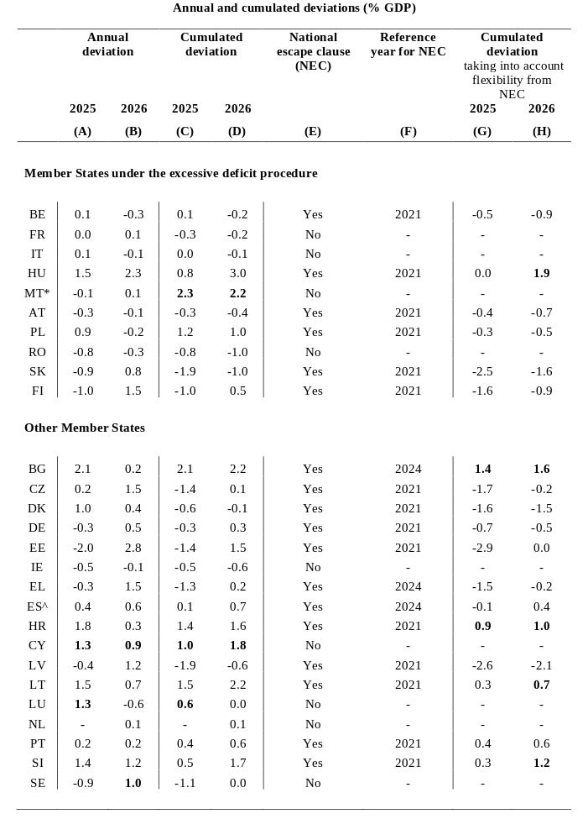

Table 3 - continued
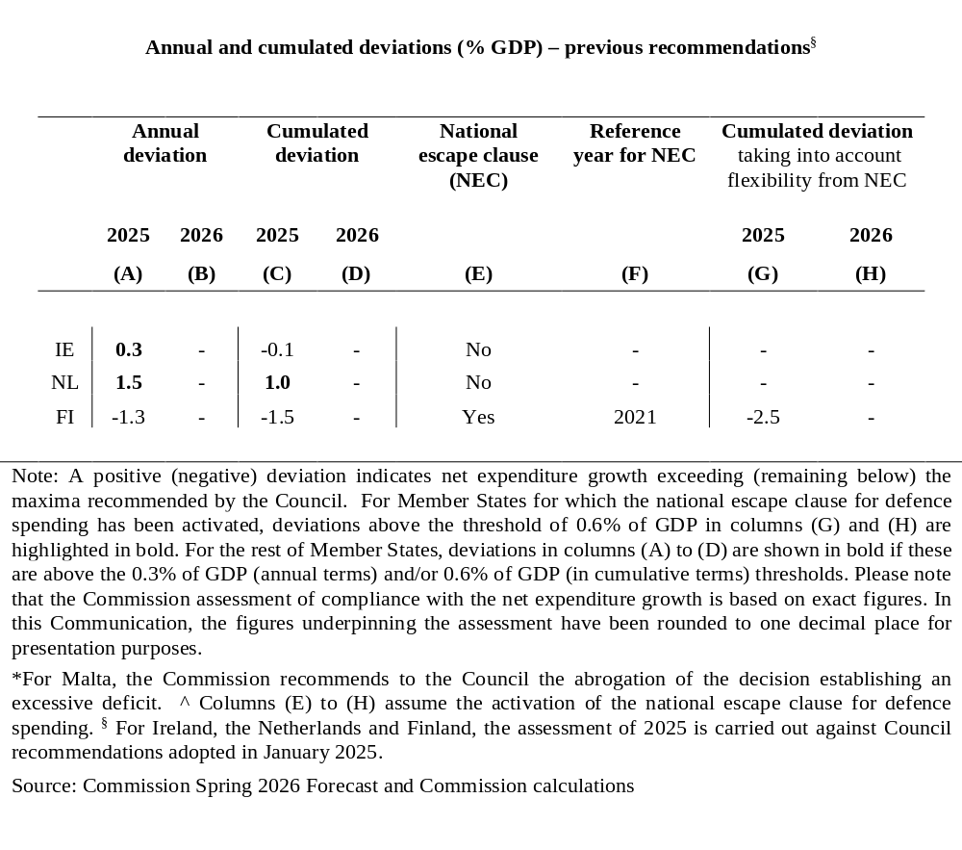

Table 4 General government balance, debt and GDP growth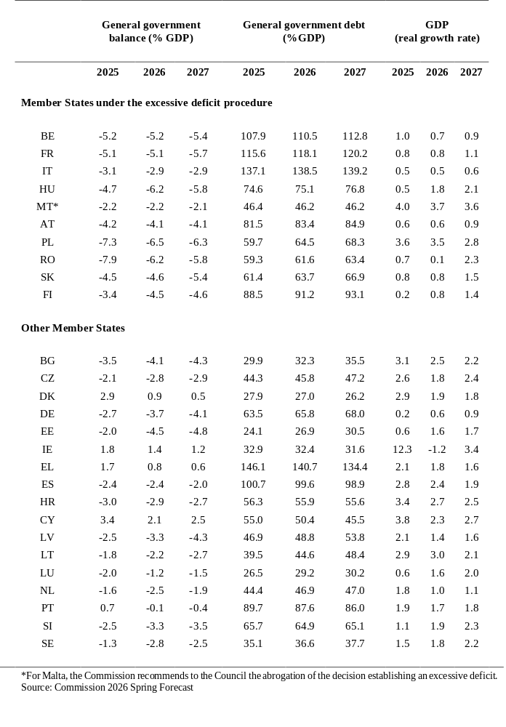

Box 5 - Methodological approach underpinning the assessment of compliance
A Member State is assessed () to be ‘compliant’ when the net expenditure () growth is within the ceilings recommended by the Council. Where net expenditure growth is higher than recommended (i.e. positive deviations), the Commission considers the size of the deviation in relation to the thresholds of 0.3% of GDP in annual terms (see columns (A) and (B) in Table X1X) and 0.6% of GDP in cumulative terms since the start of the plan (columns (C) and (D)). A positive deviation below these thresholds entails an assessment of (risk of) non-compliance, while a deviation above these thresholds entails an assessment of (risk of) material non-compliance (). In its assessment of compliance based on net expenditure growth, the Commission also takes into account the overall budgetary position of a Member State, in particular whether it is close to balance or in surplus.
In Spring 2026, for the first time after the entry into force of the reformed Economic Governance framework, the fiscal assessment reflects the Commission’s calculation of the control account for each Member State based on outturn data. The control accounts keep track of deviations from the recommended maximum growth rates of net expenditure both in annual and cumulative terms since the base year of the relevant Council recommendation for each Member State. They also constitute the basis to monitor compliance with the Council recommendations under the excessive deficit procedure.
For the Member States for which the national escape clause for defence spending has been activated (column (E)), the assessment of compliance focusses on the comparison in cumulative terms and includes a check whether any positive deviation from the recommended maximum growth of net expenditure in cumulative terms is explained by a corresponding increase in defence expenditure compared to a reference year (column (F)), up to 1.5% of GDP over the period 2025 to 2028. If the cumulated deviation can be explained by the increase in defence expenditure compared to the reference year (columns (G) and (H)), the Member State is considered to be compliant.

A Competitiveness Compass for the EU, COM(2025) 30 final.
AccelerateEU, COM(2026) 370 final.
Communication from the Commission – Middle East Crisis Temporary State Aid Framework, OJ C, C/2026/2593, 5.5.2026; ELI: http://data.europa.eu/eli/C/2026/2593/oj.
Communication from the Commission to the European Parliament, the Council, the European Economic and Social Committee and the Committee of the Regions “Demographic change in Europe: a toolbox for action”.
To ensure equal treatment, Member States that might have already fully used the flexibility under the NEC to increase defence expenditure could receive temporary and limited additional flexibility under the same conditions, including the condition that overall fiscal sustainability risks remain contained.
Net expenditure as defined in Article 2, point (2), of Regulation (EU) 2024/1263: ‘net expenditure’ means government expenditure net of (i) interest expenditure; (ii) discretionary revenue measures; (iii) expenditure on programmes of the Union fully matched by revenue from Union funds; (iv) national expenditure on co-financing of programmes funded by the Union; (v) cyclical elements of unemployment benefit expenditure; and (vi) one-offs and other temporary measures.
Fiscal Statistical Tables providing background data relevant for the assessment of the budgetary policies of the Member States, SWD(2026) 200 final, Brussels 3.6.2026.
The national escape clause for higher defence spending provides limited and temporary flexibility, up to 1.5% of GDP compared to a reference year, over the period 2025 to 2028.
To date, the Council has activated the national escape clause for defence spending for 17 Member States (Belgium, Bulgaria, Czechia, Denmark, Germany, Estonia, Greece, Croatia, Latvia, Lithuania, Hungary, Austria, Poland, Portugal, Slovenia, Slovakia, Finland). For Spain, on 22 May 2026 the Commission has adopted recommendation to the Council to activate the national escape clause for defence, which is now pending adoption by the Council.
For those Member States, the assessment focusses on the comparison in cumulative terms, and checks whether any positive deviation from the recommended ceilings is explained by a corresponding increase in defence expenditure. The flexibility provided for by the national escape clause for defence is the only flexibility taken into account in the Commission’s assessment in spring 2026.
Belgium, France, Italy, Hungary, Malta, Austria, Poland, Romania, Slovakia and Finland.
¹² Based on data provided by Eurostat, Italy’s general government deficit decreased from 3.4% of GDP in 2024 to 3.1% of GDP in 2025. Based on policy measures known by the cut-off date of the forecast, the Commission Spring 2026 Forecast projects a deficit of 2.9% of GDP in both 2026 and 2027.
At the current juncture, there is no outturn data for 2026 and a stepping-up of the procedure could be considered at a later stage if the comparison between net expenditure growth projected in the Commission forecast and the recommended corrective net expenditure path (taking the flexibility for defence spending under the national escape clause into consideration as appropriate) pointed to a particularly serious case of non-compliance.
Belgium, Germany, Spain, France, Italy, Austria, Romania and Finland.
Report from the Commission, prepared in accordance with Article 126(3) of the Treaty on the Functioning of the European Union, 3.6.2026, COM(2026) 302 final. Among the Member States currently not in EDP, at end of 2025 the general government gross debt ratio exceeded the reference value in Germany, Greece, Spain, Portugal and Slovenia. For these Member States, the debt ratio is assessed as sufficiently diminishing and approaching the reference value at a satisfactory pace. Therefore, there were no Member States for which compliance with the debt criterion had to be further examined in the report under Article 126(3) TFEU.
SWD (2026) 137 to 143. The seven in-depth reviews were shared with Member States through the Council’s Economic Policy Committee and its LIME working group in two batches, one in mid-April (for the Netherlands, Romania, Sweden), another one in early-May (for Greece, Hungary, Italy, Slovakia). They are also published as European Economy Institutional Papers.
Savings and Investments Union, COM(2025) 124 final.
Commission Recommendation 2025/2029.
COM(2025) 681 final.
COM(2025) 839 final.
Further development of capital market integration and supervision within the Union, COM(2025) 940 final.
The EU Startup and Scaleup Strategy, COM(2025) 270 final.
European Research Area (ERA) Act.
European Innovation Act.
Apply AI Strategy | Shaping Europe’s digital future.
The AI Continent Action Plan | Shaping Europe’s digital future
A Simpler, Clearer and Better Enforced EU Rulebook, COM(2026) 380 final.
Regulation (EU) No 1024/2012.
Communication of the Commission on A Simpler, Clearer and Better Enforced EU Rulebook, 28 April 2026.
European Grids Package, COM(2025) 1005 final.
Communication on integrated wildfire risk management, COM(2026) 330 final.
Communication on A Strategic Framework for a Competitive and Sustainable EU Bioeconomy COM (2025) 960 final.
Quality Jobs Roadmap, COM(2025) 944 final.
Union of Skills, COM(2025) 90 final.
STEM Education Strategic Plan, COM(2025) 89 final.
Council Recommendation 6081/1/26.
Action Plan on Basic Skills, COM(2025) 88 final.
Conclusions on European Competitiveness in the Digital Decade - Council Conclusions (5 December 2025). Adopted alongside this Spring Package, the 2026 State of the Digital Decade report provides a comprehensive picture of the EU’s digitalisation, identifies the structural gaps to be closed by 2030 and sets out horizontal and country-specific recommendations to guide reforms and investments over the next programming period.
SWD(2026) 770 final.
SWD(2026) 772 final.
See European Commission, Union of Equality strategies: gender equality strategies (2020–2025 and 2026–2030), LGBTIQ+ equality strategies (2020–2025 and 2026–2030), EU anti-racism action plan 2020–2025, EU anti-racism strategy 2026-2030, EU Roma strategic framework 2020–2030 and strategy for the rights of persons with disabilities 2021–2030.
European Affordable Housing Plan, COM(2025) 1025 final.
The European Strategy for Housing Construction, COM(2025) 911 final.
New European Bauhaus, COM(2025) 1026 final.
⁴⁵ Proposal for a Council Recommendation on fighting housing exclusion, COM(2026) 540 final.
The European Strategy for Housing Construction, COM(2025) 911 final.
An EU Agenda for Cities, COM(2025) 739 final.
A vision for Agriculture and Food, COM(2025) 75 final.
Communication on the EU’s eastern regions bordering Russia, Belarus and Ukraine Strong regions for a safe Europe, COM(2026) 82 final.
The European Ocean Pact - Oceans and fisheries - European Commission.
See Regulation (EU) 2024/1263, Article 3 and the underlying recital.
Joint Employment Report 2026, as adopted by the EPSCO Council on 9 March 2026.
SWD(2026)122 – Second-stage country analysis on social convergence in line with the Social Convergence Framework (SCF), 2026.
Including policy action reported during the European Semester missions, in the CSR database, in the annual progress reports, as well as in the RRF reporting (biannual reporting on progress in the implementation of milestones and targets and resulting from the payment request assessment).
Measures foreseen in the annexes of the adopted Council Implementing Decisions on the approval of the assessment of the RRPs or on the approval of the medium-term fiscal structural plans and which have not yet been adopted or implemented but are considered as credibly announced in line with the CSR assessment methodology, warrant “limited progress”.
The 2025 CSRs provided, for each Member State, a consolidated set of recommendations on which further policy actions are needed, based on a review of the outstanding stock of 2019-2024 CSRs, taking into consideration their coverage in the RRPs and their continued relevance.
See also Box 5 at the end of this Appendix.
The 2026 Annual Progress Reports are available on: https://economy-finance.ec.europa.eu/economic-and-fiscal-governance/stability-and-growth-pact/preventive-arm/annual-progress-reports_en. Hungary has to date not yet submitted its APR.
This is relevant for Belgium, Germany, Spain, France, Italy, Austria, Romania and Finland.
A fiscal position ‘close to balance’ is defined as a general government deficit not exceeding 0.5% of GDP, according to recital 14 in Council Regulation (EU) 2024/1264.
Based on data provided by Eurostat, Hungary’s general government deficit decreased from 5.1% of GDP in 2024 to 4.7% of GDP in 2025. Based on policy measures known by the cut-off date of the forecast, the Commission Spring 2026 Forecast projects a deficit of 6.2% of GDP in 2026 and 5.8% of GDP in 2027.
On 1 June 2026, Hungary informed the Commission about its intention to submit a revised national medium-term fiscal-structural plan.
The decrease in the deficit in 2025 reflects high revenue growth, including from corporate and indirect taxation, mainly driven by the expansion of nominal GDP and tax bases, as well as significant tax windfalls. On the other hand, notwithstanding the non-repetition of a sizeable capital transfer granted to the national airline company in 2024, government expenditure continued to increase significantly, with substantial increases in the government’s wage bill and intermediate consumption, as well as a one-off expenditure arising from a court decision.
On 12 May 2026, Czechia informed the Commission about its intention to submit a revised national medium-term fiscal-structural plan.
For Spain, on 22 May 2026 the Commission has adopted a recommendation to the Council to activate the national escape clause for defence, which is now pending adoption by the Council. The assessment of compliance for Spain assumes that the Council will activate the national escape clause.
The Commission assessment of compliance with the net expenditure growth is based on exact figures from the control account. In this Communication, the figures underpinning the assessment have been rounded to one decimal place for presentation purposes (see Table 3).
For an analytical presentation of the net expenditure indicator and the control account, please see the Fiscal Statistical Tables, which provide background data relevant for the assessment of the budgetary policies of the Member States, SWD(2026) 200 final, Brussels 3.6.2026.
According to Regulation (EC) No 1467/97, if the general government debt of a Member State exceeds 60% of GDP, its fiscal position is not ‘close to balance or in surplus’ and the deviation of the net expenditure growth from the recommended ceilings exceeds 0.3% of GDP annually or 0.6% of GDP cumulatively, the Commission should prepare a report under Article 126(3) TFEU for the assessment of the debt criterion.

