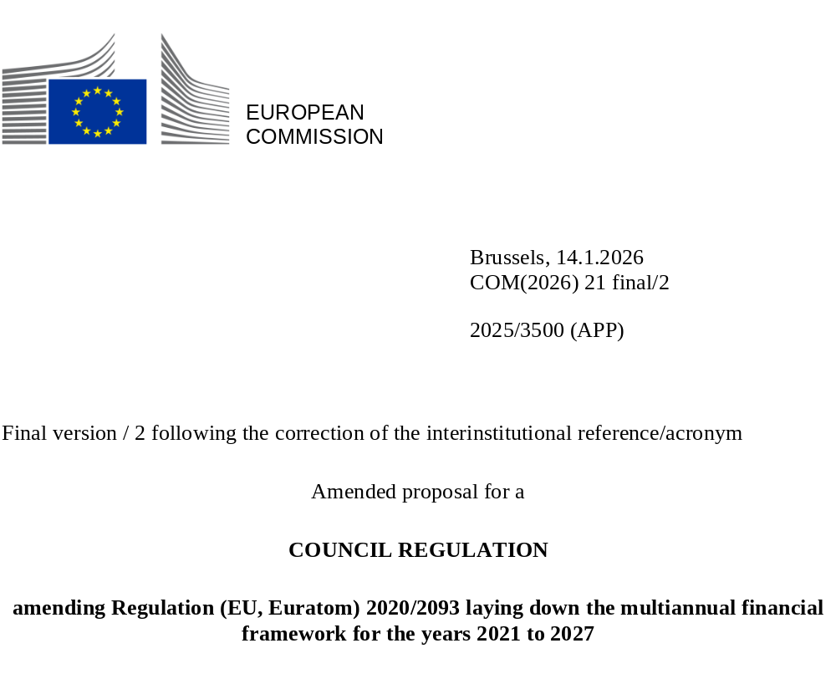

EXPLANATORY MEMORANDUM

1. CONTEXT OF THE PROPOSAL

• Reasons for and objectives of the proposal
This proposal for an amendment of Regulation (EU, Euratom) 2020/2093 is presented together with the proposal for a Regulation establishing the Ukraine Support Loan and amending Regulation (EU) 2024/792 establishing the Ukraine Facility.
Following the unprovoked and unjustified Russian invasion of Ukraine, the Union has provided substantial support to Ukraine through a series of financial measures. Ukraine will require continued assistance, which should be delivered under the proposed new Regulation establishing the Ukraine Support Loan.
The amendment of Regulation (EU, Euratom) 2020/2093 will extend the budgetary guarantee currently applied, as a rule, to loans to Ukraine under the MFA+ instrument, the Ukraine Facility and the MFA to Ukraine under the Ukraine Loan Cooperation Mechanism also covers the financial assistance to Ukraine under Regulation (EU) XXX/XXX of the European Parliament and of the Council. That guarantee should ensure that the necessary resources are always available in time in order to allow the Union to meet all its financial obligations towards its creditors. Accordingly, if the Union has to honour repayment obligations from resources of the Union’s budget - in the case a beneficiary state fails to provide the due payment on time – the necessary amounts would be mobilised over and above the MFF ceilings up to the limits of the own resources ceiling (from the so called ‘headroom’).
The budgetary coverage from the headroom should apply to financial assistance in the form of a loan to Ukraine of an amount of EUR 90 000 000 000 to be implemented in enhanced cooperation.
Concessional support to Ukraine
To provide concessional support to Ukraine and avoid adding pressures on Ukraine’s public finances, the Union budget will cover the costs arising from the borrowing for a loan by providing a borrowing costs subsidy. These costs include debt service costs (cost of funding and costs of issuing and managing liquidity) and the associated administrative costs. The debt service costs will be financed under a new thematic special instrument, the Ukraine Loan Instrument, over and above the MFF ceilings. When mobilising the Ukraine Loan Instrument in the framework of the budgetary procedure, budgetary availabilities in other special instruments, applicable sectoral rules, any legal or other obligations including under the EURI Instrument, priorities, prudent budgeting and sound financial management will be considered.

2. LEGAL BASIS, SUBSIDIARITY AND PROPORTIONALITY

• Legal basis
Article 312 TFEU constitutes the legal basis for the adoption of the Multiannual Financial Framework.

• Subsidiarity (for non-exclusive competence)
The initiative falls under a policy area where the EU has exclusive powers (under Article 312 TFEU). Therefore, the subsidiarity principle does not apply.

• Proportionality
The changes are proportionate to the urgent need to establish an instrument for providing support to Ukraine, which can be implemented only once the budgetary coverage to loans to Ukraine has been established.

• Detailed explanation of the specific provisions of the proposal
Chapter I – General Provisions
Article 2 – Compliance with the ceilings of the MFF
Under the existing provisions of Article 2(3) of Regulation (EU, Euratom) 2020/2093 amounts needed to honour repayment obligations of the Union under borrowing-and-lending operations in case the Union does not receive from the beneficiary state the due payment on time (i.e. the mobilisation of a guarantee for financial assistance to Member States and Ukraine) would be mobilised over and above the MFF ceilings.
The amount mobilised cannot result in exceeding the limits of the own resources ceiling. The provision extending the budgetary coverage from the headroom to the guarantee for financial assistance to Ukraine under the Ukraine Support Loan Regulation is therefore compatible with paragraphs 1 and 3 of Article 312 TFEU, under which the MFF ‘shall ensure that Union expenditure develops in an orderly manner and within the limits of its own resources’, and ‘shall lay down any other provisions required for the annual budgetary procedure to run smoothly’.
Chapter 3 – Special Instruments
Section 1 – Thematic Special Instruments
Article 10c – Ukraine Support Loan Instrument
This new Article is introduced to provide for the ‘Ukraine Support Loan Instrument’, a new thematic special instrument.
The specific items of expenditure for which the Ukraine Support Loan Instrument may be used are the debt service costs, which comprise costs of funding and costs of issuing and managing liquidity, due in respect of the funds borrowed on the capital markets for a loan to Ukraine to be implemented in enhanced cooperation.

4. BUDGETARY IMPLICATIONS
By extending the mobilisation of a guarantee for financial assistance over and above the MFF ceilings to Ukraine for the proposed financial assistance in addition to financial assistance to EU Member States and to Ukraine under the MFA+ instrument, the Ukraine Facility and the MFA to Ukraine under the Ukraine Loan Cooperation Mechanism, the proposal will allow a more efficient use of the budgetary resources under the MFF ceilings. The possibility to mobilise the guarantee over and above the MFF ceilings would offer full coverage of the financial assistance available to Ukraine in accordance with Regulation (EU) XXX/XXX of the European Parliament and of the Council in the next years, in accordance with the principle of sound financial management.
The ‘Ukraine Loan Instrument’ special instrument included in this proposal will be mobilised in the framework of the budgetary procedure provided for in Article 314 TFEU, for amounts established in accordance with the applicable procedures laid down in the relevant basic acts. During the current MFF period, the funds borrowed for financing the loan to Ukraine are expected to give rise to debt service costs, invoiced in 2027, whose coverage may require the mobilisation of the ‘Ukraine Support Loan Instrument’ special instrument. When mobilising the Ukraine Support Loan Instrument in the framework of the annual budgetary procedure, budgetary availabilities in other special instruments, applicable sectoral rules, any legal or other obligations including under the EURI Instrument, priorities, prudent budgeting and sound financial management will be considered.
As expenditure in relation to special instruments is entered in the budget ‘over and above’ the relevant MFF ceilings, the present proposal does not impact the MFF ceilings.

2025/3500 (APP)
Amended proposal for a
COUNCIL REGULATION
amending Regulation (EU, Euratom) 2020/2093 laying down the multiannual financial framework for the years 2021 to 2027
THE COUNCIL OF THE EUROPEAN UNION,
Having regard to the Treaty on the Functioning of the European Union, and in particular Article 312 thereof,
Having regard to the Treaty establishing the European Atomic Energy Community, and in particular Article 106a thereof,
Having regard to the proposal from the European Commission,
Having regard to the consent of the European Parliament⁶,
Acting in accordance with a special legislative procedure,
Whereas:
(1) Following Russia’s unprovoked and unjustified war of aggression against Ukraine, the Union has been supporting Ukraine with a series of financial measures.
(2) Ukraine will require continued financial and economic assistance in a predictable, continuous, orderly, flexible and timely manner covering its financing needs notably resulting from Russia’s war of aggression. To that end, the Union has established a new instrument under Regulation (EU) XXX/XXX of the European Parliament and of the Council. Under that instrument, the envisaged financial assistance is to be provided in the form of loans.
(3) Council Decision (EU) XXX has authorised enhanced cooperation for the establishment of a Ukraine Support Loan of an amount of EUR 90 000 000 000. . Pursuant to Article 332 TFEU, the expenditure resulting from the implementation of enhanced cooperation, is to be borne by the participating Member States. The administrative costs related to the implementation of any enhanced cooperations should be borne by the Union budget.
(4) To that end, tThe Union budget guarantee should be extended to cover the financial assistance in the form of a loan to Ukraine of an amount of EUR 90 000 000 000 implemented in enhanced cooperation under Regulation (EU) XXX/XXX of the European Parliament and of the Council. That guarantee should ensure that the necessary resources are always available in time in order to allow the Union to meet all its financial obligations towards its creditors.
(5) It should be possible to mobilise the necessary appropriations in the Union budget over and above the ceilings of the multiannual financial framework for additional financial assistance to Ukraine. That possibility should be without prejudice to the obligation to respect the own resources ceiling laid down in Article 3(1) of Council Decision (EU, Euratom) 2020/2053.
(6) With a view to providing support to Ukraine on a highly concessional basis, it is appropriate to establish a new thematic special instrument – ‘the Ukraine Support Loan Instrument’, which would allow financing of the debt service costs. The debt service costs comprise cost of funding and costs of issuing and managing liquidity, due in respect of the funds borrowed on the capital markets for a loan to Ukraine to be implemented in enhanced cooperation. Given that the debt service costs related to the loan to Ukraine are expected to start being invoiced in the last year of the Multiannual Financial Framework for the years 2021 to 2027, it is appropriate to consider budgetary availabilities in other special instruments while taking into account applicable sectoral rules, any legal or other obligations including under Article 10a of Council Regulation (EU, Euratom) 2020/2093, priorities, prudent budgeting and sound financial management, when mobilising the Ukraine Support Loan Instrument in the framework of the budgetary procedure.
(7) In view of the urgency entailed by the exceptional needs of Ukraine in the context of Russia’s unprovoked and unjustified war of aggression, it is considered to be appropriate to invoke the exception to the eight-week period provided for in Article 4 of Protocol No 1 on the role of national Parliaments in the European Union, annexed to the Treaty on European Union, to the Treaty on the Functioning of the European Union and to the Treaty establishing the European Atomic Energy Community.
(8) Council Regulation (EU, Euratom) 2020/2093 should therefore be amended accordingly.
(9) In light of the situation in Ukraine and in order to allow for the prompt application of the measures provided for in this Regulation, it should enter into force as a matter of urgency on the day following that of its publication in the Official Journal of the European Union,
HAS ADOPTED THIS REGULATION:
Article 1
Regulation (EU, Euratom) 2020/2093 is amended as follows:
- Article 2 is amended as follows:
  - in paragraph 2, the first subparagraph is replaced by the following:
‘2. Where it is necessary to use the resources from the special instruments provided for in Articles 8, 9, 10, 10a, 10b, 10c and 12, commitment and corresponding payment appropriations shall be entered in the budget over and above the relevant MFF ceilings.’
  - in paragraph 3In Article 2(3) of Regulation (EU, Euratom) 2020/2093, the following subparagraph is added:
‘Where it is necessary to mobilise a guarantee for financial assistance in the form of a loan to Ukraine to be implemented in enhanced cooperation under Regulation (EU) XXX/XXX of the European Parliament and of the Council and authorised in accordance with Article 223(1) of the Regulation (EU, Euratom) 2024/2509 of the European Parliament and Council, the necessary amount shall be mobilised over and above the MFF ceilings. ’
- the following Article 10c is inserted:
‘Article 10c
Ukraine Support Loan Instrument
The Ukraine Support Loan Instrument may be used for the sole purpose of financing debt service costs of a loan to Ukraine to be implemented in enhanced cooperation. The Ukraine Support Loan Instrument may be mobilised by the European Parliament and the Council in the framework of the budgetary procedure provided for in Article 314 TFEU.ʼ
Article 2
This Regulation shall enter into force on the day following that of its publication in the Official Journal of the European Union.
This Regulation shall be binding in its entirety and directly applicable in all Member States.
Done at Brussels,
For the Council
The President

Council Regulation (EU, Euratom) 2020/2093 of 17 December 2020 laying down the multiannual financial framework for the years 2021 to 2027, OJ L 433I, 22.12.2020, p. 11.
Regulation (EU) XXX/XXX of the European Parliament and of the Council of XXX on establishing the Limited Recourse Loan to Ukraine (OJ XXX).
Regulation (EU) 2022/2463 of the European Parliament and of the Council of 14 December 2022 establishing an instrument for providing support to Ukraine for 2023 (macro-financial assistance +) (OJ L 322, 16.12.2022, p. 1, ELI: http://data.europa.eu/eli/reg/2022/2463/oj).
Regulation (EU) 2024/792 of the European Parliament and of the Council of 29 February 2024 establishing the Ukraine Facility (OJ L, 2024/792, 29.2.2024, ELI: http://data.europa.eu/eli/reg/2024/792/oj).
Regulation (EU) 2022/2463 of the European Parliament and of the Council of 14 December 2022 establishing an instrument for providing support to Ukraine for 2023 (macro-financial assistance +) (OJ L 322, 16.12.2022, p. 1, ELI: http://data.europa.eu/eli/reg/2022/2463/oj).
Council Decision (EU) 2026/… (OJ L …, ELI: …).
Council Regulation (EU, Euratom) 2020/2093 of 17 December 2020 laying down the multiannual financial framework for the years 2021 to 2027 (OJ L 433 I, 22.12.2020, p. 11).

