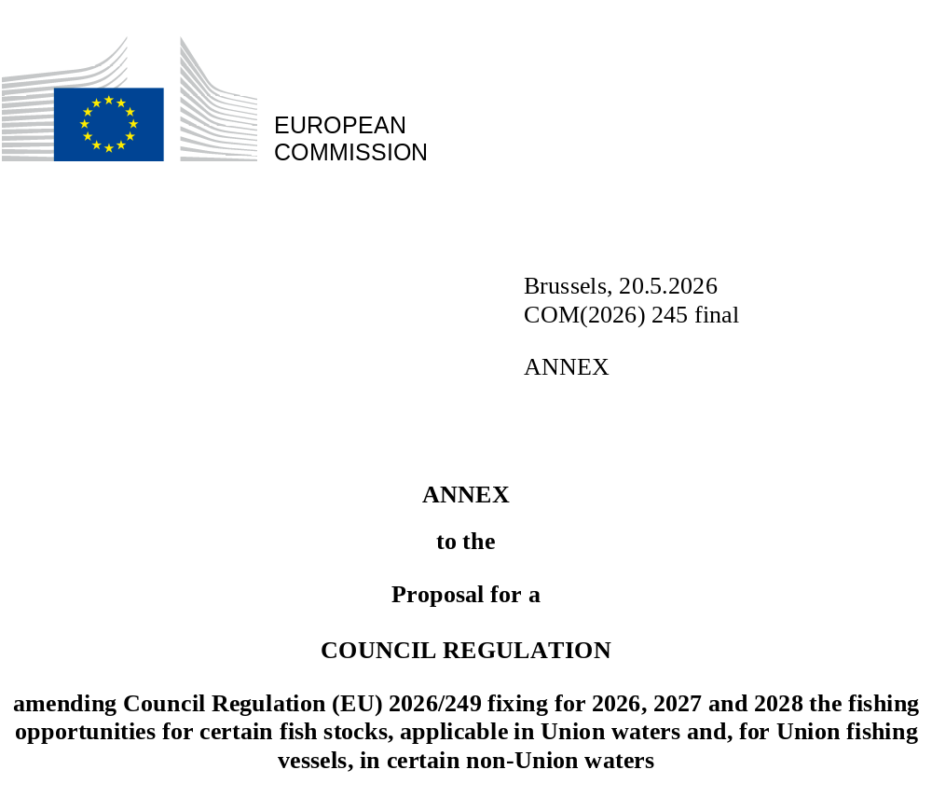

ANNEX

Amendments to Regulation (EU) 2026/249

- Annex IA is amended as follows:
      - In Part A, Table 2(1) is replaced by the following:
“
 |  |  | Table | 2(1)
Species: | Anchovy |  |  | Zone: | 9W⁽¹⁾ and 10
 | Engraulis encrasicolus |  |  |  | (ANE/9WX10)
Spain |  | pm | ⁽²⁾ | Analytical TAC
Portugal |  | pm | ⁽²⁾
Union |  | pm | ⁽²⁾
TAC |  | pm | ⁽²⁾
⁽¹⁾ | Part of subarea 9 west of the line connecting the following points:
 | Point | Latitude | Longitude
 | 1 | 36°00'00"N | 11°00'00"W
 | 2 | 37°01'20"N | 8°59'47"W
⁽²⁾ | This quota may be fished only from 1 July 2026 to 30 June 2027.
”

      - In Part B, Table 77 is replaced by the following:
“
 |  |  | Table | 77
Species: | Northern prawn |  |  | Zone: | 3a
 | Pandalus borealis |  |  |  | (PRA/03A.)
Denmark |  | pm | ⁽¹⁾ | Analytical TAC
Sweden |  | pm | ⁽¹⁾ | Article 3(2) and (3) of Regulation (EC) No 847/96 shall not apply.
Union |  | pm | ⁽¹⁾ | Article 4 of Regulation (EC) No 847/96 shall not apply.
TAC |  | pm | ⁽¹⁾
⁽¹⁾ | This quota may only be fished from 1 July 2026 to 30 June 2027.
”

      - In Part B, Table 79 is replaced by the following:
“
 |  |  | Table | 79
Species: | Northern prawn |  |  | Zone: | Norwegian waters south of 62ºN
 | Pandalus borealis |  |  |  | (PRA/4N-S62)
Denmark |  | pm |  | Analytical TAC
Sweden |  | 123 | ⁽¹⁾ | Article 3(2) and (3) of Regulation (EC) No 847/96 shall not apply.
Union |  | pm |  | Article 4 of Regulation (EC) No 847/96 shall not apply.
TAC |  | Not relevant
⁽¹⁾ | By-catches of cod, haddock, pollack, whiting and saithe are to be counted against the quotas for these species.
”

      - In Part B, Tables 113 and 114 are replaced by the following:
“
 |  |  | Table | 113
Species: | Sprat and associated by-catches |  |  | Zone: | 3a
 | Sprattus sprattus |  |  |  | (SPR/03A.)
Denmark |  | pm | ⁽¹⁾⁽²⁾⁽³⁾ | Analytical TAC
Germany |  | pm | ⁽¹⁾⁽²⁾⁽³⁾
Sweden |  | pm | ⁽¹⁾⁽²⁾⁽³⁾
Union |  | pm | ⁽¹⁾⁽²⁾⁽³⁾
TAC |  | pm | ⁽²⁾
⁽¹⁾ | Up to 5 % of the quota may consist of by-catches of whiting and haddock (OTH/*03A.). By-catches of whiting and haddock counted against the quota pursuant to this provision and by-catches of species counted against the quota pursuant to Article 15(8) of Regulation (EU) No 1380/2013 shall, together, not exceed 9 % of the quota.
⁽²⁾ | This quota shall apply from 1 July 2026 to 30 June 2027.
⁽³⁾ | Transfers of this quota may be effected to United Kingdom and Union waters of 2a and 4. However, such transfers shall be notified in advance to the Commission and to the United Kingdom.
”

“
 |  |  | Table | 114
Species: | Sprat and associated by-catches |  |  | Zone: | United Kingdom and Union waters of 4; United Kingdom waters of 2a
 | Sprattus sprattus |  |  |  | (SPR/2AC4-C)
Belgium |  | pm | ⁽¹⁾⁽²⁾ | Analytical TAC
Denmark |  | pm | ⁽¹⁾⁽²⁾ | Article 3(2) and (3) of Regulation (EC) No 847/96 shall not apply.
Germany |  | pm | ⁽¹⁾⁽²⁾ | Article 4 of Regulation (EC) No 847/96 shall not apply.
France |  | pm | ⁽¹⁾⁽²⁾
Netherlands |  | pm | ⁽¹⁾⁽²⁾
Sweden |  | pm | ⁽¹⁾⁽²⁾⁽³⁾
Union |  | pm | ⁽¹⁾⁽²⁾
Norway |  | pm | ⁽¹⁾
Faroe Islands |  | pm | ⁽¹⁾⁽⁴⁾
United Kingdom |  | pm | ⁽¹⁾
TAC |  | pm | ⁽¹⁾
⁽¹⁾ | The quota shall apply from 1 July 2026 to 30 June 2027.
⁽²⁾ | Up to 2 % of the quota may consist of by-catches of whiting (OTH/*2AC4C). By-catches of whiting counted against the quota pursuant to this provision and by-catches of species counted against the quota pursuant to Article 15(8) of Regulation (EU) No 1380/2013 shall, together, not exceed 9 % of the quota.
⁽³⁾ | Including sandeels.
⁽⁴⁾ | May contain up to 4 % of by-catch of herring.
”

      - In Part B, Table 115 is replaced by the following:
“
 |  |  | Table | 115
Species: | Sprat |  |  | Zone: | 7d and 7e
 | Sprattus sprattus |  |  |  | (SPR/7DE.)
Belgium |  | pm | ⁽¹⁾ | Analytical TAC
Denmark |  | pm | ⁽¹⁾
Germany |  | pm | ⁽¹⁾
France |  | pm | ⁽¹⁾
Netherlands |  | pm | ⁽¹⁾
Union |  | pm | ⁽¹⁾
United Kingdom |  | pm | ⁽¹⁾
TAC |  | pm | ⁽¹⁾
⁽¹⁾ | The quota shall apply from 1 July 2026 to 30 June 2027.
”

- Annex IB is amended as follows:
      - Table 3 is replaced by the following and Table 3(1) is inserted:
“
 |  | Table | 3
Species: | Cod |  | Zone: | Greenland waters of 2 and 12; Greenland waters of 5 and 14, south-west of 42°W
 | Gadus morhua |  |  | (COD/GL251214)
Germany | 2 050 | ⁽¹⁾ | Analytical TAC  Article 3(2) and (3) of Regulation (EC) No 847/96 shall not apply  Article 4 of Regulation (EC) No 847/96 shall not apply
Union | 2 050 | ⁽¹⁾
TAC | Not relevant
⁽¹⁾ | May not be fished from 1 March to 31 May within the ‘Kleine Bank management area’ bounded by the lines joining the following coordinates:
 | Point | Latitude | Longitude
 | 1 | 65°00ʹN | 38°00ʹW
 | 2 | 65°00ʹN | 35°15ʹW
 | 3 | 64°00ʹN | 35°15ʹW
 | 4 | 64°00ʹN | 38°00ʹW
”

“
 |  | Table | 3(1)
Species: | Cod |  | Zone: | Greenland waters of 5 and 14, north-east of 42°W
 | Gadus morhua |  |  | (COD/GL51442)
Union | 900 | ⁽¹⁾ | Analytical TAC  Article 3(2) and (3) of Regulation (EC) No 847/96 shall not apply  Article 4 of Regulation (EC) No 847/96 shall not apply
TAC | Not relevant | ⁽¹⁾
⁽¹⁾ | May only be fished by vessels in the framework of the experimental fishery and conducting scientific sampling. That scientific sampling shall be carried under conditions to be determined by the Greenland Institute of Natural Resources.
”

      - Table 9 is replaced by the following:
“
 |  |  | Table |  | 9
Species: | Capelin |  |  |  | Zone: | Greenland waters of 2, 5, 12 and 14
 | Mallotus villosus |  |  |  |  | (CAP/GL251214)
Year | 2026 |  | 2027
Denmark | 0 | ⁽²⁾ | 0 | ⁽³⁾ | Analytical TAC  Article 3(2) and (3) of Regulation (EC) No 847/96 shall not apply  Article 4 of Regulation (EC) No 847/96 shall not apply
Germany | 0 | ⁽²⁾ | 0 | ⁽³⁾
Sweden | 0 | ⁽²⁾ | 0 | ⁽³⁾
All Member States | 0 | ⁽¹⁾⁽²⁾ | 0 | ⁽¹⁾⁽³⁾
Union | 0 | ⁽²⁾ | 0 | ⁽³⁾
Norway | 0 | ⁽²⁾ | 0 | ⁽³⁾
TAC | Not relevant | ⁽²⁾ | Not relevant | ⁽³⁾
⁽¹⁾ | Denmark, Germany and Sweden may access the ‘All Member States’ quota only once they have exhausted their own quota. However, Member States with more than 10 % of the Union quota shall not access the ‘All Member States’ quota at all. Catches to be counted against this shared quota shall be reported separately (CAP/GL251214_AMS).
⁽²⁾ | This quota shall apply from 15 October 2025 to 15 April 2026.
⁽³⁾ | This quota shall apply from 15 October 2026 to 15 April 2027.
”

      - Table 13 is replaced by the following:
“
 |  | Table | 13
Species: | Northern prawn |  | Zone: | Greenland waters of 2, 5, 12 and 14
 | Pandalus borealis |  |  | (PRA/GL251214)
Denmark | pm |  | Analytical TAC
France | pm |  | Article 3(2) and (3) of Regulation (EC) No 847/96 shall not apply.
Union | pm |  | Article 4 of Regulation (EC) No 847/96 shall not apply.
Norway | pm
Faroe Islands | 0
TAC | Not relevant
”

- In Annex IC, Table 1 is replaced by the following:
“
 |  | Table | 1
Species: | Cod |  | Zone: | NAFO 2J3KL
 | Gadus morhua |  |  | (COD/N2J3KL)
Bulgaria | pm | ⁽¹⁾⁽²⁾ | Analytical TAC
Germany | pm | ⁽¹⁾⁽²⁾ | Article 3(2) and (3) of Regulation (EC) No 847/96 shall not apply.
Estonia | pm | ⁽¹⁾⁽²⁾ | Article 4 of Regulation (EC) No 847/96 shall not apply.
Spain | pm | ⁽¹⁾⁽²⁾
France | pm | ⁽¹⁾⁽²⁾
Latvia | pm | ⁽¹⁾⁽²⁾
Lithuania | pm | ⁽¹⁾⁽²⁾
Poland | pm | ⁽¹⁾⁽²⁾
Portugal | pm | ⁽¹⁾⁽²⁾
Romania | pm | ⁽¹⁾⁽²⁾
Union | pm | ⁽¹⁾⁽²⁾
TAC | pm | ⁽¹⁾⁽²⁾
⁽¹⁾ | This quota shall apply from 1 July 2026 to 30 June 2027.
⁽²⁾ | No directed fisheries are permitted under this quota between 00:00 UTC 15 April 2027 and 23:59 UTC 30 June 2027. During this period, this species shall only be taken as by-catch within the following limits: a maximum of 1 250 kg or 5 %, whichever is greater.
”

- Annex ID is amended as follows:
      - Table 7 is replaced by the following:
“
 |  |  | Table | 7
Species: | Northern Albacore |  |  | Zone: | ICCAT Convention area, north of 5°N, excluding Mediterranean
 | Thunnus alalunga |  |  |  | (ALB/ICAN05NXM)
Ireland |  | 4 959,40 |  | Analytical TAC
Spain |  | 27 953,00 |  | Article 3(2) and (3) of Regulation (EC) No 847/96 shall not apply
France |  | 8 791,67 |  | Article 4 of Regulation (EC) No 847/96 shall not apply
Portugal |  | 3 065,81
Union |  | 44 769,88 | ⁽¹⁾⁽²⁾
United Kingdom |  | 741 | ⁽³⁾
TAC |  | 47 251,00
⁽¹⁾ | The number of Union fishing vessels fishing for Northern albacore as a target species shall be: 1 241.
⁽²⁾ | Special condition: Within the limit of this quota, no more than the following quantities may be taken in United Kingdom waters (ALB/*ICAN05NXM-UK):
 | Ireland | 62,03
 | Spain | 349,65
 | France | 109,97
 | Portugal | 38,35
 | Union | 560,00
⁽³⁾ | Special condition: Within the limit of this quota, no more than the following quantities may be taken in Union waters (ALB/*ICAN05NXM-EU):
 |  | 560,00
”

      - Table 12(1) is replaced by the following:
“
 |  |  | Table | 12
Species: | Bluefin tuna |  |  | Zone: | ICCAT Convention area, east of 45°W
 | Thunnus thynnus |  |  |  | (BFT/ICAE45W)
Cyprus |  | 240,16 | ⁽⁴⁾ | Analytical TAC
Greece |  | 480,79 |  | Article 3(2) and (3) of Regulation (EC) No 847/96 shall not apply
Spain |  | 8 352,55 | ⁽²⁾⁽⁴⁾ | Article 4 of Regulation (EC) No 847/96 shall not apply
France |  | 8 067,21 | ⁽²⁾⁽³⁾⁽⁴⁾
Croatia |  | 1 353,64 | ⁽⁶⁾
Italy |  | 6 534,98 | ⁽⁴⁾⁽⁵⁾
Malta |  | 517,31 | ⁽⁴⁾
Portugal |  | 858,28
Others |  | 104,03 | ⁽¹⁾
Union |  | 26 508,95 | ⁽²⁾⁽³⁾⁽⁴⁾⁽⁵⁾⁽⁶⁾
TAC |  | 48 403,00 | ⁽¹⁾
⁽¹⁾ | Except Cyprus, Greece, Spain, France, Croatia, Italy, Malta and Portugal, and exclusively as by-catch. Catches to be counted against this shared quota shall be reported separately (BFT/ICAE45W_AMS).
⁽²⁾ | Special condition: within this TAC, the following catch limits and allocation between Member States shall apply to catches of bluefin tuna between 8 kg/75 cm and 30 kg/115 cm by the vessels referred to in point 1 of Annex VI (BFT/*E45W8301):
 | Spain | 1 267,03
 | France | 588,60
 | Union | 1 855,63
⁽³⁾ | Special condition: within this TAC, the following catch limits and allocation between Member States shall apply to catches of bluefin tuna weighing no less than 6,4 kg or measuring no less than 70 cm by the vessels referred to in point 1 of Annex VI (BFT/*E45W641):
 | France | 100,00
 | Union | 100,00
⁽⁴⁾ | Special condition: within this TAC, the following catch limits and allocations between Member States shall apply to catches of bluefin tuna between 8 kg/75 cm and 30 kg/115 cm by the vessels referred to in point 2 of Annex VI (BFT/*E45W641):
 | Spain | 167,05
 | France | 322,69 | *
 | Italy | 130,70
 | Cyprus | 4,80
 | Malta | 10,35
 | Union | 635,59
 | * Of which 50% may only be fished in the Gulf of Lion.
⁽⁵⁾ | Special condition: within this TAC, the following catch limits and allocations between Member States shall apply to catches of bluefin tuna between 8 kg/75 cm and 30 kg/115 cm by the vessels referred to in point 3 of Annex VI (BFT/*E45W643):
 | Italy | 130,70
 | Union | 130,70
⁽⁶⁾ | Special condition: within this TAC, the following catch limits and allocations between Member States shall apply to catches of bluefin tuna between 8 kg/75 cm and 30 kg/115 cm by the vessels referred to in point 3 of Annex VI for farming purposes (BFT/*E45W8303F):
 | Croatia | 1 218,28
 | Union | 1 218,28
”

- Annex IM is replaced by the following:

“
ANNEX IM
NPFC CONVENTION AREA

 |  |  |  | Table | 1
Species: | Chub mackerel and blue mackerel  Scomber japonicus and Scomber australasicus |  |  |  | Zone: | NPFC Convention area
Union |  | 5 560 |  | ⁽¹⁾⁽³⁾⁽⁴⁾⁽⁵⁾ | Precautionary TAC
NPFC Contracting Parties, including Union |  | 47 940 |  | ⁽¹⁾⁽²⁾⁽³⁾⁽⁴⁾ | Article 3 of Regulation (EC) No 847/96 shall not apply
TAC |  | Not relevant
⁽¹⁾ | May only be fished from 1 June 2026 to 31 December 2026.
⁽²⁾ | Special condition: under this catch limit no more than the quantities given below may be taken by the following vessels:
 | Trawlers*  (M/M/NPFC-TR) |  | Purse seiners*  (M/M/NPFC-PS)
 | 5 703 |  | 42 237
 | * The fisheries under those catch limits will be closed by NPFC Contracting Parties, including for the Union by the Commission, within two days from the issue date of the notice of the NPFC Executive Secretary that the utilisation of those catch limits has reached 95 %.
⁽³⁾ | Only one trawler flying the flag of a Member State shall be authorised to fish for chub mackerel and blue mackerel at any time. That applies without prejudice to any allocation of future fishing opportunities by the Union in the NPFC Convention area, in particular to the Member State authorised to fish in the period from 1 June 2026 to 31 December 2026.
⁽⁴⁾ | Union fishing vessels over 10 000 gross tonnage shall not be authorised to fish for chub mackerel.
⁽⁵⁾ | Catches under this quota shall be reported separately (M/M/NPFC-EU).
”

