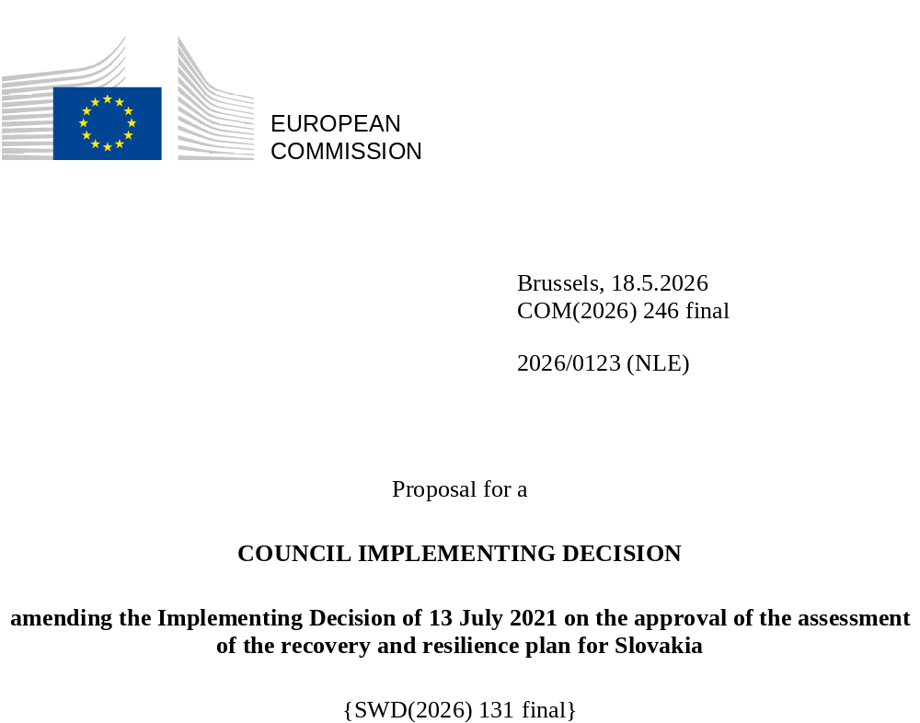

2026/0123 (NLE)
Proposal for a
COUNCIL IMPLEMENTING DECISION
amending the Implementing Decision of 13 July 2021 on the approval of the assessment of the recovery and resilience plan for Slovakia
THE COUNCIL OF THE EUROPEAN UNION,
Having regard to the Treaty on the Functioning of the European Union,
Having regard to Regulation (EU) 2021/241 of the European Parliament and of the Council of 12 February 2021 establishing the Recovery and Resilience Facility, and in particular Article 20(1) thereof,
Having regard to the proposal from the European Commission,
Whereas:
(1) Following the submission of the national recovery and resilience plan (‘RRP’) by Slovakia on 29 April 2021, the Commission proposed its positive assessment to the Council. On 13 July 2021, the Council approved the positive assessment by means of an implementing decision (‘the Council Implementing Decision of 13 July 2021’). The Council Implementing Decision of 13 July 2021 was amended by the Council Implementing Decisions of 14 July 2023, 13 May 2025 and 13 November 2025.
(2) On 30 April 2026, Slovakia made a reasoned request to the Commission to make a proposal to amend the Council Implementing Decision of 13 July 2021 in accordance with Article 21(1) of Regulation (EU) 2021/241 on the grounds that the RRP is partially no longer achievable because of objective circumstances. On that basis, Slovakia has submitted an amended RRP.
Amendments based on Article 21 of Regulation (EU) 2021/241
(3) The amendments to the RRP submitted by Slovakia because of objective circumstances concern 41 measures.
(4) Slovakia has explained that five measures are partially no longer achievable, because beneficiaries withdrew from contracts, interest among potential applicants lacked and delays manifested in implementation. This concerns Investment 1 named Construction of new renewable electricity sources; Investment 3 named Development of intermodal freight transport; Investment 4 named Support for the construction of alternative propulsion infrastructure; Investment 4 named Support for projects aiming at the development of digital technologies and infrastructure; and Reform 3 Creation of a database and data exchange system on the energy performance of buildings. On this basis, Slovakia has requested that those measures be amended. The Council Implementing Decision of 13 July 2021 should be amended accordingly.
(5) Slovakia has explained that 16 measures have been amended to implement better alternatives in order to achieve their original ambition. This concerns Reform 1 named Reform of the content and form of education; Investment 2 named Completion of the school infrastructure; Reform 5 named Concentration of excellent educational and research capacities; Investment 4 named Promoting internationalisation in the academic environment; Investment 7 named Humanisation of institutional psychiatric care; Investment 2 named Extension and restoration of after-care and nursing capacities; Reform 2 named Fighting corruption and strengthening the integrity and independence of the judiciary; Investment 1 named Better services for citizens and businesses; Investment 2 named Digital transformation of public service delivery; Investment 3 named Engaging in European multi-country projects related to the digital economy; Investment 4 named Support for projects aiming at the development of digital technologies and infrastructure; Investment 5 named Hackathons; Investment 6 named Preventive measures, speed of incident detection and resolution (ITVS – Information technologies for public administration); Investment 7 named Digital skills of seniors or disadvantaged people; Reform 4 named Standardisation of technical and procedural cybersecurity solutions (ITVS – Information technologies for public administration); and Reform 5 named Cybersecurity training and skills (ITVS – Information technologies for public administration). On this basis, Slovakia has requested that those measures be amended. The Council Implementing Decision of 13 July 2021 should be amended accordingly.
(6) Slovakia has explained that 13 measures have been amended to implement a better alternative that allow the administrative burden to be reduced and simplify the Council Implementing Decision, while still achieving the objectives of those measures. This concerns Investment 1 named Digital Infrastructure in schools; Investment 6 named Financial instruments to support innovation; Investment 2 named Strengthening relations with the diaspora; Investment 3 named Digitalisation in health; Investment 4 named Construction and rehabilitation of ambulance stations; Reform 1 named Optimisation of the hospital network; Investment 3 named Building community-based mental healthcare centres; Reform 1 named Promoting sustainable energy; Reform 4 named Management of central government buildings; Investment 1 named Increasing energy efficiency of family houses; Investment 2 named Renovation of historical and listed buildings; Investment 8 named Coordination capacities and communication support; and Investment 4 named Supporting the renovation of households at risk of energy poverty. On this basis, Slovakia has requested that those measures be amended. The Council Implementing Decision of 13 July 2021 should be amended accordingly.
(7) Following the decrease in the level of implementation of measures in accordance with Article 21 of Regulation (EU) 2021/241, Slovakia has requested to increase the level of implementation of seven measures. This concerns Investment 2 named Modernising the existing renewable energy sources (repowering); Investment 3 named Increasing flexibility of electricity systems for greater renewables integration; Investment 1 named The development of low-carbon infrastructure; Investment 2 named New hospital network – construction, reconstruction and equipment; Investment 4 named Streamlining, optimizing and strengthening administrative capacity at different levels of government; Investment 2 named Digital transformation of public service delivery; and Investment 3 on Renovation of public historical and listed buildings. On this basis, Slovakia has requested that the level of implementation of eight measures be increased. The Council Implementing Decision of 13 July 2021 should be amended accordingly.
Distribution of milestones and targets
(8) The distribution of milestones and targets in instalments should be amended to take into account the amendments to the RRP and the indicative timeline presented by Slovakia.
Corrections of clerical errors
(9) One clerical error has been identified in recital 25 of the Council Implementing Decision of 13 November 2025. This clerical error relates to the updated maximum financial contribution available for Slovakia. Recital 25 of the Council Implementing Decision of 13 November 2025 states that EUR 6 407 240 019 is allocated for Slovakia, but EUR 6 408 465 019 is allocated for Slovakia. This correction does not affect the assessment or the implementation of the RRP.
Commission’s assessment
(10) The Commission has assessed the amended RRP against the assessment criteria laid down in Article 19(3) of Regulation (EU) 2021/241.
Contribution to the green transition including biodiversity
(11) In accordance with Article 19(3), point (e), of, and criterion 2.5 of Annex V to, Regulation (EU) 2021/241, the amended RRP contains measures that contribute to a large extent (rating A) to the green transition, including biodiversity, or to addressing the challenges resulting therefrom. The measures supporting climate objectives account for an amount which represents 40.0% of the amended RRP’s total allocation and 81.7% of the total estimated costs of measures in the REPowerEU chapter calculated in accordance with the methodology set out in Annex VI to Regulation (EU) 2021/241. In accordance with Article 17 of Regulation (EU) 2021/241, the amended RRP is consistent with the information included in the National Energy and Climate Plan 2021-2030.
(12) The amendment of the RRP does not materially impact its ambition towards the green transition despite a decrease of 0.19 percentage points in the share of the total allocation to measures supporting climate objectives. This decrease mainly results from the decrease in the level of implementation of investment 1 named Construction of new renewable electricity sources under Component 1of the climate tag from investment 2 named Completion of school infrastructure under Component 7. The amended RRP still significantly supports green transition objectives, the enhancement of biodiversity, and environmental protection. In particular, the REPowerEU chapter continues to support the green transition, as its reforms and investments contribute to reduce the reliance on fossil fuels, reduce energy demand and increase energy efficiency.
Contribution to the digital transition
(13) In accordance with Article 19(3), point (f), of, and criterion 2.6 of Annex V to, Regulation (EU) 2021/241, the amended RRP contains measures that contribute to a large extent (rating A) to the digital transition or to addressing the challenges resulting from it. The measures supporting digital objectives account for an amount which represents 21.2% of the amended RRP’s total allocation calculated in accordance with the methodology set out in Annex VII to that Regulation.
(14) The amendment of the RRP does not materially impact ambition towards the digital transition despite a decrease of 0.57 percentage points in the share of the total allocation to measures supporting digital objectives. This decrease mainly results from the decrease in the amount of costs which are tagged digitally and related to investment 2 named Digital transformation of public service delivery and investment 3 named Engaging in European multi-country projects related to the digital economy under Component 17.
Costing
(15) In accordance with Article 19(3), point (i), of, and criterion 2.9 of Annex V to, Regulation (EU) 2021/241, the justification provided in the amended RRP on the amount of the estimated total cost of the RRP is to a medium extent (rating B) reasonable and plausible, is in line with the principle of cost efficiency and is commensurate to the expected national economic and social impact.
(16) The outcome of the costing assessment in the Council Implementing Decision of 13 July 2021 therefore remains unchanged. Slovakia’s justification on the amount of the estimates of total costs of the RRP were reasonable and plausible to a medium extent, in line with the principle of cost efficiency, and was commensurate with the expected national and economic impact. For a limited number of measures, cost benchmarks were less clear, based on little comparable information. Demarcation with other financing sources for projects was also not always clearly indicated, but safeguards were put in place to prevent double funding.
(17) The assessment of the cost estimates for the amended measures shows that most of the costs are reasonable and plausible, according to the information provided. For some amended measures, information on the reasonability and plausibility of cost estimates is limited or missing. This precludes an A rating under the given assessment criterion. Changes in the cost estimates for amended measures were justified and proportional where possible and as such the reasonability and plausibility of these cost estimates were not altered compared to the original RRP. Details on the methodology and the assumptions used to make the cost estimates were justified and proportional throughout most of the amended RRP. Finally, the amount of the estimated total cost of the RRP is in line with the principle of cost efficiency and commensurate to the expected national economic and social impact.
Any other assessment criteria
(18) The Commission considers that the amendments put forward by Slovakia do not affect the positive assessment of the RRP set out in the Council Implementing Decision ST 10156/21 of 13 July 2021 on the approval of the assessment of the RRP for Slovakia regarding the relevance, effectiveness, efficiency and coherence of the RRP against the assessment criteria laid down in Article 19(3), points (a), (b), (c), (d), (da), (db), (g), (h), (j) and (k).
Measures supporting investment operations contributing to the objectives of the Strategic Technologies for Europe Platform (STEP)
(19) In accordance with Article 4(4) of Regulation (EU) 2024/795, Slovakia considered as a matter of priority projects that have been awarded a Sovereignty Seal pursuant to Article 4(1) of Regulation (EU) 2024/795. However, Slovakia considered that no project having been awarded a Sovereignty Seal was to be included in the amended RRP because of insufficient time to complete such projects before the end date of the RRF.
Positive assessment
(20) Following the positive assessment by the Commission of the amended RRP, with the finding that the RRP satisfactorily complies with the criteria for assessment set out in Regulation (EU) 2021/241, in accordance with Article 20(2) of and Annex V to that Regulation, the reforms and investment projects necessary for the implementation of the amended RRP, the relevant milestones, targets and indicators, and the amount made available from the Union for the implementation of the amended RRP should be set out.
Financial contribution
(21) The estimated total costs of Slovakia’s amended RRP is EUR 6 408 465 020. As the amount of the estimated total cost of the amended RRP is higher than the updated maximum financial contribution available for Slovakia, the financial contribution determined in accordance with Article 4a of Regulation (EU) 2021/1755 of the European Parliament and of the Council, and with Article 20(4) and Article 21a(6) of Regulation (EU) 2021/241 that is allocated for Slovakia’s amended RRP should be equal to EUR 6 408 465 019. Therefore, the financial contribution made available to Slovakia remains unchanged.
(22) The amount of the financial contribution for Slovakia should be determined in this decision in accordance with Article 20 of Regulation (EU) 2021/241. However, pursuant to Commission Implementing Decision of 8 May 2025 on the reduction of the amount of the fifth instalment of the non-repayable support for Slovakia, adopted in accordance with Article 24(8) of Regulation (EU) 2021/241, the financial contribution has been reduced by EUR 1 225 000 and Slovakia cannot request its disbursement from the Commission.
(23) The Council Implementing Decision of 13 July 2021 should therefore be amended accordingly. For the sake of clarity, the Annex to the Council Implementing Decision of 13 July 2021 should be replaced entirely.
(24) This Decision should be without prejudice to the outcome of any procedures relating to the award of Union funds under any Union programme other than the Facility or to procedures relating to distortions of the operation of the internal market that may be undertaken, in particular under Articles 107 and 108 of the Treaty. It does not override the requirement for Member States to notify instances of potential State aid to the Commission under Article 108 of the Treaty,
HAS ADOPTED THIS DECISION:
Article 1
Approval of the assessment of the RRP
The assessment of the amended RRP for Slovakia on the basis of the criteria provided for in Article 19(3) of Regulation (EU) 2021/241 is approved.
Article 2
Amendments
The Council Implementing Decision of 13 July 2021 on the approval of the assessment of the recovery and resilience plan for Slovakia is amended as follows:
the Annex is replaced by the text set out in the Annex to this Decision.
Article 3
Addressee
This Decision is addressed to the Slovak Republic.
Done at Brussels,
For the Council
The President

OJ L 57, 18.2.2021, p. 17, ELI: https://eur-lex.europa.eu/eli/reg/2021/241/oj
See documents ST 10156/21 INIT, ST 10156/21 ADD 1, ST 10156/21 ADD 1 COR 1 at http://register.consilium.europa.eu
See documents ST 11205/23 INIT, ST 11205/23 ADD 1, ST 11205/23 ADD 1 COR 1 at http://register.consilium.europa.eu
See documents ST 8054/25 INIT and ST 8054/25 ADD 1 at http://register.consilium.europa.eu
See documents ST 14450/25 INIT and ST 14450/25 ADD 1 at http://register.consilium.europa.eu
See documents ST 14450/25 INIT and ST 14450/25 ADD 1 at http://register.consilium.europa.eu
Regulation (EU) 2021/1755 of the European Parliament and of the Council of 6 October 2021 establishing the Brexit Adjustment Reserve (OJ L 357, 8.10.2021, p. 1, ELI: http://data.europa.eu/eli/reg/2021/1755/oj).

