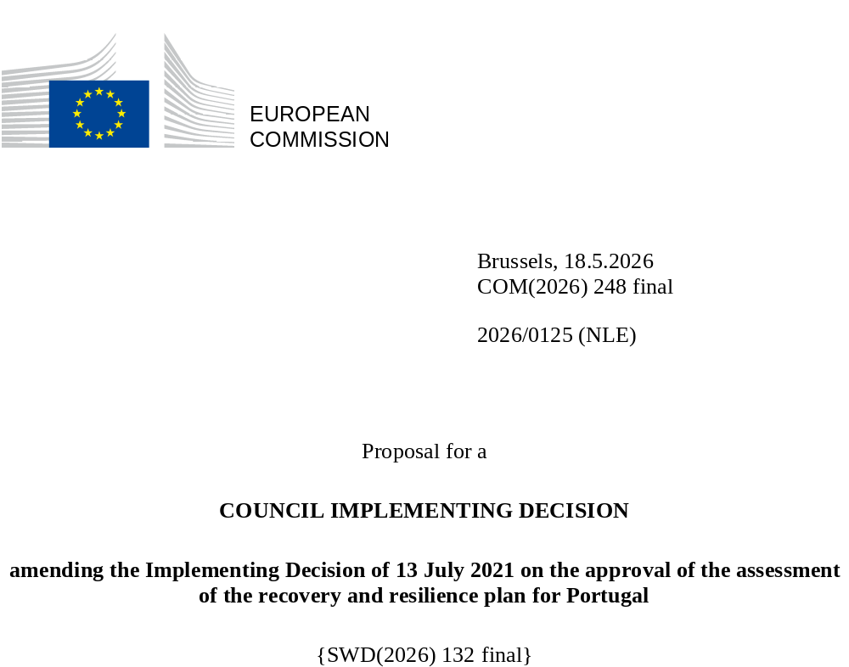

2026/0125 (NLE)
Proposal for a
COUNCIL IMPLEMENTING DECISION
amending the Implementing Decision of 13 July 2021 on the approval of the assessment of the recovery and resilience plan for Portugal
THE COUNCIL OF THE EUROPEAN UNION,
Having regard to the Treaty on the Functioning of the European Union,
Having regard to Regulation (EU) 2021/241 of the European Parliament and of the Council of 12 February 2021 establishing the Recovery and Resilience Facility, and in particular Article 20(1) thereof,
Having regard to the proposal from the European Commission,
Whereas:
(1) Following the submission of the national recovery and resilience plan (‘RRP’) by Portugal on 22 April 2021, the Commission proposed its positive assessment to the Council. On 13 July 2021, the Council approved the positive assessment by means of an implementing decision (‘the Council Implementing Decision of 13 July 2021’). The Council Implementing Decision of 13 July 2021 was amended by the Council Implementing Decisions of 17 October 2023, 8 October 2024, 13 May 2025, 29 September 2025 and 12 December 2025.
(2) On 31 March 2026, Portugal made a reasoned request to the Commission to make a proposal to amend the Council Implementing Decision of 13 July 2021 in accordance with Article 21(1) of Regulation (EU) 2021/241 on the grounds that the RRP is partially no longer achievable because of objective circumstances. On that basis, Portugal has submitted an amended RRP.
Amendments based on Article 21 of Regulation (EU) 2021/241
(3) The amendments to the RRP submitted by Portugal because of objective circumstances concern 92 measures.
(4) Portugal has explained that two measures are no longer achievable, because of unexpected technical difficulties. This concerns measures C21-09 (One-stop shop for permitting and monitoring renewable energy projects) and C21-i14 (Bus Rapid Transit Braga). On this basis, Portugal has requested that those measures be removed. The Council Implementing Decision of 13 July 2021 should be amended accordingly.
(5) Portugal has explained that 24 measures are partially no longer achievable, because of natural disasters, unexpected technical difficulties or lack of demand. This concerns measures C01-i01 (Primary health care services with more answers), C01-i02 (National Network of Integrated Continuous Care and National Network of Palliative Care), C01-i03 (Support to mental health reform), C01-i05-RAM (Support to Madeira's Regional Health Service), C02-i02 (National Urgent and Temporary Accommodation Exchange), C03-i02 (Accessibility 360), C05-i04-RAA (Recapitalisation of the Business System of the Azores), C05-i07-RAM (Capitalisation instruments for companies in Madeira), C05-i15-RAA (Equity fund for the recapitalisation of the Business System of the Azores), C06-i01 (Mordenisation of vocational education and training institutions), C06-i06 (Capacities in Science), C06-i09 (New or renovated schools), C07-i00 (Extension of the electric vehicle charging network), C07-i02 (Missing links and increasing the capacity of the Network) C07-i06 (Business Reception Areas), C09-i03-RAM (Plan for water efficiency and supply and irrigation systems of Madeira), C10-i02 (Green and Digital Transition and Safety in Fisheries), C10-i07 (Green Shipping), C13-i02 (Energy efficiency in government buildings or public buildings), C16-i02 (Digital Transition of Enterprises), C16-i03 (Catalyst for the Digital Transition of Enterprises), C17-i02 (Modernisation of the information systems of the Tax and Customs Authority for rural property taxation), C19-i01 (Redesign of public and consular services), C21-i13-RAM (Decarbonisation of transport). On this basis, Portugal has requested that those measures be amended. The Council Implementing Decision of 13 July 2021 should be amended accordingly.
(6) Portugal has explained that 20 measures have been amended to implement better alternatives in order to achieve their original ambition. This concerns measures C01-i04 (Modernisation and renovation of hospital areas and equipment for hospitals), C02-i03-RAM (Social housing in the Autonomous Region of Madeira), C02-i05 (Affordable public housing stock), C05-i05-RAA (Economic Recovery of Azorean Agriculture), C05-i08 (More Digital Science), C06-i03 (Adult incentive), C06-r14 (Reform of vocational education and training ), C08-i03 (Fuel management breaks - primary network), C09-i01 (Algarve Water Efficiency Regional Plan), C09-i05 (Alqueva Photovoltaic Park), C12-i02 (Recycling and recovery of waste), C14-i03-RAA (Energy Transitions in the Azores), C18-r33 (Economic justice and business environment), C18-i01 (Economic justice and business environment, C19-i05-RAM (Digital transition of Madeira's public administration), C19-i06-RAA (Digital transition of the public administration in Azores), C2-i02-RAA (Digital education (Azores)) C21-i04-RAM (Energy efficiency in public or regional administration buildings in Madeira), C21-i03 (Scale-up measure: Energy efficiency I buildings used by the services sector), C21-i17 (Scheme to support renewable hydrogen and renewable gases). On this basis, Portugal has requested that those measures be amended. The Council Implementing Decision of 13 July 2021 should be amended accordingly.
(7) Portugal has explained that 35 measures have been amended to implement a better alternative that allow the administrative burden to be reduced and simplify the Council Implementing Decision, while still achieving the objectives of those measures. This concerns measures C01-i10 (NHS Technology Modernisation Programme), C01-i11-RAA (Modernisation and requalification of the Regional Health Service), C02-i07-RAA (Infrastructure for parcels of land for residential housing), C03-i01 (New generation of equipment and social responses), C03-i03-RAM (Social responses in the Autonomous Region of Madeira), C03-i04-RAA (Regional Strategy for Combating Poverty and Social Exclusion - Social Support Networks (ARA)), C03-i06 (Social interventions in disadvantaged communities in the Metropolitan Areas of Lisbon and Porto), C03-r38 (Simplification of the Social Security System), C04-i01 (Cultural Networks and Digital Transition), C04-i02 (Cultural Heritage), C05-i03 (Research and innovation agenda for sustainable agriculture, food and agro-industry [Innovation Agenda for Agriculture 2030]), C05-i11 (Scale-up: Mobilising and Green Agendas/Alliances for Business Innovation (Loans)), C05-i13 (Scientific research units), C06-i05-RAA (Adult Qualification and Lifelong Learning (ARA)), C07-i05-RAA (Logistic Circuits - Regional Network of the Azores), C07-i03 (Cross-border links and accessibility of Business Reception Areas), C08-i01 (Landscape Transformation in Vulnerable Forest Areas), C10-i04-RAA ('Cluster do Mar dos Açores'), C10-i05-RAA (Energy transition, digitalisation and reduction of environmental impact in the fisheries and aquaculture sector), C10-i06-RAM (Oceanic technologies), C12-01 (Bioeconomy), C12-r39 (Circular economy and waste management), C13-i01 (Energy efficiency in residential buildings), C13-i03 (Energy efficiency in buildings used by the services sector), C15-i08 (Construction of the Porto Metro Network expansion - Casa da Música-Santo Ovídio, construction phase), C16-i04 (Industry 4.0), C16-i05-RAA (Digital Capacity and Transformation of Enterprises in the Azores), C16-i06-RAM (Enterprises 4.0), C17-r40 (Simplification of the Tax System), C19-i03 (Reinforce the overall cybersecurity framework), C19-i07 (Public administration empowered to create public value), C19-i08 (Intelligent territories), C20-i03-RAM (Accelerating the digitalisation of ARM education), C21-r48 (Simplification of the legal and regulatory framework applicable to renewable energy projects), C21-i16 (Nazaré Funicular). On this basis, Portugal has requested that those measures be amended. The Council Implementing Decision of 13 July 2021 should be amended accordingly.
(8) Following the removal and decrease in the level of implementation of measures in accordance with Article 21 of Regulation (EU) 2021/241, Portugal has requested to use the resources freed up by the removal of measures and the decrease in the level of their implementation to add one new measure. This concerns measure C01-i13 (Primary health care - Health centres). Furthermore, Portugal has requested to increase the level of implementation of 10 measures. This concerns measures C05-i14 (Business innovation), C05-i06 (Capitalisation of companies and financial resilience/Banco Portugues de Fomento), C08-i05 (More Forest Programme), C10-i01 (Blue Hub, Network of Infrastructure for the Blue Economy), C14-i04 (Grant scheme for Hydrogen and renewable gases), C15-i06 (Digitisation of Rail Transport), C19-i04 (Efficient, secure and shared critical digital infrastructure), C21-i02 (Scaled-up measure: Energy efficiency in residential buildings), C21-i18 (Scheme to support network flexibility and storage), C21-i11-RAM (System of incentives for the production and storage of energy from renewable sources in Madeira and Porto Santo). On this basis, Portugal has requested that the level of implementation of 10 measures be increased and that one new measure be added. The Council Implementing Decision of 13 July 2021 should be amended accordingly.
Distribution of milestones and targets
(9) The distribution of milestones and targets in instalments should be amended to take into account the amendments to the RRP and the indicative timeline presented by Portugal.
Corrections of clerical errors
(10) Four clerical errors have been identified in the text of the Council Implementing Decision, affecting three targets and one measure under four components. The Council Implementing Decision should be amended to correct these clerical errors that do not reflect the content of the RRP submitted to the Commission on 26 May 2023, as agreed between the Commission and Portugal. These clerical errors relate to target 1.40 in measure C01-i04 (Modernisation and renovation of hospital areas and equipment for hospitals) under component 1 (National Health Service), target 14.17 in measure C14-i04 (Grant Scheme for Hydrogen and renewable gases) under Component 14 (Hydrogen and Renewables), measure C15-i01 (Expansion of the Lisbon Metro Network — Red Line to Alcântara, contracting phase) under component 15 (Sustainable Mobility) and target 21.32 in measure C21-i10-RAA (System of incentives for the purchase and installation of renewable energy storage system in the Azores) under component 21 (REPowerEU). Those corrections do not affect the implementation of the measures concerned.
Commission’s assessment
(11) The Commission has assessed the amended RRP against the assessment criteria laid down in Article 19(3) of Regulation (EU) 2021/241.
Do no significant harm
(12) In accordance with Article 19(3), point (d), of and Annex V, criterion 2.4, to Regulation (EU) 2021/241, the amended RRP is expected to ensure that no measure (rating A) for the implementation of reforms and investments projects included in the RRP does significant harm to environmental objectives within the meaning of Article 17 of Regulation (EU) 2020/852 of the European Parliament and of the Council (the principle of ‘do no significant harm’).
(13) Portugal submitted an assessment of the principle of ‘do no significant harm’ for each of the new investments. Other modifications of the measures included in the original RRP do not have an impact on the assessment of the principle of ‘do no significant harm’. The information provided allows to conclude that the modified plan is expected to ensure that no measure does significant harm within the meaning of Article 17 of Regulation (EU) 2020/852.
Contribution to the REPowerEU objectives
(14) In accordance with Article 19(3), point (da), of, and criterion 2.12 of Annex V to, Regulation (EU) 2021/241, the REPowerEU chapter is expected to effectively contribute to a large extent (rating A) to energy security, the diversification of the Union’s energy supply, an increase in the uptake of renewables and in energy efficiency, an increase of energy storage capacities or the necessary reduction of dependence on fossil fuels before 2030.
(15) Within the REPowerEU chapter, two measures are removed (C21-09 One-stop shop for permitting and monitoring renewable energy projects) and C21-i14 (Bus Rapid Transit Braga) and the support scheme for renewable gases (C21-i17) was consolidated with the support schemes in Component 14 (C14-i04) for simplification purposes. At the same time, some measures are scaled-up such as energy efficiency in residential buildings (C21-i02) and the support scheme for electricity storage (C21-i18).
Contribution to the green transition including biodiversity
(16) In accordance with Article 19(3), point (e), of and Annex V, criterion 2.5, to Regulation (EU) 2021/241, the amended RRP contains measures that contribute to a large extent (rating A) to the green transition, including biodiversity, or to addressing the challenges resulting therefrom. The measures supporting climate objectives account for an amount which represents 37.93% of the amended RRP’s total allocation and 99.31% of the total estimated costs of measures in the REPowerEU chapter calculated in accordance with the methodology set out in Annex VI to Regulation (EU) 2021/241. In accordance with Article 17 of Regulation (EU) 2021/241, the amended RRP is consistent with the information included in the National Energy and Climate Plan 2021-2030.
(17) Overall, due to the differing climate tagging content of the increased measure and the decreased measures, the amendments to Portugal’s RRP entail a net increase in the overall contribution to the climate target of the RRP by 0.60 percentage points to 37.93% from 37.33%. The measures of the plan are expected to reduce the greenhouse gas emissions and facilitate the uptake of renewable energy and thus contribute to the attainment of the 2030 climate targets and the objective of the Union climate neutrality by 2050.
Contribution to the digital transition
(18) In accordance with Article 19(3), point (f), of and Annex V, criterion 2.6, to Regulation (EU) 2021/241, the amended RRP contains measures that contribute to a large extent (rating A) to the digital transition or to addressing the challenges resulting from it. The measures supporting digital objectives account for an amount which represents 22.32% of the amended RRP’s total allocation calculated in accordance with the methodology set out in Annex VII to that Regulation.
(19) Overall, due to the differing digital tagging content of the increased measure and the decreased measures, the amendments to Portugal’s RRP entail a net decrease in the overall contribution to the digital target of the RRP by 0.48 percentage points to 22.32% from 22.80%. The modified RRP continues to significantly contribute to the digital transition, including by increasing digitalisation of the public administration and enterprises, increasing the number of digital services for citizens and business as well as investments in e-health and digitalisation of transport sector.
Costing
(20) In accordance with Article 19(3), point (i), of and Annex V, criterion 2.9, to Regulation (EU) 2021/241, the justification provided in the amended RRP on the amount of the estimated total cost of the RRP is to a medium extent (rating B) reasonable and plausible, is in line with the principle of cost efficiency and is commensurate to the expected national economic and social impact.
(21) Portugal has provided individual cost estimates for the modified and new investments included in the modified RRP, relying on proportional reduction or increase, and on several sources to justify them. The cost information provided is mostly sufficiently detailed and substantiated. Portugal provided estimates and assumptions on costs, including descriptions and explanations of the main drivers and changes in the costs of the modified measures and their proportionality. The assessment of the cost estimates and supporting documents shows that the majority of the costs of the new and modified measures are well justified, reasonable and plausible. Portugal has also provided sufficient information and evidence that the amount of the estimated total costs is not covered by existing or planned Union financing. Finally, the estimated total cost of the RRP is in line with the principle of cost-efficiency and commensurate to the expected national economic and social impact.
Any other assessment criteria
(22) The Commission considers that the amendments put forward by Portugal do not affect the positive assessment of the RRP set out in the Council Implementing Decision ST 10149/21 of 13 July 2021 on the approval of the assessment of the RRP for Portugal regarding the relevance, effectiveness, efficiency and coherence of the RRP against the assessment criteria laid down in Article 19(3), points (a), (b), (c), (db), (g), (h), (j) and (k).
Measures supporting investment operations contributing to the objectives of the Strategic Technologies for Europe Platform (STEP)
(23) In accordance with Article 4(4) of Regulation (EU) 2024/795, of the European Parliament and of the Council of 29 February 2024 establishing the Strategic Technologies for Europe Platform (STEP), Portugal considered as a matter of priority projects that have been awarded a Sovereignty Seal pursuant to Article 4(1) of Regulation (EU) 2024/795. However, Portugal considered that no project having been awarded a Sovereignty Seal was to be included in the amended RRP because part of these projects have already secured funding from European sources other than the Recovery and Resilience Facility. In addition, projects with a Sovereignty Seal that have not yet secured funding could be funded under the new measure C05-i14 Business innovation in the revised RRP.
Positive assessment
(24) Following the positive assessment by the Commission of the amended RRP, with the finding that the RRP satisfactorily complies with the criteria for assessment set out in Regulation (EU) 2021/241, in accordance with Article 20(2) of and Annex V to that Regulation, the reforms and investment projects necessary for the implementation of the amended RRP, the relevant milestones, targets and indicators, and the amount made available from the Union for the implementation of the amended RRP should be set out.
Financial contribution
(25) The estimated total costs of Portugal’s amended RRP is EUR 21 905 333 169. As the amount of the estimated total cost of the amended RRP is higher than the updated maximum financial contribution available for Portugal, the financial contribution determined in accordance with Article 4a of Regulation (EU) 2021/1755 of the European Parliament and of the Council, and with Article 20(4) and Article 21a(6) of Regulation (EU) 2021/241 that is allocated for Portugal’s amended RRP should be equal to EUR 16 325 113 960. Therefore, the financial contribution made available to Portugal remains unchanged.
Loans
(26) The loan support made available to Portugal amounting to EUR 5 580 219 209 remains unchanged.
(27) The Council Implementing Decision of 13 July 2021 should therefore be amended accordingly. For the sake of clarity, the Annex to the Council Implementing Decision of 13 July 2021 should be replaced entirely.
(28) This Decision should be without prejudice to the outcome of any procedures relating to the award of Union funds under any Union programme other than the Facility or to procedures relating to distortions of the operation of the internal market that may be undertaken, in particular under Articles 107 and 108 of the Treaty. It does not override the requirement for Member States to notify instances of potential State aid to the Commission under Article 108 of the Treaty,
HAS ADOPTED THIS DECISION:
Article 1
Approval of the assessment of the RRP
The assessment of the amended RRP for Portugal on the basis of the criteria provided for in Article 19(3) of Regulation (EU) 2021/241 is approved.
Article 2
Amendments
The Council Implementing Decision of 13 July 2021 on the approval of the assessment of the recovery and resilience plan for Portugal is amended as follows:
the Annex to the Council Implementing Decision of 13 July 2021 on the approval of the assessment of the recovery and resilience plan for Portugal is replaced by the text set out in the Annex to this Decision.
Article 3
Addressee
This Decision is addressed to the Portuguese Republic.
Done at Brussels,
For the Council
The President

OJ L 57, 18.2.2021, p. 17, ELI: https://eur-lex.europa.eu/eli/reg/2021/241/oj.
ST 10149/21 INIT; ST 10149/21 ADD 1 REV 1.
ST 13351/23 INIT; ST 13351/23 ADD 1 REV 1.
ST 13497/24 INIT; ST 13497/24 ADD 1.
ST 8055/25 INIT; ST 8055/25 ADD 1.
ST 12491/25 INIT; ST 12491/25 ADD 1.
ST 15796/25 INIT, ST 15796/25 ADD 1.
Regulation (EU) 2020/852 of the European Parliament and of the Council of 18 June 2020 on the establishment of a framework to facilitate sustainable investment, and amending Regulation (EU) 2019/2088 (OJ L 198, 22.6.2020, p. 13, ELI: https://eur-lex.europa.eu/eli/reg/2020/852/oj/eng).
Regulation (EU) 2024/795 of the European Parliament and of the Council of 29 February 2024 establishing the Strategic Technologies for Europe Platform (STEP), and amending Directive 2003/87/EC and Regulations (EU) 2021/1058, (EU) 2021/1056, (EU) 2021/1057, (EU) No 1303/2013, (EU) No 223/2014, (EU) 2021/1060, (EU) 2021/523, (EU) 2021/695, (EU) 2021/697 and (EU) 2021/241 (OJ L, 2024/795, 29.2.2024, ELI: http://data.europa.eu/eli/reg/2024/795/oj).
Regulation (EU) 2021/1755 of the European Parliament and of the Council of 6 October 2021 establishing the Brexit Adjustment Reserve (OJ L 357, 8.10.2021, p. 1, ELI: http://data.europa.eu/eli/reg/2021/1755/oj).

