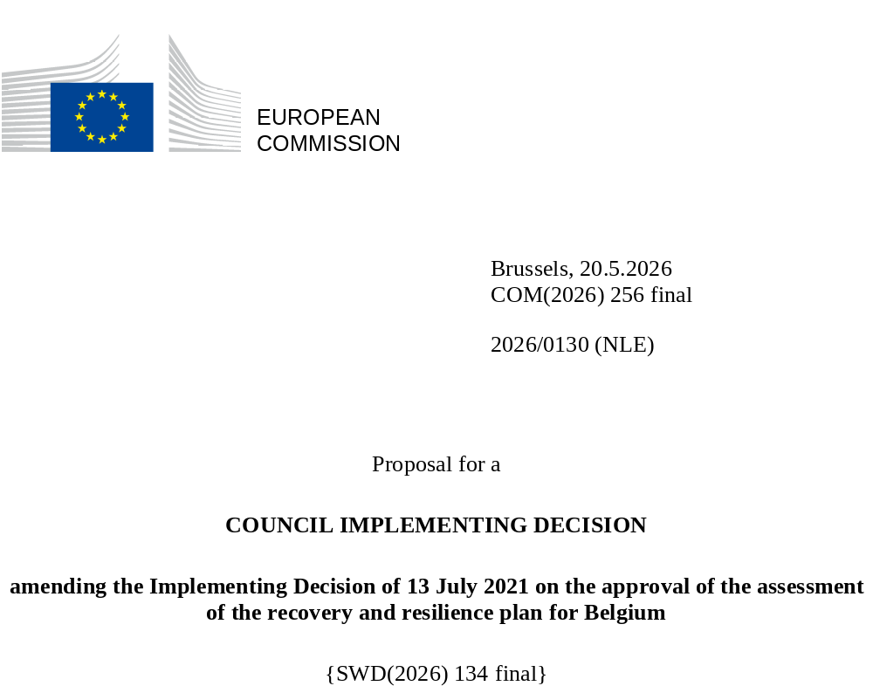

2026/0130 (NLE)
Proposal for a
COUNCIL IMPLEMENTING DECISION
amending the Implementing Decision of 13 July 2021 on the approval of the assessment of the recovery and resilience plan for Belgium
THE COUNCIL OF THE EUROPEAN UNION,
Having regard to the Treaty on the Functioning of the European Union,
Having regard to Regulation (EU) 2021/241 of the European Parliament and of the Council of 12 February 2021 establishing the Recovery and Resilience Facility, and in particular Article 20(1) thereof,
Having regard to the proposal from the European Commission,
Whereas:
(1) Following the submission of the national recovery and resilience plan (‘RRP’) by Belgium on 30 April 2021, the Commission proposed its positive assessment to the Council. On 13 July 2021, the Council approved the positive assessment by means of an implementing decision (‘the Council Implementing Decision of 13 July 2021’). The Council Implementing Decision of 13 July 2021 was amended by the Council Implementing Decisions of 8 December 2023, 10 December 2024, 18 February 2025, 11 March 2025, 20 June 2025, 8 July 2025, and 13 November 2025.
(2) On 20 March 2026, Belgium made a reasoned request to the Commission to make a proposal to amend the Council Implementing Decision of 13 July 2021 in accordance with Article 21(1) of Regulation (EU) 2021/241 on the grounds that the RRP is partially no longer achievable because of objective circumstances. On that basis, Belgium has submitted an amended RRP.
Amendments based on Article 21 of Regulation (EU) 2021/241
(3) The amendments to the RRP submitted by Belgium because of objective circumstances concern 39 measures.
(4) Belgium has explained that one measure is partially no longer achievable, by the fact that the renovation of dwellings in the Brussels region has already been carried out in the context of the overachievement of Target 5. As a result, the actions initially envisaged under Target 6 have been effectively completed and accounted for under Target 5, rendering Target 6 redundant. This concerns target 6 of investment Renovations of dwellings (I-1A). On this basis, Belgium has requested that this measure be removed. The Council Implementing Decision of 13 July 2021 should be amended accordingly.
(5) Belgium has explained that one measure is partially no longer achievable, due to a risk of overlap with other measures. This concerns target 71 of investment Regional data exchange platform of the Brussels-Capital Region (I-2.10). On this basis, Belgium has requested that this measure be removed. The Council Implementing Decision of 13 July 2021 should be amended accordingly.
(6) Belgium has explained that nine measures have been amended to implement better alternatives in order to achieve their original ambition. This concerns the description of milestone 52 of investment Digitalisation IPSS/OISZ (I-2.04), the description of milestone 53 of investment Digitalisation IPSS/OISZ (I-2.04) (sub-measure 3), the description of milestone 55b of investment Digitalisation FPS (I-2.05bis), the description of milestone 65 of investment Digitalisation of ONE (I-2.07), the description of target 73 of investment Digitalisation of citizen-business processes (I-2.11), the description of targets 115 and 115b of investment Greening the bus fleet (I-3G), the description of target 152 of investment Development of public utility housing and housing for vulnerable persons (I-4.12), the description of investment R&D: Minimization of waste during dismantling (I-5.10) and milestone 185 of investment R&D: Minimization of waste during dismantling (I-5.10), the description of targets 190 and 191 of investment Relocation of food and development of logistics platforms (I-5.12), the description of investment Digitisation of the Walloon tourism sector (I-5.13) and target 192 of investment Digitisation of the Walloon tourism sector (I-5.13). On this basis, Belgium has requested that those measures be amended. The Council Implementing Decision of 13 July 2021 should be amended accordingly.
(7) Belgium has explained that 25 measures have been amended to implement better alternatives that allow the administrative burden to be reduced and simplify the Council Implementing Decision, while still achieving the objectives of those measures. This concerns the description of investment Renovations of social housing of the Brussels-Capital Region (I-1.02) and target 7 of investment Renovations of dwellings of the Brussels-Capital Region (I-1.02), the description of investment Building renovations (I-1B), the description of investment Renovation of buildings in the Flemish Region (I-1.05) and target 13 of investment Renovation of buildings in the Flemish Region (I-1.05), the description of investment Renovation of buildings - local authorities & sport in the Walloon Region (I-1.07) and target 14bis of investment Renovation of buildings - local authorities & sport in the Walloon Region (I-1.07), the description of investment Renovation of buildings in the Brussels-Capital Region (I-1.08) and target 14bis of investment Renovation of buildings in the Brussels-Capital Region (I-1.08), the description of investment Renovation of buildings in the French Community in the education, sport, youth and culture domains (I-1.09) and target 14 of investment Renovation of buildings in the French Community in the education, sport, youth and culture domains (I-1.09), the description of milestone 20 of investment An industrial value chain for hydrogen transition of the Federal State (I-1.15), the description of targets 37 and 39 of investment Biodiversity and adaptation to climate change in the Walloon Region (I-1.22), the description of target 252 of investment Marine Nature Restoration Programme (I-1.25), the description of investment Cybersecurity: NTSU/CTIF interception registry (I-2.03) and milestone 50 Cybersecurity: NTSU/CTIF interception registry (I-2.03), the description of investment Digitalisation FPS (I-2.05) and milestones 55, 58, and 60 of investment Digitalisation FPS (I-2.05), the description of milestone 69 of investment Digitalisation of the Flemish Government (I-2.09), the description of investment Development of an AI institute in order to use this technology to meet societal challenges (I-2.14) and target 83 of investment Development of an AI institute in order to use this technology to meet societal challenges (I-2.14), the description of target 100 of investment Enhancing public transport in Wallonia (I-3B), the description of investment Storage, analysis and visualization of mobility data on a digital platform (I-3D) and target 108 of investment Storage, analysis and visualization of mobility data on a digital platform (I-3D), the description of reform Enhancing the Flemish vehicle emission monitoring framework (R-3.07), the description of investment Rail – efficient network of the Federal State (I-3.10), the description of reform Legal acts to reduce early school leaving and absenteeism and address permanent exclusions (R-4.03) and milestone 129 of reform Legal acts to reduce early school leaving and absenteeism and address permanent exclusions (R-4.03), the description of reform End of career and pensions of the Federal State (R-4.07), the description of investment ‘EU Biotech Campus of the Walloon Region (I-5.02) and milestone 161 of investment ‘EU Biotech Campus of the Walloon Region (I-5.02), the description of targets 160 and 163 of investment Upgrading of advanced training infrastructure (I-5.03), the description of investment Digital lifelong learning (I-5.07) and description of target 171 of investment Digital lifelong learning (I-5.07), the description of investment R&D: Minimization of waste during dismantling of the Federal State (I-5.10) and milestone 185 of investment R&D: Minimization of waste during dismantling of the Federal State (I-5.10), the description of reform Revision of the code on air, climate and energy - BCR (R-7.01) and milestone 211 of reform Revision of the code on air, climate and energy - BCR (R-7.01), and milestone 220 of investment ‘Research platform for energy transition’ of the French Community (I-7.11). On this basis, Belgium has requested that those measures be amended. The Council Implementing Decision of 13 July 2021 should be amended accordingly.
(8) Belgium has explained that one measure has been amended due to unforeseen technical difficulties. Owing to shortages on the labour market and high demand for the services of subcontractors to install fibre networks, the contractor was unable to mobilise a sufficient number of workers to complete the works on time. This concerns description of target 84 of investment Improving the connectivity of 35 business parks in Wallonia (I-2.15). On this basis, Belgium has requested that the measure be amended. The Council Implementing Decision of 13 July 2021 should be amended accordingly.
(9) Following the removal of target 71 of investment Regional data exchange platform of the Brussels-Capital Region (I-2.10) and target 6 of investment Renovations of dwellings (I-1A) in accordance with Article 21 of Regulation (EU) 2021/241, Belgium has requested to decrease the level of their implementation. This decrease is offset by the increase the level of implementation of two measures. This concerns target 261 Improved energy subsidy scheme of the Brussels-Capital Region (I-7.01) and target 262 Renovation of social housing of the Brussel-Capital Region (I-1.02). On this basis, Belgium has requested that the level of implementation of these two measures be increased. The Council Implementing Decision of 13 July 2021 should be amended accordingly.
Distribution of milestones and targets
(10) The distribution of milestones and targets in instalments should be amended to take into account the amendments to the RRP and the indicative timeline presented by Belgium.
Corrections of clerical errors
(11) 14 clerical errors have been identified in the text of the Council Implementing Decision of 13 July 2021, affecting seven milestones, five targets and 15 measures under nine components. The Council Implementing Decision of 13 July 2021 should be amended to correct these clerical errors, which do not reflect the content of the RRP submitted to the Commission on 30 April 2021, as agreed between the Commission and Belgium. Those clerical errors relate to the description of milestone 26 of investment An industrial value chain for hydrogen transition (I-1.17) under component 1.2, the description of target 40 of investment Ecological defragmentation (I-1.23) under component 1.3, the description of target 43 of investment Blue Deal (I-1.24) under component 1.3, the description of the following measure Charging stations (I-3F) under component 3.3, the description of milestone 106 and target 107 of investment Canal Albert and Trilogiport (I-3.11) under component 3.2, the description of milestone 139 of reform Re-qualification strategy (R-4.05) under component 4.1, the description of target 166 Strategy for relaunching the labour market focused on the efficiency and optimisation of activation and training policies (I-5.05) under component 5.1, the description of the following measure Equity injection into Participatiemaatschappij Vlaanderen (PMV) to support companies active in the field of biotechnology (I-5.19) under component 5.2, the description of milestones 257 and 258 of investment Capital injection into SFPIM Defence of the Federal state (I-5.20) under component 5.2, the description of milestone 259 of investment Scaled-up measure: Capital injection into SFPIM Defence of the Federal state (I-5.21) under component 5.2, the description of the following measure Renovation of social housing – WAL (I-7.04) under component 7.1, the description of target 216 of investment Energy-climate measures in public buildings – Federal state (I-7.05) under component 7.1, and the description of milestone 234 of investment Optimization of energy distribution (I-7.17) under component 7.3. Those corrections do not affect the implementation of the measures concerned.
Commission’s assessment
(12) The Commission has assessed the amended RRP against the assessment criteria laid down in Article 19(3) of Regulation (EU) 2021/241.
(13) The Commission considers that the amendments put forward by Belgium do not affect the positive assessment of the RRP set out in the Council Implementing Decision of 13 July 2021 regarding the relevance, effectiveness, efficiency and coherence of the RRP against the assessment criteria laid down in Article 19(3) of Regulation (EU) 2021/241 points (a), (b), (c), (d), (da), (db), (g), (h), (i), (j), and (k).
Contribution to the green transition including biodiversity
(14) In accordance with Article 19(3), point (e), of, and criterion 2.5 of Annex V to, Regulation (EU) 2021/241, the amended RRP contains measures that contribute to a large extent (rating A) to the green transition, including biodiversity, or to addressing the challenges resulting therefrom. The measures supporting climate objectives account for an amount which represents 45.60% of the amended RRP’s total allocation and 70.32% of the total estimated costs of measures in the REPowerEU chapter calculated in accordance with the methodology set out in Annex VI to Regulation (EU) 2021/241. In accordance with Article 17 of Regulation (EU) 2021/241, the amended RRP is consistent with the information included in the National Energy and Climate Plan 2021-2030.
(15) The measures in the amended RRP continue to significantly contribute to the green transition. The green contribution of the amended RRP has increased from 45.41% to 45.60% compared to the amended assessment of 13 November 2025.
(16) The increase was the result of the increased level of ambition of two measures namely investment I-1.02 Renovation of social housing of the Brussels-Capital Region and investment I-7.01 ‘Improved energy subsidy scheme’ of the Brussels-Capital Region.
Contribution to the digital transition
(17) In accordance with Article 19(3), point (f), of, and criterion 2.6 of Annex V to, Regulation (EU) 2021/241, the amended RRP contains measures that contribute to a large extent (rating A) to the digital transition or to addressing the challenges resulting from it. The measures supporting digital objectives account for an amount which represents 26.96% of the amended RRP’s total allocation calculated in accordance with the methodology set out in Annex VII to that Regulation.
(18) The measures in the amended RRP continue to significantly contribute to the digital transition. The digital contribution of the amended RRP has decreased from 27.47% to 26.96% compared to the amended assessment of 13 November 2025.
(19) The decrease was the result of the decreased level of ambition of one measure namely investment I-2.10 Regional Data Exchange Platform.
Positive assessment
(20) Following the positive assessment by the Commission of the amended RRP, with the finding that the RRP satisfactorily complies with the criteria for assessment set out in Regulation (EU) 2021/241, in accordance with Article 20(2) of and Annex V to that Regulation, the reforms and investment projects necessary for the implementation of the amended RRP, the relevant milestones, targets and indicators, and the amount made available from the Union for the implementation of the amended RRP should be set out.
Financial contribution
(21) The estimated total cost of Belgium’s amended RRP is EUR 5 265 406 908. As the amount of the estimated total cost of the amended RRP is higher than the updated maximum financial contribution available for Belgium, the financial contribution determined in accordance with Article 4a of Regulation (EU) 2021/1755 of the European Parliament and of the Council, and with Article 20(4) and Article 21a(6) of Regulation (EU) 2021/241 that is allocated for Belgium’s amended RRP should be equal to EUR 5 033 950 235. Therefore, the financial contribution made available to Belgium remains unchanged.
Loans
(22) The loan support made available to Belgium amounting to EUR 230 100 000 remains unchanged.
(23) The Council Implementing Decision of 13 July 2021 should therefore be amended accordingly. For the sake of clarity, the Annex to the Council Implementing Decision of 13 July 2021 should be replaced entirely.
(24) This Decision should be without prejudice to the outcome of any procedures relating to the award of Union funds under any Union programme other than the Facility or to procedures relating to distortions of the operation of the internal market that may be undertaken, in particular under Articles 107 and 108 of the Treaty. It does not override the requirement for Member States to notify instances of potential State aid to the Commission under Article 108 of the Treaty,
HAS ADOPTED THIS DECISION:
Article 1
Approval of the assessment of the RRP
The assessment of the amended RRP for Belgium on the basis of the criteria provided for in Article 19(3) of Regulation (EU) 2021/241 is approved.
Article 2
Amendments
The Council Implementing Decision of 13 July 2021 on the approval of the assessment of the recovery and resilience plan for Belgium is amended as follows:
the Annex is replaced by the text set out in the Annex to this Decision.
Article 3
Addressee
This Decision is addressed to the Kingdom of Belgium.
Done at Brussels,
For the Council
The President

OJ L 57, 18.2.2021, p. 17, ELI: https://eur-lex.europa.eu/eli/reg/2021/241/oj.
See documents ST 10161/21 INIT and ST 10161/21 ADD 1.
See documents ST 15570/23 INIT and ST 15570/23 ADD 1.
See documents ST 15974/24 INIT and ST 15974/24 ADD 1.
See documents ST 5654/25 INIT and ST 5654/25 ADD 1.
See documents ST 6545/25 INIT and ST 6545/25 ADD 1.
See documents ST 9584/25 INIT and ST 9584/25 ADD 1.
See documents ST 10529/25 INIT and ST 10529/25 ADD 1.
See documents ST 14449/25 INIT and ST 1445225/25 ADD 1.
Regulation (EU) 2021/1755 of the European Parliament and of the Council of 6 October 2021 establishing the Brexit Adjustment Reserve (OJ L 357, 8.10.2021, p. 1, ELI: http://data.europa.eu/eli/reg/2021/1755/oj).

