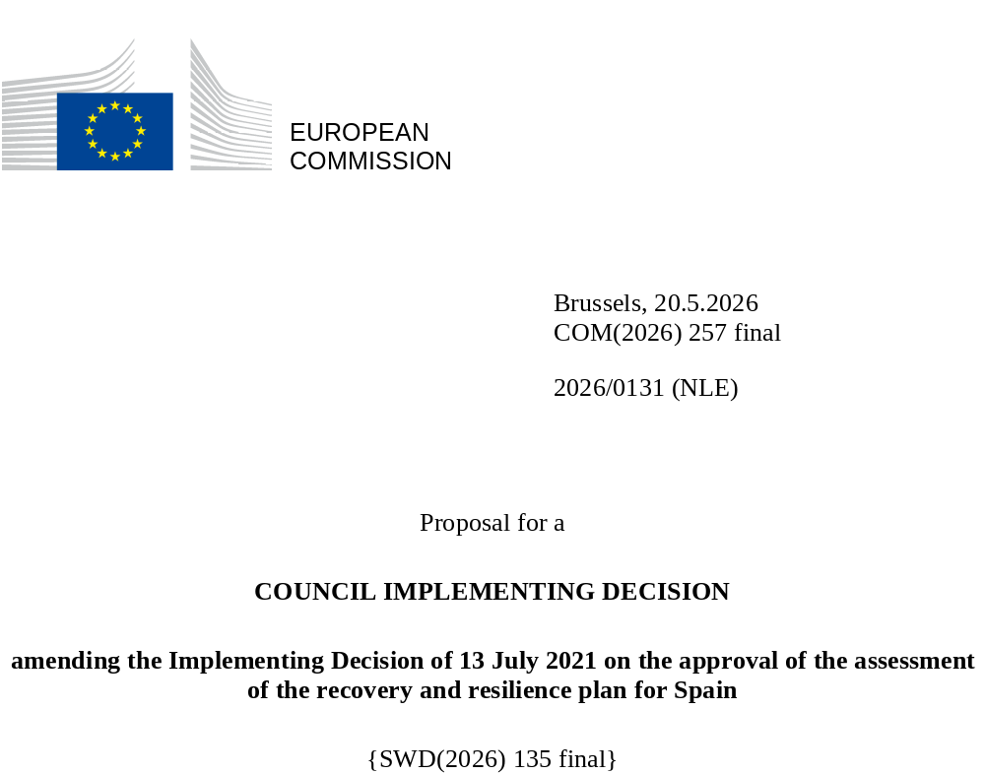

2026/0131 (NLE)
Proposal for a
COUNCIL IMPLEMENTING DECISION
amending the Implementing Decision of 13 July 2021 on the approval of the assessment of the recovery and resilience plan for Spain
THE COUNCIL OF THE EUROPEAN UNION,
Having regard to the Treaty on the Functioning of the European Union,
Having regard to Regulation (EU) 2021/241 of the European Parliament and of the Council of 12 February 2021 establishing the Recovery and Resilience Facility, and in particular Article 20(1) thereof,
Having regard to the proposal from the European Commission,
Whereas:
(1) Following the submission of the national recovery and resilience plan (‘RRP’) by Spain on 3 April 2021, the Commission proposed its positive assessment to the Council. On 13 July 2021, the Council approved the positive assessment by means of an implementing decision (‘the Council Implementing Decision of 13 July 2021’). The Council Implementing Decision of 13 July 2021 was amended by the Council Implementing Decisions of 17 October 2023, 14 May 2024, 21 January 2025, 13 May 2025, 12 June 2025, 10 October 2025, and 20 January 2026.
(2) On 10 March 2026, Spain made a reasoned request to the Commission to make a proposal to amend the Council Implementing Decision of 13 July 2021 in accordance with Article 21(1) of Regulation (EU) 2021/241 on the grounds that the RRP is partially no longer achievable because of objective circumstances. On that basis, Spain has submitted an amended RRP.
Amendments based on Article 21 of Regulation (EU) 2021/241
(3) The amendments to the RRP submitted by Spain because of objective circumstances concern 62 measures.
(4) Spain has explained that one measure has been amended due to lack of demand. This concerns C13.I3 (Digitalisation and Innovation and subsidy scheme for the digitalisation of companies). On this basis, Spain has requested that that measure be amended. The Council Implementing Decision of 13 July 2021 should be amended accordingly.
(5) Spain has explained that 59 measures have been amended to implement better alternatives that allow the administrative burden to be reduced and simplify the Council Implementing Decision, while still achieving the objectives of those measures. This concerns C1.I1 (Low-emission areas and transformation of urban and metropolitan transport), C1.I2 (Incentive scheme for the installation of recharging points, the purchase of electric vehicles and innovation in electro-mobility), C1.I3 (Measures to improve the attractiveness and accessibility of the railway network), C3.I1 (Plan to enhance efficiency and sustainability in irrigation), C3.I12 (Plan to improve efficiency and sustainability in irrigation), C10.I1 (Investment in Just Transition), C11.R1 (Reform for the modernisation and digitalisation of the administration), C11.I1 (Modernisation of the General State Administration), C11.I3 (Digital transformation and modernisation of the Ministry of Territorial Policy and Democratic Memory, Ministry of Digital Transformation and Public Service, and the regional and local administrations, as well as the National Health Service), C11.I4 (Energy transition plan in the General State Administration), C11.I6 (Cybersecurity), C12.R2 (Waste policy and boosting the circular economy), C12.I2 (Programme to boost competitiveness and industrial sustainability), C12.I4 (Reinforcing the industry of the semiconductors value chain), C12.I5 (Subsidy scheme to support the circular economy), C12.I6 (Subsidy scheme to support strategic projects in the value chain of electric cars and other industrial sectors (grants)), C12.I7 (Support scheme to strategic projects in the value chain of electric cars (loans)), C13.R3 (Revision of Securities Markets and Investment Services Law); C13.I1 (Entrepreneurship), C13.I4 (Support for Trade), C13.I5 (Internationalisation), C13.I10 (The COVID-19 Business Recapitalisation Fund (FONREC)), C13.I12 (ENISA Entrepreneurship and SME Fund), C13.I14 (Equity injection into ICO). C14.I2 (Smart destination platform and digitalisation of the tourism sector), C14.I3 (Tourism resilience for extra-peninsular territories), C14.I4 (Special actions in the field of competitiveness), C15.I2 (Enhancing connectivity in centres of reference), C16.R1 (National AI Strategy), C17.I6 (Health), C17.I9 (Aerospace), C17.I10 (Loan support under PERTE Health and PERTE Aerospace), C18.R3 (State Agency for Public Health, appointment and reappointment of Centres, Services and Units of Reference (CSURs), and reorganisation of care not managed by those Centres), C18.I3 (Increased capacities to respond to health crises), C18.I4 (Training of health professionals and improving the treatment of patients with rare diseases), C18.I5 (Plan to rationalise the consumption of pharmaceuticals and promote sustainability, and expand the portfolio of genomic services in the National Health System), C18.I6 (National Health Data Space), C19.I1 (Transversal digital skills), C19.I4 (Digital professionals), C20.I1 (Skills development), C20.I3 (Offer expansion and internationalisation of vocational training), C21.R2 (New curriculum model to improve the quality of education), C21.I2 (Program for orientation, progress and educational enrichment (“PROA+”), C21.I3 (Support to vulnerable students), C21.I5 (University digital capacities and education), C22.R5 (Improvement of the system of non-contributory financial benefits of the General State Administration), C22.I1 (Long-term care and support plan: deinstitutionalisation, equipment and technology), C22.I3 (Spain Accessible Country Plan), C22.I4 (Plan Spain protects you from violence against women), C23.I5 (Governance and boost of policies to support activation, C23.I6 (Comprehensive plan to boost the social economy), C23.I7 (Promoting inclusive growth by linking social inclusion policies to the national minimum income scheme (‘IMV’)), C24.I2 (Boosting culture across the territory), C26.I3 (Promotion of sports), C31.I1 (Investment promoting self-consumption (based on renewable energy and behind-the-meter storage)), C31.I2 (Scheme to support the production and uptake of renewable hydrogen), C31.I3 (Subsidy Scheme to support the decarbonisation of the industrial sector and value chain of renewable energy sources and storage), C31.I6 (Subsidy scheme for decarbonisation projects (grants), and C32.I1 (Green and sustainable mobility and infrastructure). On this basis, Spain has requested that those measures be amended. Furthermore, Spain has requested that the implementation timeline of target 311 be extended. The Council Implementing Decision of 13 July 2021 should be amended accordingly.
(6) Spain has explained that milestone 280 under C18.I2 (Public health campaigns and actions) is no longer achievable within the timeline envisaged, because of the need to follow verification procedures that are lengthier than initially planned but more conducive to meet the policy objectives of the measure. On this basis, Spain has requested that the implementation timeline of milestone 280 be extended. The Council Implementing Decision of 13 July 2021 should be amended accordingly.
(7) Following the decrease in the level of implementation of measure C13.I3 (Digitalisation and Innovation and subsidy scheme for the digitalisation of companies) in accordance with Article 21 of Regulation (EU) 2021/241, Spain has requested to use the resources freed up to increase the level of implementation of C13.I14 (Equity injection into ICO). On this basis, Spain has requested that the level of implementation of one measure be increased. The Council Implementing Decision of 13 July 2021 should be amended accordingly.
(8) Following the Judgment of 15 May 2025 of the Court of Justice of the European Union in Joined Cases C-623/23 [Melbán] and C-626/23 [Sergamo] (ECLI:EU:C:2025:358), the Commission considers that milestone 412 under Reform 4 (Streamlining of maternity add-ons) of Component 30 (Pensions) contains requirements that are incompatible with Union law. To ensure that the Recovery and Resilience Facility only supports measures that are compliant with Union law, milestone 412 should be removed. In order to ensure that the policy objective that milestone 412 intended to contribute is still addressed in the Council Implementing Decision, milestone 412a under Reform 6 (Measures to support gender equality in public office and policy making and enhance labour protections) of Component 22 (Action plan for the care economy, strengthening equality and inclusion policies) should be added. The Council Implementing Decision of 13 July 2021 should be amended accordingly.
Distribution of milestones and targets
(9) The distribution of milestones and targets in instalments should be amended to take into account the amendments to the RRP and the indicative timeline presented by Spain.
Corrections of clerical errors
(10) Eight clerical errors have been identified in the text of the Council Implementing Decision of 13 July 2021, affecting seven milestones and targets and one measure under eight components. The Council Implementing Decision should be amended to correct these clerical errors that do not reflect the content of the RRP submitted to the Commission on 3 April 2021, as agreed between the Commission and Spain. Those clerical errors relate to target 427 under C5.I1 (Treatment, sanitation, efficiency, savings, re-use and infrastructure safety (DSEAR) actions), milestones 93 and 94 under C6.I2 (Trans-European Network for Transport Program, other works), milestone 123 under C8.R3 (Regulatory framework for a more flexible energy system), target 221 under C14.I1 (Transformation of the tourism model towards sustainability), milestone 276 under C18.R4 (Regulation of hard-to-fill posts or areas, working hours, on-call duties, retributions, training, work-life balance, retention of talent of healthcare professionals, teaching or research, and strengthening professional skills), milestone 324 under C22.I2 (Plan for the Modernisation of Social Services - Technological transformation, innovation, training and strengthening childcare), target 356 under C24.I2 (Boosting culture across the territory), and the description of the following measure, C13.I11 (Guarantee Instrument SGR-CERSA). These corrections do not affect the assessment or the implementation of the RRP.
Commission’s assessment
(11) The Commission has assessed the amended RRP against the assessment criteria laid down in Article 19(3) of Regulation (EU) 2021/241.
(12) The Commission considers that the amendments put forward by Spain do not affect the positive assessment of the RRP set out in the Council Implementing Decision of 13 July 2021 regarding the relevance, effectiveness, efficiency and coherence of the RRP against the assessment criteria laid down in Article 19(3) of Regulation (EU) 2021/241 points (a), (b), (c), (d),(da), (db), (e), (g), (h), (i), (j) and (k).
Contribution to the digital transition
(13) In accordance with Article 19(3), point (f), of, and criterion 2.6 of Annex V to, Regulation (EU) 2021/241, the amended RRP contains measures that contribute to a large extent (rating A) to the digital transition or to addressing the challenges resulting from it. The measures supporting digital objectives account for an amount which represents 22,7 % of the amended RRP’s total allocation calculated in accordance with the methodology set out in Annex VII to that Regulation.
(14) The amendments to the contribution to the digital transition relate to the correction of a clerical error resulting from the inclusion of the REPowerEU chapter in the digital tagging of the plan in the previous revision, the rectification of the digital tagging of certain projects under measure C13.I3 (Digitalisation and Innovation and subsidy scheme for the digitalisation of companies), to ensure that these projects retain their original classification of a 40% digital contribution, and to the decrease in the level of implementation of measure C13.I3. Overall, the amendments to Spain’s RRP entail a net increase in the overall contribution to the digital target of the RRP by 1,2 % to 22,7 % from 21,5%. The limited scope of these amendments does not change the overall assessment of this criterion.
Financial contribution
(15) The estimated total costs of Spain’s amended RRP is EUR 102 575 266 373. As the amount of the estimated total cost of the amended RRP is higher than the updated maximum financial contribution available for Spain, the financial contribution determined in accordance with Article 4a of Regulation (EU) 2021/1755 of the European Parliament and of the Council, and with Article 20(4) and Article 21a(6) of Regulation (EU) 2021/241 that is allocated for Spain’s amended RRP should be equal to EUR 79 854 183 024. Therefore, the financial contribution made available to Spain remains unchanged.
Loans
(16) The loan support made available to Spain amounting to EUR 22 705 547 373 remains unchanged.
(17) The Council Implementing Decision of 13 July 2021 should therefore be amended accordingly. For the sake of clarity, the Annex to the Council Implementing Decision of 13 July 2021 should be replaced entirely.
(18) This Decision should be without prejudice to the outcome of any procedures relating to the award of Union funds under any Union programme other than the Facility or to procedures relating to distortions of the operation of the internal market that may be undertaken, in particular under Articles 107 and 108 of the Treaty. It does not override the requirement for Member States to notify instances of potential State aid to the Commission under Article 108 of the Treaty,
HAS ADOPTED THIS DECISION:
Article 1
Approval of the assessment of the RRP
The assessment of the amended RRP for Spain on the basis of the criteria provided for in Article 19(3) of Regulation (EU) 2021/241 is approved.
Article 2
Amendments
The Council Implementing Decision of 13 July 2021 on the approval of the assessment of the recovery and resilience plan for Spain is amended as follows:
the Annex is replaced by the text set out in the Annex to this Decision.
Article 3
Addressee
This Decision is addressed to the Kingdom of Spain.
Done at Brussels,
For the Council
The President

OJ L 57, 18.2.2021, p. 17, ELI: https://eur-lex.europa.eu/eli/reg/2021/241/oj
ST 10150/21 INIT; ST 10150/21 ADD 1 REV 2.
ST 13695/23 INIT; ST 13695/23 REV 1 (en); ST 13695/23 ADD 1 REV 1.
ST 9303/24 INIT; ST 9303/24 ADD 1.
ST 17099/24 INIT; ST 17099/24 ADD 1.
ST 8053/25 INIT; ST 8053/25 ADD 1.
ST 9583/25 INIT; ST 9583/25 ADD1; ST 9583/25 ADD 1 COR 1; ST 10408/25.
ST 13075/25 INIT; ST 13075/25 ADD 1.
ST 17031/25 INIT; ST 17031/25ADD1; ST 17031/25 COR1 (es).
Regulation (EU) 2021/1755 of the European Parliament and of the Council of 6 October 2021 establishing the Brexit Adjustment Reserve (OJ L 357, 8.10.2021, p. 1, ELI: http://data.europa.eu/eli/reg/2021/1755/oj).

