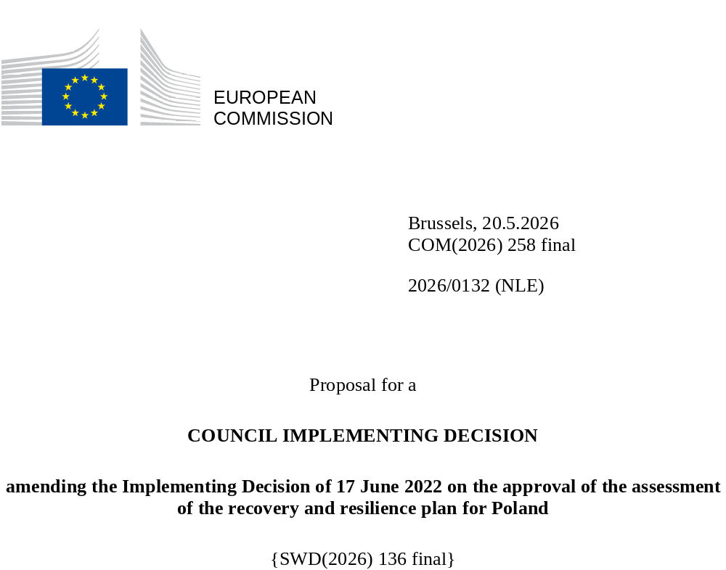

2026/0132 (NLE)
Proposal for a
COUNCIL IMPLEMENTING DECISION
amending the Implementing Decision of 17 June 2022 on the approval of the assessment of the recovery and resilience plan for Poland
THE COUNCIL OF THE EUROPEAN UNION,
Having regard to the Treaty on the Functioning of the European Union,
Having regard to Regulation (EU) 2021/241 of the European Parliament and of the Council of 12 February 2021 establishing the Recovery and Resilience Facility, and in particular Article 20(1) thereof,
Having regard to the proposal from the European Commission,
Whereas:
(1) Following the submission of the national recovery and resilience plan (‘RRP’) by Poland on 3 May 2022, the Commission proposed its positive assessment to the Council. On 17 June 2022, the Council approved the positive assessment by means of an implementing decision (‘the Council Implementing Decision of 17 June 2022’). The Council Implementing Decision of 17 June 2022 was amended by Council Implementing Decisions of 8 December 2023, 16 July 2024, 20 June 2025 and 12 December 2025.
(2) On 11 March 2026, Poland made a reasoned request to the Commission to make a proposal to amend the Council Implementing Decision of 17 June 2022 in accordance with Article 21(1) of Regulation (EU) 2021/241 on the grounds that the RRP is partially no longer achievable because of objective circumstances. On that basis, Poland has submitted an amended RRP.
Amendments based on Article 21 of Regulation (EU) 2021/241
(3) The amendments to the RRP submitted by Poland because of objective circumstances concern 34 measures.
(4) Poland has explained that six measures are no longer achievable, because of unexpected delays due to difficult winter weather conditions, procurement issues, project delays or lack of demand. This concerns measures A1.4.1 (Modernisation of infrastructure or equipment in the agricultural sector), B3.2.1 (Investments in risk neutralisation and the restoration of onshore and offshore sites), B3.5.1 (Investment in housing projects), C2.2.1 (Digital technologies in teaching), E3.1.1 (Facility for support of a low-carbon economy) and G1.1.2 (Supporting the scale-up of energy communities). On this basis, Poland has requested that those measures be amended. The Council Implementing Decision of 17 June 2022 should be amended accordingly.
(5) Poland has explained that three measures are no longer achievable, because of unexpected legal challenges arising from public procurement procedures. This concerns measures A1.3.1 (Implementation of the land-use planning reform), A4.6 (Increase labour market participation of certain groups by developing long-term care), and G3.1.1 (Streamlining the permitting process for renewable energy sources). On this basis, Poland has requested that those measures be amended. The Council Implementing Decision of 17 June 2022 should be amended accordingly.
(6) Poland has explained that two measures have been amended to implement better alternatives in order to achieve their original ambition. This concerns measures E1.1 (Increase in the use of environmentally friendly transport and E1.2.1 (Zero-emission public transport in cities (trams)). On this basis, Poland has requested that those measures be amended and a new measure B4.1 (Reducing dependency on coal) be added. The Council Implementing Decision of 17 June 2022 should be amended accordingly.
(7) Poland has explained that 21 measures have been amended to implement better alternatives that allow the administrative burden to be reduced and simplify the Council Implementing Decision, while still achieving the objectives of those measures. This concerns measures A1.1 (Reform of the fiscal framework), A2.6 (Reform of the national system of monitoring services, products, analytical tools, services and accompanying infrastructure using satellite data), A2.6.1 (Investment in the National Satellite Information System (NSIS) and satellites), A4.1.1 (Investment in support of labour market institution reform), A4.3.1 (Investment into social economy entities), B2.2.3 (Construction of offshore terminal infrastructure), B2.3 (Support for investment in offshore wind farms), C1.1.1 (Access to broadband network), C2.1.2 (Digital technologies in school education – portable devices), C4.1.1 (Support for advanced digital transformation), D1.1.1 (Modernisation of highly specialised care centres and other healthcare providers), D4.1.1 (Increasing long-term care provision by modernisation of medical entities at district level), E1.1.2 (Zero and low-emission buses and trams), E2.1.1 (Railways lines), E2.1.2 (Railways passenger rolling stock), E2.1.3 (Intermodal projects), E2.2.1 (Transport safety investments), E2.2.2 (Digitalisation of transport), G1.2.3 (Transmission networks and smart electricity infrastructure), G1.3.2 (Zero-emission collective transport (buses)) and G3.1.2 (Skills for the green transition). On this basis, Poland has requested that those measures be amended. The Council Implementing Decision of 17 June 2022 should be amended accordingly.
(8) Following the decrease in the level of implementation of measures in accordance with Article 21 of Regulation (EU) 2021/241, Poland has requested to use the resources freed up by the decrease in the level of implementation of measures to increase the level of implementation of two measures. This concerns A2.7.1 (Investment - Security and Defence Fund) and A6.1 (Voluntary contribution to the EU Secure Connectivity Programme (IRIS2)). On this basis, Poland has requested that the level of implementation of two measures be increased. The Council Implementing Decision of 17 June 2022 should be amended accordingly.
Distribution of milestones and targets
(9) The distribution of milestones and targets in instalments should be amended to take into account the amendments to the RRP and the indicative timeline presented by Poland.
Commission’s assessment
(10) The Commission has assessed the amended RRP against the assessment criteria laid down in Article 19(3) of Regulation (EU) 2021/241.
(11) The Commission considers that the amendments put forward by Poland do not affect the positive assessment of the RRP set out in the Council Implementing Decision of 17 June 2022 regarding the relevance, effectiveness, efficiency and coherence of the RRP against the assessment criteria laid down in Article 19(3) of Regulation (EU) 2021/241 points (a), (b), (c), (d),(da), (db), (g), (h), (j) and (k).
Contribution to the green transition including biodiversity
(12) In accordance with Article 19(3), point (e), of, and criterion 2.5 of Annex V to, Regulation (EU) 2021/241, the amended RRP contains measures that contribute to a large extent (rating A) to the green transition, including biodiversity, or to addressing the challenges resulting therefrom. The measures supporting climate objectives account for an amount which represents 40,05% of the amended RRP’s total allocation and 68,17% of the total estimated costs of measures in the REPowerEU chapter calculated in accordance with the methodology set out in Annex VI to Regulation (EU) 2021/241.
(13) While Poland failed to submit its National Energy and Climate Plan by 30 June 2024 in line with Article 14 of Regulation 2018/1999 of the European Parliament and of the Council, the amended RRP remains consistent with the information provided in December 2019 in the National Energy and Climate Plan for the years 2021-2030. The modification of the amended RRP does not materially impact its ambition towards the climate transition. Despite the amendments, the amended RRP continues to significantly contribute to climate change mitigation with interventions in renewable energy production and distribution, energy efficiency, decarbonisation of buildings and zero emission transport.
(14) The measures in the amended RRP continue to significantly contribute to the green transition. The climate contribution of the amended RRP has decreased from 40,26 % to 40,05% compared to the previous assessment.
Contribution to the digital transition
(15) In accordance with Article 19(3), point (f), of, and criterion 2.6 of Annex V to, Regulation (EU) 2021/241, the amended RRP contains measures that contribute to a large extent (rating A) to the digital transition or to addressing the challenges resulting from it. The measures supporting digital objectives account for an amount which represents 21,30% of the amended RRP’s total allocation calculated in accordance with the methodology set out in Annex VII to that Regulation.
(16) The measures in the amended RRP continue to significantly contribute to the digital transition. The digital contribution of the amended RRP has increased from 20,92 % to 21,30 % compared to the previous assessment.
Costing
(17) In accordance with Article 19(3), point (i), of, and criterion 2.9 of Annex V to, Regulation (EU) 2021/241, the justification provided in the amended RRP on the amount of the estimated total cost of the RRP is to a medium extent (rating B) reasonable and plausible, is in line with the principle of cost efficiency and is commensurate to the expected national economic and social impact.
(18) Poland has provided cost estimates for all types of measures under its amended RRP that entail a cost. Overall, the methodology and the assumptions used to reach the cost estimates are clear and understandable, very often based on previous projects financed by the cohesion policy funds. In some cases, details on the methodology and assumptions used to make the cost estimates are limited, hindering a full positive assessment of the cost estimates. Poland has also provided detailed supporting documentation for most types of interventions to underpin the justification and the evidence relating to the cost estimates. Poland has provided sufficient information and assurance that the cost of its amended RRP is not covered by other Union financing. Finally, the estimated total cost of the amended RRP is in line with the principle of cost-efficiency and is commensurate with the expected national economic and social impact.
Measures supporting investment operations contributing to the objectives of the Strategic Technologies for Europe Platform (STEP)
(19) In accordance with Article 4(4) of Regulation (EU) 2024/795, Poland considered as a matter of priority projects that have been awarded a Sovereignty Seal pursuant to Article 4(1) of Regulation (EU) 2024/795. However, Poland considered that no project having been awarded a Sovereignty Seal was to be included in the amended RRP because of insufficient time to complete such projects before the end date of the Recovery and Resilience Facility.
Positive assessment
(20) Following the positive assessment by the Commission of the amended RRP, with the finding that the RRP satisfactorily complies with the criteria for assessment set out in Regulation (EU) 2021/241, in accordance with Article 20(2) of and Annex V to that Regulation, the reforms and investment projects necessary for the implementation of the amended RRP, the relevant milestones, targets and indicators, and the amount made available from the Union for the implementation of the amended RRP should be set out.
Financial contribution
(21) The estimated total costs of Poland’s amended RRP is EUR 54 718 157 234. As the amount of the estimated total cost of the amended RRP is higher than the updated maximum financial contribution available for Poland, the financial contribution determined in accordance with Article 4a of Regulation (EU) 2021/1755 of the European Parliament and of the Council, and with Article 20(4) and Article 21a(6) of Regulation (EU) 2021/241 that is allocated for Poland’s amended RRP should be equal to EUR 25 276 853 716. Therefore, the financial contribution made available to Poland remains unchanged.
Loans
(22) The loan support made available to Poland amounting to EUR 29 441 303 518 remains unchanged.
(23) The Council Implementing Decision of 17 June 2022 should therefore be amended accordingly. For the sake of clarity, the Annex to the Council Implementing Decision of 17 June 2022 should be replaced entirely.
(24) This Decision should be without prejudice to the outcome of any procedures relating to the award of Union funds under any Union programme other than the Facility or to procedures relating to distortions of the operation of the internal market that may be undertaken, in particular under Articles 107 and 108 of the Treaty. It does not override the requirement for Member States to notify instances of potential State aid to the Commission under Article 108 of the Treaty,
HAS ADOPTED THIS DECISION:
Article 1
Approval of the assessment of the RRP
The assessment of the amended RRP for Poland on the basis of the criteria provided for in Article 19(3) of Regulation (EU) 2021/241 is approved.
Article 2
Amendments
The Council Implementing Decision of 17 June 2022 on the approval of the assessment of the recovery and resilience plan for Poland is amended as follows:
the Annex is replaced by the text set out in the Annex to this Decision.
Article 3
Addressee
This Decision is addressed to the Republic of Poland.
Done at Brussels,
For the Council
The President

OJ L 57, 18.2.2021, p. 17, ELI: https://eur-lex.europa.eu/eli/reg/2021/241/oj.
ST 9728/22 INIT; ST 9728/22 ADD 1.
ST 15835/23 INIT; ST 15835/23 REV1; ST 15835/23 ADD 1.
ST 11805/24 INIT; ST 11805/24 ADD 1.
ST 9590/25 INIT; ST 9590/25 ADD 1.
ST 15795/25 INIT; ST 15795/25 ADD 1; ST 15795/25 REV 1 (pl).
Regulation (EU) 2018/1999 of the European Parliament and of the Council of 11 December 2018 on the Governance of the Energy Union and Climate Action, amending Regulations (EC) No 663/2009 and (EC) No 715/2009 of the European Parliament and of the Council, Directives 94/22/EC, 98/70/EC, 2009/31/EC, 2009/73/EC, 2010/31/EU, 2012/27/EU and 2013/30/EU of the European Parliament and of the Council, Council Directives 2009/119/EC and (EU) 2015/652 and repealing Regulation (EU) No 525/2013 of the European Parliament and of the Council (OJ L 328, 21.12.2018, p.1, ELI: http://data.europa.eu/eli/reg/2018/1999/oj).
Regulation (EU) 2021/1755 of the European Parliament and of the Council of 6 October 2021 establishing the Brexit Adjustment Reserve (OJ L 357, 8.10.2021, p. 1, ELI: http://data.europa.eu/eli/reg/2021/1755/oj).

