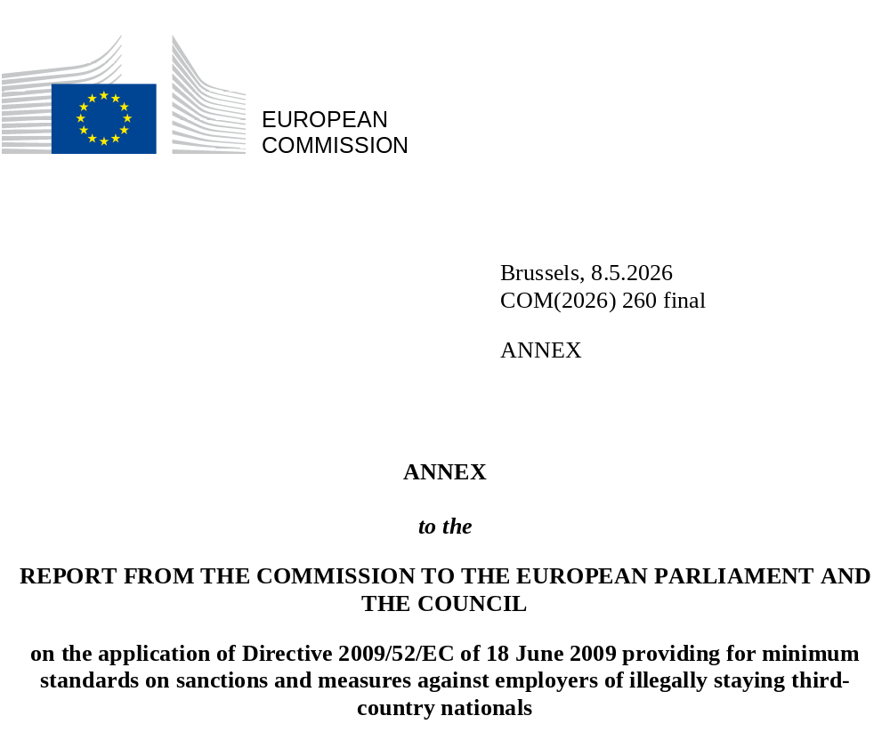

Statistical Annex

Graph 1: Total number of inspections per year (2019-2024)
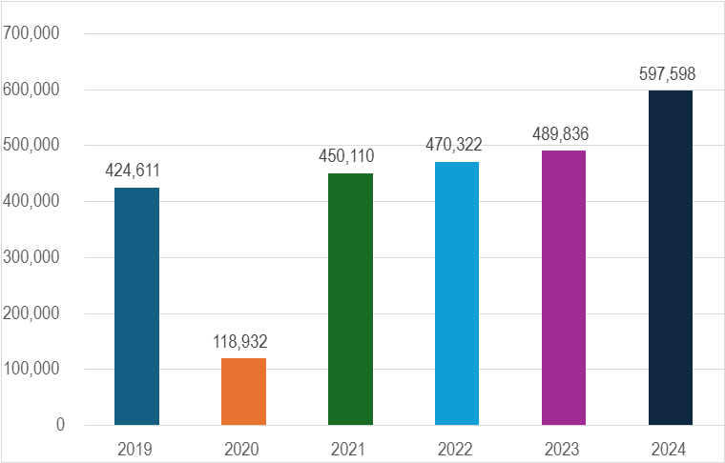
Table 1. Inspections carried out by Member States and percentage of total employers inspected in 2021, 2022, 2023, 2024

Member State | 2021 |  | 2022 |  | 2023 |  | 2024
Member State | Number of inspections carried out | Rates of coverage of inspections  (%) | Number of inspections carried out | Rates of coverage of inspections (%) | Number of inspections carried out | Rates of coverage of inspections (%) | Number of inspections carried out | Rates of coverage of inspections (%)
Austria | 25,525 | 15.4% | 26,053 | 15.1% | 24,925 | 13.8% | 25,296 | 14.1%
Belgium | 15,174 | 6.4% | 14,559 | 6.0% | 15,664 | 6.6% | 78,809 | 33.3%
Bulgaria | 40,727 | 10.2% | 42,319 | 9.7% | 48,567 | 10.8% | 49,600 | 11.9%
Croatia | 8,247 | 2.1% | 8,652 | 2.1% | 7,862 | 2.0% | 7,593 | 2.1%
Cyprus | 5,296 | 13.1% | 7,028 | 15.9% | 5,097 | 9.4% | 6,285 | N/A*
Czechia | 5,222 | 4.0% | 6,573 | 5.1% | 6,574 | 5.1% | 6,328 | 0.5%
Estonia | 256 | 1.0% | 149 | 0.6% | 364 | 2.1% | 754 | 3.1%
Finland | 2,043 | 0.4% | 2,353 | 0.4% | 2,200 | 0.4% | 2,087 | N/A*
France | 104,328 | 9.0% | 100,988 | 6.9% | 112,633 | 38.6% | 111,389 | N/A*
Germany | 46,912 | 12.4% | 53,061 | 14.0% | 42,487 | 18.3% | 25,222 | N/A*
Greece | 21,285 | 9.2% | 26,495 | 14.4% | 26,611 | 15.5% | 30,150 | 16.2%
Hungary | 14,355 | 2.7% | 13,889 | 2.6% | 13,447 | 2.6% | 13,031 | 2.6%
Italy | 84,901 | 16.6% | 83,416 | 4.7% | 89,098 | 0.5% | 146,595 | N/A*
Latvia | 563 | 0.3% | 1,031 | 0.6% | 1,065 | 0.6% | 973 | 0.5%
Lithuania | 3,881 | 3.6% | 4,217 | 3.7% | 5,621 | 1.9% | 7,032 | 4.9%
Luxembourg | 11,385 | 25.4% | 10,171 | 43.2% | 17,328 | 40.4% | 16,174 | 37.7%
Malta | 3,630 | 4.7% | 5,110 | 6.3% | 5,314 | 6.1% | 5471 | 5.9%
The Netherlands | 2,205 | 0.7% | 2,248 | 0.1% | 3,018 | 0.7% | 3,387 | 1.0%
Poland | 8,195 | 0,13% | 10,242 | 0.17% | 10,397 | 0.20% | 10,091 | 0.19%
Portugal | 1,205 | 0.3% | 981 | 0.2% | 508 | 0.1% | 70 | 0.0%
Romania | 1,259 | 0.2% | 2,526 | 0.3% | 5,681 | 0.8% | 3,287 | 0.1%
Slovakia | 17,233 | 30.4% | 17,637 | 77.4% | 18,485 | 43.9% | 18,266 | 50.3%
Slovenia | 10,508 | 4.6% | 10,875 | 48.0% | 6,439 | 26.7% | 6,415 | N/A*
Spain | 13,928 | 1.6% | 17,222 | 1.9% | 17,029 | 1.8% | 18,412 | 2.1%
Sweden | 1,847 | 0.3% | 2,527 | 0.7% | 3,422 | 0.3% | 4,881 | 0.4%

*Data not available

Graph 2: Number of illegally staying third-country nationals detected per year (2019-2024)

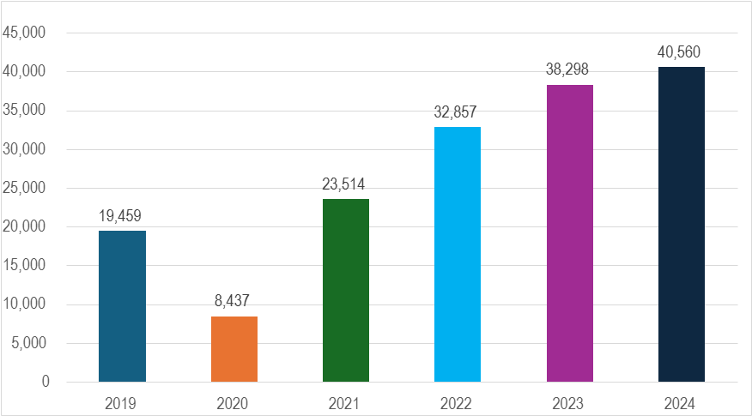

Table 2. Results of inspections: number of illegally staying third country nationals detected and proceedings opened as a result of inspections

Member State | 2021 |  |  | 2022 |  |  | 2023 |  |  | 2024
Member State | Number of inspections in which illegal workers were detected | Number of illegal workers detected | Proceedings opened by Member States following inspections | Number of inspections in which illegal workers were detected | Number of illegal workers detected | Proceedings opened by Member States following inspections | Number of inspections in which illegal workers were detected | Number of illegal workers detected | Proceedings opened by Member States following inspections | Number of inspections in which illegal workers were detected | Number of illegal workers detected | Proceedings opened by Member States following inspections
Austria | 3,457 | 5,992 | 6,695 | 3,612 | 6,495 | 8,045 | 3,788 | 5,816 | 8,278 | 3,740 | 5,303 | 7806
Belgium | 900 | 1,679 | 2,020 | 893 | 2,208 | 574 | 1,021 | 1,511 | 544 | 1,778 | 2,880 | 546
Bulgaria | 10 | 10 | 9 | 9 | 10 | 9 | 12 | 11 | 11 | 14 | 14 | 14
Croatia | 160 | 357 | 389 | 315 | 526 | 551 | 364 | 578 | 486 | 564 | 1,002 | 553
Cyprus | 4 | 5 | 0 | N/A* | 507 | N/A* | 120 | 263 | 0 | 206 | 307 | 282
Czechia | 41 | 145 | 4 | 48 | 77 | 8 | 41 | 51 | 5 | 49 | 87 | 35
Estonia | 56 | 138 | 3 | 23 | 84 | 17 | 68 | 253 | 34 | 10 | 10 | 39
Finland | 33 | 55 | 0 | 23 | 28 | 4 | 23 | 31 | 0 | 18 | 25 | 4
France | 959 | 1,644 | 1,288 | 885 | 1,831 | 1261 | 993 | 1,924 | 1,376 | N/A* | N/A* | 1359
Germany | 6,765 | 5,851 | 4,628 | 8,693 | 7,955 | 5,268 | 11,043 | 9,329 | 6,411 | 10,310 | 9,562 | 6941
Greece | 40 | 58 | 40 | 55 | 80 | 55 | 62 | 120 | 62 | 52 | 81 | 52
Hungary | 21 | 31 | 44 | 56 | 107 | 107 | 83 | 253 | 65 | 127 | 333 | 131
Italy | 389 | 960 | 522 | 1,404 | 2,614 | 609 | 1,465 | 3,196 | 870 | 1,641 | 3,912 | 1134
Latvia | N/A* | 4 | N/A* | 5 | 10 | 5 | 9 | 15 | 9 | 9 | 21 | 9
Lithuania | 7 | 19 | 7 | 10 | 27 | 10 | 24 | 35 | 24 | 55 | 86 | 55
Luxembourg | 52 | 65 | 52 | 105 | 160 | 105 | 167 | 283 | 202 | 124 | 171 | 132
Malta | 7 | 18 | 5 | 14 | 28 | 7 | 35 | 73 | 27 | 34 | 65 | 10
The Netherlands | 442 | 673 | 517 | 494 | 928 | 574 | 649 | 1,160 | 783 | 871 | 1,903 | 1032
Poland | 170 | 364 | 96 | 83 | 146 | 45 | 191 | 290 | 97 | 423 | 1,042 | 272
Portugal | N/A* | N/A* | 101 | N/A* | N/A* | 93 | N/A* | N/A* | 39 | N/A* | 7 | 7
Romania | N/A* | 1 | 34 | N/A* | 73 | 68 | 951 | 597 | 430 | N/A* | 602 | 132
Slovakia | 1 | 1 | 1 | 0 | 0 | 0 | 0 | 0 | 0 | 0 | 0 | 0
Slovenia | 44 | 75 | 40 | 66 | 86 | 58 | 62 | 84 | 67 | 83 | 99 | 73
Spain | 3,332 | 4,893 | 13,928 | 5,719 | 8,637 | 18,312 | 7,124 | 12,176 | 18,402 | 8,124 | 12,806 | 19,694
Sweden | 300 | 476 | 237 | 161 | 240 | 274 | 176 | 249 | 269 | 174 | 242 | 349

*Data not available

Graph 3: Proceedings opened as a result of inspections per year (2021-2024)

Graph 4: Total sum of fines applied against infringing employers per year (2021-2024)

Proceedings are intended to be any action taken by Member State authorities following an inspection, leading to an administrative or criminal sanction.

