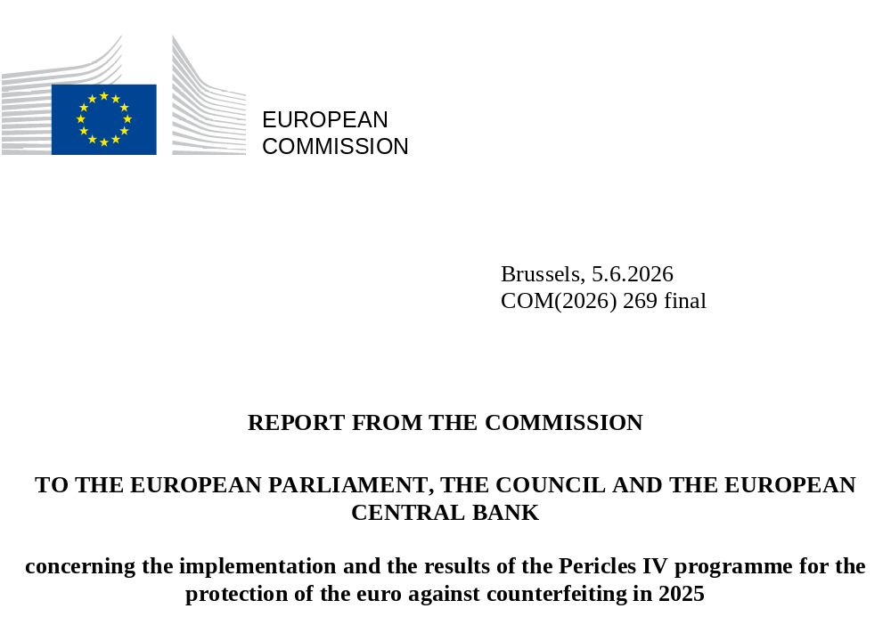

REPORT FROM THE COMMISSION
TO THE EUROPEAN PARLIAMENT, THE COUNCIL AND THE EUROPEAN CENTRAL BANK
concerning the implementation and the results of the Pericles IV programme for the protection of the euro against counterfeiting in 2025

- General
The Pericles IV programme (‘the programme’) is an exchange, assistance and training programme for the protection of the euro against counterfeiting. It replaces the Pericles 2020 programme that ran from 2013 to 2020 and the Pericles programmes that ran during the 2002-2013 period. The programme was established by Regulation (EU) 2021/840 (). Its application was extended to the non-participating Member States by Council Regulation (EU) 2021/1696 (). Regulation (EU) 2021/840 establishes the duration of the programme until 31 December 2027. Article 12(3) of that Regulation requires the European Commission to report annually on the results of the programme to the European Parliament, the Council and the European Central Bank. This is the annual report for 2025. The report provides information on the commitments made and on the implementation of actions of the programme in 2025.
- Commitments under the 2025 annual work programme

The annual budget for the implementation of the 2025 programme was set at EUR 902 450. It was financed from budget line VOBU-2025-E.06030100 (protection of the euro against counterfeiting) () of the general EU budget for 2025. A total of EUR 902 449.47 was committed in 2025, which is 100% of the total budget. The programme is implemented through co-financed actions (grants) originating from the competent authorities of the Member States and ‘Commission actions’ organised directly by the Commission. The total commitment amount also includes EUR 37 038 to cover the annual costs of using the eGrants tool, a fully electronic (paperless) grant management system. In addition to the operational budget line, EUR 15 440.30 was made available on the budget line via the internal assigned revenue (budget line IAR2/2-2024-ECFIN-E.06030100) and committed in 2025 ().

The Member States’ and the Commission’s implementation of the programme reflects their commitment to protecting the euro against counterfeiting. The Euro Counterfeiting Experts Group (ECEG) discussions on the annual strategy made it possible to identify and address the main threats and fully allocate the budget in 2025.

A total of 10 projects were funded under the programme (): 7 grants were awarded to applications from Member State competent authorities and 3 Commission actions were funded. Of the 3 Commission actions, 2 were committed and implemented in 2025 and 1 Commission action will be implemented in 2026. The grants committed in 2025 will be fully implemented in 2026 and beyond.
Chart I and Chart II: Type of action financed and number of actions by Member State (actions committed in 2025, see Annex I)

Italy and Spain, two of the Member States most affected by euro counterfeiting, again received Pericles grants in 2025. In addition, Croatia, Finland and Latvia (the latter two are first-time applicants in the programme) received grants under the 2025 programme. All these efforts boost the protection of the euro, which benefits all other Member States.

The actions under the commitments made in 2025 consist of 5 seminars; 4 technical training sessions; and 1 staff exchange.

The actions are set to take place both inside and outside the EU, depending on specific needs. Since its inception, the programme has consolidated its regional approach by implementing actions involving regions of the world which are particularly important in the fight against counterfeiting, such as south-eastern Europe, Türkiye and South America.

- Implementation of actions in 2025

Overview

This section analyses the implementation of all Pericles-funded actions in the 2025 calendar year. It therefore includes actions committed to under the 2024 () and 2025 () Pericles IV budgets.

Overall, 2025 saw the implementation of 10 Pericles-funded actions, including:
- 8 grant actions committed to in 2024: these actions were implemented by Spain (3 actions), Portugal (2 actions), Italy (2 actions) and Croatia (1 action);
- 2 procured Commission actions committed to in 2025.

The above actions consist of 3 staff exchanges, 3 technical training sessions, 3 seminars and 1 purchase of equipment. An estimated 394 experts participated in the actions ().

Chart III and Chart IV: Origin and professional background of participants (actions implemented in 2025)

Origin of participants

The participants came from 50 countries. Most of those attending training (68%) were European: 40% from euro area Member States, 3% from non-euro area Member States and 25% from non-EU countries in Europe. Of the remaining participants, 16% were from Latin America, 9% from Africa, 6% from the European institutions, and 1% from other regions.

Professional background of participants

Police staff represented 46% of the participants in 2025. That prominent presence is due to the fact that police authorities represent the frontline in the fight against euro counterfeiting, and police staff include both investigators and technicians. Experts from the national central banks represented 37% of participants, making them the second largest group, due to several actions that focused on cooperation with and among national central banks. Staff of the European institutions (6%), the judiciary (3%), national mints (1%), customs (1%) and other categories (1%) also participated, reflecting a full range of professional backgrounds. The training course on the handling of coins unfit for circulation was attended by representatives from the coin processing machine industry (5%). This continues to affirm the private sector’s role as a significant stakeholder in the fight against counterfeiting. As a result, the implementation of the programme meets the transnational and multidisciplinary dimensions required under Regulation (EU) 2021/840 with a high degree of diversification in terms of professional background.

Highlights from 2025

The programme succeeded in maintaining and further strengthening regional international cooperation in south-eastern Europe and Latin America in 2025.
- The year 2025 saw the implementation of several Pericles actions focusing on encouraging and maintaining strong cooperation among national authorities in south-eastern Europe and with Türkiye. This included (i) staff exchanges organised by the Italian Comando Carabinieri Antifalsificazione Monetaria (CCAFM); (ii) a staff exchange organised by the Italian Guardia di Finanza (GdF); and (iii) a technical training session organised by the Croatian National Bank (CNB) with participants from nine south-eastern European countries. These actions also included study visits to, and/or participation of experts from, Türkiye, which is a key priority country as it is a potential hotspot for the production and transit of euro counterfeits.
- The Spanish Brigada de Investigación del Banco de España (BIBE) organised a currency counterfeiting course (25-28 November 2025) for experts from Latin American countries, bringing together the authorities of 11 Latin American countries in Buenos Aires, Argentina. The action promoted measures to protect the euro against counterfeiting in Latin American countries that are potentially susceptible to it. Furthermore, the action strengthens the links between specific recently established national central offices (NCOs) in this region. BIBE also organised a staff exchange (between Uruguay and Spain) to raise awareness among institutions of the need for setting up an NCO in Uruguay, with a view to centralising all information on currency counterfeiting at national level.

The implementation of the programme in 2025 was also characterised by actions focusing on topical developments in the fight against currency counterfeiting.
- A priority addressed by several actions was the fight against high-quality classes of counterfeits, the implementation of Regulation (EU) No 1210/2010 and the handling of euro coins unfit for circulation. Actions with this focus included a training session on counterfeit coin analysis for technical experts organised by the Bank of Spain (Banco de España) and a seminar entitled ‘A practical vision on the fight against counterfeiting’ organised by the Bank of Portugal (Banco de Portugal). A training course on enhancing the detection of euro coins unfit for circulation, organised as a Commission action, also brought together stakeholders from the coin processing machine industry and the coin national analysis centres.
- The priority of support for the establishment, reinforcement of and networking among NCOs was reflected in three actions. These include the above-mentioned BIBE staff exchange between Uruguay and Spain and a ‘legislative and institution-building seminar for the protection of the euro in Ukraine’. Organised as a Commission action, the legislative and institution-building seminar sought to inform Ukrainian authorities about the EU framework for the protection of the euro against counterfeiting. It focused on the legislative and institutional changes Ukraine should make to implement the body of EU law and the various models Member States have adopted to set up the relevant anti-counterfeiting infrastructure. The Portuguese Polícia Judiciária finalised the ‘capacity-building initiative for detection, analysis and reporting of counterfeit euro banknotes by Cape Verdean police authorities’ (Counteract). This included purchasing the equipment needed for the Cape Verdean authorities to carry out anti-counterfeiting investigations and training them on how to use it.

- Monitoring of the quantitative and qualitative indicators

Article 12(3) of Regulation (EU) 2021/840 requires this report to take into account the quantitative and qualitative indicators of the programme. The following list sets out the data on these indicators for 2025.
- Number of counterfeit euro detected (banknotes: 444 000, coins: 335 290): the target for this indicator is to keep the number of counterfeit euro banknotes and coins detected under control within a range of +/-5% of the average for the 2014-2020 period (671 000/174 112). The number of banknotes detected was lower than the target, while the number of coins exceeded the target. However, there is only an indirect link between the programme and these indicators, as a variety of external factors also play an important role. These external factors include the progress made by police investigations and the extent of counterfeit production.
- Number of illegal workshops dismantled (11): the target for the number of illegal workshops dismantled is to keep the number under control within +/-10% of the figure for 2019 (22). The number of illegal workshops dismantled in 2025 was lower than the target. As explained under indicator 1, the link between the programme and this indicator is only indirect, as a variety of external factors play an important role.
- Number of unique competent authorities applying to the programme (11): this indicator aims to measure interest from competent national authorities in the programme. The target for 2024 was 12 and for 2027 it is 24. While the number of unique applicants to the programme is increasing, it remains lower than the target.
- Satisfaction rate of participants in the actions financed by the programme (99.64%): this indicator measures the quality of the training as perceived by participants. The target is 75%. The rate of positive feedback was significantly higher than the target.
- Feedback from participants who have already taken part in previous actions on the impact of the programme on their activities in protecting the euro against counterfeiting (97.80%): this indicator measures the sustainability of the programme’s actions. The target is 75%. The percentage of positive feedback was significantly higher than the target.

- Conclusions and way forward

The programme, like its predecessor, remains an important and efficient tool in the fight against counterfeiting. The programme (i) supports studies; (ii) maintains and develops cooperation; and (iii) supports the exchange of best practice among all stakeholders involved in the fight against euro counterfeiting. The fact that the budget was fully allocated in 2025 reflects Member States’ interest in the programme.

The Commission regularly shares the results of projects supported under the programme among the experts in the ECEG. In 2025, three ECEG meetings took place. The programme shows a high degree of consistency and complementarity with other relevant programmes and actions at EU level because it is dedicated exclusively to protecting the euro by preventing and fighting a specific form of organised crime: euro counterfeiting. Examples include Directorate-General for Neighbourhood and Enlargement Negotiations “DG NEAR’s” Technical Assistance and Information Exchange (TAIEX) instrument, which is most often used in support of accession negotiations, and Directorate-General for Migration and Home Affairs “DG HOME’s“ Internal Security Fund – Police (), which covers the prevention and combating of crime in general. Since counterfeiting was included as one of the priorities in the EMPACT () operational action plan, the Commission has been coordinating closely with the EMPACT driver in order to maximise the complementarity between the two sources of financing.

Based on the results of the programme so far and the continuous analysis of emerging threats discussed in the ECEG, the priorities for 2026 are the following ():
- supporting activities aimed at improving cooperation among those Member States which are particularly affected by the production and distribution of counterfeits;
- promoting cooperation with authorities of non-EU countries where there is a suspicion or evidence of counterfeit euro production;
- maintaining an efficient framework for the protection of the euro in south-eastern Europe;
- topical developments:
  - awareness raising and exchange of best practices among law enforcement, the judiciary and customs on the internet / darknet / social media / encrypted chat apps as distribution platforms, altered design banknotes and counterfeit security features;
  - support for the establishment, reinforcement of and networking among NCOs;
  - euro coins: the fight against high-quality classes of counterfeits, the implementation of Regulation (EU) No 1210/2010 and the handling of euro coins unfit for circulation.

Regulation (EU) 2021/840 of the European Parliament and of the Council of 20 May 2021 establishing an exchange, assistance and training programme for the protection of the euro against counterfeiting for the period 2021-2027 (the ‘Pericles IV’ programme), and repealing Regulation (EU) No 331/2014.
Council Regulation (EU) 2021/1696 of 21 September 2021 extending to the non-participating Member States the application of Regulation (EU) 2021/840 of the European Parliament and of the Council establishing an exchange, assistance and training programme for the protection of the euro against counterfeiting for the period 2021-2027 (the ‘Pericles IV programme’).
VOBU: voted budget appropriations for 2025.
IAR = internal assigned revenue: The assigned revenue comes from a recovery order (amount returned by a beneficiary to the Commission resulting from unspent pre-financing) in respect of Article 21 of the Financial regulation applicable to the general budget of the Union.
Two budget lines for the commitment for grant ref. 101251502 (HECC: Helsinki Euro Coin Conference and study visit): EUR 31 149.70 from the VOBU budget line and EUR 15 440.30 from the IAR budget line.
A comprehensive overview of Pericles actions committed to in 2025 can be found in Annex I. All Pericles IV-funded projects are published on the EU Funding & Tenders Portal.
A comprehensive overview of actions which were implemented in 2025 can be found in Annex II.
A comprehensive overview of Pericles actions committed to in 2025 can be found in Annex I. Please note that this section only refers to those actions found in Annex I that were (partially) implemented in 2025.
Estimate based on the final technical report (if already received) and on application forms sent by beneficiaries.
Regulation (EU) 2021/1149 Regulation (EU) 2021/1149 of the European Parliament and of the Council of 7 July 2021 establishing the Internal Security Fund (OJ L 251, 15.7.2021, p. 94).
EMPACT (European Multidisciplinary Platform Against Criminal Threats) is a security initiative driven by EU Member States to identify, prioritise and address threats posed by organised and serious international crime. In 2021, EMPACT became a permanent instrument, as set out in the Council conclusions on the permanent continuation of the EU Policy Cycle for organised and serious international crime. The driver Member State for the EMPACT priority covering ‘intellectual property crime, counterfeiting of goods and currencies’ is Bulgaria.
The priorities of the programme for 2026 are an essential part of the annual work programme, which is annexed to the Commission Decision of 30.1.2026 on the financing of the Pericles IV programme and the adoption of the annual work programme for 2026, C(2026) 479 final.

