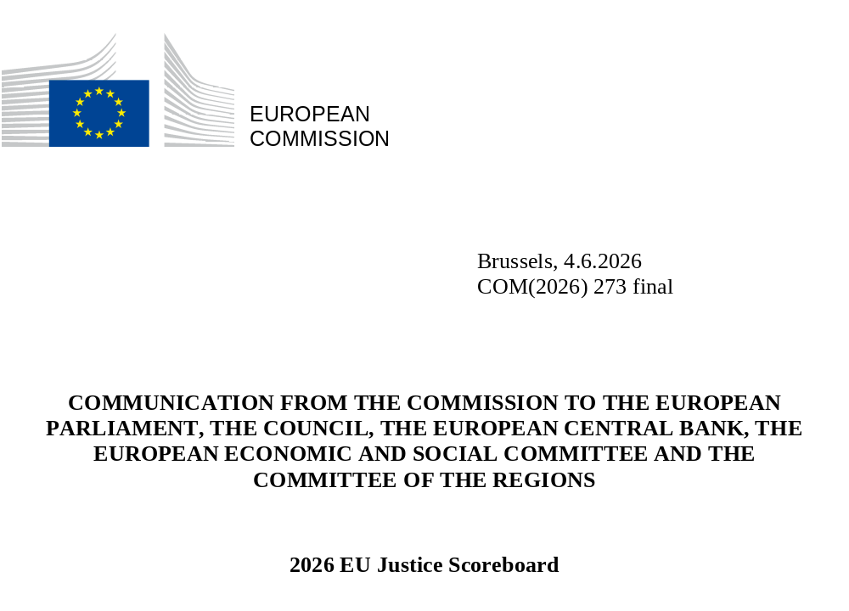

1. Introduction
Effective justice systems are essential for the application and enforcement of EU law and upholding the rule of law and other values the EU is founded on and which are common to the Member States. National courts act as EU courts when applying EU law. It is national courts in the first place that ensure that the rights and obligations set in EU law are enforced effectively (see the obligation of Member States to ensure effective legal protection in the fields covered by Union law under Article 19 of the Treaty on European Union (TEU)).
In addition, effective justice systems are also essential for mutual trust and for improving the investment climate and the sustainability of long-term growth. This is why improving the efficiency, quality and independence of national justice systems features among the priorities of the European Semester – the EU’s annual cycle of economic policy coordination. The EU Competitiveness Compass () and the 2026 Annual Single Market and Competitiveness Report () recall that respect for the rule of law is central for the functioning of the Single Market, as it provides a stable operating environment that gives the EU and its Member States a global competitive edge. The respect for the rule of law ensures a business environment in which laws apply effectively and uniformly, businesses can work in another Member State on an equal footing with local companies, and budgets are spent on a transparent and objective basis.
Well-functioning and fully independent justice systems can have a positive impact on investment and are key for investment protection. They are associated with greater productivity and competitiveness. They are also important for ensuring the effective cross-border enforcement of contracts, administrative decisions and dispute resolution, essential for a well-functioning single market ().
In this context, the EU Justice Scoreboard provides an annual overview of indicators measuring the three essential parameters of effective justice systems:
- efficiency;
- quality;
- independence.

The 2026 Scoreboard also contains new and updated figures on accessibility to justice for people with disabilities, selected powers of equality bodies, specific arrangements for child-friendly justice/proceedings, prevention of corruption and the digitalisation of justice (). As started in the 2025 edition, the 2026 Scoreboard also continues to develop indicators of specific relevance for the functioning of the single market for which effective justice systems and respect for the rule of law are central. It solidifies the business and single market dimension by presenting new indicators on first instance public procurement review bodies, supreme audit institutions and national competition authorities.

− The Annual Rule of Law Cycle –
In 2020, the Commission set up the comprehensive Annual Rule of Law Cycle to deepen its monitoring of the rule of law situation in Member States. The Rule of Law Cycle acts as a preventive tool, promoting dialogue and joint awareness of rule of law issues. At the centre of the cycle is the annual Rule of Law Report, which provides a synthesis of significant developments – both positive and negative – in all Member States and in the EU as a whole. The report, whose latest edition was published on 8 July 2025, draws on a variety of sources, including the EU Justice Scoreboard (). The 2026 EU Justice Scoreboard has also been further developed to reflect the need for additional comparative information identified during the preparation of the 2025 Rule of Law Report.
What is the EU Justice Scoreboard?
The EU Justice Scoreboard is an annual comparative information tool. Its purpose is to assist Member States in improving the effectiveness of their national justice systems by providing objective, reliable and comparable data on a number of indicators relevant for the assessment of the (i) efficiency, (ii) quality and (iii) independence of justice systems in all Member States. It does not present an overall single ranking. Rather, it gives an overview of how all Member States’ justice systems function, based on indicators that are of common interest and relevance for all Member States.
The Scoreboard does not promote any particular type of justice system and treats all Member States on an equal footing.
Efficiency, quality and independence are the essential parameters of an effective justice system, irrespective of the model or the legal tradition on which the national justice system is based. Data for these three parameters should be read together, as the three are often interlinked (initiatives aimed at improving one may affect another).
The Scoreboard presents indicators covering mainly civil, commercial and administrative cases, and, subject to the availability of data, certain criminal cases (i.e. cases concerning money laundering and bribery at first instance courts). Its aim is to assist Member States in their efforts to create an efficient, investment-friendly environment which works in the interest of both business and the public. The Scoreboard is a comparative tool which evolves in the course of a dialogue with Member States and the European Parliament (). Its objective is to assess the essential parameters of an effective justice system and to provide relevant annual data.
What is the methodology of the EU Justice Scoreboard?
The Scoreboard uses a range of information sources. The Council of Europe’s European Commission for the Efficiency of Justice (CEPEJ), with which the Commission has concluded a contract to carry out a specific annual study, provides much of the quantitative data. The data cover 2014 to 2024 and have been provided by Member States in line with the CEPEJ’s methodology. The study also provides detailed comments and country-specific factsheets that give more context. They should be read together with the figures ().
Data on the length of proceedings collected by the CEPEJ show the ‘disposition time’ – the estimated length of court proceedings (calculated as the ratio between pending and resolved cases over the course of a year). Data on the efficiency of courts and administrative authorities in applying EU law in specific areas show the average length of proceedings derived from the actual length of court cases. Note that the length of court proceedings may vary substantially between different regions in a Member State. Cases may take particularly long in urban centres where the concentration of commercial activities may lead to a higher caseload.
Other data sources, covering the period from 2014 to 2025, are:
- the group of contact persons on national justice systems ();
- the national contact points in the fight against corruption ();
- the European Network of Councils for the Judiciary (ENCJ) ();
- the Network of the Presidents of the Supreme Judicial Courts of the EU (NPSJC) ();
- the Association of the Councils of State and Supreme Administrative Jurisdictions of the EU (ACA-Europe) ();
- the Council of Bar and Law Societies in Europe (CCBE) ();
- the European Competition Network (ECN) ();
- the Network of First Instance Review Bodies on Public Procurement ();
- the Communications Committee (COCOM) ();
- the European Observatory on infringements of intellectual property rights ();
- the Consumer Protection Cooperation Network (CPC) ();
- the Expert Group on Money Laundering and Terrorist Financing (EGMLTF) ();
- Eurostat ();
- the national contact points in the fight against corruption ();
- the Network of Public Prosecutors or equivalent institutions at the Supreme Judicial Courts of the Member States of the European Union (NADAL Network) ();
- the Contact Committee on Supreme Audit Institutions (), and
- the Council of the Notariats of the European Union (CNUE) ().
Over the years, the Scoreboard methodology has been further developed and refined in close cooperation with the group of contact persons on national justice systems, particularly through the use of a questionnaire (updated annually) and by collecting data on certain aspects of the functioning of justice systems.
The availability of data, in particular for indicators on the efficiency of justice systems, continues to improve. This is because many Member States have invested in their capacity to produce better judicial statistics. Persisting difficulties in gathering or providing data, if any, are due either to insufficient statistical capacity or to lack of exact correspondence between the national categories for which data are collected and the ones used for the Scoreboard. Only in very few cases is the data gap due to a lack of contributions from national authorities. The Commission continues to encourage Member States to further reduce this data gap.

How does the EU Justice Scoreboard feed into the European Semester and how is it related to the Recovery and Resilience Facility?
The Scoreboard provides data for assessing the efficiency, quality and independence of national justice systems. In doing so, it aims to help Member States make their national justice systems more effective. By comparing information on Member States’ justice systems, the Scoreboard makes it easier to identify best practices and shortcomings and to keep track of challenges and progress made. In the context of the European Semester, country-specific assessments are carried out through a bilateral dialogue with the national authorities and the relevant stakeholders. Where the shortcomings identified have macroeconomic significance, the European Semester analysis may lead to the Commission proposing to the Council to adopt country-specific recommendations to improve the national justice systems in individual Member States ().
The Recovery and Resilience Facility (RRF) has made available more than EUR 577 billion in loans and non-repayable financial support, of which each Member State would need to allocate a minimum of 20% to the digital transition and a minimum of 37% to measures contributing to climate objectives. The RRF offers an opportunity to address country-specific recommendations related to national justice systems and to accelerate national efforts to complete the digital transformation of justice systems. Payments to Member States under the performance-based RRF are contingent on the fulfilment of milestones and targets. Around 6 300 milestones and targets related to investment and reforms. Under the RRF Regulation, before the adoption of the Member States’ recovery and resilience plans (RRPs), the Commission had to assess whether they could contribute to effectively addressing all or a significant number of challenges identified in the relevant country-specific recommendations or challenges identified in other Commission documents adopted in the context of the European Semester (). Around 285 milestones and targets are included in Member States’ RRPs to strengthen the rule of law by increasing the efficiency, quality and independence of the judicial system and the anti-corruption framework including anti-money laundering. Until May 2026, following pre-financing payments as well as payment requests by Member States, a total of EUR 400 billion in RRF grants and loans have been disbursed.
Why are effective justice systems important for an investment-friendly business environment?
Effective justice systems that uphold the rule of law have a positive economic impact. The respect for the rule of law ensures a business environment in which laws apply effectively and uniformly, where businesses can operate in another Member State on an equal footing with local companies. The respect for the rule of law is central to the functioning of the single market and to maintaining a stable operating environment that gives the EU and its Member States a global competitive edge (). Effective justice systems are also particularly relevant in the context of the European Semester and the RRF. Where judicial systems guarantee the enforcement of rights, creditors are more likely to lend, transaction costs are reduced and businesses are more likely to invest, have higher confidence and are dissuaded from opportunistic behaviour. In fact, an effective justice system is vital for sustained economic growth. It can improve the business climate, foster innovation, attract foreign direct investment, secure tax revenues and support economic growth. The benefits of well-functioning national justice systems for the economy are confirmed by a wide-range of studies (), including by the International Monetary Fund (IMF) (), the European Central Bank (ECB) (), the European Network of Councils for the Judiciary (), the Organisation for Economic Cooperation and Development (OECD) (), the World Economic Forum (), and the World Bank ().
One study found a strong correlation between a reduction in the length of court proceedings (measured in disposition time ()) and the growth rate of companies (). In addition, according to the study, a higher percentage of companies perceiving the justice system as independent correlates with higher firm turnover and greater productivity growth (). Another study stated that access to justice has a sizable positive effect on economic growth ().
Other surveys have highlighted the importance of an effective national justice system for companies’ investment decisions and ability to solve intellectual property rights conflicts. For example, in one survey, 93% of large companies replied that they systematically and continuously review the rule of law conditions (including judicial independence) in the countries they invest in (). In another survey, over half of small and medium-sized enterprises (SMEs) replied that high costs and lengthy judicial proceedings were the main reasons for not starting court proceedings over the infringement of intellectual property rights (). The importance of effective justice systems for the functioning of the single market, in particular for businesses, is also stressed in the Commission’s communications Identifying and addressing barriers to the single market () and Single market enforcement action plan ().
How does the Commission support the implementation of good justice reforms through technical support?
From 2021 to 2025, the Technical Support Instrument (TSI) available through the Reform and Investment Task Force (SG REFORM) funded 36 projects, which included 43 reforms, to help 20 Member States to implement their justice reforms. TSI has been supporting projects aiming to improve the quality and effectiveness of justice, such as leveraging technology to better manage case workflows and take a data-driven approach to allocate caseload and resources, facilitating access to justice for vulnerable groups, and enhancing the capacities of prosecution authorities for effective litigation of high profile and cross-border corruption cases.
The 2025 TSI call for proposal provided the platform for Member States to apply for support on digitalisation reforms like using technology to address mass litigation challenges and automate routine tasks to reduce manual effort and error, so that judges and administrative staff can focus on the more demanding tasks. The TSI also supported Member States in the implementation of their RRPs. The RRPs include actions on improving the effectiveness of justice, namely by digitalisation, reduction of backlogs, improvement of court and cases management and judicial map reform.
How does the justice programme support the effectiveness of justice systems?
With a total budget of around EUR 305 million for 2021 to 2027, the justice programme supports the further development of the European area of justice based on the rule of law including the independence, quality and efficiency of the justice system, based on mutual recognition and mutual trust and on judicial cooperation. In 2025, around EUR 40.7 million were provided to fund projects and other activities under the three specific objectives of the programme: (i) promotion of judicial cooperation in civil and criminal matters; (ii) training of legal professionals on EU civil, criminal and fundamental rights law, legal systems of the Member States and the rule of law; (iii) promotion of access to justice (including e-Justice); protection of victims’ rights and the rights of persons suspected or accused of crime; and support to the development and use of digital tools and the maintenance and extension of the e-Justice portal.
Why does the Commission monitor the digitalisation of national justice systems?
The digitalisation of justice is key to increasing the efficiency, quality and resilience of justice systems, while facilitating access to justice. Digital tools also enhance judicial cooperation. Following the COVID-19 pandemic, Member States accelerated modernisation reforms in this area. Artificial Intelligence (‛AI’) is also increasingly being used in the field of justice ().
Since 2013, the EU Justice Scoreboard has included comparative information on the digitalisation of justice across the Member States, for example in the areas of online access to judgments or online claim submission and follow-up. New data on the digitalisation of justice were added in consecutive years.
Regulation (EU) 2023/2844 on digitalisation of cross-border judicial cooperation in civil, commercial and criminal matters () entitles natural and legal persons to communicate electronically with the competent judicial authorities in the context of cross-border proceedings, as well as to pay court fees electronically.
The Regulation also created a legal basis for conducting videoconferencing in cross-border civil, commercial and criminal matters. A digital communication channel to be used for the exchange of data between the competent judicial authorities is also being set up. In this context, the EU Justice Scoreboard monitors the progress achieved by Member States in implementing the Regulation and using videoconferencing.
Key findings from the EU Justice Scoreboard contributed to the Digital Justice@2030 strategy for 2025–2030 on the use of digital technologies, to make EU civil and criminal justice systems more efficient, resilient and secure ().

2. Key findings of the 2026 EU Justice Scoreboard
Efficiency, quality and independence are the main parameters of an effective justice system. The Scoreboard presents indicators for each of these parameters.

2.1. Efficiency of justice systems
The Scoreboard presents indicators for the efficiency of proceedings in the broad areas of civil, commercial and administrative cases, and in specific areas where administrative authorities and courts apply EU law ().

2.1.1. Summary on the efficiency of justice systems
An efficient justice system manages its caseload and backlog of cases, and delivers its decisions without undue delay. The main indicators used by the EU Justice Scoreboard to monitor the efficiency of justice systems are therefore the length of proceedings (disposition time or average time in days needed to resolve a case), clearance rate (the ratio of resolved cases to incoming cases) and number of pending cases (that remain to be dealt with at the end of the year).
General data on efficiency
The 2026 EU Justice Scoreboard contains data on efficiency spanning 10 years (2014–2024). This timespan allows trends to become apparent and makes it possible to take account of the fact that it often takes time for the effect of justice reforms to be felt.
The data from 2014 to 2024 in civil, commercial and administrative cases shows positive trends in most cases. After the dip in efficiency observed in 2020-2021, possibly due to the COVID-19 pandemic, 2022 saw a return to the efficiency levels of 2019. In 2023 and 2024, some of the Member States that are reporting data have continued improving their efficiency, while in others efficiency levels remained stable. This shows the effect of the measures taken by Member States to make their systems more resilient to future disruptions.
There were some positive developments in the Member States that, in the past, were considered to be facing specific challenges, in the context of the European Semester ().
- From 2014, based on the existing data for these Member States, the length of first instance court proceedings in the broad ‘all cases’ category (Figure 4) in 12 Member States decreased or remained stable. For the ‘litigious civil and commercial cases’ category (Figure 5) the length of first instance court proceedings continued to decrease or remained stable in 10 Member States, while in the remaining 16, the length increased. In administrative cases (Figure 7), the length of proceedings since 2014 has decreased or remained stable in about 12 Member States. Compared to the previous year, nine Member States saw a decrease in the length of proceedings in administrative cases in 2024.
- The EU Justice Scoreboard presents data on the length of proceedings in all court instances for litigious civil and commercial cases (Figure 6) and administrative cases (Figure 8). Data show that eight of the Member States identified faced challenges with regard to the length of proceedings in first instance courts, higher instance courts having performed more efficiently. However, for six other Member States facing challenges, the average length of proceedings in higher instance courts was even longer than in first instance courts.
- In the broad ‘all cases’ and ‘litigious civil and commercial cases’ categories (Figures 9 and 10), the overall number of Member States whose clearance rate is over 100% fell in comparison to 2023. In 2024, 17 Member States, including those facing challenges, reported a high clearance rate (more than 97%). This means that courts are generally able to deal with the incoming cases in these categories. In administrative cases (Figure 11), the clearance rate in 12 Member States in 2024 remained broadly the same as in 2023. While the clearance rate in administrative cases is generally lower than for other categories of cases, seven Member States continue to make good progress. In particular, five of the Member States facing challenges reported an increase in the clearance rate for administrative cases since 2014.
- Since 2014, the situation has remained stable or continued to improve in four of the Member States facing the most substantial challenges with their backlogs, regardless of the category of cases (Figure 12). In 2024, despite the increase in the number of pending cases, the number of pending cases remained stable in litigious civil and commercial cases (Figure 13) and in administrative cases (Figure 14) in 10 Member States. However, significant differences remain between Member States with comparatively few pending cases and those with a high number of pending cases.

Efficiency in specific areas of EU law
Data on the average length of proceedings in specific areas of EU law (Figures 15–21) provide an insight into the functioning of justice systems in concrete types of business-related disputes.
Data on efficiency in specific areas of EU law are collected based on narrowly defined scenarios, so the number of relevant cases may be low. However, compared to the calculated length of proceedings presented in the general data on efficiency, these figures show an actual average length of all relevant cases in specific areas in a year. It is worth noting that Member States where the general data on efficiency do not appear to show challenges nonetheless report significantly longer average case lengths in specific areas of EU law. At the same time, the length of proceedings in different specific areas may also vary considerably within the same Member State. Another figure introduced over the last several years focuses on the length of criminal proceedings, particularly those involving bribery, revealing the level of efficiency in that area of EU law.
Finally, the 2026 Scoreboard continues to provide insight into the efficiency of the overall enforcement chain, which is important for a positive business and investment environment. For example, in competition law cases, there is a chart focusing on the length of (i) proceedings before the national competition authority and (ii) the judicial review of decisions by the authority.
- For judicial review of competition cases (Figure 15), as the overall caseload faced by courts across the EU increased, the length of judicial review decreased or remained stable in 11 Member States, while it increased in 10. Despite the moderately positive trend, five Member States reported an average length exceeding 1 000 days in 2024. For proceedings before the national competition authorities (Figure 16), eight Member States reported that proceedings took less than 1 000 days. Among the Member States cited as experiencing issues with efficiency in the judicial review of competition cases, three are among the most efficient when it comes to proceedings before the national competition authorities.
- For electronic communications (Figure 17), the caseload faced by courts decreased compared to previous years, continuing the positive trend observed in 2022 and 2023 of reductions in the length of proceedings. In 2024, nine Member States registered a decrease in the average length of proceedings compared to 2023 or saw this figure remain stable, and five showed an increase.
- For EU trademark infringement cases (Figure 18), in 2024 the overall caseload decreased in comparison to 2023. However, while four Member States managed their caseload more efficiently, registering reduced or stable lengths of proceedings, six saw a clear increase in the average length of proceedings.
- In the area of EU consumer law, the average length of judicial review proceedings can be seen in Figure 19. In 2024, where decisions by the consumer protection authorities were challenged in court, trends in the length of the judicial review of an administrative decision in 2024 diverged, with increases in four Member States and decreases in five others compared to 2023. In two Member States, the average length of a judicial review was over 1 000 days in 2024.
- Effective measures to combat money laundering are crucial to protecting the financial system, ensuring fair competition and preventing negative economic consequences. Excessively long court proceedings may hamper the EU’s ability to fight money laundering or reduce the effectiveness of efforts in this field. Figure 20 presents updated data on the length of judicial proceedings dealing with money laundering offences. It shows that, while in 12 Member States first instance court proceedings take up between a month to a year on average, they take up between one and two years on average in 10 Member States, and in three Member States they take up more than three years on average ().
- Corruption is a particularly serious crime with a cross-border dimension. It has negative economic consequences and can only be effectively tackled by common minimum rules across the EU. The EU Justice Scoreboard presents figures on the length of judicial proceedings dealing with bribery cases. Figure 21 shows varying levels of data availability among Member States, and differences in the average length of proceedings before first-instance criminal courts. Looking at 2024 data, proceedings are concluded within about a year in six Member States, in ten Member States proceedings last between a year and two years, while in four other where data are available, proceedings can last two years or more. Overall, the complexity of prosecuting and adjudicating bribery offences reflects the serious nature of the crime. This is also reflected in the length of proceedings.

2.1.2. Developments in caseload
The caseload of national justice systems decreased in five Member States, in two of which by a large amount compared to the previous year. It increased or remained stable in 20 Member States. Overall, it continues to vary considerably between Member States (Figure 1).
Figure : Number of incoming civil, commercial, administrative and other cases in 2014, 2022 – 2024 (*) (at first instance/per 100 inhabitants) (source: CEPEJ study ())
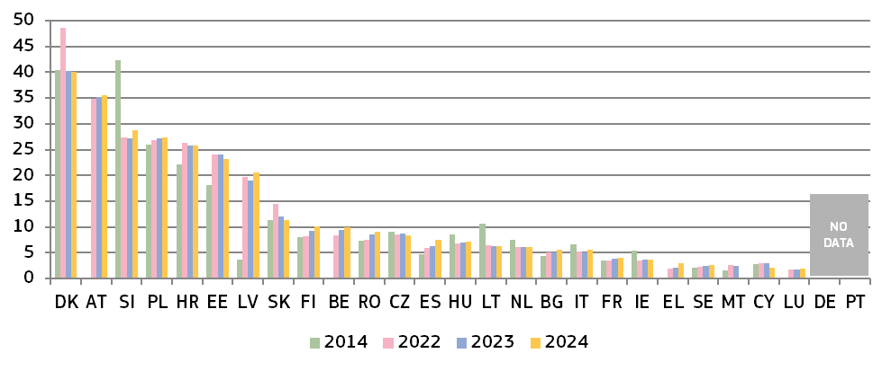
(*) Under the CEPEJ methodology, this category includes all civil and commercial litigious and non-litigious cases, non-litigious land and business registry cases, other registry cases, other non-litigious cases, administrative law cases and other non-criminal cases.
Figure : Number of incoming civil and commercial litigious cases in 2014, 2022 – 2024 (*) (at first instance/per 100 inhabitants) (source: CEPEJ study)
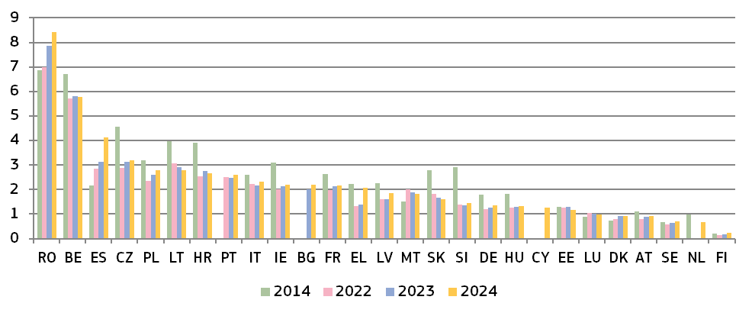(*) Under the CEPEJ methodology, litigious civil/commercial cases concern disputes between parties, e.g. disputes about contracts. Non-litigious civil/commercial cases concern uncontested proceedings, e.g. uncontested payment orders.
Figure : Number of incoming administrative cases in 2014, 2022 – 2024 (*) (at first instance/per 100 inhabitants) (source: CEPEJ study)
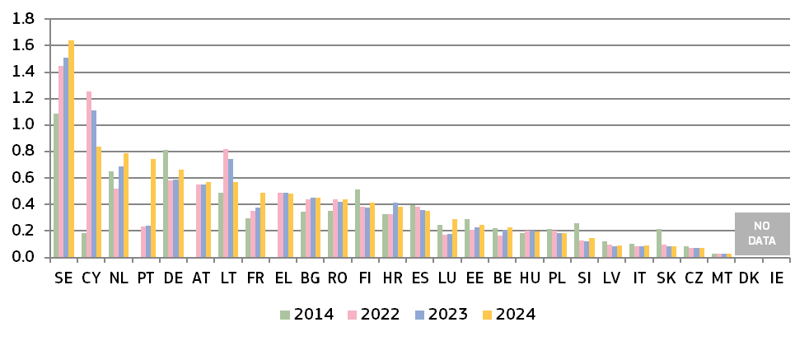(*) Under the CEPEJ methodology, administrative law cases concern disputes between individuals and local, regional or national authorities. DK and IE do not record administrative cases separately. Methodology changes in EL, SK and SE. PT: The increase of incoming cases in 2024 was in part due to the very high number of applications for authorisation or renewal of the residence permit that were lodged with the Lisbon Administrative Court.

2.1.3. General data on efficiency
The indicators on the efficiency of proceedings in the broad areas of civil, commercial and administrative cases are: (i) estimated length of proceedings (disposition time), (ii) clearance rate and (iii) number of pending cases.

– Estimated length of proceedings –
The estimated length of proceedings indicates the estimated time (in days) needed to resolve a case in court, meaning the time taken by the court to reach a decision at first instance. ‘Disposition time’ indicates the estimated minimum time that a court would need to resolve a case while maintaining its current working conditions. This indicator is calculated as the number of unresolved cases divided by the number of resolved cases at the end of a year, multiplied by 365 (days) (). The higher the value, the higher the probability that it takes the court longer to reach a decision. The data mostly concern proceedings at first instance courts and compare, where available, data for 2014, 2022, 2023 and 2024 (). Figure 6 shows the disposition time in 2024 in civil and commercial litigious cases at all court instances, and Figure 8 for administrative cases at all court instances.
Figure : Estimated time needed to resolve civil, commercial, administrative and other cases in 2014, 2022 – 2024 (*) (at first instance/in days) (source: CEPEJ study)
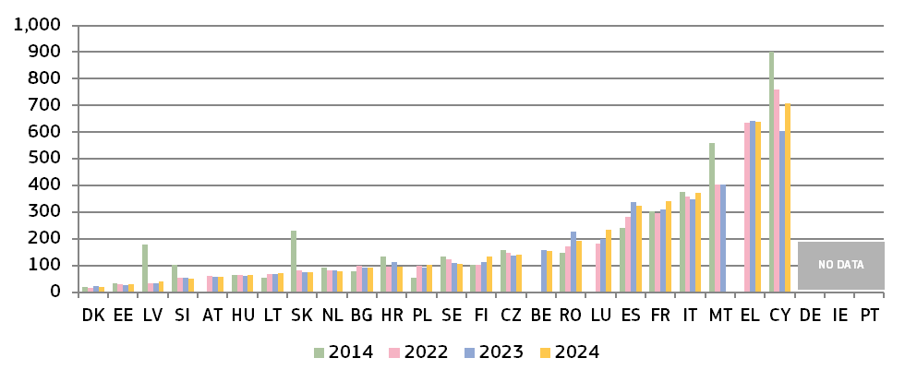
(*) Under the CEPEJ methodology, this category includes all civil and commercial litigious and non-litigious cases, non-litigious land and business registry cases, other registry cases, other non-litigious cases, administrative law cases and other non-criminal cases. Methodology changes in SK. Pending cases include all instances in CZ and, until 2016, in SK. For LV, the sharp decrease is due to court system reform, error checks and data clean-ups of the information system. In PT, the new Code of Civil Procedure, which creates a new enforcement regime, entered into force on 1 September 2013. It is based on a new paradigm, which states that court proceedings must be clearly distinguished from out-of-court proceedings. However, so far it has not been possible to adjust the collection of data accordingly and provide the necessary data for this Figure.
Figure : Estimated time needed to resolve litigious civil and commercial cases at first instance in 2014, 2022 – 2024 (*) (at first instance/in days) (source: CEPEJ study)
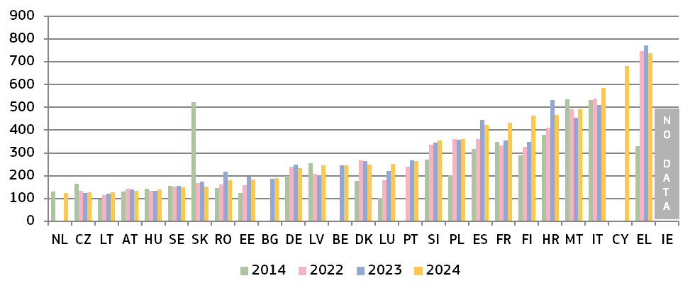
(*) Under the CEPEJ methodology, litigious civil/commercial cases concern disputes between parties, e.g. disputes about contracts. Non-litigious civil/commercial cases concern uncontested proceedings, e.g. uncontested payment orders. Methodology changes in EL and SK. Pending cases include all instances in CZ and, up to 2016, in SK. For IT, the temporary slowdown of judicial activity due to strict restrictive measures to address the COVID-19 pandemic affected the disposition time. Data for NL include non-litigious cases.
Figure : Estimated time needed to resolve litigious civil and commercial cases at all court instances in 2024 (*) (at first, second and third instance/in days) (source: CEPEJ study)
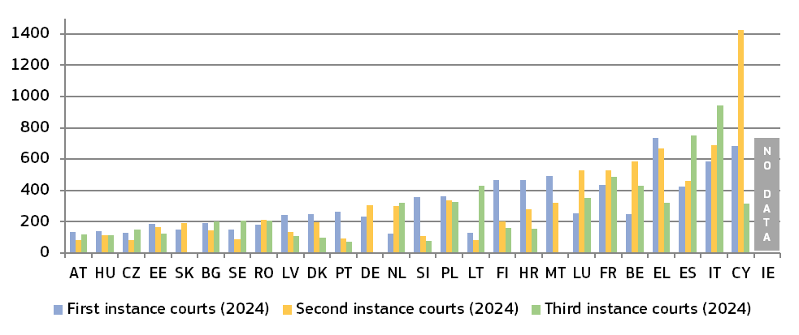
(*) The order of Member States in the figure is determined by the court instance with the longest proceedings in each Member State. No data are available for first, second and third instance courts in IE, nor for third instance courts in SK. There is no third instance court in DE and MT. Access to a third instance court may be limited in some Member States.
Figure : Estimated time needed to resolve administrative cases at first instance in 2014, 2022 – 2024 (*) (at first instance/in days) (source: CEPEJ study)
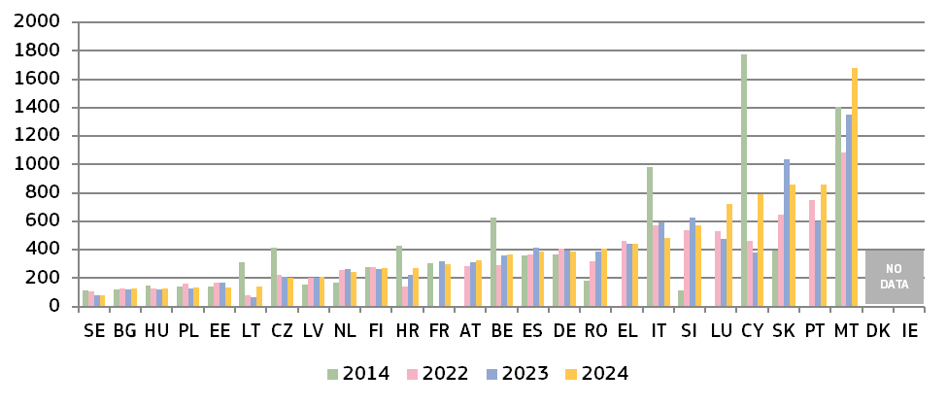(*) Under the CEPEJ methodology, administrative law cases concern disputes between individuals and local, regional or national authorities. Methodology changes in EL and SK. Pending cases include courts of all instances in CZ and, until 2016, in SK. DK and IE do not record administrative cases separately. PT: The increase in disposition time in 2024 was in part due to the very high number of applications for authorisation or renewal of the residence permit that were lodged with the Lisbon Administrative Court.
Figure : Estimated time needed to resolve administrative cases at all court instances in 2024 (*) (at first and, where applicable, second and third instance/in days) (source: CEPEJ study)
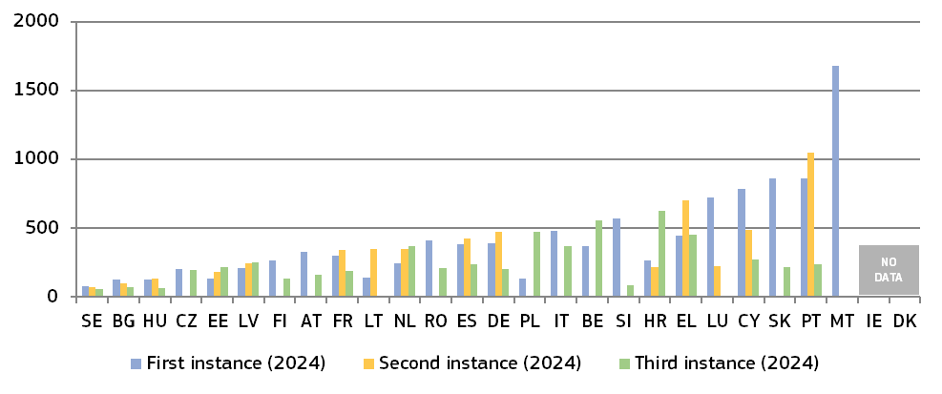(*) The order of Member States in the figure is determined by the court instance with the longest proceedings in each Member State. No data available for second instance courts in BE, CZ, IT, MT, AT, PL, RO, SI, SK and FI, for third instance courts in LT, LU and MT. The supreme, or other highest court, is the only appeal instance in CZ, IT, AT, SI and FI. There is no third instance court for these types of cases in LT, LU and MT. The highest administrative court is the first and only instance for certain cases in BE. Access to third instance courts may be limited in some Member States. DK and IE do not record administrative cases separately. In CY, the organisation of the justice system underwent a significant reform in July 2023, including the establishment of a Court of Appeals and a third instance.

– Clearance rate –
The clearance rate is the ratio of resolved cases to incoming cases. It measures whether a court is keeping up with its incoming caseload. The clearance rate is around 100% or higher when the outflow of cases is equal or higher compared to the inflow of cases. When the clearance rate is below 100%, it means that the courts are resolving fewer cases than the number of incoming cases.
Figure : Rate of resolving civil, commercial, administrative and other cases in 2014, 2022 – 2024 (*) (at first instance/in % — values higher than 100% indicate that more cases are resolved than come in, while values below 100% indicate that fewer cases are resolved than come in) (source: CEPEJ study)
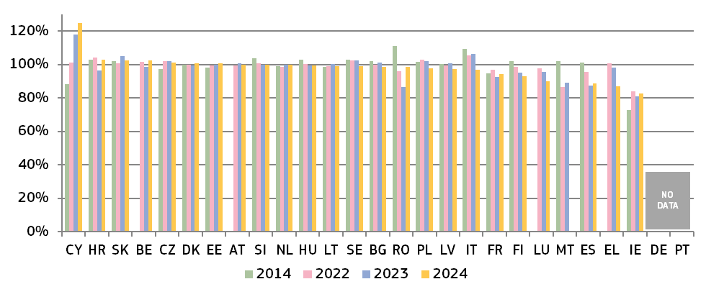(*) Under the CEPEJ methodology, this category includes all civil and commercial litigious and non-litigious cases, non-litigious land and business registry cases, other registry cases, other non-litigious cases, administrative law cases and other non-criminal cases. Methodology changes in SK. In IE, the number of resolved cases is expected to be underreported due to the methodology.
Figure : Rate of resolving litigious civil and commercial cases in 2014, 2022 – 2024 (*) (at first instance/in %) (source: CEPEJ study)
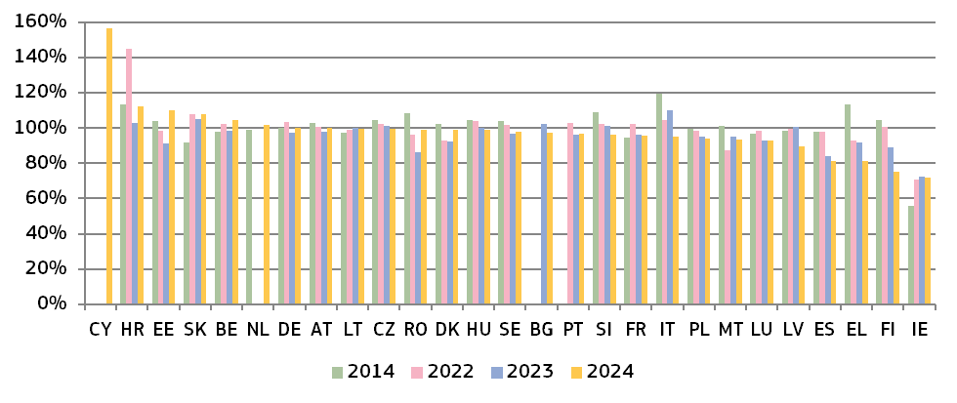
(*) Methodology changes in EL and SK. In IE, the number of resolved cases is expected to be underreported due to the methodology. Data for NL include non-litigious cases.
Figure : Rate of resolving administrative cases in 2014, 2022 – 2024 (*) (at first instance/in %) (source: CEPEJ study)
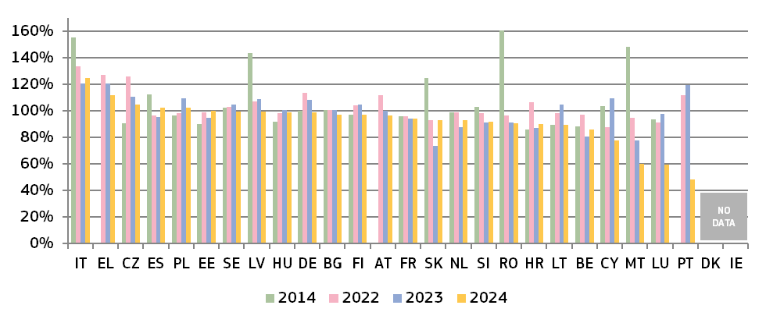(*) Methodology changes in EL and SK. DK and IE do not record administrative cases separately. In CY, the number of resolved cases has increased because cases were tried together, 2 724 consolidated cases were withdrawn and an administrative court was set up in 2015. PT: The decrease of clearance rate in 2024 was due to the very high number of applications for authorisation or renewal of the residence permit that were lodged with the Lisbon Administrative Court.

– Pending cases –
The number of pending cases is the number of cases that remains to be dealt with at the end of the year in question. It also affects disposition time.
Figure : Number of pending civil, commercial, administrative and other cases in 2014, 2022 – 2024 (*) (at first instance/per 100 inhabitants) (source: CEPEJ study)
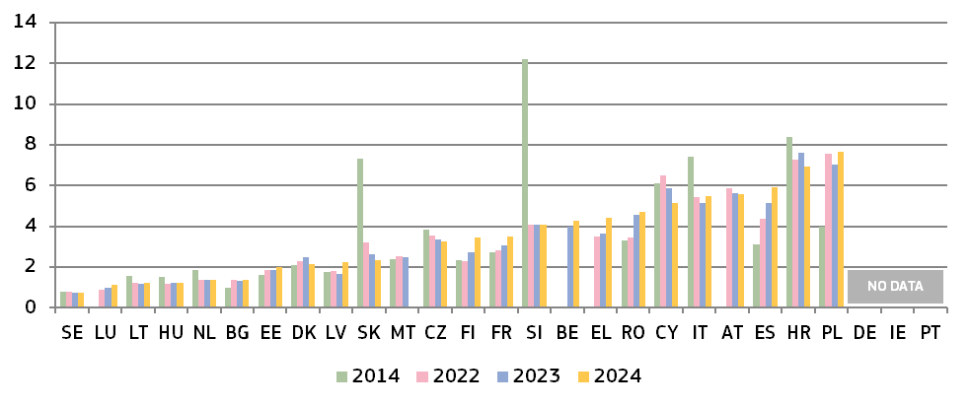(*) Under the CEPEJ methodology, this category includes all civil and commercial litigious and non-litigious cases, non-litigious land and business registry cases, other registry cases, other non-litigious cases, administrative law cases and other non-criminal cases. Methodology changes in SK. Pending cases include cases before courts of all instances in CZ and, until 2016, in SK.

Figure : Number of pending litigious civil and commercial cases in 2014, 2022 – 2024 (*) (at first instance/per 100 inhabitants) (source: CEPEJ study)
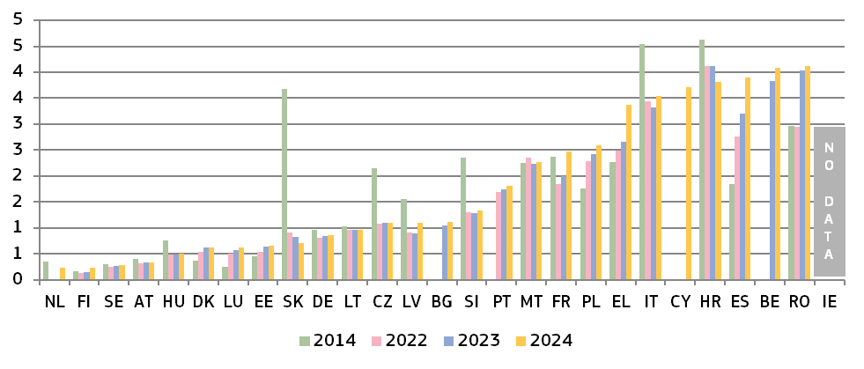(*) Methodology changes in EL and SK. Pending cases include cases before courts of all instances in CZ and, until 2016, in SK. Data for NL include non-litigious cases.
Figure : Number of pending administrative cases in 2014, 2022 – 2024 (*) (at first instance/per 100 inhabitants) (source: CEPEJ study)
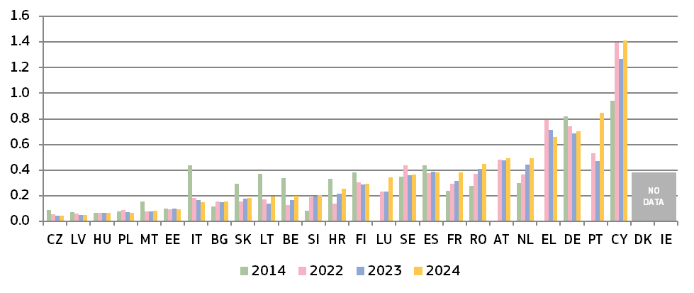(*) Methodology changes in EL and SK. Pending cases include cases before courts of all instances in CZ and, until 2016, in SK. DK and IE do not record administrative cases separately. PT: In 2024, there was a very high number of applications for authorisation or renewal of the residence permit that were lodged with the Lisbon Administrative Court.

2.1.4. Efficiency in specific areas of EU law
The data in this section complements the general data on the efficiency of justice systems. It shows the average length of proceedings () in specific areas of EU law. The 2026 Scoreboard builds on previous data for competition, electronic communications, the EU trademark, consumer law, anti-money laundering and anti-corruption.
The six areas of EU law were selected because of their relevance for the single market and the business environment. The overview of the efficiency of administrative authorities continues in this edition of the Scoreboard, with updated figures on the areas of competition and consumer protection. In general, long delays in judicial and administrative proceedings may have negative impacts on rights stemming from EU law e.g. when appropriate remedies are no longer available or serious financial damages become irrecoverable. For businesses in particular, administrative delays and uncertainty in some cases can lead to significant costs and undermine planned or existing investments ().
– Competition –
The effective enforcement of competition law is essential for an attractive business environment, as it ensures a level playing field for businesses. It promotes economic initiative, innovation and efficiency, and leads to a wider choice for consumers, lower prices and better quality. Figure 15 presents the average length of cases brought against decisions of national competition authorities applying Articles 101 and 102 of the Treaty on the Functioning of the European Union (TFEU) (). Figure 16 presents the average length of proceedings before the national competition authorities applying Articles 101 and 102 TFEU.
Figure : Competition: average length of judicial review in 2014, 2022 – 2024 (*) (at first instance/in days) (source: European Commission with the European Competition Network)
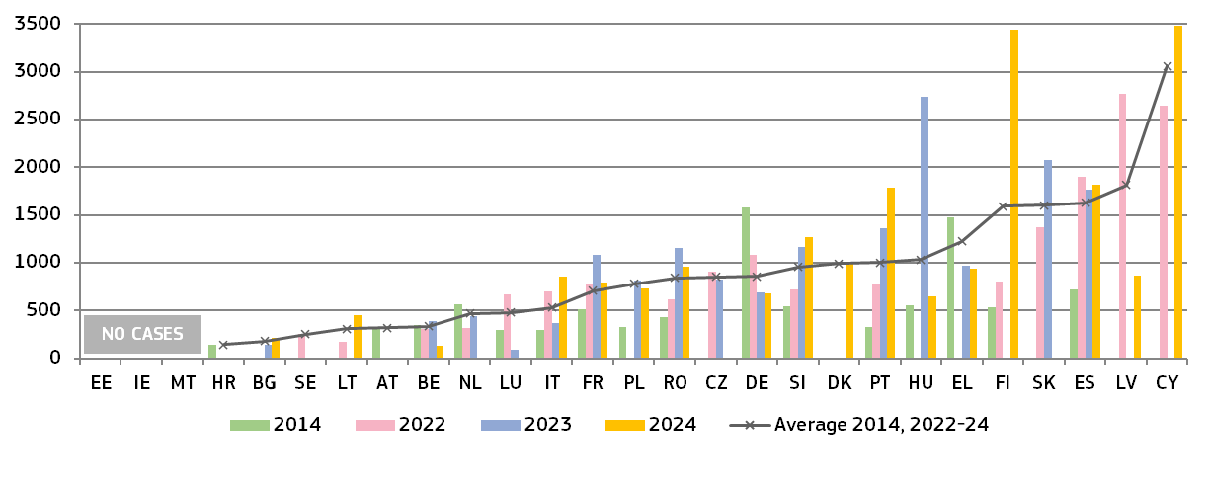
(*) The average is weighted by the number of cases in the respective year. AT: data for 2014 include decisions of the Cartel Court on the substance, not the judicial review of these decisions by the Supreme Court. Since the 2024 EU Justice Scoreboard, the decisions of the Cartel Court are included in the length of proceedings before the national competition authorities (see below). IT: an estimation of length was used for 2014 and 2022. An empty column can indicate that the Member State reported no cases for the year in question. The number of cases is low (below five a year) in many Member States. This can make the annual data dependent on one exceptionally long or short case (e.g. FI where there was only one case). ES: The number of appeals corresponds to the number of companies that filed an appeal against each CNMC decision. IE: Not applicable for 2020, 2021 and 2022, as before 2023 the CCPC was not empowered to make decisions of the relevant type capable of being judicially reviewed.
Figure : Competition: average length of proceedings before the national competition authorities in 2020, 2022 – 2024 (*) (in days) (source: European Commission with the European Competition Network)
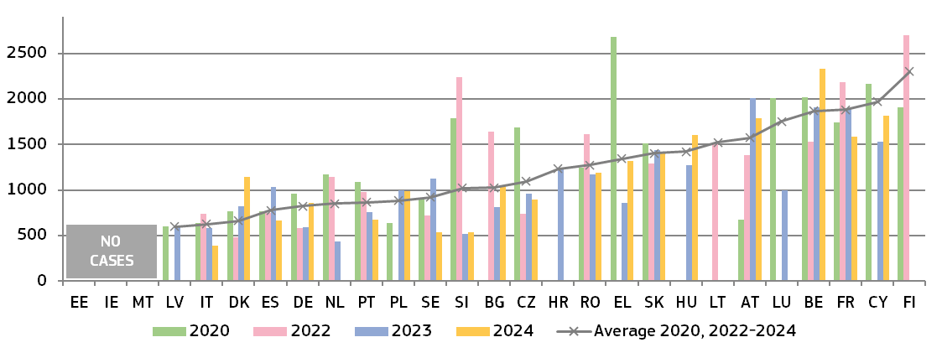
(*) The average is weighted by the number of cases in the respective year. Since the 2024 EU Justice Scoreboard, the average length of proceedings before the national competition authorities has been calculated as follows: the number of days between the first formal investigative measure and the adoption of a final decision by the national competition authority (by the administrative authority or, in Member States with a judicial system, by the court that has the power to adopt a prohibition decision and/or impose or confirm fines). For this reason, the data since the 2024 edition in the above figure cannot be compared to the data published in earlier editions. This calculation method allows for comparable data at EU level for the sole purpose of the EU Justice Scoreboard and may differ from the reporting at national level in certain Member States. CZ and SK have a two-instance administrative procedure. When appealed, first instances decisions are reviewed by the second instance body of the authority, which may prolong proceedings. DK: In 2021, following the transposition of the ECN+ Directive, Denmark moved from a purely criminal enforcement system to a system where the Danish competition authority can now directly apply for the imposition of a fine before a civil court and adopt settlement decisions in its own administrative proceedings. This has led to an increase in decisions since 2022. For AT, DK and FI, the length of proceedings covers the combined duration of proceedings before the administrative and judicial national competition authorities. AT: data include proceedings involving to a large-scale cartel in the construction sector. Due to the size of this case, proceedings triggered by the same first investigative measure were (and still are) being led and concluded successively, gradually distorting the average length of proceedings. ES and IT: data excludes commitment decisions adopted by the national competition authority. IE: Not applicable for 2020, 2021 and 2022, as the CCPC did not have the power to make its own binding administrative decisions in antitrust cases until September 2023 (prior to that date, it could only take enforcement action in such cases through the courts). SK: Article 102: 4 decisions of first instance and 0 decisions of appellate body (total: 1 117 days); Article 101: 0 decisions of first instance and 1 decision of appellate body (total: 1 730 days). Average length of proceedings is therefore 1 423 days.
– Electronic communications –
The objective of EU electronic communications legislation is to encourage competition, contribute to the development of the single market and generate investment, innovation and growth. The positive effects for consumers can be achieved through effective enforcement of this legislation which can lead to lower prices for end users and better-quality services. Figure 17 presents the average length of judicial review cases against the decisions of national regulatory authorities applying EU law on electronic communications (). It covers a broad range of cases, from more complex ‘market analysis’ reviews to more straightforward consumer-focused issues.
Figure : Electronic communications: average length of judicial review in 2014, 2022 – 2024 (*) (first instance/in days) (source: European Commission with the Communications Committee)
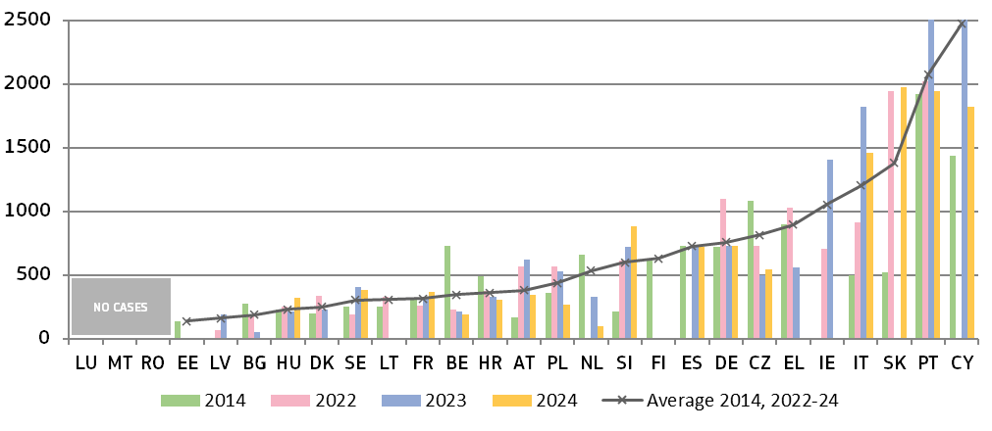(*) Values for some Member States have been reduced for presentation purposes (PT in 2023 = 2.830; CY in 2023 = 3.285). The average is weighted by the number of cases in the respective year. The number of cases varies from one Member State to another. An empty column indicates that the Member State reported no cases for the year. Sometimes, the limited number of relevant cases (BE, CY, HU, NL, SK, SE) can cause the annual data to rely heavily on a single case that is exceptionally long or short; this may result in wide variations in the data from one year to the next. In DK, a quasi-judicial body is in charge of first instance appeals. In ES, AT, and PL, different courts are in charge, depending on the subject matter. NL: one case withdrawn, one case declared unfounded. ES: Out of 13 cases, 10 concerned telecoms. BE: In the specific case of electronic communications, the Market Court of Brussels is the first instance court. The only possibility for appeal is before the Court de Cassation on the basis of legal arguments (not merits). FI: The Regulator's decisions on significant market power (SMP), including decisions related to the supervision and enforcement of SMP obligations - such as compliance with pricing obligations — as well as decisions designating a universal service provider - can be appealed to the Supreme Administrative Court which is the first and only appeal Court in these cases. HR: Includes cases of first instance before the administrative courts and cases before the High Administrative Court.
– EU trademark –
Effective enforcement of intellectual property rights is essential to stimulate investment in innovation. EU legislation on EU trademarks () gives the national courts a significant role to play, empowering them to act as EU courts and take decisions that affect the single market. Figure 18 shows the average length of EU trademark infringement cases in litigation between private parties.
Figure : EU trademark: average length of EU trademark infringement cases in 2014, 2022 – 2024 (*) (at first instance/in days) (source: European Commission with the European Observatory on infringements of intellectual property rights)
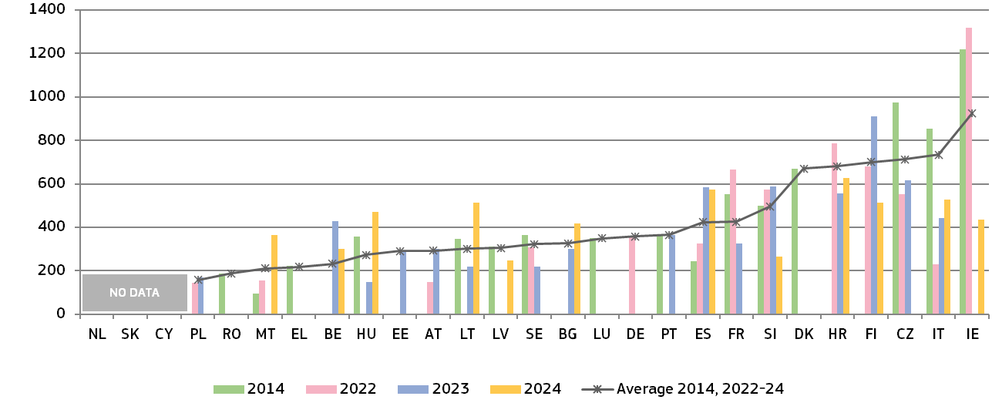(*) The average is weighted by the number of cases in the respective year. FR, IT, LT, LU: A sample of cases used for data for certain years. DK: Data from all trademark cases (not only EU) in commercial and maritime high courts; for 2023, 372 cases concerning intellectual property law were finalised. 53 were regular civil cases, 275 were handled as small claim procedures and 44 were prohibition proceedings and injunction proceedings. No information is available on what the case processing times is. EL: Data based on weighted average length from two courts. ES: Cases concerning other EU IP titles are included in the calculation of average length. PL: For 2023, the weighted average was calculated on the basis of the number of cases resolved. FI: For 2023, a preliminary ruling from the Court of Justice was requested in one of the two cases. The time during which the case was pending before the Court of Justice was included in the calculation of the average number of days.
– Consumer protection –
Effective enforcement of consumer law ensures that consumers’ rights are protected and that companies infringing consumer laws do not gain an unfair advantage. Consumer protection authorities and courts play a key role in enforcing EU consumer law () within the various national enforcement systems. Figure 19 illustrates the average length of judicial review cases against decisions of consumer protection authorities applying EU law.

Figure : Consumer protection: average length of judicial review in 2014, 2022 – 2024 (*) (first instance/in days) (source: European Commission with the Consumer Protection Cooperation Network)
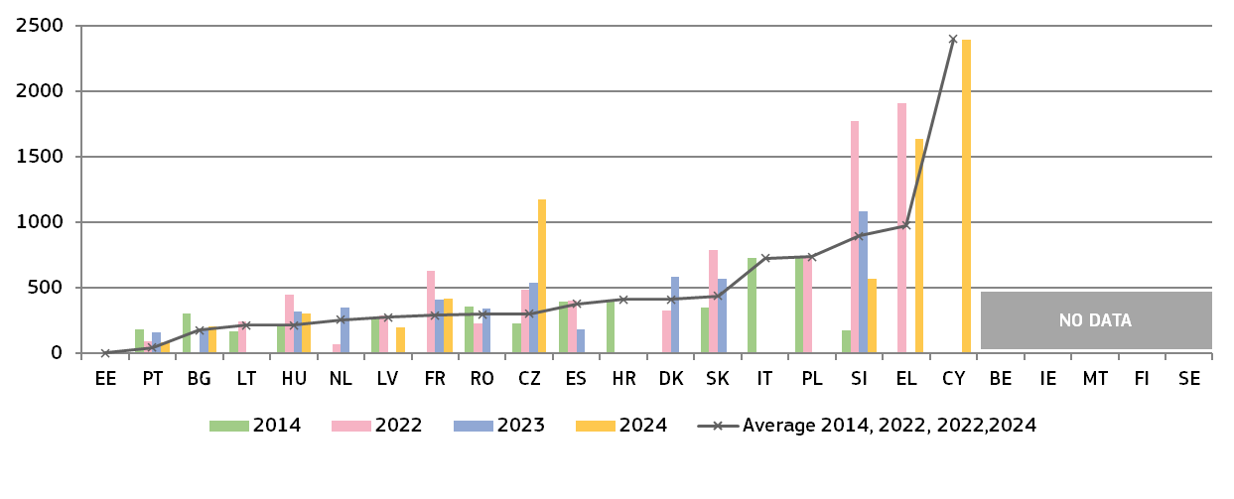(*) The average is weighted by the number of cases in the respective year. DE, LU, AT: scenario is not applicable as consumer authorities are not empowered to decide on infringements of the relevant consumer rules. An estimate of average length was provided by EL and RO for certain years.
– Money laundering –
In addition to depriving criminals of resources for perpetrating their illicit acts and effectively dismantling organised crime networks, preventing and combating money laundering () is crucial for the soundness, integrity and stability of the financial sector, confidence in the financial system and fair competition in the single market (). Money laundering can discourage foreign investment, distort international capital flows and negatively affect a country’s macroeconomic performance, resulting in welfare losses, thereby draining resources from more productive economic activities (). Article 44(1) of Directive (EU) 2015/849 requires Member States to maintain statistics on the effectiveness of their systems to combat money laundering and terrorist financing (). In cooperation with Member States, an updated questionnaire was used to collect data on the judicial aspects in national anti-money laundering regimes. Figure 20 shows the average length of first instance court cases dealing with money laundering criminal offences.

Figure : Money laundering: average length of court cases in 2014 and 2022 – 2024(*) (at first instance/in days) (source: European Commission with the Expert Group on Money Laundering and Financing of Terrorism)
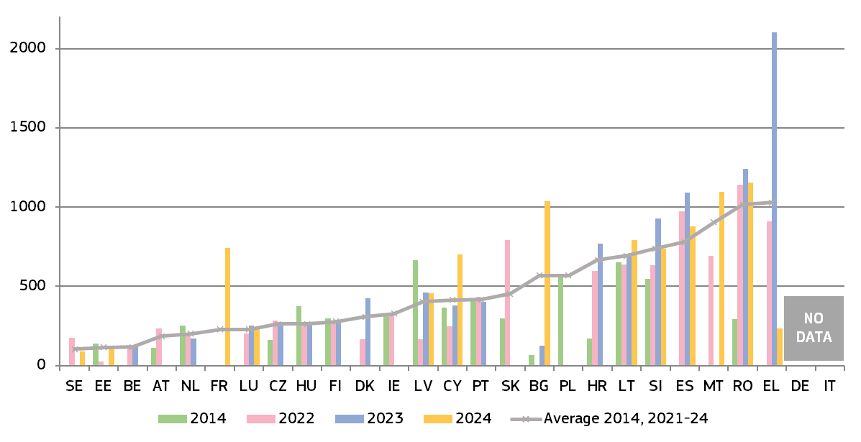
(*) The average is weighted by the number of cases in the respective year. For PT: The database was filtered, for each judicial county, by the relevant criteria to reach the information related to money laundering files; the dates of infringement and the date of final decision or closure were taken into account in calculating the average number of days CY: Serious cases, before the Assize Court, are on average tried within a year. Less serious offences, before the district courts, take longer to be tried. SI: The 2024 data show a slightly longer length, calculated from the receipt of the cases at the trial court until they are classified as finished. SK: Data correspond to the average length of the whole proceedings, including at appeal court.
– Anti-corruption –
Corruption is an impediment to sustainable economic growth, diverting resources from productive outcomes, undermining the efficiency of public spending and deepening social inequalities. It hampers the effective and smooth functioning of the single market, creates uncertainties in doing business and holds back investment. Moreover, corruption represents a major threat to our security and democracies. Corruption is particularly complex to tackle since, unlike most crimes, both parties involved in a corruption case are generally interested keeping it secret. This also contributes to a general difficulty in quantifying the true magnitude of the corruption phenomenon across the EU. Corruption is a particularly serious crime with a cross-border dimension, as referred to in Article 83(1) TFEU, and can only be effectively tackled by common minimum rules across the European Union.
On 29 April 2026, the European Parliament and Council adopted the new Directive on combating corruption (). The Directive updates and aligns EU rules on the definitions of and penalties for corruption offences, to ensure high standards in the fight against the full range of corruption offences (going beyond bribery and covering misappropriation, trading in influence, the unlawful exercise of public functions, as well as obstruction of justice and enrichment related to corruption offences). It also includes provisions aimed at strengthening preventive and integrity measures in Member States, and contributes to making investigations and the prosecution of corruption more effective. In cooperation with Member States, a questionnaire was developed in 2022 to collect data on the length of court proceedings before first instance courts in bribery cases, which is presented in Figure 21 below ().
Figure : Corruption (bribery): average length of court cases from 2021 – 2024 (*) (at first instance/in days) (source: European Commission with the National Contact Points for Anti-corruption)
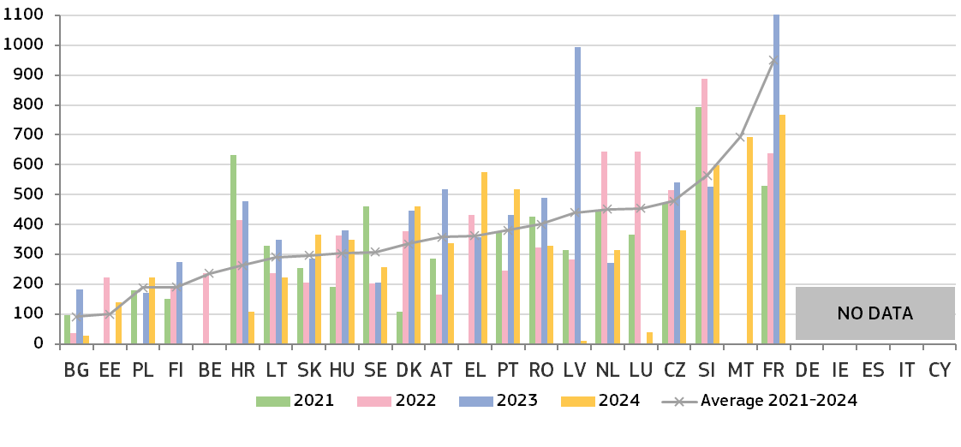(*) The average is weighted by the number of cases in the respective year. No reply to this question from DE, IE, ES, IT, CY, MT. NL: In this calculation for 2022, the period starts to run from the date the public prosecution service summons the defendant to appear in court; the period ends on the day when the judge of first instance delivers the final verdict. The average processing time for the aforementioned 35 cases is 645 days. However, account must be taken of the fact that a case is often not ready for the hearing at the moment the period starts to run. As a result, it takes some time before the case is presented for hearing. The average length from first hearing until delivery of the final verdict is 194 days. FR: Data from 2024 were calculated using a new method, therefore the multiannual average is not possible. The average delay is calculated from the prosecution decision by the prosecutor and not from the referral to the trial court. The opening of the judicial information is considered as a decision to initiate prosecution. The figure provided corresponds to the average duration reported by the French authorities (which reflects the duration from prosecution to judgment, excluding and including the “instruction” proceedings). It is not possible in all cases to calculate a timeframe by taking as the starting point the moment when the charges become final, as certain procedures (particularly those involving an “instruction”) can take several years and may sometimes result in the case being dropped.

2.2. Quality of justice systems
There is no single way to measure the quality of justice systems. The 2026 EU Justice Scoreboard continues to examine factors that are generally accepted as relevant for improving the quality of justice. They fall into four categories:
1) access to justice for the public and businesses;
2) adequate financial and human resources;
3) digitalisation.

2.2.1. Summary on the quality of justice systems
Easy access, sufficient resources, effective assessment tools and digitalisation all contribute to a high-quality justice system. The public and businesses expect high-quality decisions from an effective justice system. The 2026 EU Justice Scoreboard makes a comparative analysis of these factors.
Accessibility
The 2026 EU Justice Scoreboard looks again at a number of elements that contribute to a people-friendly justice system:
- The availability of legal aid and the level of court fees have a major impact on access to justice, in particular for people living in poverty or at risk of poverty. Figure 22 shows that in three Member States, people whose income is below the Eurostat poverty threshold cannot receive legal aid. The level of court fees (Figure 23) has remained largely stable since 2016, although in four Member States court fees were higher than in 2024, in particular for low-value claims. The burden of court fees continues to be proportionally higher for low-value claims. Difficulties in claiming legal aid combined with high court fees in two Member States could discourage people living in poverty from accessing justice. The 2026 EU Justice Scoreboard presents, for the third time, the rate of legal aid paid to criminal defence lawyers in a specific criminal case (Figure 24), and for the first time rate of legal aid fees for lawyers in a civil case (Figure 25). Both figures show that a wide disparity exists between Member States in the amounts lawyers would be paid from the public budget.
- The 2026 EU Justice Scoreboard provides a mapping of the authorities involved in non-contentious judicial procedures in the area of divorce procedures in Figure 26.
- The 2026 EU Justice Scoreboard continues to analyse the ways in which Member States promote voluntary use of alternative dispute resolution methods (ADR) (Figure 27), including the possibility of using digital technologies. In 2025, the overall promotion effort increased in comparison to 2024, with three Member States reporting more means of promotion, particularly for ADR methods in consumer disputes. The number of ways used to promote ADR methods for administrative disputes is still lower than for other disputes, but has also increased since 2023.
- The 2026 EU Justice Scoreboard takes stock of specific arrangements for accessible digital solution for persons with disabilities which comply with the relevant accessibility standards and legislation at first instance courts. Figure 28 shows that 5 Member States provide a full range of digital solutions covering both criminal, civil and commercial and administrative justice. 23 Member States have taken steps to ensure accessible publication of judgments online for persons with disabilities. 17 Member States provide for accessible online payment of court fees.
- For the third time, the 2026 EU Justice Scoreboard presents specific selected measures for representative actions protecting the collective interests of consumers. Figure 29 shows that 24 Member States have at least one such measure in place. From among the selected measures, specific arrangements to inform consumers about the actions and the outcomes is the most widespread, being in place in 18 Member States.
- Figure 30 shows that all Member States have some specific arrangements for child-friendly justice and proceedings, for both civil and criminal/juvenile justice proceedings. 11 Member States have all nine of the monitored specific arrangements in place, including, for example, a website specifically designed to be child-friendly and helplines to provide information about the justice system or measures in place to hold children separately from adults when they are deprived of their liberty. In all Member States, the privacy and personal data of children involved in judicial or non-judicial proceedings are protected in accordance with national law. Furthermore, all Member States have child-friendly specialised settings/hearing, where children can be heard. A mapping of specific arrangements for children involved in criminal proceedings as victims or suspects and accused persons (Figure 31) shows, for example, that all Member States provide information about the victim’s or suspect’s rights and the proceedings in a child-friendly way and in 25 Member States, any form of deprivation of liberty of children is used as a measure of last resort and for the shortest appropriate period of time.
- Figure 32 illustrates the selected powers that equality bodies—or, in certain cases, other designated bodies—possess in each Member State to address discrimination cases. In 19 Member States, equality bodies are empowered to offer ADR mechanisms directly to the parties involved. In 11 Member States, they also have the authority to initiate court proceedings in their own name to defend the public interest.
Resources
High-quality justice systems in Member States depend on sufficient financial and human resources. This requires appropriate investment in physical and technical infrastructure, initial and continuing training, and diversity among judges, including gender balance. The 2026 EU Justice Scoreboard shows the following:
- In terms of financial resources, overall in 2024 general government spending on law courts increased in all but one Member State taking into account the number of inhabitants, while it decreased in five Member States as compared to GDP. It still shows significant differences between Member States in spending levels, both per inhabitant and as a percentage of GDP (Figures 33 and 34).
- The 2026 EU Justice Scoreboard continues to explore the situation in the Member States as regards salaries in the justice system. It presents, for the fourth time, the ratio of annual salaries of judges and prosecutors to the average annual salary in the country (Figure 35). This figure shows wide-ranging differences among the Member States.
- Women still account for fewer than 50% of judges at supreme court level in 18 Member States (Figure 37), while in nine Member States at least half the judges at supreme court level are female. Figures for 2023 - 2025 show diverging levels and trends between Member States.
Digitalisation
Since 2021, the EU Justice Scoreboard has included a large, detailed section on aspects related to the digitalisation of justice. Although Member States already use digital solutions in different contexts and to varying degrees, there is significant room for improvement.
- All 27 Member States provide some online information about their judicial system, including websites with clear information on accessing legal aid, on court fees and on eligibility criteria for reduced fees (Figure 39). The situation remains stable compared to last year, but some differences still exist between Member States as regards information and the degree to which it responds to people’s needs. For example, nine Member States employ chatbots to help the public find information about the justice system. 22 Member States provide clearly visible and understandable information on compensation for victims.

- Six Member States have digital-ready procedural rules (Figure 40), which allow fully for the use of distance communication and for the admissibility of evidence in digital format only. In 20 Member States, this is possible only in a limited number of situations. Nonetheless, there has been steady overall progress in this regard since 2020.
- Figure 41 reveals the use of digital technology by courts and prosecution services. It shows that Member States do not fully use the potential allowed by their procedural rules (see Figure 40). Member State courts, prosecutors and court staff already have various digital tools at their disposal, such as case-management systems, videoconferencing systems and teleworking arrangements. However, further progress could still be achieved in the use of distributed ledger technologies (blockchain).
- Courts in all Member States have some secure electronic tools for communication at their disposal although only 14 Member States have such tools for all types of communication that are monitored and for all cases (Figure 42). Five Member States still lack tools for digital communication with notaries, detention facilities or bailiffs/judicial officers. All Member States also provide for secure electronic communication within the prosecution services (Figure 43). All Member States except for two provide for secure electronic communication between prosecution services and courts. Seven Member States still lack tools for electronic communication between the prosecution services and defence lawyers.
- In civil/commercial and administrative cases, 23 Member States provide individuals and businesses (or their legal representatives) with online access to their ongoing or closed cases (Figure 44), albeit to varying degrees. As regards digital solutions to conduct and follow court proceedings in criminal cases, Figure 45 shows that victims can submit written statements online either partly or fully in 18 Member States. However, in 10 Member States, defendants and victims do not have the possibility to follow or pursue their case electronically.
- Online access to court judgments (Figure 46) has remained stable compared to last year. It is mainly judgments from the highest instances that are made accessible online.
- As in previous years, the 2026 EU Justice Scoreboard analyses arrangements for producing machine-readable judicial decisions (Figure 47). All Member States have at least some arrangements in place for civil/commercial, administrative and criminal cases, although there is considerable variation between them. In general, there is a tendency to introduce more arrangements, particularly for downloading the judgments free of charge (databases and other automated solutions), for modelling judgments to make them machine-readable, or for anonymising/pseudonymising judgments using algorithms. In 2025, four Member States reported improvement compared to the previous year, while the situation in six Member States remained stable. Justice systems with arrangements for modelling judgments in line with standards to make them machine-readable seem to have the potential to achieve better results in the future.

2.2.2. Access to justice
Accessibility is required throughout the whole justice chain to enable all people, including people at risk of discrimination, older persons and victims of crime, to obtain relevant information – about the justice system, about how to make a claim and the related financial aspects, and about how proceedings are advancing (up until they are complete) – and to access the judgments online.
– Legal aid, court fees and legal fees –
The cost of litigation is a key factor that determines access to justice. High litigation costs, including court fees () and legal fees (), may hinder access to justice. Litigation costs in civil and commercial matters are not aligned at EU level. They are governed by national legislation and vary from one Member State to another.
Access to legal aid is a fundamental right enshrined in the Charter of Fundamental Rights of the EU (). It allows access to justice to people who would not otherwise be able to bear or advance the costs of litigation. Most Member States grant legal aid based on the applicant’s income ().
Figure 22 shows the availability of full or partial legal aid in a specific consumer case involving a claim of EUR 6 000. It compares the income thresholds for granting legal aid, expressed as a percentage of the Eurostat poverty threshold for each Member State (). For example, if the threshold for legal aid is 20% it means that an applicant with an income 20% higher than the Eurostat poverty threshold for their Member State will still be eligible for legal aid. However, if the threshold for legal aid is below zero, this means that a person with an income below the poverty threshold may not be eligible for legal aid.
In 13 Member States there is a legal aid system that provides for 100% coverage of the costs linked to litigation (full legal aid), complemented by a system covering partial costs (partial legal aid) which applies different eligibility criteria. In 10 Member States there is both a full or partial legal aid system, but not both. In two Member States, the courts have discretion over granting legal aid.
Figure : Income threshold for legal aid in a specific consumer case, 2025 (*) (differences in % from Eurostat poverty threshold) (source: European Commission with the Council of Bar and Law Societies in Europe (CCBE) ())
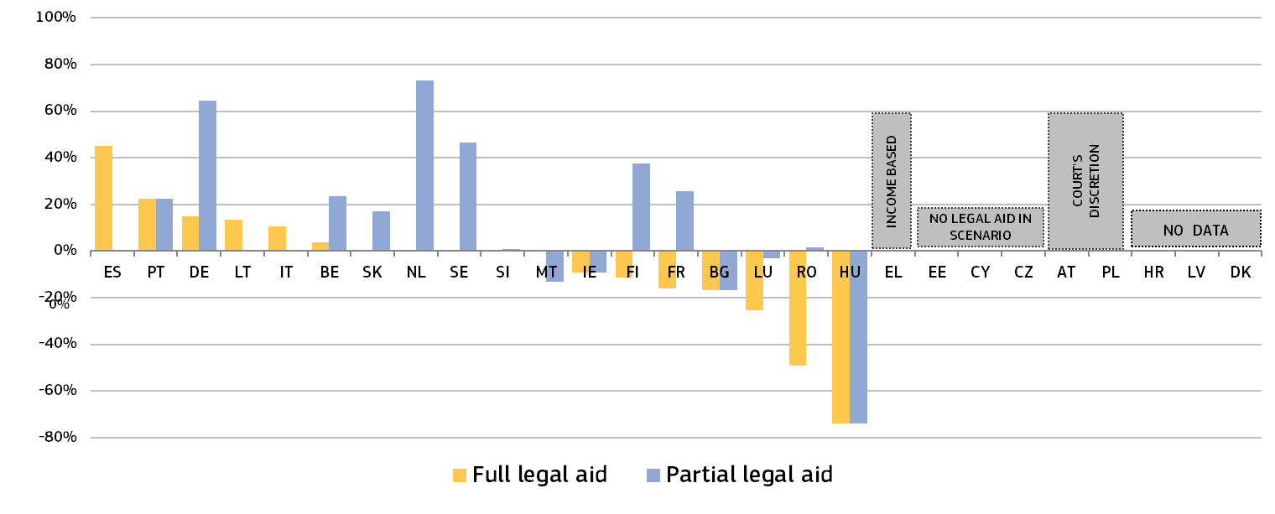(*) Calculations are based on 2023 at-risk-of-poverty (AROP) threshold values. BE, DE, ES, FI, FR, IE, IT, LT, LU, NL, SE, SI, SK: Legal aid also has to take into account the applicant’s disposable assets. EL: Beneficiary of legal aid is a person whose capital annual income does not exceed 2/3 of the lowest annual salaries as provided for by the existing legislation. EE, CY and CZ: no legal aid in scenario. AT and PL: Court's discretion. HR, LV and DK: No data provided.
Recipients of legal aid are often exempt from paying court fees. Only in five Member States are recipients of legal aid not automatically exempt from paying court fees. In Czechia, the court decides on a case-by-case basis whether or not to exempt a legal aid recipient from paying court fees. In Luxembourg, litigants who benefit from legal aid do not have to pay bailiff fees. Figure 23 compares, for two scenarios, the amount of the court fee presented as a proportion of the value of the claim. For example, if the court fee in the figure below is 10% of a EUR 6 000 claim, the consumer will have to pay a EUR 600 court fee to start judicial proceedings. The low-value claim is based on the Eurostat at-risk-of-poverty (AROP) threshold for each Member State.

Figure : Court fee to start judicial proceedings in a specific consumer case, 2025 (*) (amount of court fee as a proportion of the value of the claim) (source: European Commission with the Council of Bar and Law Societies in Europe (CCBE) ())
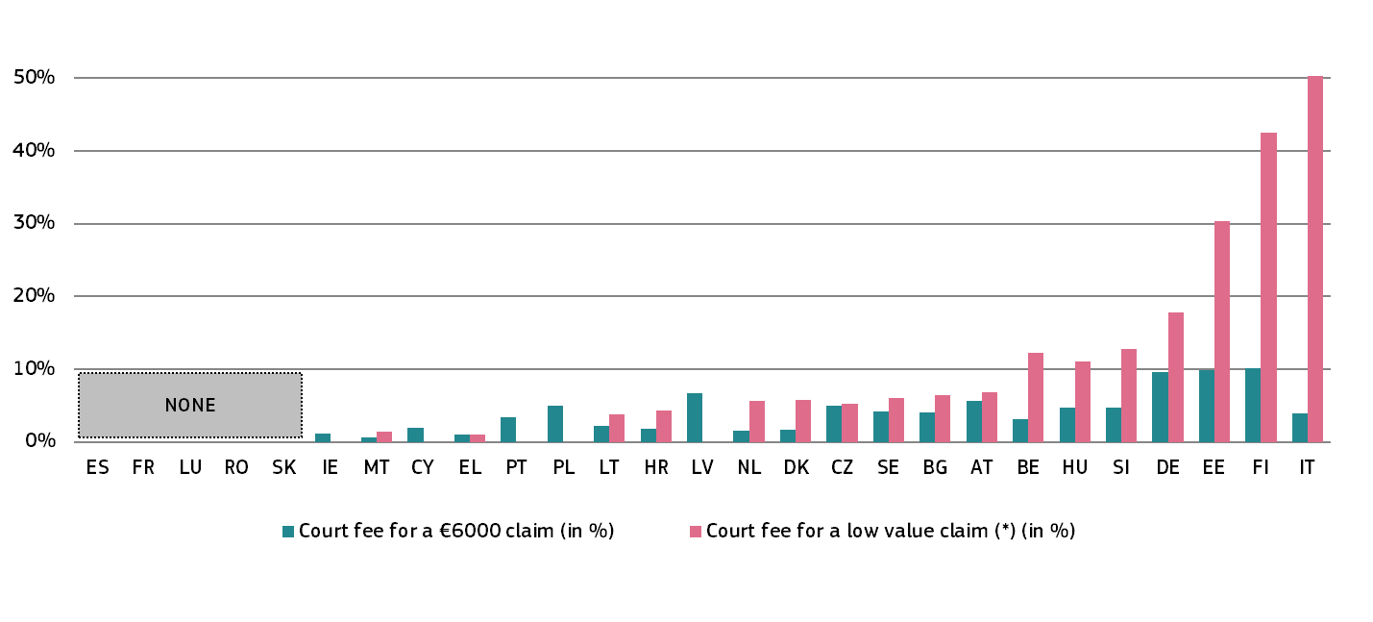(*) Calculations are based on 2024 at-risk-of-poverty (AROP) threshold values. A ‘low-value claim’ is a claim corresponding to the Eurostat poverty threshold for a single person in each Member State, converted to monthly income (e.g. in 2022, this value ranged from EUR 326 in BG to EUR 2 381 in LU). BE: EUR 26 contribution to the Fund for the second line legal aid; Court registry fees: EUR 50 or EUR 165. Afterwards, if dismissed/convicted: possibly EUR 1 350 for procedural indemnity. NL: Court fees values correspond to a litigant with an annual income of less than EUR 30 200. SE: The court fee applies if the value of the claim exceeds EUR 2 673. LV: Court fee calculated for a claim of up to EUR 1000.

Figure 24 presents the rate of legal aid paid to criminal defence lawyers in a specific criminal case based on a case study (). Respondents have indicated how much lawyers would be paid from the public budget in the fictional scenario described.
Figure : Rate of legal aid paid to criminal defence lawyers in a specific criminal case, 2025 (*) (source: European Commission with the Council of Bar and Law Societies in Europe (CCBE) ())
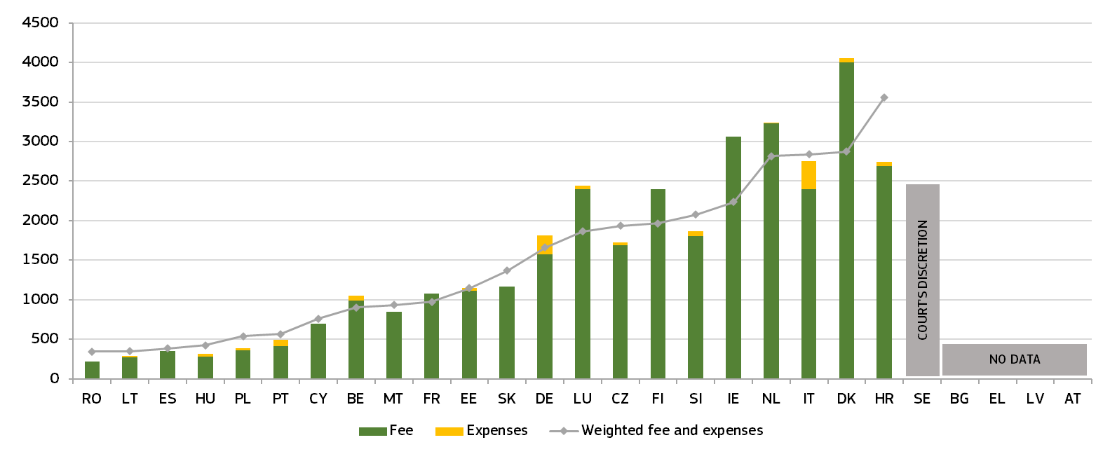(*) The data are gathered based on a specific case study. The amounts are all in EUR, and where needed they were converted from national currencies. To take account of the economic differences between Member States the added value of the fee and expense were divided by the comparative price level indices expressed in percentage where the EU average is 100%, DK is 141%. This adjusts the sum of fees and expenses that the lawyers receive. IE: In Ireland, legal representation is divided between solicitors and barristers. Under the Legal Aid Scheme, their fees are calculated separately (solicitors have a fixed case fee structure for family law matters, while barristers (Junior or Senior Counsel) have their own case fees and additional allowances for interim or enforcement applications). This distinction is relevant when determining the total claim under the legal aid system. The calculation is based on the Legal Aid Board Schedule of Fees for counsel (barristers) in the Circuit Court, which is the court of jurisdiction for divorce proceedings in Ireland. Solicitors are not paid expenses or outlays, barristers receive driving expenses. AT: The Austrian legal aid system is state funded and based on the solidarity of all Austrian lawyers who all participate on a rotation-based system in the legal aid system. In general, the individual lawyer does not receive any direct remuneration for legal aid services. Instead, the Austrian state pays a yearly lump sum to the Austrian Bar for the total of legal aid services rendered by all lawyers. The Austrian Bar distributes this sum to the regional bars on the basis of the number of registered lawyers who provided legal aid services and on the basis of the number of legal aid cases which were handled by the regional bars. The money is used for the lawyers’ social security and pension scheme, which is not state funded. The legal aid for access to the services of each of the professions differs. The figure above presents the maximum that could be charged as a fee under the legal aid scheme in the particular scenario. ES: Fees calculated for free legal aid in Spanish regions that have not been transferred competence for justice matters. The other regions may provide different compensations. RO and SK: Reimbursement of expenses requires the submission of receipts, for SK it is capped at EUR 240.
Figure : Rate of legal aid paid to lawyers in a specific civil case, 2025 (*) (source: European Commission with the Council of Bar and Law Societies in Europe (CCBE) ())
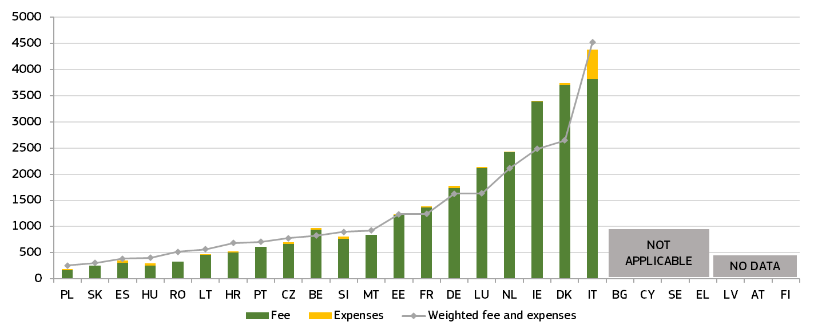(*) BG, CY, SE: no legal aid in scenario. LV, AT, FI: no data provided. DE: the fee is calculated based on a ‘value in dispute’ of EUR 2 000 net per month. IE: The legal profession is split into barristers and solicitors. The legal aid fees each of the professions are entitled to differs. The figure above represents the sum of the fees charged by one junior solicitor and one junior barrister as counsel fee under the legal aid scheme in the particular scenario. ES: the fee is calculated without considering the execution of measures after the divorce or the compulsory mediation. Only some regions that have been transferred competence for justice matters cover them. RO, SK: Reimbursement of expenses requires the submission of receipts, for SK capped at EUR 250. CZ: According to § 30 of Act No. 99/1963 Coll., Civil Procedure Code, the court can appoint a representative at the request of a court hearing participant who meets the conditions for being exempted from court fees by the court, if this is absolutely necessary to protect their interests. If it is required to protect the interests of the participant or if it concerns the appointment of a representative for proceedings in which representation by an attorney (notary) is mandatory, the court appoints a representative from among the attorneys. For a lawyer (an attorney) appointed by the court for divorce proceedings, the fee for one legal act, according to the law, is EUR 95, plus additional administrative expenditures fee of EUR 18.60 for each legal act performed. The lawyer made six legal acts: 1) acceptance of representation and advising client, 2) drafting and filing divorce petition, 3-4) attending court hearings, 5) drafting and filing an enforcement claim and 6) attending enforcement court hearing. The rest of the acts above remain unpaid. The travelling expenses for each half hour, even if only begun, are EUR 6.20, provided the lawyer travels to a place that is not in the city/town of their workplace. However, we cannot calculate the total amount of expenses, because we do not know exact electricity consumption of the electric car. EE: Remunerations: For pre-trial proceedings - EUR 104, for court proceedings phase in this case limit is reached (attorney receives max EUR 720), for court hearings – EUR 216. If preparing for a client meeting was in pre-trial phase, then maximum limit will not be met and then the attorney would receive a total of EUR 1 260 as a fee. Also, enforcement court hearing and trips related are not taken into account as in Estonia there are no court hearings for enforcement proceedings. IE: In Ireland, legal representation is divided between solicitors and barristers. Under the Legal Aid Scheme, their fees are calculated separately (solicitors have a fixed case fee structure for family law matters, while barristers (Junior or Senior Counsel) have their own case fees and additional allowances for interim or enforcement applications). This distinction is relevant when determining the total claim under the legal aid system. The calculation is based on the Legal Aid Board Schedule of Fees for counsel (barristers) in the Circuit Court, which is the court of jurisdiction for divorce proceedings. Solicitors are not paid expenses or outlays, (additional costs or disbursements incurred by the lawyer in handling a case, separate from the lawyer’s professional fee) barristers receive driving expenses. EL: From the legal aid scheme it can be claimed the lowest lawyer fees as provided in the Code of Lawyers. Moreover, proven expenses (expenses with receipts) can be claimed. There is also fee for extrajudicial employment 80 euro/per hour according to the Code of Lawyers which can be claimed. ES: The tables do not include either the enforcement of measures after the divorce or mandatory mediation (which is covered by some regions but still not in the common territory). CY: The scenario does not apply in Cyprus, because the Legal Aid Law does not cover civil and/or commercial cases. According to the Law, legal aid is not granted in civil proceedings in Cyprus between consumer and companies. LT: In divorce proceedings where there is no dispute, the statutory legal fee is 175 EUR. HU: The fee of legal aid counsel is based on 11/2004 (III.30.) IM decree on the remuneration of legal aid counsel: HUF 7000 hourly fee and 25% expenses, plus VAT. SE: In Sweden, legal aid is not usually granted in divorce cases. It is only granted if more extensive assistance from a legal representative is required, which is unusual. PL: The divorce fee is fixed (lump-sum) and does not depend on hours spent. For a divorce case, the fixed legal-aid fee is PLN 720 (EUR 169.65.). Enforcement after the decree (egzekucja): under legal-aid rules this is generally value-linked (it is calculated as a percentage of the fee table that depends on the value of the claim). Because the case description does not give the value of what is being enforced, there is no single ‘certain’ amount without an assumption.
Non-contentious judicial procedures, such as in the area of divorce law, are frequently done by notaries, aiming at unburdening courts and in that way potentially enhancing the efficiency and quality of the justice system. Figure 26 serves as an initial exploration in this regard, mapping which authorities are involved in consensual divorce procedures in the Member States.
Figure : Authorities involved in non-contentious divorce procedures, 2025 (*) (source: European Commission and Council of the Notariats of the European Union (CNUE) ())
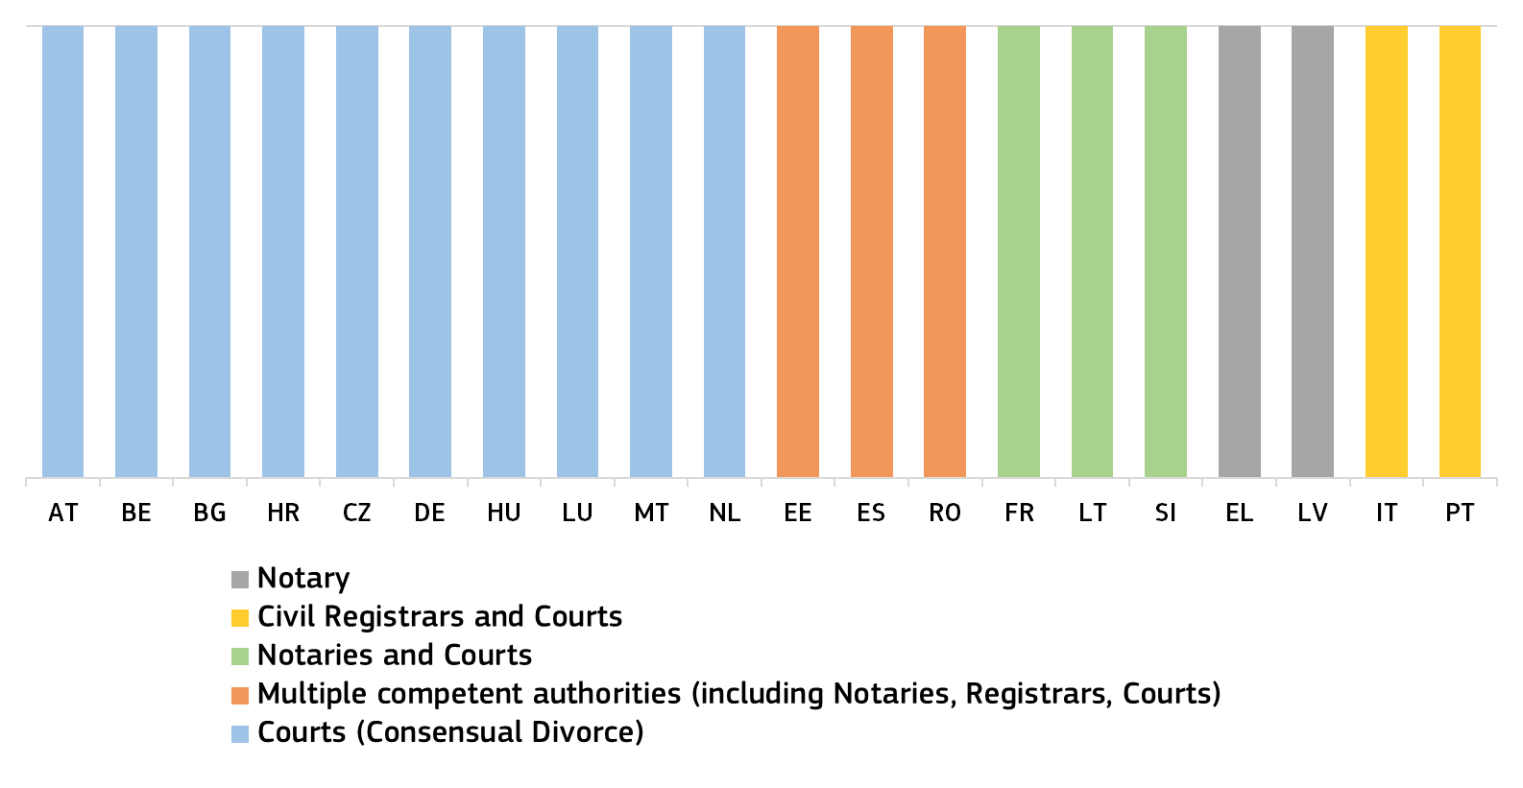
(*) Data are based on the Justice Without Litigation II project, which covers the 22 Member States in which the profession of civil law notaries is established. Among the Member States that replied to the questionnaire PL and SK do not have a consensual divorce procedure. EE: Notary, civil registrar and as concerns courts: a consensual divorce before the court is only possible when the parties cannot submit a joint application for the divorce (for example when one of the spouses is abroad and does not have an Estonian digital identity). ES: court, notary or the Council of the administration of justice. FR: the consensual divorce is only dealt with by the court when a hearing for a minor child is requested. RO: court, notary or civil registrar.
– Accessing alternative dispute resolution methods –
Figure 27 shows Member States’ efforts to promote the voluntary use of alternative dispute resolution (ADR) methods with specific incentives. These may vary depending on the area of law ().
Figure : Promotion of and incentives for using ADR methods, 2025 (*) (source: European Commission ())
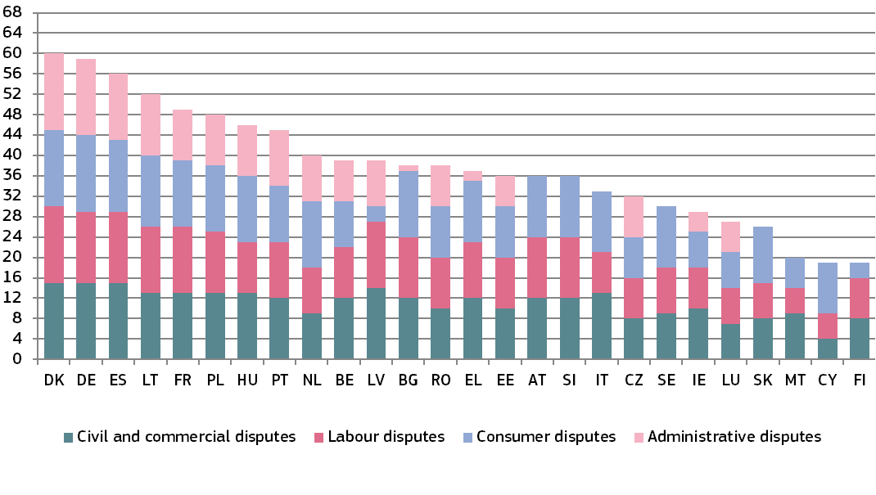(*) Maximum possible: 68 points. Aggregated indicators based on the following indicators: 1) website providing information on ADR; 2) media publicity campaigns; 3) brochures for the general public; 4) provision by the court of specific information sessions on ADR upon request; 5) court ADR/mediation coordinator; 6) publication of evaluations on the use of ADR; 7) publication of statistics on the use of ADR; 8) partial or full coverage by legal aid of costs ADR incurred; 9) full or partial refund of court fees, including stamp duties, if ADR is successful; 10) no requirement for a lawyer for ADR procedures; 11) judge can act as a mediator; 12) agreement reached by the parties becomes enforceable by the court; 13) possibility to initiate proceedings/file a claim and submit documentary evidence online; 14) parties can be informed of the initiation and different steps of procedures electronically; 15) possibility of online payment of applicable fees; 16) use of technology (artificial intelligence applications, chat bots) to facilitate the submission and resolution of disputes; and 17) other means. For each of these 17 indicators, one point was awarded for each area of law. IE: Administrative cases fall into the category of civil and commercial cases. EL: ADR exists in public procurement procedures before administrative courts of appeal. ES: ADR is mandatory in labour law cases. PT: For civil/commercial disputes, court fees are only refunded for justices of the peace. SK: The Slovak legal order does not support the use of ADR for administrative purposes. FI: Consumer and labour disputes are also considered to be civil cases. SE: Judges have procedural discretion on ADR. Seeking an amicable dispute settlement is a mandatory task for the judge unless it is inappropriate due to the nature of the case.
– Specific arrangements for access to justice –
The 2022 EU Justice Scoreboard presented dedicated figures on specific arrangements to facilitate equal access to justice of persons with disabilities. The 2023 EU Justice Scoreboard continued to further explore selected specific arrangements that facilitate equal access to justice for persons at risk of discrimination, and also for two specific groups: older people and victims of violence against women and domestic violence. The 2026 EU Justice Scoreboard again presents data on access to justice for persons with disabilities.
The chart below outlines the digital solutions accessible for persons with disabilities at first instance courts. The chart shows the accessibility of different solutions in civil and commercial, criminal, and administrative justice.
Figure : Digital solutions at first instance courts accessible for persons with disabilities, which comply with the relevant accessibility standards and legislation (source: European Commission ())
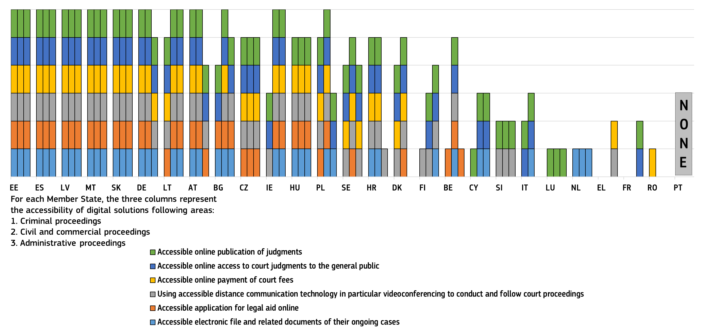

Figure 29 complements Figure 19 on the efficiency of proceedings in the area of consumer law by showing specific selected measures undertaken by EU Member States to increase awareness on the new European model of collective redress () aimed at improving consumers’ access to justice in mass harm situations.

Figure : Specific arrangements for representative action protecting the collective interests of consumers, 2025 (*) (source: European Commission ())
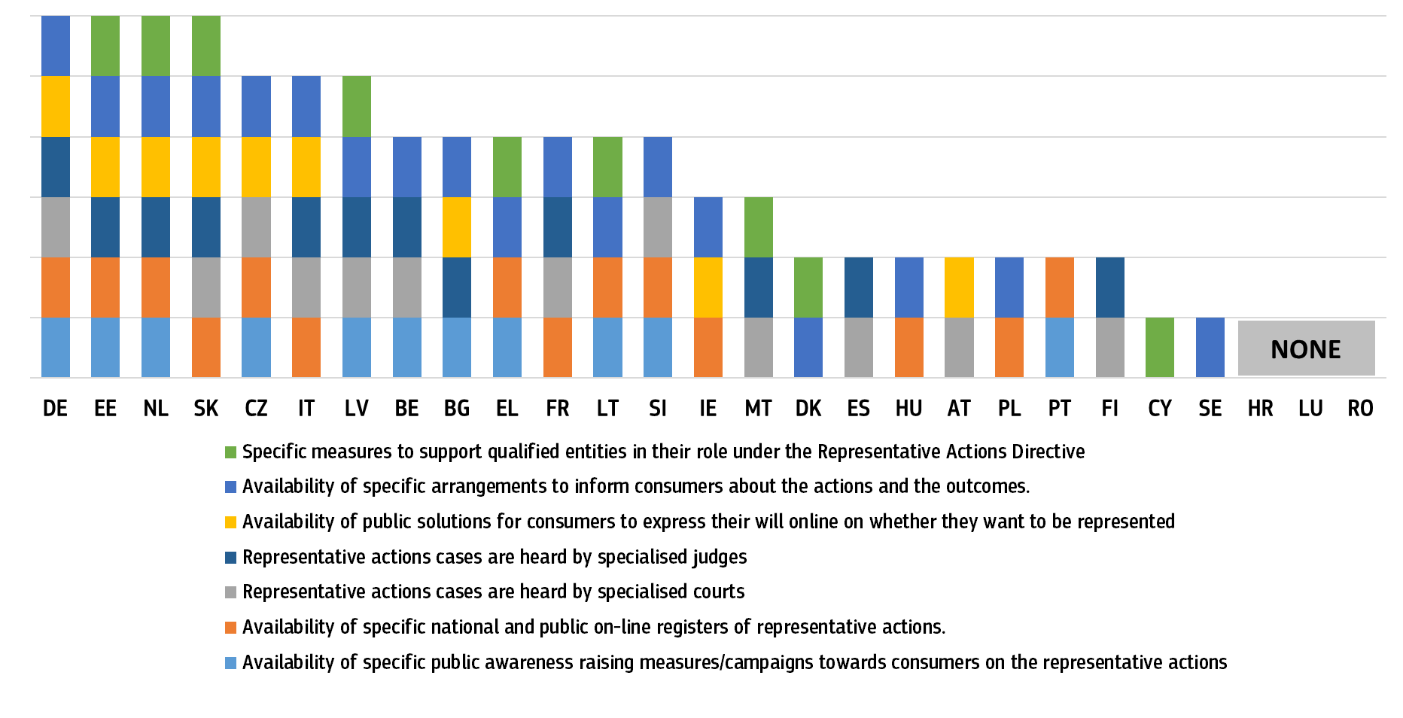(*) Representative actions as set out by Directive (EU) 2020/1828. They are actions brought by qualified entities before national courts or administrative authorities on behalf of groups of consumers to seek injunctive measures (i.e. to stop a trader’s unlawful practices, similarly to what is provided for in the Injunctions Directive 2009/22/EC), redress measures (such as refund, replacement, repair) or both injunctive and redress measures. This question intends to collect information on specific practices, which are not necessarily directly linked to the implementation of the Directive. Data are not reported for HR, LU, RO. BE: there is no registry but certain decisions have to be published on the website of the Ministry of Economy and the official journal. DK: Currently, the qualified entities are the Danish Consumer Ombudsman (Forbrugerombudsmanden) and the Danish Medicines Agency (Lægemiddelstyrelsen) which are both supported by public funding. EE: consumer disputes are heard at the Consumer Disputes Committee which is an independent and impartial entity resolving consumer disputes. IE: the Citizens Information website has published an article on representative actions as part of their ‘How to complain’ information page for consumers. EL: Law 5019/2023 puts in place a new system of representative actions. LV: There is one cross-border qualified entity designated in Latvia. There have not been any representative action cases yet. LT: Public awareness measures on consumer representative actions are mainly implemented by providing relevant information on the websites of the State Consumer Rights Protection Authority (SCRPA) and consumer associations (e.g. memo published on the website of SCRPA, https://vvtat.lrv.lt/media/viesa/saugykla/2024/2/o2moBOazC4c.pdf). PT: The list of the representative actions brought before PT courts is available on the Directorate-General for Consumers’ website, as well as the contact of the entity and any relevant document for consumers: https://www.consumidor.gov.pt/consumidor_4/acoes-coletivas/informacoes-sobre-acoes-coletivas. SK: consumers are able to join the collective action through any notary. The application form is available at the following link https://static.slov-lex.sk/pdf/prilohy/SK/ZZ/2023/289/20230725_5563264-2.pdf.
The 2026 EU Justice Scoreboard extends the analysis of child-friendly justice. Figure 30 looks at a broader variety of specific arrangements for child-friendly justice (both civil and criminal/juvenile justice proceedings). Figure 31 explores a broader range of specific arrangements available when a child is involved as a victim or as a suspect/accused person in judicial proceedings.
Figure : Specific arrangements for child-friendly justice/proceedings (both civil and criminal/juvenile justice proceedings), 2025 (*) (source: European Commission ()).
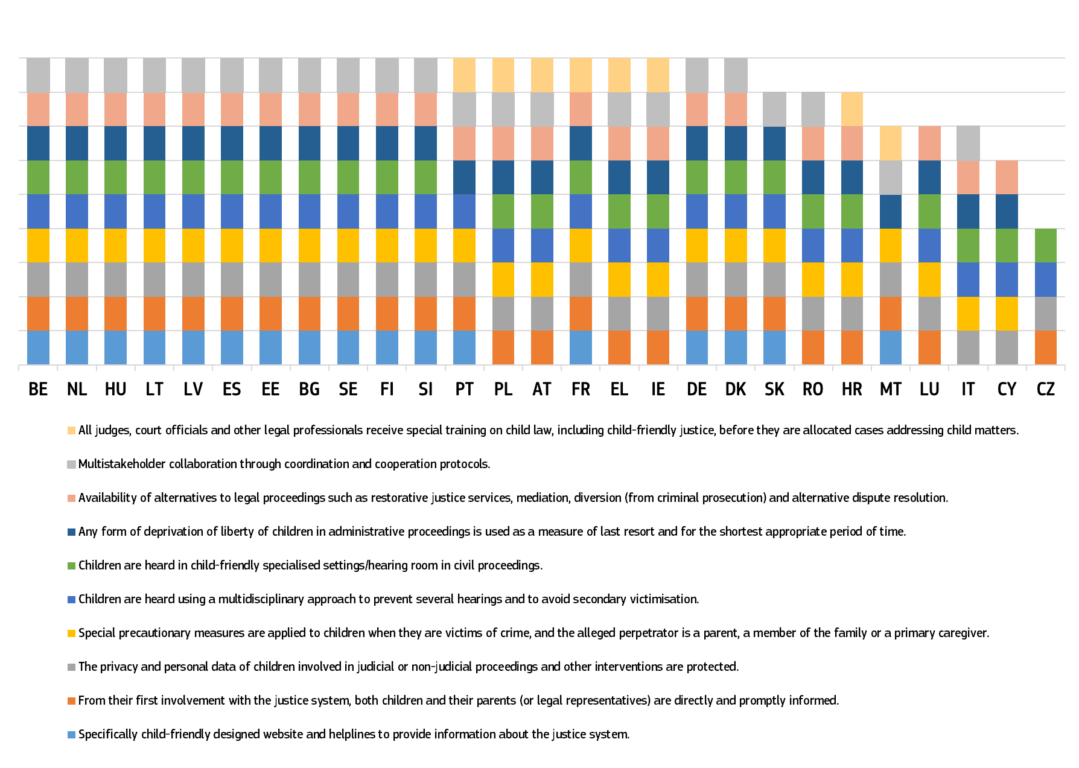 (*) Children: people under 18 years.
Figure : Specific arrangements for children involved in criminal proceedings as victims or suspects and accused persons, 2025 (*) (source: European Commission ())
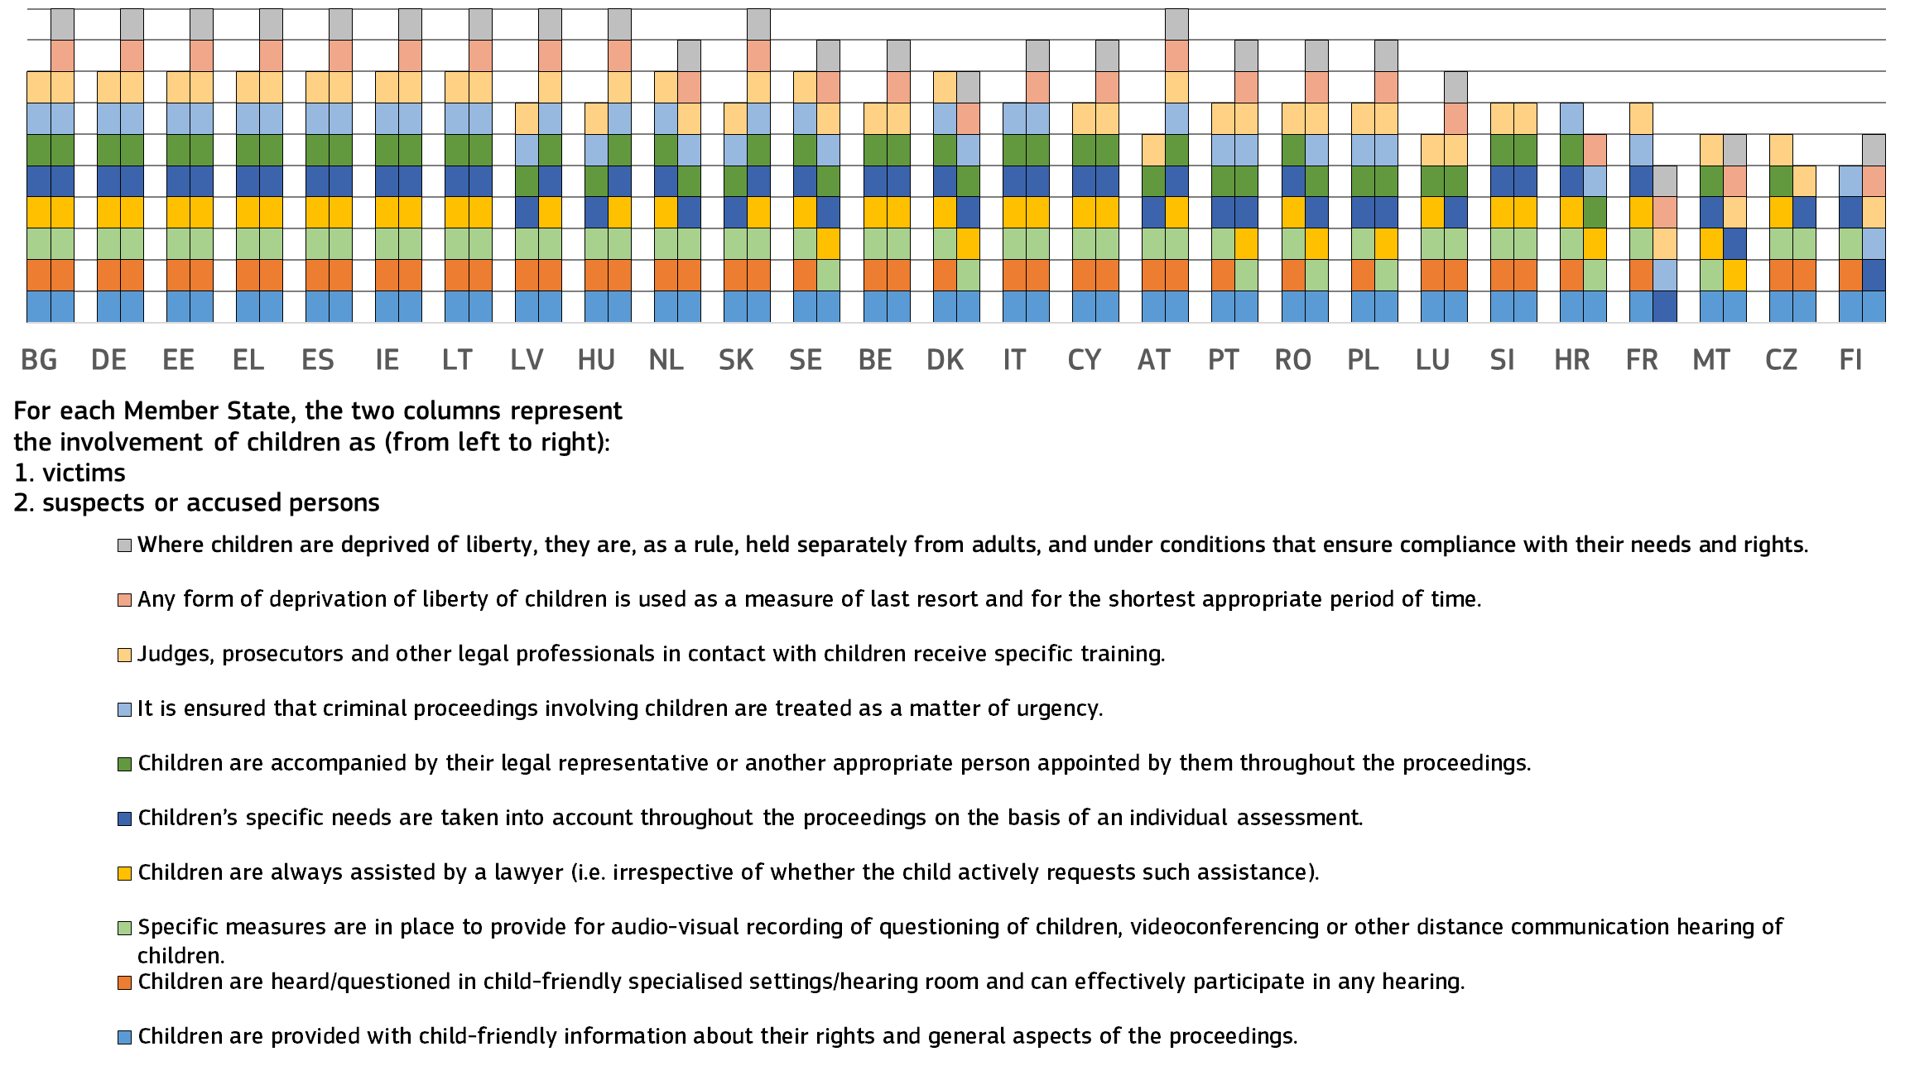(*) Children: people under 18 years.
For the second time, the 2026 EU Justice Scoreboard provides an overview of selected specific powers of equality bodies to assist victims of discrimination to access justice. Figure 32 below shows which selected powers the equality body/bodies – or in certain cases other specific bodies – hold in each Member State to resolve cases of discrimination. These include offering the parties the possibility to seek an alternative resolution to their dispute (for example mediation or conciliation procedures), issuing binding decisions in discrimination cases, acting in court in cases of discrimination either on behalf of victims or in its own name to defend the public interest, or initiating proceedings in support of victims. The exercise of those powers in practice varies depending on the Member State.
Figure : Selected powers of equality bodies to help victims of discrimination to access justice, 2025 (source: European Commission ())
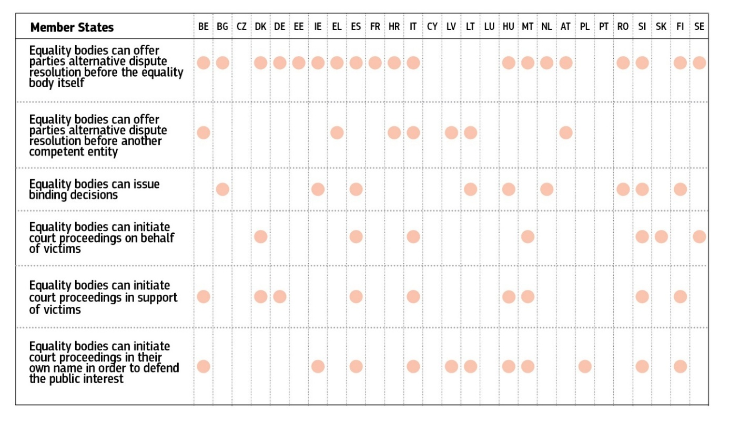

2.2.3. Resources
Sufficient resources are necessary for the justice system to work properly. This includes the necessary investment in physical and technical infrastructure and well qualified, trained and adequately paid staff of all kinds. Without adequate facilities, tools or staff with the required qualifications, skills and access to continuous training, the quality of proceedings and decisions is undermined.
– Financial resources –
The figures below show the actual government expenditure on the operation of the justice system (excluding prisons), both per inhabitant (Figure 33) and as a proportion of gross domestic product (GDP) (Figure 34).

Figure : General government total expenditure on law courts in EUR per inhabitant, 2014, 2022 – 2024 (*) (source: Eurostat (online data code gov 10a exp))
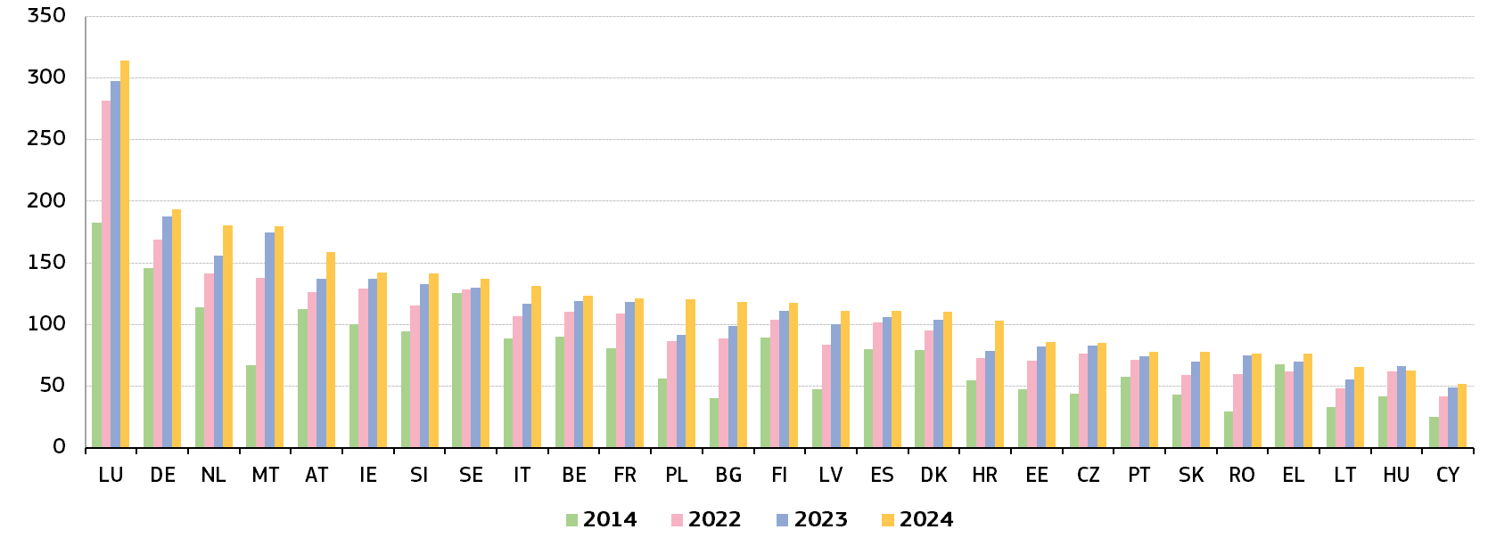
(*) Member States are ordered according to their expenditure in 2024 (from highest to lowest). Data for BE (2024), DE (2022-2024), ES (2024), FR (2023-2024) PT (2024), SK (all years) is provisional. Data for BE (2024), DE (2022-2024), ES (2024), FR (2023-2024) PT (2024), SK (all years) is provisional.

Figure : General government total expenditure on law courts as a percentage of GDP, 2014, 2022 – 2024 (*) (source: Eurostat (online data code gov_10a_exp))
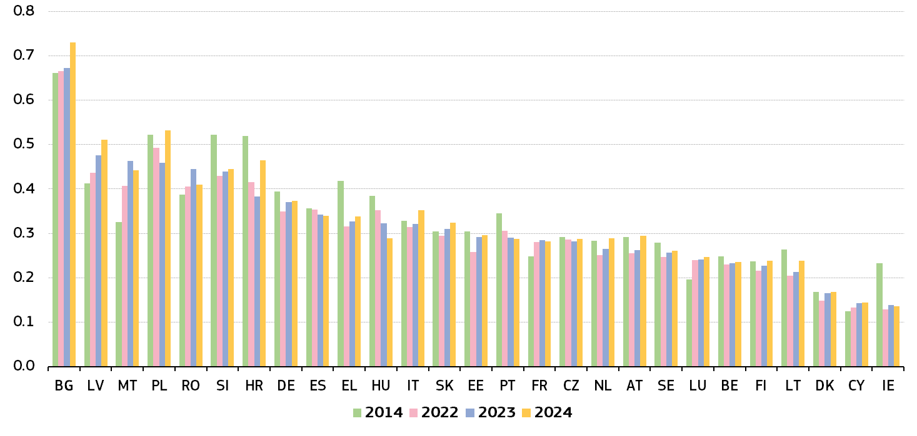(*) Member States are ordered according to their expenditure in 2024 (from highest to lowest). Data for BE (2024), DE (2022-2024), ES (2024), FR (2023-2024) PT (2024), SK (all years) is provisional. Data for PL have a break in series in 2022. Source: Eurostat (online data code gov_10a_exp)

Figure 35 presents the ratio of the annual salaries of judges and prosecutors to the average annual salary in the country. For each country, the bars present these ratios for judges and prosecutors at the beginning of their respective careers and at their peak. By virtue of Article 19(1) TEU, Member States have to ensure that both their courts as a whole and the individual judges are independent in the fields covered by EU law. While temporary reduction in remuneration in the context of austerity measures, have not been deemed to violate this provision, the Court of Justice of the EU has stated that the receipt by members of the judiciary of a level of remuneration commensurate with the importance of the functions carried out constitutes an essential guarantee of judicial independence ().
Figure : Ratio of annual salaries of judges and prosecutors to annual average gross salary in the country in 2024 (*) (source: CEPEJ study)
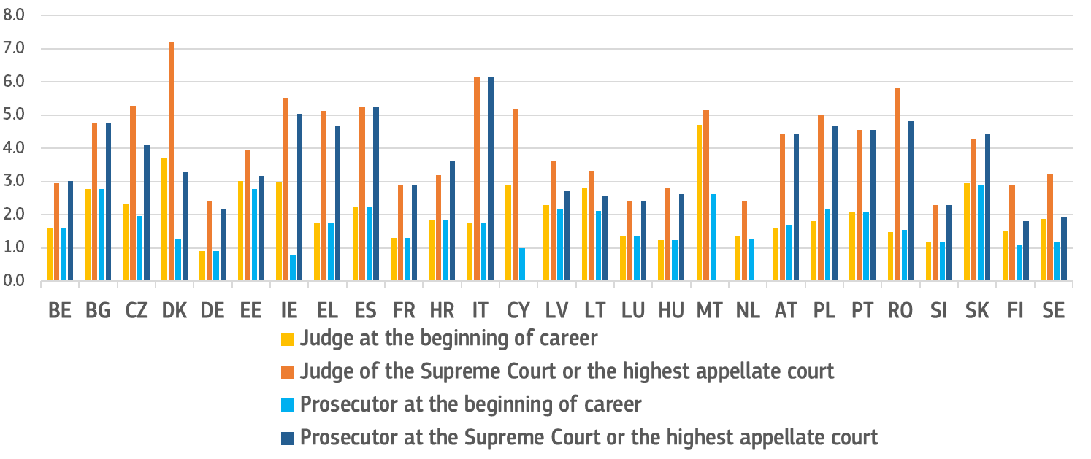(*) Member States specific comments on the data are accessible in the CEPEJ study (). This figure does not take into account any additional benefits provided to judges and prosecutors, such as special pensions, housing benefits or other financial benefits.

– Human resources –
Adequate human resources are essential for the quality of a justice system. Diversity among judges, including gender balance, adds complementary knowledge, skills and experience and reflects the reality of society.
Figure : Number of judges, 2014, 2022 – 2024 (*) (per 100 000 inhabitants) (source: CEPEJ study)
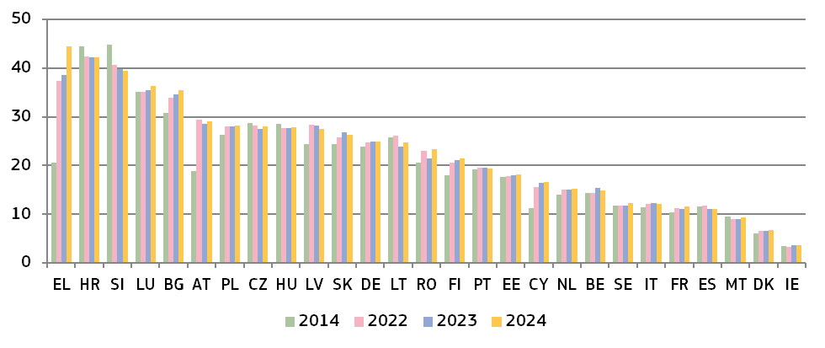(*) This category consists of judges working full-time, according to the CEPEJ methodology. It does not include the Rechtspfleger/court clerks that exist in some Member States. EL: since 2016, data on the number of professional judges include all the ranks for criminal and civil justice as well as administrative judges. IT: Regional audit commissions, local tax commissions and military courts are not taken into consideration. Administrative justice has been taken into account since 2018. AT: data on administrative justice have been part of the data since 2016.
Figure : Proportion of female professional Supreme Court judges 2023 – 2025 (*) (source: European Commission ())
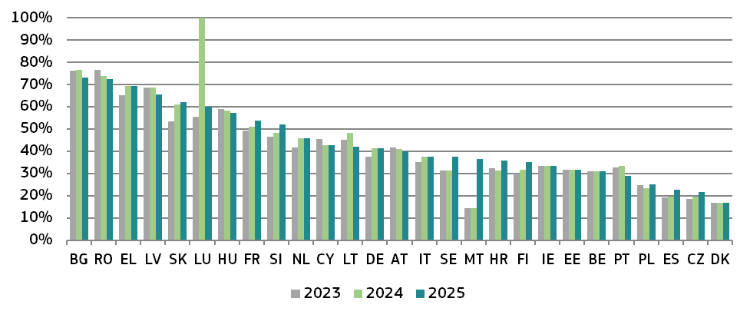(*) The data are sorted by 2024 values, from the highest to the lowest.
Figure : Number of lawyers, 2014, 2022 – 2024 (*) (per 100 000 inhabitants) (source: CEPEJ study)
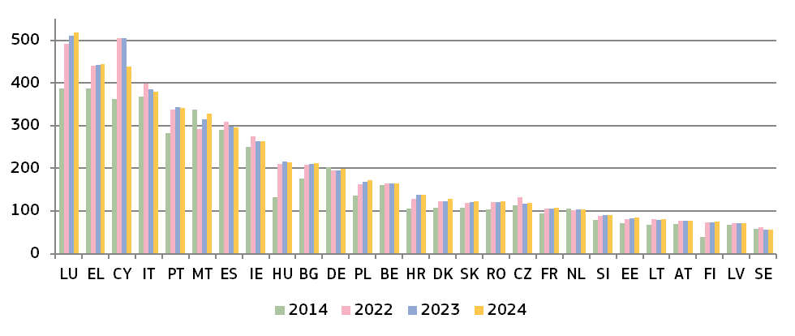
(*) According to the CEPEJ methodology, a lawyer is a person qualified and authorised by national law to plead and act on behalf of their clients; to engage in the practice of law; to appear before the courts or advise and represent their clients in legal matters (Recommendation Rec (2000)21 of the Committee of Ministers of the Council of Europe on the freedom of exercise of the profession of lawyer). DE: No distinction is made between different groups of lawyers in Germany. FI: Since 2015, the number of lawyers provided includes both the number of lawyers working in the private sector and the number of lawyers working in the public sector.

2.2.4. Digitalisation
The use of information and communication technologies (ICT) can strengthen Member States’ justice systems and make them more accessible, efficient, resilient and ready to face current and future challenges. The COVID-19 pandemic has highlighted a number of challenges affecting the functioning of the judiciary and revealed the need for national justice systems to further improve their digitalisation.
Earlier editions of the EU Justice Scoreboard provided comparative data on certain aspects of ICT in justice systems. As announced in the Commission’s Communication on the digitalisation of justice in the EU of 2 December 2020 (), the Scoreboard has been substantially augmented with further data on digitalisation in the Member States. This should allow for more in-depth monitoring of progress areas and challenges that remain.
Citizen-friendly justice requires that information about national judicial systems is not only easily accessible but is also tailored to specific groups of society that would otherwise have difficulties in accessing the information, including persons with disabilities. Figure 39 shows the availability of online information about the judicial system for the general public that can help persons access justice.

Figure : Availability of online information about the judicial system for the general public, 2025 (*) (source: European Commission ())
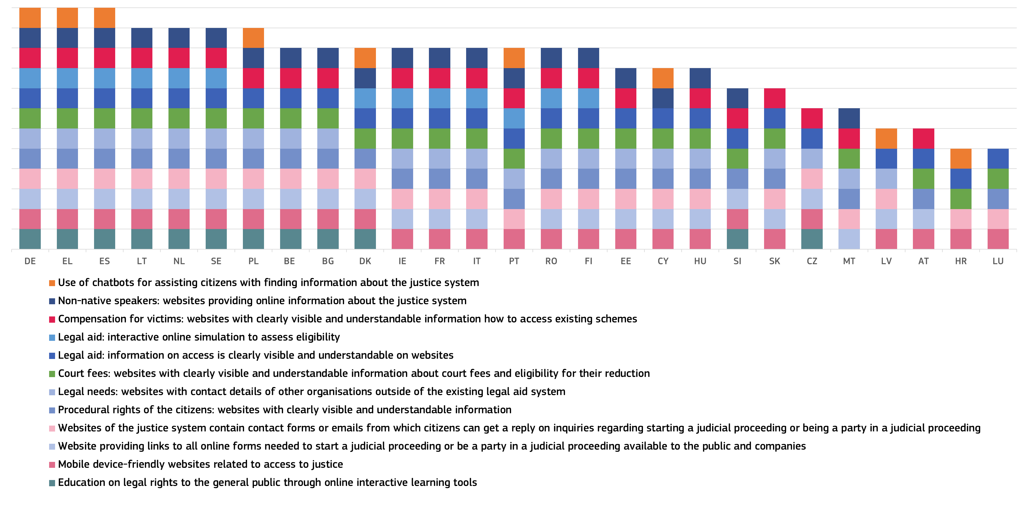
(*) DE: Each federal state as well as the federal level decide individually which information to provide online.

– Digital-ready rules –
The use of digital solutions in civil/commercial, administrative and criminal cases often requires appropriate regulation in national procedural rules. Figure 40 illustrates the possibilities set out by law for various actors to use distance communication technology (such as videoconferencing) for court and court-related procedures, and reflects the current situation on the admissibility of digital evidence.
Figure : Procedural rules allowing digital technology in courts in civil/commercial, administrative and criminal cases, 2025 (*) (source: European Commission ()
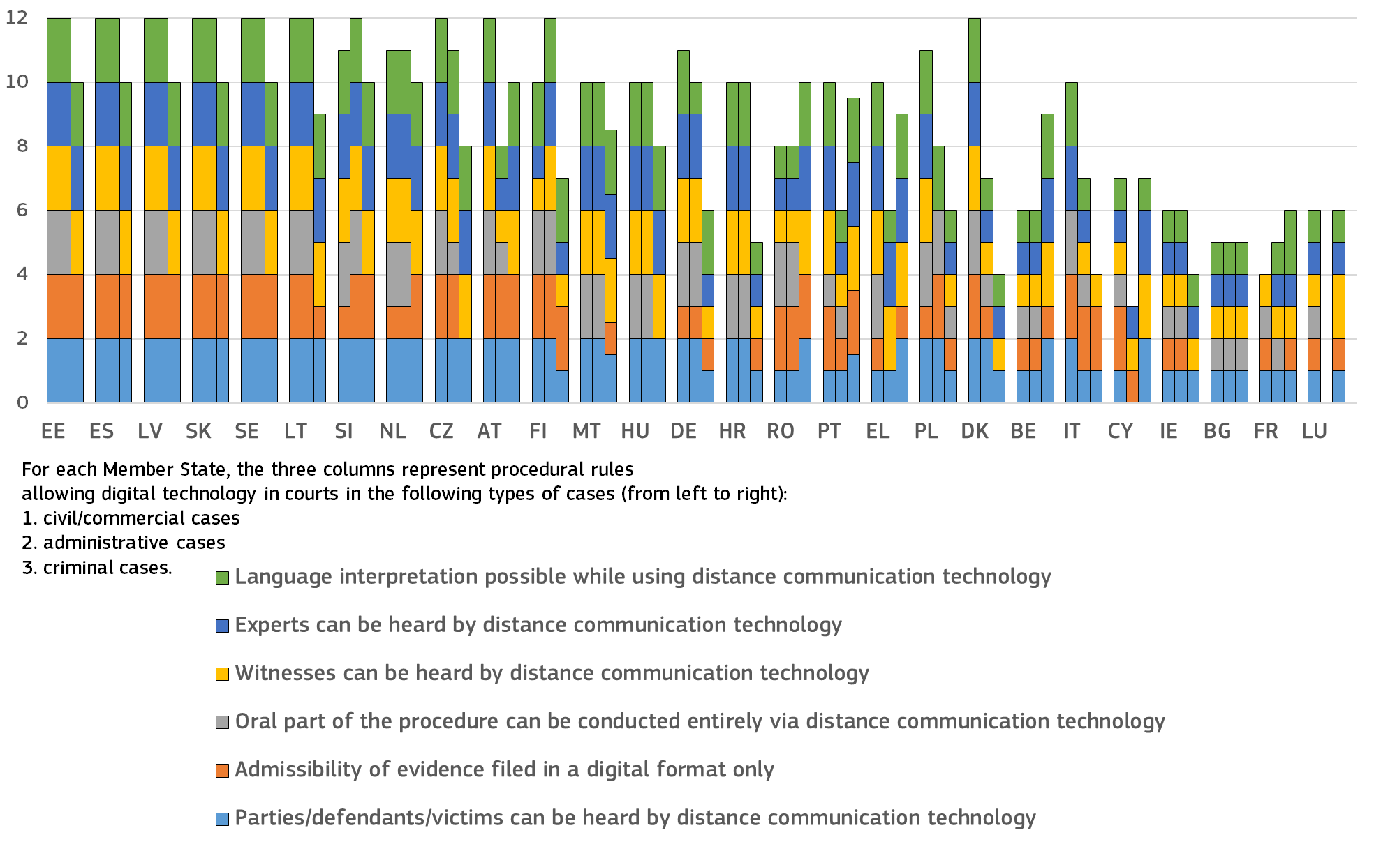
(*) Maximum possible: 12 points. For each criterion, two points were given if the possibility exists in all civil/commercial, administrative and criminal cases, respectively (in criminal cases, the possibility of hearing the parties was split to cover both defendants and victims). The points are divided by two when the possibility does not exist in all cases. For those Member States that do not distinguish between civil/commercial and administrative cases, the same number of points has been given for both areas. The data on “Possibility to conduct the oral part of the procedure entirely via distance communication technology, in particular videoconferencing” for criminal cases reflects the situation in 2024.
– Use of digital tools –
Beyond digital-ready procedural rules, courts and prosecution services need to have appropriate tools and infrastructure in place for distance communication and secure remote access to the workplace (Figure 41). Adequate infrastructure and equipment are also needed for secure electronic communication between courts/prosecution services and legal professionals and institutions (Figures 42 and 43).
ICT, including innovative technology, plays an important role in supporting the work of judicial authorities. It therefore contributes significantly to the quality of justice systems. The availability of various digital tools at the disposal of judges, prosecutors and judicial staff can streamline work processes, ensure fair workload allocation and lead to significant time savings
Figure : Use of digital technology by courts and prosecution services, 2025 (*) (source: European Commission ())
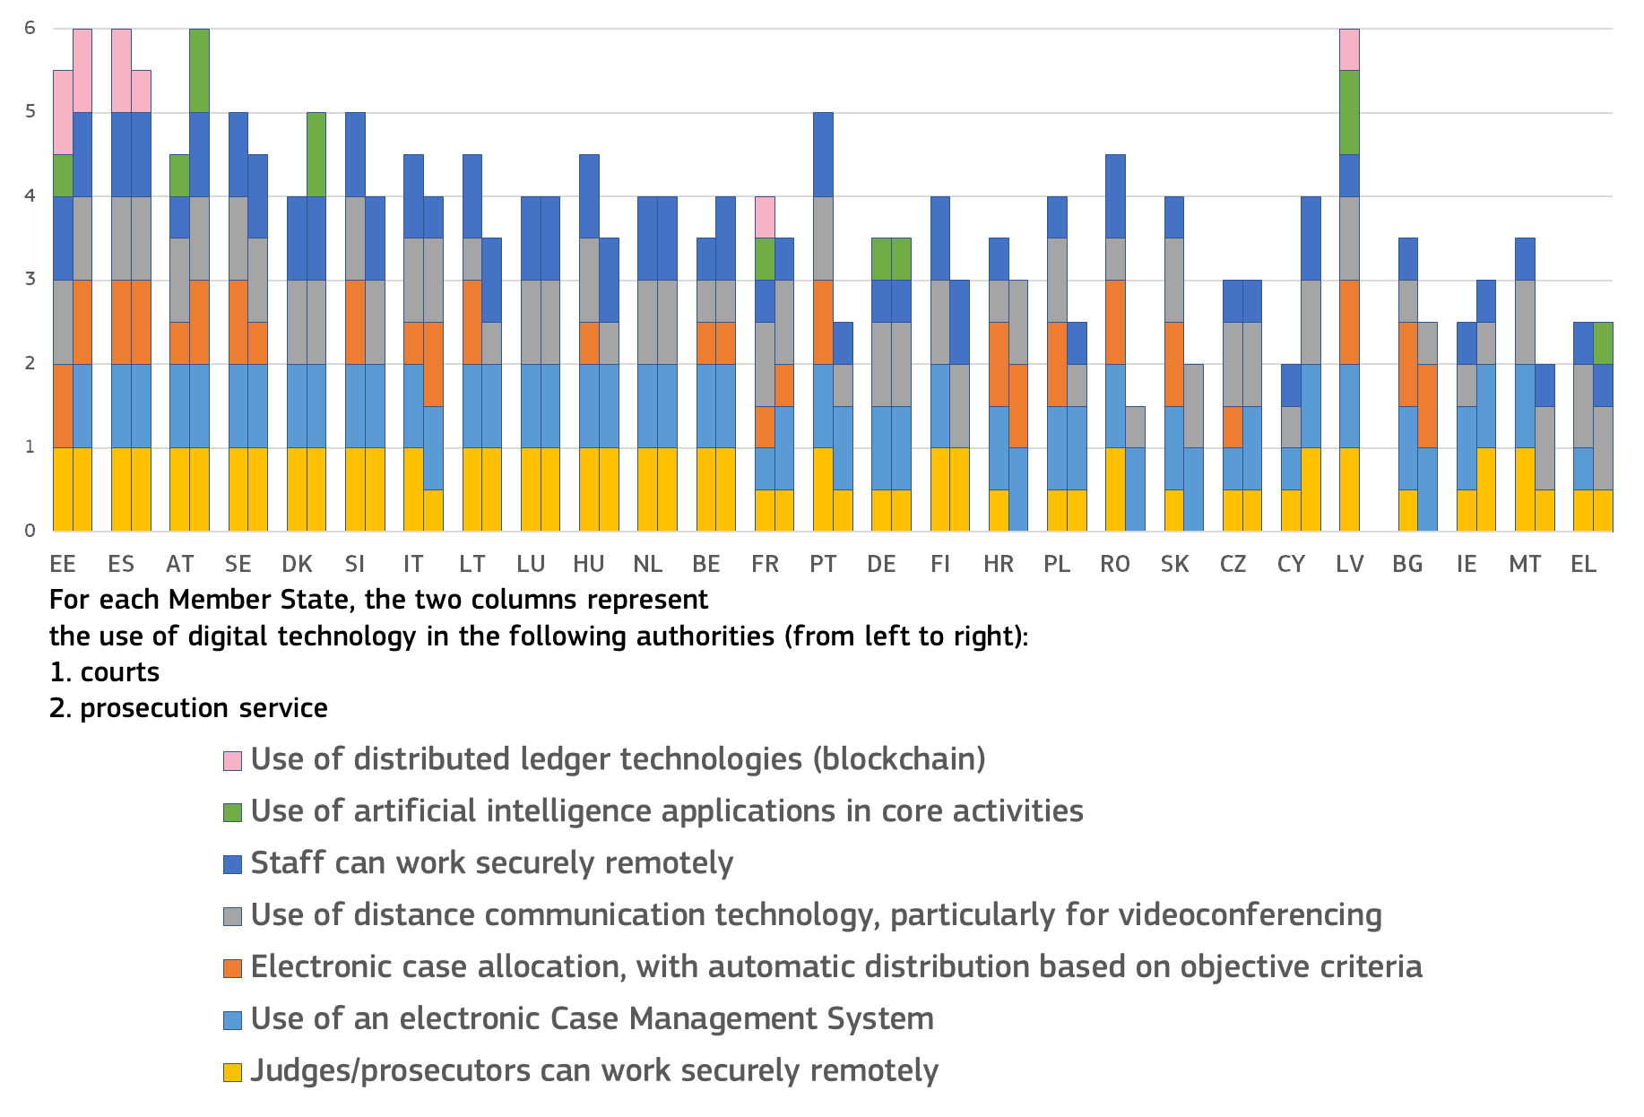(*) Maximum possible: 7 points. For each criterion, 1 point was given if courts and prosecution services, respectively, use a given technology and 0.5 point was awarded when the technology is not always used by them.
Secure electronic communication can contribute to improving the quality of justice systems. If courts can communicate electronically with each other and with legal professionals and other institutions, this can streamline processes and reduce the need for paper-based communication and physical presence. This leads to reductions in the length of pre-trial activities and court proceedings.

Figure : Courts: electronic communication tools, 2025 (*) (source: European Commission ())
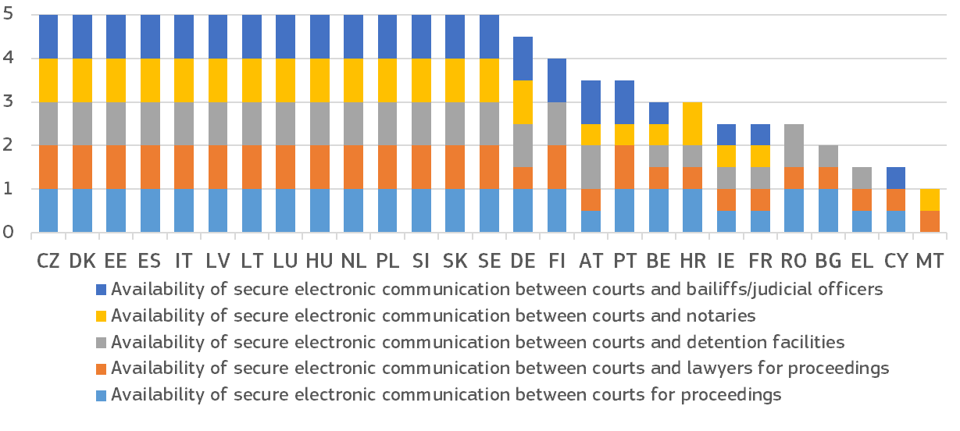
(*) Maximum possible: 5 points. For each criterion, 1 point was given if secure electronic communication is available for courts. 0.5 was awarded when the possibility does not exist in all cases. FI: The tasks of notaries do not relate to courts. Therefore, there is no reason to provide them with secure connection.
Prosecution services are essential to the functioning of the criminal justice system. Access to a secure electronic communications channel could facilitate their work and thus improve the quality of court proceedings. The possibility for secure electronic communication between prosecution services and investigating authorities, defence lawyers and courts would enable a more expedient and efficient preparation of the proceedings before the court.
Figure : Prosecution service: electronic communication tools, 2025 (*) (source: European Commission ())
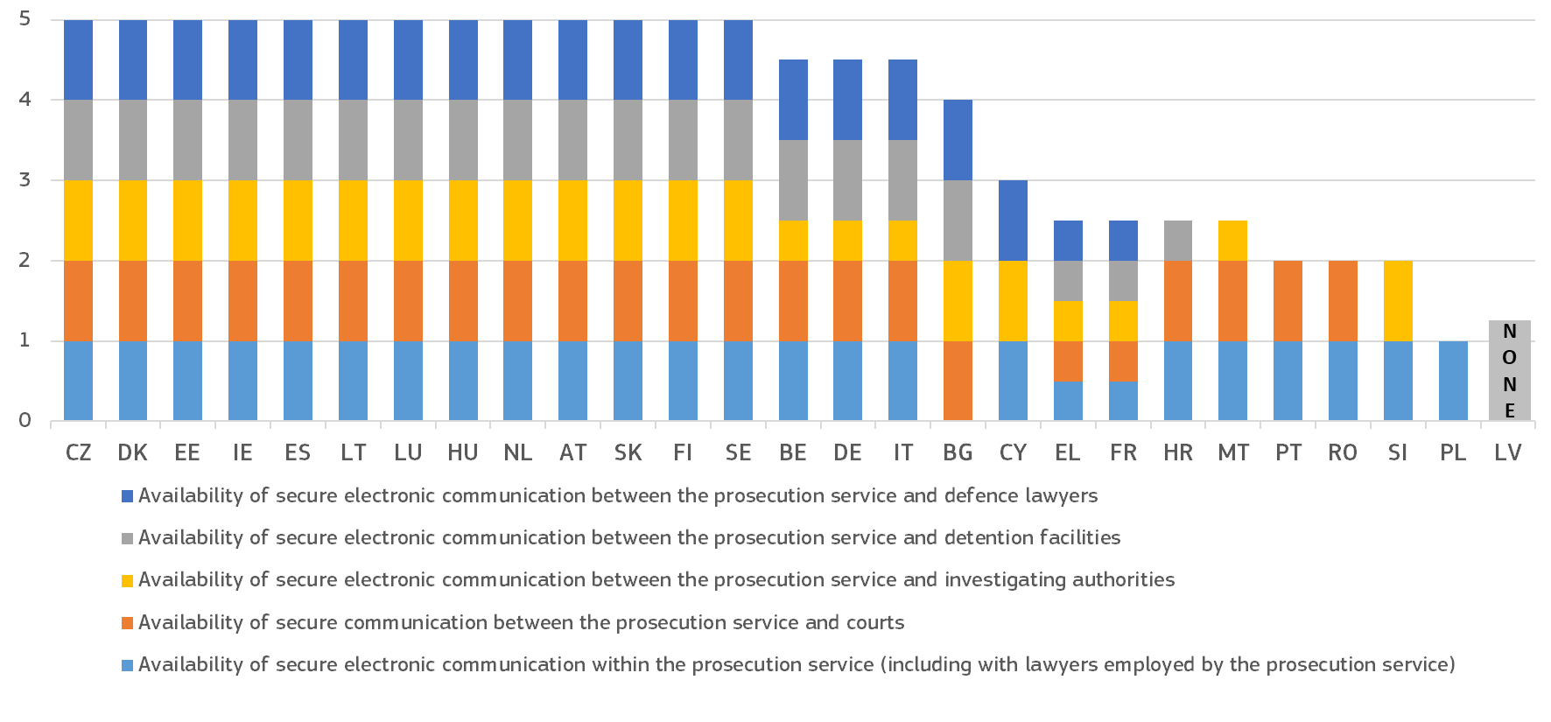
(*) Maximum possible: 5 points. For each criterion, 1point was given if secure electronic communication is available for prosecution services. 0.5 was awarded when the possibility does not exist in all cases. Availability of electronic communication tools within prosecution service includes communication with lawyers employed by the prosecution service.
– Online access to courts –
The ability to carry out specific steps in a judicial procedure electronically is an important aspect of the quality of justice systems. The electronic submission of claims, the possibility of monitoring and advancing proceedings online or serving documents electronically can noticeably improve access to justice for the general public and businesses (or their legal representatives) and reduce delays and costs. Making digital public service like these available would help bring courts one step closer to the general public and businesses, and by extension increase public trust in the justice system.
Figure : Digital solutions to initiate and follow proceedings in civil/commercial and administrative cases, 2025 (*) (source: European Commission ())
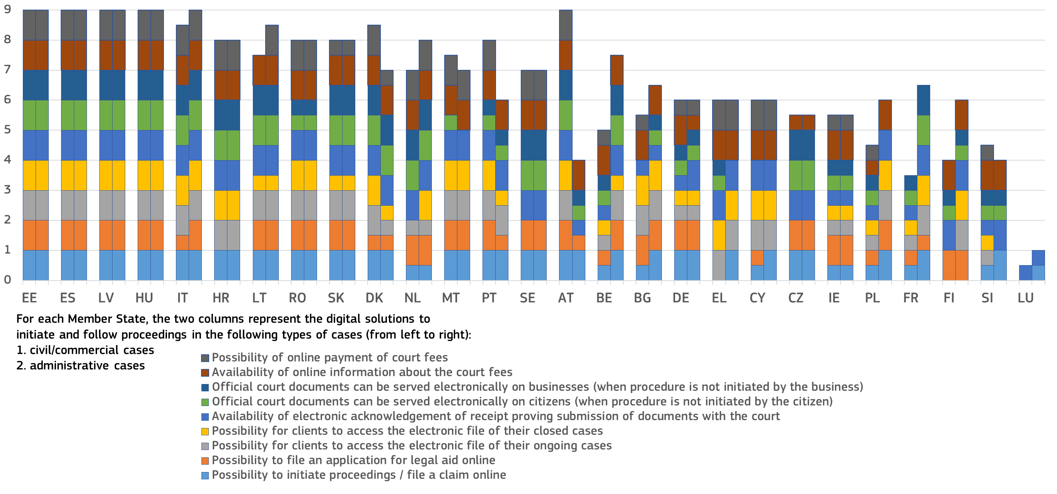

(*) Maximum possible: 9 points. For each criterion, 1 point was given if the possibility exists in all civil/commercial and administrative cases, respectively. 0.5 point was awarded when the possibility does not exist in all cases. For those Member States that do not distinguish civil/commercial and administrative cases, the same number of points has been given for both areas.
Using digital tools to conduct and follow court proceedings in criminal cases can also help guarantee the rights of victims and defendants. For example, digital solutions can enable confidential remote communication between defendants and their lawyers, allow defendants in detention to prepare for their hearing, and help victims of crime avoid secondary victimisation.

Figure : Digital solutions to conduct and follow court proceedings in criminal cases, 2025 (*) (source: European Commission ())
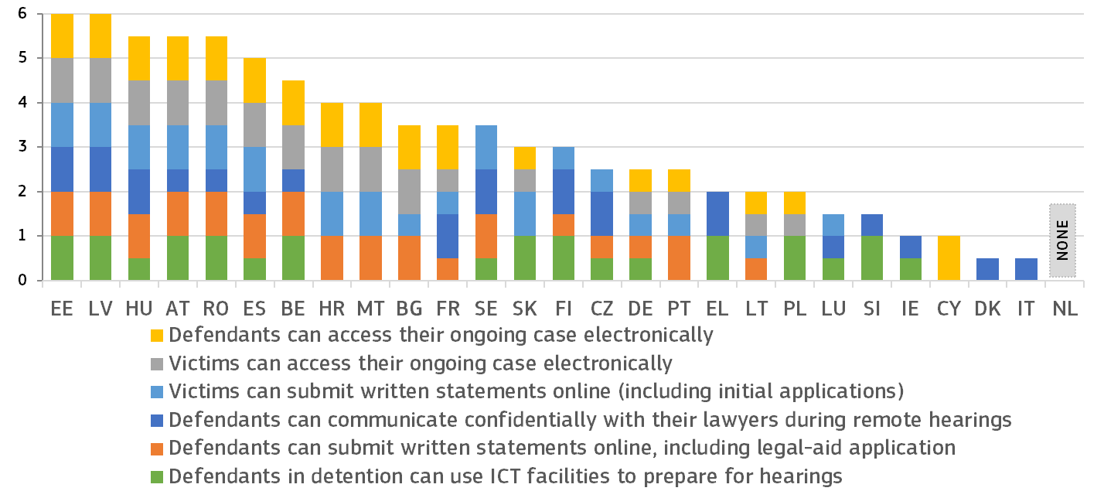
(*) Maximum possible: 6 points. For each criterion, 1 point was given if the possibility exists in all criminal cases. 0.5 points were awarded when the possibility does not exist in all cases.
– Access to judgments –
Ensuring online access to judgments increases the transparency of justice systems, helps the public and businesses understand their rights and can contribute to consistency in case law. Having the right arrangements in place for publishing judicial decisions online is essential to creating user-friendly search facilities () that make case law more accessible to legal professionals and the general public, including persons with disabilities. Seamless access to case law and its easy reuse make the justice system algorithm-friendly, enabling innovative ‘legal tech’ applications that support practitioners.
The online publication of court decisions requires balancing a variety of interests, within the boundaries set by legal and policy frameworks. The General Data Protection Regulation () fully applies to the processing of personal data by courts. When assessing what data to make public, a fair balance has to be struck between the right to data protection and the obligation to publicise court decisions to ensure the transparency of the justice system. This is particularly true when there is a prevailing public interest that justifies the disclosure of those data. In many countries, the law or practice requires the anonymisation or pseudonymisation () of judicial decisions before publication, either systematically or upon request. Data produced by the judiciary are also governed by EU legislation on open data and the reuse of public sector information ().
Making judicial decisions available in a machine-readable format (), as displayed in Figure 47, makes the justice system ‘algorithm-friendly’, i.e. more easily searchable ().
Figure : Online access to published judgments by the general public, 2025 (*) (civil/commercial, administrative and criminal cases, all instances) (source: European Commission ())
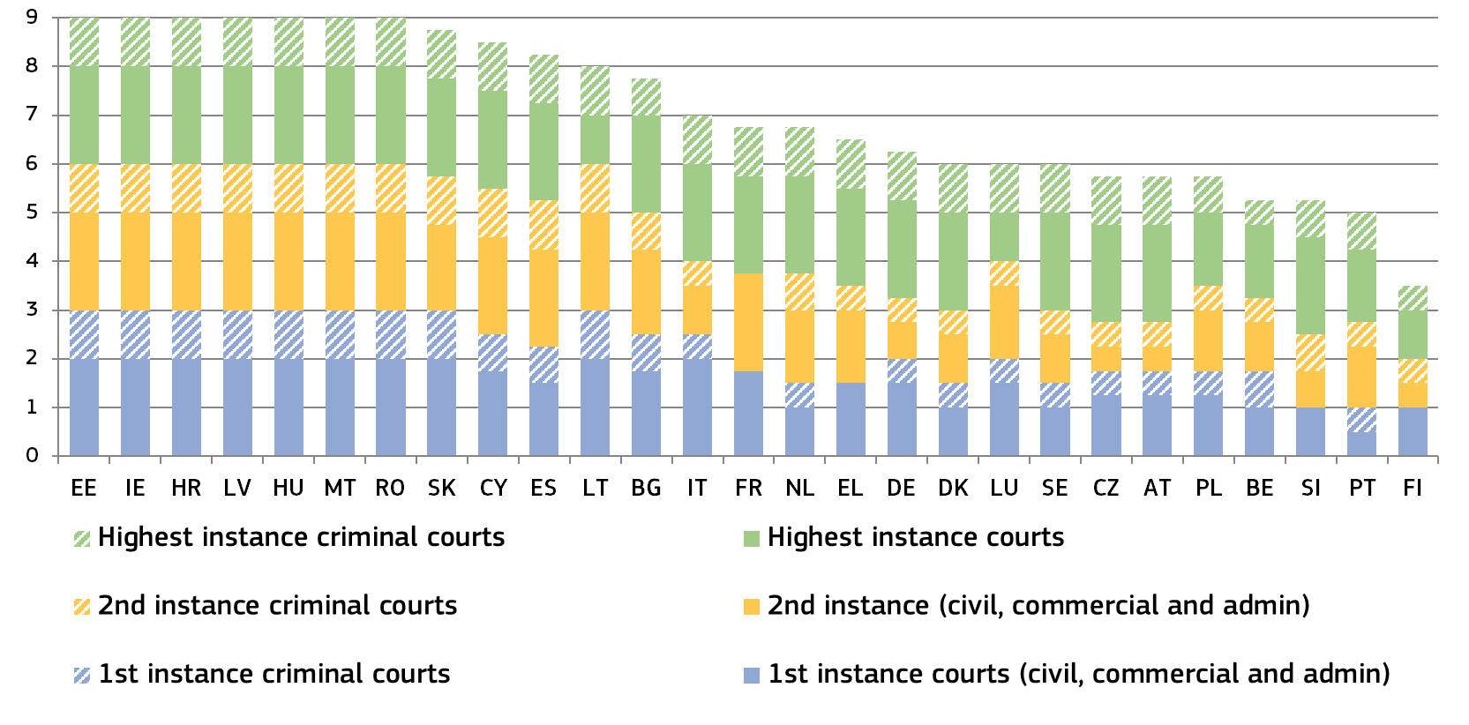
(*) Maximum possible: 9 points. For each court instance, 1 point was given if all judgments are available for civil/commercial and administrative and criminal cases respectively, 0.75 points when most judgments (more than 50% are available) and 0.5 points when some judgments (less than 50%) are available. For Member States with only two court instances, points have been given for three court instances by mirroring the respective higher instance court of the non-existing instance. For those Member States that do not distinguish the two areas of law (civil/commercial and administrative), the same number of points has been given for both areas. BE: For civil and criminal cases, each court is in charge of deciding on the publication of its own judgments. DE: Each federal state decides on the online availability of first instance judgments. AT: For first and second instance, judges decide which judgments are published. Decisions of the Supreme Court that reject an appeal without substantial reasoning are not published. Decisions of the Supreme Administrative Court taken by a single judge are published if the judge concerned decides to publish them. Furthermore, decisions only containing legal issues where there is already continuous jurisprudence of the Supreme Administrative Court and non-complicated decisions concerning discontinuance of proceedings are not published. NL: Courts decide on publication according to published criteria. PT: A commission within the court decides on the publication. SI: procedural decisions with little or no significance for case law are not published; from decisions in cases which are identical in substance (e.g. bulk cases), only the leading decision is published (together with the list of case files with the same content). Individual higher courts decide which judgments can be published. SK: Decisions on several types of civil cases such as inheritance matters or determining paternity are not published. FI: Courts decide which judgments are published.

Figure : Arrangements for producing machine-readable judicial decisions, 2025 (*) (civil/commercial, administrative and criminal cases, all instances) (source: European Commission ())
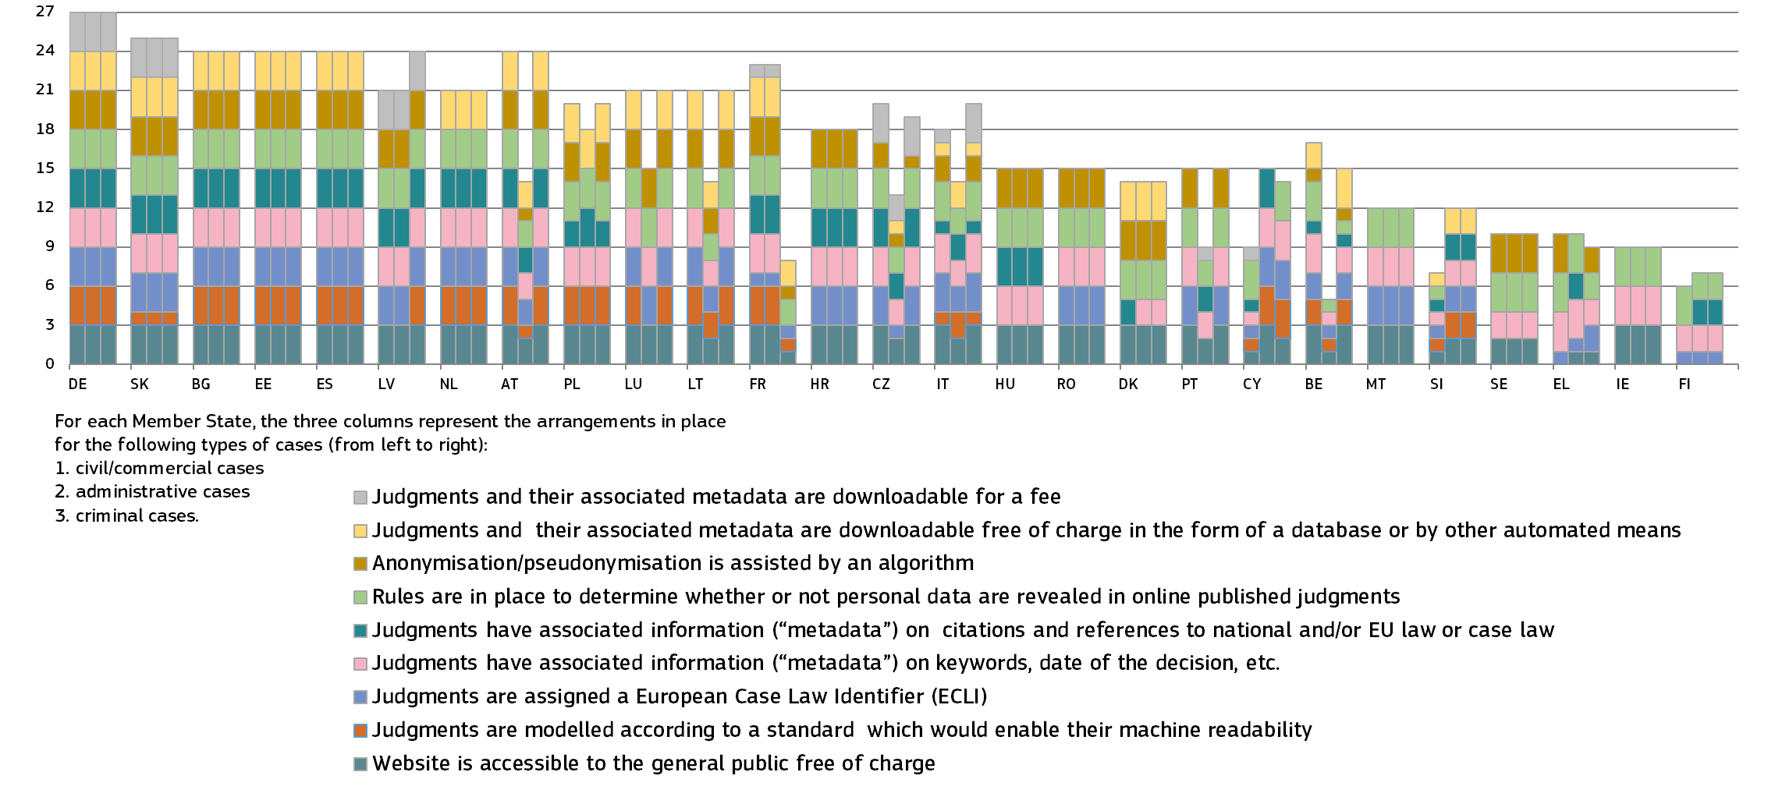
(*) Maximum possible: 27 points per type of case. For each of the three instances (first, second, final) 1 point can be given if all judicial decisions are covered. If only some judicial decisions are covered at a given instance, only 0.5 points are awarded. Where a Member State has only two instances, points have been given for three instances by mirroring the respective higher instance as the non-existing instance. For those Member States that do not distinguish between administrative and civil/commercial cases, the same points have been allocated for both areas of law. IE: Administrative cases are in effect subsumed within the category civil and commercial cases in the Irish legal order. AT, CY, FI, IT, LU, SI: no second instance for admin cases but directly highest instance. Corresponding points are given to the second instance here to ensure fair score accounting for the ‘missing’ layer.

2.3. Independence of justice systems
Judicial independence, which is integral to the task of judicial decision-making, is a requirement in EU law stemming from (i) the principle of effective judicial protection referred to in Article 19 TEU, and, (ii) the right to an effective remedy before a court or tribunal enshrined in Article 47 of the Charter of Fundamental Rights of the EU (). Judicial independence presumes the following:
(a) external independence, where the relevant body exercises its functions autonomously, without being subject to any hierarchical constraint or subordinated to any other body and without taking orders or instructions from any source whatsoever, thus being protected against external interventions or pressure that could impair the independent judgement of its members and influence their decisions; and
(b) internal independence and impartiality, where an equal distance is maintained from the parties to the proceedings and their respective interests with regard to the subject matter of those proceedings (), and when individual judges are protected from undue internal pressure within the judiciary ().
Judicial independence is vital to guarantee that all the rights that individuals derive from EU law will be protected and that the values common to the Member States set out in Article 2 TEU, in particular the value of the rule of law, will be safeguarded (). Preserving the EU legal order is fundamental for all people and businesses whose rights and freedoms are protected under EU law.
A high level of perceived independence of the judiciary is vital for the trust which justice must inspire in individuals in a society governed by the rule of law. It also contributes to a growth-friendly business environment, as a perceived lack of independence can deter investment. The Scoreboard includes indicators for the judiciary’s independence relating to the effectiveness of investment protection. In addition to indicators on perceived judicial independence from various sources, the Scoreboard presents indicators on how justice systems are organised to protect judicial independence in certain types of situations where independence could be at risk. This reflects input from the European Network of Councils for the Judiciary (ENCJ), the Network of the Presidents of the Supreme Judicial Courts of the EU (NPSJC), and the Network of Public Prosecutors or equivalent institutions at the Supreme Judicial Courts of the Member States of the European Union (NADAL Network).

2.3.1. Summary on judicial independence
Judicial independence is an essential element of the right to an effective remedy before a court or tribunal, as enshrined in Article 47 of the Charter of Fundamental Rights of the EU, and indispensable for ensuring effective judicial protection, as required under Article 19 TEU. It is a fundamental element of an effective justice system and essential for upholding the rule of law. It is vital for ensuring the fairness of judicial proceedings and the trust of the public and businesses in the legal system. The national judicial systems must therefore fully respect the requirements as regards judicial independence following from EU law as interpreted by the Court of Justice of the EU and take due account of European standards on judicial independence. The 2026 EU Justice Scoreboard shows trends in the general public’s and companies’ perceptions of judicial independence. This edition also presents some new indicators on the safeguards regarding the probationary periods for judges, and the powers of Prosecutors General and how cases are allocated within prosecution offices.
The structural indicators do not in themselves allow for conclusions to be drawn about the independence of these bodies, but represent elements that may be taken as a starting point for such an analysis.
a) The 2026 Scoreboard presents the developments in perceived independence from surveys of the general public (Eurobarometer FL581) and companies (Eurobarometer FL582):
- The Eurobarometer survey among the general public (Figure 48) shows that the perception of independence of courts and judges has improved or remained stable in 20 Member States when compared to 2016. On the other hand, compared to last year, the general public’s perception of independence improved or remained stable in 17 Member States while it decreased in ten Member States. In two Member States, the level of perceived independence remained particularly low.
- The Eurobarometer survey of companies (Figure 50) shows that the perception of independence of courts and judges has improved or remained stable in 18 Member States when compared with 2016, while it decreased in nine Member States. Compared with last year, the companies’ perception of independence improved or remained stable in 18 Member States and decreased in nine Member States. In three Member States, the level of perceived independence remained particularly low.
- Among reasons for the perceived lack of independence of courts and judges, interference or pressure from government and politicians was the most often stated, followed by pressure from economic or other specific interests. Both reasons remain notable for the two Member States where perceived independence is very low (Figures 49 and 51).
- Since 2022, the EU Justice Scoreboard has presented the results of a Eurobarometer survey on how companies perceive the effectiveness of investment protection by the law and courts as regards, in their view, unjustified decisions or inaction by the State (Figure 52). Administrative conduct, stability and quality of the law-making process, as well as effectiveness of courts and property protection still remain key factors of comparable significance for confidence in investment protection (Figure 53). Compared to last year, confidence in investment protection improved in 15 Member States.
- Figure 54 presents, for the first time, how judges perceive whether cases have been allocated to judges in circumvention of the established rules or procedures.
- Figure 55 shows the safeguards regarding probationary periods for judges.
- Figure 56 looks at the management powers of the Prosecutors General over lower standing prosecutors, while Figure 57 presents the systems for allocation of cases within prosecution offices.
- Figure 58 shows that the independence of lawyers is generally ensured, allowing lawyers to freely pursue their activities of advising and representing their clients.

2.3.2. Perceived judicial independence and effectiveness of investment protection
Figure : How the general public perceives the independence of courts and judges (*) (source: Eurobarometer () – from left to right, light colours: 2016, 2024 and 2025, dark colours: 2026)
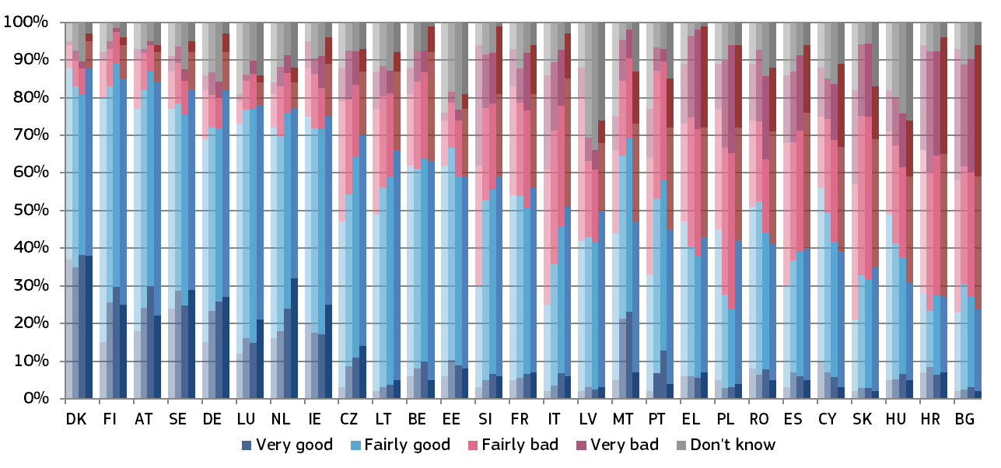
(*) Member States are ordered first by the percentage of respondents who stated that the independence of courts and judges is ‘very good’ or ‘fairly good’ (total good); if some Member States have the same percentage of ‘total good’, then they are ordered by the percentage of respondents who stated that the independence of courts and judges is ‘fairly bad’ or ‘very bad’ (total bad); if some Member States have the same percentage of total good and total bad, then they are ordered by the percentage of respondents who stated that the independence of courts and judges is very good; if some Member States have the same percentage of total good, total bad and ‘very good’ then they are ordered by the percentage of respondents who stated that the independence of courts and judges is ‘very bad’.
Figure 49 shows the main reasons given by respondents for a perceived lack of independence of courts and judges. Respondents among the general public who rated the independence of the justice system as being ‘fairly bad’ or ‘very bad’ could choose between three reasons to explain their rating. The Member States are listed in the same order as in Figure 48.

Figure : Main reasons among the general public for the perceived lack of independence (share of all respondents - higher value means more influence) (source: Eurobarometer ())
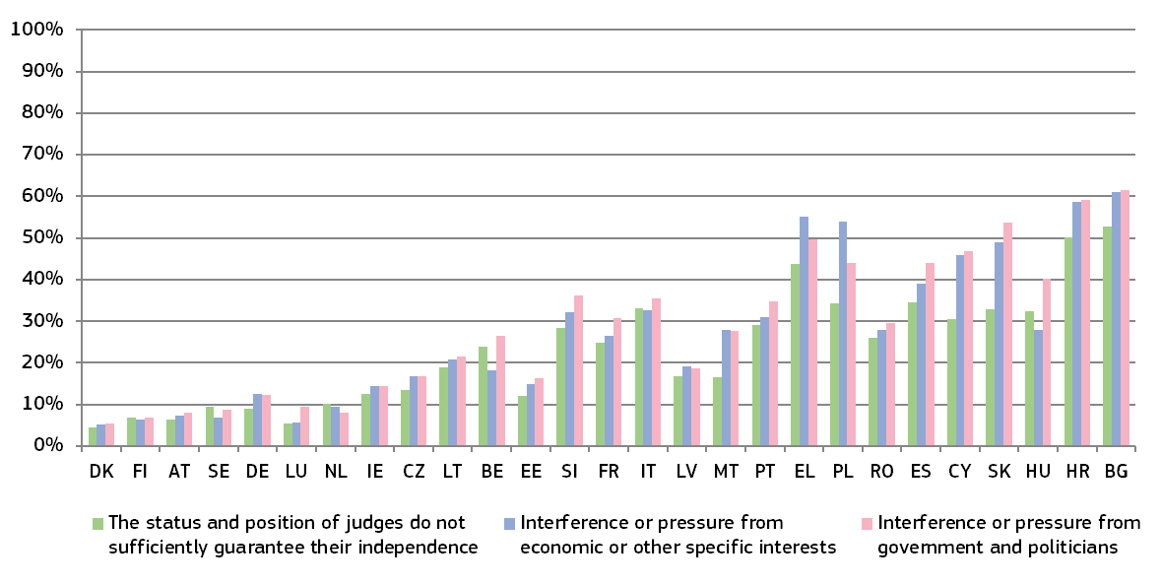
Figure : How companies perceive the independence of courts and judges (*) (source: Eurobarometer () – from left to right, light colours: 2016, 2024 and 2025, dark colours: 2026)
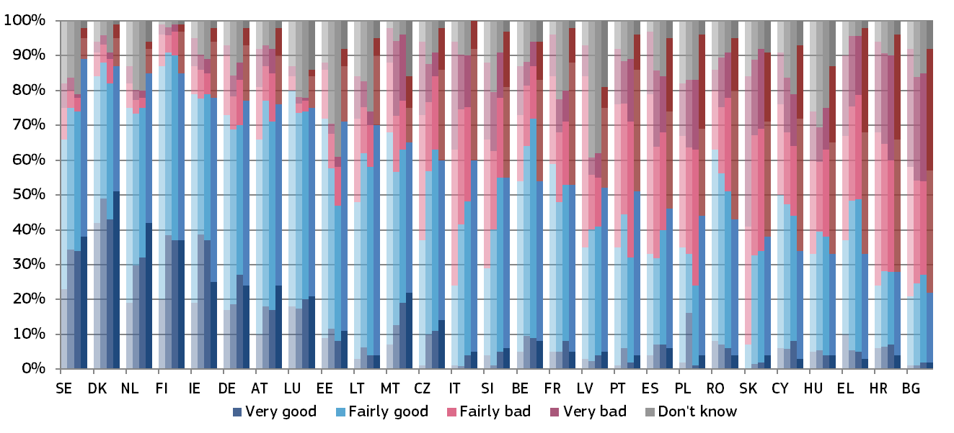
(*) Member States are ordered first by the percentage of respondents who stated that the independence of courts and judges is ‘very good’ or ‘fairly good’ (total good); if some Member States have the same percentage of total good, then they are ordered by the percentage of respondents who stated that the independence of courts and judges is ‘fairly bad’ or ‘very bad’ (total bad); if some Member States have the same percentage of total good and total bad, then they are ordered by the percentage of respondents who stated that the independence of courts and judges is ‘very good’; if some Member States have the same percentage of total good, total bad and ‘very good’, then they are ordered by the percentage of respondents who stated that the independence of courts and judges is ‘very bad’.
Figure 51 shows the main reasons given by companies for the perceived lack of independence of courts and judges. Respondents who rated the independence of the justice system as being ‘fairly bad’ or ‘very bad,’ could choose between three reasons to explain their rating. The Member States are listed in the same order as in Figure 50.
Figure : Main reasons among companies for the perceived lack of independence (rate of all respondents - higher value means more influence) (source: Eurobarometer ())
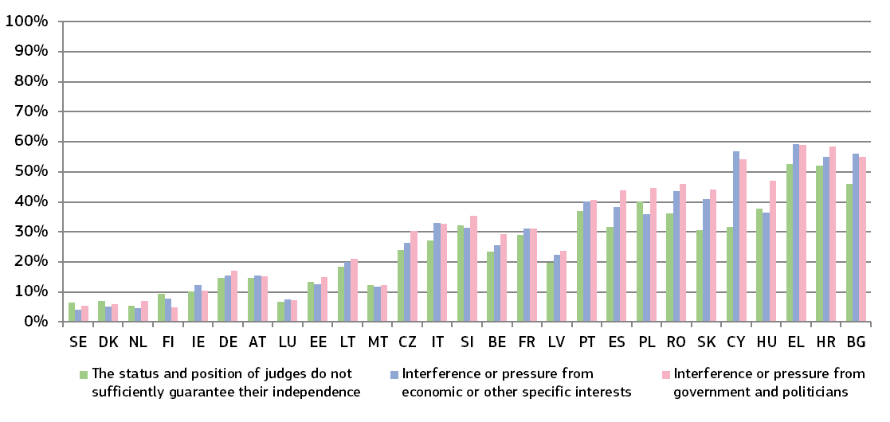
Promoting, facilitating and protecting investment are key priorities within the EU single market. EU law aims to maintain a harmonious balance between protecting investments and pursuing other public interest goals that improve the welfare of its people. Figure 52 shows, for the fifth time, the indicator on how companies perceive the effectiveness of investment protection by the law and courts in relation to what they see as unjustified decisions or inaction by the State.
Figure : How companies perceive the effectiveness of investment protection by the law and courts (*) (source: Eurobarometer () – from left to right, light colours: 2022, 2024, 2025, dark colours: 2026)
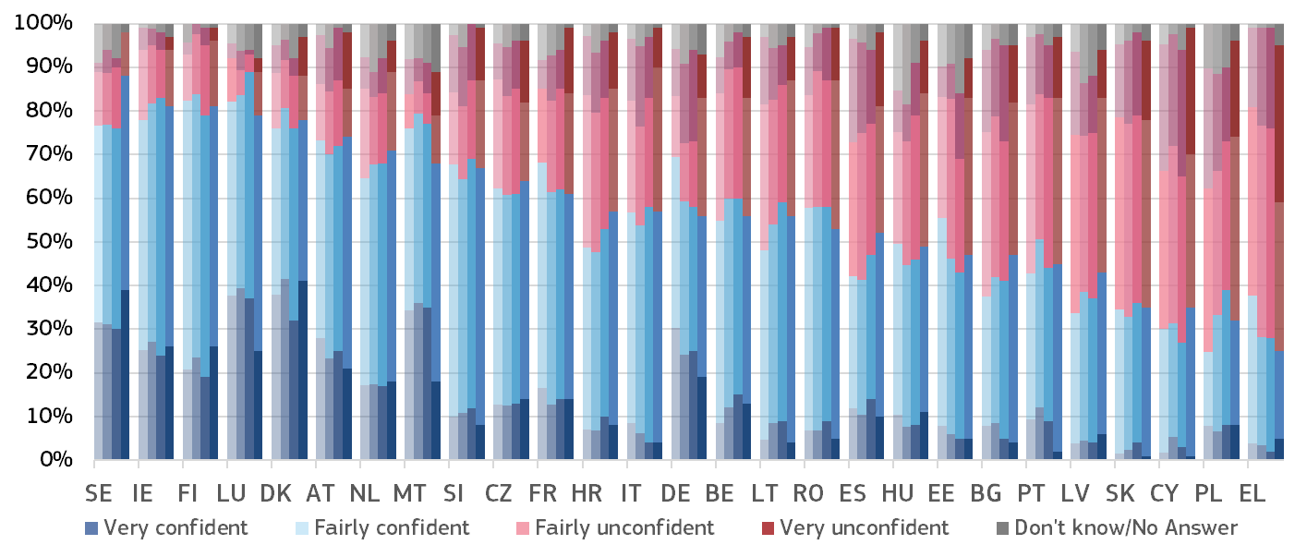
(*) Member States are ordered first by the combined percentage of respondents who stated that they are very or fairly confident in investment protection by the law and courts (total confident); if some Member States have the same percentage of total confident, then they are ordered by the percentage of respondents who stated that they are ‘fairly unconfident’ or ‘very unconfident’ in the effectiveness of investment protection (total unconfident); if some Member States have the same percentage of total confident and total unconfident, then they are ordered by the percentage of respondents who stated that they are ‘very confident’ in the effectiveness of investment protection; if some Member States have the same percentage of total confident, total unconfident and ‘very confident’, then they are ordered by the percentage of respondents who stated that they are ‘very unconfident’ in the effectiveness of investment protection.
Figure 53 shows the main reasons given by companies for the perceived lack of effectiveness of investment protection. Respondents who rated their level of confidence as ‘fairly unconfident’ or ‘very unconfident’, could choose between four reasons to explain their rating (and some indicated ‘other’). The Member States are listed in the same order as in Figure 52.
Figure : Main reasons among companies for their perceived lack of effectiveness of investment protection (rate of all respondents - higher value means more influence) (source: Eurobarometer ())
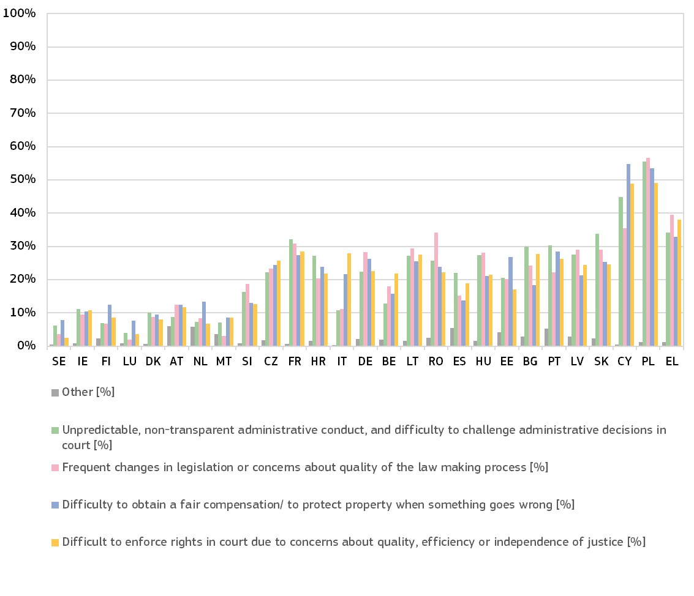

Figure : How judges perceive whether cases have been allocated to judges in circumvention of the established rules or procedures (source: European Network of Councils for the Judiciary (), 2025)
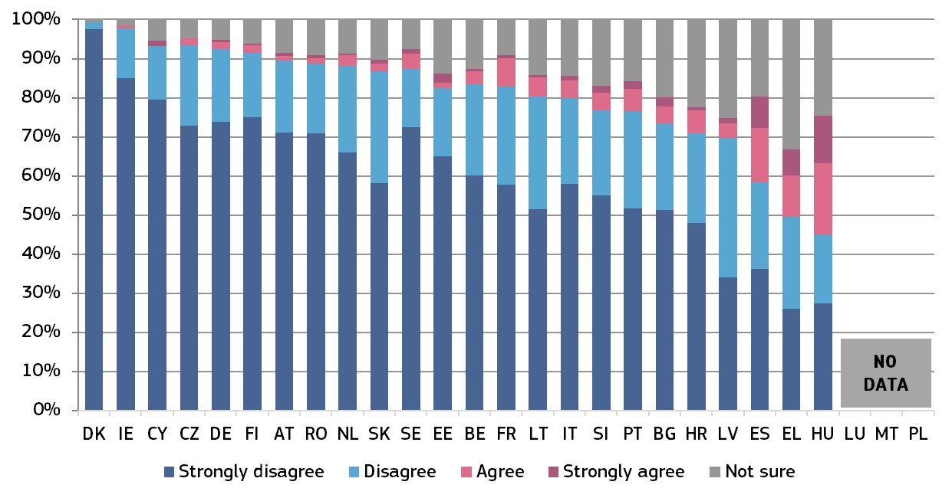

2.3.3. Structural judicial independence
The guarantees of structural independence require rules, particularly on the composition of the court and the appointment, length of service and grounds for abstention, rejection and dismissal of its members, that are such as to dispel any reasonable doubt in the minds of individuals as to the imperviousness of the court to external factors and its neutrality with respect to the interests before it (). They must, in particular, be such as to preclude not only any direct influence, in the form of instructions, but also types of influence that are more indirect and that are liable to have an effect on the decisions of the judges concerned ().
European standards have been developed, particularly by the Council of Europe, for example in the 2010 Council of Europe Recommendation on judges: independence, efficiency and responsibilities (). The EU Justice Scoreboard presents certain indicators on issues that are relevant when assessing how justice systems are organised to safeguard judicial independence. Implementing policies and practices to promote integrity and prevent corruption within the judiciary is also essential to guarantee judicial independence. Ultimately, the effective protection of judicial independence also requires, beyond whatever necessary norms, a culture of integrity and impartiality shared by magistrates and respected by wider society.
This edition of the Scoreboard contains new and updated indicators on: safeguards regarding probationary periods for judges (Figure 55) (), allocation of criminal cases within the prosecution offices (Figure 57) (), and on the independence of bars and lawyers (Figure 58) (). The figures present the national frameworks as they were in December 2024.
The figures presented in the Scoreboard do not provide an assessment or present quantitative data on the effectiveness of the safeguards. They are not intended to reflect the complexity and details of the procedures and accompanying safeguards.

– Safeguards regarding probationary periods for judges –
Where they exist, probationary periods for new judges must include all necessary safeguards, be based on established international standards, and not be unnecessarily long. Final appointment after the probation period should be the rule ().
Figure 55 shows whether judges are appointed for a probationary period, and if they are, the safeguards in place in relation to the assessment of the judge’s performance during the probationary period (and by which body), and according to what criteria and where these are defined.

Figure : Safeguards regarding probationary periods for judges (*) (source: European Network of Councils for the Judiciary and Network of Presidents of Supreme Judicial Courts of the EU ())
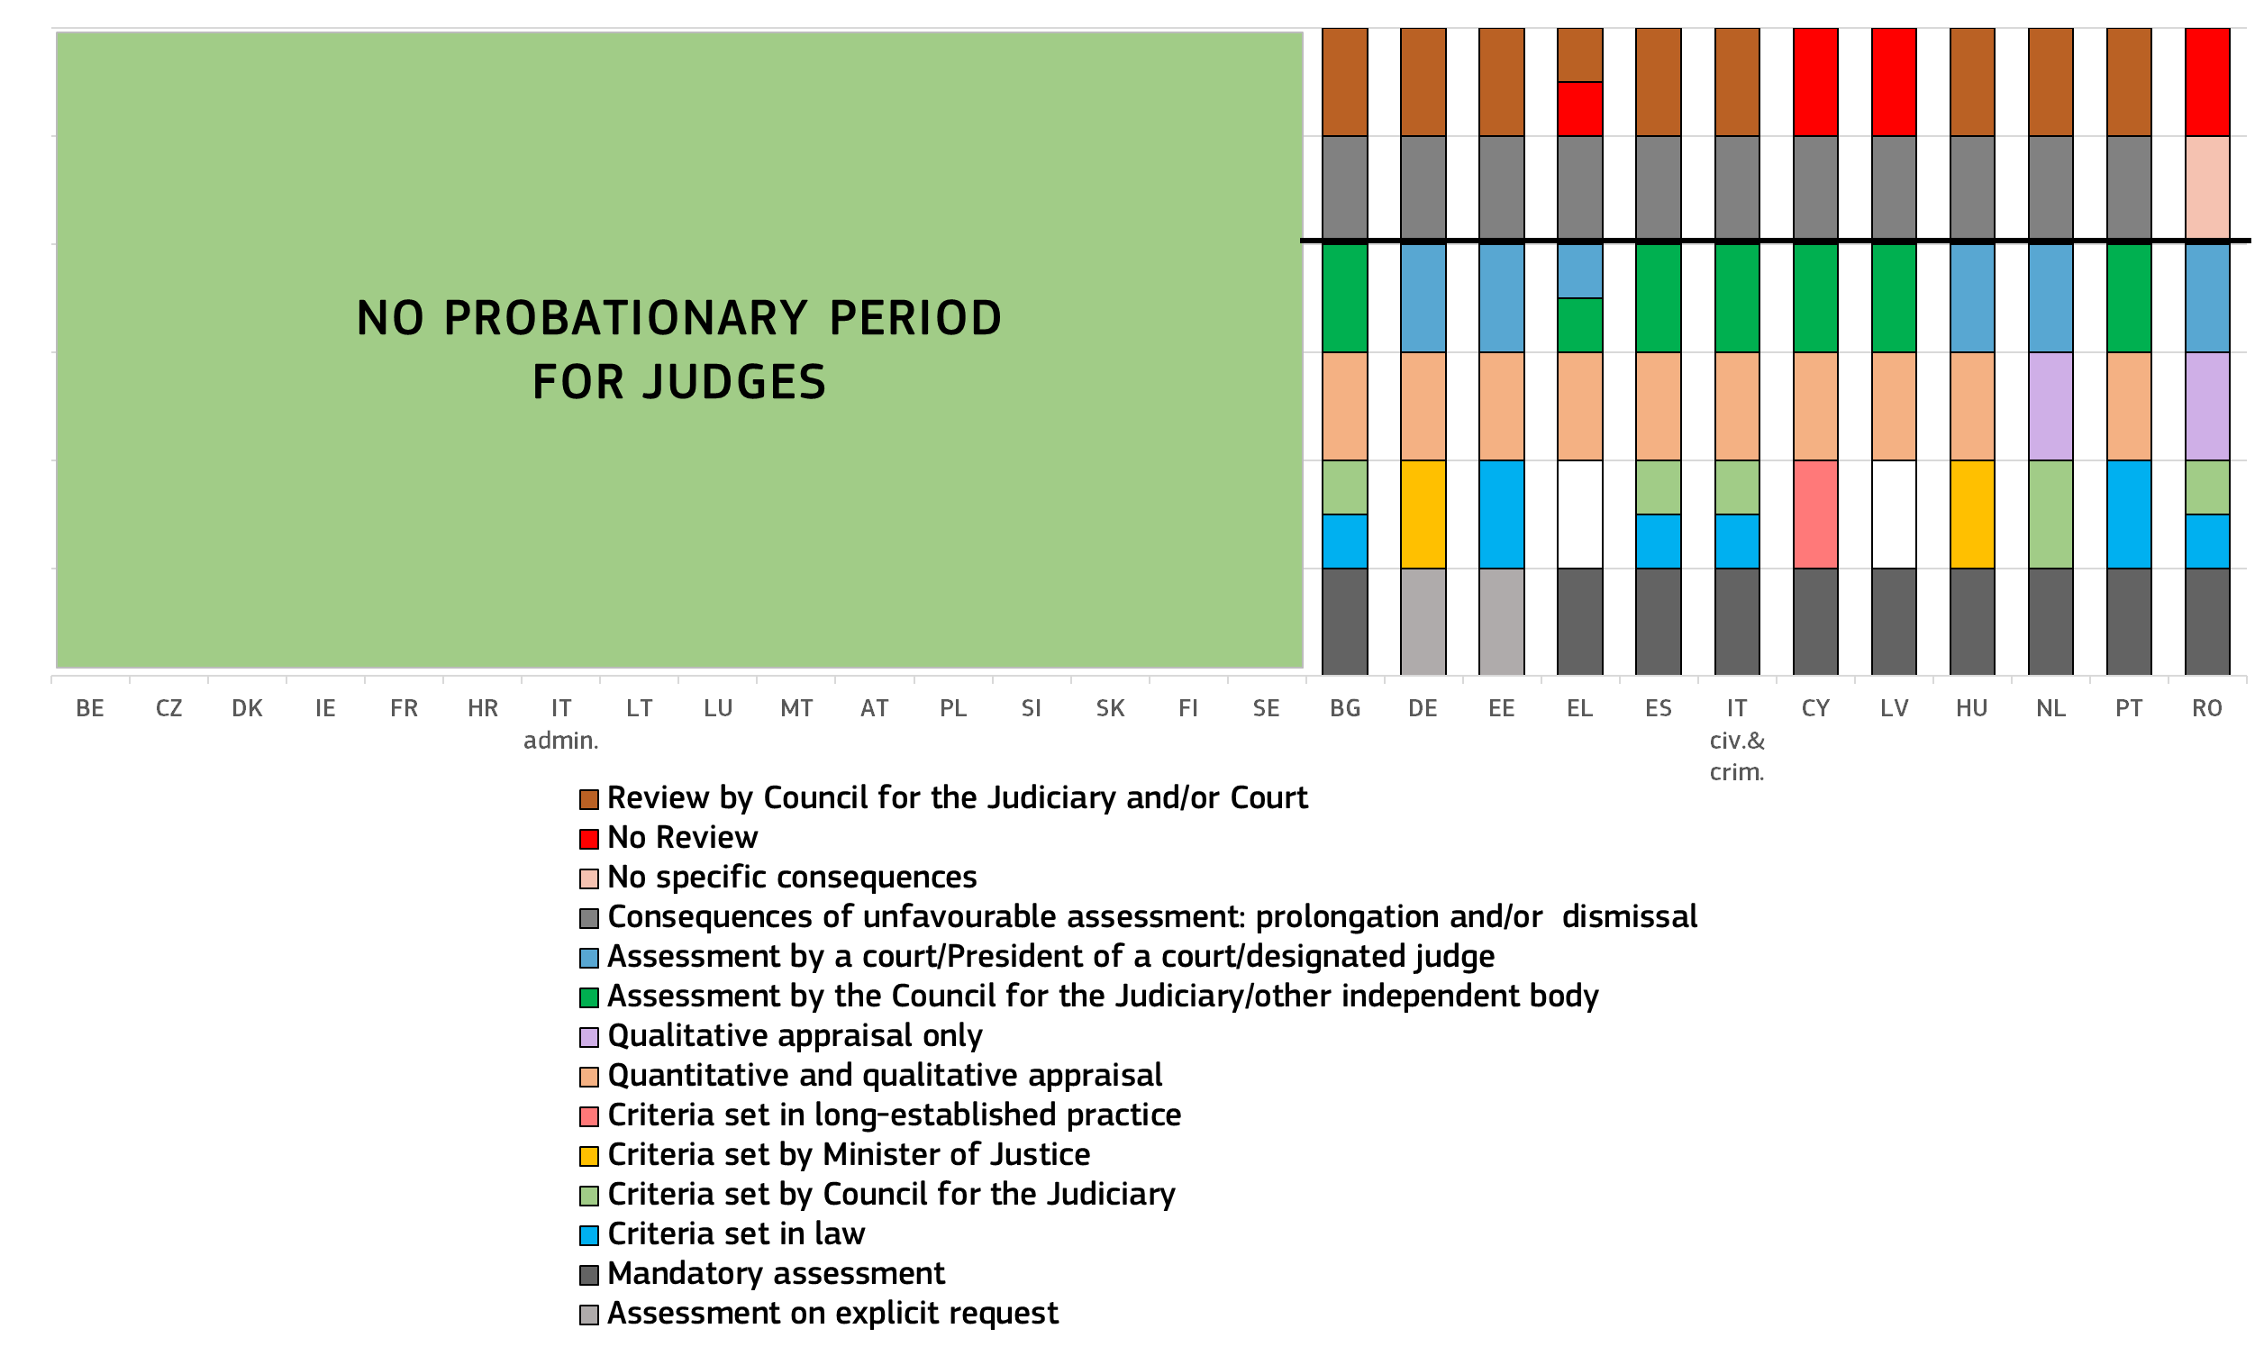
(*) Non-coloured blocks indicate no data. BG: Reviews are conducted by the Council of the Judiciary and the Supreme Administrative Court. Consequences of unfavourable assessment: prolongation or dismissal. Review of the assessment by the council for the judiciary and a court. DE: The chart reflects the situation for state judges. For federal judges there is not probationary period. Assessments of state judges during their probationary period has to be specifically requested. According to Section 22 subsection 1 of the German Judiciary Act a judge on probation can be dismissed on expiry of six, twelve, eighteen or twenty-four months following their appointment. Even though the Section does not literally say so, objective reasons are required for a dismissal. Section 22 subsection 2 states that a judge on probation can be dismissed on expiry of the third or fourth year (1) where they are not suited to hold judicial office, or (2) where a judicial selection committee refuses to give them judicial tenure for life or for a specified term. Furthermore, according two subsection 3 of Section 22 a judge on probation can in addition be dismissed where they have conducted themself in a manner, which would lead, in the case of a judge for life, to a disciplinary measure imposable in formal disciplinary proceedings. Finally, in the cases under subsections 1 and 2 the judge is notified of the dismissal order at least six weeks before the day of dismissal. Review during probationary period performed by special service courts for state judges in the 16 states. Consequences of unfavourable assessment: dismissal. Review of the assessment by a court. EE: If there is an unfavourable assessment, according to §100 of the Courts Act a person may be released from the office of judge due to unsuitability for office only within three years after appointment to office if the judge has been declared unsuitable for office by a decision of the Supreme Court en banc. Upon assessment of suitability for the office of judge, the Supreme Court en banc considers the proposal of a person or body entitled to commence disciplinary proceedings, the opinion of the judge’s examination committee and other information characterising the work of the judge. Consequences of unfavourable assessment: dismissal. Review of the assessment by a court. EL: Probationary period of 10 months. Assessment by the council for the judiciary (administrative courts) or by the Appeal Court sitting in council and consisting of the President, the Prosecutor and three Appeal judges (civil and criminal courts). Consequences of unfavourable assessment: prolongation or dismissal. EL (administrative courts): Review before the plenum of the Council of State. EL (civil and criminal courts): no review. ES: The Judicial School performs the mandatory assessment of how the judge worked during the probationary period based on quantitative and qualitative criteria. The probationary period includes not only one year of theoretical and practical activities in the school for judiciary but also two more steps, a trainee activity and a period of acting as a judge under the supervision of a senior/permanent judge. During these periods, assessments criteria are qualitative in the vast majority of cases but there exists also a quantitative assessment (for example on the number of judgments issued) to fulfil requirements. Candidates who do not pass the course may take it again and will be incorporated to the new promotion. If they do not pass the course in the second attempt, they will be finally excluded and any rights to access the Judicial Career by virtue of the access examinations will lapse. Consequences of unfavourable assessment: prolongation. Review of the assessment by the council for the judiciary and a court. IT (civil and criminal courts): Consequences of unfavourable assessment: prolongation or dismissal. CY: Probationary period of 2 years. Consequences of unfavourable assessment: prolongation or dismissal. Review of the assessment by a court. LV: A judge of a district (city) court is appointed to the office by Parliament, upon proposal of the Minister of Justice, for three years. After three years served in the office, Parliament, upon the proposal of the Minister of Justice, on the basis of statement of the Judicial Qualification Committee provided in its assessment of professional activity of the judge, appoints the judge of a district (city) court to the office without limitation of term of office, or appoints him or her to the office repeatedly for the term not exceeding two years. After expiration of repeated term of office, Parliament approves the judge of a district (city) court to the office without limitation of term of office. If work of a judge is unsatisfactory, the Minister of Justice, based on the statement of the Judicial Qualification Committee provided in its assessment of professional activity of the judge, does not nominate the candidature of a judge for re-appointment or re-approval to the office of a judge. Consequences of unfavourable assessment: prolongation or dismissal. HU: Probationary period of 3 years. Consequences of unfavourable assessment: dismissal. Review of the assessment by the service court. If the evaluation of a judge ends with a result that the judge is not sufficient for the judicial job, a procedure starts to define if the dismissal is necessary (similar to a disciplinary procedure). The judge can turn to the service court against the assessment done by the president of court. Only the service court can dismiss the judge. After an amendment of the internal rules of the intermediate “minor” assessment after the first year those are less formal and less detailed than before, therefore they cannot be regarded as a review anymore. NL: Probation period up to 4 years, depending on professional experience. Consequences of unfavourable assessment: dismissal. PT: Probationary period between 1 Sept. and 15 July (could be extended up to 6 months). The High Judicial Council gather information on the suitability, merit and performance of the probationary magistrate, and the Centre for Judicial Studies (Ministry of Justice) must provide them with the appropriate information on a regular basis. The Pedagogical Council of the Centre for Judicial Studies may, on a proposal from the Director, issue a reasoned opinion to the effect that a magistrate on probation should not be appointed on a permanent basis if it concludes that the magistrate is not suitable for the job. Consequences of unfavourable assessment: dismissal.

– Safeguards relating to the functioning of national prosecution services in the EU –
Public prosecution plays a major role in the criminal justice system and in cooperation between Member States in criminal matters. The proper functioning of the national prosecution service is crucial for the effective fight against crime, including economic and financial crime, such as money laundering and corruption. According to the case law of the Court of Justice on the European Arrest Warrant Framework Decision (), a public prosecutor’s office can be considered a Member State judicial authority for the purpose of issuing and executing a European arrest warrant whenever it can act independently, without being exposed to the risk of being subject, directly or indirectly, to directions or instructions issued by the executive (e.g. a Minister for Justice) in a specific case ().
The organisation of national prosecution services varies across the EU and there is no uniform model for all Member States. However, the Council of Europe has noted a widespread tendency to have a more independent prosecutor’s office, rather than one subordinate or linked to the executive (). According to the Consultative Council of European Prosecutors, an effective and autonomous prosecution service committed to upholding the rule of law and human rights in the administration of justice is one of the pillars of a democratic state ().
In order to present the autonomy of the prosecution services in the Member States, the figures below provide an overview of the hierarchical powers within the prosecution services, as well as the system for allocation of cases used in the different Member States. These figures do not assess the effective functioning of the prosecution services, which requires a qualitative assessment taking into account specific circumstances of each Member State. Figure 56 presents the main management powers of the Prosecutor General over lower ranking prosecutors, and Figure 57 presents the systems for allocation of cases available in the Member States.

Figure : Prosecutor General: powers (*) (Source: European Commission with the NADAL ())
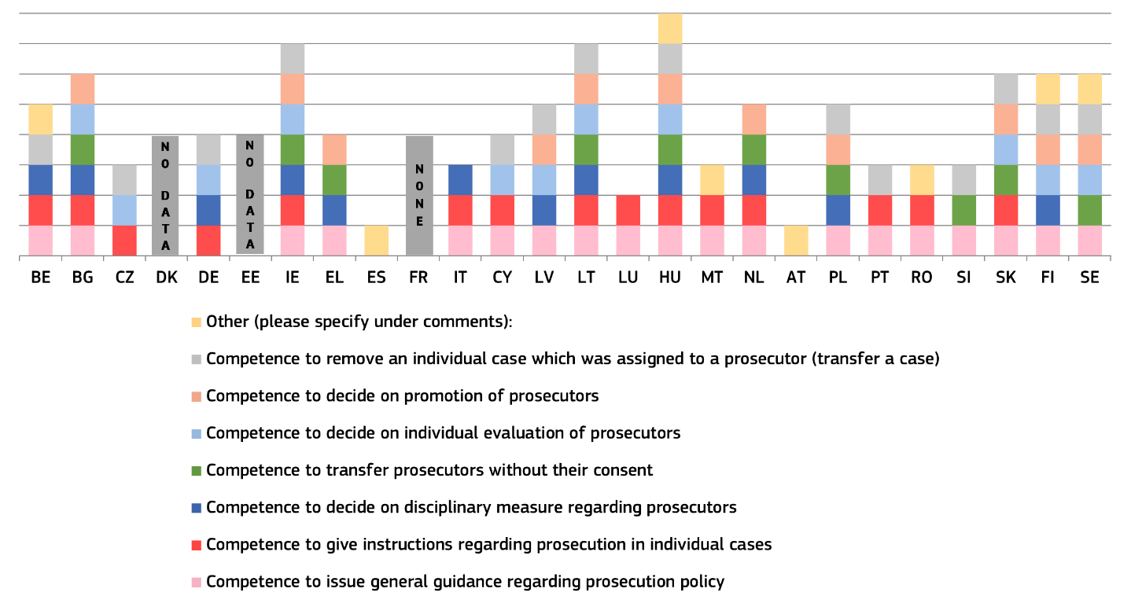
(*) The Member States appear in the alphabetical order of their geographical names in the original language. BE: The Prosecutor General may instruct the public prosecutor to reopen a criminal investigation. BG: The powers of promotion, evaluation and disciplinary sanctions are exercised through the position of the Prosecutor General in the Supreme Judicial Council. While there is no provision that allows the Prosecutor General to transfer a case, there are practical possibilities that could allow for it. CZ: Power to give instructions in individual cases only for the Prosecutor General Office and directed towards high public prosecutor offices. The power to decide on individual evaluation of prosecutors applies only within the Prosecutor General’s Office. EL: The General Prosecutor has the right to address general directions and recommendations to all prosecutors in the country. ES: The Attorney General sets internal orders and instructions appropriate to the service and to the exercise of prosecuting functions, which may be general or related to specific matters. The transfer without consent of a prosecutor is possible only in cases of high workload. IT: Prosecutors General at the Court of Appeal have the powers to remove an individual case from a prosecutor in case of inaction; also, they can acquire data and information from the prosecution offices of the district and to send these to the Prosecutor General at the Court of Cassation, in order to verify the correct and uniform functioning of the prosecution offices and compliance with the rules on due process. The Prosecutor General at the Court of Cassation is in charge by Law of the control over the National Anti-Mafia Directorate, and of resolving the conflicts of competence between two or more territorial prosecution offices. CY: The Attorney General decides on minor disciplinary violations. In serious disciplinary offences, the Attorney General does not propose sanctions but recommends the initiation of disciplinary measures by the Public Service Commission. LT: As to the instructions on individual cases, the Prosecutor General (PG) cannot instruct which decision to make; as to the promotion of prosecutors, the PG decides on the conclusions of the Prosecutor Selection Commission or the Chief Prosecutor Selection Commission; as to the decision on disciplinary measure the PG decides on the conclusions of the Prosecutor Ethics Commission or the Internal Investigation Commission. The PG does have the right to remove the prosecutor from the pre-trial investigation. LU: The Prosecutor General has the power to instruct prosecution services to prosecute in a case (but cannot instruct not to prosecute). To promote a prosecutor, the state prosecutor / Prosecutor General suggests the promotion to the executive by means of a favourable opinion and the Head of State signs the nomination. NL: There is a stepwise competence regarding the general and specific power to issue instructions. The Judiciary (Organization) Act Article 130, paragraph 6 states that the Board can issue instructions to the prosecution service. The Judiciary (Organization) Act Article 136, paragraph 3, states that the head of the district office can issue instructions to the civil servants working at his districts office relating to the tasks and responsibilities of his office. The Board of Prosecutors General decides whether the candidate is to be nominated for appointment by the King for appointment as a senior Public Prosecutor. The actual appointment takes place by royal decree. AT: The powers of the Prosecutor General do not include direct management over the prosecution service as referred to in the chart. The Independent Personnel Body, consisting of four prosecutors, evaluates a prosecutor. PL: The Prosecutor General is also the Minister of Justice. RO: The General Prosecutor has the power to transfer an individual case from a prosecution unit to another prosecution unit and to issue general guidance on prosecution policies, in order to guarantee a unitary approach on criminal investigations. SI: Both the Prosecutor General and the head of the State Prosecutor’s Offices have the powers to issue general guidance on prosecution policy and to remove an individual case assigned to a prosecutor.
Figure 57 presents, for the first time, how criminal cases are allocated within the prosecution offices. Systems vary among Member States, with some prosecution offices allocating criminal cases through random allocation made by an automated system, some in which cases are allocated by superior prosecutors to lower prosecutors based on their specialisation and some in whichallocation of cases depends on availability of prosecutors according to the predefined work schedule. External oversight in the allocation of cases to prosecutors is exercised by the hierarchically superior prosecutors, a body within the prosecution, or by an external body (e.g. ministry of justice).
Figure : Prosecution services: systems for allocation of cases (*) (Source: European Commission with the NADAL ())
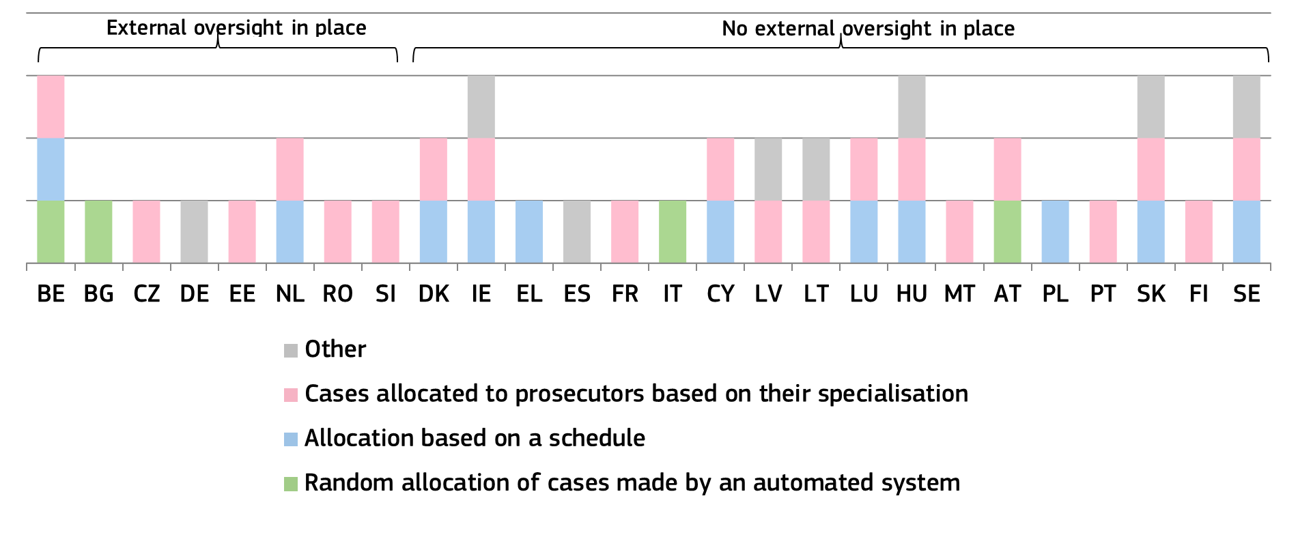(*) BE: In most public prosecutors' offices, allocation is based on the subject matter (e.g. money laundering, environmental offences). Usually, within a department of the prosecution service, prosecutors are divided into teams that specialise in one or more phenomena/types of crime (e.g. cybercrime, human trafficking, drugs) and within those teams, cases are assigned using a distribution key that was agreed upon with the other team members and the team leader. Today, the case allocation is also done by a ‘parameter box’ that assigns cases automatically. BG: Cases and case files are distributed based on the random selection principle through even electronic assignment in the order of their receipt. CZ: The cases are allocated to prosecutors by the heads of prosecution offices, their deputies or prosecutors determined by them (e. g. directors of departments). The specialisations are laid down by internal regulation. DK: A schedule for allocation of cases is created within the local prosecution service, based on the prosecutor’s specialisation, seniority and workload. DE: Within a public prosecutor's office, cases are assigned according to a fixed allocation of business. It is possible for the head of the office to make individual assignments. IE: Cases are allocated to a prosecutor on the basis of specialisation, seniority and capacity. Cases are allocated by unit managers who are aware of their team’s current caseloads. EL: Case allocation is one of the duties of the heads of the prosecution offices. They take into account the specific needs of each prosecution office, the number of staff, the seniority of the Prosecutors serving at the Office and, in certain cases, their specialisation. ES: Chief prosecutors are responsible for organising the services and for the transparent and equitable distribution of work among the staff of their prosecution office. IT: Random allocation can be exceptionally waived. LV: Cases are allocated to units of the prosecution office corresponding to the specialisation indicated in internal regulatory enactments, and further to prosecutors – by the heads of prosecution offices. LT: Cases are allocated on the basis of the location and qualification of the offence; the location and jurisdiction of the prosecutors; the specialisation and workload of the prosecutors; and the size and complexity of the criminal case. The allocation is made through the integrated criminal procedure information system (IBPS). LU: The Prosecution Office is the only responsible authority. HU: After registration and preliminary search for background, all incoming documents have to be presented to the head at the Office of the Prosecutor General having competence to manage the case in accordance with the rules of procedure, to the chief prosecutor at the Appellate Chief Prosecution Office, to the chief prosecutor at the Chief Prosecution Office, to the head of the District Prosecution Office at the District Prosecution Office, or to the person or head of the organisational unit designated by them, for the purpose of selecting the appropriate computerised filing system or case log book and designating the case worker. If case worker assignments are already predetermined based on regional or case-specific distribution, the document must go directly to the pre-assigned case worker unless the responsible leader decides otherwise. MT: The cases are allocated according to specialisation. The complexity of the case and the experience of prosecutors are taken into consideration when allocating cases. Another factor is the case-load of the individual prosecutors. NL: Allocation takes place by the “weekly shift” of the district public prosecutor’s office or through a project proposal of the most specialised unit. The authority responsible for the allocation is the chief of the public prosecutor’s office. AT: Cases are distributed according to a general, predetermined allocation of duties defined by the head of the prosecution service in coordination with the superior service authority. These rules of allocation may also provide for the designation of specialised units for certain types of cases. The allocation of these cases is then based on this specialisation. Certain types of cases are already assigned by law to a specialised public prosecutor's office (Centralised Public Prosecutor's Office for Combating Economic Crimes and Corruption). PT: For some specific crimes, cases are allocated to a prosecutor based on their specialisation. RO: Beside the specialisation of the prosecutors the cases are allocated taking into account the legal competence of the prosecutor's offices depending on their rank. SK: Cases are assigned to individual prosecutors by the chief prosecutor (e.g. a district prosecutor assigns new cases to prosecutors of the relevant district prosecutor's office), based on their specialisation according to a predetermined ratio of assigned cases between prosecutors working on the same agenda (specialisation) depending on overall caseload. The schedule is created by the chief prosecutor depending on the overall caseload and the number of active prosecutors, while the specialisation of a particular prosecutor is determined by the relevant district/regional prosecutor. In practice, there are cases when one prosecutor has several specialisations due to the lower budget of a particular prosecutor's office or the lack of prosecutors. The lists of prosecutor specialists are notified to superior prosecutor's offices. FI: The cases in prosecution areas are distributed by the deputy chief prosecutors to their subordinates. The basis is their expertise and the number of cases they have at that time. In the Office of the Prosecutor General, cases are distributed by department chiefs who are senior state prosecutors, and in more severe and important cases by the Prosecutor General or their deputy. SE: Allocation of a case varies between different prosecution chambers. There is a list with the names of the prosecutors and their respective specialisation. The cases are then distributed by a prosecutor's officer or by a chief prosecutor (or deputy chief prosecutor) to the different prosecutors so that a fair distribution is obtained within the different specialties. If there is someone deprived of liberty in the case, it is usually the chief prosecutor or the deputy chief prosecutor who distributes the case according to specialty and workload.
On external oversight: BE: The board of public ministry. This does not apply to the Court of Cassation. BG: Inspectors from the Inspectorate to the Supreme Judicial Council. CZ: Theoretically, the procedure of supervision by the next closest superior prosecution office can be initiated, but nobody has ever done so. DE: The oversight mechanisms are in place within the official hierarchy. The responsible ministry also exercises administrative and professional supervision. NL: Criminal cases are registered in the national integrated criminal justice system and in the national case overview system of each public prosecutor’s office. RO: Both the Prosecutor General and the Judicial Inspectorate have the possibility to check how the allocation of cases was done. SI: Ministry of Justice has the possibility of judicial supervision. Department for the organisation and development of management can make a supervision on the initiative of Prosecutor General.

– Independence of bars and lawyers in the EU –
Lawyers and their professional associations play a fundamental role in ensuring the protection of fundamental rights and the rule of law (). Their ability to act freely, loyally and confidentially in the exclusive interest of their clients is essential not only for the protection of the rights of their clients, but also for the credibility, effectiveness and legitimacy of justice systems and respect for the rule of law across the European Union. The Court of Justice of the European Union has already recognised that legal professional privilege and the confidentiality of lawyer-client communications constitute general principles of EU law, closely linked to the rights to a defence and the proper administration of justice (). A fair system of administering justice requires that lawyers be free to pursue their activities of advising and representing their clients. Lawyers’ membership of a liberal profession and the authority deriving from that membership help maintain their independence, and bar associations play an important role in helping to ensure lawyers’ independence. European standards set out the freedom of exercise of the profession of lawyer and the independence of bar associations. These standards also set out the basic principles for disciplinary proceedings against lawyers ().

Figure : Independence of bars and lawyers, 2025 (*) (source: European Commission with the CCBE ())
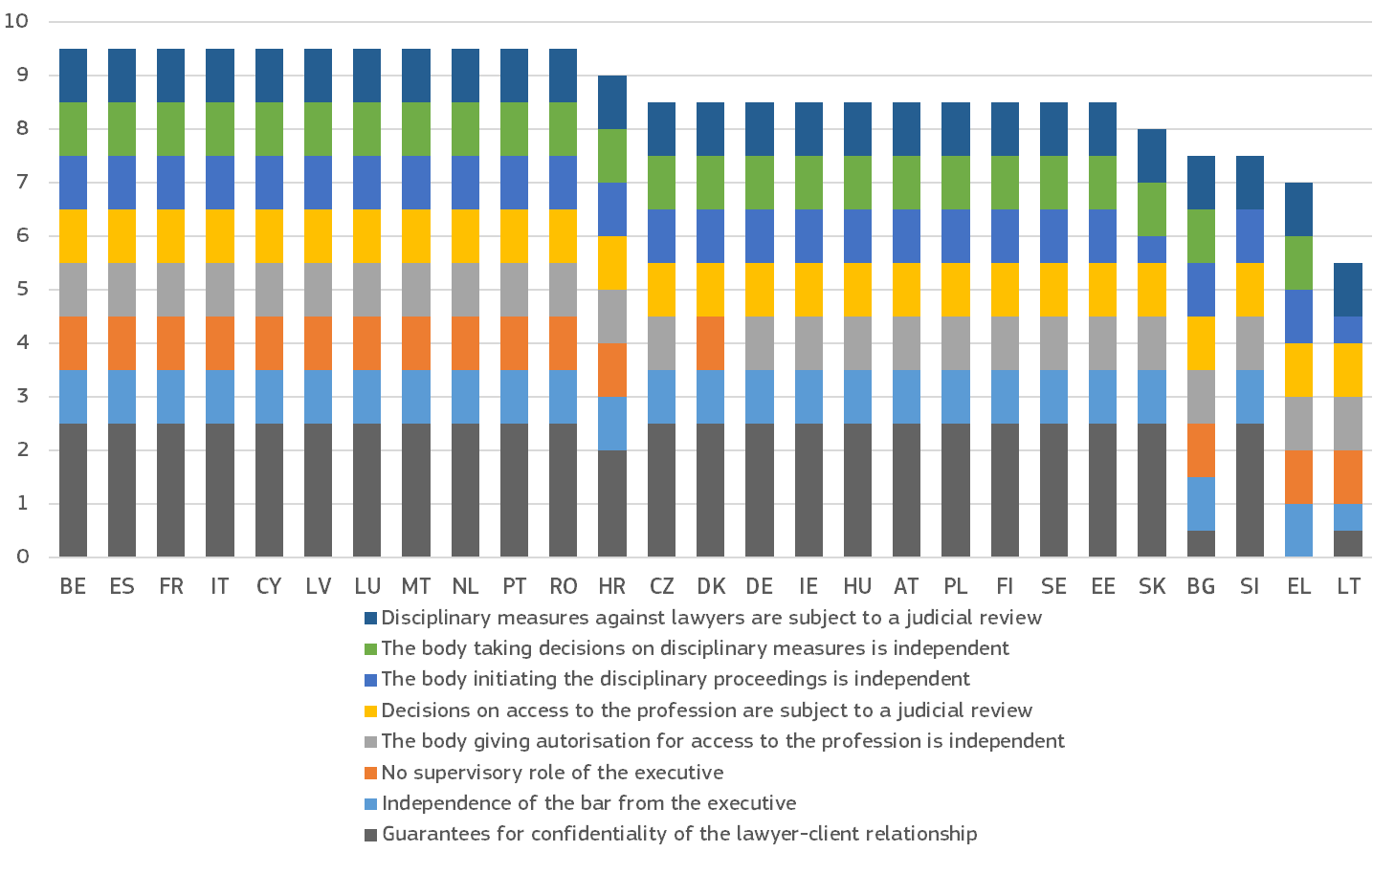
(*) Based on the survey results, Member States could score a maximum of 9.5 points. The survey was conducted at the end of 2024. For the question on guarantees of the confidentiality of the lawyer/client relationship, 0.5 points were awarded for each scenario fully covered (search and seizure of e-data held by the lawyer, search of the lawyer’s premises, interception of lawyer/client communication, surveillance of the lawyer or their premises, tax audit of the law firm and other administrative checks). For all other criteria fully met, 1 point was awarded. No points were awarded if the criterion was not met. MT: 2020 replies, adapted to the new methodology. EE: The Ministry of Justice has broad supervisory powers over the organisation of the legal aid system. The score takes into account the decision of the Supreme Court’s decision of 10 October 2025 on the lawyer-client communications, and the fact that the Ministry of Justice and Digital Affairs is working towards specifying the law to clarify the rule on interception of lawyer-client communications. LT: According to the Law on the Bar, the Bar Council can institute disciplinary action against lawyers. However, the Law on the Bar establishes that the Minister of Justice also has such a right. Overall, the Bar Council is an independent body, but if the Minister of Justice initiates disciplinary action against a lawyer, the Bar has no say in the proceedings, and the case proceeds directly to the disciplinary court. On search and seizure of electronic data held by lawyers, if the device is seized, an electronic copy of its data is created. After creating such a copy, law enforcement officers search the data for specific keywords. As a rule, a delegated lawyer participates in such a search as an authorised representative of the Bar Council. However, no safeguards are ensuring that any other data has not been searched or examined without the participation of the authorised representative. On interception of lawyer-client communication, the formal guarantees exist but law enforcement authorities follow the approach that possibly criminal activities of a lawyer are not subject to the lawyer-client privilege. PL: The Ministry of Justice has a supervisory role over the bar, organising bar examinations and setting the amount of minimal legal fees (following non-mandatory opinion of the supreme bar council). SI: Disciplinary proceedings are conducted exclusively within the bar association itself. An appeal is possible against the decision of the disciplinary committee of the first instance, which is considered by the disciplinary committee of the second instance. There is no possibility of appeal against the decisions of the disciplinary committee of second instance. SK: Primarily, it is the independent supervision committee of the Slovak Bar Association that files a petition based on a complaint. However, the Minister of Justice may also initiate a disciplinary proceeding if ‘a lawyer performed an act which might be viewed as a professional misconduct under the legal rules which were in force so far, the chair of the supervision committee or the Minister of Justice (acting in their capacity of a petitioner) may apply for commencement of the disciplinary proceeding to the appropriate bar´s governing body.’ FI: The bar association is under the supervision of the Chancellor of Justice as public authority. The Chancellor has supervisory authority over attorneys as regulated in the Advocates Act.

2.4. Other indicators relevant for the single market
Beyond the courts, prosecution services and other judicial bodies, which are important for the independent application of EU law, several other public authorities are tasked with applying EU law in specific areas, such as anti-corruption, public procurement and competition.
Following-up from the introduction of this section in the 2025 EU Justice Scoreboard, the 2026 edition includes additional charts related to bodies that are pivotal for the good functioning of the single market such as new indicators on national frameworks regarding transparency of lobbying and on the functioning of the supreme audit institutions, which play an important role in the area of anti-corruption. It also presents data on the perceived independence and functioning of the national competition authorities and the first instance public procurement review bodies, which are key authorities for the functioning of the single market.

2.4.1. Summary of indicators relevant for the single market
Beyond the courts, prosecution services and other judicial bodies, the 2026 Justice Scoreboard again presents data on other public authorities, that are tasked with applying EU law in specific areas, such as anti-corruption, public procurement and competition.
Figures 59 and 60 present updated information on how companies perceive the independence of the first instance public procurement review bodies and of the national competition authorities. Compared with last year, the companies’ perception of independence of the first instance public procurement review bodies improved or remained stable in 14 Member States and decreased in 13 Member States. Compared with last year, the companies’ perception of independence of the national competition authorities improved or remained stable in 10 Member States and decreased in 17 Member States.
The 2026 Justice Scoreboard presents updated and new information on independent authorities which are relevant for the functioning of the single market. Figure 61 presents the term of appointment of members and/or heads of first instance public procurement review bodies.
Figure 62 presents updated information on the way in which members and/or heads of national competition authorities are appointed and dismissed.
Figures 63 and 64 present whether the supreme audit institutions have the right to access the required information in law and practice and what measures they have at their disposal if access to information is not granted.
Figures 65 to 67 present jurisdictions of supreme administrative courts in business-related cases and what measures they have at their disposal to improve their efficiency in these cases.
Figures 68 and 69 present national frameworks regarding transparency of lobbying.

2.4.2. Independent authorities relevant for the functioning of the single market
Independent authorities are a key rule-of-law safeguard for the functioning of the single market. Following up on the 2025 EU Justice Scoreboard, the 2026 edition presents new structural aspects of some of these authorities, such as the first instance public procurement review bodies, national competition authorities and the supreme audit institutions. It presents for the second time the perceived independence of the first instance public procurement review bodies, and of the national competition authorities.
Figure 59 presents how companies perceive the independence of the first instance public procurement review bodies. These bodies are set up in Member States on the basis of the Remedies Directives (Directive 89/665/EEC and Directive 92/13/EEC, as amended by Directive 2007/66/EC and Directive 2014/23/EU). According to the Remedies Directives, as regards contracts falling within the scope of Directive 2014/23/EU, Directive 2014/24/EU and Directive 2014/25/EU, decisions taken by the contracting authorities and contracting entities may be reviewed effectively and, in particular, as rapidly as possible on the grounds that such decisions have infringed national rules transposing Union law. The body responsible for the review may be judicial or non-judicial. Non-judicial bodies usually take the form of an independent administrative authority. In that case, the Remedies Directives stipulate further procedural requirements as well as the availability of further judicial review.
Figure : How companies perceive the independence of the first instance public procurement review bodies (*) (source: Eurobarometer () - from left to right, light colours: 2025, dark colours: 2026)
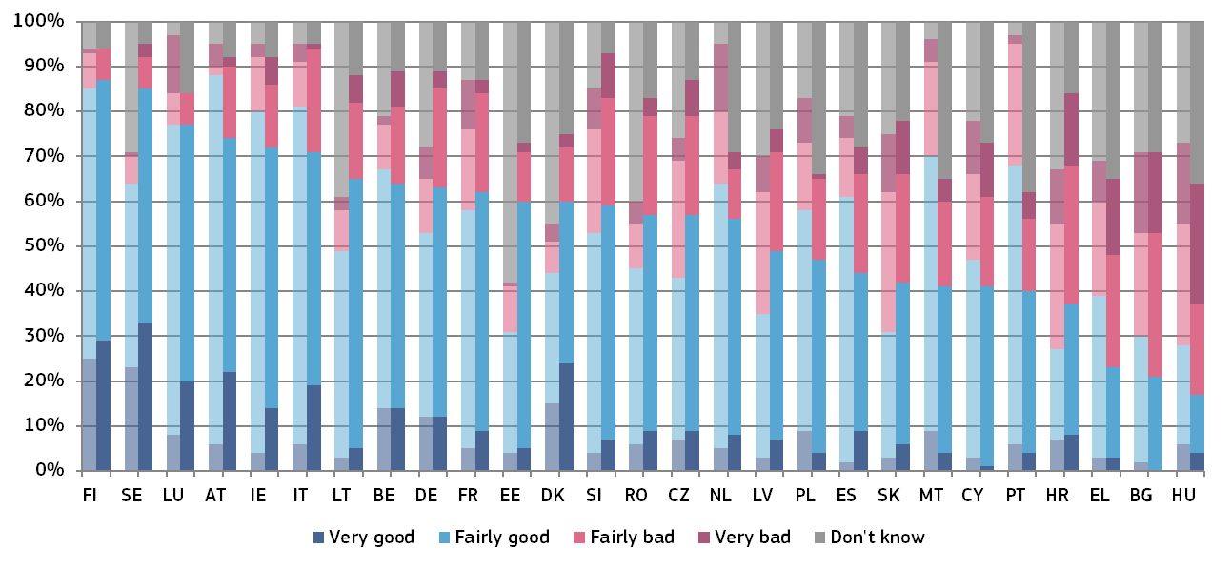
(*) Member States are ordered first by the percentage of respondents who stated that the independence is ‘very good’ or ‘fairly good’ (total good); if some Member States have the same percentage of total good, then they are ordered by the percentage of respondents who stated that the independence is ‘fairly bad’ or ‘very bad’ (total bad); if some Member States have the same percentage of total good and total bad, then they are ordered by the percentage of respondents who stated that the independence is ‘very good’; if some Member States have the same percentage of total good, total bad and ‘very good’, then they are ordered by the percentage of respondents who stated that the independence is ‘very bad’.
Figure 60 presents how companies perceive the independence of the national competition authorities. These authorities form a part of a decentralised system that is based on the parallel competence of the Commission and the national competition authorities and national courts of the Member States to enforce EU antitrust rules. As such, they are one of the key authorities for the functioning of the single market.
Figure : How companies perceive the independence of the national competition authorities (*) (source: Eurobarometer () - left to right, light colours: 2025, dark colours: 2026)
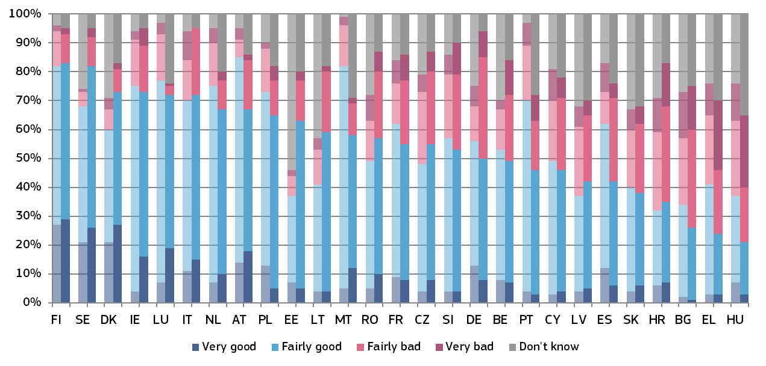
(*) Member States are ordered first by the percentage of respondents who stated that the independence is ‘very good’ or ‘fairly good’ (total good); if some Member States have the same percentage of total good, then they are ordered by the percentage of respondents who stated that the independence is ‘fairly bad’ or ‘very bad’ (total bad); if some Member States have the same percentage of total good and total bad, then they are ordered by the percentage of respondents who stated that the independence is ‘very good’; if some Member States have the same percentage of total good, total bad and ‘very good’, then they are ordered by the percentage of respondents who stated that the independence is ‘very bad’.
Figure 61 shows the term of appointment of the members and presidents of the first instance public procurement review bodies, namely whether they are appointed for an unlimited term, or for a limited term, and in this case whether it is renewable or non-renewable. The footnote indicates the length of term in years. In majority of Member States the term of members and presidents of the first instance review bodies is from 4 to 8 years and renewable.

Figure : First instance public procurement review bodies: term of appointment of members and president (*) (source: European Commission with the Network of First Instance Review Bodies on Public Procurement)
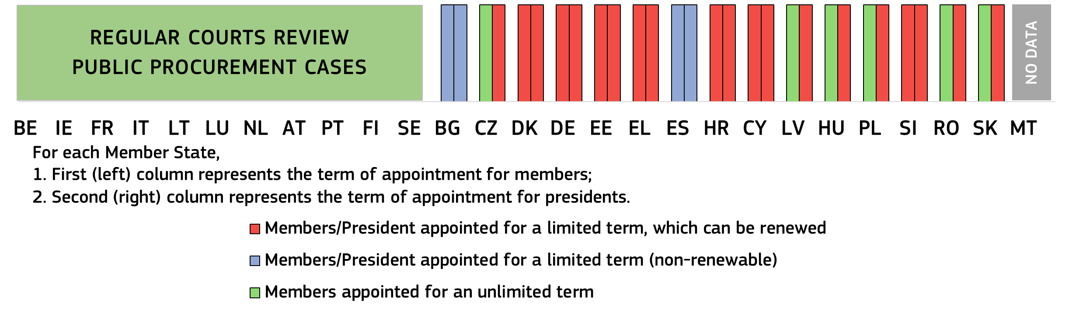
(*) The chart refers to the bodies listed under Figure 61 in the 2025 EU Justice Scoreboard. BG: members and president: seven-year term (cannot be re-elected immediately for another term). The 2025 amendments to the Protection of Competition Act introduced a specific transitional arrangement concerning the terms of the members of the Commission on Protection of Competition. Pursuant to this arrangement, upon the expiry of the mandate of the current composition of the Commission, at the subsequent election three of its members shall be elected for a term of three years and six months. Upon the expiry of this term, new members shall be elected in their place in accordance with the established procedure and for the term of office provided for in Article 4(1) of the Act (seven years). This regulatory approach aims to introduce a staggered renewal of the Commission’s composition by differentiating the duration of mandates, thereby ensuring institutional continuity and stability in its functioning. CZ: the Office does not have formally established members of the first instance public procurement review body. In practice, the administrative proceedings on review of public procurement are conducted by departments headed by directors; there are three such departments/directors in total. These directors are appointed/ dismissed in accordance with the Public Service Act. The same applies to the members of the departments – public officials who are appointed and dismissed in accordance with the Public Service Act. The president (the vice-chair of the Office): six-year term (unlimited number of terms). The president of the Office for the Protection of Competition acts as the second instance administrative review body. DK: members and president: four-year term (unlimited number of terms). DE: members and president: five-year term (unlimited number of terms). EE: members and president: five-year term (unlimited number of terms). EL: members and president: five-year term (not more than two terms). ES: members and president: six-year term (non-renewable). HR: members and president: five-year term (they may be appointed for two terms). CY: members and president: five-year term (may be renewed for one additional term). LV: members: unlimited term; president: five-year term (not more than two successive terms). HU: members: unlimited term; the president (the chair and the deputy chair of the Arbitration Board) five-year term (unlimited number of terms). PL: members: unlimited term; president: three-year term (unlimited number of terms). SI: members and president: eight-year term (according to the law, the number of terms is not limited, although in practice, none of the members has been appointed for more than two terms). RO: members: unlimited term; president: three-year term (not more than two terms) SK: members: unlimited term; vice-chair: five-year term (not more than two successive terms); The Public Procurement Office does not have formally established members of the first instance public procurement review body. In practice, the administrative proceedings on review of public procurement are conducted by the review department headed by director and the vice-chair for the strategic agenda. The director of the review department is appointed/ dismissed in accordance with the Public Service Act. The same applies to members of the review department – public officials who are appointed and dismissed in accordance with the Public Service Act. The vice-chair for the strategic agenda is appointed and dismissed by the Government upon proposal by the head of the Office of the Government. The president of the Public Procurement Office acts as the second instance administrative review body.
Figure 62 presents an updated overview of the authorities involved in the appointment and dismissal procedures for the members of the decision-making bodies of national competition authorities, which was first presented in the 2025 EU Justice Scoreboard.

Figure : National competition authorities: appointment and dismissal (*) (source: European Commission with the Network of National Competition Authorities)
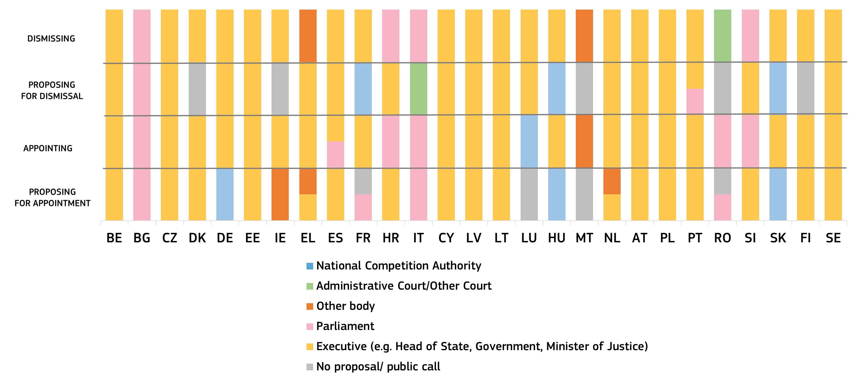(*) BE: The Minister for the Economy proposes and appoints. The minister appoints a selection committee for the members. The Minister for the Economy proposes the dismissal, the Head of State (King) dismisses. CZ: The Chart reflects the situation of the Chairperson of the Office. The Government proposes the chair of the office, the President of the Republic appoints them. The Government proposes the dismissal, the President of the Republic dismisses. The Chairperson of the Office has three Vice-Chairpersons, who are appointed and dismissed by the Chairperson on their own initiative. DK: The Ministry of Industry, Business and Financial Affairs proposes, the Government appoints. There is no authority that proposes a dismissal. The Government dismisses. DE: The decision-making bodies of the Bundeskartellamt are the decision divisions. The decisions of the decision divisions are taken by the division members (the Chairperson and two associate members). They are civil servants appointed for life and must be qualified to serve as judges or senior civil servants. It is the Authority that proposes case handlers to become a division member, they are appointed by Federal Ministry of Economic Affairs and Energy. There is no explicit provision for a member of a decision division to be removed from its function. A dismissal, ordered by the Federal Ministry of Economic Affairs and Energy, is only possible under general civil service regulations. The Authority may transfer division members from the division to any other department within the Authority. IE: The Public Appointments Service proposes, the Minister for Enterprise, Trade and Employment appoints the chairperson and the two to four commissioners. The Minister for Enterprise, Trade and Employment dismisses the chairperson and the two to four commissioners. EE: The Director General of the Estonian Competition Authority is appointed to and released from office by the Minister of Justice on the proposal of the Secretary General of the Ministry of Justice. EL: The Board of the Hellenic Competition Commission, the decision-making body of the Authority, consists of 10 members, including a president, a vice-president, six rapporteurs and two regular members, with their alternates. The president and the vice-president of the Commission are selected, following a proposal of the Minister of Development, by a decision of the Council of Ministers, issued following the consent of the parliamentary committee on institutions and transparency. The selection of the rapporteurs and the two regular and alternate members of the Commission is made by the Minister of Development, following the consent of the parliamentary committee on institutions and transparency, on the basis of a list of candidates, drawn up by a selection committee, following an open competition. The regular and alternate members of the Competition Commission, as well as the rapporteurs are appointed by decision of the Minister for Development and Investments. The five-member selection committee consists of: (i) the President or Vice-President of the Council of State or the president or vice-president of the State Legal Counsel, as chair, (ii) the president or vice-president of the Supreme Council for Civil Personnel Selection (ASEP), (iii) a former president or vice-president of the Competition Commission, appointed by lot, (iv) a TSS HEI member specialised in competition law, nominated by the Minister for Development, and (v) a TSS HEI member specialised in competition economics, nominated by the Minister for Development. ES: The Ministry of Economy and Competitiveness proposes the 10 board members of the CNMC, including its President and Vice-President, the Government appoints them. Parliament may veto the appointment of the proposed candidates by absolute majority (50% +1). The Government proposes the dismissal and dismisses the board members. FR: The President of the Republic appoints all four vice-presidents of the board (permanent members) as well as the 12 non-permanent members and the two specialist members who sit when the NCA rules on matters pertaining to regulated legal professions. The NCA Board proposes the dismissal, the President of the Republic dismisses the member of the board. HR: The Government proposes, parliament appoints the members of the NCA. The Government proposes the dismissal, parliament dismisses the members of the NCA. IT: The presidents of the House and Senate appoint the chairman and members of the Authority’s Board. The Presidents of Parliament take the final decision on dismissal, once judge’s decision to apply the accessory penalty of disqualification from public office is final. CY: The Minister for Energy, Commerce and Industry proposes, the Government (Council of Ministers) appoints. The Government (Council of Ministers) proposes a dismissal and dismisses. LV: The Ministry of Economics proposes the chairperson of the Competition Council and four council members, the Cabinet of Ministers appoints them. The Ministry of Economics proposes their dismissal, a committee established by the Cabinet of Ministers dismisses them. LT: The Prime Minister proposes the members in the decision-making body of the Lithuanian Competition Council, the President appoints. The Prime Minister proposes the dismissal of the members in the decision-making body of the Lithuanian Competition Council, the President dismisses. LU: There is a public call for application, the president of the Competition Authority appoints. The Government proposes the dismissal, the Head of State (Grand-Duke) dismisses. HU: The President of the Hungarian Competition Authority proposes, the President of Hungary appoints the members of the Competition Council, which acts like a separated decision-making forum within the Hungarian Competition Authority. The president of the Hungarian Competition Authority proposes a dismissal, the President of Hungary dismisses the members of the Competition Council. MT: There is a public call for application. The board of governors of the Malta Competition and Consumer Affairs Authority appoints the director-general of the Office for Competition (the national administrative competition authority) by consulting the minister responsible for competition matters. The board of governors of the Malta Competition and Consumer Affairs Authority dismisses the director-general. NL: A selection commission, which consists of an NCA (ACM) board member, the director of the policy directorate responsible for NCA at the Ministry, an NCA director, on request an ‘outsider’, and a consultant from the Dutch senior civil service (ABD), proposes the chair and the other two board members of the NCA to the Minister for Economic Affairs, who then proposes them further. The Council of Ministers appoints them. The Ministry of Economic Affairs proposes the dismissal and dismisses the members. AT: The Government proposes the director-general of the Federal Competition Authority, the President appoints. The Government proposes the dismissal of the authority’s director-general, the President dismisses them. PL: The Prime Minister proposes and appoints the members of the NCA. The Prime Minister proposes the dismissal and dismisses the members of the NCA. PT: The Ministry of Economy proposes the members of the decision-making body of the NCA, parliament gives a reasoned opinion, the Government appoints them. Parliament or the Council of Ministers propose a dismissal, the Council of Ministers dismisses. RO: There is an open call for application for the nine members of the plenum of the Competition Council. The Standing Bureaux of the Chamber of Deputies and the Senate and the Legal and Economic Committees of the Chambers propose the candidates, the Chamber of Deputies and the Senate elect and appoint the members. The dismissal of the members takes place de iure, when the Supreme Court decides upon an infringement. SI: The Government and the Ministry of Economy propose the members of the NCA, parliament elects them. The Government proposes the dismissal, parliament dismisses them. SK: The decision-making of the Antimonopoly Office consists of two instances, the Office and the Council of the Antimonopoly Office. In the first instance, the decision is adopted by respective department of the Office. In the second instance, the Council of the Antimonopoly Office of the SR (the “Council”) decides on appeals and reviews the Office´s decisions. The chart reflects the situation of the Council of the Antimonopoly Board. The Chairperson of the Office proposes the members of the Council of the Antimonopoly Office, which consists of the Chairperson of the Office themselves and six members of the Council. The Government appoints them. The Chairperson of the Office proposes the dismissal, the Government dismisses. Chair of the Council is appointed and dismissed by the President of the Republic. FI: The Ministry of the Economic Affairs and Employment proposes the director-general as well as the head of Competition Division of the Competition and Consumer Authority, the Government appoints them. The Government dismisses the directors. SE: The Government proposes and appoints the director-general of the NCA. The Government proposes their dismissal, the Government disciplinary board for higher officials dismisses the director-general.
Supreme audit institutions (SAIs) are public oversight institutions which audit the use of public funds. Their principal task is to examine whether public funds are spent economically, efficiently and effectively in compliance with existing rules and regulations. Effective auditing helps build integrity in the public finances and combat corruption. It leads to the detection of illicit use of funds and corruption and helps to bring perpetrators to justice. SAIs are also part of the national systems of checks and balances in safeguarding the rule of law. Cooperation between the SAIs of the EU and the European Court of Auditors (ECA) principally takes place within the framework of the Contact Committee ().
The organisation of SAIs varies across the EU and there is no uniform model for all Member States. SAIs can be divided into two types: bodies with judicial authority () and those without. SAIs are either headed by a single person () or governed by a collegiate body (). SAIs need to be independent operationally and financially autonomous. Unrestricted access to information is a core pillar of effective SAI functioning. International standards indicate that SAIs should have adequate powers to obtain timely, unfettered, direct, and free access to all the necessary documents and information, for the proper discharge of their statutory responsibilities ().
Figures 63 and 64 explore different aspects of the SAIs’ powers to obtain the necessary information for the efficient performance of their mandate. Figure 63 includes information on SAIs access in law and in practice, while Figure 64 indicates the measures available when the SAI is faced with obstacles in accessing information.
Figure : Supreme audit institutions: access to information in law and practice (*) (source: European Commission with the Contact Committee on Supreme Audit Institutions)
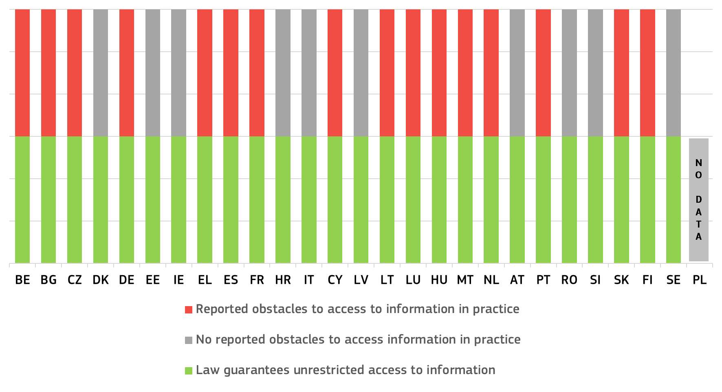
(*) On Restrictions: PL: access to information prescribed as privileged by law is excluded or limited; CY, CZ, NL: restrictions resulting from limitations/lack of clarity as to the SAI mandate; EL, FI: restrictions due to technical difficulties; BG, CZ, EL: obstacles/delays due to administrative practices; CY, NL, PL: SAIs report obstacles due to administrative practice; CY, EL, ES, NL, FI: obstacles when auditing central banks and financial institutions; BE, IT, LT, NL, EL, AT, CY, DE, EE, ES, FI, FR, HU, MT, PL, PT, SK: auditees invoke rules on personal data protection and/or confidentiality to contest access. MT: no right to access information from private companies.
Figure : Supreme audit institutions: measures in case access to information is not granted (*) (source: European Commission with the Contact Committee on Supreme Audit Institutions)
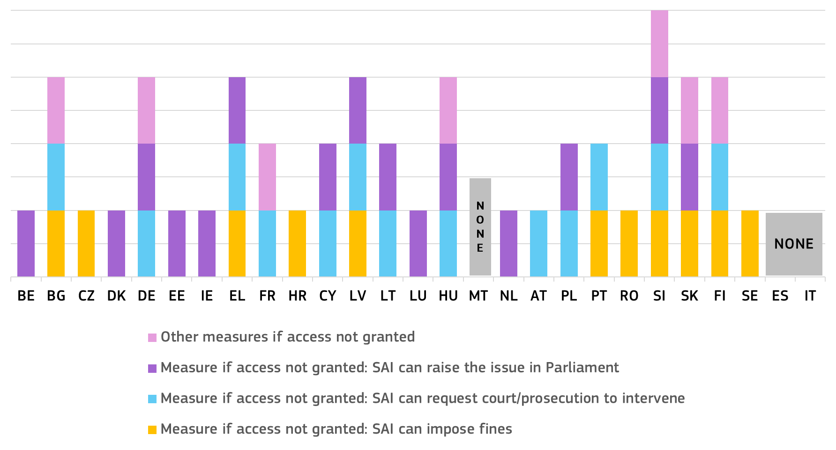(*) Recourse to judicial authorities: AT, CY: recourse to Constitutional Court; proposal/request for the initiation of judicial proceedings (criminal): Other measures: BG, FI, FR, SI, SK: public disclosure of unlawful non-cooperation; HU: other measures include seeking the suspension of public funding, grants, or eligibility to receive donations from 1% of personal income tax; DE: issuance of formal audit order. SI: as other measures the SAI can call on the competent authority for action; call for dismissal of the person in the responsible body, in cases of serious breach; criminal charges and misdemeanour proposals; post-audit procedure.

2.4.3. Specialised jurisdictions relevant for the functioning of the single market
Figure 65 presents the jurisdictions responsible for commercial cases. Specialisation of courts in commercial matters strengthens the efficiency, quality, and predictability of justice systems across the European Union. By equipping judges with expertise in complex business-related proceedings and cross-border disputes, specialised commercial courts help deliver faster, more consistent, and more reliable decisions. This reduces uncertainty for companies operating within the single market, improves contract enforcement, and fosters investor confidence. In doing so, specialisation not only enhances judicial efficiency and fairness at national level but also contributes to a more integrated and competitive European economy.

Figure : Jurisdictions responsible for commercial cases (*) (source: European Commission)
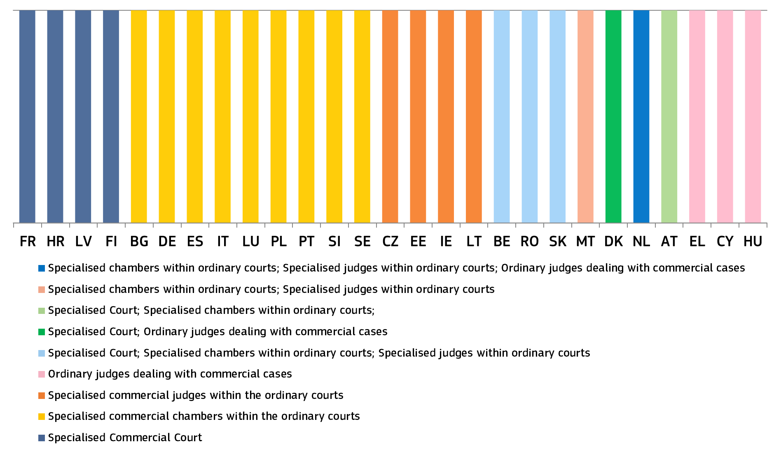 (*) BE: Commercial cases are dealt with by a Specialised Commercial Court, as well as by specialised commercial judges and chambers within ordinary courts. The Specialised Commercial Court deals with disputes between companies, regardless of the claim value. Commercial cases involving citizens are dealt with by a Justice of the Peace, a court of first instance, or a civil court if the value claim exceeds EUR 5 000. RO: Commercial cases are dealt with by a Specialised Commercial Court, as well as by specialised commercial judges and chambers within ordinary courts. At the level of tribunals there are specialised sections that deal with commercial cases. Where there are no specialised sections, there are specialised panels. There are also three specialised tribunals, namely the Specialised Tribunals of Argeș, Cluj and Mureș. SK: Commercial cases are dealt with by a Specialised Commercial Court, as well as by specialised commercial judges and chambers within ordinary courts. Commercial cases for the Bratislava Region are only dealt with by the Municipal Court Bratislava III, at first instance. In other regions there are ordinary first instance courts within which commercial judges deal with commercial cases. Upon request, a commercial law panel within a district court can be established. The only exception is Municipal Court Košice, where a commercial law panel is established by default. At the Supreme Court, there are four divisions, among them a commercial division. MT: Commercial cases are dealt with by specialised commercial judges and chambers with the ordinary courts. Appeals form the Commercial Court are heard by the Court of Appeal (Superior Jurisdiction). Currently the Commercial Court is a division of the First Hall, Civil Court. There is an ongoing legislative process that will establish the Commercial Court as an independent court. DK: Commercial cases are dealt with by the ordinary courts. Upon request, international commercial cases are dealt with by the Danish Maritime and Commercial Court. Parties may also choose the ordinary courts for these kinds of cases. NL: Commercial cases are dealt with by specialised commercial judges and chambers within the ordinary courts. Commercial cases are handled by civil judges, specialised commercial judges and the subdistrict judges. The specialised commercial chamber in the Amsterdam District Court deals with cases with value claims above EUR 25 000. AT: Commercial cases are dealt with by a Specialised Commercial Court, as well as by specialised commercial chambers within the ordinary courts. Under Austrian law commercial cases are civil law cases. They are subject to the ordinary civil procedure, with few special rules. When a commercial case is heard by a division in a court of first or second instance, a lay assessor representing companies joins the division. This is not the case in the Supreme Court. Vienna has a separate District Court for Commercial Matters and a separate Commercial Court. Outside Vienna, Commercial Chambers within District Courts and Regional Courts also hear commercial cases. Decisions of the District Court for Commercial Matters may be appealed with the Commercial Court. Outside Vienna, there are no regulations deviating from the general regulations for appeals. CY: A reform of the judicial system in 2023 provided for the establishment of the Commercial Court, with special jurisdiction over high value commercial disputes by specialised judges. However, this Court is not operational yet.
Figure 66 presents the jurisdiction of supreme administrative courts in business-related proceedings, and Figure 67 the mechanisms at their disposal for efficiently dealing with business-related cases. Supreme administrative courts play a pivotal role in the single market by ensuring uniform interpretation and application of EU law in administrative matters, such as public procurement, State aid, competition rules, and regulatory compliance, which directly impact businesses operating cross-border. Their expertise guarantees legal certainty and predictability, reducing disparities between Member States and fostering mutual trust essential for seamless economic integration. Presenting their competence over business-related cases is crucial to highlighting the role these courts have in safeguarding a level playing field, improve contract enforcement, and support investor confidence, thereby strengthening the overall business environment and the resilience of the single market.
Figure : Supreme administrative courts: jurisdiction in business-related cases (*) (source: European Commission with ACA-Europe)
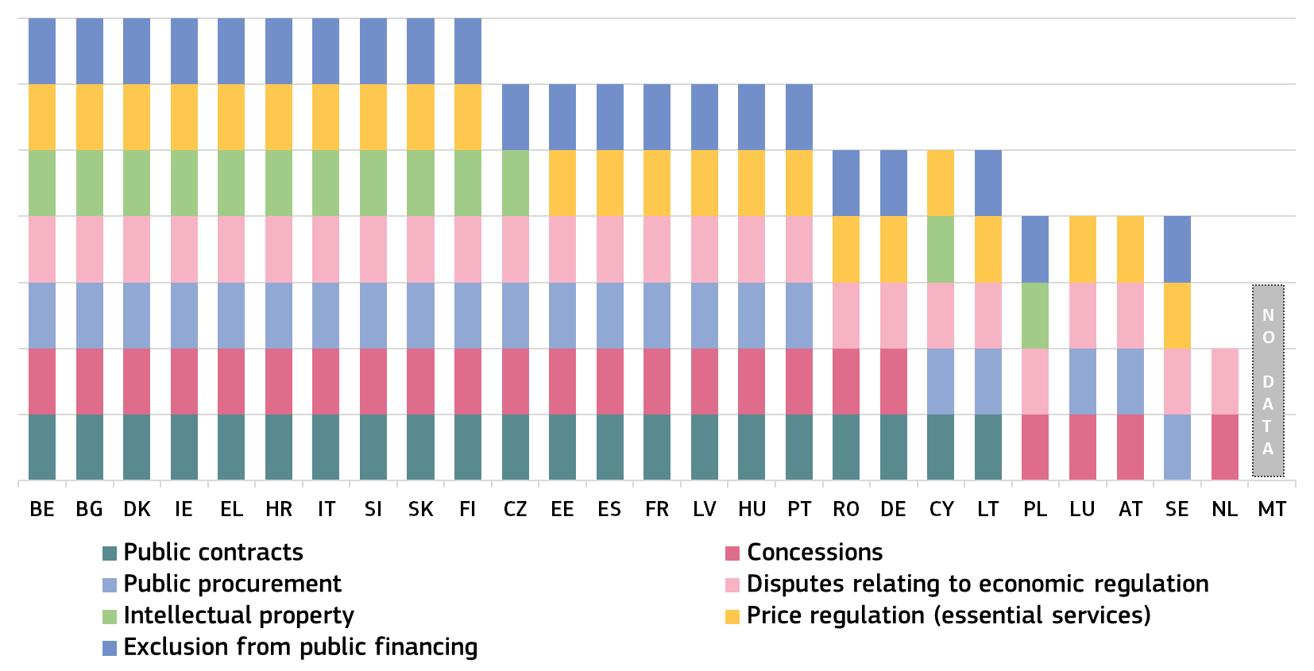

(*) BE, EE, BG, LU, PL: Administrative courts are competent to rule on disputes concerning the legality of concession awards but not disputes concerning their performance. IT: The administrative courts do not have jurisdiction over disputes relating to acts and measures on compensation, royalties, or other financial payments or charges, nor over matters falling within the jurisdiction of the Public Water Courts or the Superior Court of Public Waters, nor disputes in the field of public services relating to public service concessions that involve compensation, royalties and other charges, nor relating to measures adopted by the public administration or the operator of a public service in an administrative procedure, nor again relating to the award of a public service, and the supervision and control of the operator, or relating to supervision of the credit, insurance and securities market, pharmaceutical services, transport, telecommunications and public utilities. NL: The Administrative Jurisdiction Division of the Council of State is competent to rule on disputes concerning production licences (formerly concessions) under the Mining Act. CZ: The work of the administrative court does not include reviewing the granting of concessions or deciding on sanctions for poor performance, but rather whether the activity of an administrative authority could have infringed public subjective rights. HU: For it to fall under the jurisdiction of the administrative courts, concession contract must be classified as an administrative contract.

Figure : Supreme administrative courts: mechanisms for improving efficiency in business-related cases (*) (source: European Commission with ACA-Europe)
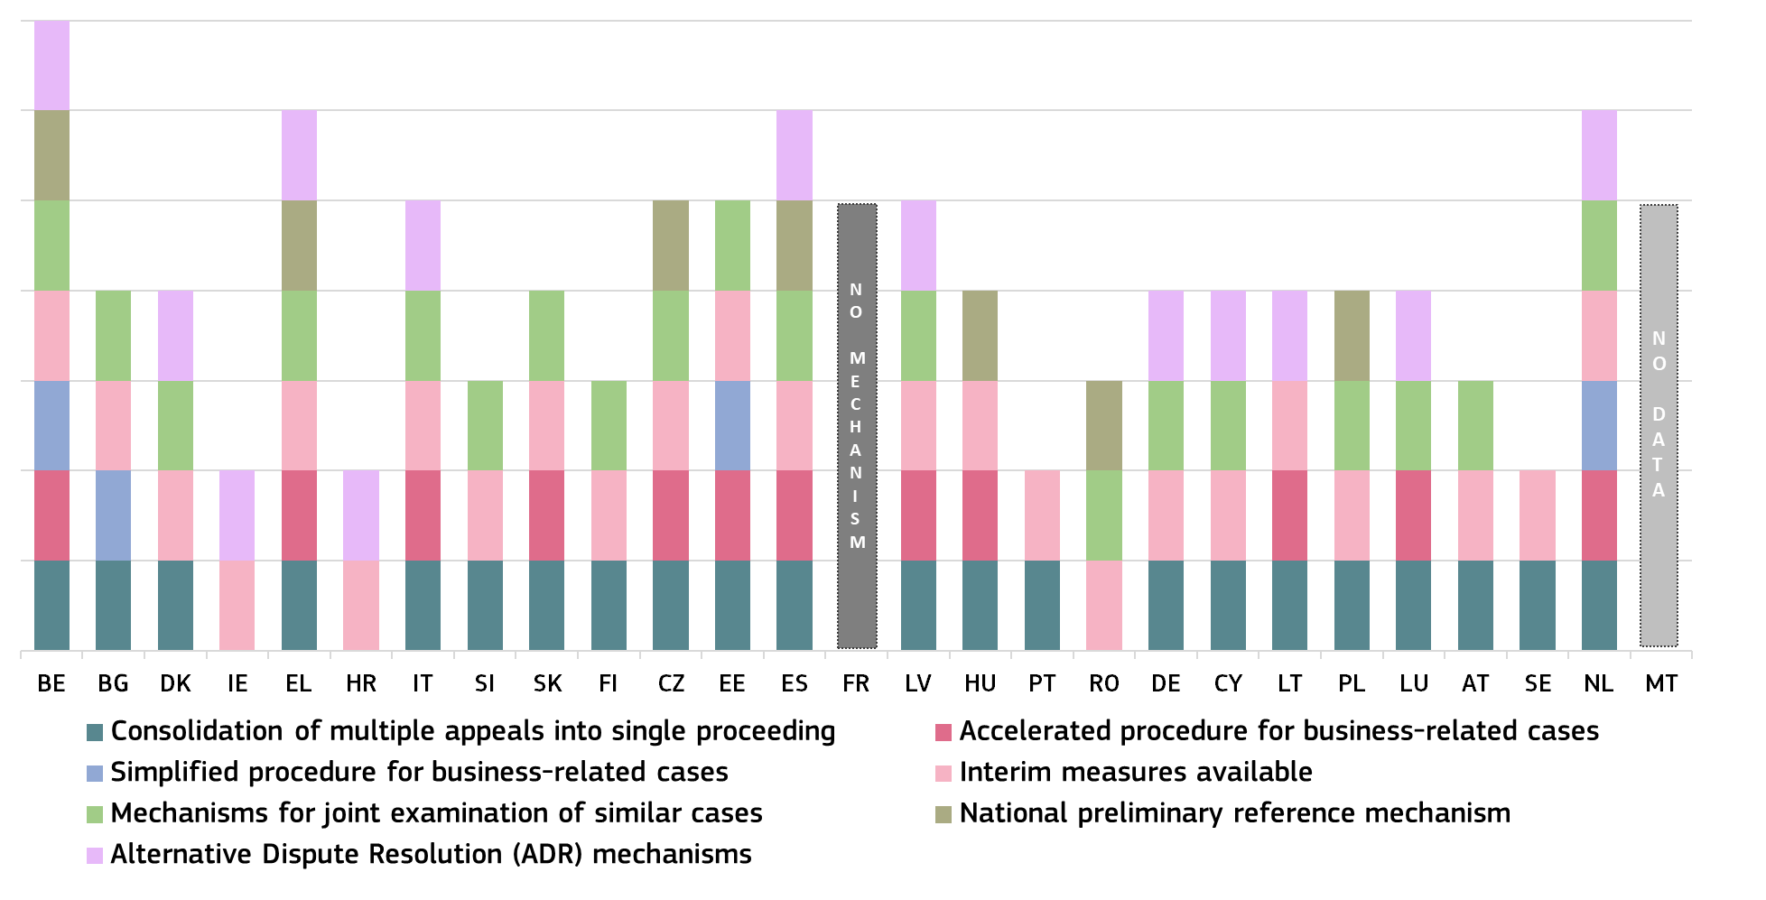
(*) PT, NL, LV, SI, HU, IE, SE, FI have the following interim measures available: suspension of the application of regulations or the law, suspension of the application of the administrative act, imposing obligations, and granting rights.

2.4.4. Prevention of corruption: transparency of lobbying
National anti-corruption frameworks are monitored by the Commission through the annual Rule of Law Report and, if relevant, also under the European Semester, the RRPs and as part of assessments under the Conditionality Regulation ().
The new Directive on combating corruption, as adopted in April 2026 by the European Parliament and Council (see Section 2.1.4. above), indicates the importance of the prevention of corruption, in order to foster a culture of integrity and includes some provisions aimed at strengthening integrity measures.
The Justice Scoreboard has in the past covered various corruption prevention topics. In 2024, the obligation for certain public officials to disclose assets was the focus of the data collection exercise, as asset declaration is recognised as an important tool in ensuring transparency and preventing corruption.
The 2026 EU Justice Scoreboard builds on the 2024 Scoreboard’s figures and maps the transparency of lobbying in Member States – particularly the functions of their transparency registers. Interest representation that seeks to legitimately influence public decision-making but does not entail an undue exchange of advantages is an entirely legitimate political activity. However, such forms of interest representation should be carried out in a regulated environment precisely to avoid situations where a lack of transparency may allow such contacts to become gateways to corruption. This topic is also addressed in the anti-corruption pillar of the European Commission’s annual Rule of Law Report. In December 2023, the Commission adopted a proposal for a Directive on interest representation carried out on behalf of third countries (). Moreover, the RRPs of several Member States include measures relating to the national frameworks on lobbying ().
The figures show whether a transparency register on lobbying exists, including who is obliged to register (Figure 68), and the personal scope (Figure 69) of the transparency registers.
Figure : Transparency registers on lobbying (*) (Source: European Commission with the national contact points for anti-corruption ())
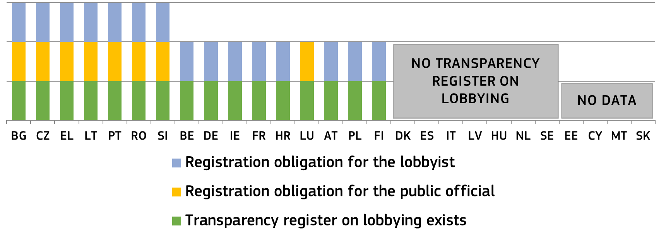(*) BE: Different rules may apply at the regional level. ES: For regional and local level, regional regulations apply, with some Autonomous Communities establishing transparency registers and obligations on contacts with lobbyists. IT: Some ministries and government departments maintain meeting registers (e.g. the stakeholder register (Transparency Register) of the Ministry of Enterprise and of ‘Made in Italy’ Product). At the subnational level, several regions have adopted legislation on lobbying. The Chamber of Deputies has adopted its own Transparency Registe, and its list of registered entities is freely available on the institution’s website and is maintained by the office of the Presidency. LV: Amendments to lobbying transparency laws introduce a transitional period (2025–2028). From September 1, 2028, a mandatory Register of Interest Representation and Declaration System will launch, with data publicly available. Voluntary registration is possible via the Enterprise Register (Latvian Open Data Portal). HU: Government Decree No. 50/2013 (II. 25.) on the integrity management system of public administration bodies and the reception of stakeholders regulates the management of integrity and corruption risks for public administration bodies and their employees under the direction or supervision of the Government and members of the Government. The Government Decision 1025/2024 (II. 14.) on the adoption of the medium-term National Anti-Corruption Strategy 2024-2025 and the related action plan set several tasks in relation to the regulation of lobbying activities. The Government invited the bodies concerned a) to prepare codes of ethics; and b) provide training on integrity awareness, taking into account the content of the code of ethics established under point a). The Government invites the Minister of Justice to ensure that the new lobbying law is drafted taking into account international recommendations. The Government instructs the Minister for Public Administration and Regional Development to prepare, with the involvement of the ministers concerned, a methodology guide on the interaction of local governments with lobbyists with a view to identifying and promoting best practices. NL: There is no such register but other instruments are in place to promote integrity and transparency, including publicising the agendas of ministers and lobby paragraphs in legislative processes. An evaluation of these instruments has taken place. The Government has indicated in their coalition agreement that it intends to implement a lobbying register that is workable and practical for both Government officials and lobbyists. The government is currently working on a proposal for the implementation. PL: For the purposes of this chart, a transparency register is in place despite national rules being more limited in practice. According to the Law on lobbying activities in the process of lawmaking a register of entities performing professional lobbying activities is maintained by the Ministry of the Interior and Administration, which is public. Every public institution specifies the detailed manner of conduct of employees when handling matters with entities performing professional lobbying activities or carrying out activities falling within the scope of such activities without registration in the register of entities performing professional lobbying activities, consisting of representing the interests of persons or entities for which they act, including the manner of documenting the contacts undertaken. Every public institution is obliged to prepare annually public information on activities involving these authorities in the previous year and entities engaged in professional lobbying. The information must be made immediately available in the Public Information Bulletin RO: Voluntary registration in RUTI for decision-makers and lobbyists. Mandatory for some officials to register in RUTI and disclose meetings (names, date/location, purpose, and topics discussed). Members of Parliament (deputies/senators) must register and only meet registered third parties for legislative lobbying according to Law 197/2025. Third parties engaging with members of Parliament must register in RUTI (annual updates). SE: There are no lobbying registers but the principle of public access to official documents is applicable to all Government activity. Any document related to lobbying activities (such as invitations and other correspondence, visitor logs etc) are as a general rule public and can be disclosed to the public on request, unless a specific provision on secrecy that entails confidentiality on information in the document applies. The grounds for secrecy are strictly regulated.
Figure : Transparency registers on lobbying: personal scope (*) (Source: European Commission with the national contact points for anti-corruption ())
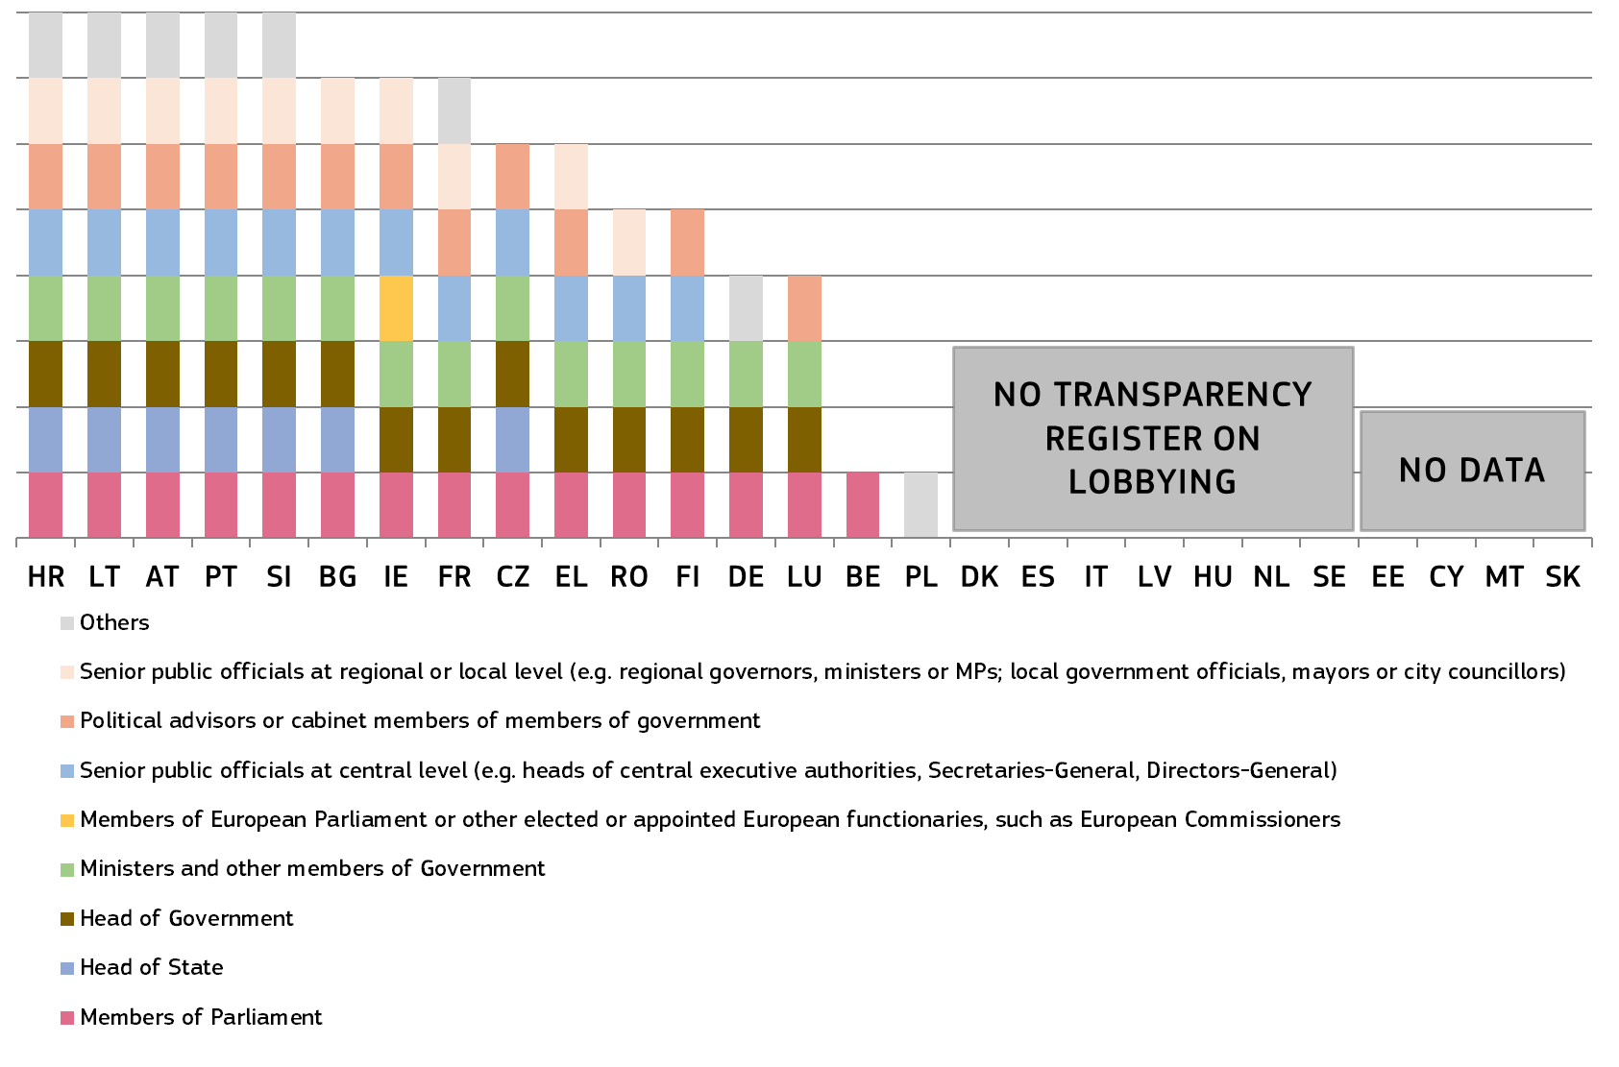
(*) BE: Different rules may apply at the regional level. DE: There is a lobby register, where (only) lobbyists are obliged to register. Lobbyists include, in principle, all natural and legal persons who represent interests regularly, permanently, as a business or against renumeration. They have to register when they regularly contact members of Parliament and the central (federal) Government (head of Government, ministers, senior public officials at central level). Registered parties have to provide general information on the subjects and targets of their lobbying, but not on specific meetings. EL: Senior public at regional and local level: (a) The Regional Governors and the Deputy Governors and (b) mayors and deputy mayors. ES: For regional and local level, regional regulations apply. Some Autonomous Communities establish transparency obligations in relation to contacts with lobbyists for their senior public officials. FR: The section "other" includes public officials from the Hospital public sector, namely directors of hospital centres with a budget exceeding EUR 200 million; as well as certain positions subject to the Government’s decision (e.g. ambassadors). HR: A lobbied person is any person elected, appointed or employed as a public official, a special adviser or a managerial civil servant, or otherwise engaged in legislative or executive authorities, state administration bodies, other state bodies, bodies of local or regional self-government units, including their administrative bodies, or in other legal persons and bodies vested with public powers, who participates or is responsible for public decision-making and has agreed to communicate with a lobbyist. LT: Lobbied persons are the President of the Republic, members of Parliament, the Government, vice-ministers, chancellors of the Government, ministries, heads of parliamentary political parties, mayors, members of municipal councils, directors of municipal administrations and their deputies, other civil servants, state officials and other persons who, in accordance with the procedure established by legal acts, take part in the preparation, consideration and adoption of draft legal acts. LV: Unable to provide comprehensive information because the currently maintained list of interest representatives is voluntary and temporary in nature. Consequently, complete data regarding interest representatives and their representation activities is not included in the list, and no sanctions are prescribed for non-inclusion. AT: Any public officials and employee can be the subject of lobbying if they work in legislation, the executive branch or are engaged in business deals of state actors on a federal, state or municipal level. PT: The legal framework also includes the Bank of Portugal, independent administrative bodies and regulatory bodies (see column Other). RO: The registration is voluntary for specialised groups. Following Law no. 49 of 14 April 2025, the following decision makers are required to register in RUTI and disclose meetings: Members of Government; The Head of the Prime Minister’s Chancellery; The Secretary-General and Deputy Secretaries-General of the Government; Secretaries and Undersecretaries of State, and their equivalents within ministries and other central government bodies; State counsellors within the Prime Minister’s Chancellery. Decision-makers may request the registration of third parties in the RUTI system as a prerequisite for their participation in official meetings. In addition, dignitaries from autonomous administrative authorities, prefects, deputy prefects, and representatives of local public administration authorities may request the registration of third parties in RUTI and may choose to publish their official meetings with such entities. Since 28 November 2025, under a new legal framework, Deputies and senators are required to register in RUTI and to conduct meetings related to influencing legislative initiatives exclusively with third parties registered in the register. Third parties seeking to engage with members of Parliament must also register in RUTI. SI: According to the Integrity and Corruption Prevention Act, lobbied persons are holders of public office and public employees in state bodies, the Bank of Slovenia, local community bodies and administrations and holders of public authority who are responsible for decision-making, or who participate in the discussion and adoption of regulations, other general documents and other decisions. Political advisors who are not employed/hold office with a state body or do not meet other abovementioned criteria of the definition, do not fall within the category of lobbied persons. FI: The personal scope of the Transparency Register extends to all public officials working in the ministries – not only senior level public officials. SE: There is no transparency register, but the principle of public access to official document encompasses all official documents. A document is official if it is held by a public authority and considered under specific rules to have been received or drawn up by such an authority. The term ‘public authorities’ refers to all bodies that are part of the central government and local government administration. The Government, the administrative authorities, the courts and the municipal boards are all public authorities. Thus, the principle of access to document not only includes documents held by senior public officials, but all public officials.

3. Conclusion
The 2026 EU Justice Scoreboard further develops an in-depth insight into the effectiveness of justice systems in the Member States. The indicators present continuous efforts to improve the efficiency, quality and independence of the justice systems. In addition, they show certain structural aspects of other public authorities tasked with applying EU law. The information in the EU Justice Scoreboard contributes to the monitoring carried out as part of the Annual Rule of Law Cycle and feeds into the Commission’s annual Rule of Law Report.

2025 EU Compass to regain competitiveness and secure sustainable prosperity, COM(2025) 30 final.
COM(2026) 46 final.
See Communication from the Commission to the European Parliament, the Council, the European Economic and Social Committee and the Committee of the Regions, Identifying and addressing barriers to the Single Market, COM(2020)93, and accompanying SWD(2020)54.
See Communication from the Commission to the European Parliament, the Council, the European Economic and Social Committee and the Committee of the Regions, Digitalisation of justice in the European Union: A toolbox of opportunities, COM(2020)710, and accompanying SWD(2020)540.
https://commission.europa.eu/publications/2025-rule-law-report-communication-and-country-chapters_en.
E.g. European Parliament resolution of 29 May 2018 on the 2017 EU Justice Scoreboard (P8_TA(2018)0216).
https://commission.europa.eu/strategy-and-policy/policies/justice-and-fundamental-rights/upholding-rule-law/eu-justice-scoreboard_en.
To help prepare the EU Justice Scoreboard and promote the exchange of best practice on the effectiveness of justice systems, the Commission asked Member States to designate two contact persons, one from the judiciary and one from the ministry of justice. This informal group meets regularly.
The Commission maintains an informal group of contact persons dealing with corruption. https://commission.europa.eu/strategy-and-policy/policies/justice-and-fundamental-rights/democracy-eu-citizenship-anti-corruption/anti-corruption/eu-network-against-corruption_en.
The ENCJ brings together Member States’ national institutions that are independent of the executive and legislature, and are responsible for supporting the judiciary in the independent delivery of justice: https://www.encj.eu/.
The NPSJC provides a forum that gives European institutions the opportunity to request the opinions of supreme courts, and brings them closer by encouraging discussion and the exchange of ideas: http://network-presidents.eu/.
ACA-Europe is composed of the Court of Justice of the EU and the Councils of State or the Supreme administrative jurisdictions of each EU Member State: https://www.aca-europe.eu/index.php/en/.
CCBE represents European bars and law societies in their common interests before European and other international institutions. It regularly acts as a liaison between its members and the European institutions, international organisations, and other legal organisations around the world: https://www.ccbe.eu/.
The ECN was set up as a forum for discussion and cooperation between European competition authorities in cases where Articles 101 and 102 of the Treaty on the Functioning of the EU (TFEU) are applied. The ECN is the framework for close cooperation referred to in Council Regulation (EC) No 1/2003. Through the ECN, the Commission and the national competition authorities in all EU Member States cooperate with each other: http://ec.europa.eu/competition/ecn/index_en.html.
The Network of First Instance Review Bodies on Public Procurement was set up to strengthen cooperation between national first instance public procurement review bodies in the EU. The group’s task is to advise the European Commission on matters related to the implementation of the Remedies Directives and the functioning of the national remedies systems. As a result of the evaluation of the effectiveness of Remedies Directives (COM(2017) 28 final of 24 January 2017), the Commission encourages first instance review bodies to cooperate to improve the exchange of information and good practice.
The COCOM is composed of EU Member State representatives. Its main role is to provide an opinion on the draft measures that the Commission intends to adopt on digital market issues: https://ec.europa.eu/transparency/comitology-register/screen/committees.
The European Observatory on Infringements of Intellectual Property Rights is a network of experts and specialist stakeholders. It is composed of public and private sector representatives, who collaborate in active working groups: https://euipo.europa.eu/ohimportal/en/web/observatory/home.
The CPC is a network of national authorities responsible for enforcing EU consumer protection laws in EU and EEA countries: https://commission.europa.eu/live-work-travel-eu/consumer-rights-and-complaints/enforcement-consumer-protection/consumer-protection-cooperation-network_en.
The EGMLTF meets regularly to share views and helps the Commission to set out its define policy and draft new anti-money laundering and counter-terrorist financing legislation: https://ec.europa.eu/transparency/expert-groups-register/screen/expert-groups/consult?lang=en&do=groupDetail.groupDetail&groupID=2914.
Eurostat is the statistical office of the EU: https://ec.europa.eu/eurostat/.
The Commission maintains an informal group of contact persons dealing with the fight against corruption. See also https://commission.europa.eu/strategy-and-policy/policies/justice-and-fundamental-rights/democracy-eu-citizenship-anti-corruption/anti-corruption/eu-network-against-corruption_en.
https://www.npg-nadal.eu/
The Contact Committee brings together the heads of the supreme audit institutions of the Member States and the European Court of Auditors and provides a forum for discussing and enhancing cooperation in audit and related activities. https://www.eca.europa.eu/sites/CC/en/pages/about.aspx.
The Council of the Notariats of the European Union (CNUE) is the official body representing the notarial profession in dealings with the institutions of the EU and brings together the notariats of the 22 Member States familiar with these institutions. https://www.notariesofeurope.eu/fr/.
In the context of the European Semester, the Council, on the basis of the Commission’s proposal, addressed country-specific recommendations on their justice systems to seven Member States in 2019 (HR, IT, CY, HU, MT, PT and SK) and eight Member States in 2020 (HR, IT, CY, HU, MT, PL, PT and SK). There were no country-specific recommendations in 2021 due to the ongoing RRF processes. In 2022, there were two Member States (PL and HU) with country-specific recommendations related to judicial independence. In 2024, one Member State had a country-specific recommendation related to the effectiveness, independence and integrity of the judicial and anti-corruption system (SK). In 2025, seven Member States had a country-specific recommendation related to the effectiveness, independence and integrity of the judicial and anti-corruption system (BG, EL, ES, IT, HU, PT and SK).
Article 19(3), point (b), and Article 24(3) and (5) of Regulation (EU) 2021/241 of the European Parliament and of the Council of 12 February 2021 establishing the Recovery and Resilience Facility, OJ L 57, 18.2.2021, p. 17. The EU Justice Scoreboard is one of the sources of information feeding into the European Semester. This information does not prejudge the Commission’s assessments of the satisfactory fulfilment of milestones and targets under the RRF.
Furter information can be found in the Recovery and Resilience Scoreboard, accessible via: https://ec.europa.eu/economy_finance/recovery-and-resilience-scoreboard/index.html.
A Competitiveness Compass for the EU, COM(2025) 30 final, p. 19, The 2025 Annual Single Market and Competitiveness Report, COM(2025) 26 final, p. 3.
Khan, M.A. et al. 2024. ‘Justice and finance: Does judicial efficiency contribute to financial system efficiency?’ Borsa Istanbul Review 24(2): pp. 248–255, https://www.sciencedirect.com/science/article/pii/S2214845023001709 ; Chemin, M., 2020. ’ Judicial efficiency and firm productivity: Evidence from a world database of judicial reforms,’ The Review of Economics and Statistics 102(1): pp. 49–64, https://direct.mit.edu/rest/article/102/1/49/58536/Judicial-Efficiency-and-Firm-Productivity-Evidence ; Kapopoulos, P. and Rizos, A., 2024. ’Judicial efficiency and economic growth: Evidence based on European Union data,’ Scottish Journal of Political Economy 71(1): pp. 101–131, https://onlinelibrary.wiley.com/doi/10.1111/sjpe.12357?msockid=1a8244b340af65701f02511641c36474.
IMF, Regional Economic Outlook, November 2017, Europe: Europe Hitting its Stride, pp. xviii, 40, 70: https://www.imf.org/~/media/Files/Publications/REO/EUR/2017/November/eur-booked-print.ashx?la=en.
ECB, ‘Structural policies in the euro area’, June 2018, ECB Occasional Paper Series No 210: https://www.ecb.europa.eu/pub/pdf/scpops/ecb.op210.en.pdf?3db9355b1d1599799aa0e475e5624651.
European Network of Councils for the Judiciary and the Montaigne Centre for the Rule of Law and Administration of Justice of Utrecht University, ‘Economic value of the judiciary – A pilot study for five countries on volume, value and duration of large commercial cases’, June 2021: https://pgwrk-websitemedia.s3.eu-west-1.amazonaws.com/production/pwk-web-encj2017-p/Reports/Economic%20value%20of%20te%20judiciary%20-%20pilot%20study.pdf.
See e.g. OECD, ‘What makes civil justice effective?’ OECD Economics Department Policy Notes, No 18, June 2013 and idem, ‘The Economics of Civil Justice: New Cross-Country Data and Empirics’, OECD Economics Department Working Papers, No 1060, August 2013.
World Economic Forum, ‘The Global Competitiveness Report 2019’, October 2019: https://www.weforum.org/reports/global-competitiveness-report-2019.
World Bank, ‘World Development Report 2017: Governance and the Law, Chapter 3: The role of law’, pp. 83, 140: http://www.worldbank.org/en/publication/wdr2017.
The ‘disposition time’ indicator is the number of unresolved cases divided by the number of resolved cases at the end of a year, multiplied by 365 (days). It is a standard indicator developed by the CEPEJ: http://www.coe.int/t/dghl/cooperation/cepej/evaluation/default_en.asp.
Bove, V. and Elia, L., 2017 ‘The judicial system and economic development across EU Member States’, JRC Technical Report, EUR 28440 EN, Publications Office of the EU, Luxembourg: http://publications.jrc.ec.europa.eu/repository/bitstream/JRC104594/jrc104594__2017_the_judicial_system_and_economic_development_across_eu_member_states.pdf.
Ibidem.
The study used the structural evolution from 1970 to 2019 in the number of judges as an indicator for access to justice. Deseau A., Levai A., and Schmiegelow M., 2025 ‘Access to justice and economic development: Evidence from an international panel dataset’, European Economic Review, Volume 172, 104947: https://doi.org/10.1016/j.euroecorev.2024.104947.
The Economist Intelligence Unit, ‘Risk and Return – Foreign Direct Investment and the Rule of Law’, 2015 http://www.biicl.org/documents/625_d4_fdi_main_report.pdf, p. 22.
EU Intellectual Property Office (EUIPO), Intellectual Property (IP) SME Scoreboard 2016: https://euipo.europa.eu/tunnel-web/secure/webdav/guest/document_library/observatory/documents/sme_scoreboard_study_2016/Executive-summary_en.pdf.
COM(2020)93 and SWD(2020)54.
Communication from the Commission to the European Parliament, the Council, the European Economic and Social Committee and the Committee of the Regions, Long term action plan for better implementation and enforcement of single market rules, COM(2020)94, in particular actions 4, 6 and 18.
AI can contribute to a more efficient justice system by helping judges and justice professionals to focus on their substantive work. For example, AI has been used in following cases, document filing or handling of repetitive tasks, as well as research of legislation and case law.
Regulation (EU) 2023/2844 of the European Parliament and of the Council of 13 December 2023 on the digitalisation of judicial cooperation and access to justice in cross-border civil, commercial and criminal matters, and amending certain acts in the field of judicial cooperation, PE/50/2023/REV/1, OJ L, 2023/2844, 27.12.2023.
COM(2025)802 – DigitalJustice@2030.
The enforcement of court decisions is also important for the efficiency of a justice system. However, comparable data are not readily available. More details on the individual Member States’ situation are presented in the 2025 study on the functioning of judicial systems in the EU Member States – country profiles, carried out by the CEPEJ Secretariat for the Commission: https://commission.europa.eu/strategy-and-policy/policies/justice-and-fundamental-rights/upholding-rule-law/eu-justice-scoreboard_en.
In the context of the European Semester, the Council, on the basis of the Commission’s proposal, addressed country-specific recommendations (CSRs) on their justice systems to seven Member States in 2019 (HR, IT, CY, HU, MT, PT and SK) and eight Member States in 2020 (HR, IT, CY, HU, MT, PL, PT and SK). There were no CSRs in 2021 due to the ongoing RRF process. In 2022, there were two Member States (PL and HU) with CSRs related to judicial independence. In addition, in 2023 the justice system was mentioned for two Member States (HU, PL). In 2023, only PL received a CSR on its justice system, which was based on the 2022 CSR. In 2024, SK received a CSR related to the judicial system and anti-corruption framework, HU received a CSR related to improving the regulatory framework in line with principles of the rule of law , while BG received a CSR regarding the regulatory authorities and their independence. As per the Commission’s 2025 spring package, CSRs reiterate the same issues for SK, HU and BG. Additionally, CSRs address effectiveness of anti-corruption measures for BG and the legislative process for SK, while a CSR regarding judicial efficiency is issued to ES. Several RRPs include measures to increase the efficiency, quality, or independence of justice.
Directive (EU) 2018/1673 of the European Parliament and of the Council of 23 October 2018 on combating money laundering by criminal law will eliminate certain legal obstacles that may delay prosecution, such as a rule that prosecution for money laundering can only start when the proceedings for the underlying predicate offence have been concluded. Member States were required to transpose the Directive by 8 December 2020.
2025 study on the functioning of judicial systems in the EU Member States, carried out by the CEPEJ Secretariat for the Commission: https://commission.europa.eu/strategy-and-policy/policies/justice-and-fundamental-rights/upholding-rule-law/eu-justice-scoreboard_en#documents.
Length of proceedings, clearance rate and number of pending cases are standard indicators defined by CEPEJ: http://www.coe.int/t/dghl/cooperation/cepej/evaluation/default_en.asp.
The years were chosen to keep the 10-year perspective with 2014 as a baseline, while at the same time not overcrowding the figures. Data for 2010, 2012, 2013, 2015, 2016, 2017, 2018, 2019, 2020 and 2021 are available in the CEPEJ report.
The length of proceedings in specific areas is calculated in calendar days, counting from the day on which an action or appeal was lodged before the court (or the indictment became final) until the day on which the court adopted its decision (Figures 15-22). Where data were not available for all years, the average reflects the available data presented in the chart, based on all cases, a sample of cases or, in very few countries, estimations.
Figure 18 of the Retention and Expansion of Foreign Direct Investment, Political Risk and Policy Responses, 2019 the World Bank Group.
See Council Regulation (EC) No 1/2003 of 16 December 2002 on the implementation of the rules on competition laid down in Articles 81 and 82 of the Treaty (Text with EEA relevance), OJ L 1, 4.1.2003, pp. 1–25, in particular Articles 3 and 5.
The calculation was based on the length of appeal cases against national regulatory authority decisions applying national laws that implement the EU regulatory framework for electronic communications (Directives 2002/19/EC (Access Directive), Directive 2002/20/EC (Authorisation Directive), Directive 2002/21/EC (Framework Directive), Directive 2002/22/EC (Universal Service Directive), as well as other relevant EU law such as the radio spectrum policy programme and Commission spectrum decisions, excluding Directive 2002/58/EC on privacy and electronic communications.
Regulation (EU) 2017/1001 of the European Parliament and of the Council of 14 June 2017 on the European Union trademark (OJ L 154, 16.6.2017, pp. 1–99).
Figures 19 and 20 relate to the enforcement of the Unfair Terms Directive (93/13/EEC), the Consumer Sales and Guarantees Directive (1999/44/EC), the Unfair Commercial Practices Directive (2005/29/EC) and the Consumer Rights Directive (2011/83/EC), and their national implementing provisions.
EU legislation addresses the fight against money laundering through Directive (EU) 2018/1673 of the European Parliament and of the Council of 23 October 2018 on combating money laundering by criminal law and through Directive (EU) 2015/849 of the European Parliament and of the Council of 20 May 2015 on the prevention of the use of the financial system for the purposes of money laundering or terrorist financing.
Recital 2 of Directive (EU) 2015/849.
IMF factsheet, 8 March 2018: https://www.imf.org/en/About/Factsheets/Sheets/2016/08/01/16/31/Fight-Against-Money-Laundering-the-Financing-of-Terrorism.
See also the amendment to Article 44 (EU) 2015/849 through Directive (EU) 2018/843 of the European Parliament and of the Council of 30 May 2018, which entered into force in June 2018 and had to be transposed by Member States in their legal order by 10 January 2020.
Proposal for a Directive on combating corruption COM(2023) 234 final and Joint Communication on the fight against corruption JOIN(2023) 12 final.
This data collection has focused on criminal courts of first instance, which usually contribute the most to the overall length of criminal proceedings.
Court fees are understood as an amount to be paid to start non-criminal legal proceedings in a court or tribunal.
Legal fees are the bill for services provided by lawyers to their clients.
Article 47(3) of the Charter of Fundamental Rights of the EU.
Member States use different methods to set the eligibility threshold, e.g. different reference periods (monthly/annual income). In 14 Member States there is also a threshold tied to the applicant’s personal capital. This is not taken into account for this figure. In BE, BG, IE, ES, FR, HR, HU, LT, LU, NL and PT, certain groups of people (e.g. individuals who receive certain benefits) are automatically entitled to receive legal aid in civil/commercial disputes. Additional criteria that Member States may use, such as the merits of the case, are not reflected in this figure. Although not directly related to the figure, in several Member States (AT, CZ, DE, DK, IT, NL, PL, SI) legal aid is not limited to natural persons. In EE, the decision to grant legal aid is not based on the level of financial resources of the applicant. In IE, partial legal aid has to take into account also the disposable assets of the applicant. In LV, the data are not comparable with the previous year due to the adaptation of calculation method.
To collect comparable data, each Member State’s Eurostat poverty threshold has been converted to a monthly income. The at-risk-of-poverty (AROP) threshold is set at 60% of the national median equivalised disposable household income. Source: Eurostat (online data code ilc_li01).
The 2025 data are collected using replies from members of the Council of Bar and Law Societies in Europe (CCBE) to a questionnaire based on the following specific scenario: a dispute between a consumer and a company (two different claim values indicated: EUR 6 000 and the Eurostat at-risk-of-poverty (AROP) threshold for each Member State). Given that conditions for legal aid depend on the applicant’s situation, the following scenario was used: a single 35-year-old employed applicant without any dependent or legal expenses insurance, with a regular income and a rented apartment.
The data, referring to income thresholds valid in 2024, have been collected using replies from members of the Council of Bar and Law Societies in Europe (CCBE) to a questionnaire based on the following scenario: a consumer dispute between an individual and a company (two different claim values indicated: EUR 6 000 and the Eurostat at-risk-of-poverty (AROP) threshold for each Member State).
See 2024 EU Justice Scoreboard, footnote 70 for the description of the case study.
The data, referring to income thresholds valid in 2024, have been collected using replies from Council of Bar and Law Societies in Europe (CCBE) members to a questionnaire based on the following scenario: a consumer dispute between an individual and a company (two different claim values indicated: EUR 6 000 and the Eurostat at-risk-of-poverty (AROP) threshold for each Member State).
Conversion made using the European Central Bank’s Euro Foreign Exchange Reference Rates applicable on 18 November 2025 - BGN 1.9558, CZK 24.188, DKK 7.4684, HUF 384.96, PLN 4.2440, RON 5.0870, SEK 10.9970.
The data, referring to income thresholds valid in 2024, have been collected using replies from Council of Bar and Law Societies in Europe (CCBE) members to a questionnaire based on the following scenario: a consumer dispute between an individual and a company (two different claim values indicated: EUR 6 000 and the Eurostat at-risk-of-poverty (AROP) threshold for each Member State).
The data has been collected by Council of the Notariats of the European Union (CNUE) in cooperation with the European Commission.
The methods for promoting and incentivising the use of ADR do not include compulsory requirements to use it before going to court. Such requirements may raise concerns about their compatibility with the right to an effective remedy before a tribunal, as per the EU Charter of Fundamental Rights.
2025 data collected in cooperation with the group of contact persons on national justice systems.
2025 data collected in cooperation with the group of contact persons on national justice systems.
As introduced by Directive (EU) 2020/1828 on representative actions, https://commission.europa.eu/law/law-topic/consumer-protection-law/representative-actions-directive_en, to protect the collective interests of consumers.
2025 data collected in cooperation with the group of contact persons on national justice systems.
2025 data collected in cooperation with the group of contact persons on national justice systems.
2025 data collected in cooperation with the group of contact persons on national justice systems.
2025 data collected in cooperation with the group of contact persons on national justice systems.
Judgment of the Court of Justice of the European Union, Case C‑64/16 Associação Sindical dos Juízes Portugueses, (ECLI:EU:C:2018:117) para. 45, ‘Like the protection against removal from office of the members of the body concerned (see, in particular, judgment of 19 September 2006, Wilson, C-506/04, EU:C:2006:587, paragraph 51), the receipt by those members of a level of remuneration commensurate with the importance of the functions they carry out constitutes a guarantee essential to judicial independence.’ See also Judgment of the Court of Justice of the European Union, Joined Cases C-146/23 and C-374/23 Sąd Rejonowy w Białymstoku and Adoreikė (ECLI:EU:C:2025:109), where the Court confirms that the detailed rules for determining the remuneration of judges must be objective, foreseeable, stable and transparent. The determination of that remuneration must have a legal basis and meet the criteria of objectivity, foreseeability, stability and transparency. Any derogation from the method for determining the remuneration must be justified by an objective of general interest.
https://commission.europa.eu/strategy-and-policy/policies/justice-and-fundamental-rights/upholding-rule-law/eu-justice-scoreboard_en#documents.
European Institute for Gender Equality, Gender Statistics Database: https://eige.europa.eu/gender-statistics/dgs/indicator/wmidm_jud_natcrt__wmid_natcrt_supcrt/datatable.
Communication from the Commission to the European Parliament, the Council, the European Economic and Social Committee and the Committee of the Regions ‘Digitalisation of justice in the European Union: A toolbox of opportunities’ COM(2020) 710 and accompanying SWD(2020)540.
2025 data collected in cooperation with the group of contact persons on national justice systems.
2025 data collected in cooperation with the group of contact persons on national justice systems.
2025 data collected in cooperation with the group of contact persons on national justice systems.
2025 data collected in cooperation with the group of contact persons on national justice systems.
2025 data collected in cooperation with the group of contact persons on national justice systems.
2025 data collected in cooperation with the group of contact persons on national justice systems.
2025 data collected in cooperation with the group of contact persons on national justice systems.
See Best practice guide for managing Supreme Courts, under the project Supreme Courts as guarantee for effectiveness of judicial systems, p. 29.
Regulation (EU) 2016/679 of the European Parliament and of the Council of 27 April 2016 on the protection of natural persons with regard to the processing of personal data and on the free movement of such data, and repealing Directive 95/46/EC (General Data Protection Regulation) (OJ L 119, 4.5.2016, p. 1).
Anonymisation/pseudonymisation is more efficient if assisted by an algorithm. However, human supervision is needed since the algorithms do not understand context.
Directive 2003/98/EC of the European Parliament and of the Council of 17 November 2003 on the reuse of public sector information (OJ L 345, 31.12.2003, p. 90) and Directive (EU) 2019/1024 of the European Parliament and of the Council of 20 June 2019 on open data and the reuse of public sector information (OJ L 172, 26.6.2019, p. 56).
Judgments modelled according to standards (e.g. Akoma Ntoso) and their associated metadata are downloadable free of charge in the form of a database or by other automated means (e.g. Application Programming Interface).
See also Communication from the Commission to the European Parliament, the Council, the European Economic and Social Committee and the Committee of the Regions – A European strategy for data, COM(2020) 66 final, Commission White Paper on Artificial Intelligence – A European approach to excellence and trust, COM(2020) 65 final, and Conclusions of the Council and the representatives of the Governments of the Member States meeting within the Council on Best Practices regarding the Online Publication of Court Decisions (OJ C 362, 8.10.2018, p. 2).
2025 data collected in cooperation with the group of contact persons on national justice systems.
2025 data collected in cooperation with the group of contact persons on national justice systems.
See http://eur-lex.europa.eu/legal-content/EN/TXT/PDF/?uri=CELEX:12012P/TXT&from=EN
Court of Justice, judgment of 6 March 2025, D. K. and Others v Prokuratura Rejonowa (Withdrawal of cases), joined cases C-647/21 and C-648/21, EU:C:2025:143, judgment of 25 February 2025 (Grand Chamber), XL and Others (Judicial salaries), joined cases C-146/23 and C-374/23, EU:C:2025:109, judgment of 14 November 2024, S. S.A. v C. sp. z o.o. (Allocation of cases), C-197/23, EU:C:2024:956; judgment of 22 February 2022, RS (Effect of the decisions of a constitutional court), C-430/21, EU:C:2022:99; judgment of 16 November 2021, Criminal proceedings against WB and Others, Joined Cases C-748/19 to C-754/19, EU:C:2021:931; judgment of 6 October 2021, W. Ż., C-487/19, EU:C:2021:798; judgment of 15 July 2021, Commission v. Poland, C-791/19, EU:C:2021:366; judgment of 2 March 2021, AB, C-824/18, EU:C:2021:153; judgment of 19 November 2019, A. K. and Others, C-585/18, C-624/18 and C-625/18, EU:C:2019:982, paras. 121 and 122; judgment of 5 November 2019, Commission v Poland, C-192/18, EU:C:2019:924; judgment of 24 June 2019, Commission v. Poland, C-619/18, EU:C:2019:531 paras. 73 and 74; judgment of 27 February 2018, Associação Sindical dos Juízes Portugueses, C‑64/16, EU:C:2018:117, para. 44; judgment of 25 July 2018, Minister for Justice and Equality, C‑216/18 PPU, EU:C:2018:586, para. 65.
Court of Justice, judgment of 11 July 2024 (Grand Chamber), Hann-Invest, C-554/21 and C-622/21, EU:C:2024:594. Supreme Courts, as final instance courts, and higher/appeal courts in general, are essential to secure the uniform application of the law in Member States. Nevertheless, hierarchical judicial organisations should not undermine individual independence (Recommendation CM/Rec(2010)12, para. 22). Superior courts should not address instructions to judges about the way they should decide individual cases, except in national preliminary rulings or when deciding on legal remedies according to the law (Recommendation CM/Rec(2010)12, para. 23). A hierarchical organisation of the judiciary in the sense of a subordination of judges to higher instances in their judicial decision-making activity would be a clear violation of the principle of internal independence, according to the Venice Commission (Venice Commission, Report on the independence of the judicial system, Part I: the independence of courts, Study No 494/2008, 16 March 2010, CDL-AD(2010)004, paras. 68 - 72). Any procedure for the unification of case law must comply with fundamental principles of separation of powers, and even after such a decision by a higher/Supreme Court, all courts and judges must remain competent to assess their cases independently and impartially, and to distinguish new cases from the interpretation previously unified by a higher/supreme court (2022 EU Justice Scoreboard, p. 45).
Court of Justice, judgment of 5 June 2023, Commission v. Poland, C-204/21, ECLI:EU:C:2023:442, para. 354 and the case law cited.
Eurobarometer survey FL581, conducted between 17 and 25 April 2026. Replies to the question: ‘From what you know, how would you rate the justice system in (your country) in terms of the independence of courts and judges? Would you say it is very good, fairly good, fairly bad or very bad?’, see: https://commission.europa.eu/strategy-and-policy/policies/justice-and-fundamental-rights/upholding-rule-law/eu-justice-scoreboard_en#surveys.
Eurobarometer survey FL581, replies to the question: ‘Could you tell me to what extent each of the following reasons explains your rating of the independence of the justice system in your country: very much, somewhat, not really, not at all?’ if the reply to Q1 is ‘fairly bad’ or ‘very bad’.
Eurobarometer survey FL582, conducted between 23 April and 8 May 2026, replies to the question: ‘From what you know, how would you rate the justice system in (your country) in terms of the independence of courts and judges? Would you say it is very good, fairly good, fairly bad or very bad?’, see: https://commission.europa.eu/strategy-and-policy/policies/justice-and-fundamental-rights/upholding-rule-law/eu-justice-scoreboard_en#surveys.
Eurobarometer survey F582; replies to the question: ‘Could you tell me to what extent each of the following reasons explains your rating of the independence of the justice system in (your country): very much, somewhat, not really, not at all?’ if the response to Q1 was ‘fairly bad’ or ‘very bad’.
Eurobarometer survey FL582, conducted between 23 April and 8 May 2026, replies to the question Q3: ‘To what extent are you confident that your investments are protected by the law and courts in (your country) if something goes wrong?’ For the purpose of the survey, investment was defined as including any kind of asset that a company owns or controls and that is characterised by the commitment of capital or other resources, the expectation of gain or profit or the assumption of risk.
Eurobarometer survey FL582; replies to the question: ‘What are your main reasons for concern about the effectiveness of investment protection?’ if the response to Q3 was ‘fairly unconfident’ or ‘very unconfident’.
Survey by the European Network of Councils for the Judiciary conducted between 7 January to 12 March 2025; replies to the question ‘During the last three years cases have been allocated to judges other than in accordance with established rules or procedures in order to influence the outcome of the particular case ?’.
See Court of Justice, judgment of 6 March 2025, D. K. and Others v Prokuratura Rejonowa (Withdrawal of cases), joined cases C-647/21 and C-648/21, judgment of 25 February 2025 (Grand Chamber), XL and Others (Judicial salaries), joined cases C-146/23 and C-374/23, judgment of 14 November 2024, S. S.A. v C. sp. z o.o. (Allocation of cases), C-197/23, judgment of 11 July 2024 (Grand Chamber), Hann-Invest, C-554/21, judgment of 21 December 2023, Krajowa Rada Sądownictwa (Maintien en fonctions d’un juge), C-718/21, ECLI:EU:C:2023:1015, paras. 76-77, and the case-law cited, judgment of 5 June 2023, Commission v. Poland, C-204/21, ECLI:EU:C:2023:442, para. 355; judgment of 16 November 2021, Criminal proceedings against WB and Others, Joined Cases C-748/19 to C-754/19, para. 67; judgment of 6 October 2021, W.Ż., C-487/19, para. 109; judgment of 15 July 2021, Commission v. Poland, C-791/19, para. 59; judgment of 2 March 2021, A.B., C-824/18, para.117; judgment of 19 November 2019, A. K. and Others (Independence of the Disciplinary Chamber of the Supreme Court), C-585/18, C-624/18 and C-625/18, ECLI:EU:C:2019:982, paras. 121 and 122; judgment of 24 June 2019, Commission v. Poland, C-619/18, ECLI:EU:C:2019:531 paras. 73 and 74; judgment of 25 July 2018, LM, C-216/18 PPU, ECLI:EU:C:2018:586, para. 66; judgment of 27 February 2018, Associação Sindical dos Juízes Portugueses, C‑64/16, ECLI:EU:C:2018:117, para. 44. See also paragraphs 46 and 47 of the Recommendation CM/Rec(2010)12 Judges: Independence, Efficiency and Responsibility (adopted by the Committee of Ministers of the Council of Europe on 17 November 2010) and the explanatory memorandum. These provide that the authority taking decisions on the selection and career of judges should be independent of the executive and legislative powers. With a view to guaranteeing its independence, at least half of the members of the authority should be judges chosen by their peers. However, where the constitutional or other legal provisions prescribe that the head of state, the government or the legislative power take decisions concerning the selection and career of judges, an independent and competent authority drawn in substantial part from the judiciary (without prejudice to the rules applicable to councils for the judiciary contained in Chapter IV) should be authorised to make recommendations or express opinions which the relevant appointing authority follows in practice.
See Court of Justice, judgment of 5 June 2023, Commission v. Poland, C-204/21, ECLI:EU:C:2023:442, para. 355; judgment of 2 March 2021, A.B., C-824/18, para. 119; judgment of 19 November 2019, A. K. and Others (Independence of the Disciplinary Chamber of the Supreme Court), C-585/18, C-624/18 and C-625/18, ECLI:EU:C:2019:982, para. 123; judgment of 24 June 2019, Commission v. Poland, C-619/18, ECLI:EU:C:2019:531 para. 112.
See Recommendation CM/Rec(2010)12 Judges: Independence, Efficiency and Responsibility, adopted by the Committee of Ministers of the Council of Europe on 17 November 2010 and the explanatory memorandum (‘the Recommendation CM/Rec(2010)12’).
The figure is based on the responses to an updated questionnaire drawn up by the Commission in close association with the ENCJ. Responses to the updated questionnaire from Member States that have no councils for the judiciary or that are not ENCJ members (CZ, DE, EE, AT and PL) were obtained in cooperation with the Network of the Presidents of the Supreme Judicial Courts of the EU.
Figures are based on responses to an updated questionnaire drawn up by the Commission in close cooperation with the Network of Public Prosecutors or equivalent institutions at the Supreme Judicial Courts of the Member States of the European Union – the NADAL Network.
Figure is based on the responses to an updated questionnaire drawn up by the Commission in close association with the Council of Bars and Law Societies of Europe (CCBE).
According to paragraphs 51 and 44 of the Recommendation CM/Rec(2010)12, where recruitment is made for a probationary period or fixed term, the decision on whether to confirm or renew such an appointment should only be taken based on objective criteria pre-established by law or by the competent authorities. Such decisions should be based on merit, having regard to the qualifications, skills and capacity required to adjudicate cases by applying the law while respecting human dignity.
Data collected through an updated questionnaire drawn up by the Commission in close association with the ENCJ. Responses to the updated questionnaire from Member States that have no councils for the judiciary are not ENCJ members, were obtained through cooperation with the NPSC.
Council Framework Decision 2002/584/JHA on the European arrest warrant and the surrender procedures between Member States (OJ L 190, 18.7.2002, p. 1).
Court of Justice, judgment of 27 May 2019, OG and PI (Public Prosecutor’s Office of Lübeck and Zwickau), Joined Cases C-508/18 and C-82/19 PPU, paras 73, 74 and 88, ECLI:EU:C:2019:456; judgment of 27 May 2019, C‑509/18, para 52, ECLI:EU:C:2019:457; see also judgments of 12 December 2019, Parquet général du Grand-Duché de Luxembourg and Openbaar Ministerie (Public Prosecutors of Lyon and Tours), in Joined Cases C-566/19 PPU and C-626/19, ECLI:EU:C:2019:1077; Openbaar Ministerie (Swedish Prosecution Authority), C-625/19 PPU, ECLI:EU:C:2019:1078, and Openbaar Ministerie (Public Prosecutor in Brussels), C-627/19 PPU, ECLI:EU:C:2019:1079; judgment of 24 November 2020, AZ, C-510/19, para 54, ECLI:EU:C:2020:953. See also judgment of 10 November 2016, Kovalkovas, C-477/16 PPU, paras 34 and 36, ECLI:EU:C:2016:861, and judgment of 10 November 2016, Poltorak, C-452/16 PPU, para 35, ECLI:EU:C:2016:858, on the term ‘judiciary’, ‘which must […] be distinguished, in accordance with the principle of the separation of powers which characterises the operation of the rule of law, from the executive’. See also Opinion No 13(2018) Independence, accountability and ethics of prosecutors, adopted by the Consultative Council of European Prosecutors (CCPE), recommendation xii.
CDL-AD(2010)040-e Report on European Standards as regards the Independence of the Judicial System: Part II - the Prosecution Service - Adopted by the Venice Commission - at its 85th plenary session (Venice, 17-18 December 2010), para. 26.
In a democratic society, both courts and the investigative authorities must remain free from political pressure. The concept of independence means that prosecutors are free from unlawful interference in the exercise of their duties to ensure full respect for and application of the law and the principle of the rule of law and that they are not subject to any political pressure or unlawful influence of any kind. Independence applies not only to the prosecution service as a whole, but also to its particular bodies and to individual prosecutors. Whatever the model of the national justice system or the legal tradition in which it is anchored, European standards provide that Member States take effective measures to guarantee that public prosecutors are able to fulfil their professional duties and responsibilities under appropriate legal and organisational conditions and without unjustified interference. See Consultative Council of European Prosecutors (CCPE) Opinion No 15 (2020) on the role of prosecutors in emergency situations, in particular when facing a pandemic; Opinion No 16 (2021) on the implications of the decisions of international courts and treaty bodies as regards the practical independence of prosecutors, para. 13. See also Recommendation Rec(2000)19 on the role of public prosecution in the criminal justice system, adopted by the Committee of Ministers of the Council of Europe on 6 October 2000 (the 2000 Recommendation), paras. 4, 11 and 13. Opinion No 13 (2018) Independence, accountability and ethics of prosecutors, adopted by the Consultative Council of European Prosecutors (CCPE), recommendations i and iii; Group of States against corruption (GRECO), fourth evaluation round ‘Corruption prevention - Members of Parliament, Judges and Prosecutors’, a large number of recommendations ask for the introduction of arrangements to shield the prosecution service from undue influence and interference in the investigation of criminal cases.
Data collected through a questionnaire drawn up by the Commission in close association with the NADAL Network of Prosecutors.
Data collected through a questionnaire drawn up by the Commission in close association with the NADAL Network of Prosecutors.
‘Lawyers play an important role in protecting the rule of law and judicial independence, while respecting the separation of powers and fundamental rights.’, ‘Access to a lawyer and rule of law’, Presidency discussion paper for the meeting of the Justice and Home Affairs Council on 3 and 4 March 2022: https://data.consilium.europa.eu/doc/document/ST-6319-2022-INIT/en/pdf.
CJEU, Case C-155/79, AM & S Europe Ltd v Commission, paragraphs 18–21 (recognising legal professional privilege as a general principle of EU law protecting confidential communications with independent lawyers); CJEU, Case C-550/07 P, Akzo Nobel Chemicals and Akcros Chemicals v Commission, paragraphs 42–46 and 54 (confirming that legal professional privilege is a fundamental guarantee of the right to a defence); CJEU, Case C-694/20, Orde van Vlaamse Balies and Others, paras. 26–30 and 34–36 (holding that the confidentiality of communications between lawyers and their clients is protected under Article 7 of the Charter and forms part of the essence of that right).
Recommendation No. R(2000)21 of the Committee of Ministers of the Council of Europe.
The 2025 data are collected through replies by CCBE members to a questionnaire.
Eurobarometer survey FL582, conducted between 23 April and 8 May 2026, replies to the question: ‘From what you know, how would you rate the public procurement review body that reviews public procurement cases in terms of its independence? Would you say it is very good, fairly good, fairly bad or very bad?’, see: https://commission.europa.eu/strategy-and-policy/policies/justice-and-fundamental-rights/upholding-rule-law/eu-justice-scoreboard_en#surveys.
Eurobarometer survey FL582, conducted between 23 April and 8 May 2026, replies to the question: ‘From what you know, how would you rate the national competition authority that decides in competition matters in terms of its independence? Would you say it is very good, fairly good, fairly bad or very bad?’, see: https://commission.europa.eu/strategy-and-policy/policies/justice-and-fundamental-rights/upholding-rule-law/eu-justice-scoreboard_en#surveys.
The Contact Committee structure consists of the Contact Committee itself, composed of the heads of the EU SAIs and the ECA, the Liaison Officers, who provide an active network of professional contacts around Europe, as well as working groups, networks and task forces on specific audit topics.
BE, FR, EL, IT, PT, ES.
AT, HR, CY, DK, EE, FI, HU, IRE, LT, MT, SK, SE.
BE, BG, CZ, FR, DE, EL, LV, LU, NL, PL, PT, RO, SI, ES.
INTOSAI (2019), Mexico Declaration on SAI Independence, Principle 4.
Regulation (EU, Euratom) 2020/2092 of the European Parliament and of the Council of 16 December 2020 on a general regime of conditionality for the protection of the Union budget (OJ L 433I, 22.12.2020).
Proposal for a Directive of the European Parliament and of the Council establishing harmonised requirements in the internal market on transparency of interest representation carried out on behalf of non-EU countries and amending Directive (EU) 2019/1937 COM(2023) 637 final.
The key findings in the 2026 EU Justice Scoreboard do not prejudge the assessment of a fulfilment of a measure in the RRP, if relevant.
Data collected through a questionnaire drawn up by the Commission in close association with the national contact points in the fight against corruption and updated in Spring 2026.
Data collected through a questionnaire drawn up by the Commission in close association with the national contact points in the fight against corruption and updated in Spring 2026.

