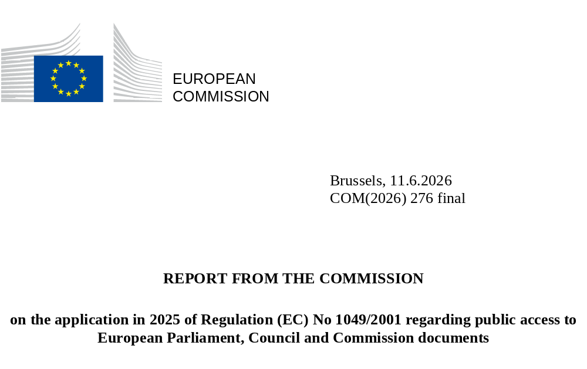

Table of Contents
1. Introduction 2
2. Making information and documents available online and in registers 3
3. Analysis of applications for access to documents 3
3.1. Number of applications (Annex – Tables 3 and 4) 3
3.2. Applications received by Directorate-General or Service (Annex – Table 5) 5
4. Exceptions to the right of access 6
4.1. Level of access granted to the documents requested (Annex – Tables 8 and 9) 6
4.2. Exceptions applied to the documents requested (Annex – Table 10) 7
5. Complaints to the European Ombudsman 8
6. New case-law on access to documents 8
6.1. The Court of Justice 8
6.1.1. Clarifications of substantive rules 9
6.2. The General Court 9
6.2.1. Clarifications of substantive rules 10
6.2.2. Clarifications of procedural rules 10
6.3. New Court cases introduced against the European Commission 10

Introduction
This annual report is drafted in accordance with Article 17(1) of Regulation (EC) No 1049/2001 regarding public access to European Parliament, Council and Commission documents (hereafter ‘Regulation (EC) No 1049/2001’). It explains how the European Commission implemented Regulation (EC) No 1049/2001 in 2025, based on statistical data summarised in the Annex. It also draws on the findings of the European Ombudsman on the European Commission’s implementation of Regulation (EC) No 1049/2001 and the rulings handed down by the EU courts.
Transparency, integrity, and accountability are the essential prerequisites of democracy based on the rule of law. They are key principles for promoting good governance and building trust in the decision-making process, thereby enhancing the legitimacy and credibility of public institutions. Further to the Political Guidelines for the next European Commission 2024-2029 of President Ursula von der Leyen, the general part of the mission letters to Commissioners commits the College to putting into practice the principles of openness and transparency in its relations with the co-legislators, interest representatives, and the public. Safeguarding citizens’ right of access to documents remains an integral part of the European Commission’s 2024-2029 priorities. The statistics in Chapter 4 on fully or partially disclosed documents demonstrate the European Commission’s commitment to enabling the public to exercise its right to access documents, as part of the European Commission’s broader transparency policy.
In the European Commission, initial applications for access to documents are handled on a decentralised basis by each Commission department. In 2025 there were 6 434 initial applications. The number of confirmatory applications, whereby applicants request a review of the initial replies partially or fully refusing access, reached 697.
Confirmatory applications are handled centrally by the Secretariat-General’s Unit for Document Management and Access to Documents, to ensure that the initial replies are independently reviewed. This Unit also manages EASE, the European Commission-wide IT system for handling applications for access to documents.
European Commission departments are supported by the Historical Archives Service (HAS), involved especially in cases where applications for access to documents relate to the archives of previous Commissioners and their Cabinets, or older documents which have been moved to the historical archives following the document management rules. In 2025, HAS provided assistance in 427 cases, mostly to the Secretariat-General (105) and the Directorates-General for: Climate Action (40); Internal Market, Industry, Entrepreneurship and SMEs (34); Health and Food Safety (25); Agriculture and Rural Development (24); Environment (24); and Justice and Consumers (22).

Making information and documents available online and in registers
The European Commission proactively publishes a wide range of legal, policy, administrative and other documents on different websites and registers. Many such documents are available in the Register of Commission documents (RegDoc), the Register of delegated and implementing acts and other corporate registers managed by the Secretariat-General. Others are available on websites managed by the Directorates-General or on EUR-Lex. Moreover, Article 3 of the Annex to the Commission’s Rules of Procedure, adopted on 4 December 2024, further enhances proactive transparency by listing categories of documents that shall be directly accessible to the public.
In 2025, 11 274 new documents were added to RegDoc (see Table 1 in the Annex), in the following categories: C – Commission autonomous acts, including delegated and implementing acts, other types of decisions etc.; COM – Commission proposals, recommendations, communications, reports etc.; JOIN – Commission and High Representative Joint Acts; OJ – Agendas of Commission meetings; P – Decisions by the President of the Commission; PV – Minutes of Commission meetings; SEC – Commission documents that cannot be classified in any of the other series; SWD – Commission staff working documents.
In 2025, the number of page views reached 16 159 for the Access to Documents website on Europa and 70 950 for RegDoc.

Analysis of applications for access to documents

Number of applications (Annex – Tables 3 and 4)
As stated above, 6 434 initial applications were made to access documents in 2025. The Commission provided 4 471 replies under Regulation (EC) No 1049/2001 and 6 408 replies in total. A single request can concern several documents held by different Commission departments and can consequently give rise to several different replies. Conversely, several requests can sometimes be grouped together, giving rise to a single reply. The number of other replies refers to replies given under different legal frameworks (due to the contents of the application or status of the applicant, etc.) or closures following an applicant’s failure to provide the clarification asked of them or to fulfil procedural requirements.

There were 697 confirmatory applications in 2025. The Commission provided 384 replies under Regulation (EC) No 1049/2001 and 681 replies in total.

Applications received by Directorate-General or Service (Annex – Table 5)
In 2025, the Directorate-General for Internal Market, Industry, Entrepreneurship and SMEs received the highest proportion of initial applications (14.3%). It was followed by the Secretariat-General (12.5%) and the Directorates-General for: Health and Food Safety (6.1%); Environment (5.7%); and Communications Networks, Content and Technology (5.6%). The remaining departments each accounted for less than 5% of all initial applications.

In 2025, the highest proportion of confirmatory applications was submitted in cases handled at the initial stage by the Directorate-General for Internal Market, Industry, Entrepreneurship and SMEs (12.9%). It was followed by the Directorate-General for Health and Food Safety (9.3%), the Secretariat-General (8%) and the Directorates-General for: Environment (7.3%); Communications Networks, Content and Technology (6.3%); and Migration and Home Affairs (5.6%). The remaining departments each accounted for less than 5% of all confirmatory applications.

Exceptions to the right of access
The right of access provided in Regulation (EC) No 1049/2001 is subject to several specific exceptions laid down in Article 4. Any decision to reject an application for access to a document, whether fully or partially, must be justified under at least one of these exceptions.

Level of access granted to the documents requested (Annex – Tables 8 and 9)

Exceptions applied to the documents requested (Annex – Table 10)

Complaints to the European Ombudsman
In 2025, the European Ombudsman opened 100 new inquiries in cases involving the European Commission where access to documents was the main or a subsidiary part of the complaint and closed 104 complaints. The European Ombudsman found instances of maladministration in eight cases only, representing 7.6% of all complaints. The remaining 96 cases were closed without remarks.

New case-law on access to documents

The Court of Justice
In 2025, the Court of Justice issued one judgment and one order on appeals concerning the right of public access to documents under Regulation (EC) No 1049/2001 where the European Commission was a party to the proceedings.
It dismissed the appeal in one case. In one case, it suspended the operation of point 2 of the operative part of the judgment of the General Court in Case T-761/21 until the delivery of the judgment closing the proceedings on the appeal in Case C-632/24 P, following the Commission’s request for interim measures.

Clarifications of substantive rules
In 2025, the substantive clarifications the Court of Justice issued revolved around the application of the exception relating to the protection of the decision-making process.

The General Court
In 2025, the General Court issued six judgments and 12 orders concerning the right of public access to documents under Regulation (EC) No 1049/2001 where the European Commission was a party to the proceedings.
The action for annulment was dismissed in two cases. In three cases, the General Court partially annulled the decision of the European Commission and dismissed the action as to the remainder. In two cases, it annulled the decision of the European Commission.
In five cases, it declared that there was no longer any need to adjudicate. In two cases, it ordered the removal of the case from the Register of the General Court. In one case, it dismissed the action partly because of the manifest lack of jurisdiction and partly as manifestly inadmissible. In one case, it refused an application for interim measures. In one case, it dismissed the action as inadmissible. In one case, it declared that there was no longer any need to adjudicate and dismissed the action as to the remainder.

Clarifications of substantive rules
In 2025, the substantive clarifications the General Court issued revolved around the application of exceptions relating to the protection of international relations, of commercial interests, and of the decision-making process.
The General Court further clarified the extraction and assessment of documents from databases and the presumption of veracity attached to the Commission’s declaration of non-possession of documents.

Clarifications of procedural rules
The main procedural issue the General Court clarified in 2025 concerned the Commission’s assessment of third parties’ objections to the disclosure of their documents.

New court cases brought against the European Commission
In 2025, 19 cases involving the European Commission were brought before the EU courts in relation to decisions concerning the right of public access to documents under Regulation (EC) No 1049/2001.
Of these 19 cases, 18 were brought before the General Court, three of which were adjudicated in 2025.
In parallel, one appeal was brought before the Court of Justice against a judgment issued by the General Court in a case where the European Commission was a party to the proceedings.

Regulation (EC) No 1049/2001 of the European Parliament and of the Council of 30 May 2001 regarding public access to European Parliament, Council and Commission documents; OJ L 145, 31.5.2001, p. 43.
Percentages are rounded to the nearest decimal place. The statistics include, among other things, the number of applications received and of replies given in 2025. The figures in this report and the previous ones may differ slightly as a result of regular checks and corrections.
https://commission.europa.eu/document/download/e6cd4328-673c-4e7a-8683-f63ffb2cf648_en
https://commission.europa.eu/about/organisation/college-commissioners_en
https://commission.europa.eu/priorities-2024-2029/democracy-and-our-values_en
Electronic AccesS to European Commission Documents; https://ec.europa.eu/transparency/documents-request/home
https://commission.europa.eu/about/service-standards-and-principles/transparency/how-access-commission-documents
https://eur-lex.europa.eu/
Commission Decision (EU) 2024/3080 of 4 December 2024 establishing the Rules of Procedure of the Commission and amending Decision C(2000) 3614 (OJ L, 2024/3080, 5.12.2024, ELI: http://data.europa.eu/eli/dec/2024/3080/oj).
https://commission.europa.eu/about/service-standards-and-principles/transparency/how-access-commission-documents
https://ec.europa.eu/transparency/documents-register/
Statistics on the social and occupational profile and geographical origin of applicants are given in Tables 6 and 7 in the Annex.
The Reform and Investment Task Force (SG REFORM) was created in February 2025 by merging the Recovery and Resilience Task Force (SG RECOVER) and the Directorate-General for Structural Reform Support (DG REFORM). The data for the European Anti-Fraud Office include applications for access to documents related to its administrative activities, recorded in the same IT system (EASE) as the one other European Commission departments use. This report does not cover applications for access to documents concerning OLAF’s investigative activities. The Directorate-General for Enlargement and Eastern Neighbourhood (DG ENEST) started operating in February 2025 after the Directorate-General for European Neighbourhood and Enlargement Negotiations (DG NEAR) was divided into DG ENEST and the Directorate-General for the Middle East, North Africa and the Gulf (DG MENA). Since the creation of the European External Action Service (EEAS), only documents of the Service for Foreign Policy Instruments (FPI) are held by the European Commission. Statistics on the FPI encompass some initial applications received by the European Peace Facility (EPF). The EPF is an off-budget instrument that enhances the EU’s ability to act as a global security provider. Under Commission Decision C(2021) 2011, the European Commission agreed to act as administrator, accounting officer and internal auditor for assistance measures of the EPF. Seven such initial applications and no confirmatory applications were submitted to the European Commission in its capacity as administrator for assistance measures in 2025.
Individual applications may concern several documents or entire files on a specific subject or procedure. The way EASE is designed means that the figures in Chapter 4 of this report reflect the documents requested in cases handled in EASE and closed in 2025.
The statistics cover European Ombudsman cases for all European Commission departments, except the European Anti-Fraud Office.
The Ombudsman considered that the delay in replying to the applicant amounted to maladministration in case 1249/2023 (https://www.ombudsman.europa.eu/en/case/en/64317). The Ombudsman concluded that the refusal to grant wide public access constituted maladministration in cases 2421/2023 (https://www.ombudsman.europa.eu/en/case/en/65469) and 849/2024 (https://www.ombudsman.europa.eu/en/case/en/66373). The Ombudsman considered that the Commission’s refusal to handle the complainant’s public access requests constituted maladministration in case 1634/2023 (https://www.ombudsman.europa.eu/en/case/en/64691). The Ombudsman considered that there was maladministration by the Commission in how it handled the public access requests in cases 1405/2024 (https://www.ombudsman.europa.eu/en/case/en/66916), 1498/2024 (https://www.ombudsman.europa.eu/en/case/en/67020), and 318/2025 (https://www.ombudsman.europa.eu/en/case/en/68195). The Ombudsman considered that the Commission’s use of a general presumption of non-disclosure constituted maladministration in case 1746/2024 (https://www.ombudsman.europa.eu/en/case/en/67261).
Judgment of 16 January 2025, Commission v Pollinis France, C-726/22 P, EU:C:2025:17.
Order of 4 February 2025, Commission v Courtois and Others, C-632/24 P-R, EU:C:2025:70.
Judgment in Commission v Pollinis France, C-726/22 P, op.cit.
Order in Commission v Courtois and Others, C-632/24 P-R, op.cit.
Judgment in Commission v Pollinis France, C-726/22 P, op.cit. Paragraphs 65, 71-74 and 78-79.
Judgments of 14 May 2025, Stevi and The New York Times v Commission, T-36/23, EU:T:2025:483; of 22 January 2025, eClear v Commission, T-127/23, EU:T:2025:51; of 3 September 2025, Huhtamaki Holding v Commission, T-225/24, EU:T:2025:830; of 14 May 2025, Smart Kid v Commission, T-227/24, EU:T:2025:488; of 18 June 2025, Zver v Commission, T-235/24, EU:T:2025:607; of 10 September 2025, Smart Kid v Commission, T-337/24, EU:T:2025:848.
Orders of 21 May 2025, APEDA and O'Connor v Commission, T-70/25; of 8 October 2025, WS v Commission, T-90/25, EU:T:2025:955; of 16 May 2025, Rizza v Commission, T-118/25; of 11 February 2025, Reverbel v Commission, T-178/24, EU:T:2025:173; of 18 September 2025, Onescu v OLAF, T-299/25; of 16 July 2025, Onescu v OLAF, T-299/25 R; of 7 January 2025, Compass-Datenbank v Commission, T-350/24, EU:T:2025:20; of 14 April 2025, Molitorisová v Commission, T-353/24; of 20 August 2025, APEDA and O'Connor v Commission, T-458/24; of 27 January 2025, Pech v Commission, T-485/24; of 16 June 2025, Reclaim and Martínez González v Commission, T-546/24; of 20 March 2025, Public.Resource.Org and Right to Know v Commission, T-580/24.
Judgment in Huhtamaki Holding v Commission, T-225/24, op.cit.; order in Onescu v OLAF, T-299/25, op.cit.
Judgments in eClear v Commission, T-127/23, op.cit.; Zver v Commission, T-235/24, op.cit.; Smart Kid v Commission, T-337/24, op.cit.
Judgments in Stevi and The New York Times v Commission, T-36/23, op.cit.; Smart Kid v Commission, T-227/24, op.cit.
Orders in WS v Commission, T-90/25, op.cit.; Reverbel v Commission, T-178/24, op.cit.; Compass-Datenbank v Commission, T-350/24, op.cit.; Pech v Commission, T-485/24, op.cit.; Reclaim and Martínez González v Commission, T-546/24, op.cit.
Orders in Rizza v Commission, T-118/25, op.cit.; Public.Resource.Org and Right to Know v Commission, T-580/24, op.cit.
Order in APEDA and O'Connor v Commission, T-70/25, op.cit.
Order in Onescu v OLAF, T-299/25 R, op.cit.
Order in Molitorisová v Commission, T-353/24, op.cit.
Order in APEDA and O'Connor v Commission, T-458/24, op.cit.
Judgment in Smart Kid v Commission, T-337/24, op.cit. Paragraphs 40-42, 49-54 and 61-67.
Judgments in Smart Kid v Commission, T-227/24, op.cit. Paragraphs 38-39, 46, 56-60, 64-66, 72-79 and 80-88; eClear v Commission, T-127/23, op.cit. Paragraphs 86-92.
Judgment in Zver v Commission, T-235/24, op.cit. Paragraphs 96-98 and 103-107.
Judgment in eClear v Commission, T-127/23, op.cit. Paragraphs 46-48, 76-77 and 101-102.
Judgment in Stevi and The New York Times v Commission, T-36/23, op.cit. Paragraphs 38-41, 45-48, 57-60, 67-68, 72-73, 79 and 81-85.
Judgment in Smart Kid v Commission, T-337/24, op.cit. Paragraphs 33-37.
Cases Public.Resource.Org and Right to Know v Commission, T-53/25; APEDA and O'Connor v Commission, T-70/25, op.cit.; WS v Commission, T-90/25; Rizza v Commission, T-118/25, op.cit.; Nouwen v Commission, T-132/25; De Capitani and Others v Commission, T-146/25; Rizza v Commission, T-205/25; Galić v Commission, T-276/25; Onescu v OLAF, T-299/25, op.cit.; Pakistan and Altius v Commission, T-360/25; Wölken v Commission, T-483/25; Access Info Europe v Commission, T-507/25; Mowi Poland v Commission, T-567/25; De Capitani v Commission, T-621/25; ClientEarth v Commission, T-641/25; Wölken v Commission, T-662/25; ClientEarth v Commission, T-738/25; Wölken v Commission, T-784/25.
Cases APEDA and O'Connor v Commission, T-70/25, op.cit.; Rizza v Commission, T-118/25, op.cit.; Onescu v OLAF, T-299/25, op.cit.
Case Molitorisová v Commission, C-396/25 P.

