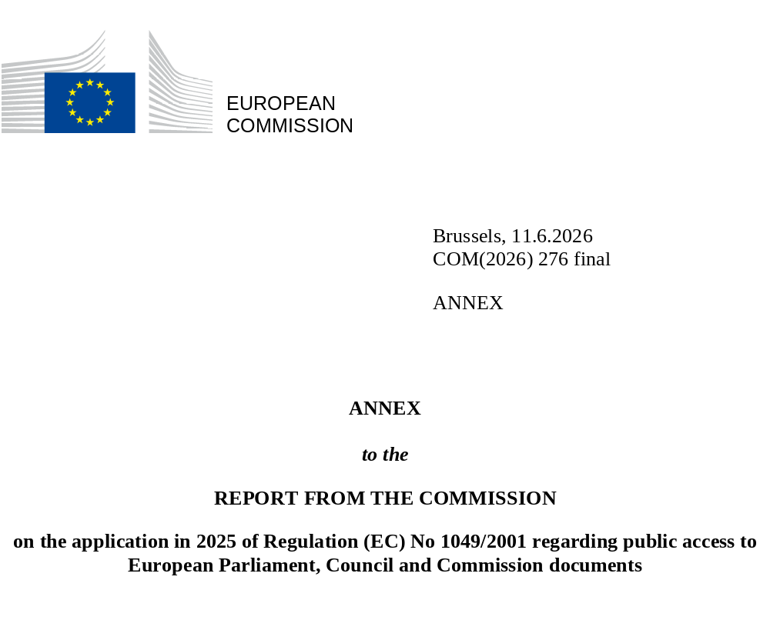

Statistics on the application of Regulation (EC) No 1049/2001
- Documents entered in the Register of Commission documents
 | C | COM | JOIN | OJ | P | PV | SEC | SWD | Total
2024 | 8 764 | 687 | 32 | 33 | 7 | 34 | 1 329 | 390 | 11 276
2025 | 8 376 | 1 091 | 44 | 39 | 14 | 38 | 1 145 | 527 | 11 274
- Page views of access-to-documents websites on Europa
 | ACCESS-TO-DOCUMENTS WEBSITE ON EUROPA | REGISTER OF COMMISSION DOCUMENTS
2025 | 16 159 | 70 950
- Initial applications received and handled
 | 2021 | 2022 | 2023 | 2024 | 2025
Applications registered | 8 420 | 7 410 | 7 274 | 6 938 | 6 434
Replies given based on Regulation (EC) No 1049/2001 | 8 280 | 7 503 | 6 469 | 5 542 | 4 471
Other replies | 861 | 1,146 | 1,268 | 1,321 | 1,937
- Confirmatory applications received and handled
 | 2021 | 2022 | 2023 | 2024 | 2025
Applications registered | 355 | 418 | 599 | 641 | 697
Replies given based on Regulation (EC) No 1049/2001 | 247 | 296 | 366 | 305 | 384
Other replies | 50 | 102 | 27 | 209 | 297
- Applications received by Directorate-General or Service
 | INITIAL STAGE  (%) |  |  | CONFIRMATORY STAGE (%)
 | 2024 | 2025 |  | 2024 | 2025
Secretariat-General – SG | 11.2 | 12.5 |  | 8.3 | 8.0
Reform and Investment Task Force – SG REFORM | 0 | 0.7 |  | 0 | 0.3
Legal Service – SJ | 1.8 | 2.5 |  | 1.4 | 1.7
Directorate-General for Communication – DG COMM | 0.5 | 0.4 |  | 0.2 | 0.1
Inspire, Debate, Engage and Accelerate Action – IDEA | 0.2 | 0.1 |  | 0.3 | 0
Directorate-General for Budget – DG BUDG | 0.8 | 1.4 |  | 0.8 | 0.9
Directorate-General for Human Resources and Security – DG HR | 1.1 | 2.0 |  | 2.3 | 3.4
Directorate-General for Digital Services – DG DIGIT | 0.4 | 1.0 |  | 0.2 | 0.6
Internal Audit Service – IAS | 0 | 0.1 |  | 0 | 0
European Anti-Fraud Office – OLAF | 0.3 | 0.4 |  | 0 | 0.3
Directorate-General for Economic and Financial Affairs – DG ECFIN | 1.2 | 1.1 |  | 0.6 | 1.1
Directorate-General for Internal Market, Industry, Entrepreneurship and SMEs – DG GROW | 10.5 | 14.3 |  | 8.3 | 12.9
Directorate-General for Defence Industry and Space – DG DEFIS | 0.7 | 1.5 |  | 1.1 | 1.3
Directorate-General for Competition – DG COMP | 4.2 | 4.8 |  | 5 | 4.9
Directorate-General for Employment, Social Affairs and Inclusion – DG EMPL | 1.8 | 1.3 |  | 2.5 | 2.0
Directorate-General for Agriculture and Rural Development – DG AGRI | 2.1 | 2.0 |  | 2.7 | 1.4
Directorate-General for Mobility and Transport – DG MOVE | 2.3 | 1.7 |  | 1.7 | 1.9
Directorate-General for Energy – DG ENER | 3 | 3.5 |  | 4.4 | 4.2
Directorate-General for Environment – DG ENV | 5.2 | 5.7 |  | 5 | 7.3
Directorate-General for Climate Action – DG CLIMA | 3.6 | 2.6 |  | 2 | 0.7
Directorate-General for Research and Innovation – DG RTD | 2.3 | 2.0 |  | 1.3 | 0.6
Directorate-General for Communications Networks, Content and Technology – DG CNECT | 8 | 5.6 |  | 8.4 | 6.3
Joint Research Centre – JRC | 0.3 | 0.4 |  | 0.2 | 0
Directorate-General for Maritime Affairs and Fisheries – DG MARE | 1.1 | 1.2 |  | 1.9 | 0.6
Directorate-General for Financial Stability, Financial Services and Capital Markets Union – DG FISMA | 3.1 | 2.5 |  | 3.7 | 2.2
Directorate-General for Regional and Urban Policy – DG REGIO | 0.9 | 1.2 |  | 0.5 | 0.9
Directorate-General for Structural Reform Support – DG REFORM | 0.2 | 0 |  | 0.5 | 0
Directorate-General for Taxation and Customs Union – DG TAXUD | 2.2 | 3.1 |  | 1.7 | 2.0
Directorate-General for Education, Youth, Sport and Culture – DG EAC | 0.8 | 0.8 |  | 0.5 | 0.6
Directorate-General for Health and Food Safety – DG SANTE | 6.9 | 6.1 |  | 9.8 | 9.3
Health Emergency Preparedness and Response Authority – HERA | 0.3 | 0.3 |  | 0.5 | 0.4
Directorate-General for Migration and Home Affairs – DG HOME | 4.2 | 3.4 |  | 4.7 | 5.6
Directorate-General for Justice and Consumers – DG JUST | 3 | 3.1 |  | 4.8 | 4.4
Directorate-General for Trade and Economic Security – DG TRADE | 3 | 3.6 |  | 1.9 | 3.3
Directorate-General for Enlargement and Eastern Neighbourhood – DG ENEST | 0 | 1.8 |  | 0 | 2.6
Directorate-General for the Middle East, North Africa and the Gulf – DG MENA | 0 | 1.1 |  | 0 | 2.2
Directorate-General for European Neighbourhood and Enlargement Negotiations – DG NEAR | 5.4 | 0.1 |  | 8.4 | 0.9
Directorate-General for International Partnerships – DG INTPA | 5.2 | 1.9 |  | 2 | 1.6
Directorate-General for European Civil Protection and Humanitarian Aid Operations – DG ECHO | 0.6 | 0.5 |  | 0.3 | 0.3
Eurostat – ESTAT | 0.3 | 0.2 |  | 0.3 | 0.1
Directorate-General for Interpretation – DG SCIC | 0 | 0.1 |  | 0 | 0
Directorate-General for Translation – DGT | 0.1 | 0.1 |  | 0 | 0
Publications Office of the European Union – OP | 0.1 | 0.2 |  | 0 | 0.3
Service for Foreign Policy Instruments – FPI | 0.6 | 0.5 |  | 0.2 | 0
Office for the Administration and Payment of Individual Entitlements – PMO | 0.3 | 0.3 |  | 0.3 | 0.7
Office for Infrastructure and Logistics in Brussels – OIB | 0.4 | 0.2 |  | 0 | 0.1
Office for Infrastructure and Logistics in Luxembourg – OIL | 0 | 0 |  | 0 | 0
European Personnel Selection Office – EPSO | 0.2 | 0.4 |  | 1.6 | 2.0
Total (%) | 100 | 100 |  | 100 | 100
- Social and occupational profile of applicants
 | INITIAL STAGE  (%) |  |  | CONFIRMATORY STAGE  (%)
 | 2024 | 2025 |  | 2024 | 2025
Academic institution/think tank | 11.6 | 9.9 |  | 9.5 | 6
Company/business association | 15.3 | 10.7 |  | 7.2 | 7
Journalist | 15.1 | 15.2 |  | 20.1 | 21.1
Law firm/self-employed attorney | 6.5 | 7.1 |  | 7.6 | 11.2
MEP/assistant MEP | 0.5 | 0.6 |  | 0.5 | 2.7
Non-governmental organisation (NGO) | 9.9 | 8.3 |  | 22.8 | 17.8
Member States under Regulation (EC) No 1049/2001 | 0.7 | 2.5 |  | 0 | 0
(Sub)national authority | 0.2 | 0.3 |  | 0.2 | 0.3
Not specified (citizens) | 22.5 | 26.3 |  | 25.9 | 28.7
Unknown | 17.8 | 19.3 |  | 6.2 | 5.2
Total (%) | 100 | 100 |  | 100 | 100
- Geographical origin of applicants
 | INITIAL STAGE  (%) |  |  | CONFIRMATORY STAGE  (%)
 | 2024 | 2025 |  | 2024 | 2025
Belgium | 24.2 | 11 |  | 24.7 | 13.6
Bulgaria | 0.4 | 0.8 |  | 0.8 | 1.6
Czech Republic | 0.7 | 0.9 |  | 0.3 | 3
Denmark | 2.1 | 2.8 |  | 0.9 | 2.7
Germany | 16.7 | 18.2 |  | 15.6 | 10.8
Estonia | 0.1 | 0.1 |  | 0.2 | 0.1
Ireland | 2.6 | 4.6 |  | 5.9 | 4
Greece | 1.4 | 2 |  | 4.7 | 1.4
Spain | 10.8 | 7.9 |  | 6.1 | 14.8
France | 9.1 | 8.4 |  | 5.6 | 7
Croatia | 0.3 | 0.2 |  | 0.2 | 0
Italy | 6.2 | 8.7 |  | 8 | 7.9
Cyprus | 0 | 0.1 |  | 0 | 0.1
Latvia | 0.1 | 0.2 |  | 0 | 0
Lithuania | 0.2 | 0.3 |  | 0 | 0.3
Luxembourg | 0.8 | 0.4 |  | 0 | 0.4
Hungary | 0.5 | 1.8 |  | 1.7 | 0.7
Malta | 0.8 | 0.2 |  | 0.6 | 0.1
The Netherlands | 5.7 | 4.8 |  | 9.8 | 9.8
Austria | 1.4 | 1.5 |  | 0.9 | 0.9
Poland | 2.3 | 4.2 |  | 2 | 3.4
Portugal | 1.1 | 0.7 |  | 1.9 | 0.3
Romania | 0.7 | 2.9 |  | 0.3 | 1.2
Slovenia | 0.2 | 0.3 |  | 0 | 0.1
Slovakia | 0.4 | 0.6 |  | 0.2 | 0.1
Finland | 0.9 | 1.4 |  | 1.1 | 1.6
Sweden | 1.6 | 1.7 |  | 0.8 | 1.9
Non-EU countries | 8.8 | 13.5 |  | 7.7 | 12.1
Total (%) | 100 | 100 |  | 100 | 100
- Level of access granted to the documents requested at the initial stage
 | 2025
 | No | %
Full access | 5 198 | 28.5
Partial access | 8 891 | 48.7
Access refused | 4 150 | 22.8
Total | 18 239 | 100
- Level of access granted to the documents requested at the confirmatory stage
 | 2025
 | No | %
Full revision – full access | 250 | 19.5
Partial revision – partial access | 594 | 46.3
Confirmation of initial reply – no (further partial) access | 440 | 34.3
Total | 1 284 | 100
- Exceptions applied to the documents requested
Exceptions laid down in Article 4 of Regulation (EC) No 1049/2001 | INITIAL STAGE (2025) |  |  | CONFIRMATORY STAGE (2025)
 | No | % |  | No | %
4(1)(a)1. – public security | 1 109 | 6.1 |  | 67 | 3.8
4(1)(a)2. – defence and military matters | 361 | 2 |  | 2 | 0.1
4(1)(a)3. – international relations | 1 018 | 5.6 |  | 74 | 4.2
4(1)(a)4. – financial, monetary or economic policy of the EU or a Member State | 149 | 0.8 |  | 9 | 0.5
4(1)(b) – privacy and the integrity of the individual | 9 947 | 54.6 |  | 760 | 42.8
4(2)1. – commercial interests | 2 522 | 13.9 |  | 158 | 8.9
4(2)2. – court proceedings and legal advice | 432 | 2.4 |  | 179 | 10.1
4(2)3. – purpose of inspections, investigations and audits | 1 456 | 8 |  | 381 | 21.5
4(3)1. – ongoing decision-making process | 1 010 | 5.5 |  | 123 | 6.9
4(3)2. – closed decision-making process | 205 | 1.1 |  | 21 | 1.2
Total | 18 209 | 100 |  | 1 774 | 100

C – Commission autonomous acts, including delegated and implementing acts, other types of decisions etc.; COM – Commission proposals, recommendations, communications, reports etc.; JOIN – Commission and High Representative Joint Acts; OJ – Agendas of Commission meetings; P – Decisions by the President of the Commission; PV – Minutes of Commission meetings; SEC – Commission documents that cannot be classified in any of the other series; SWD – Commission staff working documents.
https://commission.europa.eu/about/service-standards-and-principles/transparency/how-access-commission-documents
https://ec.europa.eu/transparency/documents-register/
The Reform and Investment Task Force (SG REFORM) was created in February 2025 by merging the Recovery and Resilience Task Force (SG RECOVER) and the Directorate-General for Structural Reform Support (DG REFORM).
The data for the European Anti-Fraud Office include applications for access to documents related to its administrative activities, recorded in the same IT system (EASE) as the one other European Commission departments use. This report does not cover applications for access to documents concerning OLAF’s investigative activities.
The Directorate-General for Enlargement and Eastern Neighbourhood (DG ENEST) started operating in February 2025 after the Directorate-General for European Neighbourhood and Enlargement Negotiations (DG NEAR) was divided into DG ENEST and the Directorate-General for the Middle East, North Africa and the Gulf (DG MENA).
Since the creation of the European External Action Service (EEAS), only documents of the Service for Foreign Policy Instruments (FPI) are held by the European Commission. Statistics on the FPI encompass some initial applications received by the European Peace Facility (EPF). The EPF is an off-budget instrument that enhances the EU’s ability to act as a global security provider. Under Commission Decision C(2021) 2011, the European Commission agreed to act as administrator, accounting officer and internal auditor for assistance measures of the EPF. Seven such initial applications and no confirmatory applications were submitted to the European Commission in its capacity as administrator for assistance measures in 2025.
Member State authorities is a category created in 2018 to reflect the fact that national authorities of Member States are entitled to submit applications for access to documents under Regulation (EC) No 1049/2001. Since the EASE application was created in September 2022, the social/occupational category field has become optional when submitting a request using the portal. This has resulted in the ‘Unknown’ category for applicants who left the social/occupational category blank.
These statistics cover the individual exceptions made to (partially) protect the documents access to which was requested based on Article 4 of Regulation (EC) No 1049/2001. Since the exceptions can be cumulative, some documents were counted more than once.

