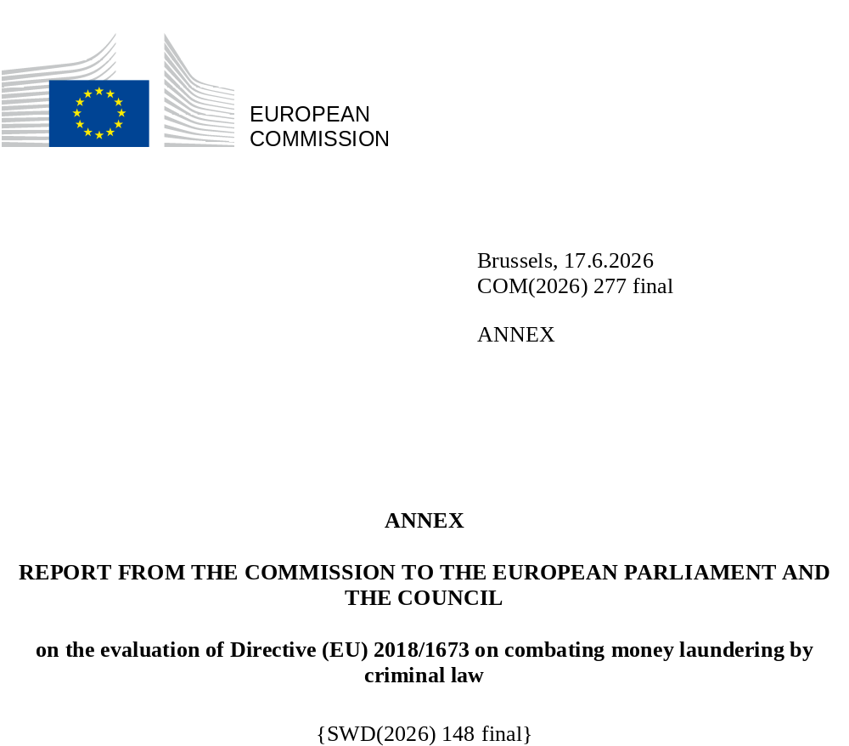

REPORT FROM THE COMMISSION TO THE EUROPEAN PARLIAMENT AND THE COUNCIL

assessing the extent to which the Member States have taken the necessary measures to comply with Directive (EU) 2018/1673 of the European Parliament and of the Council of 23 October 2018 on combating money laundering by criminal law

INTRODUCTION

Directive 2018/1673 on combating money laundering by criminal law (hereafter ‘the Directive’) entered into force on 2 December 2018. The 25 EU Member States bound by the Directive (i.e. all except Denmark and Ireland) had to bring into force the laws, regulations and administrative provisions necessary to comply with this Directive by 3 December 2020.

In line with Article 14(1) of the Directive this report assesses the extent to which the Member States have taken the necessary measures to comply with the Directive. The current report is submitted as annex to the report pursuant to Article 14(2) of the Directive assessing the added value of the Directive.

This analysis is based on information provided by the Member States to the European Commission until 20 October 2025, as well as on an external study.

The Directive sets out common definitions of criminal offences and sanctions across EU Member States aimed at combating money-laundering, in order to facilitate police and judicial cooperation and prevent criminals from exploiting less stringent national systems. As the laundering of illicit proceeds constitutes a core enabler of organised crime, the Directive helps to weaken the financial base of criminal networks and supports efforts to dismantle them. It requires Member States to criminalise, when committed intentionally, the conversion or transfer of property known to come from criminal activity, the concealment or disguise of the true nature, source, location, movement or ownership of that property, and the acquisition, possession or use of such property. The Directive also allows Member States to extend the offence of money-laundering to cases where the offender “suspected or ought to have known” that the property derived from criminal activity. It obliges Member States to introduce aggravating circumstances (e.g., involvement of a criminal organisation, or laundering via professional activities) and requires penalties to be effective, proportionate and dissuasive, including a minimum maximum imprisonment term of at least four years and, where relevant, legal-entity liability measures. It contains rules on jurisdictions and the obligation to freeze and confiscate proceeds and instrumentalities and obliges Member States to ensure that effective investigative tools for the investigation of money laundering are in place.

The report indicates that Member States have made considerable efforts to ensure the alignment of national laws with the provisions of the Directive, with some apparent inconsistencies and gaps by a limited number of Member States.

Beyond the analysis provided by this report on the basis of the information made available to the Commission to-date, there may be further challenges in transposition and other provisions not reported to the Commission or further legislative and non-legislative developments that affect transposition. Therefore, this report should not prevent the Commission from further assessing transposition and implementation of the Directive in the Member States.

COMPLIANCE OF TRANSPOSITION OF THE DIRECTIVE BY PROVISION

This chapter reviews the transposition of the Directive by Member States into national law, assessing article by article the completeness and conformity of national laws and regulations with the requirements of the Directive.

Article 2 – Definitions (including predicate offences)

Article 2 contains three definitions. Article 2(1) defines “criminal activity” as all offences punishable by a maximum term of at least one year of imprisonment, or, where no maximum penalty is prescribed, all offences punishable by a minimum term of more than six months of imprisonment. The offences constituting criminal activity shall be considered as predicate offences for money laundering, i.e. Member States shall criminalise the laundering of property derived from these offences, as a minimum.

In addition, irrespective of the penalty thresholds, Member States are in any case required to include a range of offences within each of the 22 categories of offences listed in Article 2(1), (these include the offences harmonised at EU level).

A large majority of Member States bound by the Directive have gone beyond it by adopting a so-called “all-crime approach”, whereby any criminal offence can constitute a predicate offence to money laundering. Five Member States (France, Netherlands, Luxemburg, Portugal, Austria) designate specific categories of criminal offences that can represent predicate offences to money laundering.
All Member States have correctly transposed the definition of criminal activity as laid down in Article 2(1).

Article 2(2) provides for a broad definition of ‘property’ that can be a suitable object of a money laundering offence. In this regard, property is defined as assets of any kind, whether corporeal or incorporeal, movable or immovable, tangible or intangible, and legal documents or instruments in any form, including electronic or digital, evidencing title to, or an interest in, such assets. While Member States have not specifically transposed the term property in their money laundering legislation, they often foresee definitions in other legal texts, which are used also for the purposes of defining the objects of money laundering ensuring compliance with the provision.

While 23 Member States have transposed the definition of property as laid down in Article 2(2), it appears that the legislation in Germany and Austria does not consider saved expenses (such as taxes withheld through committing a tax crime) as property that can be laundered. Essentially, Section 165 para. 6 of the Austrian Criminal Code excludes mere savings such as unrealised losses that did not occur, waivers of claims or avoided expenses and charges from the scope of money laundering. This prevents Austrian authorities from applying a money laundering offence in the case of money saved by unlawfully not paying taxes and then laundered. In the old version of Section 261 para. 5 of the German Criminal Code, expenses saved through tax evasion were explicitly included in the scope of money laundering. With a reform in 2021 this paragraph was deleted, consequently excluding such saved expenses from the scope. Therefore, both jurisdictions seem to consider that only property that represents a positive increase of a person’s assets, e.g. money gained through a drug trafficking offence or a tax rebate, can be object of a laundering offence. However, the broad definition of property in the Directive covers all types of property, including saved expenses even if not explicitly mentioned.

Article 2(3) defines “legal person” as any entity having legal personality under the applicable law, except for states or public bodies in the exercise of state authority and for public international organisations. In similar fashion as with the term “property”, many Member States define “legal person” in other pieces of legislation, which also apply for the purpose of money laundering offences. This is compliant with the Directive.

Article 3 – Money laundering offences

Article 3(1) requires Member States to criminalise (a) the conversion or transfer of property, (b) the concealment or disguise of various features of the property, and (c) the acquisition, possession, or use of property, to the extent that the perpetrator of such acts knows that such property is derived from criminal activity.

Member States have transposed this provision in different ways. Seven Member States (Bulgaria, Czech Republic, Greece, Finland, Hungary, Poland, and Romania) have transposed the element of intent indirectly by relying on general criminal law principles that establish that an offence is characterised only if the element of intent is present. The remaining Member States have explicitly included the element of intent in the national provisions criminalising money laundering.

Article 3(2) provides Member States with the option to further criminalise money laundering when the offender did not know but suspected or ought to have known that the property was derived from criminal activity (negligent money laundering). 15 Member States made use of this option, criminalising negligent money laundering.

Considering that complex money laundering schemes make it hard to prove the predicate offence, the Directive also intends to remove practical and legal barriers for the prosecution of money laundering as a stand-alone offence. To do so, it obliges Member States to enable the prosecution and conviction for money laundering without requiring a conviction for the predicate offence (Article 3(3)(a)), and without requiring authorities to prove all the elements of the predicate offence (which could include the identity of the perpetrator of the criminal activity from which the property was derived)(Article 3(3)(b)). This is hereafter referred to as ‘stand-alone money laundering’.

Sixteen Members States have not transposed the provision explicitly but through ‘implied transposition’, i.e. by not mentioning expressly in their national legislation on money laundering that conditions such as a prior or simultaneous conviction for the predicate offence or the establishment of all facts and circumstances of the predicate offence must be fulfilled.

The Commission notes that the threshold for proving the illicit origin of the property in court differs considerably among Member States.

In fourteen Member States, it is not necessary to specify the type of the predicate offence, when proving the illicit origin of the property. Rather, it is sufficient to establish that the laundered property originates from a criminal activity that has been committed, which significantly facilitates the prosecution of money laundering.

However, courts in a number of Member States still impose high standards for proving the existence of a predicate offence. Ten Member States still require authorities to identify the category of offence to which the predicate offence belongs (e.g. drug trafficking, trafficking in human beings, fraud etc.). Among these, two Member States (Bulgaria and Poland) require a specifically high threshold of proof regarding the predicate offence. Bulgaria still requires proving the type of criminal offence, and the time and place of its commission. In Poland, case law requires to establish that specific assets were derived from a specific predicate offence in a sufficiently specific way.

As also indicated in the evaluation report, the wording of the Directive is very broad, allowing for such transposition. The Directive requires that a conviction for money laundering is possible “without it being necessary to establish all the factual elements or all circumstances” of the predicate offence, but such a wording means that legislation can still require authorities to prove all elements of the predicate offence except one.

Taking into account this wide margin that the Directive provides for Member States, as regards Article 3(3)(a) and (b) no case of non-compliance has been identified.

All Member States transposed in a compliant manner that money laundering offences extend to property derived from conduct in another Member State or non-EU country, where the conduct would constitute a predicate offence had it occurred domestically (Article 3(3)(c)).

For proportionality reasons, Article 3(4) gives Member States the option to narrow down the scope of cross-border cases where money laundering is punishable, i.e. when the predicate offence took place in countries where such conduct is not criminalised (requirement of “double criminality”). For certain categories of serious offences, however, such possibility to narrow down the cross-border scope is not available. In cases of participation in an organised criminal group, terrorism, trafficking in human beings, migrant smuggling, sexual exploitation, drug trafficking and corruption, committed in another EU Member State or third country, it must still be possible to prosecute a person for money laundering even if the conduct that generated the money does not constitute a criminal offence in that other country.

Eight Member States made use of the option to require “double criminality”. However, Luxemburg requires double criminality for some of the offences for which such a principle should not be applied, namely the participation in a criminal organisation and racketeering. .

Finally, Member States must ensure that the conducts being criminalised as money laundering in Article 3(1)(a) and (b) are punishable in case of “self-laundering” (Article 3(5)), meaning a case where the person who committed or was involved in the commission of the predicate offence is laundering the proceeds of its own crime.

Member States implemented this provision expressly in their national legislation or implicitly by not making it a condition that the perpetrator of the predicate offence is distinct from the perpetrator of the money laundering offence. Some Member States included exceptions in their national legislation that do not affect compliance, e.g. Germany requires that the illegal assets are somehow brought into circulation, and Italy and Estonia exclude the use for personal enjoyment from the scope. Therefore, no case of non-conformity has been identified.

Article 4 – Aiding and abetting, inciting and attempting

Article 4 requires that ancillary offences, i.e. aiding and abetting, inciting someone to commit a money laundering offence and attempting a money laundering offence, must be punishable as a criminal offence.

All 25 Member States transposed Article 4 correctly.

Article 5 – Penalties for natural persons

Article 5 requires that money laundering offences and ancillary offences are punishable by effective, proportionate, and dissuasive criminal penalties, specifying that money laundering offences must be punishable by a maximum term of imprisonment of at least four years.

In this regard, the Commission notes that Sweden has set in its legislation a maximum of two years, while Greece seems not to have followed the four years threshold if the predicate offence is a misdemeanor, which in practice means that the penalty for money laundering is not sufficiently high for a wide range of the predicate offences established in the Directive.

Article 6 – Aggravating circumstances

Article 6(1) establishes two mandatory aggravating circumstances: when money laundering is committed within a criminal organisation or when it is committed in the course of the professional activities of an “obliged entity”, meaning an entity subject to specific reporting and customer verification obligations under the EU’s anti-money laundering legislation.

In this regard, it should be noted that Lithuania, Poland and Slovenia have not introduced in their legislation the aggravating circumstance money laundering being committed by an obliged entity; Cyprus does not provide for aggravating circumstances for aiding, abetting, inciting, and attempting money laundering; Greece cannot apply aggravating circumstances where the predicate offence is a misdemeanour, which in practice excludes a wide range of the predicate offences established in the Directive.

Article 6(2) offers Member States the possibility to introduce two additional aggravating circumstances, (a) when the laundered property is of considerable value or (b) when the laundered property was derived from a set of specific offences. Option (a) was transposed by 14 Member States, option (b) by four Member States.

All Member States that used the options transposed them in a manner compliant with the Directive.

Article 7 – Liability of legal persons

According to the Directive it must be possible to hold legal persons liable for money laundering offences, including self-laundering. This includes actions by any person, acting either individually or as part of an organ of the legal person, and having a leading position within that entity (Article 7(1)). Member States also need to ensure that legal persons can be held liable where lack of supervision or control has made the commission of the offence possible (Article 7(2)). Liability of legal persons should however not exclude the possibility of bringing criminal proceedings against natural persons involved as perpetrators in the commission of the offences (Article 7(3)).

With regard to the liability of legal persons, France has not introduced in its legislation the possibility to hold legal persons liable when the money laundering offences were possible due to the lack of supervision or control by a person in leading position within that entity.

Article 8 – Sanctions for legal persons

Article 8 requires Member States to ensure that a legal person held liable pursuant to Article 7 is punishable by effective, proportionate, and dissuasive sanctions including, in any case, criminal or non-criminal fines. All Member States have transposed this provision in a compliant manner.

In addition, Article 8 lists options for further sanctions, from excluding the legal entity from public benefits or aid, to the exclusions from access to public funding, the disqualification from the practice of commercial activities, placing the entity under judicial supervision, the closure of establishments used for committing the offence and even the possibility for a judicial order to dissolve the company (i.e. winding-up). 19 Member States have made use of one or more of these options. Six Member States have not used any of the options at all.

All Member States that used these options have transposed them in a manner compliant with the Directive.

Article 9 – Confiscation

Article 9 requires Member States to ensure, as appropriate, that national competent authorities freeze or confiscate the proceeds derived from, and instrumentalities used or intended to be used in the commission or contribution to the commission of the money laundering offences as referred to in this Directive in accordance with the confiscation Directive 2014/42/EU.

All 25 Member States transposed Article 9 in compliance with the Directive.

Article 10 – Jurisdiction

Article 10(1) requires a Member State to establish its jurisdiction over money laundering offences, when the offence is committed on their territory (Article 10(1)(a)), or when the offender is one of their nationals (Article 10(1)(b)). All Member States have transposed the provision in compliance with the Directive.

As regards Article 10(1)(b), it should be noted that specifically in the instance where the offender is a national of the Member State, the provision has been transposed in a divergent manner, particularly with respect to the requirement of double criminality.
In the absence of a specific provision addressing this matter, 10 Member States seem to have implemented the Directive without explicitly stipulating double criminality as a precondition for the assertion of jurisdiction. Conversely, 11 Member States have expressly incorporated the aforementioned requirement as a condition for establishing jurisdiction over their nationals. Meanwhile, three Member States have explicitly excluded the double criminality requirement for money laundering offences.

Article 10(2) allows Member States to extend their jurisdiction to cases when (a) the offender is a habitual resident on their territory, or (b) when the offence was committed for the benefit of a legal person established on their territory. 14 Member States have made use of the option under Article 10(2)(a). Ten Member States have made use of the option under Article 10(2)(b) in a compliant manner.

Article 11 – Investigative tools

Article 11 requires that effective investigative tools, such as those used in organised crime or other serious crime cases, are available to the persons, units, or services responsible for investigating or prosecuting money laundering offences, including their aiding, abetting, inciting and attempt. All 25 Member States transposed Article 11 in compliance with the Directive.

CONCLUSIONS

Given the importance of money laundering for organised crime networks as a crucial financing tool, and as a mean to secure illicit gains and to infiltrate the legal economy, the harmonisation of the criminal law response to money laundering is an essential component in the Union’s broader efforts to disrupt and dismantle criminal networks, as highlighted in the European Internal Security Strategy ProtectEU.
The Commission acknowledges the efforts made by Member States to take measures to comply with the Directive. Although some inconsistencies and gaps remain, in sum the transposition of the Directive has been broadly compliant, with Member States taking comprehensive measures to align national laws with EU standards. Most Member States have adopted specific legislation to meet the requirements of the Directive, while a few relied completely or to a large extent on existing national provisions.
To ensure full and correct transposition of the Directive the Commission will continue to support the Member States to address identified deficiencies. This includes monitoring and ensuring that national measures comply with the provisions in the Directive.

When this report refers to “25 Member States” or any other number of Member States, this implies that these are Member States bound by the Directive.
See recital 5.
Belgium, Cyprus, Czech Republic, Germany, Spain, Finland, Croatia, Hungary, Latvia, Malta, Netherlands, Poland, Sweden, Slovenia, and Slovakia
Belgium, Bulgaria, Czech Republic, Estonia, Finland, France, Croatia, Hungary, Italy, Netherlands, Poland, Portugal, Romania, Sweden, Slovenia, and Slovakia.
Austria, Belgium, Spain, France, Italy, Luxemburg, Latvia, Lithuania, Malta, the Netherlands, Romania, Sweden, Slovakia, and Slovenia.
Bulgaria, Croatia, Cyprus, Czechia, Germany, Estonia, Greece, Hungary, Poland, and Portugal
Art. 253 Bulgarian criminal code.
Supreme Court ruling on Art. 299 § 1 criminal code.
Austria, Germany, Estonia, Greece, Finland, Hungary, Luxemburg, and Portugal.
Art. 506-3(2) code pénal, in combination with Article 5-1 Code de procédure pénale.
Lag (2014:307) om straff för penningtvättsbrott, 3 §.
Article 39(1)(d), L. 4557/2018.
See in particular Article 2(1) of Directive (EU) 2015/849 of the European Parliament and of the Council of 20 May 2015 on the prevention of the use of the financial system for the purposes of money laundering or terrorist financing, OJ L 141, 5.6.2015, pp. 73–117, latest consolidated version available under: EUR-Lex - 02015L0849-20241230 - EN - EUR-Lex
Part I §4(4). L. 188(I)/2007.
Article 39(1)(d), L. 4557/2018.
Participation in an organised criminal group or racketeering, terrorism, trafficking in human beings and migrant smuggling, sexual exploitation, illicit trafficking of narcotic drugs, and corruption.
Austria, Bulgaria, Cyprus, Czech Republic, Estonia, Greece, Finland, Croatia, Hungary, Latvia, Poland, Sweden, Slovenia, and Slovakia.
Greece, Span, Finland, and Croatia.
Belgium, Cyprus, Czech Republic, Germany, Greece, Spain, France, Croatia, Hungary, Italy, Lithuania, Luxemburg, Latvia, Malta, Poland, Portugal, Romania, Slovenia, and Slovakia.
See recital 16 of the CMLD Directive: “[…] Member States should, as a minimum, ensure the freezing and confiscation of the instrumentalities and proceeds of crime in all cases provided for in Directive 2014/42/EU. Member States should also strongly consider enabling confiscation in all cases where it is not possible to initiate or conclude criminal proceedings, including in cases where the offender has died.”.
That is the principle whereby jurisdiction can only be established where the conduct in question is criminalised both in the prosecuting state and in the state in which it was committed.
Bulgaria, Czechia, Italy, Latvia, Hungary, Malta, Poland, Slovenia, Slovakia, Finland.
Belgium, Germany, Estonia, Spain, France, Croatia, Cyprus, Lithuania, Luxembourg, Austria, Sweden.
Greece, The Netherlands, Romania.
Austria, Belgium, Estonia, Spain, Finland, Croatia, Lithuania, Luxemburg, Latvia, Malta, the Netherlands, Portugal, Sweden, and Slovakia.
Austria, Czech Republic, Estonia, Greece, Spain, Luxemburg, Latvia, Poland, Slovenia, and Slovakia.
See also recital 19: “It should thereby be ensured that sufficient personnel and targeted training, resources and up-to-date technological capacity are available. […].”
EUR-Lex - 52025DC0148 - EN - EUR-Lex

