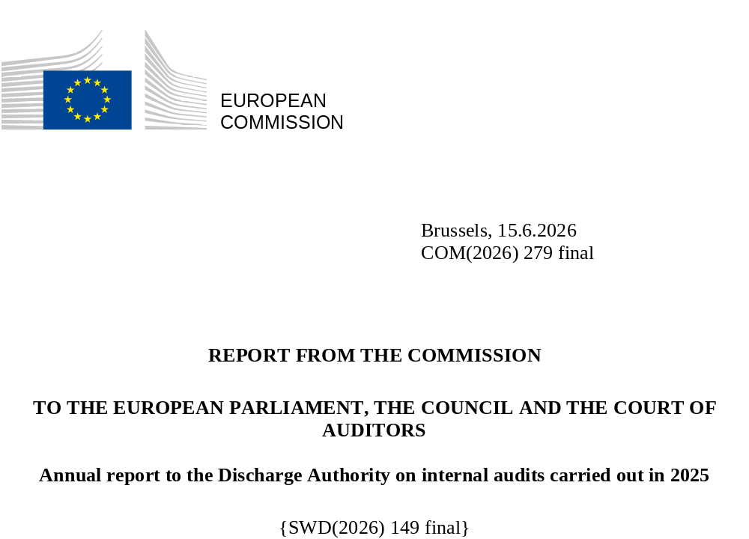

Table of contents
Objective and scope of the report 2
The Internal Audit Service 2
Overview of the audit work 4
Overall results based on the audit work performed in 2025 6
Overall results on performance 6
Overall conclusion on the Commission’s financial management 9
Actions taken by auditees 11
Consultation with the Commission’s financial irregularities panel 12

Objective and scope of the report
This report informs the European Parliament and the Council about internal audits carried out in 2025 by the European Commission’s Internal Audit Service in 51 organisational entities: directorates-general, services, EU offices, and executive agencies (). It is an input to the discharge procedure and contains: (a) a summary of the number and type of internal audits carried out; (b) a synthesis of the principal recommendations made; and (c) the actions taken on those recommendations. In accordance with Articles 118(8) and 253 of the Financial Regulation (), the Commission is forwarding the report to the European Parliament and to the Council. It is based on the report drawn up in accordance with Article 118(4) of the Financial Regulation by the Commission’s Internal Auditor on Internal Audit Service audits and other engagement reports completed in 2025 ().
Furthermore, as required by Article 118(5) of the Financial Regulation, the report focuses on the overall compliance with the principles of sound financial management and performance by providing the overall results on performance and an overall conclusion on financial management (Section 4) () and highlights any systemic problems detected by the Commission’s financial irregularities panel (Section 5).

The Internal Audit Service
The Internal Audit Service is an independent service in the Commission and is led by the Commission’s Internal Auditor.
Under its mandate stemming from the Financial Regulation, the Internal Auditor advises the Commission on dealing with risks, by assessing:
- the suitability and effectiveness of internal management systems;
- the performance of departments in implementing policies, programmes and actions;
- the efficiency and effectiveness of the control and audit systems applicable to all budget implementation operations.
The mission of the Internal Audit Service is to strengthen the Commission's ability to create, protect, and sustain public value – as a modern, accountable and performance-oriented institution – by providing independent, risk-based, and objective assurance, advice, insight, and foresight.

To this end, the Internal Audit Service provides:
- independent assessments of the effectiveness of the governance, risk management, and control processes for operations, activities and financial transactions (‘assurance services’); and
- advice, insight and foresight (‘non-assurance services’).
The main deliverables are internal audit reports that contain independent opinions on the quality of management and control systems as well as recommendations for improving operations and promoting sound financial management.
In 2025, the Commission adopted a recast mission charter (), marking a significant update to the Internal Audit Service's legal and operational framework. The Charter ensures full alignment with the 2024 recast Financial Regulation and the new Global Internal Audit Standards (). By guaranteeing the Internal Auditor’s independence and granting full and unlimited access to the information and personnel required for their work, the Charter provides the necessary safeguards for the service to operate effectively. The 2021 external quality assessment, which is valid for five years, confirmed the Internal Audit Service’s conformance with the Standards and the Code of Ethics in force at that time.
The Internal Audit Service adopted its 2025-2029 Audit Strategy in 2025. This is aligned with the Commission's new political mandate and aims to drive improved performance and accountability in the Commission and other EU entities, as well as to provide value-added services to stakeholders.
In conformance with Article 8(2) of the mission charter, the Internal Auditor fulfils a number of annual reporting obligations to the Audit Progress Committee. The Audit Progress Committee assists the College in fulfilling its obligations under the Treaties, the Financial Regulation and other statutory instruments. Its role, which is established under Article 123 of the Financial Regulation, is to ensure the independence of the Internal Audit Service, monitor the quality of the internal audit work and ensure that recommendations are taken into account and followed up by the Commission, its executive agencies and other bodies.
In her annual declaration to the Audit Progress Committee, the Internal Auditor confirmed that the Internal Audit Service preserved full organisational independence in 2025 and was free from interference or limitations in the conduct of its audit work; and that there were no impairments to individual objectivity in fact or in appearance.
The Internal Auditor ensured that the resources available in 2025 were sufficient and were effectively deployed to optimise the achievement of the approved internal audit plan. The resources had an appropriate mix of knowledge, skills and other competences.
The Internal Audit Service does not audit Member States’ systems of control over EU funds. Such audits reach down to the level of individual beneficiaries, and are carried out by Member States’ internal auditors, national audit authorities, other Commission directorates-general and the European Court of Auditors. However, the Internal Audit Service does audit measures taken by the Commission to supervise and audit: (a) bodies in Member States; and (b) other bodies that are responsible for disbursing EU funds.

Overview of the audit work
2025 was the first year of the implementation of the Internal Audit Service’s 2025-2029 Audit Strategy, which is aligned with the Commission's new political mandate, priorities and objectives. By the cut-off date of 31 December 2025 (), the Internal Audit Service had completed a total of 35 engagements (29 assurance audits, and 6 non-assurance engagements) in the Commission’s directorates-general and services. The Internal Audit Service delivered 100% of the assurance reports planned in the 2025 audit plan for the Commission. One audit report was finalised in March 2025 and included in the annual internal audit report for 2024 ().
In accordance with its charter and with global auditing standards, the Internal Audit Service plans its audit work on the basis of a risk assessment and a capacity analysis. The aim is to draw up an audit plan that covers the highest risk areas, thereby maximising its added value, as well as helping to ensure the best use of resources and the efficient and effective implementation of the audit plan. The Internal Audit Service regularly monitors the implementation of the audit plan and adjusts it as necessary.
In 2025, the Internal Audit Service issued 33 reports (final audit reports and insight notes) and two internal reports.
The chart below shows the contribution of the assurance engagements to the achievement of the general objectives included in the Commission’s 2025-2029 strategic plan.
Contribution to the Commission's general objectives
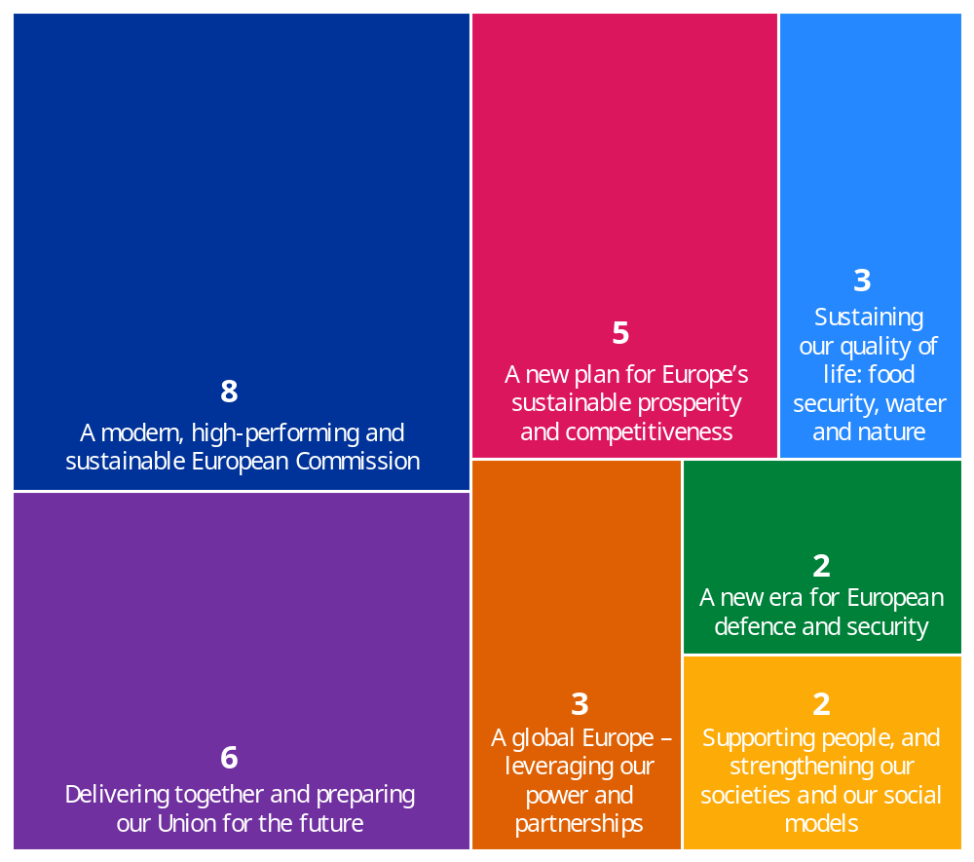
Source: European Commission, Internal Audit Service

The Internal Audit Service issued 123 recommendations stemming from its 2025 audit work. As illustrated below, 2% of these recommendations were rated as critical, 52% as very important and 46% as important.
Recommendations by rating
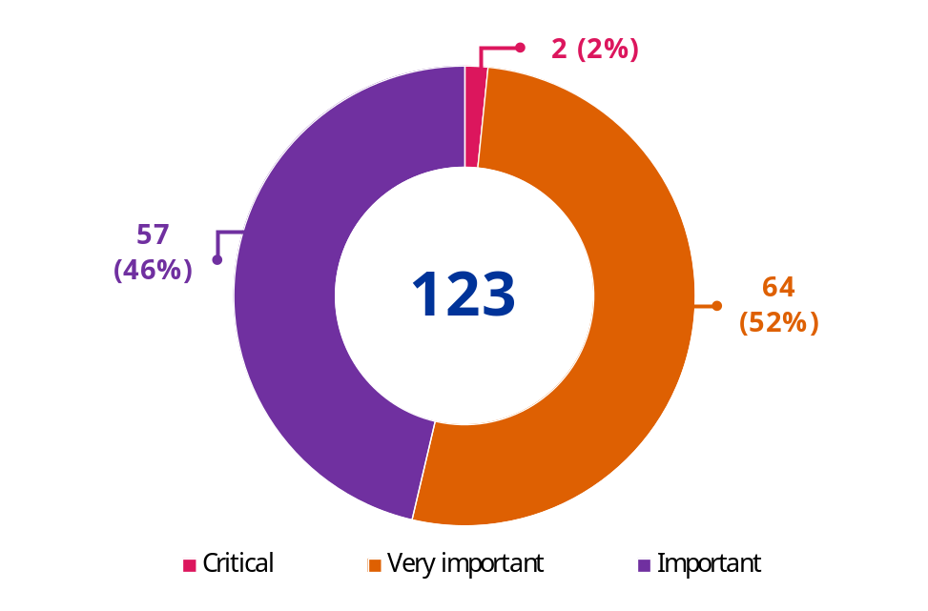
Source: European Commission, Internal Audit Service
In 2025, the auditees accepted 118 recommendations and partially accepted 5 recommendations. For all (partially accepted) recommendations, the auditees drafted action plans. The Internal Audit Service then assessed them as being satisfactory or requested a revised action plan. For the recommendations that were partially not accepted, the auditees accepted the residual risk. All the assurance reports were submitted to the Commission’s Audit Progress Committee together with the action plans.

Overall results based on the audit work performed in 2025

Overall results on performance
To support the Commission’s performance-based culture and emphasis on value for money, the Internal Audit Service finalised 29 audit engagements focused on performance aspects. For approximately 80% of these engagements, the Internal Audit Service identified high residual risks in the areas or processes audited that gave rise to very important recommendations. One audit report issued a critical recommendation to two entities, noting very high residual risks. Various strengths and good practices were also noted.
In line with its methodology and good practices, the Internal Audit Service audits performance in an indirect way. It assesses the performance of the Commission’s departments in implementing policies, programmes, and actions, by reference to the risks associated with them. With this approach, it aims to ensure that directorates-general and services have developed robust performance frameworks, adequate performance measurement tools, and comprehensive monitoring systems; and that they use them to manage performance and risks.
The Internal Audit Service’s 2025 engagements indicate that the Commission’s financial management, operational and support processes remain robust, though certain areas require attention to ensure compliance and long-term effectiveness.
While financial management systems are generally effective (see the Overall Conclusion), some vulnerabilities in procurement and grant management, notably assurance and audit strategies, require to be addressed. Audits of funding programmes revealed a need for greater consistency in performance measurement, where clearer indicators and streamlined processes could enhance transparency and impact, in particular in view of the move towards performance-based delivery models. Similarly, the operational performance would benefit from clearer definition of roles and responsibilities and from the sound management of risks related to the support systems, mainly IT. Finally, considering the reliance of the Commission on human and technological resources, the systems for selection and recruitment of staff, for IT project management and for cybersecurity management require strengthening as key founding blocks for a modern public administration.
The following sections present the conclusions of the Internal Audit Service on the various performance aspects assessed in its 2025 audits.

Financial processes
The Internal Audit Service’s audits provided assurance to the College, as well as to the directorates-general and services, that internal controls on financial management were being efficiently and effectively implemented (see also the overall conclusion on financial management in Section 4.2).
Five audits carried out by the Internal Audit Service did not reveal any major weaknesses in the control systems under examination. The other 13 audits revealed a need for improvements and led to the issuance of critical and very important recommendations.
In the field of grant management, the Internal Audit Service identified two cases where the entities under examination needed to improve the processes in place.
Five audits carried out by the Internal Audit Service on grant management ended in unqualified audit conclusions: (a) non-governmental organisations (NGO) funding under the Programme for the Environment and Climate Action (LIFE); (b) implementation of the Connecting Europe Facility; (c) project management and payment process for the EU4Health Programme; (d) project management and payment process of the European Defence Fund; and (e) early implementation of grants in the short-term defence instruments European Defence Industry Reinforcement through common Procurement Act (EDIRPA) and the Act in Support of Ammunition Production (ASAP).
An audit on the European Innovation Council’s grant agreements preparation and award procedures resulted in a negative opinion and a critical recommendation concerning the need for the Directorate-General and the executive agency concerned to revise the award decision process specific to the European Innovation Council Accelerator scheme in line with the applicable rules. The audit also resulted in very important recommendations to both auditees for reinforcement of the controls related to the grant agreement preparation; revision of the reporting on the time-to-grant indicator in the Annual Activity Report and assessing the key root causes of delays; revision of the amending award decision process; and reinforcement of budget monitoring, and ensuring formal transmission of the award decisions to the European Investment Bank.
In another audit carried out on grants, the internal control system for managing grants under the Customs Control Equipment Instrument programme was found to be adequately designed and effectively implemented, except for two issues related to the instrument’s control strategy, and for documenting of the project monitoring and payment processing in the eGrants tool.
The Internal Audit Service carried out two audits in the field of programme management for the current programming period.
In the first of these two programme management audits, with a view to simplifying the implementation of the cohesion policy funds in the 2021-2027 programming period, adequate and effective internal control processes had been designed and implemented for capacity building, ex ante assessment and monitoring and reporting on simplified cost options and financing not linked to costs. However, related guidance, documentation and ex ante assessments need to be improved. In addition, training needs to be enhanced and risks of dependency on external experts need to be monitored. Finally, the directorates-general need to improve monitoring and reporting.
In the second of these two programme management audits, the Internal Audit Service concluded that the internal control processes for reviewing and approving the amendments to the Common Agricultural Policy (CAP) national strategic plans, had been adequately designed and implemented. However, there was a lack of clarity on the starting date of eligibility for approved changes in the European Agricultural Fund for Rural Development interventions which had been previously notified but found to be non-compliant with the legal basis for notifications. In addition, a very important weakness was identified regarding the clarification on the acceptable deviations between result indicators and outputs and correction of detected non-compliances in the CAP Strategic Plans.
In the thematic area of assurance building and audit strategy the Internal Audit Service identified cases where the entities under examination needed to improve the processes in place.
In a programme covered by the Common Provisions Regulation for the 2021-2027 programming period, the audited directorate-general had set up audit arrangements based on the Single Audit Strategy but by the end of the audit fieldwork it had not fully established additional audit arrangements for the special handling of documents, a comprehensive risk assessment approach and audit planning incorporating fund-specific and common risk factors.
In another audit, risk management and control processes for the Recovery and Resilience Facility risk assessment methodology and ex post audits on milestones and targets in compliance with the Recovery and Resilience Facility Regulation had been adequately designed and effectively implemented, except for two very important issues related to: (a) the duration of audits; and (b) the auditing standards and quality assurance programme.
As regards the reliability of audit opinions on the legality and regularity of Erasmus+ expenditure declared by national agencies, the audited directorate-general had effectively implemented measures that were adequately designed to ensure the reliability of audit opinions issued by the independent audit bodies to obtain the necessary assurance, except for one issue related to the management of observations.
To ensure that financial aid provided to the countries covered by a crisis declaration is delivered in accordance with the principle of sound operational and financial management, the risk management and control systems put in place were found to be adequately designed and effectively implemented, except for the monitoring and reporting mechanism related to contracts concluded under flexible procedures.
The Internal Audit Service also carried out limited reviews on control results provided by partners. These reviews concluded that the systems designed and implemented by the responsible directorates-general in the area of external relations to ensure that the management declarations contribute to the assurance on the effective implementation of EU funds under indirect management with entrusted entities are adequate, except for issues related to some aspects of the design and to the effectiveness and efficiency of management declarations as a control measure.
As regards the performance monitoring and evaluation framework, the Internal Audit Service identified cases where the entities under examination needed to improve the processes in place:
An audit on the InvestEU programme confirmed an adequate and effective internal steering and coordination mechanism for the financing of InvestEU Fund operations and a robust methodology on performance and monitoring indicators to monitor the implementation has been put in place. However, it identified shortcomings in the objectives that are defined in the relevant legal basis and in the indicators used to monitor and evaluate the achievement of the programme’s objectives.
An audit on the design of the performance monitoring and evaluation framework for the 2023-2027 Common Agricultural Policy, found that it was adequately designed to monitor, evaluate and report on the performance of the CAP Strategic Plans. However, the approach for approving changes to targets and milestones for result indicators needed further clarifications in the absence of clear provisions in the basic legislation.
Concerning procurement and contract management the Internal Audit Service identified three instances where the entities under examination needed to improve the processes in place.
One audit identified one very important issue regarding the effectiveness and efficiency of the procurement approach followed for outsourced translations. Another audit identified one very important issue concerning the identification of (potential) conflict-of-interest aspects, which the responsible executive agency needs to reinforce, in cooperation with its parent directorates-general.
In an audit on high value procurement and contract management, the internal control system set up needs to be significantly enhanced to strengthen its efficiency and effectiveness. The Internal Audit Service identified five very important issues concerning: (a) the risk management and control strategy; (b) award criteria and the evaluation process; (c) contract value estimation and contract duration; (d) the early detection and exclusion system; and (e) ex ante controls on payments.

Operational processes
The Internal Audit Service performed six audits that focused on specific activities or programmes.
An audit on the management of EURopean Employment Services (EURES) and the EURES portal found that the responsible directorate-general and the affiliated decentralised agency had put in place a number of arrangements to govern their cooperation. However, these arrangements had not always been sufficiently detailed or kept up to date in a number of areas, including IT governance and the mandate of the IT Steering Committee.
An audit carried out on the coordination mechanisms related to financial supervision found that the responsible directorate-general had adequately designed and effectively and efficiently implemented the coordination mechanisms with the three supervisory authorities except for issues related to the questions and answers process, and review and evaluation.
Another audit found that processes for managing the control data of the Common Fisheries Policy had been adequately designed and effectively and efficiently implemented, in line with the legal framework applicable at the time of the audit, except for one issue related to the reception, use and publication of data related to fishing opportunities.
An audit on the selection process in the European Personnel Selection Office concluded that the governance, risk management and control processes set up by the Office responsible for the new competition model for permanent staff was not adequately designed. The identified issues included the management of clients’ needs and related communication aspects; the roadmap for the deployment of the new competition model and procedure for the selection process; and the indicators and monitoring for assessing the achievement of the objectives of the new competition model.
An audit carried out on the management of childcare services found that the offices in charge had, overall, designed an adequate framework and control system. However, issues were identified in the implementation concerning the roles and responsibilities of the oversight committees and external actors involved; the establishment of the interinstitutional budget and allocation of costs and calculation of parental and institutional contributions; and IT controls on project management and the IT security of the relevant IT tool.
An audit on the management of in-kind contributions under Horizon Europe concluded that overall, the responsible directorate-general had provided adequate support to the joint undertakings, except for one very important issue concerning IT support and the functionalities available in the IT tool.

Support processes
Human resource management
An audit carried out on the Human Resources Transformation Programme concluded that although the programme’s governance structure and processes had been well set up overall, a very important issue relating to the IT security management processes remained that may affect the achievement of the programme’s strategic objectives and compliance with the Commission’s internal security standards.
Information technology (IT) governance, IT project management and IT security management
The Internal Audit Service carried out two audits in this area.
An audit carried out on IT governance and IT security management in one directorate-general revealed that, overall, the governance, risk management and control system put in place for IT governance and IT security arrangements was adequately designed and efficiently and effectively implemented, except for one issue related to aligning business needs and recovery expectations, maintaining IT security plans and formalising processes about incident and user access management.
For the Arachne+ project, the governance, risk management and control processes put in place by a directorate-general, as system owner, with the support of other directorates-general, were not appropriate to deliver phase 2 of the project effectively and to achieve the strategic objectives and business expectations for the overall project within the allocated time and resources. IT security and personal data protection control processes were compliant with the Commission’s process steps, but significant improvements were necessary as regards the quality of IT security artefacts.
Additionally, a number of other audits looked at the IT aspects of audited processes and identified in different cases adequate controls or weaknesses.

Overall conclusion on the Commission’s financial management
As required by its mission charter, the Internal Audit Service issues an annual overall conclusion on the Commission’s financial management. This is based on the audit work in the area of financial management in the Commission carried out in the past three years (2023 to 2025). It also takes into account information from other sources, namely the reports of the European Court of Auditors. The overall conclusion is issued at the same time as this report and covers the same year.
Based on this audit information, the Internal Auditor considered that in 2025 the Commission put in place governance, risk management and internal control procedures which, taken as a whole, are adequate to give reasonable assurance over the achievement of its financial objectives, with the exception of those areas of financial management over which authorising officers by delegation have expressed reservations in their declaration of assurance.
Without further qualifying the overall conclusion for 2025, the Internal Auditor draws attention to the need to ensure that the control and assurance framework remains robust, proportionate and effective to manage risks to an acceptable level, especially in the context of concurrent priorities and continuous pressure on resources. This is particularly pertinent in view of the need to accelerate implementation and ensure a timely closure of the current programmes while preparing for the upcoming multiannual financial framework, which will introduce further innovative instruments and delivery models.
The challenging socio-economic and political environment and need to respond to the various crises during the past few years required rapid mobilisation of unprecedented amounts of resources and funding, and the creation of novel performance-based instruments. Delays in finalising and implementing the control and audit strategies for the current programming period, as a result of the necessary adaptations to the revised delivery models, should be given due attention. At the same time, the Commission has to continue the simplification efforts to ensure that EU funding remains accessible and delivers results while ensuring sound financial management.
In the context of a major overhaul of funding and delivery models under the next multiannual financial framework, the Commission should make use of the lessons learned from the current 7-year period and ensure that the assurance model is defined from the outset, in order for control strategies for individual instruments to be developed in good time before implementation starts.
The continued shift towards performance-based delivery models will require a revised approach to enable the Commission to provide assurance on the legality and regularity of expenditure, including where necessary support to the Member States, adjustments to the organisation of the audit function and revision of traditional legality and regularity indicators, such as the error rate.
Continued attention needs to be paid to proportionate and effective controls for the oversight of budget amounts implemented by the Member States and/or third parties, considering the increased reliance the Commission places on them.
In addition, the expanding financial operations of the Union highlight the importance of a robust and well-integrated risk management framework and strong oversight of loans, budgetary guarantees and financing through the issuance of debt securities.
Finally, to ensure delivery of its objectives relating to accountability, sound financial management and protection of the EU budget, the Commission should continue efforts and seize opportunities to optimise the use of limited resources and to adjust its organisation, processes and operations. The design of new assurance models and the individual control strategies should be accompanied by a definition of adequate human resources, in numbers, skills and timing, and a strategy for effectively leveraging appropriate technological means, while carefully managing the risks they introduce.

Actions taken by auditees
The impact of the internal audit work on improving the Commission’s performance and accountability depends on the implementation of its recommendations. To enable oversight by the governing bodies, the Internal Audit Service carries out follow-up audits when the audited entity has reported the recommendation as ready for review. The Internal Audit Service also provides regular information to the Audit Progress Committee on the status of implementation of its recommendations.
The Internal Audit Service followed up on 50 previous audit engagements to review the implementation of recommendations and issued 82 () follow-up notes to the respective directorates-general and services. As a result, for 22 engagements, all recommendations were closed (), while for the other 28 engagements, one or more recommendations remained open by the cut-off date ().
As illustrated below, at the cut-off date of 31 December 2025, out of a total of 773 (partially) accepted recommendations () made by the Internal Audit Service in 2021-2025, 525 (68%) were assessed by the auditees as implemented (). This leaves a total of 248 recommendations (32%) that remain open.

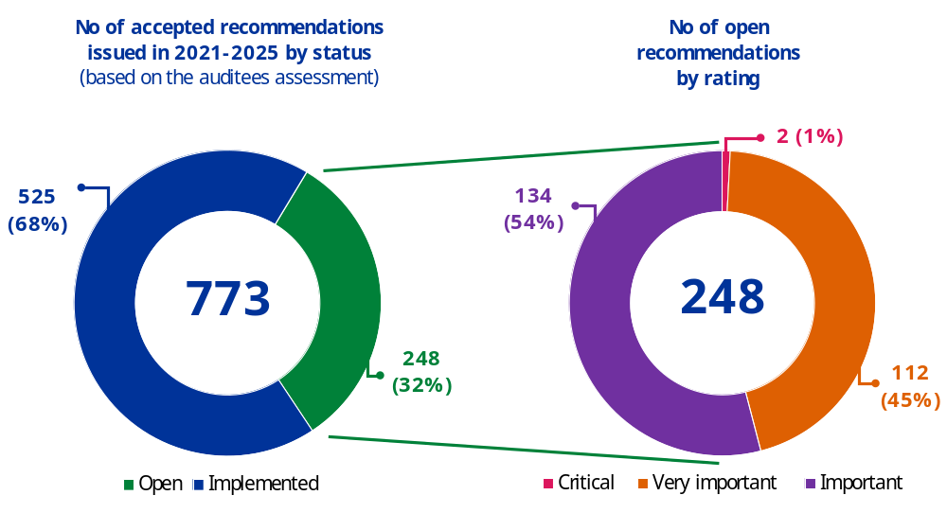
Source: European Commission, Internal Audit Service

Of the 248 recommendations that remained open on the cut-off date, two were rated as critical, 112 (45%) as very important, and 134 (54%) as important.
Of the open recommendations, 43 were overdue (i.e. not implemented by the originally agreed date). These overdue recommendations represented 5.6% of the (partially) accepted recommendations.
Of the overdue recommendations, four very important recommendations issued in 2021-2025 were classified as long overdue (i.e. open for more than six months after the original implementation date), compared to six recommendations in the previous year. These long overdue very important recommendations represented 0.5% of the total number of (partially) accepted recommendations in 2021-2025 (in line with the previous reporting period). Additionally, there is one very important long overdue recommendation that was issued before the 2021 audit plan, increasing the total number at the cut-off date to five very important recommendations.
Delay of overdue recommendations by rating
(Issued in 2021-2025)
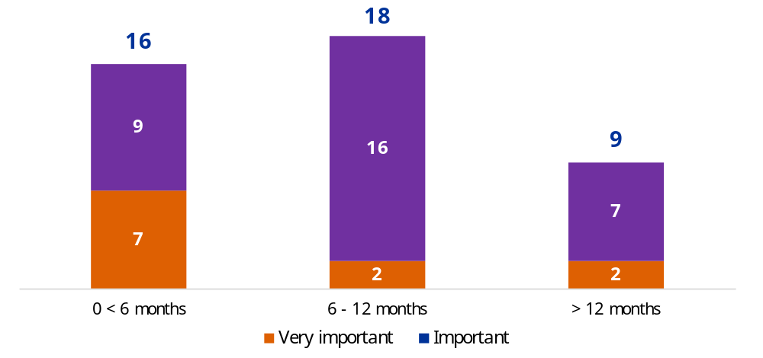
Source: European Commission, Internal Audit Service
Overall, the Internal Audit Service considers the implementation of its recommendations to be satisfactory and comparable with previous reporting periods. This shows that Commission services have been diligent in implementing the critical and very important recommendations, thus mitigating the risks highlighted by the Internal Audit Service.
Part 3 of the Staff Working Document accompanying this report summarises these very important long overdue recommendations.

Consultation with the Commission’s financial irregularities panel
The panel set up under Article 145 of the Financial Regulation did not report any systemic problems in 2025, when it gave its opinion referred to in Article 93 of the Financial Regulation.

() The report does not cover the European External Action Service, the European Data Protection Supervisor, the European Public Prosecutor’s Office, the European Peace Facility, decentralised EU agencies, EU joint undertakings or other autonomous bodies that are audited by the Internal Audit Service. They receive separate reports where relevant.
() Regulation (EU, Euratom) 2024/2509 of the European Parliament and of the Council of 23 September 2024 replacing Regulation (EU, Euratom) 2018/1046 (Article 247).
() The audit reports finalised between 1 February 2025 and 31 December 2025 are included in this report, except for the audit on human resources management in the Directorate-General for Financial Stability, Financial Services, and Capital Markets Union for which the final audit report was issued on 10 March 2025 and was exceptionally included in the Annual Internal Audit report for 2024.
() A summary of the assurance provided by the Internal Audit Service is published in parallel to this report in the Annual Management and Performance Report on the EU budget.
() Commission Decision (EU) 2025/2570 of 18 December 2025 establishing the mission charter for the Internal Audit Service of the Commission.
() The Global Internal Audit Standards, promulgated by the Institute of Internal Auditors (IIA) effective as from 9 January 2025, guide the worldwide professional practice of internal auditing and serve as a basis for evaluating and elevating the quality of the internal audit function. The Global Internal Audit Standards replace the 2017 International Professional Practices Framework of the Institute of Internal Auditors which was applicable in 2024.
() The 2025 audit plan is a transition year to the new cut-off date of 31 December 2025. Until 2024, the reference period for the audit plans was 1 February n to 31 January n+1.
() This audit report related to the audit on human resources management in the Directorate-General for Financial Stability, Financial Services, and Capital Markets Union. The final audit report for this audit was issued on 10 March 2025.
() Some audit engagements were followed up more than once and some follow-up notes covered more than one audit engagement.
() Section 2.2 of the Staff Working Document contains the list of audits that were closed after a follow-up was performed.
() Section 2.1 of the Staff Working Document contains a list of audits that remained open after a follow-up was performed on critical and/or very important recommendations.
() Out of 777 recommendations issued in 2021-2025, 763 recommendations were fully accepted, 10 were partially accepted and four were rejected.
() The chart shows the rating of the recommendations on the cut-off date. This may differ from the rating in the original audit report because, in a follow-up audit, the Internal Audit Service may assess that the actions taken by the auditee partly mitigated the risks that were initially identified and may therefore downgrade the rating of the recommendation.

