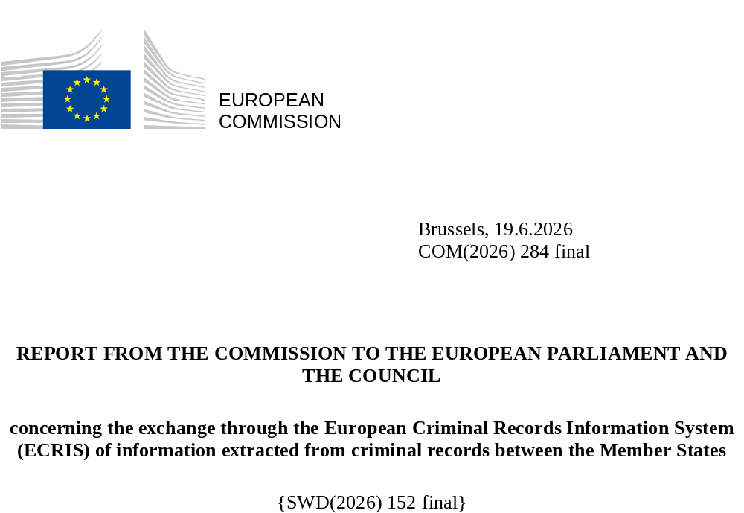

1. Introduction
The purpose of the European Criminal Records Information System (ECRIS) is to improve security within the EU Area of Freedom, Security and Justice, by enabling an efficient exchange between the Member States of information on previous criminal convictions handed down by criminal courts in the EU. ECRIS became operational in April 2012. It is regulated by Council Framework Decision 2009/315/JHA of 26 February 2009 on the organisation and content of the exchange of information extracted from the criminal record between Member States. Council Decision 2009/316/JHA of 6 April 2009 on the establishment of the European Criminal Records Information System was replaced by Directive (EU) 2019/884, but it is still binding for Denmark and Ireland.
On 29 June 2017 the Commission adopted its first Statistical Report in accordance with Article 7 of Council Decision 2009/316/JHA, which covered the period from April 2012 to 31 December 2016. The Commission’s second Statistical Report, adopted on 21 December 2020, covered the period from 1 January 2017 to 31 December 2019.
The present report is the third Statistical Report of the Commission concerning the exchange through ECRIS of information extracted from the criminal records between the Member States. Its purpose is to assess the compliance of the Member States' exchanges with the ECRIS legal framework and to identify any issues regarding the efficiency of the system, with a view to remedying the situation. The Commission reserves the right to take all appropriate action to ensure that the Member States fulfil their legal obligations under Council Framework Decision 2009/315/JHA.
This report has been adopted ahead of the entry into operation of the ECRIS-TCN system, which will supplement ECRIS with an efficient mechanism for the exchange of information on convicted third-country nationals, in order to take stock of the Member States’ information exchanges before the entry into operation of this new system.
1.1. ECRIS statistics
This report provides an overview on the use of ECRIS for in the five-year period from 1 January 2020 to 31 December 2024. It is accompanied by the Commission Staff Working Document SWD(2026)152 (‘the SWD’). Some of the statistics in the report give a general overview over the 13-year period of operation of ECRIS, since its “go-live” in April 2012. However, the comparative statistical data on all the Member States and the individual Member States' statistical tables in Section 3 of the SWD cover ECRIS exchanges in the last five years, between 2020-2024. Where relevant, the statistics for previous years have been used as a reference point. The report also includes data on exchanges with the United Kingdom until 31 December 2020.
The report is based on the statistics generated automatically by the system and subsequently sent by the Member States to the Commission. Out of the 233 statistical indicators established for ECRIS, a choice was made to publish only the most relevant and meaningful information. In addition, Member States were requested to communicate statistics on the number of convictions of nationals of other Member States handed down on their territory, to enable the Commission to provide an overview of how the notification procedure is implemented. The report includes conviction data received from all 27 Member States and the UK for 2020.
1.2. General principles of the ECRIS system
ECRIS is based on a decentralised architecture, where criminal records information is exchanged electronically, exclusively between the Central Authorities of the Member States.
Each Member State having convicted a citizen of another Member State is obliged to notify that Member State (‘Member State of nationality’) through ECRIS as soon as possible of all information related to the conviction (notifications of new convictions) and any subsequent updates (notifications of updates).
The Member State of nationality thus keeps a central repository of all convictions handed down against its nationals by criminal courts in other EU Member States, in addition to any convictions handed down in the Member State itself. The Member State of nationality is then obliged to store and update all information received through ECRIS and to provide information on criminal records (replies to requests) when requested by another Member State (requests for information) within short deadlines of 10 or 20 days.
1.3. Executive summary
More than 10 years after its launch, ECRIS reached a major milestone in 2022, when all 27 Member States became fully interconnected and the maximum possible number of 702 interconnections was established and stabilised. This ensures that information on criminal records can be exchanged across the EU without technical barriers.
After a decline caused by the pandemic and Brexit, the volume of exchanges has begun to grow again, reaching nearly 4.8 million messages in 2024, with an average of 400 000 per month. Since 2017 the structure of exchanges has changed considerably - requests for information now exceed notifications of convictions almost five times.
The number of convictions of citizens of other Member States dropped significantly in 2020, to around 250 000 per year and has remained at this level since, leading to fewer notifications of new convictions. In 2024 the number of notifications fell to 260 000, comparable to the level of 2014. All Member States now transmit notifications of new convictions, and many have cleared their backlogs, yet not all convictions are notified, notably by Denmark, Ireland, Luxembourg, Slovakia and Romania.

2. ECRIS exchanges in numbers
The number of requests for information continued to increase steadily, reaching 1.2 million in 2024. 2019 brought a complete shift in the use of ECRIS, which has been used more often for purposes other than criminal proceedings. In 2024 such requests represented 56% of all requests and concerned mainly recruitment checks for jobs involving contact with children or requests from individuals seeking information on their own criminal record.
Nevertheless, several Member States still make limited use of ECRIS for requesting information on criminal records, including Greece, Bulgaria, Estonia, Hungary, Ireland, Italy, Latvia, Malta and Slovenia. While some Member States (Belgium, Croatia, Hungary, Ireland, Italy, Luxembourg, Slovenia and Slovakia) use ECRIS exclusively or almost exclusively for the purpose of criminal proceedings, others request information almost exclusively for other purposes (Czechia, Cyprus, Greece and Spain).
In 2024, only 16.6% of replies contained information on previous convictions, reflecting the growing share of requests for purposes other than criminal proceedings. Still, over 197 000 replies revealed existence of previous convictions.
The response rates have improved significantly compared with 2019, with the number of late replies dropping by half and the number of requests for which the deadline had expired decreasing over fivefold. However, 9.7% of replies were still sent after the legal deadline, and 38 000 requests expired without receiving a reply.
Despite the positive trend in the number of updates (254 000 in 2024), still some Member States transmit only a few updates (Bulgaria, Greece, Ireland and Malta) or none at all (Estonia and Slovenia).
There has been a worrying rise in the number of unanswered requests - 317 000 requests (5.8% of all requests) in 2020-2024 received no reply, mostly from Cyprus, Bulgaria, Croatia, Spain and Greece. The increasing tendency to violate the obligation to respond to requests for information is alarming, given its potentially tragic consequences.
Exchanges concerning third-country nationals remain limited in number (88 000 - 7% of all requests), although they are expected to increase with the entry into operation of ECRIS-TCN in 2027.
Considerable differences have persisted between the Member States in terms of activity and workload.
2.1. Connected Member States
ECRIS is a decentralised system where all Member States should be interconnected with each other. A Member State is considered connected to ECRIS if it exchanges information on criminal records with at least one other connected Member State.
Another milestone has been reached in the ECRIS history - all Member States are currently connected to ECRIS and exchange information on criminal records with all other Member States.

The ECRIS system became operational in 2012, with a total of 173 interconnections out of a possible 702 at the time (27 Member States connected). By the end of 2019, 670 interconnections had been established (90% of the then possible 756). Only in 2022, after 10 years of ECRIS operation, had all 702 possible interconnections between the Member States been established and are stable since.
- All 27 Member States connected to ECRIS and exchanging information on criminal records with all other Member States
After 10 years of operation, another milestone was reached in the ECRIS history - in 2022, all 702 possible interconnections between the Member States had been established and are stable since.

2.2. Total number of messages exchanged
The graph below illustrates the growing annual volume of messages exchanged between all connected Member States from April 2012, when ECRIS became operational, to 31 December 2024. It should be noted that there were only 8 months of activity in 2012. All types of messages are included in these volumes: notifications, updates, requests, replies, denials, other replies and exchanges of additional information.

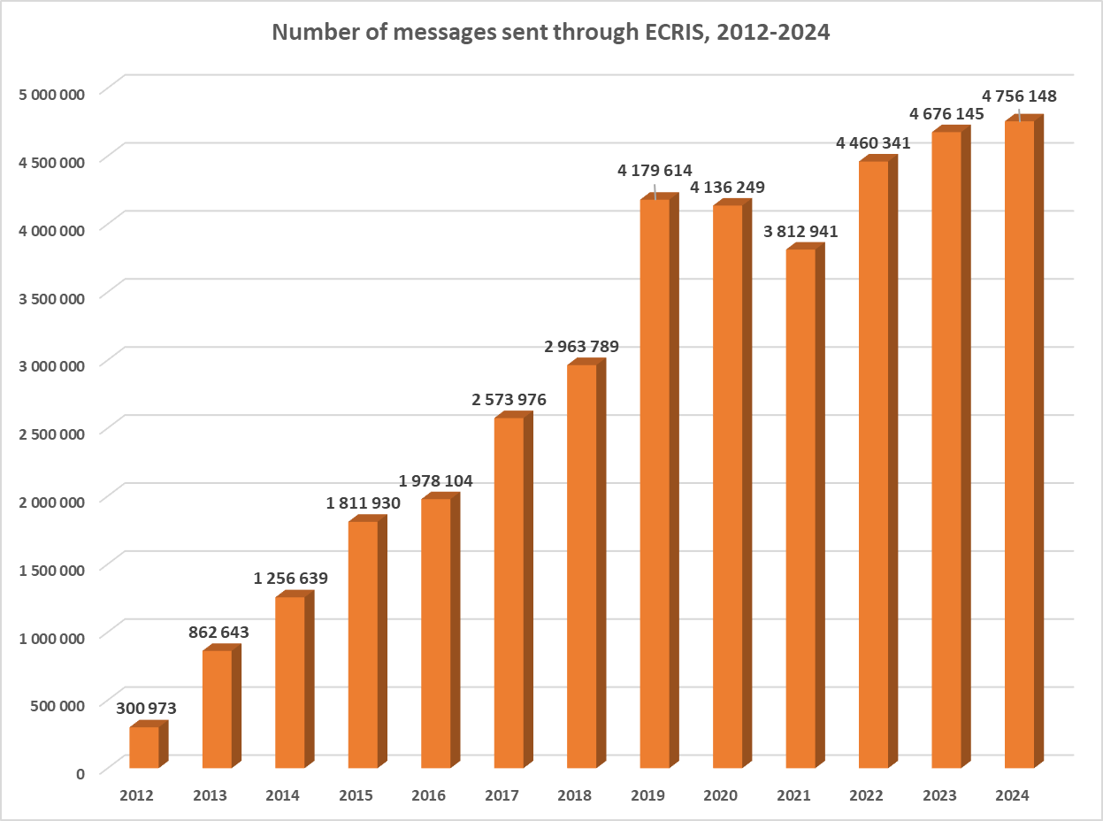
The annual volume of messages was growing rapidly until 2019, when it reached nearly 4.2 million, with an average of 348 000 messages per month. The period of pandemic and the ensuing travel limitations brought a stabilisation of this number in 2020, and then a sharp drop in 2021 to 3.8 million messages. The United Kingdom’s exit from ECRIS on 1 January 2021 also contributed to this drop. In 2022, the volume of messages started to grow steadily again to reach nearly 4.8 million in 2024, averaging 400 000 messages per month.
The graph below illustrates the trend in sent requests, replies to requests, notifications of new convictions and notifications of updates over a 13-year period of ECRIS operation. Replies include request replies, request denials and other replies.
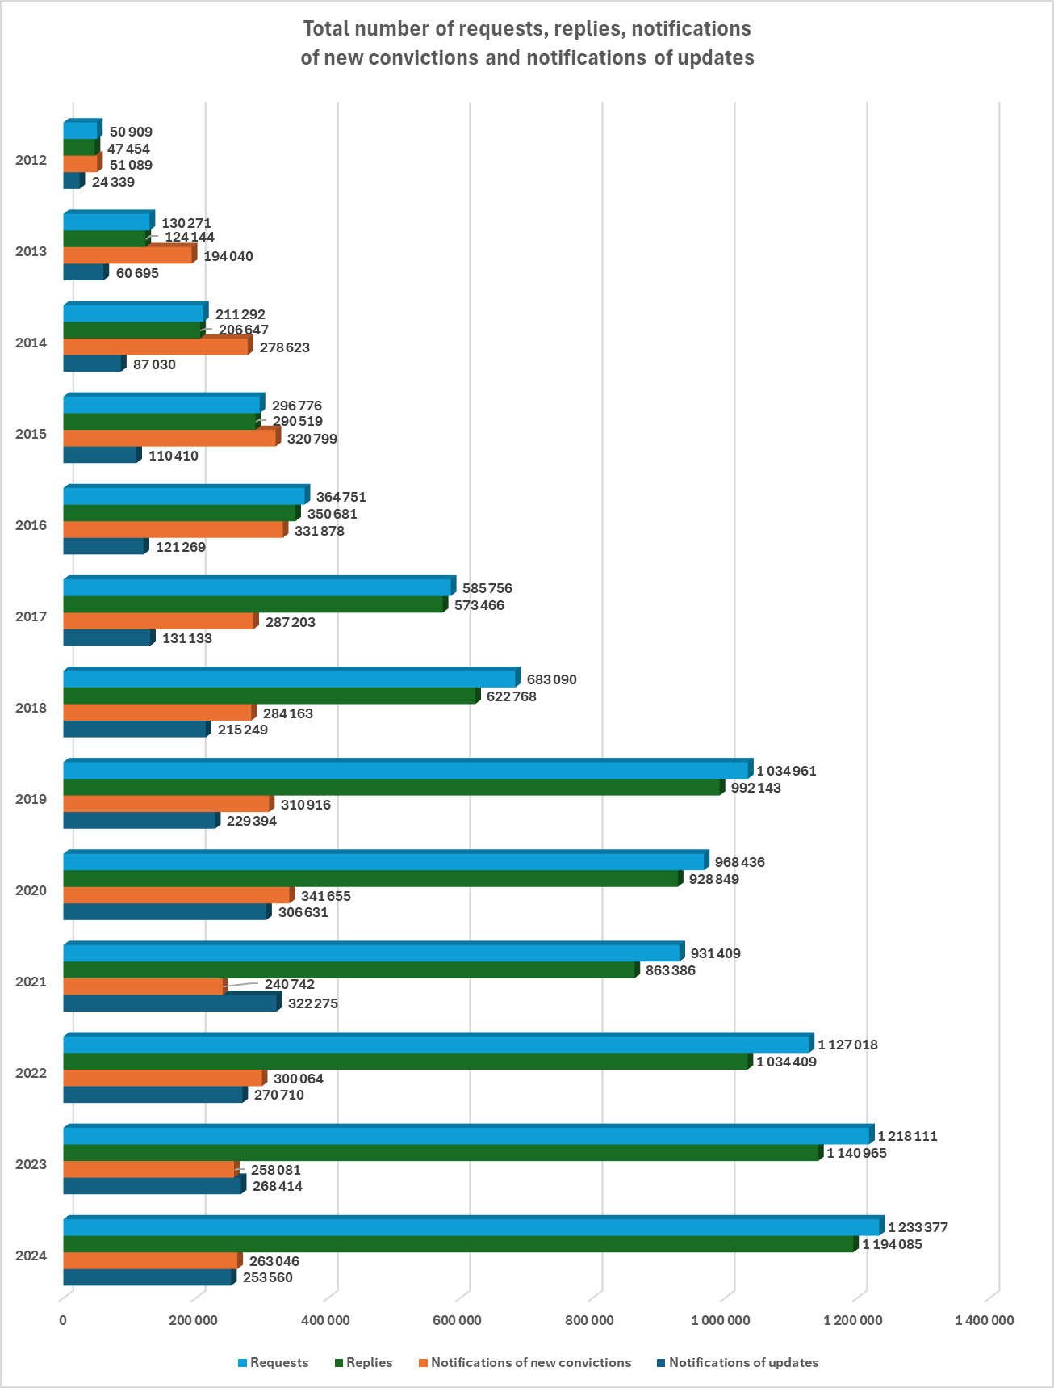

The proportions between the number of notifications of new convictions, requests and replies to requests began to shift radically since 2017. From almost equal numbers for each of these three categories in 2016, amounting roughly to 350 000 per year per category, the number of requests for information and the related number of replies to requests became three times higher than the number of notifications in the years 2019 and 2020, to finally exceed the number of notifications nearly five times in 2023 and 2024.
In 2020 the number of notifications of new convictions increased to 340 000, only to drop again in 2021 before stabilising at a rather low level of around 260 000 per year by the end of 2024, equivalent to the level of notifications of 2014. Given the growing web of interconnections between the Member States and the fact that, compared with the previous reporting period, fewer Member States had problems notifying all new convictions, this change suggests a decrease in the number of convictions of citizens of other Member States.
By contrast, the number of requests for information and related replies has been steadily growing – by 25% since 2020 – and reached a total of 1.2 million for each of these categories in 2024. This increase is not as dramatic as in the previous reference period, when the major shift in the use of ECRIS took place with purposes other than criminal proceedings outnumbering three times those related to criminal proceedings (for further details, see Section 2.8). The steady growth in the number of requests over the 13 years in which ECRIS has been operational is also a positive sign of Member States’ growing awareness of the need to use the system to request information in the course of criminal proceedings to be able to take account of previous convictions, in line with Framework Decision 2008/675/JHA.
- The number of messages exchanged increased again after the pandemic to reach 4.8 million in 2024
The period of pandemic, the related travel limitations and Brexit caused a sharp drop in the number of messages exchanged to 3.8 million in 2021. In 2022, the volume of messages began to increase steadily again to reach nearly 4.8 million in 2024 with an average of 400 000 messages per month. The proportions of notifications of convictions, requests and replies to requests have shifted radically since 2017, with the number of requests for information exceeding the number of notifications nearly five times in 2024.

2.3. Number of notifications, requests and replies per Member State
The graph below shows the total number of sent requests, replies to requests, notifications of new convictions and notifications of updates per Member State over the five years from 2020 to 2024.

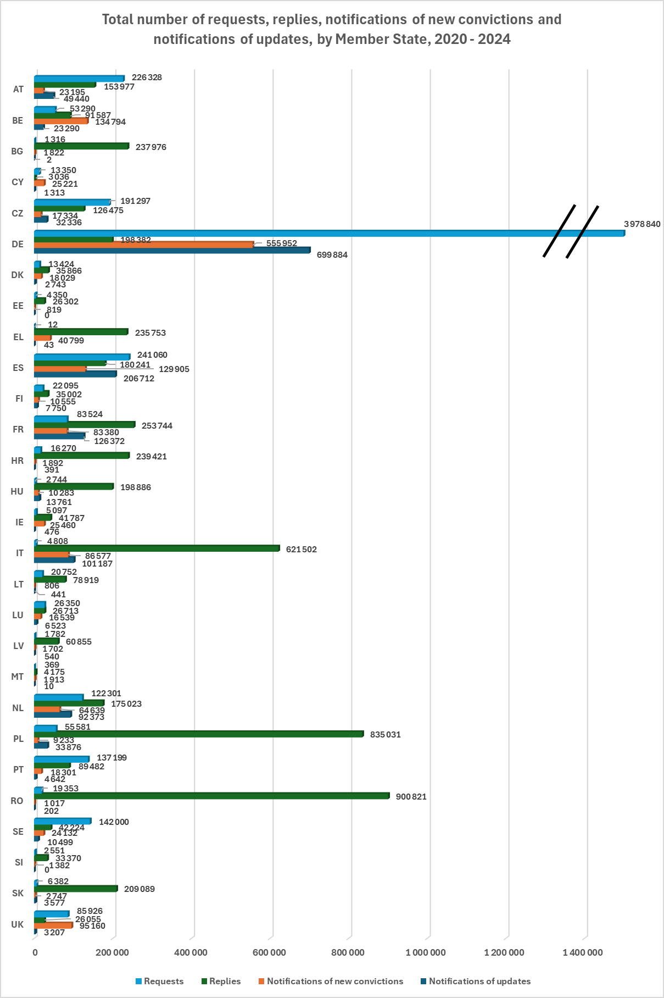
As in previous years, the most active Member States in terms of total volume of these four types of messages were Germany (25% of all such messages exchanged), Poland (4.2%), Romania (4.2%), Italy (3.7%) and Spain (3.5%).
The figures reveal significant differences between Member States in terms of ECRIS use and workload. Some Member States request information considerably more often than they are requested to provide information. Germany, for example, submitted almost 4 million requests in 2020-2024 but received only 198 000 requests and Sweden sent 142 000 requests against 42 200 received. Conversely, numerous Member States are confronted with a significant number of requests, while they send fewer requests of their own: e.g. Romania (901 000 replies given versus 19 400 requests sent), Poland (835 000 v. 55 600), Italy (622 000 v. 4 800). Other Member States send high volumes of notifications of new convictions to the Member States of the offender’s nationality, while they send fewer requests for information, among them Belgium (135 000 notifications sent, 53 300 requests sent), Italy (86 600 notifications, 4 800 requests) and Greece (40 800 notifications, 12 requests).
- Significant differences between the Member States in terms of ECRIS activities and workload
Some Member States send considerably more requests for information than they receive (Germany, Sweden and Austria), while others are confronted with a significant workload replying to these requests (Romania, Poland, Italy, France, Croatia, Bulgaria and Greece). The workload for some other Member States (Belgium, Italy and Greece) is produced mostly by sending a high number of notifications of new convictions to the Member States of offenders’ nationality.

2.4. Notifications
The graph below illustrates the total volume of convictions of nationals of other Member States, corresponding notifications of these convictions and notifications of updates sent by each Member State over the five years, from 2020 to 2024.
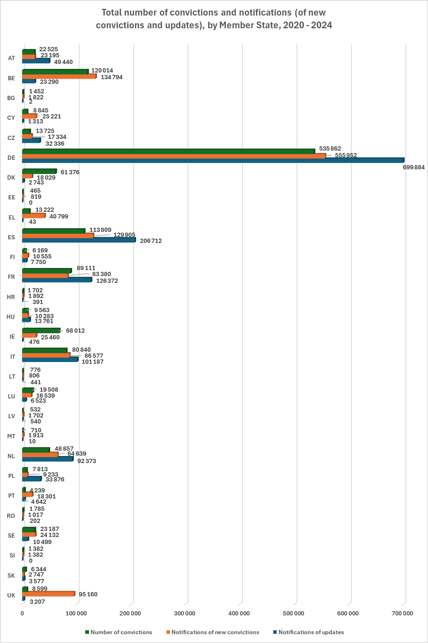Over the course of the reporting period, 1 270 000 new convictions of citizens of other Member States were handed down in the Member States, with an average of 250 000 convictions per year. The number of convictions dropped significantly in 2020 and has remained at the same level since, resulting in a decrease in the number of notifications of new convictions.
In total, Member States sent around 1.4 million notifications of new convictions and 1.4 million notifications of updates in this period.
The number of notifications sent varied considerably among Member States, from 556 000 notifications of new convictions sent by Germany to 800 such notifications sent by Lithuania and Estonia in the five years. Two factors, in particular, explain these variations: the size of the country and the number of convictions of nationals of other Member States (EU non-national population).
The most active Member States in terms of sending notifications of new convictions were Germany (40% of all such notifications), Belgium (9.6%) and Spain (9.3%). The ranking is similar for notifications of updates: Germany (49%), Spain (15%) and France (9%).
In the 2020-2024 reporting period, the respective proportions of notifications of new convictions and notifications of updates fluctuated around 50%. In particular, in 2024 these notifications accounted for 51% and 49% respectively, compared to 58% and 42% in the reference year 2019. It should be pointed out that before 2018, updates accounted for only about one third of all notifications. The present significant increase in the number of updates for many Member States should be considered a positive sign of their awareness of the importance of communicating subsequent changes to initial notifications.
The respective proportions of notifications of new convictions and notifications of updates varied significantly among the Member States, from the number of updates being four times as high (in the case of Poland) or over twice as high (in the case of Austria and Czechia) as the number of initial notifications, via roughly equal proportions of both categories of notifications (in the case of Italy, the Netherlands and Hungary) to updates accounting for a tiny part of all notifications (in the case of Bulgaria, Cyprus, Greece, Ireland, Malta and Romania). For Germany, Spain and France, which sent the highest total number of notifications in the reporting period, the updates amounted respectively to about 56%, 61% and 60%, respectively.
With regard to the issues identified in the previous Statistical Reports of many Member States not sending any, or only few, notifications of new convictions or updates, the situation improved considerably in 2020-2024, both in terms of the number of Member States fulfilling their obligations and the volume of information notified.
Firstly, all Member States now send notifications of new convictions, however, some still do not notify all the convictions handed down on their territory, including Denmark (43 300 missing notifications; 70% of convictions not notified), Ireland (42 600; 63%), Slovakia (3 600; 57%), Romania (800; 43%) and Luxembourg (3 000; 15%). As a result, these convictions have not been registered in the Member States of nationality.
On the other hand, a new phenomenon has been observed in the majority of Member States of sending amounts of notifications of new convictions far exceeding the actual number of convictions. This may be the result of Member States notifying a backlog of convictions from previous years.
Secondly, two Member States (Estonia and Slovenia) did not send any updates of previous notifications, and a further four Member States sent a low number of updates, namely Bulgaria (2), Greece (43), Ireland (476) and Malta (10). Failure by the convicting Member State to send updates results in the Member State of nationality processing and disseminating unreliable information that is not up-to-date.
- Fewer criminal convictions in the EU since the pandemic, resulting in a drop in the number of notifications
The number of convictions of citizens of other Member States dropped significantly in 2020, from over 320 000 in the previous years to 250 000 convictions per year and remained at this level since, causing a decrease in the number of notifications of new convictions. In 2024 the total number of notifications dropped to 260 000, the number recorded in 2014.

- Despite the positive trend of increasing number of updates, still many remain not notified
The number of notifications of updates has been continuously growing to reach 254 000 in 2024. Updates accounted for half of all notifications sent, up from 42% in 2019. Although noticeably more Member States send updates of previous notifications, some still send no updates at all (Estonia and Slovenia) or only a few (Bulgaria, Greece, Ireland and Malta).

- All Member States sending notifications of new and backlog convictions, but still not all convictions are notified
In comparison with previous reporting periods, the situation improved considerably in 2020-2024, and all Member States now send notifications of new convictions. Moreover, the majority of them notified numbers of convictions far exceeding the actual number of new convictions in that period, which suggests that they have been notifying a backlog of convictions from previous years.
However, some Member States still do not notify all the convictions handed down on their territory (Denmark, Ireland, Luxembourg, Slovakia and Romania).

2.5. Requests for information
The graph below compares the total volume of requests for information sent by each Member State in 2020-2024 with the volume of replies received and indicates the percentage of requests that received a reply.
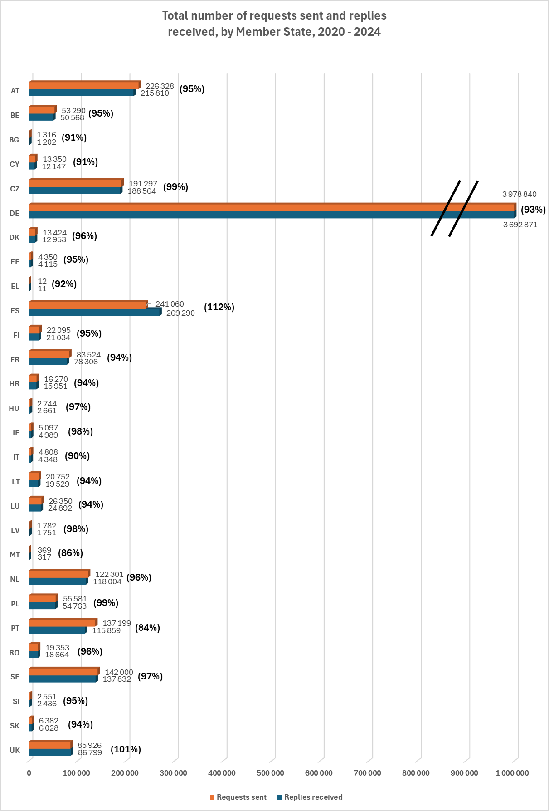
Nearly 5.5 million requests for information were issued in the period of 2020-2024. As mentioned in Section 2.2, the annual number of requests has grown by 25% since 2020, reaching 1.2 million in 2024.
The number of issued requests varied considerably among Member States, from almost 4 million sent by Germany to just 12 sent by Greece. The main factors explaining this variation are the number of nationals of other Member States residing in a given Member State and national legislation setting out obligations for presenting criminal record certificates.
As in previous years, the most active Member State in terms of issued requests was Germany (73% of all requests in 2020-2024), followed by Spain (4.4%) and Austria (4.1%). The most significant rise in the number of requests was observed in Sweden and Romania, which sent five times more requests in 2024 than in 2019, as well as in Belgium and Spain, where the number of requests sent nearly tripled.
Despite the increase in the number of requests in general, the problem noted in the previous Statistical Reports persists of some Member States sending almost no requests at all (Greece) or a low number of requests in relation to their EU non-national population (Bulgaria, Estonia, Hungary, Ireland, Italy, Latvia, Malta and Slovenia). Moreover, in 2020-2024 the number of requests sent dropped significantly in France, Ireland and Italy by comparison with the reference data for 2019. This might lead to a situation where criminal courts pass judgments without knowledge of convictions handed down in other Member States, contrary to the requirements set out in Framework Decision 2008/675/JHA. In addition, the preventive effect of requesting criminal record certificates for purposes other than criminal proceedings, such as pre-employment checks, will be hampered.
For further analysis and a breakdown of requests for criminal proceedings and for other purposes, see Section 2.8.
The above data also show that not all requests for information are replied to (see also Section 2.6.). Of the Member States sending the highest number of requests, 7% of German requests (286 000), 5% of Austrian requests (10 500) and as much as 15% of Portuguese requests (21 300) were not responded to in the reporting period. For Spain, by contrast, the number of replies received in this period exceeded 11% the number of their requests, which could result from receiving the backlog of replies from other Member States.
- Requests for information reaching 1.2 million on the back of slow but steady increase
The annual number of requests for information has grown steadily by 25% since 2020, reaching 1.2 million in 2024. However, this growth has not been as dramatic as in the previous reference period.
The number of issued requests continued to vary considerably among Member States, from 4 million sent by Germany (73% of all requests) to just 12 sent by Greece in the five-year reporting period.

2.6. Replies to requests
- ECRIS still not always used to request information on previous convictions
Despite the increase in the total number of requests, the problem noted in the previous Statistical Reports of some Member States sending almost no requests at all (Greece) or sending only a few requests in relation to their EU non-national population (Bulgaria, Estonia, Hungary, Ireland, Italy, Latvia, Malta and Slovenia) still persists and concerns mostly the same Member States.
Several Member States use ECRIS exclusively or almost exclusively for the purpose of criminal proceedings (Belgium, Croatia, Hungary, Ireland, Italy, Luxembourg, Slovenia and Slovakia). Other Member States request information almost exclusively for purposes other than criminal proceedings (Czechia, Cyprus, Greece and Spain).

The graph below shows the total number and percentage of replies sent by each Member State in 2020-2024, compared to the number of corresponding requests for information received.
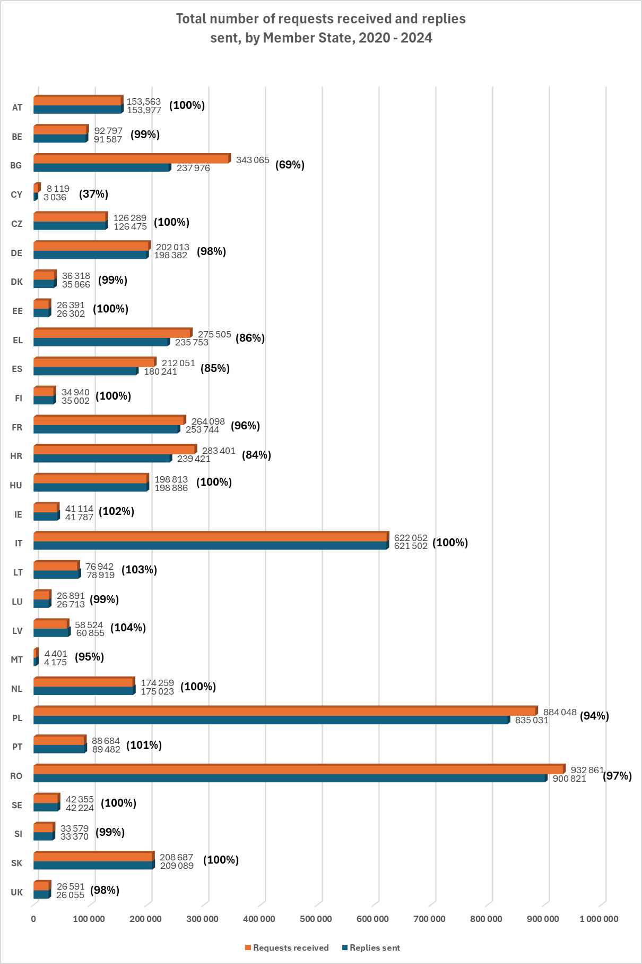
Member States sent a total of nearly 5.2 million replies to requests for information in 2020-2024. The number of requests received in this period varied significantly among Member States, from 933 000 received by Romania and 884 000 - by Poland to 4 400 requests received by Malta. Two factors, in particular, explain these variations: the overall population of the Member State and the number of its nationals residing in other Member States.
The Member States which responded to the highest number of requests in absolute terms (i.e. not necessarily the highest in proportion to what they received) in the five-year reporting period were Romania (901 000 replies – 17.5% of all replies sent through ECRIS), Poland (835 000 – 16%) and Italy (621 000 – 12%).
While all Member States respond to requests in general, in 2020-2024 still 317 000 requests for information received no reply As many as one third of Member States sent fewer replies than the number of requests they received, with an average of around 5.8% of requests remaining unanswered, up from 4.1% in 2019 and 3.6% in 2016. This growing tendency not to fulfil the obligation to respond to requests for information is alarming, given its potentially tragic consequences.
Among the Member States that received the highest number of requests, Bulgaria failed to reply to 31% of requests received (105 000), Croatia to 15.5% (44 000), Spain to 15% (39 800), Greece to 14% (39 800), Poland to 5.5% (49 000), France to 4% (10 400) and Romania to 3.4% (32 000). Italy, the Member State that received the third-highest number of requests, succeeded in responding to nearly all of them.
Cyprus was the Member State with the highest percentage of requests not replied to (62% of the requests received). By contrast, in Latvia, Lithuania, Ireland and Portugal, the number of replies sent in this period exceeded the number of requests received by 1-4%, which could be the result of sending the backlog of replies. For a detailed analysis of individual Member State statistics on replies to requests, see Section 3 of the SWD.
- Growing number of unanswered requests for information
While all Member States reply to requests in general, in 2020-2024 317 000 requests for information received no reply. This corresponds to 5.8% of all requests, up from 4.1% in 2019. The growing tendency of violating the obligation to reply to requests for information is alarming, given its potentially tragic consequences. The Member States which failed to reply to the highest percentage of the requests received by them were Cyprus, Bulgaria, Croatia, Spain and Greece.

2.7. Replies not meeting legal deadlines
Another recurring issue is the failure to reply to requests within the legal deadlines. The graphs below provide an overview for all Member States of the total volumes and percentages of replies sent after the legal deadlines in 2020-2024, and an overview of requests for which the deadline to reply expired, registered at the end of each calendar year.
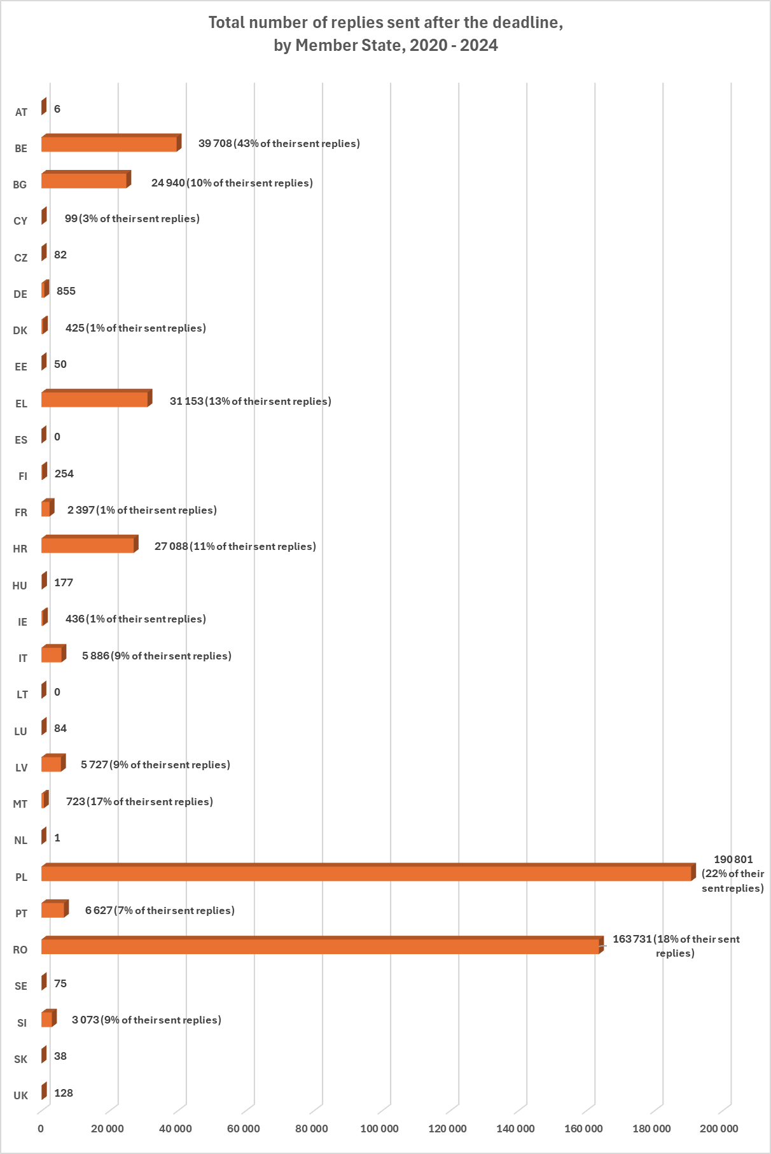
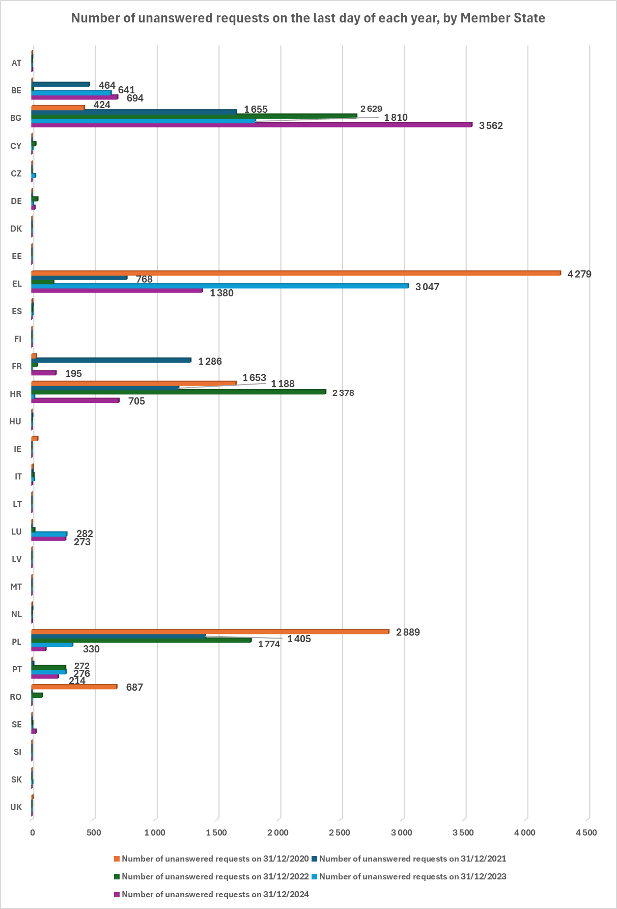
Over 500 000 replies were sent after the legal deadline in 2020-2024, which amounts to 9.7% of the total number of replies sent during that period. In addition, 38 000 requests for which the deadline to reply expired were registered, amounting to 0.7% of all requests.
These numbers demonstrate a significant improvement replying to requests in a timely manner. In comparison with the reference data for 2019, the number of late replies dropped by half and the number of requests for which the deadline expired diminished over five times.
Despite the overall decrease in the number of replies not meeting legal deadlines, the problem of late replies, which was already noted in the previous Statistical Reports, persists in several Member States. While the great majority of Member States remains under 0.5% of late replies, the struggling with respecting deadlines concerns mainly those Member States that were confronted with a huge volume of requests for information (PL: 22% of their replies were sent late in 2020-2024, amounting to 190 800 late replies), RO (18%; 163 700), EL (13%; 31 200), HR (11%; 27 000), BG (10%; 24 900), IT (9%; 5 900)), but also several other Member States (BE (43%; 39 700), MT (17%; 700), LV (9%; 5 700), SI (9%; 3 000), PT (7%; 6 600)).
The problem of requests for which the deadline to reply expired, resulting in either late replies or no reply at all, was marginal. It concerned 3.5% of requests in Greece (9.600 requests with expired deadline), 3% of requests in Bulgaria (10.100), 2% of requests in Croatia (5.900), 2% of requests in Belgium (1.800), 2% of requests in Luxembourg (600), 1% of requests in Poland (6.500) and 1% of requests in France (1.600).
- Significant improvement in replying to requests within the deadline
Compared to the reference data for 2019, the number of late replies dropped by half in the period of 2020-2024, and the number of requests for which the deadline to reply had expired diminished over 5 times. Still, 500 000 replies were sent after the legal deadline (9.7% of the total number of replies), and 38 000 requests for which the deadline to reply expired were registered (0.7% of all requests).
The problem of late replies concerned mostly the Member States that were confronted with a huge volume of requests for information (Poland, Romania, Greece, Croatia, Bulgaria and Italy), but not only (Belgium and Malta).

2.8. Requests for the purpose of criminal proceedings and for other purposes
The graphs below illustrate the respective proportions of requests for the purpose of criminal proceedings and requests for other purposes in the 2020-2024 reporting period as a whole and per year.
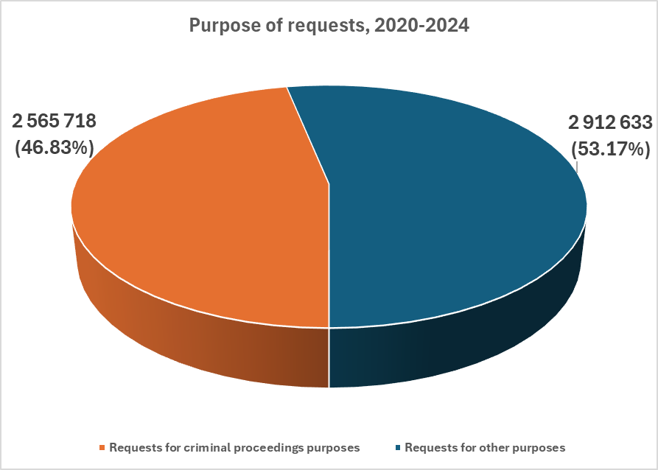

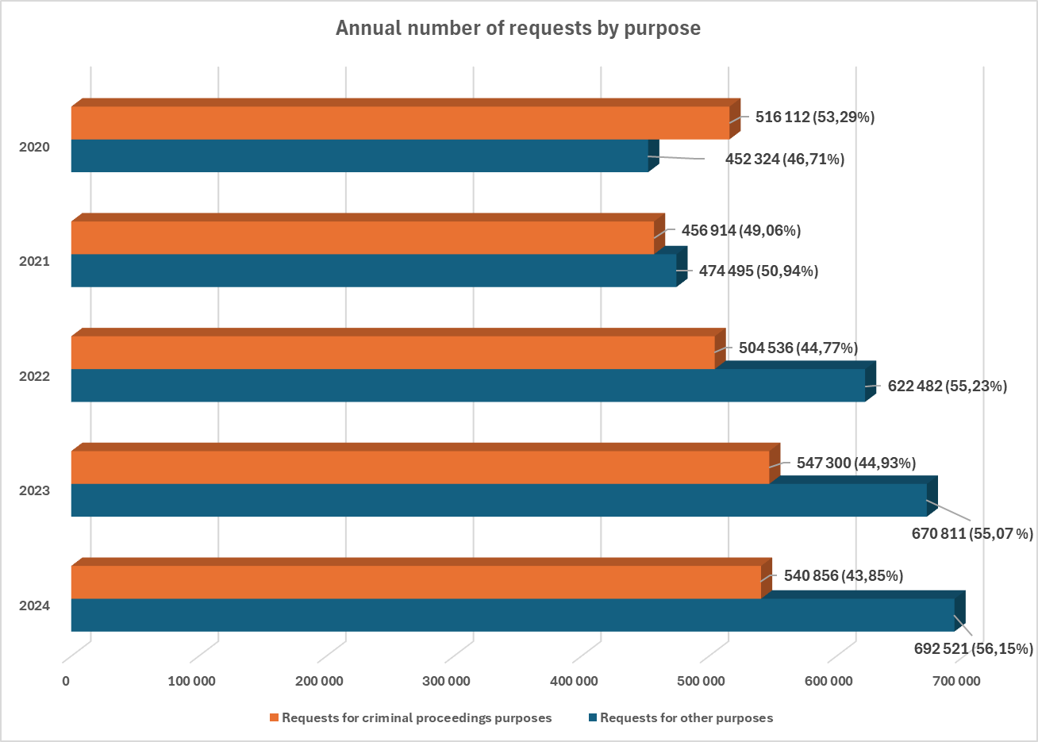
For many years the share of requests for purposes other than criminal proceedings averaged 20% of all requests. As mentioned above, the year 2019 saw a fundamental shift in the use of the system, which started to be consulted equally often for the purposes other than criminal proceedings as for the criminal proceedings (50/50%).
This tendency continued over the following years, and in 2024 requests for purposes other than criminal proceedings reached 56% of all requests, amounting to 692 500. The number of requests for the purpose of criminal proceedings remained stable, at around 540 000.
The increase in requests for purposes other than criminal proceedings is due mainly to the strong increase in requests for the purpose of recruitment for professional or organised voluntary activities involving direct and regular contact with children, in line with Directive 2011/93/EU. A total of 233 400 such requests were sent in 2024, significantly up from the 115 000 sent in 2019. The second contributing factor was a near-doubling of the number of general requests for administrative purposes compared to 2019, resulting in 34 100 such requests in 2024. Thirdly, the number of requests related to employment vetting was seven times higher in 2024 than in 2019, at 14 000. The annual number of requests made by individuals for their own criminal record has remained at nearly the same high level since 2019 of 380 400 requests.
Germany is the Member State mainly responsible for the increase in the number of requests for purposes other than criminal proceedings, with nearly 2 million such requests (68% of all requests for other purposes) sent in 2020-2024.
In 2024, most requests for purposes other than criminal proceedings were still made by individuals seeking to obtain information on their own criminal record: 55% of requests for purposes other than criminal proceedings and 31% of all requests sent. However, the share of requests for such purposes dropped from 70% in the reference year 2019. The second-highest number of requests related to recruitment in accordance with Directive 2011/93/EU (34% of requests for purposes other than criminal proceedings, up from 22% in 2019). The share of general requests for administrative purposes increased from 3.8% of requests for purposes other than criminal proceedings in 2019 to 5% in 2024 (and 3% of all requests), the third-highest share. The number of requests for the purpose of obtaining a different nationality was four times higher in 2024 than in 2019, and was placed on the fourth position with 2.5% (17 400). Finally, requests related to employment vetting amounted to 2% of requests for purposes other than criminal proceedings.
As the use of categories of requests purposes, when requesting information via ECRIS, varies a lot between the Member States, it is not possible to draw firm conclusions from the current statistics regarding the number of requests in each sub-category. Some Member States tend to use only general request categories, e.g. ‘administrative purpose’ or ‘employment vetting’, instead of indicating the specific purpose of the request.
The statistics also reveal that several Member States use ECRIS exclusively or almost exclusively for the purpose of criminal proceedings (Belgium – 100% of their requests; Hungary and Slovenia – 99 %; Croatia and Luxembourg – 96%; Ireland- 93%; Italy – 91%; Slovakia - 86%). On the other hand, some Member States request information almost exclusively for purposes other than criminal proceedings (Spain - 97% of their requests; Greece - 93%; Czechia – 88%; Cyprus – 97% of their requests in 2022 and 2024). Both of these tendencies lead to lack of vital information, which might have tragic consequences.

2.9. Requests concerning EU nationals and Third Country Nationals (TCN)
- ECRIS used more frequently for the purposes other than criminal proceedings than for the purpose of criminal proceedings!
A fundamental shift in the use of ECRIS began in 2019, with the system being consulted increasingly more often for purposes other than criminal proceedings (e.g. pre-employment screening, requests on one’s own criminal record, etc.). In 2024 these requests reached 56% of all requests sent, amounting to 692 500 requests.
This increase is due mainly to three factors. Firstly, a doubling compared to 2019 of the number of requests for the purpose of recruitment for activities involving contact with children, in line with Directive 2011/93/EU (233 400 requests, accounting for 34% of requests for purposes other than criminal proceedings). Secondly, a high number of requests by individuals for information on their own criminal record (380 400 requests, 55%). Thirdly, a near-doubling of general requests for administrative purposes (34 100 requests, 5%).

The graphs below represent the respective proportions of requests concerning EU nationals and requests concerning TCN in the 2020-2024 reporting period as a whole and per year.

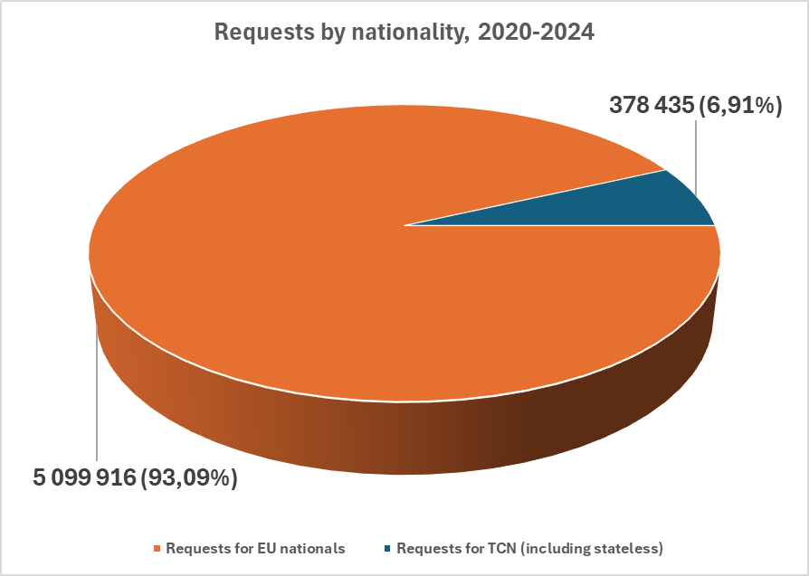

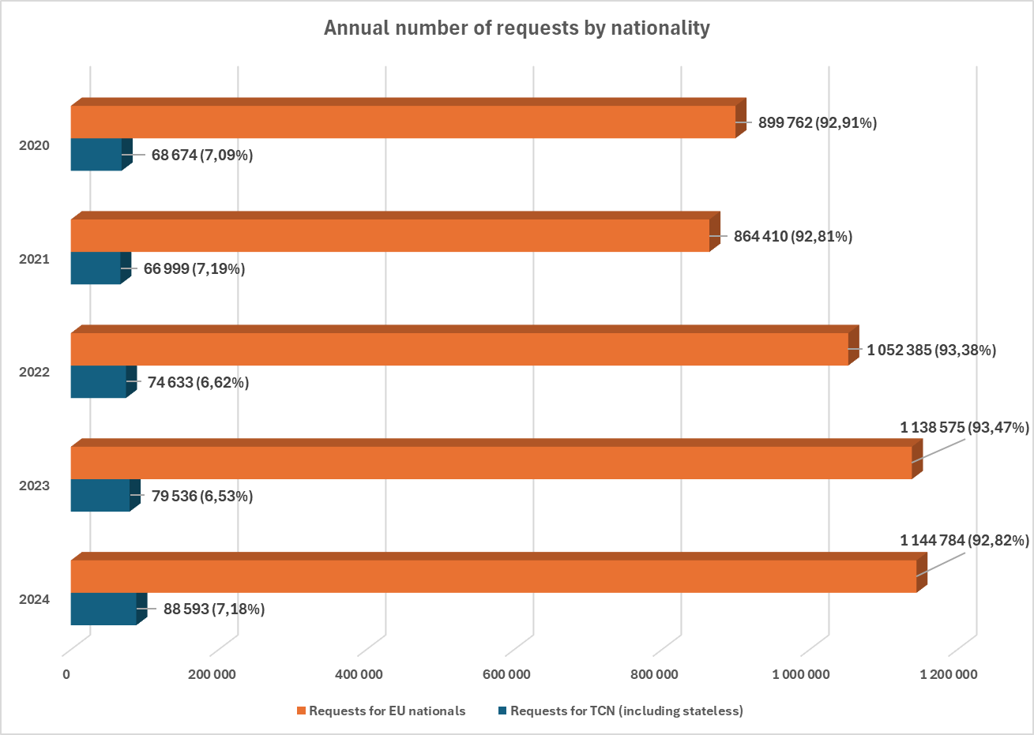
On average, 93% of all requests sent in 2020-2024 concerned EU nationals, while around 7% (378 400 requests) concerned TCN. The share of requests for stateless persons was negligible (0.01%, 550 requests).
Although the share of requests for information on TCN has remained at the same level since 2019, the actual number of such requests has been growing steadily to reach 88 600 in 2024.
In 2019, supplementary legislation was adopted establishing a centralised ECRIS-TCN system allowing for efficient identification of the Member States holding criminal records information on TCN convicted in the EU. Once the system becomes operational, it will enable more efficient exchanges through ECRIS of information on TCN, which is expected to lead to a considerable increase in the number of requests for information.
- ECRIS still rarely used for TCN
In 2020-2024, on average 93% of all requests concerned EU nationals, while around 7% concerned third country nationals and stateless persons. The number of requests for information on TCN has grown steadily since 2017 to exceed 88 000 in 2024. The entry into operation of ECRIS-TCN is expected to lead to a considerable increase in the number of exchanges concerning TCN through ECRIS.

2.10. Replies containing information on convictions
The graphs below show the respective proportions of replies to requests containing information on one or more convictions, replies with no convictions, denials of requests and other replies in the 2020-2024 reporting period as a whole and per year.

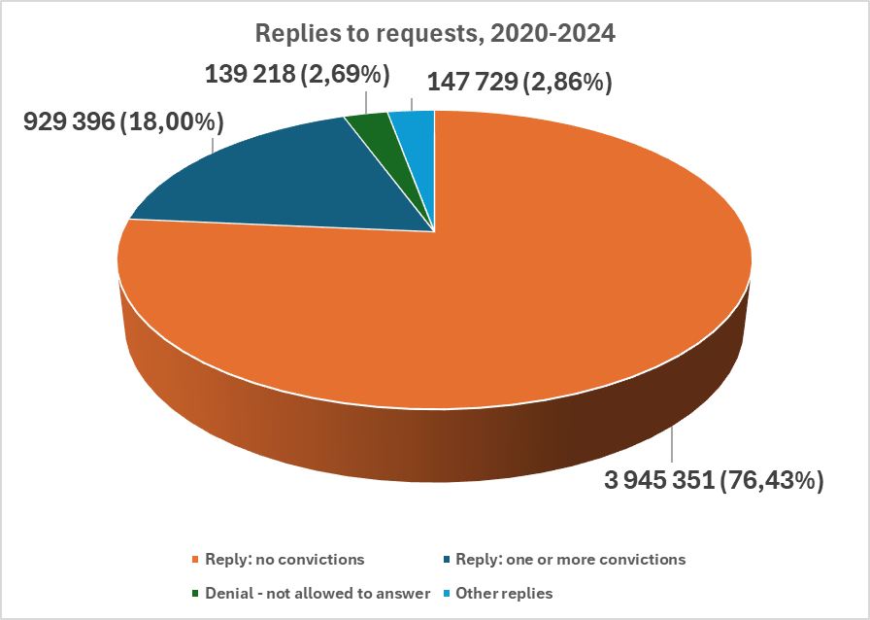

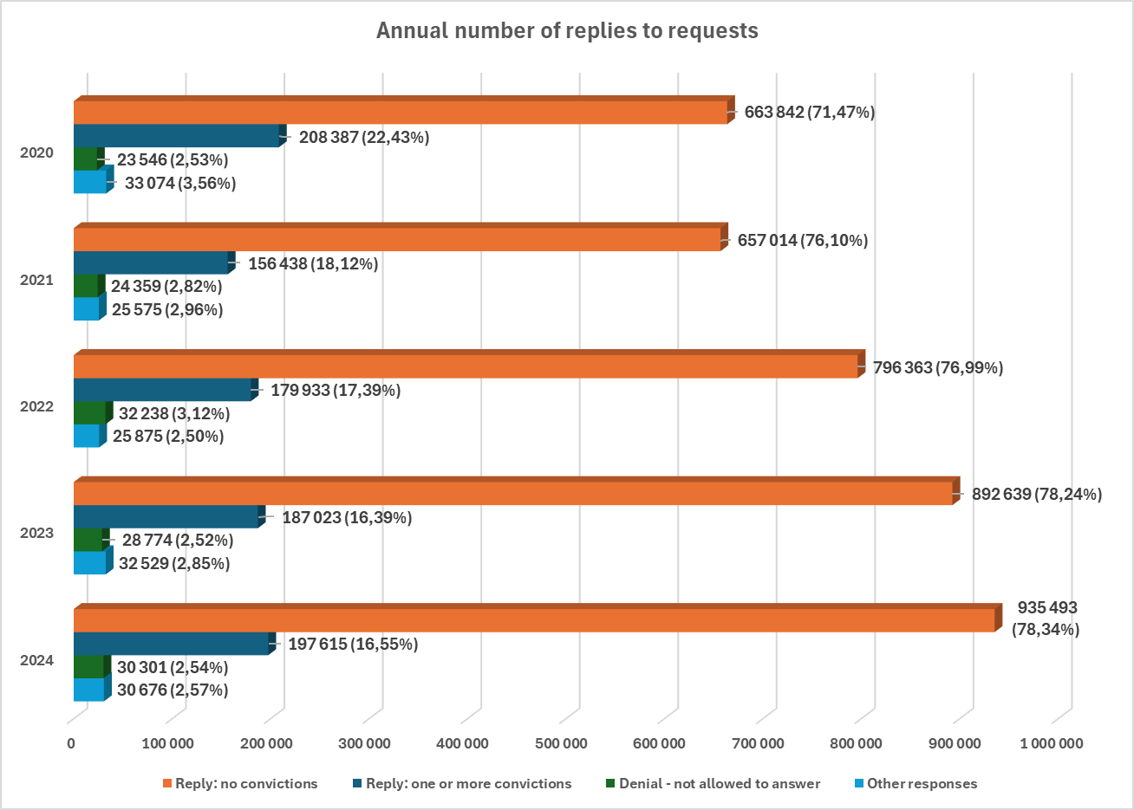
In the 13 years since ECRIS became operational, 23% of replies on average have contained information on previous convictions. This means that in nearly one case in four, the person concerned had been previously convicted one or more times, proving the value of ECRIS as a tool for obtaining information on criminal records.
For many years, this percentage remained stable at the level of around 30%, before dropping suddenly to 19% in 2019, and then to 16.6% in 2024, in parallel to the dramatic growth of the number of requests for purposes other than criminal proceedings. It is a positive sign that the majority of individuals being the subject of a request for information related to, for example, recruitment checks, obtaining a licence or for administrative purposes have not had any previous convictions.
In 2024 the replies including conviction information represented 197 600 replies to all requests for information (up from 188 000 in 2019). Replies with no conviction information accounted for 78% of all replies, with other replies and requests denials accounting for 5% of the total.
- Only 16.6% of replies revealed the existence of previous criminal convictions
In the 13 years since ECRIS became operational, on average 23% of requests for information received replies containing information on previous criminal convictions of a person concerned. With the dramatic rise since 2019 in the number of requests for purposes other than criminal proceedings, where persons concerned have not been usually convicted before, this percentage has continued to drop, reaching 16.6% in 2024. Yet again, over 197 000 replies that year contained information on previous convictions.

OJ L 93, 7.4.2009, p. 23 - as amended by Directive (EU) 2019/884, OJ L 151, 7.6.2019, p. 143.
OJ L 93, 7.4.2009, p. 33. This Decision was replaced by Directive (EU) 2019/884 with regard to the Member States bound by the Directive - as from 28 June 2022.
COM/2017/341 final; SWD/2017/242 final.
COM/2020/778 final; SWD/2020/378 final.
Based on Article 13a(3) of Framework Decision 2009/315/JHA.
See Section 2.9.
The United Kingdom was an EU Member State until 31 January 2020, but on the basis of Article 127(1) of the Withdrawal Agreement, it continued to exchange information via ECRIS during the transition period that ended on 31 December 2020. Currently, the UK exchanges information on criminal records with EU Member States on the basis of the Trade and Cooperation Agreement.
For a detailed description of the general principles governing the exchange of information via ECRIS, see Section 1 of the SWD.
For the history of connection to the ECRIS network, see Section 2.1 of the SWD.
This number takes into account the current number of Member States, after the Brexit, i.e. 27 (27*26).
Other replies are for example replies with multiple persons found, with a person not being a national of the requested Member State, etc.
This increase was caused primarily by the UK sending 95 000 backlog notifications in 2020 (triple the usual number of notifications sent annually by the UK) before exiting ECRIS.
As indicated in Section 2.4. below.
The period 2017-2019, covered by the Second Statistical Report.
OJ L 220, 15.8.2008, p. 32.
For the annual data in this period, see Section 2.2. of the SWD.
Similarly, Austria (226 300 requests sent, 154 000 requests received) and Czechia (191 300 sent, 126 500 received).
Similarly, France (254 000 replies given versus 83 500 requests sent), Croatia (239 400 v. 16 300), Bulgaria (238 000 v. 1 300), Greece (236 000 v. 12), Slovakia (209 000 v. 6 400) and Hungary (199 000 v. 2 700).
For the annual data during this period, see Section 2.3 of the SWD.
See statistics from Eurostat: https://ec.europa.eu/eurostat/statistics-explained/index.php?title=File:Non-national_population_by_group_of_citizenship,_1_January_2024.png.
Belgium, Bulgaria, Cyprus, Czechia, Germany, Estonia, Greece, Spain, Finland, Croatia, Hungary, Italy, Latvia, Malta, the Netherlands, Poland, Portugal, Sweden and the United Kingdom.
For a detailed analysis of individual Member State statistics on convictions and notifications, see Section 3 of the SWD.
For the annual data over the course of this period, see Section 2.4 of the SWD.
Followed by Czechia (3.5% of all requests sent in 2020-2024), Sweden (2.6%), Portugal (2.5%) and the Netherlands (2.2%).
Bulgaria sent a total of 1 300 requests in 2020-2024, while Estonia sent 4 350, Hungary - 2 700, Ireland - 5 100, Italy - 4 800, Latvia - 1 800, Malta - 370 and Slovenia - 2 500.
For the annual data in this period, see Section 2.5 of the SWD.
Followed by several Member States that each accounted for around 5% of all replies sent through ECRIS: France (254 000 replies sent), Croatia (239 000), Bulgaria (238 000) and Greece (235 800).
See Section 1.2 above.
For more details, see the SWD: annual data on replies sent after the legal deadline are provided in Section 2.6, and individual Member State statistics on late replies in Section 3.
190 000 late replies (18.4% of all replies); 42 000 requests for which the deadline to reply expired.
With the exception of France.
Directive 2011/93/EU on combating the sexual abuse and sexual exploitation of children and child pornography, OJ L 335, 17.12.2011, p. 1.
19% of all requests made.
For more details on the number of requests for various categories of purposes in 2020 – 2024, see Section 2.7 of the SWD.
See also the table in Section 2.8 of the SWD.
Regulation 2019/816/EU establishing ECRIS-TCN, OJ L 135, 22.05.2019, p. 1; Directive 2019/884/EU.
See footnote 11. See also the table in Section 2.9 of the SWD.

