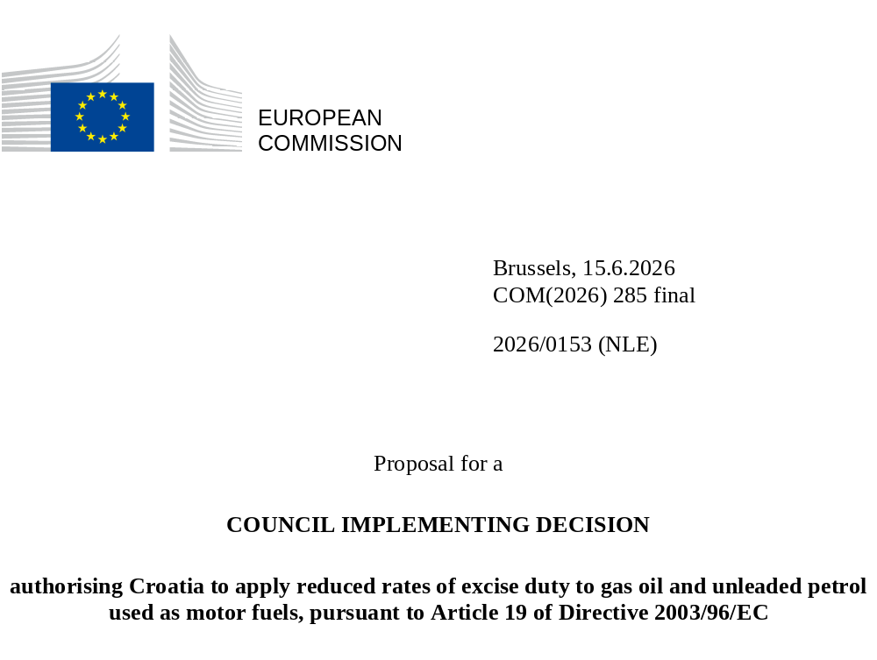

EXPLANATORY MEMORANDUM

1. CONTEXT OF THE PROPOSAL

• Reasons for and objectives of the proposal
Taxation of energy products and electricity in the Union is governed by Council Directive 2003/96/EC of 27 October 2003 restructuring the Community framework for the taxation of energy products and electricity (the ‘Energy Taxation Directive’ or the ‘Directive’).
Pursuant Article 19(1) of the Directive, in addition to the provisions laid down in particular in Articles 5, 15 and 17, the Council, acting unanimously on a proposal from the Commission, may authorise any Member State to introduce further exemptions or reductions in the level of taxation for specific policy considerations.
By letter dated 2 April 2026, the Croatian authorities informed the Commission of their intention to apply for an authorisation to apply a temporary reduction of the national tax rates for unleaded petrol and gas oil used as motor fuels, which go below the minimum levels of taxation as laid down in Article 7 and Table A of Annex I to the Directive.
By emails dated 29 April 2026 and 7 May 2026 the Croatian authorities replied to additional information requests from the European Commission.
The requested reduction is 0.2195 EUR per litre for unleaded petrol and 0.225 EUR per litre for gas oil used as motor fuels.
The requested period of validity is for a period of 6 months starting as soon as the decision is adopted by the Council, which is within the maximum period allowed by Article 19(2) of the Energy Taxation Directive.
According to the Croatian authorities, the aim of the measure is to alleviate the high retail prices of gas oil and petrol in the country, resulting from the recent geopolitical developments, and directly affecting both households and companies.
In response to the 2022 energy crisis, as a result of the Ukraine war, three derogations from the Energy Taxation Directive were granted to Member States with the objective to mitigate the high retail fuel prices resulting from the geopolitical developments at the time and directly affecting both households and companies.
In its conclusions of 19 March 2026, the European Council underlined that the energy transition remains the most effective strategy for achieving Europe’s strategic autonomy, strengthening resilience, structurally lowering energy prices, and delivering the clean, abundant and homegrown energy needed to power the economy of the future.
At the same the European Council recognised that targeted solutions are needed in the short term to ensure affordable energy, taking into account technological neutrality and the specific situations of Member States, the particular exposure of certain industrial sectors to the risk of relocation, and the need to improve the conditions for energy-intensive innovative sectors, without undermining predictability and the level playing field.
In view of this, the European Council called on the Commission to present without delay a toolbox of targeted temporary measures to address the recent spikes in the prices of imported fossil fuels arising from the crisis in the Middle East. The European Council Conclusions provide political guidance from the Member States and constitute a political mandate to adopt fiscal measures allowing for the requested flexibilities. These Conclusions clearly advocate for the full utilisation of the derogations and flexibilities foreseen in the Energy Taxation Directive, including the adoption of temporary reduced rates, carefully linked to the extraordinary circumstances and the objectives of energy affordability.
The objectives of such measures would be to enable Member States to develop targeted and temporary solutions to deal with the negative impact of the current energy crises on prices. These are needed in the short term to ensure affordable energy, taking into account technological neutrality and the specific situations of Member States, the particular exposure of certain industrial sectors to the risk of relocation, and the need to improve the conditions for energy-intensive innovative sectors, without undermining predictability and the level playing field.
Since the outbreak of the conflict on 28 February 2026 and the ensuing disruption of the Strait of Hormuz the oil price (Brent) has risen from around 60 EUR/barrel to more than 90 EUR/barrel. Following this price hike, the average fuel prices in Croatia were reported as follows:
 | Petrol (Super 95) | Gas oil
30/03/26 | €1.68 | €1.88
23/03/26 | €1.57 | €1.69
16/03/26 | €1.55 | €1.67
09/03/26 | €1.50 | €1.54
02/03/26 | €1.48 | €1.51
23/02/26 | €1.47 | €1.49
16/02/26 | €1.46 | €1.50
Looking at the energy prices development of oil within the period of this derogation, prices are expected to continue to be elevated. After that, expectations depend heavily on the duration of the conflict in the Middle East and the the disruption of the Strait of Hormuz.
Oil prices are expected to remain elevated while the conflict and the disruption of the Strait of Hormuz is ongoing. The fuel prices follow the dynamics of crude oil price with a delay of a week or two, with the distinction that gasoline prices tend to react less directly to oil prices, while diesel and jet fuel that EU is importing tend to be more volatile than crude oil prices.
The global nature of oil prices and the limited influence Member States have on those prices, makes this crisis an exogenous crisis. All EU Member States will be subject to similar global prices for energy products. The ability to cope with price increases will, however, differ significantly, for instance dependant on income, transport mode, heating source and the energy efficiency of housing. This will make effects of price increases asymmetrical. Additionally, lower income households tend to spend a larger part of their income on consumption, instead of investments or savings. This makes increases in consumption prices more impactful for lower income households.
Since the outbreak of the war on 28 February 2026 and the resulting increase in energy prices, the Government of the Republic of Croatia adopted, on 10 March 2026, an amendment to the Regulation on Excise Duty on Energy and Electricity, with the aim of mitigating the increase in the retail price of energy products. This amendment reduced the excise duty on gas oil used as motor fuel by EUR 0.02 per litre.
At the same time, through the Regulation on Determining the Maximum Retail Price of Petroleum Products, the Government introduced a cap on the retail prices of energy products by limiting trade margins, setting a maximum premium for energy undertakings of EUR 0.1735 per litre for both unleaded petrol and gas oil used as motor fuels.
As the war continued and energy prices on the international market increased further, the Government of the Republic of Croatia adopted, on 24 March 2026, a second amendment to the Regulation on Excise Duty on Energy and Electricity. This amendment reduced the excise duty on unleaded petrol by EUR 0.06 per litre and gas oil used as motor fuel by EUR 0.07613 per litre.
In addition, the premiums for energy undertakings were further reduced, to EUR 0.1545 per litre for unleaded petrol and EUR 0.1245 per litre for gas oil used as motor fuels.
Despite the above measures, retail prices of energy products remain significantly higher than those observed prior to the outbreak of the war in the Middle East. As of 24 March 2026, the retail price of unleaded motor petrol was 12% higher compared to 24 February 2026 (i.e. before the outbreak of the conflict), while the retail price of diesel fuel was 19% higher over the same period.
As a result of the above amendments, the currently applicable excise duty on gas oil used as motor fuel has reached the minimum level laid down by EU law. Consequently, the Government of the Republic of Croatia no longer has scope to further reduce retail prices through additional reductions in excise duty on gas oil used as motor fuel, while for unleaded petrol a margin for further reduction remains, amounting to EUR 0.09331 per litre.
In this context, it should be noted that in 2025, the quantities of energy products released for consumption for propulsion purposes in the Republic of Croatia were predominantly composed of diesel fuel, which accounted for 77% of total consumption. This highlights the particularly significant impact of retail diesel fuel prices on the social and economic conditions of citizens, as well as on the functioning of the economy.
Due to its specific geographical characteristics and insufficiently developed railway infrastructure, the Republic of Croatia is highly dependent on road transport for both passengers and goods, as well as on the use of private cars and buses for daily commuting.

• Consistency with existing policy provisions in the policy area
Article 19(1), first subparagraph of the Directive reads as follows:
‘In addition to the provisions set out in the previous Articles, in particular in Articles 5, 15 and 17, the Council, acting unanimously on a proposal from the Commission, may authorise any Member State to introduce further exemptions or reductions for specific policy considerations.’
By means of the tax reduction in question, the Croatian authorities intend to mitigate the high retail prices of transport fuels, gas oil and petrol triggered by the conflict in the Middle East and ultimately pursue the objective to reduce the social and economic impacts of the current geopolitical situation affecting both households and companies.
These tax reductions would lead to a situation where beneficiaries would be charged with national rates, which can fall below the EU minimum tax rates under the Energy Taxation Directive, hence the authorisation under discussion. This can contribute to the stated policy objectives.
The possibility to introduce such a tax reduction can be envisaged under Article 19 of the Directive since its purpose is to allow Member States to introduce further exemptions or reductions for specific policy considerations.
The limited period of validity of the authorisation of 6 months after the Council Implementing Decision takes effect, is within the maximum period allowed by Article 19(2) of the Energy Taxation Directive, with the possibility of renewal.
Finally, the tax reduction is not cumulative with any other sorts of tax reduction.
Under these circumstances, it appears appropriate to grant the authorisation for the requested period.
At the same time, untargeted tax reductions imply significant fiscal costs and tend to increase fossil fuel demand, thereby exacerbating the imbalance of supply and demand. Therefore, the measure should remain strictly limited in time and its expected impact on fossil fuel demand as well as its fiscal cost should be assessed. Where needed, compensatory measures should be taken.
State aid rules
The temporary tax reduction requested by the Croatian authorities will go below the minimum levels of taxation of transport fuels as laid down in Article 7 and Table A of Annex I to the Directive by 0.2195 EUR per litre for unleaded petrol and 0.2250 EUR per litre for gas oil used as motor fuels.
The present proposal is without prejudice to any assessment of the Croatian measure under State aid rules. Moreover, the proposal for a Council implementing decision does not prejudge the Member State’s obligation to ensure compliance with State aid rules.

• Consistency with other Union policies
Each draft derogation under Article 19 of the Energy Taxation Directive must be examined by the Commission taking into account the proper functioning of the internal market, the need to ensure fair competition and EU health, environment, energy and transport policies.
According to the Croatian authorities, the envisaged tax reduction should partially alleviate the social and economic burden of the Croatian population due to the recent transport fuels price increase resulting also from the conflict in Iran and the disruption in the Strait of Hormuz.
As a result of this exceptional situation, this temporary measure is not likely to affect intra-EU trade. Overall, the measure seems acceptable from the point of view of the proper functioning of the internal market and the need to ensure fair competition. Given its limited effects and the limited duration, the measure should not distort competition or hinder the functioning of the internal market.
Environmental and climate policy
The Union remains firmly committed to its climate and energy objectives, as stated in the European Climate Law (Regulation 2021/1119). The temporary tax reductions allowed by this act should not lead to a structural weakening of price signals that encourage energy efficiency and the transition to renewable energy sources.
Energy policy
Given the scale of the current energy price spike resulting from the situation in the Middle East, Member States require an ability to temporarily lower the excise rates below the EU minimum rates for products not covered by the above provision.
Given its short duration and the current exceptional circumstances linked to the geopolitical situation coupled with an exceptionally high market price of energy products, an ability to reduce excise rates below minimum rates established under Directive 2003/96/EC is considered adequate and proportionate to the need to balance out the specific policy objectives listed in Article 19 of the Energy Taxation Directive, and notably the EU’s environmental policy with the emergency imperative to ensure energy affordability for businesses and households.
Internal market policy and fair competition
As a result of the exceptional situation, this temporary measure is not likely to affect intra-EU trade. Overall, the measure seems acceptable from the point of view of the proper functioning of the internal market and the need to ensure fair competition. Given its limited effects and the limited duration, the measure should not distort competition or hinder the functioning of the internal market.
Social policy
The observed and expected increase in the cost of energy across the Union has a disproportionate impact on low-income households given that energy costs generally constitute a larger share of their budgets. Reductions in excise duties on energy products can therefore have a positive social impact by contributing to reducing energy costs for low-income households.

2. LEGAL BASIS, SUBSIDIARITY AND PROPORTIONALITY

• Legal basis
Article 19 of Council Directive 2003/96/EC.

• Subsidiarity (for non-exclusive competence)
The field of indirect taxation covered by Article 113 of TFEU is not in itself within the exclusive competence of the European Union within the meaning of Article 3 of TFEU.
However, pursuant to Article 19 of Directive 2003/96/EC, the Council has been granted an exclusive competence, as a matter of secondary law, to authorise Member States to introduce further exemptions or reductions within the meaning of that provision. Member States cannot therefore substitute themselves for the Council. As a result, the principle of subsidiarity is not applicable to the present implementing decision. In any event, since this act is not a draft legislative act, it should not be transmitted to national Parliaments pursuant to Protocol No 2 to the Treaties for review of compliance with the subsidiarity principle.

• Proportionality
The proposal respects the principle of proportionality. The tax reductions do not exceed what is necessary to attain the objective in question.
The authorisation is for a very limited period of time, namely for 6 months, and in an energy crisis context.

• Choice of the instrument
The instrument proposed is a Council implementing decision. Article 19 of Directive 2003/96/EC makes provision for this type of measure only.

3. RESULTS OF EX-POST EVALUATIONS, STAKEHOLDER CONSULTATIONS AND IMPACT ASSESSMENTS

• Ex-post evaluations/fitness checks of existing legislation
The measure does not require the evaluation of existing legislation.

• Stakeholder consultations
This proposal is based on a request made by Croatia and concerns only this Member State.

• Collection and use of expertise
There was no need for external expertise.

• Impact assessment
This proposal concerns an authorisation for an individual Member State upon its own request and does not require an impact assessment. In line with better regulation rules these types of acts are not subject to an impact assessment, by their nature.

• Regulatory fitness and simplification
The measure does not provide for a simplification. It is the result of the request made by Croatia and concerns only this Member State.

• Fundamental rights
The measure has no bearing on fundamental rights.

4. BUDGETARY IMPLICATIONS
The measure does not impose any financial or administrative burden on the Union. The proposal therefore has no impact on the budget of the Union.

5. OTHER ELEMENTS

• Implementation plans and monitoring, evaluation and reporting arrangements
An implementation plan is not necessary. This proposal concerns an authorisation for a tax reduction, which is provided for a limited period of time. The applicable tax rates can fall below the minimum levels of taxation set by the Energy Taxation Directive. The measure can be evaluated in case of a proposal to extend the validity of this Decision.

• Explanatory documents (for directives)
The proposal does not require explanatory documents on the transposition.

• Detailed explanation of the specific provisions of the proposal
Article 1 stipulates that Croatia will be allowed to apply reduced taxation rates to gas oil and unleaded petrol used as motor fuels, below the minimum levels of taxation.
Article 2 stipulates that the authorisation requested is granted for 6 months after the entry into force of the Decision, as requested by Croatia, within the maximum period of 6 years allowed by the Directive.

2026/0153 (NLE)
Proposal for a
COUNCIL IMPLEMENTING DECISION
authorising Croatia to apply reduced rates of excise duty to gas oil and unleaded petrol used as motor fuels, pursuant to Article 19 of Directive 2003/96/EC
THE COUNCIL OF THE EUROPEAN UNION,
Having regard to the Treaty on the Functioning of the European Union,
Having regard to Council Directive 2003/96/EC of 27 October 2003 restructuring the Community framework for the taxation of energy products and electricity, and in particular Article 19 thereof,
Having regard to the proposal from the European Commission,
Whereas:
(1) In the weeks preceding the adoption of this Decision, sharp and persistent increases in wholesale and retail prices of energy products have been observed across the Union, triggered by the geopolitical developments in the Middle East, which impacted supply chains of oil and oil products globally. These developments have had significant adverse effects on households, in particular vulnerable consumers, and on undertakings, including small and medium‑sized enterprises, thereby posing a serious risk to social cohesion, economic stability and the proper functioning of the internal market.
(2) In its Conclusions of 19 March 2026, the European Council recognised the extraordinary nature of the energy market situation and its macroeconomic implications. The Council invited the European Commission to work closely with Member States to design national temporary and targeted measures, to mitigate significant impacts of fuel price increases due to the crisis in the Middle East, and underlined in particular the need for a coordinated response as the conflict in the Middle East has an immediate impact on energy prices for European citizens and businesses.
(3) Excise duties as established by Directive 2003/96/EC contribute to the final cost of energy products supplied within the Union. A reduction in excise duties below the minimum rates can mitigate some of the energy cost increases currently experienced by Member States,
(4) The flexibilities provided by Directive 2003/96/EC enables Member States, within defined limits, to lower the tax burden on specific energy products in a targeted and temporary manner. In view of the exceptional and urgent nature of the current situation, it is necessary to provide for specific, time‑limited flexibilities explicitly aimed at alleviating the impact of the energy price shock.
(5) Temporary reductions in the taxation of targeted energy products can deliver rapid relief to households and undertakings by directly lowering end‑user prices. In the current situation, such extraordinary reductions are a suitable and necessary instrument to address the serious disturbance in the economy resulting from the energy price shock.
(6) By letter dated 2 April 2026, the Croatian authorities requested authorisation, pursuant to Article 19 of Directive 2003/96/EC, to apply reduced rates of excise duty to gas oil and unleaded petrol used as motor fuels which fall below the minimum levels of taxation applicable to motor fuel referred to in Article 7 of that Directive by 0.2195 EUR per litre for unleaded petrol and 0.225 EUR per litre for gas oil. The authorisation was requested for a period of 6 months.
(7) According to the Croatian authorities, the application of a reduced rate of excise duty aims to mitigate the impact of high retail prices of petrol and gas oil resulting from the geopolitical situation and directly affecting both households and companies.
(8) The requested authorisation has been reviewed by the Commission and been found unlikely to hinder the proper functioning of the internal market. Given its short duration and the exceptional circumstances linked to the geopolitical situation coupled with an exceptionally high market price of oil, the requested derogation has been found to be adequate and proportionate considering the need to strike a balance between the specific policy objectives listed in Article 19(1) of Directive 2003/96/EC, and in particular the Union environmental policy and the emergency imperative to ensure energy affordability for businesses and households.
(9) Croatia should therefore be authorised to temporarily apply reduced rates of excise duty below the minimum Union levels to unleaded petrol and gas oil used as motor fuels.
(10) In accordance with Article 19(2) of Directive 2003/96/EC, each authorisation granted under that provision is to be strictly limited in time. However, in order not to undermine future developments of the existing legal framework, it is appropriate to provide that, should the Council, acting on the basis of Article 113 or any other relevant provision of the Treaty on the Functioning of the European Union, introduce new minimum levels of taxation as referred to in Article 7 of Directive 2003/96/EC for gas oil and unleaded petrol used as motor fuels to which this authorisation would not be adapted, this authorisation should cease to apply.
(11) At the same time, untargeted tax reductions imply significant fiscal costs and tend to increase fossil fuel demand, thereby exacerbating the imbalance of supply and demand. Therefore, the measure should remain strictly limited in time.
(12) This Decision is without prejudice to the application of Union rules regarding State aid,
HAS ADOPTED THIS DECISION:
Article 1
Croatia is authorised to apply a reduction of up to 0.2195 EUR per litre for unleaded petrol used as motor fuels and up to 0.225 EUR per litre for gas oil used as motor fuels below the minimum rates of excise duty referred to in Article 7 of Directive 2003/96/EC.
Article 2
This decision shall apply for [6 months after the day of the notification].
However, in the event that the Council, acting on the basis of Article 113 or any other relevant provision of the Treaty on the Functioning of the European Union, modifies the minimum levels of taxation as referred to in Article 7 of Directive 2003/96/EC for gas oil and unleaded petrol used as motor fuels with which the authorisation granted in Article 1 of this Decision would not be compatible, this Decision shall cease to apply on the day on which that modified minimum levels of taxation become applicable.
Article 3
This Decision shall take effect on the date of its notification.
Article 4
This Decision is addressed to the Republic of Croatia.

Done at Brussels,
For the Council
The President

OJ L 283, 31.10.2003, p. 51–70.
Council implementing decision (EU) 2022/1843, Council implementing decision (EU) 2022/1662, Council implementing decision (EU) 2023/1197.
DG ENER, Weekly oil bulletin, 2 April 2026, https://energy.ec.europa.eu/data-and-analysis/weekly-oil-bulletin_en.
DG ENER, Weekly oil bulletin, 2 April 2026, https://energy.ec.europa.eu/data-and-analysis/weekly-oil-bulletin_en.
Economic and distributional effects of higher energy prices on households in the EU - Employment, Social Affairs and Inclusion
OJ L 283, 31.10.2003, p. 51, ELI: http://data.europa.eu/eli/dir/2003/96/oj.
https://www.consilium.europa.eu/media/lwhk3itd/en-20260319-european-council-conclusions.pdf

