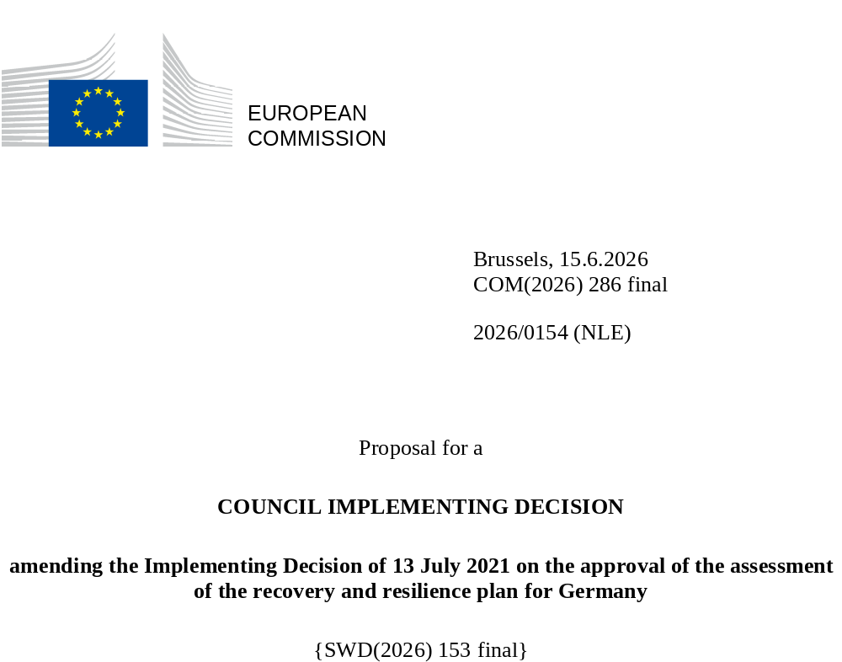

2026/0154 (NLE)
Proposal for a
COUNCIL IMPLEMENTING DECISION
amending the Implementing Decision of 13 July 2021 on the approval of the assessment of the recovery and resilience plan for Germany
THE COUNCIL OF THE EUROPEAN UNION,
Having regard to the Treaty on the Functioning of the European Union,
Having regard to Regulation (EU) 2021/241 of the European Parliament and of the Council of 12 February 2021 establishing the Recovery and Resilience Facility, and in particular Article 20(1) thereof,
Having regard to the proposal from the European Commission,
Whereas:
(1) Following the submission of the national recovery and resilience plan (‘RRP’) by Germany on 28 April 2021, the Commission proposed its positive assessment to the Council. On 13 July 2021, the Council approved the positive assessment by means of an implementing decision (‘the Council Implementing Decision of 13 July 2021’). The Council Implementing Decision of 13 July 2021 was amended by the Council Implementing Decisions of 14 February 2023, 8 December 2023, 16 July 2024, 8 July 2025 and 20 January 2026.
(2) On 29 May 2026, Germany made a reasoned request to the Commission to make a proposal to amend the Council Implementing Decision of 13 July 2021 in accordance with Article 21(1) of Regulation (EU) 2021/241 on the grounds that the RRP is partially no longer achievable because of objective circumstances. On that basis, Germany has submitted an amended RRP.
Amendments based on Article 21 of Regulation (EU) 2021/241
(3) The amendments to the RRP submitted by Germany because of objective circumstances concern five measures.
(4) Germany has explained that one measure is partially no longer achievable due to limited availability of standardised technical solutions in the market. This concerns measure 1.1.6 (Federal support for efficient heat networks). On this basis, Germany has requested that this measure be amended. The Council Implementing Decision of 13 July 2021 should be amended accordingly.
(5) Germany has explained that four measures have been amended to implement a better alternative that allows the administrative burden to be reduced and simplify the Council Implementing Decision, while still achieving the objectives of the measure. This concerns measure 2.1.1 (Innovative data policy for Germany), measure 2.2.3 (Digitalisation and technology research centre of the Bundeswehr), measure 6.1.3 (Digitalisation of the administration – modernisation of registers) and measure 7.1.3 (Digital platform for processing authorisation requests for the hydrogen core network). On this basis, Germany has requested that these measures be amended. The Council Implementing Decision of 13 July 2021 should be amended accordingly.
Corrections of clerical errors
(6) Two clerical errors have been identified in the text of the Council Implementing Decision, affecting two milestones and targets and two measures under two components. The Council Implementing Decision should be amended to correct these clerical errors that do not reflect the content of the RRP submitted to the Commission on 28 April 2021, as agreed between the Commission and Germany. Those clerical errors relate to target 5 of measure 1.1.1 (Hydrogen projects within the framework of IPCEIs) under component 1.1 (Decarbonisation using renewable hydrogen in particular) and milestone 41 of measure 1.2.7 (Promotion of the industries involved in hydrogen and fuel cell applications in transport) under component 1.2 (Climate-friendly mobility). Those corrections do not affect the implementation of the measures concerned.
Commission’s assessment
(7) The Commission has assessed the amended RRP against the assessment criteria laid down in Article 19(3) of Regulation (EU) 2021/241.
Contribution to the green transition including biodiversity
(8) In accordance with Article 19(3), point (e), of, and criterion 2.5 of Annex V to, Regulation (EU) 2021/241, the amended RRP contains measures that contribute to a large extent (rating A) to the green transition, including biodiversity, or to addressing the challenges resulting therefrom. The measures supporting climate objectives account for an amount which represents 44.1% of the amended RRP’s total allocation and 48% of the total estimated costs of measures in the REPowerEU chapter calculated in accordance with the methodology set out in Annex VI to Regulation (EU) 2021/241. In accordance with Article 17 of Regulation (EU) 2021/241, the amended RRP is consistent with the information included in the National Energy and Climate Plan 2021-2030.
(9) The only measure for which the estimated costing has been changed (1.1.6 Federal support for efficient heat networks) does not significantly impact the overall ambition of the RRP regarding the green transition. The climate contribution of the modified RRP has decreased from 44.9% to 44.1% compared to the amended assessment.
Any other assessment criteria
(10) The Commission considers that the amendments put forward by Germany do not affect the positive assessment of the RRP set out in the Council Implementing Decision of 13 July 2021 on the approval of the assessment of the RRP for Germany regarding the relevance, effectiveness, efficiency and coherence of the RRP against the assessment criteria laid down in Article 19(3), points (a), (b), (c), (d), (da), (db), (f), (g), (h), (i), (j) and (k).
Positive assessment
(11) Following the positive assessment by the Commission of the amended RRP, with the finding that the RRP satisfactorily complies with the criteria for assessment set out in Regulation (EU) 2021/241, in accordance with Article 20(2) of and Annex V to that Regulation, the reforms and investment projects necessary for the implementation of the amended RRP, the relevant milestones, targets and indicators, and the amount made available from the Union for the implementation of the amended RRP should be set out.
Financial contribution
(12) The estimated total costs of Germany’s amended RRP is EUR 30 336 828 678. As the amount of the estimated total cost of the amended RRP is higher than the updated maximum financial contribution available for Germany, the financial contribution determined in accordance with Article 4a of Regulation (EU) 2021/1755 of the European Parliament and of the Council, and with Article 20(4) and Article 21a(6) of Regulation (EU) 2021/241 that is allocated for Germany’s amended RRP should be equal to EUR 30 324 665 082. Therefore, the financial contribution made available to Germany remains unchanged.
(13) The Council Implementing Decision of 13 July 2021 should therefore be amended accordingly. For the sake of clarity, the Annex to the Council Implementing Decision of 13 July 2021 should be replaced entirely.
(14) This Decision should be without prejudice to the outcome of any procedures relating to the award of Union funds under any Union programme other than the Facility or to procedures relating to distortions of the operation of the internal market that may be undertaken, in particular under Articles 107 and 108 of the Treaty. It does not override the requirement for Member States to notify instances of potential State aid to the Commission under Article 108 of the Treaty,
HAS ADOPTED THIS DECISION:
Article 1
Approval of the assessment of the RRP
The assessment of the amended RRP for Germany on the basis of the criteria provided for in Article 19(3) of Regulation (EU) 2021/241 is approved.
Article 2
Amendments
The Council Implementing Decision of 13 July 2021 on the approval of the assessment of the recovery and resilience plan for Germany is amended as follows:
the Annex is replaced by the text set out in the Annex to this Decision.
Article 3
Addressee
This Decision is addressed to the Federal Republic of Germany.
Done at Brussels,
For the Council
The President

OJ L 57, 18.2.2021, p. 17, ELI: https://eur-lex.europa.eu/eli/reg/2021/241/oj
ST 10158/21 INIT; ST 10158/21 ADD 1.
ST 5536/23 INIT.
ST 15572/23 INIT.
ST 11674/24 INIT; ST 11674/24 COR 1; ST 11674/24 COR 2(sk); ST 11674/24 ADD1.
ST 10517/25 INIT; ST 10517/25 ADD 1.
ST 17026/25 INIT; ST 17026/25 ADD 1.
ST 10158/21 INIT; ST 10158/21 ADD 1.
Regulation (EU) 2021/1755 of the European Parliament and of the Council of 6 October 2021 establishing the Brexit Adjustment Reserve (OJ L 357, 8.10.2021, p. 1, ELI: http://data.europa.eu/eli/reg/2021/1755/oj).

