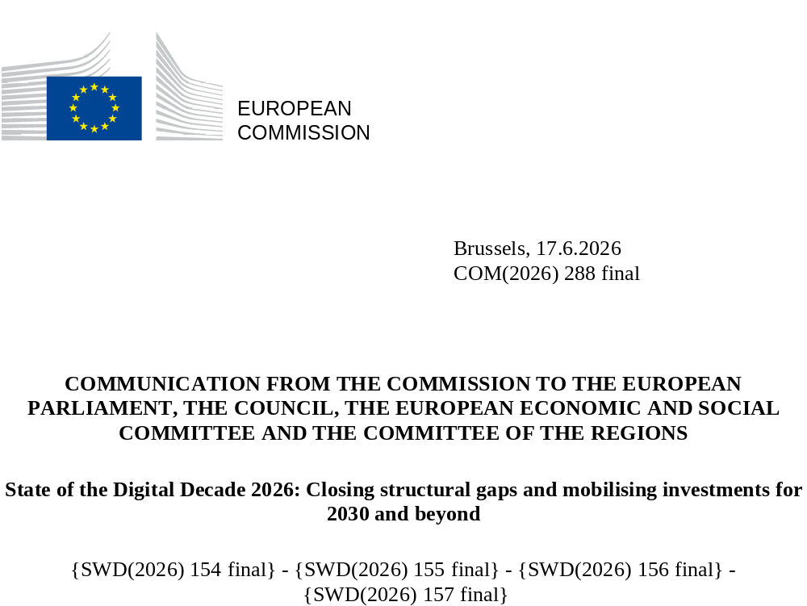

State of the Digital Decade 2026:
Closing structural gaps and
mobilising investments for
2030 and beyond

Introduction
In 2026, the EU is facing a combination of longstanding and emerging challenges to its economic and societal prosperity, competitiveness and strategic independence. Rapid technological change, intensifying global competition, geopolitical tensions and rising security risks are increasing the strategic importance of digital policy. Digital transformation is no longer only a matter of innovation and productivity; it is also increasingly tied to resilience, security and democratic stability in line with EU values. Meeting these challenges will largely depend on the success of a whole-of-society digital transformation, underpinning competitiveness, resilience and security while reducing excessive dependencies and strengthening the EU’s technological sovereignty. This requires action across the full digital chain: from education, foundational research and innovation to industrial scale-up, infrastructure deployment, adoption across the economy, effective public sector digitalisation and development of the skills and safeguards needed to ensure that digital transformation works for people.
The 2026 State of the Digital Decade Communication goes beyond stocktaking and identifies structural factors at the root of EU’s digital performance, priority reforms and investments. It concludes that, while tangible progress has been achieved since 2022, it remains insufficient to meet the EU’s objectives and address the above-mentioned challenges. The EU has advanced in a number of areas, including basic connectivity, business digitalisation and the deployment of common digital infrastructures. However, significant gaps persist in foundational technologies, computing capacity, cybersecurity, advanced digital uptake, digital skills and scale-up capacity, as well as inclusiveness and accessibility of digital technologies. These gaps point to four main aspects necessary to increase the EU’s digital leadership: consolidating the strategic technology base; strengthening the security and resilience of digital ecosystems; accelerating the diffusion and adoption of digital technologies across society and the economy; and ensuring that digital transformation works for people by increasing democratic resilience, digital skills levels and social inclusion.
A central message of this report is that delivery depends as much on investment and implementation as on strategy. Closing existing structural gaps will require a change in both the scale and coordination of investment and reforms. The coming period will therefore require a more coherent framework linking reforms, national delivery, EU funding instruments and private investment. This, in turn, will require, the EU, industry, Member States, industry and investors to join forces.
Since its adoption in 2022, the Digital Decade Policy Programme (DDPP) has emerged as a strategic anchor for identifying gaps and priorities and as an operational framework for delivering on Europe’s digital ambitions through a robust governance mechanism that drives recommendations, initiatives and coordinated action across the digital policy landscape (Figure 1). The DDPP combines common objectives and targets with a continuous monitoring cycle, Member States’ involvement, notably through National Digital Decade Strategic Roadmaps (national roadmaps) and EU-level coordination with Member States through the Digital Decade Board. The proposed framework for the next Multiannual Financial Framework (MFF) has further recognised the role of the Digital Decade in supporting Europe’s sustainable prosperity, competitiveness and technological sovereignty by providing that measures financed through the National and Regional Partnership Plans (NRPPs) should contribute to the implementation of recommendations issued under the Digital Decade Policy Programme, while digital investments supported by the forthcoming European Competitiveness Fund (ECF) should address the gaps and priorities identified in the State of the Digital Decade reports.
Figure 1: The Digital Decade objectives and targets and how they translate into EU policies and actions
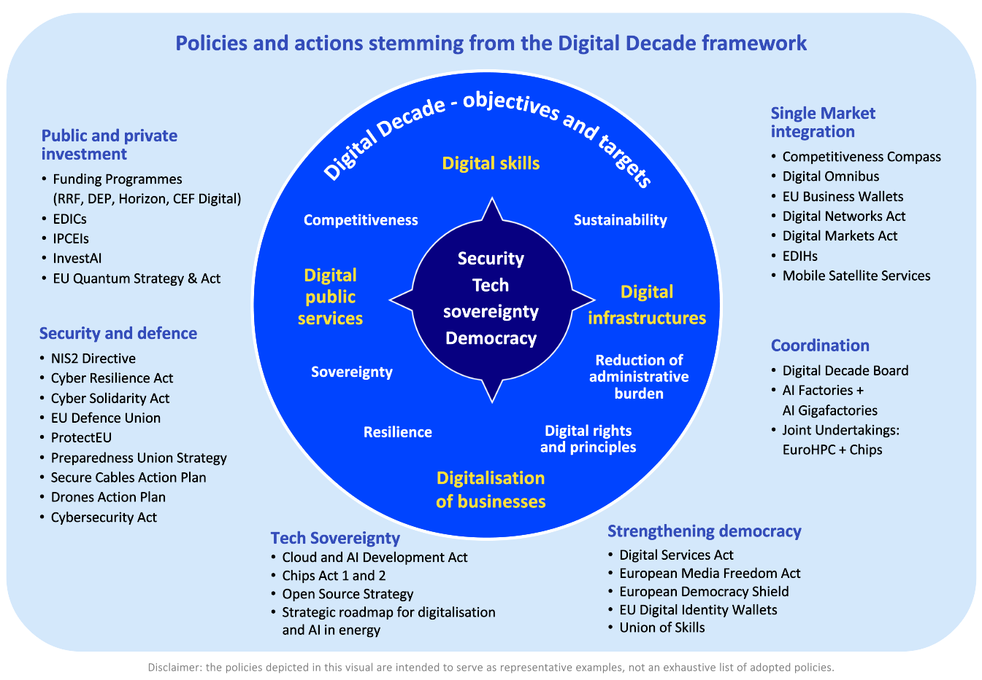
Further detailed analyses are presented in the annexes and in the supporting documents of this Communication, which together constitute the 2026 State of the Digital Decade Report. This Communication is accompanied by Annex 1 with horizontal recommendations and Annex 2 including the country-specific recommendations, which present a focused and evidence-based set of substantiated priorities for action for the next programming period. Together, they are intended to support a more coordinated, sustained and operational digital policy response capable of strengthening Europe’s competitiveness, technological sovereignty, resilience and capacity to act.
Finally, this report also lays the groundwork for the review of the DDPP later in 2026, with possible proposals for changes to targets, objectives and governance in light of recent technological and EU policy developments.

Tracking the overall progress of the EU’s Digital Decade

The strategic context: technology rivalry, AI acceleration and the competitiveness imperative
In 2025, three developments raised the strategic stakes of the EU’s digital transformation.
First, intensifying technological rivalry, the continued consequences of Russia’s war of aggression against Ukraine, the de-risking of relations with China, and renewed transatlantic tensions exposed a core vulnerability: Europe’s dependence on external actors for critical digital infrastructure, technologies, and services. Semiconductor supply chains, cloud capacity, AI ecosystems, and connectivity have become matters of economic and national security for Member States. At the same time, the cybersecurity threat landscape has worsened in both scale and sophistication, with AI amplifying adversarial capabilities and increasing systemic vulnerabilities. Digital technologies have also become key force multipliers in defence, with civilian innovation, notably AI, advanced connectivity, cloud, and autonomous systems increasingly enabling security and defence capabilities.
Second, 2025 marked a further step-change in AI, both in deployment and impact, and the EU is now better equipped than at any point since 2022 to play a leading role in this transformation. AI is shifting from experimentation to widespread adoption across the economy and society, with investment surging to unprecedented levels and AI capturing a very large share of global venture capital in 2025. There has been an historic increase in IT global investments, up 13.5% from 2025 and reaching some USD 6.31 trillion in 2026, notably related to AI with focus on data centres and software (model development). This has led to unprecedented pressure on primary resources, notably chips, storage and high-bandwidth memory. Disruptive advances, including highly autonomous agentic systems capable of tasks such as vulnerability discovery and cyber operations, carry systemic economic, security and strategic implications. Against this backdrop, the EU has substantially strengthened its readiness to compete: the AI Continent action plan, the Apply AI Strategy, the rollout of AI factories and the planned AI Gigafactories, the Cloud and AI Development Act, and the trust framework set by the AI Act together provide a coherent foundation that few other jurisdictions can match in scope. This readiness is matched by societal demand: more than half of EU citizens already use AI tools (59% in their personal lives; more than one third in their work), while around four out of five Europeans support the development of EU-owned AI tools and believe that AI should be carefully regulated for safety, even if this slows down developers.
Third, the competitiveness and resilience imperative has acquired new urgency. The EU’s labour productivity gap relative to the United States remains close to 20%, driven primarily by gaps in the production and adoption of digital technologies, while structural pressures on energy systems, capital markets and industrial supply chains are reshaping the conditions in which European firms compete globally. Recent assessments by the European Investment Bank (EIB), the Centre for Economic Policy Research (CEPR) and the Annual Single Market and Competitiveness Report converge on the need for a transformative shift in the scale and coordination of investment in digital and complementary technologies. Without such a shift, the EU risks missing the productivity dividend that digital transformation could unlock and deepening its structural dependencies in critical inputs and infrastructures.
The above developments are reflected in the results of the Digital Decade Eurobarometer 2026:
- 82% of European citizens think that the EU should reduce its dependencies on digital technologies from non-EU countries; 85% of respondents think the EU should prioritise investments in digital services that are developed and controlled in Europe. 58% of Europeans would be willing to switch to an EU-based digital service provider even if it means slightly higher costs.
- 79% of Europeans consider that digital policy should be a priority for the EU’s future and 80% think it is important to make the EU a global leader in technological infrastructures.
- 87% of citizens agree that online manipulation, including disinformation, foreign interference, AI-generated content and deepfakes pose a threat to democratic processes.
- 92% of Europeans think that strengthening the protection of children and young people online should be a priority for the EU.

What the 2025 metrics reveal about the EU’s digital trajectory
Against this background, the 2025 metrics show a mixed picture. The EU has performed strongly in 2025 in business digitalisation and the deployment of basic connectivity infrastructures. Overall technology adoption (cloud/AI/data) accelerated, with AI recording a 48% increase between 2024 and 2025. The digital intensity of SMEs also continued to improve. Basic 5G coverage has nearly been achieved and fibre to the home (FTTH) deployment has maintained a steady, albeit insufficient, expansion. Moreover, Europe continues to lag behind in terms of take-up of gigabit connectivity, mid-band and 5G standalone (SA). In digital public services, services for both citizens and businesses are projected to reach only around 90% of the target by 2030. Progress in basic digital skills has been strong, bringing the 80% target within close reach by 2037. However, the ICT specialists target has stagnated.
Figure 2: Taking stock of KPIs' progress towards 2030
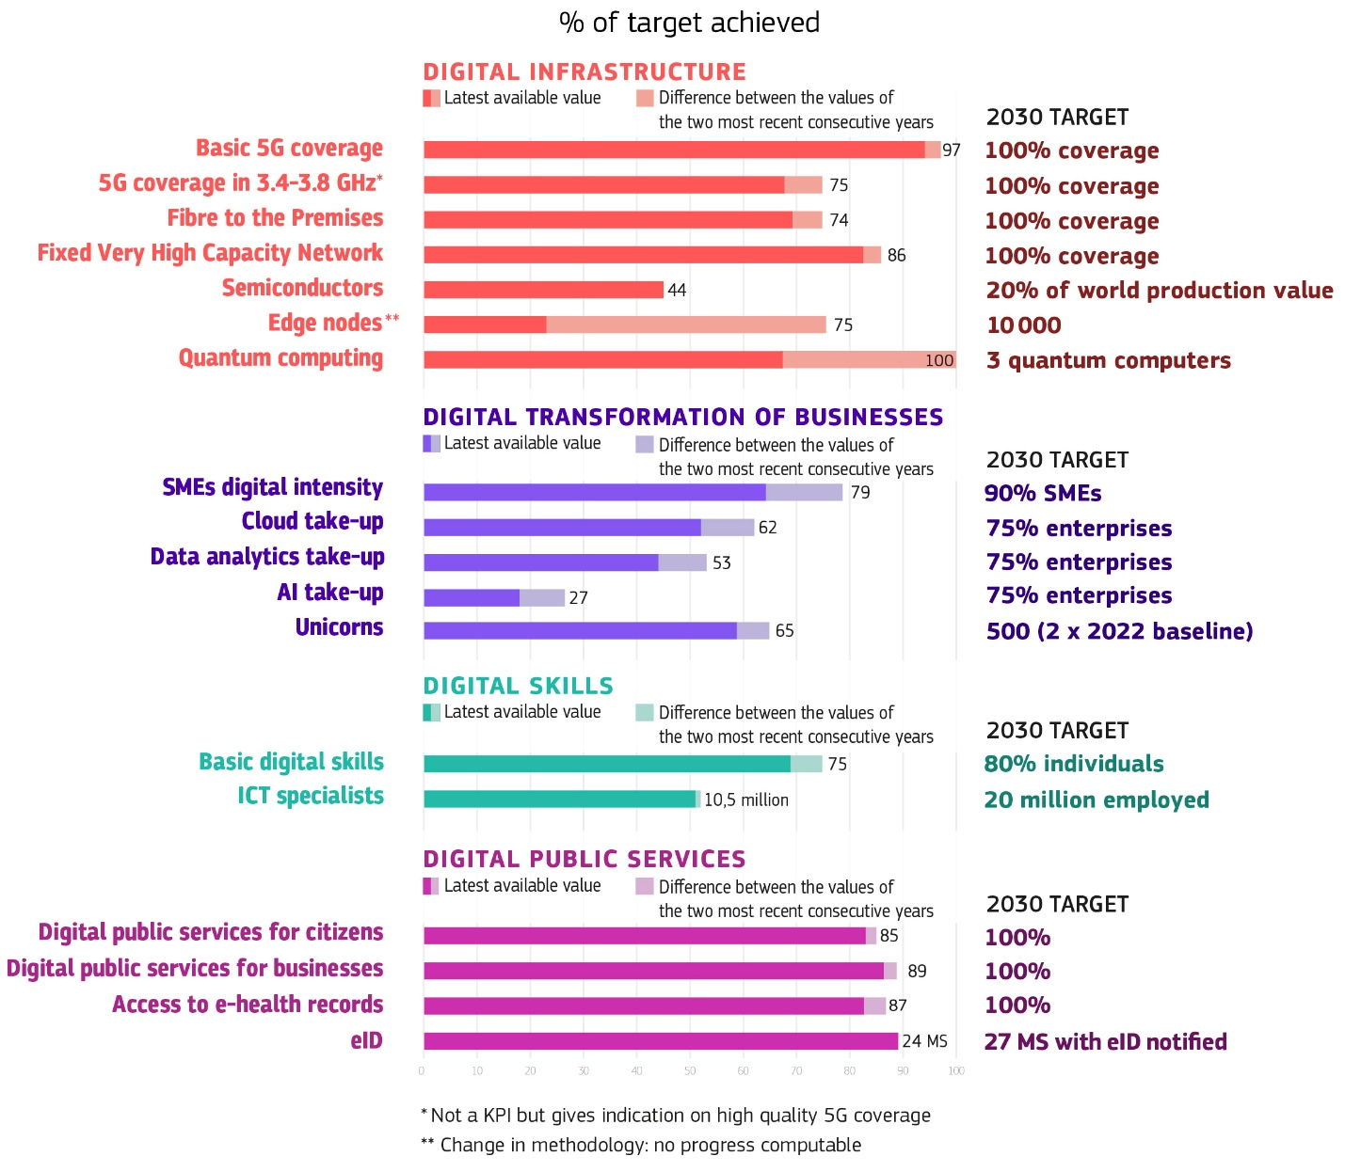
At the same time, significant structural gaps persist, notably in human capital, advanced technologies, and scale-up capacity. The shortage of ICT specialists remains severe, as policy efforts made at EU and Member-State level have not yet materialised, and is compounded by persistent gender imbalances. Several weaknesses also persist in the deployment of sovereign critical infrastructures, notably in semiconductors, cloud and AI.
Figure 3: Progress over 4 years by KPI at EU level
KPI | DESI2022  (year 2021) | DESI2026  (year 2025) | 4-year progress (%)
VHCN | 69.7% | 85.5% | 22.7
Fibre to the premises (FTTP) | 49.7% | 74.1% | 49.3
Basic 5G | 65.8% | 96.8% | 47.1
Semiconductors | 8.6% | 8.8% | 2.3
SMEs basic digitalisation | 54.8% | 71.4% | 30.2
Cloud take-up | 34.0% | 46.7% | 37.3
AI take-up | 7.7% | 20.0% | 160.8
Unicorns | 223 | 324 | 45.3
Basic digital skills | 53.9% | 60.4% | 12.0
ICT specialists | 4.5% | 5.0% | 11.1
Digital public services citizens | 74.6 | 84.6 | 13.4
Digital public services businesses | 81.7 | 88.6 | 8.4
The EU holds only 9% of the global semiconductor market, far from the 20% target, and it continues to underperform globally when it comes to unicorn-sized companies, both in absolute terms and relative to the size of its economy.
Figure 3 shows how the key Digital Decade indicators at EU level have developed between 2021 and 2025, putting the current situation into a four-year perspective. To see current progress towards the 2030 targets, Figure 4 below tracks the progress of KPIs toward the corresponding EU targets, benchmarking achievement levels against projected timelines.
Figure 4: Tracking KPIs progress and expected timeline based on trajectory projections (European Commission’s calculation)
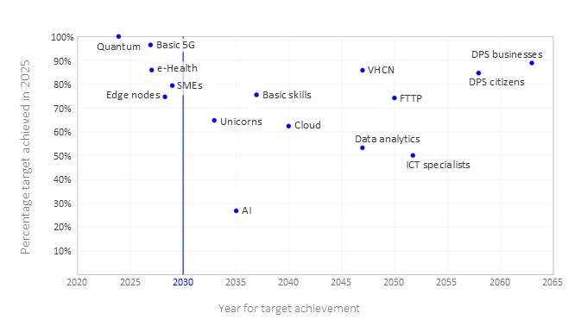

. From data to implementation
Over the past year, cooperation between Member States has translated into more tangible progress, with concrete joint investments and operational initiatives accelerating the deployment of shared digital infrastructures and capabilities across the EU. Through multi-country projects, Member States and the Commission are scaling joint investment in shared digital infrastructures. Two new European Digital Infrastructure Consortia (EDICs) have been set up this year, a further pipeline of new EDICs is advancing, and the Important Projects of Common European Interest (IPCEI) programme is being implemented in microelectronics, cloud and healthcare (including AI-enabled solutions). By operationalising a robust public-private partnership, the AI Gigafactories initiative developed under the EuroHPC Joint Undertaking demonstrates how coordinated action of EU, industry, and Member State efforts can help the EU bridge the gap between digital targets and the necessary scale of implementation. Together, these mechanisms are helping to build strategic capacities that no single Member State could deploy alone.
Snapshot of the tangible benefits of digitalisation:
In healthcare for example, AI can support faster and more accurate diagnosis by helping clinicians detect early signs of disease in medical images. It can also automate routine administrative tasks, freeing up medical staff time to focus more directly on patient care.
However, the development of trustworthy AI solutions depends on access to high-quality and representative datasets. In this respect, EUCAIM (the European Federation for Cancer Images) funded under the Digital Europe Programme (DIGITAL) illustrates the value of building a pan-European infrastructure for cancer imaging and associated clinical data. As of September 2025, EUCAIM connects 83 imaging datasets across nine cancer types (around 107 000 subjects) and provides 50 AI tools to users (researchers, innovators and healthcare professionals) in 16 countries. By the end of 2026, it is expected to exceed 60 million images and to bring together at least 30 distributed data holders from 15 countries, enabling secure and privacy-preserving collaboration for the development of innovative imaging-based AI solutions.
Progress has also been supported by stronger action and closer collaboration with and between Member States. The Digital Decade Board (DDB) has played a key role in catalysing action. The Board advanced the alignment of the DDPP with the future MFF, prepared the ground for the DDPP review, coordinated updates to national roadmaps, and followed up on the 2025 recommendations. More broadly, the DDB is increasingly functioning as the main national experts’ forum for structured exchange on implementation challenges, coordination needs and simplification.
National roadmaps remain the main vehicle through which this collective effort is translated into national commitments. Through them, Member States are collectively committing to a total of 1 934 measures, representing an overall investment of EUR 289.3 billion, including EUR 205.9 billion from public budgets (equivalent to 1.09% of EU GDP). Member States are also demonstrating their commitment to collective action through the implementation of annual Digital Decade recommendations. In 2025, Member States addressed 64% of the 186 country-specific recommendations issued by the Commission, either through significant policy changes (11%) or making some changes (53%) through new measures. 19 Member States addressed at least half of their recommendations. At EU level, approximately 55% of recommendations show notable (52.2%) or significant progress (2.4%), with particularly strong advances in areas such as uptake of advanced technologies and ICT specialists. However, 45% of recommendations have seen only limited progress.
While momentum is building in several areas, further structured and more ambitious policy efforts remain necessary to accelerate progress. As Annex 1 shows, the gaps in achieving the 2030 targets do not stem from isolated policy shortcomings or short-term cyclical factors. Rather, they point to deeper structural challenges that are closely linked to the EU’s capacity to strengthen its digital leadership. In many cases, these challenges arise in areas where the scale, complexity or cross-border nature of the issues has exceeded the capacity of existing instruments to deliver the necessary coordination and an adequate level of investment. The following section summarises these challenges and their underlying causes. They are also analysed in light of the EU’s strategic priority of establishing Europe as a true AI continent, requiring a comprehensive set of assets, capabilities, and infrastructures, from advanced skills to robust ethical frameworks.

Shaping EU’s Digital leadership and technological sovereignty in the AI continent era
In this report, ‘digital leadership’ refers to Europe’s capacity to remain at the technological frontier, shape the development and uptake of digital technologies and infrastructures, and influence the direction of the global digital transformation. It reflects the EU’s ability to leverage the Single Market, innovation, investment and regulation to foster the development, deployment and governance of critical digital capabilities, while promoting international standards and approaches that are aligned with European values and interests.
Achieving this requires coordinated action across several fronts:
- boosting homegrown industrial capacity and autonomy at key steps of the supply chain of digital technologies, progressing towards a full European technology stack while increasing the choice for consumers in the Digital Single Market;
- securing the supply of digital technologies underpinning Europe’s competitiveness by mitigating dependencies on a single or a limited number of non-EU suppliers;
- gaining control over data infrastructures and critical data while developing the capacity to leverage them effectively;
- setting the standards for key strategic technologies, addressing jurisdictional risks for data and digital service provision, and safeguarding the EU’s capacity to regulate in line with its values and standards; and
- strengthening the talent pipeline. The structural gaps identified in this section concern precisely those domains where this capacity is most at risk.

Technological sovereignty: closing the R&I and infrastructure gap
The EU still faces the critical challenge of securing control over the full digital innovation chain, from foundational research to large-scale industrial deployment. As part of the Tech Sovereignty Package, the Communication on European Tech Sovereignty outlines the EU’s approach and defines technological sovereignty as Europe’s ability to develop, control and scale the critical technologies, infrastructure, services and data, including digital ecosystems, that underpin its economy, security and society, while de-risking and diversifying supply chains and technological exposure to reduce strategic dependencies and resist foreign interference.
    - Accelerating innovation in digital technologies
European companies continue to lag in digital R&D, particularly in AI. This gap is clearly visible in research and investment trends. EU corporate R&D grew by only 2.9% in 2024, the lowest rate since the pandemic. A persistent sectoral imbalance further disadvantages digital technologies: recent R&D investment increases have been concentrated in energy (+19.8% one year growth rate) and health (+13%), while ICT-related sectors remain comparatively underdeveloped. This situation is exacerbated by the limited number of large ICT firms in Europe, which constrains private R&D, weakens innovation ecosystems and slows the commercialisation of digital technologies.
Global R&D investment is becoming increasingly concentrated among a small number of US technology giants - Amazon, Alphabet, Meta, Microsoft and Apple - particularly in AI, cloud and advanced computing. Over the past decade, these five companies have nearly doubled their share of global R&D spending among the world’s top 2 000 firms, now accounting for around 15% of the total. Without a decisive step-change in investment, coordination and support for scaling European firms, the EU risks further deepening its dependence on external technology providers, with severe consequences for European competitiveness, sovereignty, and security and falling even further behind in the global digital race.
Addressing the scale-up gap requires not only financing instruments but a structural reform of the legal environment in which European digital companies operate. The fragmentation of company law across twenty-seven national jurisdictions creates compliance costs, investor friction and governance complexity that may disadvantage EU-incorporated companies relative to their third country counterparts.
The proposal for a Regulation establishing the 28th regime corporate legal framework (‘EU Inc.’), adopted by the Commission on 18 March 2026, directly addresses this structural barrier by introducing a harmonised, digital-first and cost-effective set of corporate rules and procedures to facilitate the creation and scaling-up of companies across the single market. A new EU central interface will enable founders and companies to complete incorporation and filing procedures without having to navigate 27 different national systems. The framework will build on existing national business registers and their EU-level interconnection through the Business Registers Interconnection System (BRIS). Realising these benefits will depend not only on the formal adoption of the 28th regime, but also on its consistent operational implementation across Member States, including through clear company formation rules, well-functioning national registries and predictable cross-border enforcement, so that it provides genuine simplification and practical usability for the scale-ups it is intended to serve.
Open-source software constitutes a further under-exploited sovereignty instrument. Estimated to contribute between EUR 65 and EUR 95 billion to EU GDP and underpinning at least 70% of all code, it reduces dependency on proprietary non-EU systems, lowers barriers for SMEs and start-ups, and can be embedded in public procurement and funding at marginal cost. As its source code is publicly available, it can be freely used, modified, redistributed, and audited. Aligning a greater share of public digital spending with EU open-source development would represent a high-return, low-risk sovereignty dividend. In this regard, the EU Open Source Strategy, published on 3rd June, will review the current state of play and put forward a set of actions to be rolled out in the coming years by the public sector at European and Member-State level, as well as by the private sector and the open-source communities themselves.
    - Mastering the digital stack: from semiconductors and connectivity to AI infrastructure
Europe’s competitiveness, resilience, and security increasingly depend on its ability to develop and integrate the most advanced layers of the digital technology stack. At the core of this sovereign stack are semiconductors, high-performance computing, cloud and edge computing, AI, quantum technologies, secure connectivity networks, backbone infrastructures, trusted data ecosystems and security-by-design infrastructures. These technologies no longer evolve in isolation. They are tightly integrated and interact closely, shaped by technological progress and the evolving needs of science, industry, public services and defence, including energy efficiency.
In semiconductors, the EU’s share of global value chain revenues stands at about 9%, against a Digital Decade target of 20% to be reached in 2030, in a market where the US, China, South Korea and Taiwan are investing on a scale that risks further entrenching existing asymmetries. This puts the EU in a situation of extreme dependency, as past crises have demonstrated. The Chips Act has so far catalysed thirteen major investment announcements for a total of EUR 32 billion, and, building on its experience, the proposal for a Chips Act 2.0 has been adopted to further boost the chips industry, reduce strategic dependencies and support advanced chip production in the EU.
In computing, the EU accounts for only 20% of global data centre capacity, while demand for colocation space is outstripping supply for the third consecutive year, pushing up costs for businesses. The Cloud and AI Development Act proposal aims to triple EU data centre capacity within five to seven years. However, achieving this objective depends on resolving the EU’s persistently higher electricity costs relative to the United States and China, which constitute a structural barrier to data centre investment that the Act alone cannot address.
Quantum technologies are transitioning from research and pilot activities to integration in strategic infrastructures and industrial deployment. The EU is already deploying quantum computers and simulators-integrated with supercomputing centres-through the European High-Performance Computing (EuroHPC) Joint Undertaking. It is also advancing the EuroQCI as a secure quantum communication infrastructure spanning the entire EU, including its overseas territories, and preparing quantum chip pilot lines, design facilities, and quantum internet testbeds. The short-term challenge is to accelerate the move from research excellence to operational capabilities across quantum computing and simulation, communication, sensing, and metrology. This requires support in industrialisation, standards, testing and certification, trusted supply chains, skills development, and demand-side instruments such as public procurement and first-user deployment.
Connectivity remains one of the most critical enabling layers of Europe’s sovereign digital stack and a persistent structural challenge for competitiveness, resilience and security. Despite continued progress in basic 5G and fibre rollout, the EU still lags behind global frontrunners in deploying high-capacity infrastructures, notably full-fibre networks, 5G standalone (SA) and resilient backbone connectivity. The slow transition to 5G SA is a structural constraint, limiting the EU’s capacity to deliver the low-latency, high-reliability services that advanced industrial and AI applications require.
Strategic dependencies in backbone, satellite and submarine cable infrastructures further increase Europe’s exposure in critical data routes, while digital service delivery as a large share of capacity remains under the control of a handful of non-EU operators. Combined with the risk of satellite sabotage or deactivation, this threatens the EU’s economic and security interests. Without accelerated investment, deployment and greater regulatory convergence, these bottlenecks risk undermining the EU’s capacity to scale the next generation of digital, AI and quantum-enabled services on European terms.
The AI dimension adds urgency and acts as the overarching driver of Europe’s digital strategy. While the adoption of AI by businesses has accelerated sharply, reaching 20% in 2025, the EU remains heavily dependent on a handful of non-EU providers for foundational model infrastructure, cloud execution environments and the semiconductor architectures on which AI systems run. Building an AI continent therefore requires simultaneous and tightly coordinated progress across all layers of the digital stack.
The AI Continent action plan provides the strategic framework for this capacity-building effort. In this context, AI Gigafactories - large-scale, shared computing facilities accessible to European researchers, start-ups, and SMEs - are designed to tackle a key bottleneck: the shortage of high-performance compute infrastructure at the scale, the affordability, and security needed for cutting-edge AI development within the EU. Beyond simply providing raw computing power, these facilities are expected to integrate advanced data storage, energy-efficient supercomputing, and secure cloud environments, enabling users to train and deploy large AI models while keeping sensitive data within European jurisdiction. By pooling resources and lowering entry barriers, AI Gigafactories aim to accelerate innovation, support industrial applications and strengthen Europe’s technological leadership in the global AI race. The timely delivery of such ultra-scale sovereign AI compute infrastructure in Europe is a prerequisite for the credibility of the EU’s broader AI strategy, including the sectoral focus of Apply AI Strategy. The EU is also pursuing a comprehensive strategy to strengthen its technological stack: the core objective of the Tech Sovereignty Package adopted on 3 June is meant to strengthen the EU’s capabilities across the entire value chain, moving towards a fully integrated European technology stack.
Five structural factors cut across these technology domains. First, fragmentation: twenty-seven national regulatory and investment frameworks prevent the EU from pooling resources and deploying technology infrastructure at the scale required to compete globally. Spectrum policy, semiconductor R&I funding, and AI compute investment all suffer from the same underlying problem of insufficient coordination. Second, investment asymmetry: in each of these sectors, the EU’s existing instruments, while significant, have not yet been organised around a coherent technology investment logic tied to sovereignty objectives, leaving European support less unified and targeted than what competitor regions have. Third, private-sector underinvestment and more generally the lack of mobilisation of private finance to support the development of the European digital ecosystem, reflecting structural conditions including fragmented capital markets, a weak scale-up ecosystem, and insufficient demand-side incentives for innovation. Fourth, overly concentrated supply chain and dependencies: across chips, network equipment, cloud infrastructure and AI systems, the EU remains dependent on a limited number of external suppliers for components and services that are increasingly treated as strategic assets by competitor nations, and control of them is a lever for geopolitical influence. Fifth, administrative bottlenecks underline the need to accelerate and simplify infrastructure development through facilitated permitting.
Addressing those challenges requires simultaneous and coordinated action across technology policy, investment mobilisation and industrial strategy. Together, the proposals for the Chips Act 2.0, the Cloud and AI Development Act, the Digital Networks Act, and the upcoming Quantum Act proposal will provide an appropriate legislative framework once adopted and implemented. The AI Continent action plan provides the strategic architecture for Europe’s AI capacity-building, with the Gigafactories as its operational centrepiece alongside AI factories, Testing and Experimentation Facilities, and the European Digital Innovation Hubs being repositioned as AI Experience Centres.
Dependency risks also extend to the financial sector. International card schemes account for over 64% of electronically initiated card-based transactions in the euro area, while mobile payments are largely dominated by non-European technology firms, particularly as regards digital wallets. These dependencies create both geopolitical and cybersecurity exposure which could have spillover effects on the financial and economic sector. The digital euro, currently in the interinstitutional legislative process, is a strategic response that will strengthen Europe’s monetary sovereignty and increase the resilience of its payment infrastructure.
Concerns about technological sovereignty also extend to the use of digital technologies in the education sector. European schools and training institutions depend overwhelmingly on non-EU providers for their digital infrastructure - from cloud and operating systems to AI-powered learning tools and learning management systems. The Commission is supporting preparatory work with Member States to set up multi-country projects and collaboration among Member States to strengthen technological sovereignty for schools and training institutions.
Promoting the ethical development and adoption of AI in the cultural and creative sectors is essential to preserving Europe’s cultural sovereignty. AI should be designed and trained in ways that support Europe’s cultural and linguistic diversity, drawing on diverse and representative datasets that reflect the richness of European cultures, while respecting creators’ rights. As announced in the AI Continent action plan, the Apply AI initiative and the Culture Compass, the Commission is preparing a strategy that promotes the development and use of AI in ways that uphold genuine creation, European cultural and linguistic diversity and inclusion.
Legislative and strategic frameworks need to be strengthened by a step-change in investment scale and coordination. The next MFF will play an important role in steering resources towards EU technology priorities, in particular with the proposed European Competitiveness Fund (ECF) and its Digital Leadership window and the new Research and Innovation Framework Programme. The conditions for private R&I at scale must also be improved structurally - through the Savings and Investments Union, the Capital Markets Union, simplified regulatory requirements for R&D-intensive firms, and stronger demand-side incentives including public procurement, as reflected in the Tech Sovereignty Package. The specific investment priorities emerging from this strand are set out in Section 4.

3.1.3 Fostering synergies with defence
The accelerated integration of digital technologies such as AI, advance connectivity or cloud computing into European defence capabilities has emerged as a defining trend of 2025-2026. Technologies originally developed for civilian applications are increasingly dual-use and/or adapted for defence purposes. This ’spin-in’ dynamic means that the EU’s digital industrial capacity and its defence technological capacity are now closely interlinked: both are constrained by weaknesses in semiconductors, computing and cloud infrastructure, AI and secure connectivity.
The EU responded with solid policy and funding architecture in 2025-2026. The Defence Readiness Roadmap 2030, adopted in October 2025, pointed to cyber, AI and electronic warfare as one of nine priority capability areas identified by Member States. The Defence Industry Transformation Roadmap consolidated this direction, framing software-defined warfare, dual-use spin-in and engagement with SMEs and start-ups as cornerstones of Europe’s defence industrial transformation. On the funding side, the European Defence Fund, with a budget of close to EUR 8 billion for the period 2021-2027, is the Commission’s flagship programme in support of defence R&D. As part of it, the EU Defence Innovation Scheme (EUDIS) supports defence innovation and non-traditional defence actors. The AGILE programme, proposed on 25 March 2026, will complement these efforts, with a particular focus on the rapid development and delivery of disruptive defence products and technologies. The European Defence Industry Programme (EDIP) adopted at the end of 2025, delivered its first work programme and launch of calls for proposals at the beginning of 2026. The Security Action for Europe (SAFE), adopted in May 2025, which includes AI and electronic warfare among its eligible procurement categories, has approved national investment plans covering EUR 38 billion of the EUR 150 billion available, with the first disbursements expected in 2026.
Moreover, the mid-term review of cohesion policy (October 2025) enabled cohesion funds to be channelled towards defence and civil preparedness projects. By the same token, the Regulation on incentivising defence-related investments in the EU budget (December 2025) broadened the scope of the Digital Europe Programme to dual-use across all objectives, extended the European Innovation Council (EIC) Accelerator scope to support dual-use innovation, and opened the STEP Scale-Up Scheme to defence. The Commission has proposed that these efforts should continue and be further increased as part of the proposed European Competitiveness Fund (ECF) under the next MFF.
Three structural factors continue to shape the EU’s ability to translate civilian digital investment into defence capability. First, the alignment of strategic priorities between civilian and defence programmes could be further improved across the EU: while EU instruments increasingly recognise dual-use, Member States have yet to systematically embed this convergence in their national roadmaps and national investment planning, and the structural separation between civilian digital and defence innovation communities persists at national level. Second, the industrial base remains concentrated and partly dependent on non-EU providers in semiconductors, cloud and AI. This exposes EU systems to supply disruption and limits the scope for a fully sovereign defence digital supply chain. Third, the security culture and reporting standards across the civilian digital sector are not yet sufficiently developed to make full use of the funding pathways opened by recent regulatory changes. Addressing these challenges requires complementary action and approaches on strategic priorities and on funding-level synergies including across future ECF policy windows, so that investments in computing capacity, connectivity resilience, cybersecurity and AI can consistently support both civilian competitiveness and defence preparedness. Member States are also invited to reflect on dual-use considerations in their updated national roadmaps, and to make use of relevant defence instruments and promote them among their national industrial ecosystems, to participate actively in Capability Coalitions, and to make systematic use of SAFE, EDIP, EUDIS, the dual-use scope of the Digital Europe Programme, the EIC Accelerator and the AGILE programme.

Strengthening the security and resilience of digital ecosystems
The resilience of the digital ecosystem is central to EU’s technological sovereignty as cybersecurity threats becomes more complex, large-scale and systemic. Recent EU data highlight the scale and accelerating nature of cyber risk across the EU: nearly 4 900 significant cybersecurity incidents were recorded in a single year (July 2024-June 2025), pointing to a persistent and evolving threat environment. These attacks are increasingly high-impact, with over 80% of cybercrime incidents involving ransomware, often combined with data theft and multi-layered extortion. Cyber operations are now embedded in state strategies, targeting government, defence and critical infrastructure, while the line between state-sponsored actors and cybercriminals continues to blur through shared tools and infrastructure. Attacks are also becoming more targeted: more than half affect essential entities, while public administrations account for over one third, which means the attacks are increasingly focused on critical sectors such as energy, healthcare, transport and telecommunications, as well as core state functions. At the same time, attacks are becoming more sophisticated and harder to detect, increasingly leveraging AI and combining multiple techniques. Supply chain attacks have emerged as a major systemic risk, whereby a single breach can cascade across multiple organisations due to dependencies on third-party providers and widely used software. This risk is particularly acute for public administrations, which rely on interconnected systems to deliver essential services. Together, these trends illustrate not only the rising frequency of cyber incidents, but also their increasing severity and implications for the EU’s economic security and resilience.
The EU has developed a broad and increasingly robust cybersecurity framework, anchored in NIS2, the Cyber Resilience Act and the proposed revision of the Cybersecurity Act (CSA2). As part of a wider cybersecurity package, these measures aim to strengthen capabilities and resilience, prevent fragmentation in the digital single market and enhance the security of EU ICT supply chains by ensuring - through a simplified certification framework - that products placed on the market are secure by design. They also seek to facilitate compliance with existing EU rules and increase the role of the EU Agency for Cybersecurity (ENISA) in supporting Member States and the EU in managing cyber threats. In addition, the Cyber Solidarity Act, in force since February 2025, further strengthens collective detection and response capacities at EU level.
However, five structural factors continue to shape the EU’s vulnerability to the evolving cyber threat landscape and limit the effectiveness of its regulatory response. First, implementation fragmentation: while the NIS2 Directive and the Cyber Resilience Act set common requirements, transposition of the NIS2 Directive and enforcement of rules remain uneven across Member States, creating resilience gaps within the single market. Progress also remains uneven across Member States when it comes to restricting high-risk suppliers and preparing for emerging challenges such as post-quantum cryptography. Second, industrial dependency: continued reliance on non-EU vendors (including persistence exposure to high-risk suppliers in critical areas such as 5G networks) exposes the EU to jurisdictional risks and external strategic decisions. Third, a persistent cybersecurity skills deficit, constrains organisations’ ability to operationalise requirements, particularly as AI-enabled threats accelerate. Fourth, AI asymmetry: adversaries are deploying AI faster than it is being integrated into EU defensive systems, creating a structural imbalance not fully addressed by existing frameworks. Fifth, and linked to AI asymmetry, the fundamental shift in cybersecurity brought by the most advanced general-purpose AI models. As these models show unprecedented cyber capabilities, notably in identifying vulnerabilities, and operate at a speed and level of automation that outpaces traditional defensive cycles, we need to stay ahead and ensure our own capacity to use AI as a first line of defence against the possible misuse of such capabilities.
Addressing these gaps requires sustained investment in implementation support, EU-wide interoperability standards, the cybersecurity skills base, and shared detection and response capabilities at EU level. This must be accompanied by full and consistent transposition and enforcement of the NIS2, the Cyber Solidarity Act and the Cyber Resilience Act, the structured phase-out of high-risk suppliers from critical infrastructure and the establishment by Member States of stable, multiannual national funding mechanisms for cybersecurity aligned with EU strategic priorities.

Making digitalisation work for competitiveness: adoption, simplification and decarbonisation
The third structural challenge for digital leadership is to build wider ecosystems and ensure the diffusion of digital technologies across the economy and society. It means ensuring that the digital capabilities being developed in the EU are effectively deployed where they are needed, across businesses, public authorities and society at large, at the speed and scale required by intensifying global competition. Such efforts are critical: so far, the EU has failed to fully capture the gains of the internet revolution, which has led it to lag both in the development of key technologies and in the uptake of digital solutions by public administrations and businesses.

3.3.1. From access to use: accelerating technology diffusion and adoption
Digitally enabled transformation of private and public activities is a catalyst for EU competitiveness. Digitalisation is a key driver of growth and productivity in the EU, and recent evidence points to strong macroeconomic returns on digital investments. The productivity dividend of digital transformation is substantially larger than what the EU is currently capturing, as can be seen in the estimate that 39% of US growth in 2025 was linked to AI technologies. The limited productivity gains from digital investments compared to the US stem not only from differences in ICT capital, but also insufficient investments in intangible assets, such as skills, organisational capacity and management practices, which are essential for the diffusion of digital technologies: between 2009 and 2020, ICT capital accounted for 11.7% of US productivity growth, compared with 3.3% in Europe; over the same period, total factor productivity (TFP), which captures efficiency gains from organisational change and improved resource allocation, contributed 32% in the United States but was negative in Europe.
Broad-based adoption by the general public, enterprises (especially SMEs) and public authorities therefore remains a central challenge. As the KPI data in Section 2 show, AI adoption stands at 20% of enterprises against a 2030 target of 75%, the cloud gap between large firms and SMEs is 36 percentage points, and on current trends the data analytics gap will not close until 2047, while the adoption of gigabit connectivity fast fixed broadband is still low, representing only 27% of subscriptions in the EU in 2025. The main barrier is not only technological availability but access, simplicity and organisational capacity for change. The digital transformation of public services shows similar patterns: while performance at national level is strong (services for the public: 84.6/100; business services: 88.6/100), persistent structural gaps remain in cross-border availability, AI deployment in public administration and the cybersecurity of public digital infrastructure. More than one third of EU government websites are hosted on servers controlled by operators whose ultimate beneficial ownership lies outside EU jurisdiction, and more than half of governmental email domains rely on non-EU operators, creating systemic security exposure and trust concerns that the digital public service agenda alone cannot resolve.
Adoption at scale continues to be constrained by a set of structural factors. A persistent deficit in skills and intermediation limits the capacity of enterprises, in particular SMEs, to identify relevant use cases, ensure compliance and integrate digital technologies into core operations. This is compounded by the limited availability of trusted intermediaries capable of providing integrated technical, legal and business support. At the same time, the pace of organisational transformation remains insufficient. Digital investment does not translate into productivity gains without accompanying changes in business processes, management practices and workforce skills, and evidence indicates that such transformation remains less developed in the EU. Uneven implementation across Member States - in terms of governance, investment levels and delivery capacity - continues to create disparities in adoption.
Public administrations face comparable barriers. While progress at national level is notable, gaps persist in cross-border service provision, the deployment of AI and the security of digital infrastructure. While digitalisation of public services offers significant benefits and opportunities to increase growth through efficiency gains and cost savings for Member States, businesses and individuals, it also requires considerable investment both from the EU and the Member States at the national level to overcome technical difficulties and delays in the delivery of national and cross-border judicial services, as illustrated in the case of digitalisation of justice. Finally, continued reliance on non-EU providers in critical areas creates vulnerabilities affecting both resilience and sovereignty.
Addressing these challenges requires coordinated action across several dimensions. Strengthening skills and intermediation is essential, including through increased investment in digital and AI training and the repositioning of European Digital Innovation Hubs as integrated AI Experience centres linked to AI factories, testing and experimentation facilities and upcoming sandboxes. Greater emphasis must also be placed on organisational transformation, providing the possibility for public support instruments to combine technology uptake with investments in management practices, process redesign and workforce reskilling. Increasing trust requires the development and uptake of secure and sovereign digital infrastructures, including EU-based cloud solutions for public administrations. The EU, Member States, regions and cities should increasingly and systematically leverage public sector demand as a driver of diffusion, notably through strategic public procurement, the deployment of digital public services, and the use of government as a lead customer to create markets, scale solutions and accelerate adoption across the wider economy. Finally, national delivery frameworks should be strengthened through clear governance, dedicated funding and measurable targets, to ensure consistent implementation across Member States, supported by the DDPP.

3.3.2. Simplification: removing the regulatory and infrastructure barriers to adoption
Simplification is itself a critical enabler of technological uptake. Regulatory complexity - particularly the interaction of regulatory obligations, sector-specific requirements and varying national implementations including the introduction of national requirements exceeding those provided for under EU legislation- has been identified by enterprises as one of the primary barriers to digital deployment, especially for SMEs. The Digital Omnibus initiative, which aims to streamline existing data and digital legislation, addresses this directly and is therefore a legislative precondition for accelerating the uptake of digital technologies by enterprises. Moreover, digital, data-driven and AI-enabled solutions for reporting, monitoring and compliance can help reduce this burden, enabling companies to meet regulatory requirements more efficiently while turning compliance into a source of trust, competitiveness and differentiation in global markets.
The European Digital Identity Wallets and European Business Wallets are a central pillar of this strand. By integrating digital verifiable credentials, trusted data sharing, and enabling AI-driven compliance checks, the forthcoming EU Business Wallets will significantly ease how businesses interact with regulators and their customers. Using them will create the conditions for fully digital cross-border interactions - for individuals authenticating to public services and other use cases, for businesses conducting cross-border transactions including e-invoicing, digital contracts and the secure exchange of verified data - and the reduction of administrative burden. All Member States are required to make the Wallet available to private individuals by end-2026. Six large-scale pilots involving over 550 stakeholders across all Member States together with Norway, Iceland, and Ukraine have demonstrated the technical feasibility of cross-border use cases in multiple sectors. Yet deployment remains uneven and the pace of national implementation risks undermining the Wallet’s potential: the certification schemes based on the Cybersecurity Act have not yet been finalised, blocking national deployment timelines; the obligations of the parties relying on the schemes - particularly in the private sector - are still not sufficiently enforced, limiting incentives for the public to adopt the schemes. Accelerating deployment requires the following parallel actions: finalising the certification scheme without further delay; and enforcing relying party obligations systematically, including through the Digital Omnibus where necessary.
Simplification is also much needed to accelerate connectivity which remains structurally insufficient to support the AI Continent agenda. Regulatory fragmentation with twenty-seven distinct national frameworks for spectrum assignment, network authorisation and different paces of legacy networks migration creates inconsistent investment conditions, prevents operators from achieving the economies of scale required for advanced network deployment and generates legal uncertainty that delays both private investment and public co-financing decisions. The continued operation of legacy copper networks in the majority of Member States negatively impacts demand for full-fibre services, reducing investment incentives, and delaying the migration of users and services to the infrastructure required for next-generation digital applications. Therefore the absence of binding national copper switch-off timelines in most Member States has become a structural rather than a transitional problem. In addition, the absence of long-term and predictable conditions for investments - in particular on spectrum licence duration and renewal - prevents operators from committing capital at the scale and over the time horizons required for 5G SA and 6G deployment. It also limits the ability of public instruments to leverage private co-investment effectively.
For enterprises, especially SMEs, the main barriers to AI and advanced digital adoption are linked to the difficulty of translating interest into deployment safely, lawfully and at an acceptable cost. Fragmented and poor-quality data, weak interoperability with legacy systems, lack of in-house skills, the complexities of aligning early compliance investments with the shifting implementation details of the AI Act, and the absence of trusted intermediaries capable of providing integrated technical, legal and business transformation support remain the proximate constraints behind the SME adoption gap. The operational priorities are fivefold.
- First, the European Digital Innovation Hubs, repositioned as AI Experience Centres and linked to AI factories and Testing and Experimentation Facilities, need to reach their full potential in providing SMEs with integrated technical, legal and business transformation support.
- Second, the deployment of common European data spaces, linked to AI factories and data labs, must be accelerated: access to high-quality, interoperable data is a prerequisite for SMEs to innovate and scale on a more equal footing with large platforms.
- Third, the Digital Omnibus must move rapidly from proposal to implementation, with Member States ensuring consistent national transposition and the Commission monitoring simplification outcomes against measurable benchmarks.
- Fourth, sustained investment in cross-border digital public service infrastructure - including EU Wallet deployment, the Once-Only Technical System, interoperability frameworks and digital identity building blocks, digital verifiable credentials, data exchange mechanisms, trust services - is required to close the gap between national and cross-border service availability, reducing administrative burden for the public and businesses across the single market.
- Fifth, the Digital Networks Act, currently under negotiation, should preserve its ambition on indefinite spectrum licences, harmonised authorisation conditions and an investment-friendly regulatory architecture as a structural response to the regulatory fragmentation identified above.
At the same time, the copper switch-off, in other words the planned EU-wide migration from legacy copper to full-fibre infrastructure, must be accelerated across all Member States. Targeted public investment must also complement regulatory reform by addressing market failures in underserved areas, particularly rural and remote regions, where private deployment alone will not deliver the coverage required by 2030.

3.3.3. Responsible digitalisation for competitiveness, resilience and decarbonisation
Digital technologies - including AI, digital twins, smart grids and sensor networks - can deliver decisive gains in industrial productivity, energy efficiency, grid optimisation and resilience and circular business models, lowering input costs for EU firms, easing pressure on imported energy and critical raw materials, while accelerating the transition to a more autonomous and resilient industrial base. In a sector as strategic as energy, preserving the Union’s capacity to develop, control and operate these critical digital technologies and infrastructures is an important component of Europe’s technological sovereignty, economic security and long-term resilience.
These positive contributions need to overcome the major resource constraints associated with the expansion of digital infrastructure. Digital infrastructure is increasingly affecting water availability, land use and energy systems at regional level. By 2030, data centre electricity consumption in Europe is expected to rise towards 115 TWh, an increase by at least 45 TWh compared to 2025, driven primarily by AI demand. The EU currently recovers less than 1% of rare earth elements from end-of-life digital equipment and remains highly dependent on external suppliers for several critical raw materials used in digital technologies.
These developments are taking place against a backdrop of tightening energy constraints. The mainstreaming of AI is driving a rapid rise in electricity demand for computing power and data infrastructure. With rising geopolitical tensions, the EU also faces persistently higher electricity costs than the United States, which benefits from lower-cost domestic energy sources, and China, which relies on state-supported supply. Without swift and sufficient expansion of affordable, low-carbon energy and grid capacity, these energy constraints risk undermining the EU’s ability to deploy advanced AI systems at the scale required to maintain competitiveness in the global digital economy.
The EU has set a policy framework to address the digital-green nexus. The proposed clean digitalisation targets - covering data centre energy consumption, net ICT emissions and the contribution of digital solutions to greenhouse gas reductions - provide a necessary basis for making this nexus measurable and operational. The Strategic Roadmap for Digitalisation and AI in the energy sector plans measures to prepare for the increased complexity of the future energy system, including both challenges and opportunities linked to the integration of data centres in the EU energy system and the large-scale AI deployment across the energy value chain. Complementary instruments - including the Cloud and AI Development Act, the Digital Product Passport and the EU Codes of Conduct on Data Centres and on telecommunications sustainability - further strengthen this framework. However, while the policy framework is largely in place, its translation into coherent investment signals, governance mechanisms and measurement systems remains incomplete.
This gap reflects four structural factors limiting the alignment between digital transformation and decarbonisation. First, a governance lag: digital technologies, especially AI, evolve faster than regulatory and investment cycles, delaying the management of their environmental impacts. Second, a growing tension between compute capacity and energy sustainability, as expanding data centre infrastructure increases electricity demand and requires closer alignment between digital, environment and energy policies, including in rural areas. Third, persistent dependencies on critical raw materials, combined with limited recycling capacity, create structural vulnerabilities not yet fully integrated into investment strategies. Fourth, insufficient measurement frameworks: the lack of harmonised EU methodologies to assess both the footprint of digital infrastructure and its contribution to emissions reduction limits effective investment and progress tracking. Addressing these structural factors requires the adoption of new clean digitalisation targets, the development of harmonised metrics, and stronger coordination between digital, energy and environmental policies, with the aims of enhancing EU competitiveness and reducing dependencies on energy and critical materials.

3.4. Ensuring digital transformation works for people
Ensuring that the digital transformation works for people is a core objective of the Digital Decade. The benefits of digital technologies should be accessible to all, while preventing the emergence of new forms of exclusion and protecting citizens and democratic societies from online harms, including disinformation, manipulation and other forms of abuse of digital technologies.
In this respect, digital skills are both a sovereignty asset and an adoption enabler, and the EU’s shortfall in both dimensions, basic skills and ICT specialists, is acute.
Despite significant national investment commitments, the EU remains off-track to meet the 2030 target for basic digital skills (80% of the population), which is currently projected to be reached in 2037. Basic digital skills stand at 60% in 2025 and are forecast to reach only 68% by 2030. The shortfall is concentrated among older individuals, those with low educational attainment, and people in rural areas, precisely the groups for whom digital exclusion carries the highest economic and social costs. A first structural challenge relates to the limited reach of existing provision systems. Current delivery mechanisms do not adequately reach the groups most at risk of lacking basic digital skills - including older people, persons with disabilities, marginalised groups facing discrimination, individuals with low educational attainment, those in rural areas who may face additional challenges linked to limited broadband access. These are largely centred on formal education and workforce-based training, while those most lacking in digital competence are also the least connected to the institutions capable of providing support at scale. A second challenge concerns the effectiveness and level of ambition of current investments. Member States have collectively committed around EUR 24 billion and 349 measures to basic digital skills. However, progress remains below the pace required to meet the target, indicating that while the current distribution of investment, predominantly focused on formal education and general digital inclusion, remains essential, it does not sufficiently address the specific barriers faced by hard-to-reach groups. A third challenge arises from the rapid development of digital technologies. The current target was defined against a pre-generative AI baseline, while the widespread use of such technologies, around 64% of young people aged 16-24 in 2025, is redefining the skills needed for effective and safe participation in the digital environment, indicating the increasing need for AI literacy. This creates a risk that even achieving the target may not create the level of competence required in practice by 2030.
Under the Union of Skills and the Council Recommendation on Human Capital, Member States are encouraged to strengthen basic skills in education and expand training and lifelong learning. The action plan on basic skills recognises digital skills as crucial in modern society and everyday life, and includes them in the basic skills, alongside literacy, mathematics, science and citizenship. The STEM Education Strategic Plan highlights the importance of increasing the talent pipeline in STEM subjects and proposes a 5% enrolment target in doctoral programmes in ICT by 2030 - including a sub-target for female enrolments. The Commission will propose measures to support digital skills development and the digital readiness of schools in the context of its education package. It will also develop guidance on digital skills assessment to improve the provision of skills in school education. The AI Skills Academy supports the workforce dimension of the AI adoption agenda, while the AI literacy framework for primary and secondary education developed in cooperation with the OECD outlines the main skills young people need to develop at school in order to benefit from the AI transformation in a critical and responsible manner. The Digital Competence Framework was updated in November 2025, particularly to take account of competences required in the face of new emerging technologies such as AI and integrate AI competence across all areas of digital competence.
The ICT specialist gap is even more pronounced, with 10.5 million employed in 2025, just 52% of the 2030 target of 20 million in a context where skills requirements are evolving rapidly, reflecting the pace of technological change and the accelerating diffusion of digital technologies across the economy. The proportion of women among ICT specialists has increased only marginally compared to 2015. Closing this gap requires a response commensurate with its scale: including dedicated investments, as well as national interim targets in the updated national roadmaps.
A number of structural factors continue to constrain the EU’s capacity to expand its ICT workforce at the pace required. First, the supply of new entrants remains insufficient. In 2023, the EU produced only 2.7 tertiary ICT graduates per 1 000 young people, compared to 3.7 in the United States and 4.6 in the United Kingdom. This gap cannot be compensated for through upskilling and reskilling alone and points to the need for sustained, long-term investment in initial education systems at a scale not yet reflected in current national commitments. Second, the rapid development of technological requirements is creating persistent mismatches between labour market needs and available skills. The growing importance of areas such as AI, cloud security and data engineering is outpacing the capacity of education and training systems to adapt curricula and programmes. This is further compounded by the increasing role of vendor-specific certifications, which can limit skills portability and reduce overall labour market flexibility. Third, progress in addressing the gender imbalance in ICT professions remains limited. This reflects structural barriers across the entire education and career pathway, from participation in STEM education to entry into and retention within ICT careers, indicating that more comprehensive and coordinated measures are required. Finally, demand for advanced digital skills is expanding rapidly beyond the ICT sector itself. The diffusion of digital technologies, in particular AI, across sectors such as healthcare, manufacturing, logistics and public administration is generating additional demand that exceeds current workforce projections. Addressing this challenge requires a broader, economy-wide approach to skills development, going beyond sector-specific policies. It also requires making the EU a global magnet for ICT talent. The launch of the European Legal Gateway Office pilot in India - in February 2026 - is a first concrete step in that direction. Furthermore, the launch of the STEM Education Strategic Plan in March 2025 lays the basis for anchoring STEM as a priority in the EU education and skills policies and provides a policy and funding framework for advancing the quality of STEM education and participation in these sectors.
Ensuring that digital transformation works for people also requires protecting them in the online environment and preserving democratic resilience. Exposure to disinformation, hostile content and online harm is increasing across all age groups: In 2025, 2 out of 3 young Europeans reported exposure to untrue or doubtful content online. This trend affects democratic processes and public health, with generative AI amplifying their scale and sophistication. It also brings the responsibility of digital actors - particularly AI providers and online platforms - to the forefront, raising issues of accountability and liability. There is increasing recognition of the role of design choices-such as algorithms, decision systems, default settings, and user interaction mechanisms-in shaping societal outcomes. While often framed as technical or commercial decisions, these choices warrant regulatory attention to ensure safer and more trustworthy digital environments. The EU's response is anchored in the enforcement of the Digital Services Act (DSA), with the first DSA fine issued in December 2025. It is complemented by broader policy initiatives, notably the European Democracy Shield, adopted on 12 November 2025, and the Cyberbullying Action Plan adopted in February 2026. These frameworks provide an important basis for addressing online risks and strengthening democratic resilience. The priority now is to ensure their effective implementation, consistent application where relevant, and adequate resourcing, in particular for the European Democracy Shield, while continuing to assess whether additional measures may be needed to address emerging AI-enabled manipulation techniques.

Bridging the funding and reforms gap
The structural challenges identified in the previous sections are reflected in the horizontal and country-specific recommendations addressed to Member States in Annexes 1 and 2 to accelerate collective progress toward Digital Decade objectives and targets. These recommendations converge around a limited set of priority areas intended to shape the EU’s digital agenda including through the next MFF, up until 2034.
Priorities include the accelerated deployment of strategic digital infrastructures: AI compute capacity, full-fibre coverage, 5G SA networks, backbone infrastructures such as submarine cables and resilient semiconductor value chains; the reduction of the advanced technologies adoption gap in enterprises, particularly for SMEs and in key sectors such as manufacturing, healthcare and public administration; the strengthening of digital skills, both in basic literacy and in the development of ICT specialists; the completion of the Digital Single Market’s interoperability architecture, including the deployment of the European Digital Identity Wallet and the Once-Only Technical System; and the reinforcement of cybersecurity across critical sectors and public administrations.
Those structural challenges require a strengthened and coordinated policy response, combining reforms and investments at EU, national and regional level.

Public digital funding is a powerful driver of economic growth, productivity and resilience across the EU
With around EUR 133 billion allocated to digital measures in the Recovery and Resilience Plans (RRPs) as of early 2026, Member States have significantly scaled up investments in digital infrastructures, skills, public services and business transformation. These investments are not only supporting progress towards the Digital Decade targets but are estimated to generate substantial macroeconomic gains across the EU economy by 2030
By 2030, digital Recovery and Resilience Facility (RRF) investments are expected to generate a cumulative economic impact of EUR 219 billion within the EU, rising to around EUR 302 billion at global level. This corresponds to a multiplier of 1.5 within the EU and 2.0 globally, significantly higher than the average impact of RRF spending overall. These strong returns reflect the concentration of digital investments in high-productivity sectors and their capacity to enhance innovation, efficiency and competitiveness. In particular, investments in digital skills and in the digitalisation of public services show the highest multiplier effects, underlining their critical role in enabling the effective uptake and diffusion of digital technologies across the economy.
Figure 5: Macroeconomic impact of digital RRF investments (in EUR bn)
EU27 | RRF envelope | Direct Impact  EU | Spillover Impact EU | Total impact EU | EU multiplier | Spillover Impact Non-EU | Total impact Global | Global multiplier
Total | 653.4 | 543.9 | 139.0 | 682.9 | 1.0 | 205.9 | 888.8 | 1.4
Total Digital | 148.8 | 168.3 | 50.9 | 219.2 | 1.5 | 83.1 | 302.3 | 2.0
Digital Infrastructure | 29.8 | 33.1 | 11.6 | 44.6 | 1.5 | 19.7 | 64.3 | 2.2
Digital skills | 23.6 | 33.7 | 8.9 | 42.6 | 1.8 | 14.2 | 56.8 | 2.4
Digitalisation of businesses | 45.0 | 53.7 | 15.9 | 69.7 | 1.5 | 25.9 | 95.6 | 2.1
Digitalisation of Public Serv. | 38.1 | 51.9 | 13.5 | 65.4 | 1.7 | 22.1 | 87.5 | 2.3
Other digital | 12.3 | 22.4 | 7.5 | 29.9 | 2.4 | 11.4 | 41.3 | 3.4

Source: Commission Services. The macroeconomic modelling results are based on RRF data available as of 30 November 2025, corresponding to
EUR 148.8 billion in digital RRF investments. This differs from the latest monitoring figure of around EUR 133 billion as of early 2026, following
subsequent revisions of the RRPs⁴⁸.
The economic benefits of digital investment extend well beyond national borders, highlighting the importance of coordinated action at EU level. Of the total EU impact, around EUR 168 billion stems from direct domestic effects, while a further EUR 51 billion arises from cross-border spillovers through trade and value chain linkages. In several Member States, these spillovers significantly amplify national gains, in some cases doubling or tripling the impact of domestic investments. This demonstrates that the single market remains a key transmission channel for digital investment, reinforcing economic convergence and collective resilience.
Digital RRF investments also generate broad-based gains across all sectors of the economy. While the largest impacts are observed in manufacturing, ICT services, professional services, trade and construction, the benefits extend to sectors that do not receive direct funding, through supply-chain linkages, increased demand and productivity improvements. This confirms the role of digital technologies as a general-purpose driver of growth, enabling efficiency gains and innovation across the entire economic system. These estimates capture the effects of digital investments only. Accompanying digital reforms, including in administrative simplification, network deployment and labour market modernisation, are not modelled, although they are likely to strengthen the effectiveness and long-term impact of RRF digital investments. The figures should therefore be understood as estimates of the investment channel rather than of the full macroeconomic impact of the digital dimensions of the RRF.
The evidence points to four conditions for maximising the impact of digital investment. First, prioritising high-impact areas such as digital skills, advanced digital infrastructures and the digitalisation of public services is essential to unlock productivity gains. Second, investments in infrastructure must be accompanied by measures supporting adoption and diffusion, in particular among businesses and public administrations, so that technological capacity translates into economic value. Third, coordinated planning and implementation across Member States enhances spillover effects and strengthens the overall impact of investment at EU level. Finally, effective governance and timely implementation of funding programmes, building on the experience of the RRF’s performance-based framework, are critical to delivering results.
Importantly, a substantial proportion of the economic benefits generated by digital investments under the RRF accrues to non-EU economies, reflecting both the EU’s openness and its continued dependencies and integration in key segments of global digital value chains. Estimates indicate that around EUR 83 billion of the total impact leaks outside the EU, with China capturing approximately 27% and the United States around 16% of these spillovers. This reflects the EU’s reliance on external suppliers for critical components and services, including semiconductors, cloud infrastructure and advanced ICT equipment. While openness remains a strength of the EU economy, these patterns underline the need to better align the demand generated by public investment with the development of domestic industrial and technological capacities. Strengthening this articulation is essential to ensure that a greater proportion of public funding translates into value creation within the EU, thereby improving Europe’s technological sovereignty, competitiveness and resilience.

Scaling up reforms and investments to accelerate delivery
At the midpoint of its Digital Decade, this report - together with a growing body of recent analysis from the EIB, CEPR, and independent research institutions - confirms that the EU’s digital objectives will not be achieved without a transformative shift in its investment landscape. The scale of the challenge is well-documented and the figures referenced below draw on a range of recent estimates produced by different institutions, with varying scopes, methodologies and time horizons. While they are not directly additive or fully comparable, they point in the same direction: meeting the EU’s digital objectives will require significantly more investment, stronger coordination and improved mobilisation of both public and private capital.
The Draghi report estimated the additional annual investment needed for digital technologies at around EUR 150 billion. More recent assessments, based on a wider set of assumptions-including geopolitical developments and defence spending, suggest that overall EU strategic investment needs could be substantially higher, potentially approaching EUR 1 200 billion annually through 2031. The size of investment required to achieve EU’s ambitions in areas critical to EU technological sovereignty points to a clear need for public and private capital to be mobilised to unprecedented levels. The strengthening the EU’s semiconductor ecosystems alone will require EUR 120 billion. Expanding data centre capacity will require around EUR 200 billion by 2036, plus another EUR 100 billion for the full realisation of the Cloud and AI leadership initiatives, as well as the deployment of AI Factories and Gigafactories. Finally, for all measures under the open-source strategy, an estimated EUR 2 billion will need to be mobilised over the next 7 years. For energy, the annual investment gap is estimated at EUR 400 billion. The 2026 Annual Single Market and Competitiveness Report confirms that the EU’s labour productivity gap relative to the United States remains 20%, driven primarily by gaps in the production and adoption of digital technologies, and estimates that achieving the EU’s digitalisation targets would unlock economic gains equivalent to 1.8% of GDP. According to estimates by the EPRS, advancing high-tech digital innovation alone across Europe will require between EUR 212 and EUR 380 billion annually, more than triple the EU’s current yearly total investment in digital technologies and infrastructure.
The digital transition is a core element of the Commission’s investment strategy to boost competitiveness. Between 2021 and 2025, EUR 229 billion of the overall EU budget (including NextGenerationEU) was dedicated to the digital transition, representing almost 14.5% of the total EU budget for that period. A significant share of the public spending comes from the Recovery and Resilience Facility, which dedicates EUR 133.1 billion to digital measures as of April 2026. Of this, EUR 120.4 billion is estimated to contribute directly to achieving Digital Decade targets.
The most acute near-term risk is the emergence of a significant investment shortfall. It is expected that nearly half of the public budget of the measures included in national roadmaps will be phased out by 2026, with 58% by 2027. This potential gap of one to two years between the expiry of RRF-funded measures and the operational deployment of ECF and NRPPs instruments could substantially reduce investment momentum in key digital priorities. The loss of predictable investment signals in ecosystem building and strategic technology development would carry significant costs for Europe's competitiveness and technological leadership. Building on this report, the Commission will help identify the areas most exposed to such investment gaps and seek to develop a bridging framework thereby enabling Member States to maintain implementation momentum.
Mobilising private investment at scale is a central priority. Closing the investment gap will require stronger synergies between public and private resources, co-investment models and innovative financial instruments, building on successful examples such as EU leadership in high-performance computing (HPC) and the rapid scale-up enabled by AI Gigafactories. The scale of the private financing gap is stark: the EU accounts for only 5% of global venture capital fundraising in innovation, compared to 52% for the United States and 40% for China. European AI start-ups raised approximately EUR 11 billion in venture capital in 2024, one-sixth of what their US counterparts raised. For cybersecurity alone, EU venture capital totalled EUR 814 million compared to EUR 15 billion in the United States. Closing this gap requires the deepening of the Savings and Investments Union, the simplification of Initial Public Offering (IPO) pathways, and the deployment of risk-sharing instruments, particularly for deep-tech investment where traditional bank financing remains structurally insufficient and ensuring that both private and public operators can internalise digital sovereignty as a measurable risk dimension.
However, relying solely on market forces will not be sufficient: all major economies are deploying large-scale public funding, including sovereign investment and equity participation in strategic sectors. Japan’s support for semiconductor initiatives in its first development phase illustrates the scale and strategic nature of such interventions. Europe must respond with a funding strategy that is similarly targeted and sufficiently large to be efficient, focused on addressing market failures, crowding in private investment and fostering cooperation with SMEs and start-ups, while preserving sustainable public debt levels
Strategic public procurement constitutes one of the most direct and under-exploited demand instruments available to Member States. The forthcoming revision of the Public Procurement Directives, combined with GovTech approaches and the proposed Cloud and AI Development Act, will provide the regulatory basis for public administrations to systematically integrate security of supply, strategic dependency and resilience considerations into the procurement of critical digital solutions, notably for cloud infrastructure, AI systems and cybersecurity.
The next MFF (2028-2034) provides a critical opportunity to support reforms and investment in digital policy and accelerate delivery. Structural reforms were already a central and legally required component of the Recovery and Resilience Plan (RPP) framework. The RRF demonstrated the value of combining investment with reform: of approximately 2 500 digital milestones and targets in recovery plans, around 24% qualify as structural reforms, covering network deployment, cybersecurity frameworks, labour market modernisation, capacity building investments and the once-only principle. National and Regional Partnership Plans will help the EU achieve its policy objectives more efficiently by linking EU funding to reforms, thereby enhancing the EU’s leverage to encourage and assist Member States in overcoming institutional and regulatory obstacles that hinder the fulfilment of EU policy priorities. Reforms can also help to increase the positive impact of investments, hence increasing the value of each euro spent. Such Plans will support the digital transformation towards the Digital Decade targets and objectives set out in the Digital Decade Policy Programme 2030. The ECF will also play a central role in supporting the digital transformation of the Union.
As proposed by the Commission, the link between the DDPP and the investment architecture of the next MFF could not only be strategic but also operational. Through its monitoring and gap analysis, the DDPP can help identify, - in complementarity to the European Semester and other relevant policy analyses, such as the post-2027 Common Agricultural Policy recommendations and National Energy and Climate Plans - investment and reform priorities that should be reflected in both EU-level instruments and national plans.
Figure 6: EU-relevant budget for the Digital Decade targets (2021-2027 MFF, incl. RRF 2020-26, EUR million, cut-off date April 2026 for RRF and March 2025 for all the other instruments)
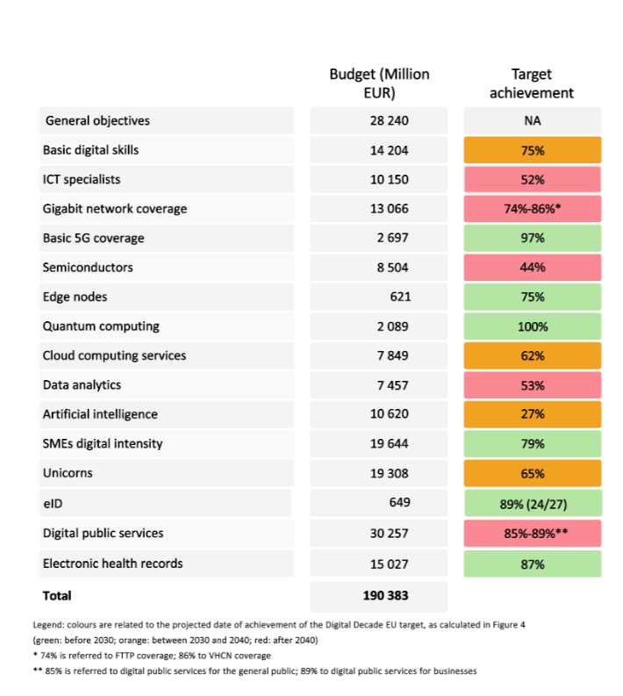
The analysis across Digital Decade KPIs and objectives can help inform the targeting of investment, by identifying areas of structural underperformance where EU-level action offers the greatest added value. Moreover, the Digital Decade recommendations will provide Member States with an evidence-based basis for shaping national programming for digital issues - fostering complementarities and synergies between EU and national level efforts. The Digital Decade tools will also contribute to inform the work of the Competitiveness Coordination Tool (CCT), through which the EU, Member States and industry are already joining forces to strengthen strategic EU-wide value chains within common competitiveness priorities. This new way of working, which is currently being used to deploy AI Gigafactories, should maximise impact through coordinated investments and reforms.
National roadmaps are the key instrument for translating these priorities into concrete commitments. They set out how Member States plan to deliver on Digital Decade targets, ensure continuity of investment beyond the Recovery and Resilience Facility, and contribute to both national and EU-level priorities. Following the DDPP rules, Member States are required to update their national roadmaps by December 2026, explicitly linking adjusted and planned measures to Member State-specific recommendations. Member States will also be encouraged to indicate whether, and to what extent, the planned measures are aligned with ECF priorities and could potentially benefit from the future NRPPs to facilitate and prepare the ground for the future MFF. These updates should take due account of the recommendations set out in Annex 2 and contribute to a more coherent, sustained and impactful implementation across the EU.

The local and regional dimension: a governance gap to close
Cities and regions are central to the delivery of the Digital Decade, as they deploy infrastructure, provide digital public services and translate EU policies into tangible outcomes for people in the EU. However, the current governance framework does not fully reflect this role. Local and regional authorities are not systematically involved in national roadmap design/update processes and territorial data remains insufficiently integrated into monitoring. Meanwhile, limited administrative and digital capacity at local level continues to be a key implementation constraint.
This gap has direct implications for delivery. Evidence from the Commission’s November 2025 workshop on the role of cities and regions, as well as from initiatives such as the LORDIMAS framework and national mapping processes involving thousands of municipalities, indicates that the main barriers to local digital transformation lie in governance arrangements and funding structures, rather than in political commitment or innovation potential. At the same time, initiatives such as the CitiVERSE EDIC demonstrate the benefits of structured cooperation when appropriate frameworks are in place.
Moreover, recent analytical work at subnational level confirms that digital divides are increasingly multidimensional and cannot be fully captured by national averages. Regional disparities persist not only in infrastructure but also in capabilities, usage and socio-economic outcomes.
The forthcoming review of the DDPP and the proposal for the next MFF provide a key opportunity to address these shortcomings. The Commission will work to strengthen the role of local and regional authorities in governance processes, improve the integration of territorial data into monitoring, and ensure that EU and national funding instruments adequately support local and regional digital capacity.

Conclusion and next steps
The 2026 State of the Digital Decade report marks a turning point in the EU’s digital governance framework, as the analytical work of previous years is now potentially matched by new, stronger operational tools to act on it, notably in the context of the next MFF
However, acting on it effectively requires three commitments from all involved. First, a commitment to scale: the investment levels required to close the structural gaps identified in this report are of an order of magnitude that neither individual Member States nor EU instruments can deliver alone, and that can only be achieved through genuine coordination and co-financing, including both private and public funding. Second, a commitment to speed: the pace of technological change means that instruments designed for a 2022 context must be recalibrated for a 2026 one, and the forthcoming DDPP review is the vehicle for that recalibration. Third, a commitment to coherence: the three structural challenges identified in this report - building strategic technologies, deploying them widely, and ensuring they work for people - must be addressed simultaneously, not sequentially. The stakes of delivering on these commitments are significant: an ambitious and coordinated digital policy response achieving the set ambitions, could raise EU GDP by up to 1.8%, reflecting gains in productivity, more efficient public service delivery, and a strengthened innovation ecosystem. This would require significantly scaled-up EU-level investment capacity, stronger coordination of public investment and RDI, reduced fragmentation, higher investment efficiency and improved mobilisation of public and private funding.
Delivering on these objectives requires renewed collective commitment from Member States, EU institutions and stakeholders at all levels. Particular attention must be paid to the risk of a severe investment shortfall. Since about half of the public budget of the digital measures currently included in national roadmaps is expected to be phased out by the end of 2026, and about six out of ten by the end of 2027, Member States and the Commission must jointly act to avoid a significant public funding gap and preserve momentum in support of EU’s digital leadership, competitiveness and technological sovereignty. The December 2026 revision of the national roadmaps is the political window to address this issue.
The revision of the National Digital Decade Strategic Roadmaps in December 2026 provides the first opportunity for Member States to translate the priorities set out in the SDD2026 package into concrete national commitments and prepare a pipeline of mature projects for implementation under the next Multiannual Financial Framework. The Commission calls therefore on all Member States to use the December 2026 revision of their national roadmaps as the central political vehicle for closing the gaps to their 2030 targets, ahead of the preparation of, and for synergies with, the next MFF. Each revised roadmap should respond to recommendations of Annexes 1 and 2 with concrete measures detailing reforms or investments, timelines, impacts, and budgets while building on existing strategies, fostering synergies with the ECF, and integrating local and regional dimensions. The Commission stands ready to support Member States throughout this process, notably through the Digital Decade Board, and will report in the 2027 State of the Digital Decade on the collective progress achieved based on the revised national roadmaps.
The evidence gathered in this report should also inform the forthcoming review of the DDPP. This will be a key opportunity to adapt the framework to technological developments, streamline its instruments, and strengthen its governance, notably by strengthening the link between strategic priorities, funding mechanisms and implementation tools.

European Parliament and Council of the European Union, Decision (EU) 2022/2481 of 14 December 2022 Establishing the 2030 Policy Programme "Path to the Digital Decade"’, OJ L 323, 19 December 2022.
European Commission, A European budget fit for Europe’s ambitions: Multiannual Financial Framework 2028–2034, legislative package adopted on 16 July 2025.
The Digital Decade Report issues recommendations under Decision (EU) 2022/2481. Article 3 defines its general objectives, including resilience, reducing the digital divide, technological sovereignty, digital capability deployment, digital empowerment, cybersecurity, and sustainability. Article 4 sets specific targets for Member States in areas such as skills, infrastructure, and the digitalisation of businesses and public services. Article 6 mandates the Commission to assess annual progress toward these objectives and targets, and to recommend actions for Member States. Article 7 lays down national Digital Decade strategic roadmaps as the main tool for implementing these recommendations.
OECD, Science, Technology and Innovation Outlook 2025, 28 October 2025.
OECD, Venture Capital Investments in Artificial Intelligence through 2025, OECD Policy Briefs No 50, February 2026.
Gartner, Gartner Forecasts Worldwide IT Spending to Grow 13.5% in 2026, Totalling $6.31 Trillion, 22 April 2026.
GONZALEZ VAZQUEZ, I., FERNANDEZ MACIAS, E., WRIGHT, S. and VILLANI, D., Digital Monitoring, Algorithmic Management and the Platformisation of Work in Europe, Publications Office of the European Union, Luxembourg, 2025
Special Eurobarometer 572] https://data.europa.eu/doi/10.2759/3200731
European Commission, Annual Single Market and Competitiveness Report 2026, COM(2026) 46 final, 30 January 2026.
https://data.europa.eu/doi/10.2759/3200731 .
The current KPI for the 5G target does not reflect the actual quality of service experienced by users. It monitors areas where a 5G signal is available, regardless of the network performance. Therefore, the current stage of 5G deployment can be considered only as ‘basic 5G’. Regarding quantum, data is based on: Strategic Advisory Board of the European Quantum Flagship, Key Performance Indicators for Quantum Technologies in Europe, March 2025. By the end of 2025, the EuroHPC Joint Undertaking had procured six quantum computers, two of which were inaugurated in 2025, and two additional analogue quantum simulators were inaugurated under the HPCQS project.
Full details on the KPIs are in the DESI 2026 Methodological note at https://digital-strategy.ec.europa.eu/en/news-redirect/938549
COM(2026) 503
JRC Publications Repository - Open but Not Powerless: Towards a Common Understanding of EU Digital Sovereignty.
The EU leads in high-impact research in only three of the 74 critical technologies; Australian Strategic Policy Institute (ASPI), Critical Technology Tracker, 2025.
European Commission Joint Research Centre, The 2025 EU Industrial R&D Investment Scoreboard, December 2025.
Ibid.
Regulation (EU) 2026/74 of the European Parliament and of the Council on the 28th regime corporate legal framework, 'EU INC.'
Open Forum Europe, cited in: Blind, K. et al., The Impact of Open Source Software and Hardware on Technological Independence, Competitiveness and Innovation in the EU Economy, Final Study Report, European Commission, September 2021. Open-source software is estimated to contribute between EUR 65 and EUR 95 billion to the EU’s GDP and underpins approximately 70% of all code.
Communication from the Commission to the European Parliament, the Council, the European Economic and Social Committee and the Committee of the Regions on European Tech Sovereignty, accompanied by an EU Open-Source Strategy, COM/2026/503 final
Regulation (EU) 2023/1781 of the European Parliament and of the Council of 13 September 2023 establishing a framework of measures for strengthening Europe’s semiconductor ecosystem and amending Regulation (EU) 2021/694 (Chips Act)
COM(2026) 504 final
COM(2026) 502
European Commission, AI Continent Action Plan, COM(2025) 165 final, 9 April 2025.
Encompasses the public sector and 10 key industry sectors: healthcare and pharmaceuticals, mobility, transport and automotive, robotics, manufacturing, engineering and construction, climate and environment, energy, agri-food, defence, security and space, electronic communications and cultural, creative and media sectors
The Tech Sovereignty package consists of 2 legislative proposals (the Chips Act 2.0 and the Cloud and AI Development Act, the EU Open-Source Strategy and a Strategic Roadmap for Digitalisation and AI in Energy
Volume share of international card schemes in total electronically initiated card payments with cards issued in the euro area, first half of 2023. Based on data collected under Regulation (EU) No 1409/2013 of the European Central Bank on payments statistics (ECB/2013/43), as amended.
Lane, P.R., ‘The Digital Euro: Maintaining the Autonomy of the Monetary System,’ keynote speech at the University College Cork Economics Society Conference, European Central Bank, 20 March 2025; the Commission’s legislative proposal on the digital euro was adopted in June 2023 and continued interinstitutional negotiations in 2024; see: European Commission, Proposal for a Regulation of the European Parliament and of the Council on the Establishment of the Digital Euro, COM(2023) 369 final, June 2023.
A Culture Compass for Europe COM(2025) 785 final
European Commission, EU Defence Industry Transformation Roadmap, COM(2025) 845 final, 19 November 2025.
European Commission, Proposal for a Regulation Establishing the Programme for Agile and Rapid Defence Innovation (AGILE), COM(2026) 135 final, 25 March 2026.
European Commission, A modernised cohesion policy: The mid-term review, COM(2025) 163 final
European Commission, Proposal for a Regulation Establishing the European Competitiveness Fund (ECF), Including the Specific Programme for Defence Research and Innovation Activities, COM(2025) 555 final, 2025.
European Union Agency for Cybersecurity (ENISA), ENISA Threat Landscape 2025, October 2025.
European Commission, Proposal for a Regulation on the European Union Agency for Cybersecurity (ENISA), the European Cybersecurity Certification Framework, and ICT Supply Chain Security, and Repealing Regulation (EU) 2019/881 (Cybersecurity Act 2), COM(2026) 11 final, 2026.
Rubinton, H. and Patro, B.A., ‘Tracking AI's Contribution to GDP Growth,’ On the Economy, Federal Reserve Bank of St. Louis, 12 January 2026.
JRC Report (upcoming).
IEA, Table A.4: Data Centres Electricity Consumption by Region, p. 110, Key Questions on Energy and AI, International Energy Agency, April 2026.
IEA, Energy Demand from AI, in Energy and AI, International Energy Agency, April 2025. EU data centre electricity consumption is projected to grow from around 70 TWh in 2024 to approximately 115 TWh by 2030.
COM(2026) 501 final
Regulation (EU) 2024/1781 of the European Parliament and of the Council of 13 June 2024 establishing a framework for the setting of ecodesign requirements for sustainable products, amending Directive (EU) 2020/1828 and Regulation (EU) 2023/1542 and repealing Directive 2009/125/EC
https://joint-research-centre.ec.europa.eu/jrc-news-and-updates/eu-code-conduct-data-centres-towards-more-innovative-sustainable-and-secure-data-centre-facilities-2023-09-05_en
https://publications.jrc.ec.europa.eu/repository/handle/JRC144975
https://data.consilium.europa.eu/doc/document/ST-6081-2026-REV-1/en/pdf
Eurostat, ICT usage in households and by individuals, 2025. Available at: Eurostat, ICT Usage in Households and by Individuals – Evaluating Data, Information and Digital Content, 2025.
K.G.M. v. Meta Platforms et al., Los Angeles County Superior Court, judgment of 25 March 2026, finding social media platforms liable for harm linked to addictive design features. Liability was based on platform design (addictive features), not just user-generated content The court held that design features (e.g. infinite scroll, autoplay) were a “substantial factor” in causing harm.
Michels, A., Ferreira, V., Annoni, P., Burton, J., Pedauga, L., Rueda-Cantuche, J. M. & Kušen, M., European Economy. Discussion Paper 249: Digital Measures under the Recovery and Resilience Facility: Economic Impacts at Macro, Sectoral and Country Levels, European Commission, Directorate-General for Economic and Financial Affairs, 2026.
See: European Investment Bank, Investment Report 2025/2026: Capitalising on Europe’s Strengths, March 2026; EIB Investment Survey 2025, October 2025; Buti, M. et al., ‘How large is the investment gap in the EU and how to close it?’, CEPR Policy Insight No. 141, 2025; Zettelmeyer, J., ‘Draghi on a shoestring: the European Commission’s Competitiveness Compass’, Bruegel Analysis, March 2026; European Parliamentary Research Service, Cost of Non-Europe in High-Tech Digital Innovation, July 2024; Draghi, M., The Future of European Competitiveness, 2024. For the private investment gap, see McKinsey Global Institute / WEF, Transforming Europe: Bold Moves to Lift a Continent, January 2026.
Buti, M. et al., ‘Time to be strategic: how public money could power Europe’s green, digital and defence transitions’, CEPR VoxEU, July 2025.
COM(2026) 503
European Commission, Annual Single Market and Competitiveness Report 2026, COM(2026) 46 final.
European Parliamentary Research Service, Cost of Non-Europe in High-Tech Digital Innovation: Investment Needs and Economic Benefits, July 2024, pp. 56-57 and 60-61. This remains the most recent EPRS estimate; an updated analysis is expected in the context of the MFF 2028-2034 debate.
European Commission, Digital Tracking, accessed 2026.
Torrecillas, J. (2026). RRF April 2026 Update. JRC146664, European Commission.
European Commission, Competitiveness Compass for the EU, COM(2025) 30 final, 29 January 2025.
Dealroom.co, Opening moves in global AI - AI, startups & venture capital, AI Action Summit, Paris, February 2025.
2025 SDD report cites: European Commission, European industrial technology roadmap for the next generation cloud-edge offering, 2021 (used for 2024 comparative data). For a more current source, see EIB Investment Report 2024/2025: Innovation, integration and simplification in Europe, 2025, which documents structural cybersecurity financing gaps in comparable terms. Recommend verification before publication.
European Commission, Savings and Investments Union: A Strategy to Foster Citizens' Wealth and Economic Competitiveness in the EU, COM(2025) 124 final, March 2025.
Center for strategic and international studies: Japan Seeks to Revitalize Its Semiconductor Industry, 2023. Also Foreign Policy, Japan Wants Semiconductor ManufacturingBack Home to Frustrate China, 9 January 2023.
The forthcoming revision of the Public Procurement Directives is listed in the Commission’s work programme for 2025-2026. GovTech refers to public sector engagement with start-ups and SMEs to procure innovative solutions (as defined in the 2025 SDD Communication, footnote 27).
Cloud and AI Development Act (CADA): Commission proposal to triple EU data centre capacity within 5-7 years, ensuring EU-based, sovereign cloud capacity for critical public sector applications.
Regulation (EU) 2021/241 establishing the Recovery and Resilience Facility, Article 18(4), requiring recovery and resilience plans to contribute to addressing challenges identified in country-specific recommendations.
Recovery and Resilience Facility Scoreboard; see also 2025 SDD Communication, section on public and private investment levels.
The figures include 5 main funding instruments: Recovery and Resilience Facility, Cohesion Policy, Horizon Europe, Digital Europe Programme and Connecting Europe Facility-Digital. Torrecillas, J. (2026). RRF April 2026 Update. JRC146664, European Commission. See also Torrecillas, J. and Nepelski, D., Update of Mapping of EU funds to Digital Decade targets 2021-2027, Publications Office of the European Union, Luxembourg, 2025, https://data.europa.eu/doi/10.2760/4123945, JRC141966.
ESPON, DigiReg – Territorial Perspectives of Digital Transition in European Regions, 2024.
European Parliamentary Research Service (EPRS), Benefit of an EU Strategic Innovation Agenda – Cost of Non-Europe, EPRS Study PE 762.853, February 2025.
In line with the Commission’s Roadmap guidance: Guidance to the Member States on the preparation of the national Digital Decade strategic roadmaps C(2023) 4025 final.

