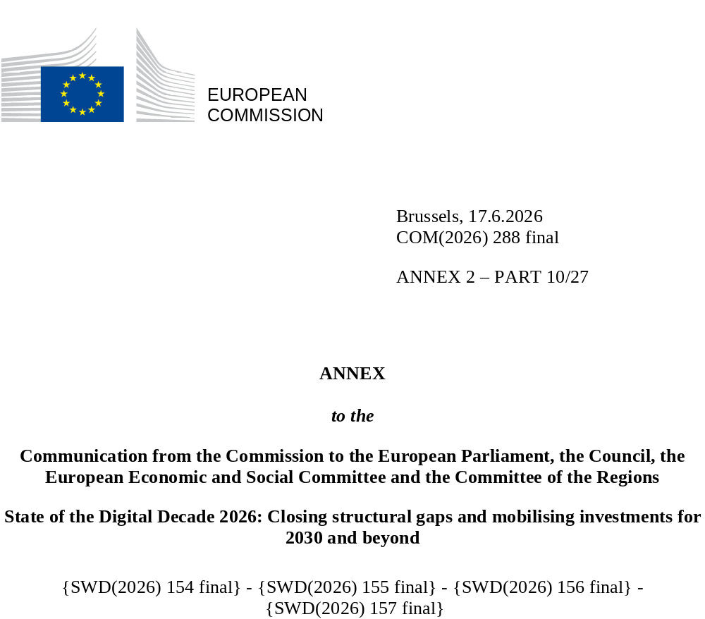

DIGITAL DECADE
SHORT COUNTRY REPORT
2026

France

Executive summary
Overall, France has strong assets in digitalisation such as a good fibre coverage, a digitally skilled population and a vibrant AI ecosystem. However, while the country has made strong progress in expanding digital adoption across businesses, it is still not fully reaping the fruits of digital transition when it comes to the general population of businesses, which lags behind in basic digitalisation and adoption of key technologies. The number of ICT specialists is also sub-par and experiencing sluggish growth, while the digitalisation of public services seems to have stagnated in recent years.
The weaknesses identified in the digitalisation of businesses are having an impact on France’s competitiveness as low digitalised businesses cannot take advantage of productivity gains brought by digital tools (basic and advanced), nor can they access new online markets. More ICT specialists in the job market could relieve skills shortages in all sectors and help businesses access the expertise required to digitalise. More widespread digital public services could also foster the digitalisation of businesses while alleviating their administrative burden.
France can, however, count on several digital leadership assets. It is home to one of the most attractive AI ecosystems for start-ups thanks to a pool of engineering and research talent and considerable public support programmes. Public policies recently shifted heavily toward AI for the digitalisation of all businesses, and for research and infrastructure with large-scale projects such as the AI Factory France (AI2F). Massive investments in research and the production of semiconductors were committed through the Digital Decade roadmap. In quantum technology, France is a frontrunner in the EU and at the forefront of computing research with the inauguration of the Ruby quantum processor in 2025 as part of the EuroHPC Joint Undertaking.

France in the Digital Decade
France shows a high level of ambition in its contribution to the Digital Decade having set 9 national targets (out of 14 possible), 100% of which aligned with the EU 2030 targets. France also set a target of 65% for the combined adoption of technologies by businesses, shy of the 75% EU level target. In its national roadmap, France provided 10 trajectory points for 2025 (out of 14 analysed). The country is following them moderately well with 50% considered on track. France addressed 67% of the 6 recommendations issued by the Commission in 2025, either by implementing significant policy changes (33%) or making some changes (33%) through new measures. According to the national roadmap, by the end of 2026, 27% of the measures will come to an end. The total public budget associated to these measures is EUR 3.15 billion, representing 28% of the total public budget outlined in the roadmap.
According to the special Eurobarometer on the Digital Decade 2026, 72% of French people consider that digital policy should have a very high/high priority for the EU in shaping our future in Europe. They also think that, in the next 10 years, the EU should cooperate with Member States to reinforce cybersecurity and protection from online threats (95%), promote digital education and skills programs (88%), and strengthen the regulation of online platforms (88%). In addition, 83% of French respondents think that the EU should reduce its dependencies on digital from third countries, and 83% that the EU should prioritise investments in digital infrastructure and services that are developed and controlled in Europe. Meanwhile, 49% would be willing to switch to an EU-based digital service provider even if it means slightly higher costs.

Funding for digital and multi-country projects
France allocates 22% of its total recovery and resilience plan to the digital transition (EUR 8.1 billion). In addition, under the cohesion policy, EUR 2.0 billion, representing 12% of the country’s total cohesion policy funding, is dedicated to advancing France’s digital transformation.
France is the host Member State for the Alliance for Language Technologies European Digital Infrastructure Consortium (ALT-EDIC) and for the Digital Commons EDIC. France is also a member of the Local Digital Twins towards CitiVERSE EDIC. France participates directly in the IPCEI on Microelectronics and Communication Technologies (IPCEI-ME/CT), in the IPCEI on Next Generation Cloud Infrastructure and Services (IPCEI-CIS), and in the IPCEI Tech4Cure. France is also a participating state of the EuroHPC Joint Undertaking (JU) and of the Chips JU.
Digital Decade KPI ⁽¹⁾ | France |  |  |  | EU |  |  | Digital Decade target by 2030
Digital Decade KPI ⁽¹⁾ | Last available data (2) | DESI 2026 (year 2025) | Annual progress | National trajectory 2025 (3) | DESI 2026 | Annual progress | FR |  | EU
Fixed Very High Capacity Network (VHCN) coverage | 87.5% | 91.7% | 4.9% | 100.0% | 85.5% | 3.7% | 100.0% |  | 100%
Fibre to the Premises (FTTP) coverage | 87.5% | 91.7% | 4.9% | - | 74.1% | 7.1% | - |  | -
Basic 5G coverage | 94.3% | 96.4% | 2.2% | 100.0% | 96.8% | 2.6% | 100.0% |  | 100%
Edge Nodes (estimate, new methodology) | - | 854 | - | - | 7451 | - | - |  | 10000
SMEs with at least a basic level of digital intensity * | 52.0% | 69.4% | 15.6% | 62.9% | 71.4% | 11.0% | 90.0% |  | 90%
Cloud * | 23.0% | 36.5% | 26.0% | - | 46.7% | 9.5% | - |  | 75%
Artificial Intelligence | 9.9% | 18.2% | 83.2% | - | 20.0% | 48.0% | - |  | 75%
Data analytics * | 33.9% | 39.3% | 7.6% | - | 39.9% | 9.5% | - |  | 75%
AI or Cloud or Data analytics * | 44.9% | 57.9% | 13.6% | 50.6% | 63.2% | 7.5% | 65.0% |  | 75%
Unicorns | 47 | 50 | 6.4% | 57 | 324 | 10.2% | 100 |  | 500
At least basic digital skills * | 59.7% | 65.7% | 5.0% | 65.5% | 60.4% | 4.3% | 80.0% |  | 80%
ICT specialists | 4.8% | 4.9% | 2.1% | 6.2% | 5.0% | 2.0% | 10.0% |  | ~10%
e-ID scheme notification |  | Yes
Digital public services for citizens | 71.2 | 72.0 | 1.1% | 80.1 | 84.6 | 2.8% | 100.0 |  | 100
Digital public services for businesses | 76.9 | 74.6 | -3.0% | 85.2 | 88.6 | 2.7% | 100.0 |  | 100
Access to electronic health records | 84.2 | 88.4 | 4.9% | 85.2 | 86.5 | 4.6% | 100.0 |  | 100
(1) Indicators full description, metadata and sources in the DESI 2026 methodological note
(2) Last available data is DESI2025 (reference year 2024) except for indicators marked with a star * for which it is DESI2024 (reference year 2023)
(3) National trajectory value for 2025, if set by the country in its Digital Decade national roadmap

A competitive, sovereign and resilient EU based on technological leadership
France is performing well in connectivity, being above the EU average in fibre coverage and slightly below for 5G. Coverage of fibre to the last non-covered premises, especially in very dense areas and outermost regions, will be key to achieving full coverage by 2030. There is a high take-up of fibre in France as it is leading in the EU in terms of the share of fixed broadband subscriptions >=1Gbps, but it is in the group of the worst performing countries for 5G take-up although a recent acceleration has been observed. The French quantum strategy is one of the most advanced in the EU but needs updating with a view to consolidating the scale-up and industrial stages. Semiconductor research facilities and production capacities are well developed, though smaller than global players.
On the business side, SMEs are still lagging in basic digitalisation, though catching up with the EU average. Training and diagnostics under the France Num scheme proved to be efficient and popular in terms of engaging smaller businesses in digitalising, despite bottlenecks related to skills availability and concerns about cybersecurity risks. Businesses’ uptake of advanced technologies such as cloud or AI is also sub-par. France decidedly embraced AI as the leading technology to digitalise its economy and in 2025 launched the plan ‘Osez l’IA’ to foster AI adoption by businesses of all sizes. The start-up and frontier AI ecosystem is very well developed and attracted record investments for AI infrastructure in 2025, further supported by a national plan to facilitate the implementation of data centres. However, as in other EU countries, French start-ups face issues in scaling up due to limited access to venture capital and could benefit from increased international visibility.

Protecting and empowering EU people and society
The level of basic digital skills of the population is satisfactory, above the EU average. Conversely, the share of ICT specialists remains below average and has been stagnating for several years, leading to constraints in the ICT job market. While the ICT training offer seems to be sufficient, its take-up is weak. Tackling this issue – linked to weak performance in STEM education – could boost the spread of innovation and digitalisation across all business sectors.
France has engaged in many initiatives for digitalising public services, with strong priority given to sovereignty. While many services are available online, indicators point to weak progress in digitalisation efforts, including in justice. Cross-border availability in particular is low and many users report difficulties with online administrative procedures. The digitalisation of healthcare continues to improve, including by using AI technologies and strengthening data storage sovereignty.

Recommendations
- Digitalisation of SMEs: Improve SMEs’ basic digitalisation by designing dedicated public support measures, including training, diagnostics and targeted financial support, to accompany businesses in cybersecurity, digital business management, and digital business development.
- ICT specialists: Expand the supply of Information and Communication Technology (ICT) specialists, in particular by improving the job market relevance of existing training pathways (higher education, vocational training, and reskilling) and aligning them with industry needs, paying particular attention to AI and cybersecurity specialists. Strengthen the ongoing national effort in mathematics in secondary education, thereby addressing the weakness in math foundations which hinders entry into the field of ICT studies. Deploy earlier-stage awareness-raising measures and career guidance in the education system to raise take-up of existing training pathways. Intensify efforts to increase women’s participation in ICT studies and careers.
- Uptake of AI: Accelerate the uptake of AI in businesses, especially SMEs, by ensuring that the recently launched national plan on AI adoption delivers on its stated training and take-up targets, with regular reporting on take-up broken down by business size. Invest in AI computing infrastructure and accelerate permitting procedures, including for data centres. Ensure effective access to the national AI factory infrastructure for SMEs and deploy sector-specific applications through the sectoral flagships of the EU Apply AI Strategy. Intensify support for European Digital Innovation Hubs (EDIHs) which are a key support tool helping businesses to adopt advanced digital technologies, especially AI, and are embedded in the wider EU AI ecosystem.
- Digital Public Services: Accelerate the digitalisation of public services for citizens and businesses, in particular by implementing cross-border public services capabilities and prioritising high-volume cross-border procedures. Step up efforts to digitalise the justice system to allow citizens to initiate and follow proceedings online. Continue the implementation of digital public services with a focus on Family, Health, and Career life events for citizens, and Regular Business Operations life events for businesses, and on regional-level services. Implement the once-only technical system (OOTS) systematically.
- Semiconductor: Sustain and deepen domestic production capacities in the semiconductor sector, in particular in back-end capacities and manufacturing of advanced chips for AI usage.
- Quantum: Consolidate France’s leadership in quantum technologies and translate it into industrial deployment, in particular by building on the achievements of the National Quantum Plan (2021-2025) and adopting a post-2025 roadmap with a clear multiannual budgetary trajectory, in order to avoid a funding gap for emerging industrial players. Deepen integration with the European supply chain and support cross-border cooperation.

