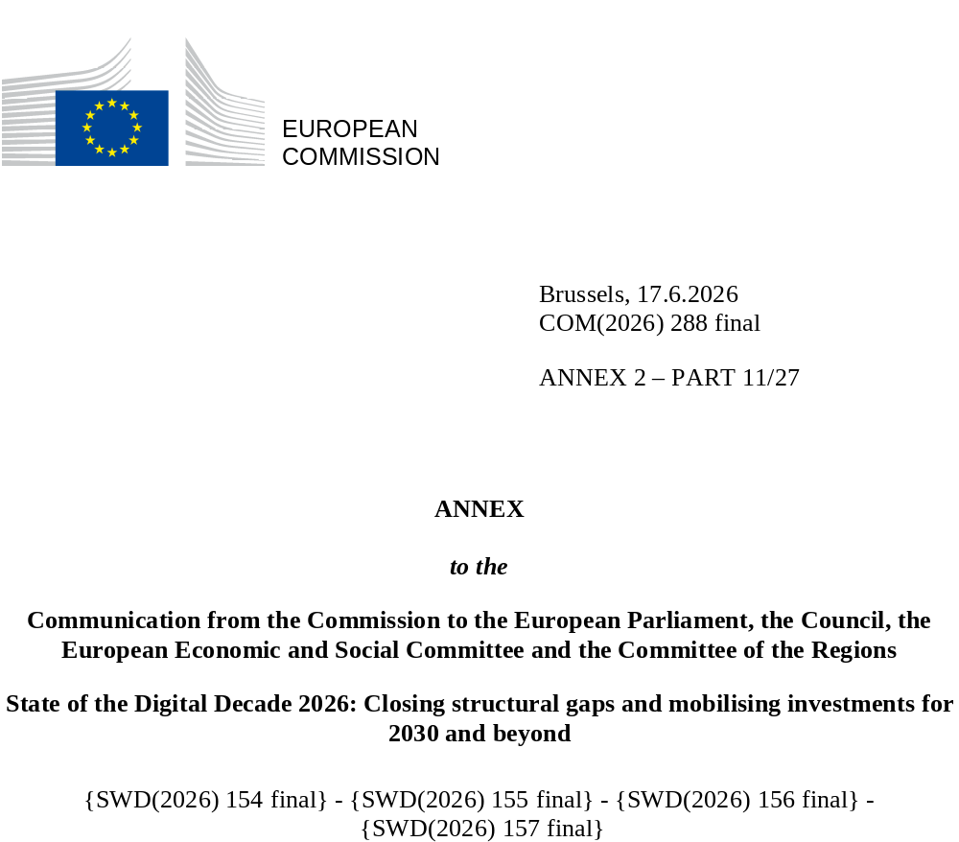

DIGITAL DECADE
SHORT COUNTRY REPORT
2026

Germany

Executive summary
Overall, Germany has strong assets in digitalisation, including a leading position in high-tech sectors such as semiconductors and quantum technology. However, persistent structural challenges – particularly in connectivity and digital public services – have constrained more substantial progress for many years. With the establishment of the new Ministry for Digital Transformation and Government Modernisation, some momentum for change has been generated, and several promising initiatives are being launched to address these challenges. However, it remains to be seen whether these efforts will translate into lasting structural improvements.
The persistent structural weaknesses limit the potential leverage that digitalisation can provide for competitiveness. Efficiency gains and reductions in administrative burden are often hindered by complex systemic issues (e.g. linked to fragmented responsibilities and implementation modes), which have been identified but not yet resolved. While gradual improvements are underway, they are so far too slow and limited in scale to generate substantial impact. Given the challenging economic situation overall, faster and more profound adjustments are needed to boost competitiveness and productivity.
At the same time, Germany remains among the leading EU Member States in several high-tech domains. It is the largest data centre as well as microelectronics location in the EU and plays a major role in semiconductor research and manufacturing. Germany also demonstrates a leading position in quantum technologies, supported by advanced research capabilities, cutting-edge infrastructure (e.g. exascale supercomputer JUPITER) and, to date, comparatively high levels of public funding.

Germany in the Digital Decade
Germany shows a substantial level of ambition in its contribution to the Digital Decade having set 9 national targets (out of a possible 14), 89% of which align with the EU 2030 targets. Germany has also set a target of 75% for the combined adoption of technologies by businesses, in line with the target at EU level. In its national roadmap, Germany provided 8 trajectory points for 2025 (out of 14 analysed). The country is following them moderately well with 50% considered on track. Germany addressed 86% of the 7 recommendations issued by the Commission in 2025, either by implementing significant policy changes (14%) or making some changes (72%) through new measures. According to the national roadmap, by the end of 2026, 66% of the measures will come to an end. The total public budget associated to these measures is EUR 15.33 billion, representing 33% of the total public budget outlined in the roadmap.
According to the special Eurobarometer on ‘the Digital Decade’ 2026, 84% of Germans consider that digital policy should be a very high or high priority for the EU in shaping our future in Europe. They also think that, in the next ten years, the EU should cooperate with Member States to reinforce cybersecurity and protection from online threats (92%), promote digital education and skills programmes (91%) and build an independent European digital infrastructure (broadband, 5G, cloud computing, semiconductors (85%)). In addition, 87% of German respondents think that the EU should reduce its dependence on digital technology from third countries, and 89% that the EU should prioritise investments in digital infrastructure and services that are developed and controlled in Europe. Meanwhile, 57% would be willing to switch to an EU-based digital service provider even if it means slightly higher costs.

Funding for digital and multi-country projects
Germany allocates 46% of its total recovery and resilience plan to digital (EUR 12.8 billion). In addition, under cohesion policy, EUR 2.4 billion, representing 12% of the country’s total cohesion policy funding, is dedicated to advancing Germany’s digital transformation.
Germany is a member of the Local Digital Twins towards the CitiVERSE EDIC, and a member of the Digital Commons EDIC. The country participates directly in the IPCEI on Microelectronics and Communication Technologies (IPCEI-ME/CT) and in the IPCEI on Next Generation Cloud Infrastructure and Services (IPCEI-CIS). Germany is also a participating state in the EuroHPC Joint Undertaking (JU) and the Chips JU.
Digital Decade KPI ⁽¹⁾ | Germany |  |  |  |  | EU |  |  | Digital Decade target by 2030
Digital Decade KPI ⁽¹⁾ | Last available data (2) | DESI 2026 (year 2025) | Annual progress | National trajectory 2025 (3) | DESI 2026 |  | Annual progress | DE |  | EU
Fixed Very High Capacity Network (VHCN) coverage | 77.4% | 79.9% | 3.2% | - | 85.5% |  | 3.7% | 100.0% |  | 100%
Fibre to the Premises (FTTP) coverage | 36.8% | 44.0% | 19.6% | 50.0% | 74.1% |  | 7.1% | 100.0% |  | -
Basic 5G coverage | 99.1% | 99.5% | 0.4% | - | 96.8% |  | 2.6% | 100.0% |  | 100%
Edge Nodes (estimate, new methodology) | - | 1948 | - | - | 7451 |  | - | - |  | 10000
SMEs with at least a basic level of digital intensity * | 61.4% | 73.6% | 9.5% | 82.0% | 71.4% |  | 11.0% | 91.0% |  | 90%
Cloud * | 38.5% | 46.0% | 9.3% | - | 46.7% |  | 9.5% | - |  | 75%
Artificial Intelligence | 19.8% | 26.0% | 31.5% | - | 20.0% |  | 48.0% | - |  | 75%
Data analytics * | 37.1% | 37.7% | 0.8% | - | 39.9% |  | 9.5% | - |  | 75%
AI or Cloud or Data analytics * | 58.0% | 63.2% | 4.4% | 24.0% | 63.2% |  | 7.5% | 75.0% |  | 75%
Unicorns | 66 | 74 | 12.1% | - | 324 |  | 10.2% | - |  | 500
At least basic digital skills * | 52.2% | 59.6% | 6.8% | 60.0% | 60.4% |  | 4.3% | 80.0% |  | 80%
ICT specialists | 5.1% | 5.5% | 7.8% | 5.0% | 5.0% |  | 2.0% | 5.3% |  | ~10%
e-ID scheme notification |  | Yes
Digital public services for citizens | 78.9 | 78.1 | -1.0% | 80.0 | 84.6 |  | 2.8% | 100.0 |  | 100
Digital public services for businesses | 77.5 | 77.8 | 0.3% | 82.5 | 88.6 |  | 2.7% | 100.0 |  | 100
Access to electronic health records | 87.0 | 87.7 | 0.9% | 100.0 | 86.5 |  | 4.6% | 100.0 |  | 100
(1) Indicators full description, metadata and sources in the DESI 2026 methodological note
(2) Last available data is DESI2025 (reference year 2024) except for indicators marked with a star * for which it is DESI2024 (reference year 2023)
(3) National trajectory value for 2025, if set by the country in its Digital Decade national roadmap

A competitive, sovereign and resilient EU based on technological leadership
In the area of connectivity, fibre rollout has accelerated in recent years and differences between urban and rural rollout levels are narrowing, but regional disparities persist. Germany still scores second-to-last on fibre coverage in the EU and has relatively low take-up rates, with a particular challenge in establishing ‘last metre' connection, i.e. bringing fibre that is already available in close proximity to additional households. Germany is working on improving the framework conditions limiting rollout, including with adjustments to its national laws. It remains to be seen whether these measures will be sufficient to overcome structural challenges, such as fragmented stakeholder interests and deployment landscape. At the same time, preparatory work for copper switch-off is ongoing. In 5G, Germany performs below the EU average in the mid-band spectrum (3.4-3.8 GHz), which is crucial for delivering both broad coverage and high capacity.
At the business level, companies perceive gaps in their uptake of advanced technologies, such as artificial intelligence (AI), and there especially within the manufacturing sector. The usage of digital technologies is often focused on productivity gains, while applications related to innovation and business model transformation remain less common. Moreover, implementation challenges such as limited human and financial resources, shortcomings in data processing and regulatory complexity persist. Against this background, Germany has continued to implement European Digital Innovation Hubs (EDIHs) and the Mittelstand-Digital funding priority to support SMEs in their digital transformation efforts. It also hosts two of the 19 European AI Factories, driving advancements in AI application in different industrial sectors. In the area of start-ups, measures to reduce administrative burden are being prepared, while efforts to improve access to funding for tech start-ups are ongoing.
Despite Germany's strong position in quantum research and infrastructure, its performance remains relatively modest in more commercialisation-oriented quantum technology activities. This is reflected in limited planned private investment, partly due to the technology's early stage of development. Against the background of increasing cyber threats and gaps in companies’ preparedness, public support measures for businesses continue, but have not been expanded accordingly.

Protecting and empowering EU people and society
The level of basic digital skills of the population is very close to the EU average, and the Digital Pact 2.0 will continue to support the digital transformation of the education system. Although Germany’s share of ICT specialists exceeds the EU average, ICT specialist shortages remain a constraint for the German economy. Demand is also rising for highly skilled professionals in areas such as AI, quantum technologies and semiconductors. It remains to be seen whether the speed and scope of ongoing and planned measures (e.g. National Skills Strategy, Skilled Labour Strategy, Work and Stay Agency) will be sufficient to address these shortages, as well as structural issues such as complex administrative procedures to attract and retain ICT talents.
Comparatively low availability and use of digital public services have been among the key challenges in Germany over recent years. Decentralised rollout is hindered by technical, organisational and political challenges, aggravated by fragmented responsibilities across different levels of government. The new Ministry for Digital Transformation and Government Modernisation has created some momentum to change dynamics, including moving from the ‘one for all’ (Einer für Alle, EfA) principle towards more standardised solutions, and launching some pilot projects to deliver a few quick positive signals and demonstrate the potential of cross-level collaboration. In this context, increasing interoperability across the fragmented IT landscape will be key, as it is also a prerequisite for the functionality of the EUDI Wallet. This is especially relevant given that eID uptake remains very low, while the EUDI Wallet could help address some of the challenges currently associated with eID usage.

Recommendations
- Digital public services: Accelerate and expand the nationwide rollout of digital public services and uptake of eID by enhancing interoperability and ensuring end-to-end digitalisation, including through greater use of standardised digital building blocks and improved connectivity between IT systems. Systematically address structural implementation barriers, including by strengthening collaboration and ensuring a more coherent allocation of resources and responsibilities across levels of government, as well as intensifying cross-border collaboration. Improve the user-friendliness of digital public services and simplify and promote eID usage, including by making it easier to (re)activate eID cards.
- Connectivity: Accelerate the rollout of very high-capacity networks, especially fibre optic infrastructure, with a focus on connecting end users and reducing regional disparities in coverage. Improve framework conditions for fibre deployment, including by strengthening efforts to streamline and standardise rollout procedures and fostering the copper networks switch-off. Promote take-up, including by increasing awareness of the benefits of fibre connectivity. Improve availability and coverage in the 5G mid-spectrum band (3.4-3.8 GHz) and take advantage of the upcoming expiry of rights of use to implement pro-investment conditions.
- Uptake of advanced technologies, especially AI: Accelerate the adoption of advanced technologies, such as AI, across businesses, including by fostering deeper integration of digital technologies to support innovation and business model transformation. In the field of AI, support the deployment of innovation infrastructures for businesses, such as AI Factories, AI Testing and Experimentation Facilities and European Digital Innovation Hubs (EDIH). Promote AI uptake in strategic sectors, such as manufacturing, supporting the EU’s Apply AI Strategy’s actions.
- ICT specialists: Increase the supply of ICT specialists by attracting more young people into ICT-related studies and careers, including through further development of existing and planned measures. Strengthen efforts to attract and retain ICT talent by streamlining administrative procedures and enhancing collaboration. Ensure a sufficiently large pool of highly skilled professionals in cutting-edge technologies to support innovation and their continued development.
- Quantum technologies: Leverage the country’s strong position in quantum technologies with adequate funding, including by ensuring continued public financial support and by incentivising private investment, in particular into the German quantum startup landscape. Accelerate commercial uptake by reinforcing technology transfer mechanisms between the country's research base and industry. Intensify cross-border collaboration and contribute to building a European quantum supply chain.
- Cybersecurity: Improve cybersecurity resilience for private and public entities, including by raising awareness of existing support and complementing it with targeted measures to improve preparedness for the evolving threat and technology development landscape.

