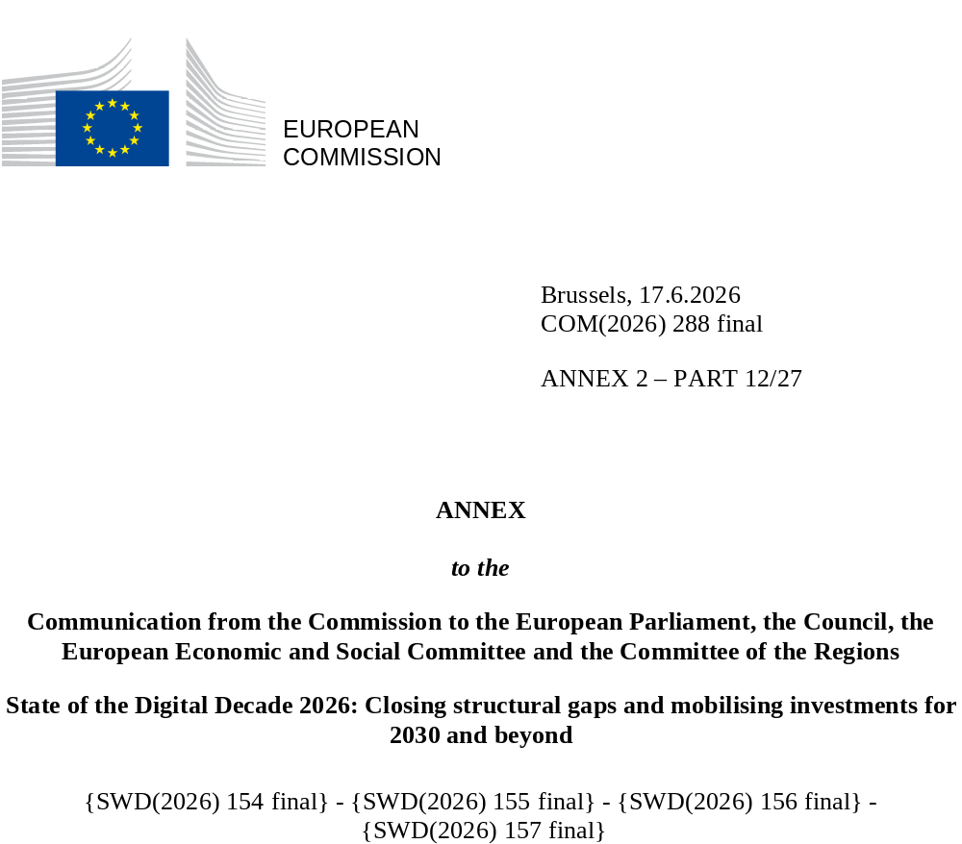

DIGITAL DECADE
SHORT COUNTRY REPORT
2026

Greece

Executive summary
Overall, Greece has made significant progress in its digital transition, particularly in establishing a framework for the safe and resilient use of digital technologies across the economy and society. Recent key achievements include the adoption of a new national framework for data governance and a cybersecurity strategy to strengthen the country’s digital resilience. However, these advancements have yet to be translated into tangible benefits, notably for businesses, which continue to lag behind in both basic digital adoption and the uptake of advanced technologies. Structural weaknesses in digital skills also persist. While the vast majority of young people have at least basic digital skills, the proportion of the entire population with at least basic digital skills has shown no progress since 2023.
The slow pace of business digitalisation risks undermining Greece’s competitiveness. Low levels of digital adoption prevent businesses from capitalising on digital innovation and emerging transformative technologies. Furthermore, the persistent gap in digital skills and the shortage of ICT specialists limit access to a trained workforce, further hindering digital transformation.
Despite these challenges, Greece is rapidly developing assets that could drive future progress in digital leadership. The AI Factory ‘Pharos’ was formally established as a legal entity in 2025; four additional AI Factory Antennas have also been launched in countries of the region. In the area of quantum communications, Greece is coordinating a project to develop a secure and scalable infrastructure connecting the national quantum communication infrastructures of four EU countries. The initiative will provide ultra-secure communication channels bolstering Europe’s cybersecurity resilience. Greece is also investing in semiconductors, having recently established the Hellenic Chips Competence Centre. Public and private stakeholders in the sector have started initial collaboration with the prospect of developing an ecosystem in Greece. Additionally, a major European Investment Bank (EIB) investment in a new gallium production facility in Greece marks a significant step toward strengthening Europe’s strategic autonomy in critical raw materials.

Greece in the Digital Decade
Greece shows a moderate level of ambition in its contribution to the Digital Decade having set 14 national targets (out of 14 possible), 57% of which are aligned with the EU 2030 targets. In its national roadmap, Greece provided 13 trajectories points for 2025 (out of 13 analysed). The country is following them moderately well with 62% considered to be on track. Greece has addressed 83% of the six recommendations issued by the Commission in 2025, either by implementing significant policy changes (16%) or making some changes (67%) through new measures. According to the national roadmap, by the end of 2026, 42% of the measures will come to an end. The total public budget associated with these measures is EUR 3.69 billion, representing 60% of the total public budget outlined in the roadmap.
According to the special Eurobarometer on ‘the Digital Decade 2026’, 76% of respondents in Greece consider that digital policy should be a very high/high priority for the EU in shaping Europe’s future. They also think that, in the next 10 years, the EU should cooperate with Member States to reinforce cybersecurity and protection online (93%), promote digital education and skills programmes (90%) and strengthen the regulation of online platforms - e.g. online social media networks, marketplaces, app stores, etc) (84%). In addition, 82% of respondents think that the EU should reduce its dependence on digital from third countries, and 85% that the EU should prioritise investments in digital infrastructure and services that are developed and controlled in Europe. 56% would be willing to switch to an EU-based digital service provider even if it meant slightly higher costs.

Funding for digital and multi-country projects
Greece allocates 22% of its total recovery and resilience plan to digital (EUR 7.8 billion). In addition, under the cohesion policy, EUR 3.1 billion, representing 15% of the country’s total cohesion policy funding, is dedicated to advancing Greece’s digital transformation.
Greece is the host Member State of the IMPACTS-EDIC, a European Digital Infrastructure Consortium (EDIC) established in December 2025 to boost interoperable digital solutions and services for public administrations across multiple countries. The country is also a member of the Alliance for Language Technologies EDIC and of the EUROPEUM EDIC, which seeks to strengthen cooperation on blockchain. Furthermore, Greece has been chosen by applicant Member States to host the CSC-EDIC on cybersecurity skills. Greece is directly participating in the Important Project of Common European Interest (IPCEI) on Microelectronics and Communication Technologies (IPCEI-ME/CT) and is a participating Member State of two Joint Undertakings (JUs), the EuroHPC and the Chips JU.
Digital Decade KPI ⁽¹⁾ | Greece |  |  |  |  | EU |  |  | Digital Decade target by 2030
Digital Decade KPI ⁽¹⁾ | Last available data (2) | DESI 2026 (year 2025) | Annual progress | National trajectory 2025 (3) | DESI 2026 |  | Annual progress | EL |  | EU
Fixed Very High Capacity Network coverage | 46.1% | 59.8% | 29.7% | 51.0% | 85.5% |  | 3.7% | 100.0% |  | 100%
Fibre to the Premises (FTTP) coverage | 46.1% | 59.8% | 29.7% | 51.0% | 74.1% |  | 7.1% | 100.0% |  | -
Overall 5G coverage | 99.8% | 99.5% | -0.3% | 90.0% | 96.8% |  | 2.6% | 100.0% |  | 100%
Edge Nodes (estimate, new methodology) | - | 89 | - | 5 | 7451 |  | - | 95 |  | 10 000
SMEs with at least a basic level of digital intensity * | 43.3% | 56.0% | 13.7% | 55.6% | 71.4% |  | 11.0% | 79.7% |  | 90%
Cloud * | 18.1% | 21.3% | 8.4% | 23.2% | 46.7% |  | 9.5% | 56.0% |  | 75%
Artificial Intelligence | 9.8% | 8.9% | -9.0% | 12.0% | 20.0% |  | 48.0% | 32.0% |  | 75%
Data analytics * | 25.0% | 31.5% | 12.2% | 18.3% | 39.9% |  | 9.5% | 40.0% |  | 75%
AI or Cloud or Data analytics * | 33.5% | 40.8% | 10.3% | - | 63.2% |  | 7.5% | - |  | 75%
Unicorns | 3 | 3 | 0.0% | 6 | 324 |  | 10.2% | 20 |  | 500
At least basic digital skills * | 52.4% | 51.0% | -1.4% | 61.4% | 60.4% |  | 4.3% | 70.2% |  | 80%
ICT specialists | 2.5% | 2.5% | 0.0% | 3.2% | 5.0% |  | 2.0% | 4.5% |  | ~10%
e-ID scheme notification |  | No
Digital public services for citizens | 76.7 | 79.4 | 3.4% | 76.2 | 84.6 |  | 2.8% | 98.2 |  | 100
Digital public services for businesses | 78.6 | 86.0 | 9.4% | 84.4 | 88.6 |  | 2.7% | 100.0 |  | 100
Access to electronic health records | 73.8 | 93.8 | 27.0% | 72.1 | 86.5 |  | 4.6% | 100.0 |  | 100
(1) Indicators full description, metadata and sources in the DESI 2026 methodological note
(2) Last available data is DESI2025 (reference year 2024) except for indicators marked with a star * for which it is DESI2024 (reference year 2023)
(3) National trajectory value for 2025, if set by the country in its Digital Decade national roadmap

A competitive, sovereign and resilient EU based on technological leadership
On gigabit connectivity, Greece continues to make steady progress in fibre deployment, in line with its national trajectory, though it remains below the EU average. In sparsely populated areas, a very low level of coverage is observed across regions, with significant disparities between urban and rural areas. On the other hand, 5G coverage is equally well deployed across the country. Leveraging its strategic geographical position at the crossroads of three continents, Greece has also taken steps to enhance connectivity across borders and strengthen the resilience and security of its digital infrastructure. This includes the development of submarine cables and attracting investment for the deployment of data centres, creating significant opportunities in a rapidly expanding sector. However, the digital transformation of SMEs is progressing too slowly to meaningfully contribute to economic growth and competitiveness. Persistent challenges remain, including a limited absorption capacity, particularly among micro enterprises, a shortage of digital skills and remaining administrative bottlenecks, all of which risk hindering progress towards the 2030 Digital Decade target. The uptake of AI by businesses overall was also slow compared to the EU average in 2025. On a positive note, the emerging AI ecosystem centred around the AI Factory, along with broader investments in high-tech sectors – such as quantum communications and data centres – could generate a positive spillover effect for the wider economy. Greece is rapidly developing its digital leadership capabilities, and in 2025, it further strengthened the framework conditions for thriving digital economy by adopting a new framework for data governance and a national cybersecurity strategy to enhance cyber resilience in the face of evolving threats in line with EU regulations.

Protecting and empowering EU people and society
In 2025, only half of people aged 16 to 74 (50.96%) in Greece possessed at least basic digital skills, a 1.4% annual decline since 2023, broadening the gap with the EU average of 60.40%. This trend is particularly alarming compared to the EU’s annual growth rate of 4.3% over the same period. Greece has implemented several initiatives to integrate digital skills into the education system, and the key performance indicator confirms that educational attainment significantly influences digital proficiency. Individuals with no or low formal education face considerable challenge, 22.62% only having at least a basic level of digital skills. This underlines the importance of educational initiatives to address the digital skills gap. Additionally, the country has launched large-scale upskilling and reskilling programmes across different population segments. Despite these efforts, however, in 2025 the KPI overall performance showed a slight decrease while disparities between age groups remain. In particular a drastic fall in the percentage of people having at least basic digital skills is observed in age groups above 34 years old. Furthermore, the share of ICT specialists in employment is stagnating at 2.5% since the previous year. To address this issue, Greece has intensified efforts to expand its pipeline of future digital talent and ICT specialists through multiple channels, including education reforms, reskilling and upskilling programmes, monitoring of the situation and use of a labour market diagnostic tool. Nevertheless, the shortage of ICT specialists in employment remains one of Greece’s most pressing challenges in its digital transition.
Greece continues to progress in implementing its national strategy for digitalisation of public services with significant milestones reached in 2025 in terms of enhancing the resilience and security of public services and data. Extensive use of the new Governmental Cloud (G-Cloud) funded by the Recovery and Resilience Facility (RRF), significantly improved efficiency and security. The new national data governance framework also serves as the foundation for interoperability across government clouds (G-Cloud); standardisation of health data formats; privacy safeguards and interoperability with the health Cloud (H-Cloud). As regards the availability of digital public services online, the availability of cross-border services for businesses improved considerably but remained below the EU average. In terms of domestic online services for citizens by governance level, central government services scored highest, followed by regional government, with local government services lagging behind. The justice system is becoming more digital but there is room to further expand the use of digital communication with courts.

Recommendations
- Building technological leadership: Strategically consolidate the emerging innovation-enabling framework in Greece to foster and sustain public and private investments into a high-tech digital infrastructure for the country (edge computing, quantum infrastructure, data centres). Leverage available public funding to consolidate the recently established assets, such as ‘Pharos’ the national AI Factory, the Hellenic Chips Competence Centre, the quantum communication projects. A special attention should be given to emerging technologies (e.g. semiconductors), as enablers for many other applications and sectors.
- Digital skills: Address the widening digital skills gap and reverse the declining trend in basic digital skills. Strengthen targeted interventions, as a priority, for groups presenting the lowest percentage of at least basic digital skills, such as (i) people without formal education or with a low level of formal education, (ii) older people, (iii) rural population, to help ensure an inclusive development of digital skills across all population groups.
- Uptake of AI: Reinforce measures to accelerate the uptake of AI by enterprises in their sectors to optimise their growth capabilities and remain competitive. By taking advantage of the recent national strategies in AI and data, shape and adapt the emerging AI ecosystem, in a timely way, around the ‘Pharos’ AI Factory with other actors of the ecosystem (such as the Greek EDIHs, the Testing and Experimentation Facilities (TEFs), the future AI regulatory sandboxes). Foster a culture of innovation and digital literacy within enterprises to enable the adoption of AI and respond to challenges and priorities in line with the EU Apply AI Strategy.
- Digitalisation of SMEs: Encourage SMEs to speed up their digitalisation path through the adoption of innovative technological solutions to boost their productivity and competitiveness. Create incentives in different sectors to strengthen the capacities of SMEs and enable them to benefit from the spillover effect of public and private investments in innovative advanced digital technology that are rapidly developing in the country, to include the SMEs in growth opportunities and to create partnerships useful for their productivity and competitiveness.
- ICT specialists: Intensify effort, investment and incentives, to attract and retain ICT specialists in Greece to close the persistent gap in the supply of ICT specialists and ensure that the human capital matches the scale of the country’s ongoing digital transition, and the need for gender balance. Monitor the labour market to strengthen the offer of training in high-in-demand digital sectors. Acting in formal education path to increase the share of ICT graduates and in aligning upskilling and reskilling programmes to the demand generated by the rapid deployment of digital technologies in all sectors, for workers and the economy to rapidly benefit from the digital transition.
- Connectivity: Pursue the redundancy of backbone networks including submarine cables. Accelerate the rollout of fibre infrastructure, including through more coordinated approach to regulation at national and regional level ensuring a balanced deployment in rural areas. Where deemed necessary, in particular to reduce regional disparities, leverage available public funding to accelerate the deployment and take-up of advanced electronic communication infrastructure. In this context, foster the copper networks switch-off, as a key enabling factor to boost investment and accelerate the greater availability of VHCN; use upcoming spectrum licence renewals to introduce pro-investment conditions.
- Digital Public Services: Accelerate the availability of cross-border public services online for businesses and people. Expand the implementation of the country’s national strategy for digitalisation of the public services and sector, with a special attention to support local and regional authorities in digitalising services. Further digitalise judicial proceedings—including cross-border services—by deploying necessary IT solutions and increasing the uptake of digital tools by courts to improve their electronic access for citizens and businesses.

