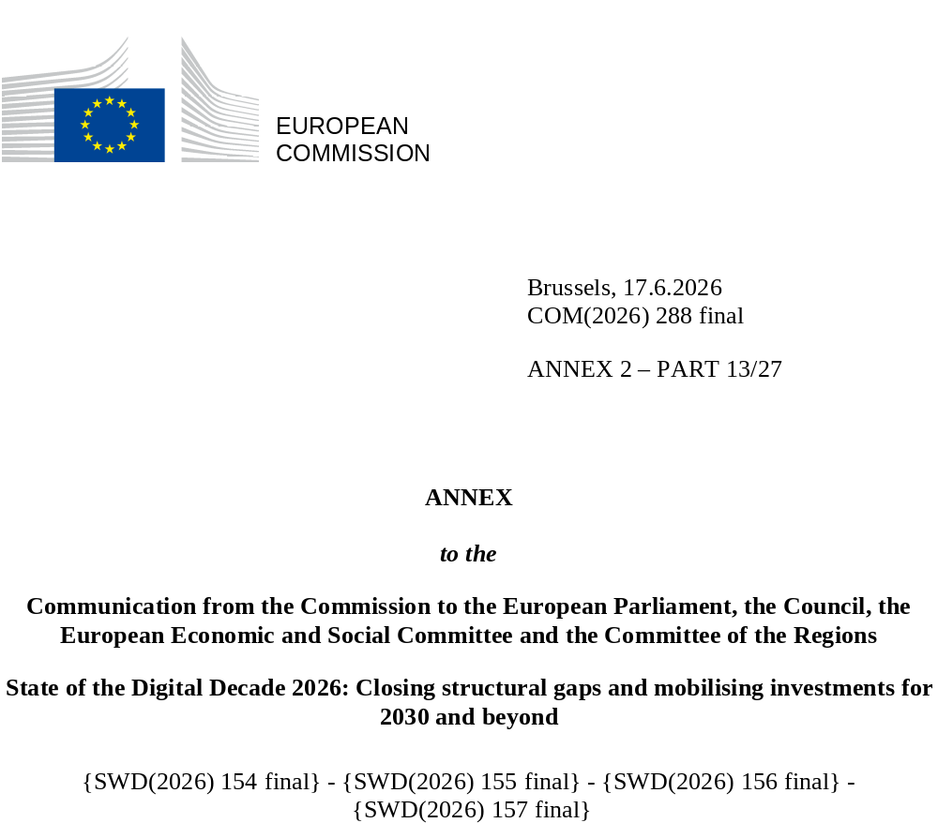

DIGITAL DECADE
SHORT COUNTRY REPORT
2026

Hungary

Executive summary
Hungary boasts a good fibre infrastructure and a strong position in digital public services for citizens, especially in the area of access to e-Health records. However, the country continues to lag in business digitalisation and the uptake of key technologies, especially in the case of small to medium size enterprises (SMEs), as well as in basic digital skills of the population.
The weaknesses identified in business digitalisation undermine Hungary’s competitiveness, as enterprises with low digital intensity are less able to achieve productivity gains from both basic and advanced digital tools and to expand into new business opportunities. Moreover, limited digital literacy constrains citizens’ effective use of technology and e-services, weakens labour productivity growth, and reduces businesses’ capacity to reap the full benefits of digital adoption.
In order to improve its digital leadership assets, Hungary will host one of the European AI Factory Antennas, under the AI Factory programme of the European High Performance Computing Joint Undertaking (EuroHPC JU). This will give access to the computational capacity of the existing EU AI Factory, without the need to build a stand-alone national infrastructure. There are currently no digital unicorns in Hungary, which represents a serious gap in the development of the digital economy.

Hungary in the Digital Decade
Hungary shows a moderate level of ambition in its contribution to the Digital Decade having set 14 national targets (out of 14 possible), 71% of which are aligned with the EU 2030 targets. In its national roadmap, Hungary provided 12 trajectory points for 2025 (out of 13 analysed). The country is progressing towards them moderately well with 50% considered on track. Hungary addressed 33% of the 9 recommendations issued by the Commission in 2025 by introducing new measures. According to the national roadmap, by the end of 2026, 48% of the measures will come to an end. The total public budget associated with these measures is EUR 575 million, representing 32% of the total public budget provided for in the roadmap. According to the special 2026 Eurobarometer on ‘the Digital Decade’, 85% of Hungarian respondents consider that digital policy should have a very high/high priority for the EU in shaping our future in Europe. They are also of the opinion that, in the next ten years, the EU should cooperate with Member States to reinforce cybersecurity and protection from online threats (92%), promote digital education and skills programmes (90%) and strengthen the regulation of online platforms (e.g. online social networks, marketplaces, app stores, etc.) (89%).
In addition, 81% of Hungarian respondents think that the EU should reduce its digital dependencies on non-EU countries, and 89% are of the opinion that EU should prioritise investments in digital infrastructure and services that are developed and controlled in Europe. Meanwhile, 56% would be willing to switch to an EU-based digital service provider even if it means slightly higher costs.

Funding for digital and multi-country projects
Hungary allocates 29% of its total funding under the recovery and resilience plan (RRP) to digital (EUR 1.7 billion). In addition, under cohesion policy, EUR 2.8 billion, representing 13% of the country’s total cohesion policy funding, is dedicated to advancing Hungary’s digital transformation.
Hungary is a member of the Alliance for Language Technologies, a European Digital Infrastructure Consortium (EDIC) and of the IMPACTS EDIC. Hungary is directly participating in the Important Project of Common European Interest (IPCEI) on Next Generation Cloud Infrastructure and Services (IPCEI-CIS) and in the Tech4Cure IPCEI. Hungarian entities are indirect and/or associated partners in the IPCEI on Microelectronics and Communication Technologies (IPCEI-ME/CT). Hungary is a participating state of the EuroHPC Joint Undertaking (JU) and of the Chips JU.
Digital Decade KPI ⁽¹⁾ | Hungary |  |  |  |  | EU |  |  | Digital Decade target by 2030
Digital Decade KPI ⁽¹⁾ | Last available data (2) | DESI 2026 (year 2025) | Annual progress | National trajectory 2025 (3) | DESI 2026 |  | Annual progress | HU |  | EU
Fixed Very High-Capacity Network coverage | 86.0% | 87.4% | 1.7% | 88.0% | 85.5% |  | 3.7% | 97.0% |  | 100%
Fibre to the Premises (FTTP) coverage | 79.9% | 81.8% | 2.4% | 83.0% | 74.1% |  | 7.1% | 95.0% |  | -
Overall 5G coverage | 85.6% | 94.0% | 9.9% | 76.0% | 96.8% |  | 2.6% | 99.0% |  | 100%
Edge Nodes (estimate) | - | 152 | - | 28 | 7451 |  | - | 82 |  | 10000
SMEs with at least a basic level of digital intensity * | 53.2% | 59.8% | 6.1% | 61.5% | 71.4% |  | 11.0% | 89.0% |  | 90%
Cloud * | 37.1% | 40.8% | 4.9% | 48.0% | 46.7% |  | 9.5% | 75.0% |  | 75%
Artificial Intelligence | 7.4% | 10.4% | 39.9% | 9.0% | 20.0% |  | 48.0% | 24.0% |  | 75%
Data analytics * | 53.2% | 40.6% | -12.7% | 59.5% | 39.9% |  | 9.5% | 75.0% |  | 75%
AI or Cloud or Data analytics * | 65.6% | 59.7% | -4.7% | - | 63.2% |  | 7.5% | - |  | 75%
Unicorns | 0 | 0 | - | - | 324 |  | 10.2% | 2 |  | 500
At least basic digital skills * | 58.9% | 57.3% | -1.3% | 66.0% | 60.4% |  | 4.3% | 70.0% |  | 80%
ICT specialists | 4.5% | 4.6% | 2.2% | 5.3% | 5.0% |  | 2.0% | 8.3% |  | ~10%
e-ID scheme notification |  | No
Digital public services for citizens | 77.7 | 85.6 | 10.3% | 77.3 | 84.6 |  | 2.8% | 96.3 |  | 100
Digital public services for businesses | 80.0 | 80.0 | 0.0% | 84.7 | 88.6 |  | 2.7% | 97.2 |  | 100
Access to electronic health records | 86.0 | 88.1 | 2.4% | 96.4 | 86.5 |  | 4.6% | 100.0 |  | 100
(1) Indicators full description, metadata and sources in the DESI 2026 methodological note
(2) Last available data is DESI2025 (reference year 2024) except for indicators marked with a star * for which it is DESI2024 (reference year 2023)
(3) National trajectory value for 2025, if set by the country in its Digital Decade national roadmap

A competitive, sovereign and resilient EU based on technological leadership
Hungary is performing well in connectivity, being above the EU average in fibre coverage and slightly below for 5G. Coverage of last premises, especially in rural areas, will be key to achieving full coverage by 2030.
Hungary has achieved mixed progress in the digitalisation of businesses. While there have been improvements in certain areas, such as the adoption of AI among SMEs and large enterprises, Hungarian enterprises, particularly SMEs, continue to lag behind their EU counterparts in most areas of technology adoption. The growth rates in most areas are also lower than the EU averages, indicating that while Hungary is making strides, it is not keeping pace with the broader EU trends.

Protecting and empowering EU people and society
Hungary’s digital skills profile reveals several areas of concern. While performance in urban areas and among young adults is good, the county’s overall digital skills rate has declined. The gender gap, educational disparities, and the urban-rural divide are notable challenges. Targeted interventions are necessary to address these disparities, especially in rural areas and among populations with lower education. Strengthening digital education and training programmes could help Hungary close the gap with the EU average and ensure more inclusive digital participation.
Even though Hungary is performing well in terms of digital public services for citizens, especially in e-Health, further improvement in cross-border services and the notification of an e-ID scheme would further contribute to the improvement of these indicators.

Recommendations
- Digitalisation of SMEs: Improve SMEs basic digitalisation by designing dedicated public support measures, including training programmes, diagnostics and targeted financial support, to assist businesses in cybersecurity, digital business management, and AI.
- ICT specialists: Continue to improve the job market relevance of ICT specialist training pathways (higher education, vocational training, and re- and upskilling), aligning them with industry needs, with particular attention to AI and cybersecurity specialists. Encourage people to pursue ICT training pathways including via raising awareness at earlier stages of education, career guidance, validating prior learning, identifying and reducing barrier to entry, and advertising campaigns. Intensify efforts to increase women’s participation in ICT studies and careers.
- Uptake of AI: Continue to support the adoption of AI by businesses by ensuring the proper implementation of current national measures. Strengthen access to AI infrastructures for SMEs, including AI factories, and promote AI adoption by SMEs via the sectoral flagships initiatives of the Apply AI strategy and skills development.
- Basic digital skills: Accelerate the country’s efforts to bridge the digital divide by developing and investing in inclusion policies that focus on vulnerable groups, such as those with lower levels of formal education and those living in rural areas.
- Cybersecurity: Accelerate efforts to implement cybersecurity legislation measures necessary to strengthen the cybersecurity position of the country. Increase efforts in ICT security for enterprises, particularly by raising employees’ awareness and improving their preparedness amid the ever-changing cyber threat and technology landscape.
- Digital Public Services: Accelerate the implementation of cross-border capabilities of public services, prioritising high-volume cross-border procedures.
- e-Health: Continue to cooperate and invest in digitalisation of its health systems to achieve the 2030 eHealth target and advance the adoption and integration of AI in healthcare. A key focus should be making the data type of medical images available to citizens through the online access service.
- 5G coverage: Hungary should accelerate 5G rollout in the 3.4–3.8 GHz band. It should also promote the deployment of 5G SA networks while enabling advanced use cases. In addition, Hungary should take advantage of the upcoming expiry of rights of use to promote pro-investment authorisation.

