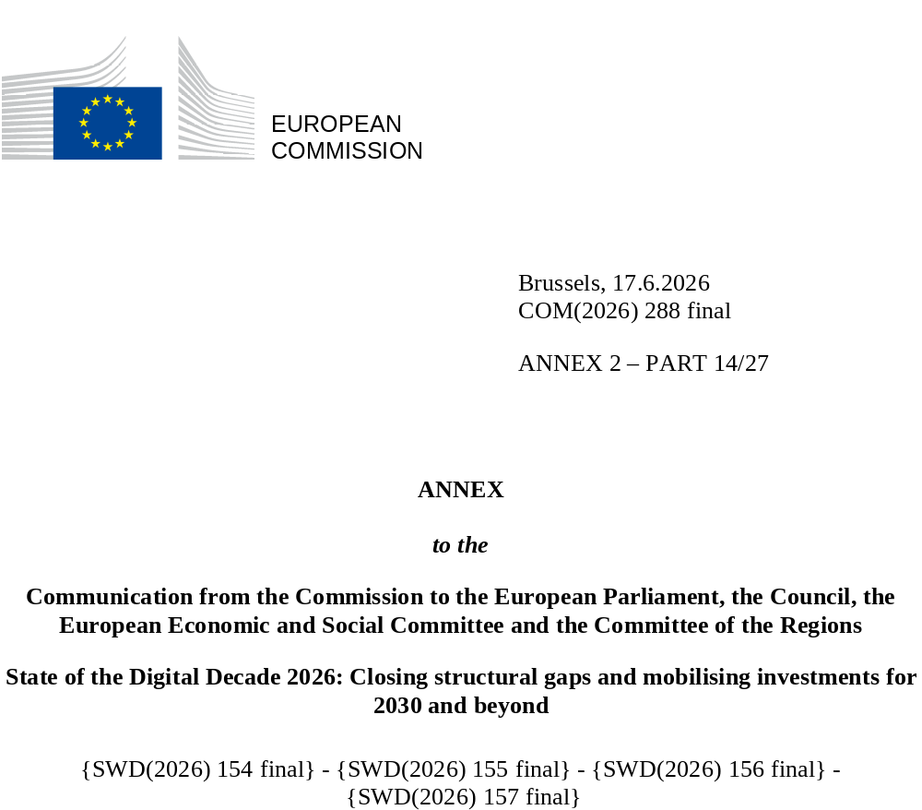

DIGITAL DECADE
SHORT COUNTRY REPORT
2026

Ireland

Executive summary
Overall, Ireland has strong assets in digitalisation, such as strong fixed connectivity, high levels of basic digital skills and a dynamic ICT ecosystem. However, it does not fully translate these strengths across the whole of its economy and society. Parts of Ireland’s SME base still lag behind in digitalisation, while growth in the number of ICT specialists remains too slow, and public-service digitalisation remains uneven, with weak access to e-Health records and the and the justice system.
Ireland’s internationally competitive global tech business base is an important asset for productivity and competitiveness. However, the uneven level of digitalisation of businesses across the wider economy weighs on performance, as firms that remain less digitalised are less well placed to improve productivity, adopt more efficient processes, and scale across markets. A stronger supply of ICT specialists could help relieve skills shortages across the Irish economy and support digital transformation, to better empower indigenous firms in benefiting from productivity gains that stem from the strong multinational base.. Finally, the more widespread provision of digital public services, in particular better access to e-Health records, could increase the efficiency gains from digitalisation and widen benefits for the public, businesses and public administration.
Ireland has several digital leadership assets. It combines a vibrant start-up ecosystem with the presence of major global technology players, and it remains one of the EU’s stronger performers on the number of digital unicorns relative to its size. Public policy in Ireland has also shifted more clearly in recent years towards promoting AI, with the updated National Digital & AI Strategy for 2030 positioning Ireland both as: (i) a location of choice for AI and digital start-ups; and (ii) a global hub for applied AI innovation. At the same time, Ireland is strengthening its role in strategic technologies through its 2025 semiconductor strategy ‘Silicon Island’ and the planned establishment of an Irish quantum centre of excellence, while digital growth is also raising challenges for the green transition and for infrastructure more broadly.

Ireland in the Digital Decade
Ireland shows a high level of ambition in its contribution to the Digital Decade, having set 11 national targets (out of 14 possible), 91% of which are aligned with the EU’s 2030 targets. In its national roadmap, Ireland provided 10 trajectory points for 2025 (out of 13 analysed). The country is following these trajectory points moderately well, with 60% considered on track. Ireland has addressed 88% of the eight recommendations issued by the Commission in 2025, either by implementing significant policy changes (for 25% of recommendations) or making some changes (63% of recommendations) through new measures. According to the national roadmap, by the end of 2026, 47% of Ireland’s roadmap measures will come to an end. The total public budget associated to these measures is EUR 535 million, representing 11% of the total public budget outlined in the roadmap.
According to the special 2026 Eurobarometer on the Digital Decade, 84% of Irish people consider that digital policy should have a high/very high priority for the EU in shaping our future in Europe. They also think that, in the next 10 years, the EU should cooperate with Member States to strengthen cybersecurity and protection from online threats (97% agree), promote digital education and skills programmes (92% agree) and strengthen the regulation of online platforms (e.g. online social networks, marketplaces, app stores, etc.) (84% agree). In addition, 79% of Irish respondents think that the EU should reduce its dependencies on digital from non-EU countries, and 86% that the EU should prioritise investments in digital infrastructure and services that are developed and controlled in Europe. Meanwhile, 59% of Irish respondents to the Eurobarometer would be willing to switch to an EU-based digital service provider even if it meant slightly higher costs.

Funding for digital and multi-country projects
Ireland is allocating 33% of its total recovery and resilience plan (RRP) to digital (EUR 0.3 billion). In addition, under cohesion policy, EUR 0.04 billion, representing 4% of the country’s total cohesion policy funding, is dedicated to advancing Ireland’s digital transformation.
Ireland is a member of both the Alliance for Language Technologies EDIC and the Local Digital Twins towards the CitiVERSE EDIC. Ireland is also directly participating in the important project of common European interest (IPCEI) on Microelectronics and Communication Technologies. In addition, Ireland is a participating state in both the EuroHPC Joint Undertaking (JU) and the Chips JU.
Digital Decade KPI ⁽¹⁾ | Ireland |  |  |  |  | EU |  |  | Digital Decade target by 2030
Digital Decade KPI ⁽¹⁾ | Last available data (2) | DESI 2026 (year 2025) | Annual progress | National trajectory 2025 (3) | DESI 2026 |  | Annual progress | IE |  | EU
Fixed Very High Capacity Network (VHCN) coverage | 87.2% | 89.0% | 2.1% | 95.2% | 85.5% |  | 3.7% | 100.0% |  | 100%
Fibre to the Premises (FTTP) coverage | 73.5% | 84.5% | 15.0% | - | 74.1% |  | 7.1% | - |  | -
Basic 5G coverage | 89.9% | 96.3% | 7.1% | 89.3% | 96.8% |  | 2.6% | 100.0% |  | 100%
Edge Nodes (estimate, new methodology) | - | 114 | - | 23 | 7451 |  | - | - |  | 10000
SMEs with at least a basic level of digital intensity * | 66.1% | 79.3% | 9.5% | 86.0% | 71.4% |  | 11.0% | 90.0% |  | 90%
Cloud * | 53.1% | 63.0% | 9.0% | 53.0% | 46.7% |  | 9.5% | 75.0% |  | 75%
Artificial Intelligence | 14.9% | 19.6% | 31.8% | 28.0% | 20.0% |  | 48.0% | 75.0% |  | 75%
Data analytics * | 37.1% | 40.8% | 4.9% | 37.0% | 39.9% |  | 9.5% | 75.0% |  | 75%
AI or Cloud or Data analytics * | 64.1% | 71.7% | 5.8% | - | 63.2% |  | 7.5% | - |  | 75%
Unicorns | 17 | 18 | 5.9% | - | 324 |  | 10.2% | - |  | 500
At least basic digital skills * | 72.9% | 82.8% | 6.6% | 72.0% | 60.4% |  | 4.3% | 80.0% |  | 80%
ICT specialists | 6.3% | 6.2% | -1.6% | 7.9% | 5.0% |  | 2.0% | 9.6% |  | ~10%
e-ID scheme notification |  | No
Digital public services for citizens | 87.1 | 91.4 | 5.0% | 82.0 | 84.6 |  | 2.8% | 100.0 |  | 100
Digital public services for businesses | 100.0 | 100.0 | 0.0% | 100.0 | 88.6 |  | 2.7% | 100.0 |  | 100
Access to electronic health records | 24.5 | 44.0 | 79.5% | - | 86.5 |  | 4.6% | 80.0 |  | 100
(1) Indicators full description, metadata and sources in the DESI 2026 methodological note
(2) Last available data is DESI2025 (reference year 2024) except for indicators marked with a star * for which it is DESI2024 (reference year 2023)
(3) National trajectory value for 2025, if set by the country in its Digital Decade national roadmap

A competitive, sovereign and resilient EU based on technological leadership
Ireland is performing well in connectivity, with rates of fixed infrastructure connectivity above the EU average, and the national broadband plan continuing to extend gigabit-capable coverage. However, the remaining challenge for connectivity in Ireland is increasingly the last phase of rollout and effective take-up of fixed-infrastructure internet connectivity. Ireland has also largely achieved broad national 5G availability, but higher-capacity deployment remains weaker, with coverage in the 3.4-3.8 GHz band still below the EU average, including in sparsely populated areas, no demand for 26 GHz connectivity, and no dedicated strategy as yet for 5G standalone or large-scale industrial use cases. As an island economy and major data hub, Ireland also faces longer-term needs related to the diversification and resilience of international connectivity infrastructure.
On the business side, Ireland ranks above the EU average in both SME digitalisation and in the uptake of advanced technologies by businesses, but its rate of growth in these areas is slower than at EU level, pointing to weak rates of diffusion across the broader domestic business base. Policy has shifted more clearly towards promoting AI in recent years, with new measures taken in 2025 to promote sectoral adoption, SME awareness, experimentation, and research infrastructure. Ireland is also strengthening its position in strategic technologies such as semiconductors, but the main challenge it faces now is to translate this into stronger domestic scale-up of its semiconductor sector. This is because access to specialised skills, commercialisation support and scale-up finance remains more limited for indigenous firms and start-ups. Cybersecurity preparedness across businesses and public services also remains uneven in Ireland, limiting both trusted digitalisation and resilience as the uptake of digital technologies increases. At the same time, better alignment between digital development and the green transition will be important to ensure that digital investment also supports decarbonisation and resource efficiency.

Protecting and empowering EU people and society
Ireland performs strongly on basic digital skills and remains well above the EU average on this measure. By contrast, growth in ICT specialists as a percentage of Ireland’s workforce remains modest and below the pace needed to meet the country’s 2030 target, while evidence points to persistent shortages in advanced digital skills across the economy. These shortages constrain firms’ capacity to adopt and scale digital technologies and may limit wider productivity gains, especially in domestic sectors already facing skills and capability gaps.
Ireland also performs strongly in digital public services, especially for businesses, and citizen-facing services are also comparatively well developed. Significant progress has also been made on digital identity, with MyGovID expected to become the basis for Ireland’s EUDI Wallet. However, important legal, interoperability and rollout steps must still be addressed before the country will have a fully operational and cross-border digital identity framework in place. . The same can be said for digitalisation of justice where some proceedings still rely on paper.. Access to e-Health records remains low despite recent progress and ongoing implementation of the country’s ‘Digital for Care’ strategy.

Recommendations
- Digital skills: Strengthen Ireland’s ICT specialist pipeline and broader digital skills base by scaling up and better aligning ICT education, training, upskilling and reskilling with enterprise demand, including in AI and cybersecurity; broadening participation in ICT careers, notably through targeted measures to increase women’s participation and reduce bottlenecks in the domestic talent pipeline; and improving the scale, accessibility and targeting of digital skills provision for groups still at risk of exclusion, notably lower-skilled adults and older people.
- E-health: Accelerate the digital transformation of the health system by speeding up the onboarding of healthcare providers to interoperable electronic health-record systems across the public and private health system; expanding the availability and effective use of core digital health services and data-sharing tools, including the Shared Care Record, ePrescribing and patient access solutions; and ensuring full, secure and user-friendly access to electronic health records for patients, including legal guardians and authorised persons, supported by stronger interoperability, governance and implementation capacity.
- SME digitalisation: Strengthen the digitalisation of SMEs by directing existing and future support more explicitly towards SMEs with lower digital maturity, including through tailored outreach, advisory support and implementation pathways; ensuring continuity and visibility of SME digitalisation support beyond the current RRF funding period; and accelerating the practical uptake of more advanced digital tools, including artificial intelligence, through accessible skills, experimentation and implementation support.
- Cybersecurity: Strengthen cybersecurity resilience across the economy and public administration by expanding practical cybersecurity support, guidance and preparedness tools for SMEs and other less digitally mature organisations; reinforcing incident response, information-sharing and supply-chain risk management across critical sectors and public services; ensuring that the rollout of AI, cloud and digital public infrastructure is underpinned by secure-by-design procurement, updated risk assessment and strong operational cyber capacity; and accelerating cybersecurity measures to strengthen the cyber posture of critical infrastructure.
- Connectivity & Resilience: Support the effective use and resilience of advanced connectivity infrastructure by facilitating stand-alone 5G, mid-band, edge and private-network use cases in strategic sectors, including through stronger demand aggregation and coordination; accelerating migration from legacy networks and addressing remaining final-phase rollout bottlenecks; and strengthening the diversification, repair capacity and resilience of international connectivity infrastructure.
- Semiconductors: Strengthen the scale-up of indigenous semiconductor firms and start-ups, including by improving access to scale-up finance, commercialisation support, pilot-line access and specialised skills, and by reinforcing links between research capacity, SMEs and EU semiconductor instruments.
- Green & Digital: Strengthen the alignment between digital growth and the green transition, in particular by improving the monitoring and deployment of digital solutions that support decarbonisation, resource efficiency and regional smart-transition projects, including through stronger coordination and scaling of successful local initiatives.

