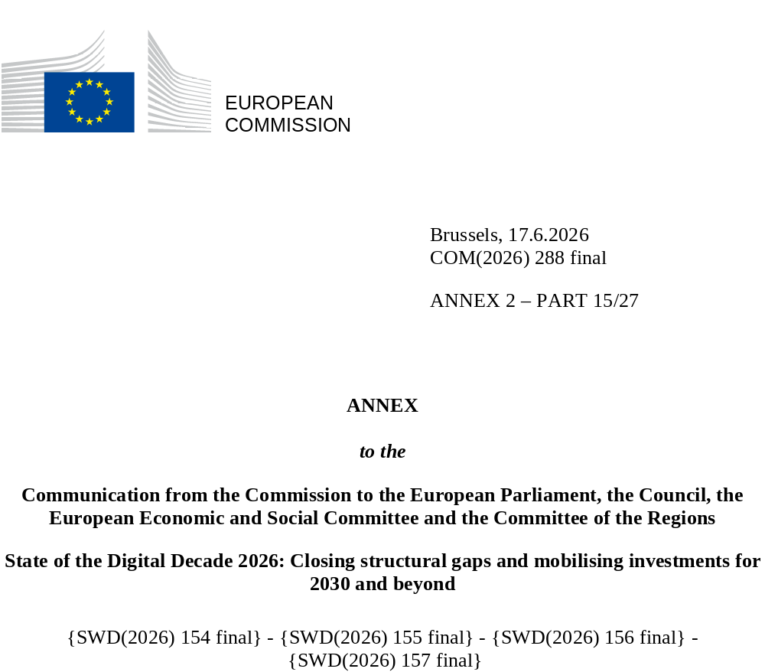

DIGITAL DECADE
SHORT COUNTRY REPORT
2026

Italy

Executive summary
Italy has made notable progress in digitalisation in recent years, particularly in rolling out fibre-to-the-premises (FTTP), SME digitalisation, and the uptake of cloud and data analytics. On these metrics, Italy outperforms the EU average. The country also benefits from strong industrial and research foundations and has assets in strategic technologies, notably semiconductors, high-performance computing and quantum. Its digital public services are well developed, including advanced digital identity and digital health. Despite promising growth, structural weaknesses persist, including low FTTP coverage in rural areas, below-EU-average basic digital skills, and uneven uptake and integration of advanced technologies in business operations. These challenges risk delaying the full roll-out of fibre, widening inequalities and fragmenting the national digital ecosystem. At the same time, too few SMEs have reached very high level of digital intensity and challenges of weak technology transfer and persistent ICT skills shortages may hamper their ability to achieve innovation and productivity gains.
Such shortcomings undermine Italy’s competitiveness, especially in high-value sectors where scaling and innovation are critical. Limited level of AI adoption, combined with weak strategic integration of AI in businesses, reduces the productivity and competitiveness of enterprises, particularly SMEs, which make up most of Italy’s business landscape. The limited progress on scaling start-ups also reflects a broader challenge in commercialising research and achieving global market reach.
Italy has the tools needed to consolidate its digital leadership. The country has a large and diversified semiconductor ecosystem, combining strong industrial players with a network of specialised SMEs active in equipment, materials and design. It benefits from strong academic and industrial capabilities in quantum technologies, guided by the Italian Strategy for Quantum Technologies (2025). The governance framework for AI and the Italian Strategy for Artificial Intelligence (2024-2026) signal ambition in this area. More broadly, Italy has mobilised national public funding for targeted investment in strategic digital infrastructure, including high-performance computing (HPC) and Important Projects of Common European Interest (IPCEI). This demonstrates strong policy alignment with the EU industrial strategy. The investments are designed to attract private capital, boost domestic industrial capacity and position Italy in key European value chains.

Italy in the Digital Decade
Italy shows a substantial level of ambition in its contribution to the Digital Decade. It has set 14 (out of 14) national targets, 79% of which are aligned with the EU 2030 targets. In its national roadmap, Italy provided 13 trajectory points for 2025 (out of 13 analysed). The country is monitoring progress very well with 92% of the targets considered on track. Italy addressed 13% of the eight recommendations issued by the Commission in 2025 by making some changes through new measures. According to the national roadmap, by the end of 2026, 88% of the measures will come to an end. The total public budget allocated to these measures is EUR 33.95 billion, or 54% of the total public budget outlined in the roadmap.
According to the special Eurobarometer on ‘the Digital Decade’ 2026, 81% of Italian people thought that digital policy should have a very high/high priority in shaping our future in Europe. They also think that, in the next 10 years, the EU should cooperate with Member States to reinforce cybersecurity and protection from online threats (91%), promote digital education and skills programmes (91%) and strengthen the regulation of online platforms (90%).
In addition, 85% of Italian respondents thought that the EU should reduce its dependency on non-EU countries to provide digital services, and 86% thought that EU should prioritise investments in digital infrastructure and services that are developed and controlled in Europe. Meanwhile, 66% would be willing to switch to an EU-based digital service provider even if it means slightly higher costs.

Funding for digital and multi-country projects
Italy allocates 26.5% of the funding under its total recovery and resilience plan to digital policies (EUR 49.8 billion). In addition, it allocates EUR 6.1 billion of cohesion policy funding, representing 14% of the country’s total cohesion policy funding, to action to advance Italy’s digital transformation.
Italy is a member of the Alliance for Language Technologies European Digital Infrastructure Consortium (EDIC), the Local Digital Twins towards the CitiVERSE EDIC, the EUROPEUM EDIC and the Digital Commons EDIC. Italy directly participates in the IPCEI on Microelectronics and Communication Technologies (IPCEI-ME/CT), in the IPCEI on Next Generation Cloud Infrastructure and Services (IPCEI-CIS) and the Tech4Cure IPCEI. It also participates in the EuroHPC Joint Undertaking and of the Chips Joint Undertaking.
Digital Decade KPI ⁽¹⁾ | Italy  EU |  |  |  | EU |  | Digital Decade target by 2030
Digital Decade KPI ⁽¹⁾ | Last available data (2) | DESI 2026 (year 2025) | Annual progress | National trajectory 2025 (3) | DESI 2026 | Annual progress | IT | EU
Fixed Very High-Capacity Network (VHCN) coverage | 70.7% | 77.6% | 9.6% | 79.0% | 85.5% | 3.7% | 100.0% | 100%
Fibre to the Premises (FTTP) coverage | 70.7% | 77.6% | 9.6% | 79.0% | 74.1% | 7.1% | 100.0% | -
Basic 5G coverage | 99.5% | 99.8% | 0.3% | 99.7% | 96.8% | 2.6% | 100.0% | 100%
Edge Nodes (estimate, new methodology) | - | 674 | - | 269 | 7451 | - | 946 | 10000
SMEs with at least a basic level of digital intensity * | 60.7% | 79.5% | 14.4% | 78.0% | 71.4% | 11.0% | 90.0% | 90%
Cloud * | 55.1% | 68.1% | 11.1% | 60.0% | 46.7% | 9.5% | 74.0% | 75%
Artificial Intelligence | 8.2% | 16.4% | 100.0% | 10.0% | 20.0% | 48.0% | 60.0% | 75%
Data analytics * | 26.6% | 42.7% | 26.7% | 12.0% | 39.9% | 9.5% | 60.0% | 75%
AI or Cloud or Data analytics * | 63.1% | 77.9% | 11.1% | - | 63.2% | 7.5% | - | 75%
Unicorns | 11 | 13 | 18.2% | 3 | 324 | 10.2% | 16 | 500
At least basic digital skills * | 45.8% | 54.3% | 8.9% | 51.7% | 60.4% | 4.3% | 80.1% | 80%
ICT specialists | 4.0% | 3.8% | -5.0% | 5.3% | 5.0% | 2.0% | 8.4% | ~10%
e-ID scheme notification |  | Yes
Digital public services for citizens | 83.6 | 86.1 | 3.0% | 75.0 | 84.6 | 2.8% | 100.0 | 100
Digital public services for businesses | 80.9 | 80.7 | -0.2% | 82.0 | 88.6 | 2.7% | 100.0 | 100
Access to electronic health records | 84.1 | 89.9 | 6.9% | 77.0 | 86.5 | 4.6% | 100.0 | 100
⁽¹⁾ Indicators full description, metadata and sources in the DESI 2026 methodological note
⁽²⁾ Last available data is DESI 2025 (reference year 2024) expect for indicators marked with a star * for which it is DESI 2024 (reference year 2023)
⁽³⁾ National trajectory value for 2025, if set by the country in its Digital Decade national roadmap"

A competitive, sovereign and resilient EU based on technological leadership
Italy has made strong progress on connectivity and it is above the EU average on both fibre-to-the-premises (FTTP) rollout and 5G coverage. However, persisting rural coverage gaps in VHCN/FTTP and low fibre take-up, also due to the persistence of consumers on the copper networks, could delay the transition to a full fibre environment. Italy also plays an important role in advancing EU capabilities in strategic technologies, with a large semiconductor ecosystem, strong high-performance computing infrastructure and a growing quantum sector, supported by national strategies, EU initiatives, and a solid research environment. In the future, it will be important to continue strengthening these capabilities to achieve long-term competitiveness and translate Italy’s strengths in research into industrial leadership.
Italian SMEs perform well on basic digitalisation and on rate of adoption of technologies such as cloud and data analytics, but they lag behind on high digital intensity rates. Although the uptake of advanced digital technologies is improving across the business population, a key gap remains in their full and strategic integration into business models, with take-up varying by technology, region, sector and size of business. In 2025, Italy drew up its AI governance framework (Law n. 132/2025), in line with the EU's AI Act, establishing a comprehensive legal structure for safe, human-centric AI deployment. The framework also includes rules to bolster cybersecurity and enhance public digital literacy and is backed with EUR 1 billion to support AI start-ups and SMEs. Although the uptake of AI is growing rapidly, it remains below potential, particularly for SMEs. At the same time, Italy’s strong computing resources and HPC capacity provide a solid basis for AI development, with the main challenge being to consolidate the ecosystem, while attracting capital and talent.
Although in 2026, Italy counts 13 unicorns, signalling a degree of progress, this figure remains low compared with leading European innovation ecosystems, indicating structural weaknesses in industrial scaling. The growth trajectory of start-ups is constrained by limited venture capital availability, especially in terms of access to late-stage financing, along with weak technology transfer from universities and research centres.

Protecting and empowering EU people and society
Italy’s digital skills landscape shows a mixed picture. On the one hand, the country has recorded solid growth in the share of citizens with at least basic digital skills; on the other, it still has a structural gap compared with the EU average. Domestic inequalities remain a challenge, especially by education level, with a wide gap in digital skills for people with low levels of education, alongside persistent gaps by gender, age and the urban-rural divide. The positive trend in digital skills acquisition suggests that public policies (such as the Digital Facilitation Service Network), with substantial support from the recovery and resilience plan (RRP), have had a positive impact. However, continued action will be needed to consolidate this progress.
The shortage of ICT specialists represents a structural weakness. Although ICT-related programmes and measures to strengthen skills, attract talent and improve alignment between higher education and labour market needs have expanded, the education and training system still does not fully meet demand, and women remain under-represented in ICT fields.
On digital public services, Italy has achieved a solid performance on public services for citizens by creating well-developed online services for national citizens and businesses, but it has room for improvement on cross-border availability of digital public services, especially for businesses. The country has continued to improve its digital identity systems, for example by further developing the IT Wallet. It has also made progress on data interoperability and on migrating public services to qualified cloud infrastructure. On digital health, Italy has advanced significantly, with the Electronic Health Record and the Health Data Ecosystem reaching significant levels of maturity. The focus on AI in healthcare and life sciences is growing, supported by the Italian Strategy for Artificial Intelligence 2024-2026.

Recommendations
- Connectivity: Sustain the roll-out of fibre-to-the-premises infrastructure across the entire country and combine infrastructure support with take-up and spectrum measures to progress towards a full fibre network. Notably, close the persistent gap in rural FTTP coverage, and ensure continuity of public investment in both fixed and mobile network development. Effectively support fibre adoption, including via measures to address the connection to the last meter infrastructure gap, and facilitate the switch-off of copper networks. Promote the deployment of 5G SA (standalone) networks while enabling advanced use cases. In addition, take advantage of the upcoming expiry of rights of use to negotiate pro-investment conditions. Continue to improve high-capacity links with the islands.
- ICT specialists and basic digital skills: Strengthen the supply of ICT specialists and close the basic digital skills gap, with particular attention to people with no or low levels of formal education, by combining actions across initial education, continuing education, and digital inclusion infrastructure (e.g. consolidating the Digital Facilitation Service Network as a permanent component of the national digital inclusion infrastructure). Intensify efforts to upskill and reskill in both the private and the public sector, especially in strategic sectors (e.g. quantum, semiconductors, AI), and to increase women’s participation in ICT studies and careers.
- AI: Accelerate action to operationalise the national AI governance framework, especially by supporting AI adoption by businesses, in particular SMEs, while ensuring close coordination among relevant initiatives and stakeholders. Promote AI use cases in strategic sectors (e.g. manufacturing and robotics), in line with broader EU priorities and initiatives. Reinforce centres of excellence in AI, research and development activities, and related enabling technologies, while maintaining strong links with industry.
- Quantum: Strengthen the Italian quantum ecosystem by supporting the development and industrial uptake of quantum technologies and strengthening connections between industrial players, while leveraging emerging regional strengths to support pilot activities. Foster collaboration between academia and industry and integrate national infrastructure into the EU’s quantum ecosystem (e.g. through sustained participation in the EuroHPC Joint Undertaking and alignment with the forthcoming Quantum Act).
- Semiconductors: Consolidate Italy's position in the semiconductor value chain, by finalising its strategic framework and improving ecosystem coordination, while ensuring complementarity with EU-level capacities and initiatives. Strengthen coordination among research centres, universities, and industry, and provide support, especially for SMEs (e.g. through shared infrastructure, pilot lines, and technology transfer services). Moreover, continue to advance the development and use of the pilot line on wide bandgap semiconductors through effective cross-border collaboration.

