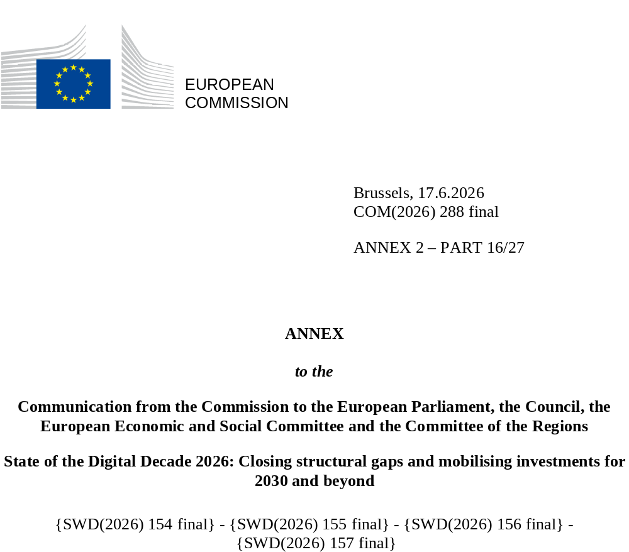

DIGITAL DECADE
COUNTRY REPORT
2026

Latvia

Executive summary
Overall, Latvia continues to rely on strong digitalisation of public services and e-Health. It has made notable progress in emerging technologies, in 5G coverage (where it now surpasses the EU average) and quantum and semiconductor initiatives. However, persistent disparities and uneven progress hold back broader transformation.
Persistent rural connectivity gaps in very high capacity networks (VHCNs) and fibre to the premises (FTTP) risk marginalising communities from the digital economy, entrenching regional disparities and restricting access to critical services. Meanwhile, uneven SME digitalisation, marked by lagging adoption of cloud and AI technologies (despite impressive year-on-year growth on these measures) threatens to undermine long-term productivity, particularly as demand for advanced digital tools intensifies. The worsening ICT skills shortage further erodes Latvia’s ability to make the most of its emerging strengths in AI, quantum, and e-Health, sectors where early progress could otherwise drive future growth. Without intervention, these interlinked challenges (in the area of infrastructure deficits, patchy business digitalisation, and skill gaps) could stifle competitiveness. This could in turn prevent Latvia from fully capitalising on its leadership in public digital services or realising the broader economic and social benefits of its technological progress. Left unaddressed, these challenges risk leaving businesses and citizens behind in an increasingly digital-dependent world.
Latvia has several digital leadership assets. To fully capitalise on its strengths (cross-Baltic collaborations, quantum and AI leadership initiatives, and a dynamic start-up scene) Latvia must accelerate SME digitalisation, bridge skill and infrastructure gaps, and scale up its cybersecurity defences. Finally, deeper regional cooperation in semiconductors and quantum – building on projects like the quantum communication infrastructure (QCI) network – could solidify Latvia’s role as a digital frontrunner in the Baltic region, provided the country addresses challenges in funding, adoption, and resilience.

Latvia in the Digital Decade
Latvia shows a substantial level of ambition in its contribution to the Digital Decade having set 14 national targets (out of 14 possible), 86% of which are aligned with the EU 2030 targets. In its national roadmap, Latvia provided 12 trajectory points for 2025 (out of 13 analysed). The country is following them not well with 42% considered on track. Latvia addressed 40% of the 5 recommendations issued by the Commission in 2025 by making some changes through new measures. According to the national roadmap, by the end of 2026, 52% of the measures will come to an end. The total public budget associated to these measures is EUR 414 million, representing 21% of the total public budget outlined in the roadmap.
According to the special Eurobarometer on ‘the Digital Decade’ 2026, 80% of Latvian people consider that digital policy should have a very high/high priority for the EU in shaping our future in Europe. They also think that the EU should cooperate with Member States in the next 10 years to ‘reinforce cybersecurity and protection from online threats’ (94% of Latvians agreed), ‘promote digital education and skills programmes’ (90% agreed), ‘strengthen the regulation of online platforms’ (84%) as well as to ‘develop shared digital public services’ (84% agreed). In addition, 75% of Latvian respondents think that the EU should reduce its dependencies on digital products and services from non-EU countries, and 80% agree that the EU should prioritise investments in digital infrastructure and services that are developed and controlled in Europe. Meanwhile, 47% of Latvians said that they would be willing to switch to an EU-based digital service provider even if it means slightly higher costs.

Funding for digital and multi-country projects
Latvia allocates 23% of its total recovery and resilience plan to digital (EUR 416 million). In addition, under cohesion policy, EUR 4 million, representing 10% of the country’s total cohesion policy funding, is dedicated to advancing Latvia’s digital transformation.
Latvia is a member of the Alliance for Language Technologies EDIC and of the Local Digital Twins towards the CitiVERSE EDIC. Latvian entities are indirect and/or associated partners in the IPCEI on Next Generation Cloud Infrastructure and Services (IPCEI-CIS) and in the Tech4Cure IPCEI. Latvia is a participating state in the EuroHPC Joint Undertaking (JU) and of the Chips JU.

Digital Decade KPI ⁽¹⁾ | Latvia |  |  |  |  | EU |  |  | Digital Decade target by 2030
Digital Decade KPI ⁽¹⁾ | Last available data (2) | DESI 2026 (year 2025) | Annual progress | National trajectory 2025 (3) | DESI 2026 |  | Annual progress | LV |  | EU
Fixed Very High Capacity Network (VHCN) coverage | 68.1% | 66.7% | -2.2% | 77.0% | 85.5% |  | 3.7% | 100.0% |  | 100%
Fibre to the Premises (FTTP) coverage | 61.1% | 62.1% | 1.7% | 77.0% | 74.1% |  | 7.1% | 100.0% |  | -
Basic 5G coverage | 71.1% | 98.2% | 38.2% | 58.0% | 96.8% |  | 2.6% | 70.0% |  | 100%
Edge Nodes (estimate, new methodology) | - | 40 | - | 0 | 7451 |  | - | 51 |  | 10000
SMEs with at least a basic level of digital intensity * | 48.2% | 58.5% | 10.2% | 63.0% | 71.4% |  | 11.0% | 90.0% |  | 90%
Cloud * | 29.0% | 37.8% | 14.1% | 40.0% | 46.7% |  | 9.5% | 75.0% |  | 75%
Artificial Intelligence | 8.8% | 12.2% | 38.3% | 22.0% | 20.0% |  | 48.0% | 75.0% |  | 75%
Data analytics * | 36.9% | 36.4% | -0.7% | 29.0% | 39.9% |  | 9.5% | 75.0% |  | 75%
AI or Cloud or Data analytics * | 48.2% | 52.2% | 4.1% | - | 63.2% |  | 7.5% | - |  | 75%
Unicorns | 1 | 1 | 0.0% | - | 324 |  | 10.2% | 2 |  | 500
At least basic digital skills * | 45.3% | 48.4% | 3.4% | 58.0% | 60.4% |  | 4.3% | 70.0% |  | 80%
ICT specialists | 4.9% | 4.5% | -8.2% | 6.4% | 5.0% |  | 2.0% | 10.0% |  | ~10%
e-ID scheme notification |  | Yes
Digital public services for citizens | 93.5 | 95.1 | 1.7% | 89.0 | 84.6 |  | 2.8% | 100.0 |  | 100
Digital public services for businesses | 96.3 | 97.5 | 1.3% | 88.0 | 88.6 |  | 2.7% | 100.0 |  | 100
Access to electronic health records | 85.9 | 94.2 | 9.7% | 83.0 | 86.5 |  | 4.6% | 100.0 |  | 100
(1) Indicators full description, metadata and sources in the DESI 2026 methodological note
(2) Last available data is DESI2025 (reference year 2024) except for indicators marked with a star * for which it is DESI2024 (reference year 2023)
(3) National trajectory value for 2025, if set by the country in its Digital Decade national roadmap

A competitive, sovereign and resilient EU based on technological leadership
In 2025, Latvia showed progress in digital connectivity and emerging technologies, but still faced persistent disparities and evolving challenges. While 5G coverage surged in 2025 to exceed the EU average, adoption of VHCN and FTTP lagged significantly behind, particularly in rural areas, reflecting limited market incentives and high deployment costs. SME digitalisation in Latvia showed mixed results in 2025: although AI adoption grew, the use of cloud and data analytics trailed EU averages. Government support programmes, like the EUR 18.5 million digitalisation fund (exhausted ahead of schedule), highlight strong demand but insufficient scaling. In quantum and semiconductors, Latvia made progress in 2025 through: (i) education initiatives (the Latvian Quantum Initiative, the Chip Competence Centre); (ii) cross-Baltic collaborations (Memoranda of Understanding with Estonia/Lithuania); and (iii) infrastructure milestones (first Baltic quantum communication network, QCI project). However, both the disinterest of Latvian SMEs in quantum (due to skills gaps and AI prioritisation) and stagnant unicorn growth (Latvia had only 1 unicorn in 2026, with a target of 2 by 2030) signal untapped potential. Since Russia’s invasion against Ukraine in 2022, the number of cyber incidents has increased sixfold, targeting citizens and critical infrastructure. Public-sector AI integration (e.g. Hugo.lv, multiple chatbots, election security tools) and growth in the start-up ecosystem show promise: there are now 569 start-up firms in Latvia, and these start-ups raised EUR 78 million in funding in 2025.

Protecting and empowering EU people and society
In 2025, Latvia continues performing well in digitalisation of public services for citizens and businesses and e-Health. However, the country lags behind EU averages in key areas, such as digital skills and ICT specialists. Although Latvian women slightly outperform men in digital skills, and Latvians’ adoption of generative AI exceeds the EU average, critical gaps persist. For example, Latvia trails EU benchmarks in both: (i) the number of older adults and low-educated individuals with digital skills; (ii) the digital safety skills of its population. Latvia continues to score highly on the provision of public digital services. For e-Health there is ongoing work on a new Citizen Portal for the country (launching in 2026). ICT specialist shortages remain, and Latvia reports a declining interest among its people in ICT training. Latvia’s work to develop an EUDI Wallet is well underway.

Recommendations
- Connectivity: (i) Promote the rollout of fibre infrastructure by supporting the expansion of fibre through coordinated funding programmes and regulatory measures at both national and regional levels, ensuring a balanced deployment, including in rural areas. (ii) Strengthen fibre take-up by supporting, through targeted funding and appropriate regulation, the deployment of fibre connections to end users. Foster the switch-off of copper networks. (iii) Accelerate 5G rollout in the 3.4–3.8 GHz band in rural areas. Promote the deployment of 5G SA networks to enable advanced use cases and enhance network performance. In addition, take advantage of upcoming spectrum licence renewals to put in place pro-investment conditions.
- ICT specialists: Develop and implement measures to increase the number of ICT specialists in employment while intensifying efforts to increase women’s participation in ICT studies and careers.
- Digital skills: Strengthen and continue to implement measures to increase digital skills across all ages with a special emphasis on people living in rural areas and those with lower educational background.
- Digitalisations of SMEs: (i) Accelerate SME digitalisation in Latvia, increase funding for high-demand programmes like AI and digital maturity support, (ii) expand rural outreach to demonstrate tangible benefits, (iii) and ensure long-term, scalable co-financing mechanisms to meet the demand.
- Unicorns: Sustain Latvia’s start-up sector growth and address stagnation in new ventures, including expanding access to early-stage funding, and strengthen incubation programmes.
- Cybersecurity: (i) Bolster Latvia’s resilient cybersecurity framework, and sustain proactive measures against escalating threats, particularly fraud. (ii) Continue efforts to implement cybersecurity measures, in particular for supply chain security, in companies, especially SMEs and those operating the critical infrastructures.
- E-health: Continue to cooperate and invest in digitalisation of healthcare to: (i) Offer a mobile application for citizens to access their electronic health records (ii). Connect more private rehabilitation centres to the online access service.

