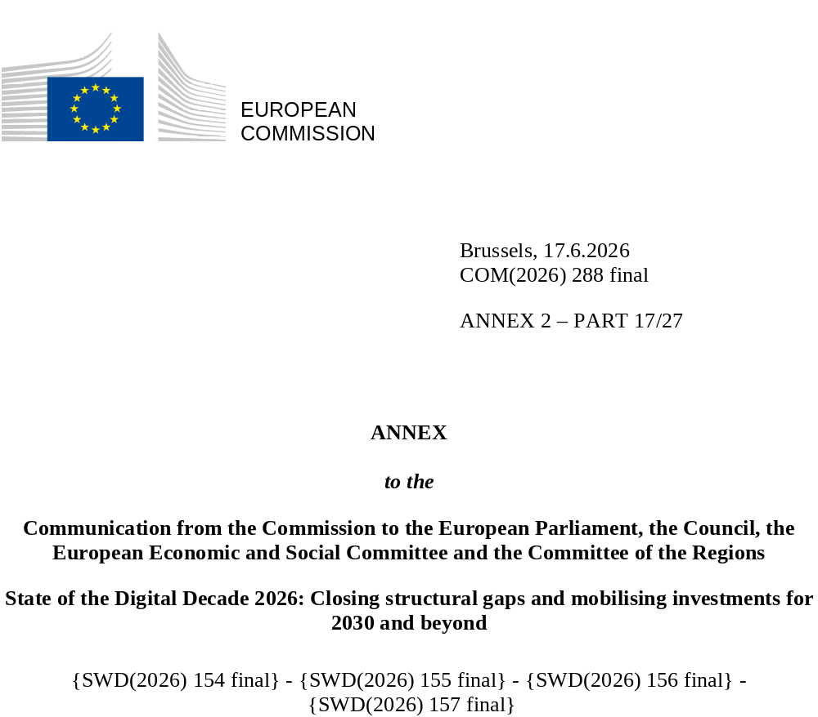

DIGITAL DECADE
COUNTRY REPORT
2026

Lithuania

Executive summary
Overall, Lithuania has strong assets in digitalisation: near-universal 5G coverage, rapidly growing SME digital intensity that now exceeds the EU average, a world-class cybersecurity framework and a globally recognised laser and photonics industry that provides a natural entry point into quantum technologies. However, Lithuania is not yet fully reaping the benefits of this transformation. Basic digital skills remain significantly below the EU average, with especially wide gaps among older adults and rural populations. In rural areas, rollout of very high capacity networks (VHCN) is falling behind the national trajectory due to a lack of public financing for last-mile connections. Female participation in ICT fell sharply in 2024, dropping below the EU average, but recovered strongly in 2025, returning above the EU average; this progress has not yet been underpinned by dedicated policy measures. On the green-digital dimension, no integrated strategy or monitoring framework has been established, despite the twin transition being a core EU strategic priority.
The weaknesses identified have direct implications for Lithuania's digital competitiveness. As a small, open economy, Lithuania’s future productivity growth will depend on how widely digital technologies spread beyond the ICT-intensive core. Weak digital skills – particularly among older and rural populations – are constraining labour market participation and limiting returns on Lithuania's digital infrastructure investment.
Lithuania can also count on several digital leadership assets. Its laser and photonics industry remains a globally recognised strength and offers a natural entry point into quantum photonics, with the country already embedded in European quantum communication networks. The start-up ecosystem is the fastest-growing in Central and Eastern Europe, supported by the newly launched Baltic Innovation Fund 3 and a planned EUR 250 million Scale-Up Fund. Looking ahead, the LitAI AI Factory is set to provide sovereign AI infrastructure from 2027, with full sectoral services expected by late 2027 to early 2028. Lithuania's leadership of the EU Permanent Structured Cooperation (PESCO) Cyber Rapid Response Teams – coordinating multinational teams that respond to cyber incidents, assess vulnerabilities and support affected states – makes it a key contributor to European digital security. Lithuania significantly scaled up its cyber awareness efforts in 2025, including targeted training for seniors and small and medium-sized enterprises, but sustaining and extending this outreach to vulnerable groups and smaller enterprises remains crucial.
Lithuania in the Digital Decade
Lithuania shows a high level of ambition in its contribution to the Digital Decade, having set 12 national targets (out of 14 possible), 92% of which are aligned with the EU 2030 targets. In its national roadmap, Lithuania provided 12 trajectory points for 2025 (out of 13 analysed). The country is following them well, with 75% considered on track. Lithuania addressed 83% of the 6 recommendations issued by the Commission in 2025, by implementing significant policy changes (50%) or making some changes (33%) through new measures. According to the national roadmap, by the end of 2026, 42% of the measures will come to an end. The total public budget for these measures is EUR 468 million, representing 32% of the total public budget outlined in the roadmap.
According to the special Eurobarometer on the Digital Decade 2026, 80% of Lithuanian people consider that digital policy should be a very high/high priority for the EU in shaping Europe’s future. They also think that, in the next 10 years, the EU should cooperate with EU countries to protect privacy and security online (94%), make digital tools more accessible for everyone, especially vulnerable groups, older ones, and people with disabilities (91%), and use digital tools and technologies to make life simpler for people and businesses (89%).
In addition, 74% of Lithuanian respondents think that the EU should reduce its dependencies on digital from non-EU countries, while 80% think that the EU should prioritise investments in digital infrastructure and services developed and controlled in Europe. Meanwhile, 53% would be willing to switch to an EU-based digital service provider even if it means slightly higher costs.
Funding for digital and multi-country projects
Lithuania allocates 23% of its total recovery and resilience plan to digital (EUR 0.7 billion). Under cohesion policy, EUR 0.3 billion, representing 5% of the country’s total cohesion policy funding, is also dedicated to advancing Lithuania’s digital transformation.
Lithuania is a member of the Alliance for Language Technologies European Digital Infrastructure Consortium (EDIC). It is also a participating state of the Euro High-Performance Computing (HPC) Joint Undertaking (JU) and of the Chips JU.
Digital Decade KPI ⁽¹⁾ | Lithuania |  |  |  |  | EU |  |  | Digital Decade target by 2030
Digital Decade KPI ⁽¹⁾ | Last available data (2) | DESI 2026 (year 2025) | Annual progress | National trajectory 2025 (3) | DESI 2026 |  | Annual progress | LT |  | EU
Fixed Very High Capacity Network coverage | 78.3% | 79.0% | 0.9% | 86.0% | 85.5% |  | 3.7% | 98.0% |  | 100%
Fibre to the Premises (FTTP) coverage | 78.3% | 79.0% | 0.9% | - | 74.1% |  | 7.1% | - |  | -
Basic 5G coverage | 99.7% | 99.7% | 0.0% | 95.0% | 96.8% |  | 2.6% | 100.0% |  | 100%
Edge Nodes (estimate, new methodology) | - | 75 | - | - | 7451 |  | - | - |  | 10000
SMEs with at least a basic level of digital intensity * | 60.0% | 73.5% | 10.7% | 71.0% | 71.4% |  | 11.0% | 90.0% |  | 90%
Cloud * | 33.6% | 54.9% | 27.8% | 46.0% | 46.7% |  | 9.5% | 75.0% |  | 75%
Artificial Intelligence | 8.8% | 21.3% | 143.2% | 19.0% | 20.0% |  | 48.0% | 75.0% |  | 75%
Data analytics * | 40.5% | 54.1% | 15.5% | 24.0% | 39.9% |  | 9.5% | 75.0% |  | 75%
AI or Cloud or Data analytics * | 53.5% | 71.4% | 15.5% | - | 63.2% |  | 7.5% | - |  | 75%
Unicorns | 3 | 3 | 0.0% | 4 | 324 |  | 10.2% | 6 |  | 500
At least basic digital skills * | 52.9% | 53.8% | 0.8% | 67.0% | 60.4% |  | 4.3% | 80.0% |  | 80%
ICT specialists | 5.3% | 5.7% | 7.5% | 5.7% | 5.0% |  | 2.0% | 6.9% |  | ~10%
e-ID scheme notification |  | Yes
Digital public services for citizens | 87.9 | 86.0 | -2.1% | 88.0 | 84.6 |  | 2.8% | 100.0 |  | 100
Digital public services for businesses | 92.5 | 96.7 | 4.6% | 96.0 | 88.6 |  | 2.7% | 100.0 |  | 100
Access to electronic health records | 95.4 | 97.9 | 2.6% | 100.0 | 86.5 |  | 4.6% | 100.0 |  | 100
(1) Indicators full description, metadata and sources in the DESI 2026 methodological note
(2) Last available data is DESI2025 (reference year 2024) except for indicators marked with a star * for which it is DESI2024 (reference year 2023)
(3) National trajectory value for 2025, if set by the country in its Digital Decade national roadmap

A competitive, sovereign and resilient EU based on technological leadership

A competitive, sovereign and resilient EU based on technological leadership
Lithuania performs above the EU average in 5G coverage but below it on VHCN, and lags behind its national trajectory on VHCN coverage, with rural areas particularly underserved. VHCN and FTTP coverage figures are virtually identical in Lithuania, reflecting a network that is almost entirely fibre-based, meaning the rural coverage gap is the same for both indicators and arises out of the same structural cause. The absence of broad-scale public support for last-mile fibre deployment to ordinary households leaves commercially unattractive areas at risk of being permanently excluded from gigabit coverage. The remaining 5G gaps concern mid-band deployment in rural areas and the transition to standalone networks, needed to enable advanced industrial use cases. Lithuania's semiconductor ecosystem remains at an early stage, but the country's world-leading laser and photonics industry provides a natural entry point into semiconductor-adjacent technologies, particularly for back-end applications and quantum photonics. Building on this strength to develop back-end production capacities and specialised skills would enable Lithuania to carve out a strategic niche in the EU semiconductor value chain. The country does not participate in the EU Chips Act’s front-end pilot lines, and its semiconductor ecosystem remains concentrated in niche and back-end activities, with a need to develop both production capacities and specialised skills in these segments. On the business side, SMEs have largely caught up with the EU basic digital intensity average, supported by a well-structured portfolio of co-funded instruments further expanded and simplified in 2025. The adoption of advanced digital technologies is above the EU average across all three indicators, but this masks significant sectoral concentration: adoption remains low outside the ICT-intensive core, and large enterprises lag behind the EU average on AI adoption. Lithuania has invested a lot in AI infrastructure through the LitAI AI Factory, expected to be operational by early 2027, and has established GovAI, an AI Competence Centre for the Public Sector that has been providing services to public institutions since February 2026. The start-up ecosystem is the fastest-growing in Central and Eastern Europe, with record levels of venture capital raised in 2025, though structural gaps in late-stage financing and exit pathways limit unicorn emergence.

Protecting and empowering EU people and society
Basic digital skills remain significantly below the EU average and are increasing well below the EU trend, with Lithuania lagging far behind its national 2030 trajectory. The gap is widest among older adults – whose proficiency rate is nearly 20 percentage points below the EU average for the same age group – and among rural and suburban populations. The Prisijungusi Lietuva (Connected Lithuania) proximity-based training model has demonstrated measurable effectiveness at reaching these excluded groups, but operates at a scale that remains insufficient relative to the gap and relies on Recovery and Resilience Facility (RRF) funding whose continuation beyond 2026 is not guaranteed. The share of ICT specialists is among the highest in Europe, but the sector contracted in 2024 due to economic stagnation, with a particularly sharp decline in ICT specialists who are women, putting Lithuania below the EU average. The share of ICT specialists who are women recovered strongly in 2025, putting the country back above the EU average, but this progress has not yet been underpinned by dedicated policy measures. Digital public services perform well, with Lithuania among the best performing EU countries when it comes to open data maturity and delivering significant e-health infrastructure improvements in 2025, including new subsystems for maternal health, laboratory data, as well as a new mental health data set. The EU Digital Identity (EUDI) Wallet is in active preparation. On the link between the green and digital transitions, no integrated strategy or monitoring framework has been adopted, and the dual transition remains largely unrealised in policy terms. The LitAI AI Factory, which will operate on green energy and include smart industry among its priority sectors from 2026 onwards, is an emerging but not yet operational contribution to this agenda.

Recommendations
- Basic Digital Skills: Strengthen Lithuania’s digital skills base, in particular by: (i) scaling up proximity-based delivery by extending the Prisijungusi Lietuva model beyond its current scope to establish a sustainable national network of trained digital mediators systematically integrated into social and employment services, (ii) introducing demand-side incentives, such as targeted training vouchers for low-skilled adults and older citizens; (iii) developing tailored awareness campaigns to reach the most excluded groups.
- AI: : Accelerate the adoption of AI across the business sector, in particular by: (i) promoting AI uptake in sectors outside the ICT-intensive core, such as manufacturing, construction and traditional services, through targeted awareness-raising and advisory support; (ii) participating in the sectoral Apply AI flagships to develop sector-specific AI applications; (iii) ensuring the timely operationalisation of the LitAI AI Factory to provide broad-based access to AI infrastructure for businesses of all sizes.
- Connectivity: Accelerate the deployment of high-capacity digital infrastructure, in particular by: (i) introducing targeted public support for last-mile fibre deployment in commercially unattractive rural areas to close the FTTP coverage gap; (ii) sustaining 5G rollout in the 3.4-3.8 GHz mid-band in rural areas and promoting the deployment of 5G Standalone networks to enable advanced use cases; (iii) taking advantage of upcoming spectrum licence renewals to put in place pro-investment conditions.
- Cybersecurity: Build on the country’s strong cyber resilience by further enhancing public cyber awareness and institutional coordination. In particular: (i) continue scaling cyber awareness efforts across all population groups and sectors, with particular attention to vulnerable groups such as seniors and SMEs; (ii) consolidate the organisational framework for cybersecurity by strengthening measurable implementation targets and structured cross-sector cooperation mechanisms.
- ICT specialists: Strengthen the ICT talent pipeline and improve gender balance in the sector. In particular, (i) scale up retraining programmes to support career transitions into ICT; (ii) introduce targeted measures to increase and structurally embed female participation in ICT specialist roles, including dedicated programme design, clear targets and funding beyond the general instruments currently available.
- Green: Adopt an integrated green-digital strategy with measurable sector-specific targets and establish a national monitoring framework to track ICT-enabled emission reductions across the economy. Build on the LitAI AI Factory's green energy and smart industry pipeline to scale up digital solutions supporting climate goals among businesses and public sector entities.
- Semiconductors: Invest in the development of semiconductor back-end technologies, and support the development of specialised semiconductor skills in advanced semiconductor technologies.

