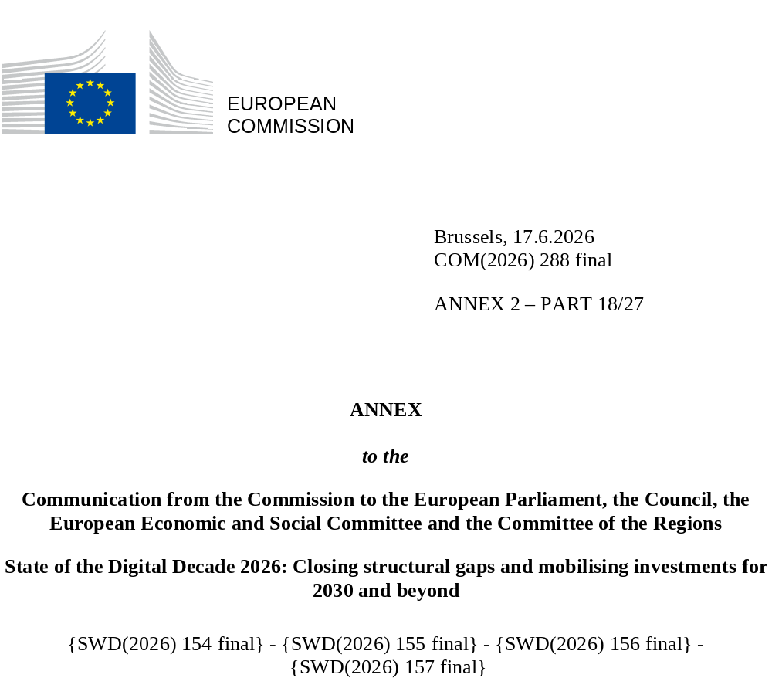

DIGITAL DECADE
SHORT COUNTRY REPORT
2026

Luxembourg

Executive summary
Overall, Luxembourg combines near-universal connectivity with a sovereign digital infrastructure strategy anchored in quantum technologies, AI Factory investment and world-class cybersecurity. However, cloud and data analytics adoption among companies trails the EU average despite strong AI performance, and basic digital skills are growing too slowly, with persistent gaps among those with a low level of education and older citizens.

The weaknesses identified in business digitalisation have direct implications for Luxembourg’s competitiveness and economic resilience. An economy as specialised and internationally exposed as Luxembourg’s depends critically on the ability of its enterprise base to adopt productivity-enhancing digital tools. Cloud and data analytics gaps in particular limit businesses’ ability to scale operations, access cross-border markets and leverage the data infrastructure Luxembourg is building at national level. The drop observed in 2024 in the share of women ICT specialists has only been partially corrected in 2025, signalling a structural vulnerability in a labour market already reliant on attracting international talent.

Luxembourg can, however, count on several digital leadership assets that position it well for the decade ahead. In 2025, the Government of Luxembourg launched the national strategic initiative “Accelerating Digital Sovereignty 2030”, comprising three complementary strategies on data, artificial intelligence, and quantum technologies, supported by strategic actions and flagship projects in priority domains, aimed at benefiting public authorities, citizens and businesses. Selected in December 2024 as one of the first seven countries to host an EuroHPC AI Factory, Luxembourg is deploying MeluXina-AI, a new AI-optimised supercomputer operated by LuxProvide alongside the existing MeluXina infrastructure, providing sovereign high-performance computing to businesses, researchers and public administrations from the second half of 2026. The landmark cross-border quantum key distribution link achieved in June 2025, and the forthcoming MeluXina-Q quantum computer confirm Luxembourg’s ambition to be a strategically significant node in Europe’s emerging quantum infrastructure. The Mistral AI partnership and the AI4LUX campaign signal a new model of sovereign AI deployment in public services. Luxembourg’s dual positioning as a financial centre and a data-sovereign digital hub offers a distinctive basis for developing integrated public-private financing vehicles for the next generation of digital ventures.

Luxembourg in the Digital Decade
Luxembourg shows a high level of ambition in its contribution to the Digital Decade having set 12 national targets (out of 14 possible), 100% of which aligned with the EU 2030 targets In its national roadmap, Luxembourg provided 12 trajectory points for 2025 (out of 13 analysed). The country is following them moderately well with 67% considered to be on track. Luxembourg addressed 100% of the 6 recommendations issued by the Commission in 2025, either by implementing significant policy changes (17%) or making some changes (83%) through new measures. According to the national roadmap, by the end of 2026, 18% of the measures will come to an end. The total public budget associated to these measures is EUR 40 million, representing 8% of the total public budget outlined in the roadmap.
According to the special Eurobarometer on the Digital Decade 2026, 79% of Luxembourg people consider that digital policy should have a high or very high priority for the EU in shaping our future in Europe. They also think that, in the next 10 years, the EU should cooperate with Member States to reinforce cybersecurity and protection from online threats (100%), build an independent European digital infrastructure including broadband, 5G, cloud and semiconductors (90%), and promote digital education and skills programs (86%).
In addition, 87% of Luxembourg respondents think that the EU should reduce its dependencies on digital from third countries, and 89% that the EU should prioritise investments in digital infrastructure and services that are developed and controlled in Europe. Meanwhile, 69% would be willing to switch to an EU-based digital service provider even if it means slightly higher costs.
Funding for digital and multi-country projects

Luxembourg allocates 27% of its total recovery and resilience plan to digital (EUR 17 million). In addition, under cohesion policy, EUR 0.01 billion, representing 17% of the country’s total cohesion policy funding, is dedicated to advancing Luxembourg’s digital transformation.
Luxembourg is a member of the Alliance for Language Technologies European Digital Infrastructure Consortium (EDIC), of the Local Digital Twins towards the CitiVERSE EDIC, of the EUROPEUM EDIC, of the IMPACTS EDIC and of the Digital Commons EDIC. Luxembourgish entities are indirect partners in the IPCEI on Next Generation Cloud Infrastructure and Services (IPCEI-CIS). Luxembourg also participates in the design of a new, upcoming candidate IPCEI on Artificial Intelligence. Luxembourg is also a participating state of the EuroHPC Joint Undertaking (JU) and of the Chips JU.
Digital Decade KPI ⁽¹⁾ | Luxembourg |  |  |  |  | EU |  |  | Digital Decade target by 2030
Digital Decade KPI ⁽¹⁾ | Last available data (2) | DESI 2026 (year 2025) | Annual progress | National trajectory 2025 (3) | DESI 2026 |  | Annual progress | LU |  | EU
Fixed Very High Capacity Network coverage | 95.2% | 95.5% | 0.3% | 98.5% | 85.5% |  | 3.7% | 100.0% |  | 100%
Fibre to the Premises (FTTP) coverage | 81.8% | 85.2% | 4.2% | 92.9% | 74.1% |  | 7.1% | 100.0% |  | -
Basic 5G coverage | 99.6% | 99.9% | 0.3% | 98.4% | 96.79% |  | 2.6% | 100.0% |  | 100%
Edge Nodes (estimate, new methodology) | - | 28 | - | - | 7451 |  | - | - |  | 10000
SMEs with at least a basic level of digital intensity * | 57.9% | 76.7% | 15.1% | 75.1% | 71.4% |  | 11.0% | 90.0% |  | 90%
Cloud * | 32.6% | 43.7% | 15.7% | 37.8% | 46.7% |  | 9.5% | 75.0% |  | 75%
Artificial Intelligence | 23.7% | 33.6% | 41.6% | 52.1% | 20.0% |  | 48.0% | 75.0% |  | 75%
Data analytics * | 32.4% | 38.2% | 8.6% | 68.6% | 39.9% |  | 9.5% | 75.0% |  | 75%
AI or Cloud or Data analytics * | 52.0% | 64.4% | 11.2% | - | 63.2% |  | 7.5% | - |  | 75%
Unicorns | 2 | 2 | 0.0% | - | 324 |  | 10.2% | - |  | 500
At least basic digital skills * | 60.1% | 62.4% | 1.9% | 71.0% | 60.4% |  | 4.3% | 80.0% |  | 80%
ICT specialists | 8.0% | 8.7% | 8.7% | 8.6% | 5.0% |  | 2.0% | 10.0% |  | ~10%
e-ID scheme notification |  | Yes
Digital public services for citizens | 97.7 | 94.7 | -3.1% | 97.4 | 84.6 |  | 2.8% | 100.0 |  | 100
Digital public services for businesses | 100.0 | 100.0 | 0.0% | 98.3 | 88.6 |  | 2.7% | 100.0 |  | 100
Access to electronic health records | 76.1 | 77.1 | 1.4% | 79.2 | 86.5 |  | 4.6% | 100.0 |  | 100
(1) Indicators full description, metadata and sources in the DESI 2026 methodological note
(2) Last available data is DESI2025 (reference year 2024) except for indicators marked with a star * for which it is DESI2024 (reference year 2023)
(3) National trajectory value for 2025, if set by the country in its Digital Decade national roadmap

A competitive, sovereign and resilient EU based on technological leadership
Luxembourg performs well above the EU average on connectivity, with near-universal Very High Capacity Network (VHCN) and 5G coverage and a mature fibre deployment model driven primarily by a single national operator. The remaining challenge for fibre to the premises (FTTP) is concentrated in hard-to-reach premises in ‘WhiteSpot’ areas, where a new legal framework is still undergoing analysis without concrete deployment results, and in stimulating take-up among cost-sensitive households despite an expanding voucher scheme. On 5G, mid-band rural coverage and standalone deployment remain the key gaps that need to be addressed. On the business side, SMEs have made rapid progress in basic digital intensity, but cloud and data analytics adoption among enterprises continues to trail the EU average, with no dedicated instrument targeting enterprises introduced in 2025. Luxembourg has invested decisively in AI infrastructure and sovereign digital capabilities through the MeluXina-AI AI Factory and the Mistral AI partnership, positioning itself as a trusted AI hub in Europe. The start-up ecosystem benefits from Luxembourg’s unique positioning as a financial centre and data-sovereign hub, though scaling ventures beyond the early stages remains a structural challenge.

Protecting and empowering EU people and society
Luxembourg’s basic digital skills level is above the EU average but below the national trajectory point set by Luxembourg in its national roadmap in 2025. It is also growing more slowly than the EU overall, with persistent gaps among those with a low level of education, older citizens and women. The second National Action Plan for Digital Inclusion, adopted in January 2026, represents a meaningful governance upgrade but further efforts are needed to reach the most excluded groups. The share of ICT specialists in the total workforce is the second highest in Europe and recovered significantly in 2025, though the volatility in the number of women ICT specialists signals a structural vulnerability that warrants continued attention. On digital public services, Luxembourg achieves a perfect score for businesses, but citizen-facing services have declined slightly, and the country ranks among the lowest in the EU for digitalisation of judicial proceedings, with citizens and businesses still unable to fully initiate and follow court proceedings digitally. Access to electronic health records remains below the EU average.
On green digital technologies, Luxembourg’s ICT sector emits almost three times the EU average per capita, and while the ‘sustainable by design’ principle is embedded in the Digital Government Strategy 2026-2030, no national monitoring framework exists to quantify ICT-enabled emission reductions across sectors.

Recommendations
- Skills: Strengthen targeted digital skills interventions for the groups most at risk of exclusion, in particular older citizens, women and low-educated populations, by (i) scaling up proximity-based delivery and personalised support mechanisms, and (ii) ensuring programme continuity beyond current funding cycles.
- Advanced technologies take-up: Develop targeted policy measures to accelerate the adoption of advanced digital technologies among enterprises, in particular by: (i) accelerating cloud and data analytics adoption among private enterprises, notably by extending the existing SME support architecture beyond basic digitalisation toward advanced technology deployment and by scaling up sovereign cloud offerings adapted to private sector needs; (ii) continuing to support AI uptake by identifying and scaling AI use cases in strategic sectors of the Luxembourg economy, in line with the Apply AI Strategy.
- Green: Develop a national monitoring framework to systematically track and report ICT-enabled emission reductions across key sectors, with sector-specific indicators aligned with EU guidance, to give measurable substance to the "sustainable by design" commitment embedded in the Digital Government Strategy 2026–2030.
- Connectivity: Accelerate the deployment of high-capacity digital infrastructure. Improve voucher activation rates among eligible low-income households through enhanced outreach and integration into social support services. Accelerate 5G rollout in the 3.4-3.8 GHz mid-band in rural areas, promote the deployment of 5G Standalone networks to enable advanced use cases.
- Cybersecurity: Continue efforts in cybersecurity to address the evolving and increasing threats, including by: (i) accelerating efforts to ensure imposition of cybersecurity measures necessary to enhance the cyber posture of critical infrastructure; and (ii) pursuing cybersecurity trainings combining technical and human approaches, supporting lifelong learning and upskilling of the cybersecurity workforce.
- eHealth: accelerate the roll-out of electronic health record access and interoperability measures in line with the European Health Data Space framework, including by making ePrescription and eDispensation data available to citizens in a timely manner and by onboarding additional types of healthcare providers to increase the supply of health data.
- Digital public services (eJustice): Accelerate the digitalisation of judicial proceedings to allow citizens and businesses to initiate and follow court proceedings digitally.

