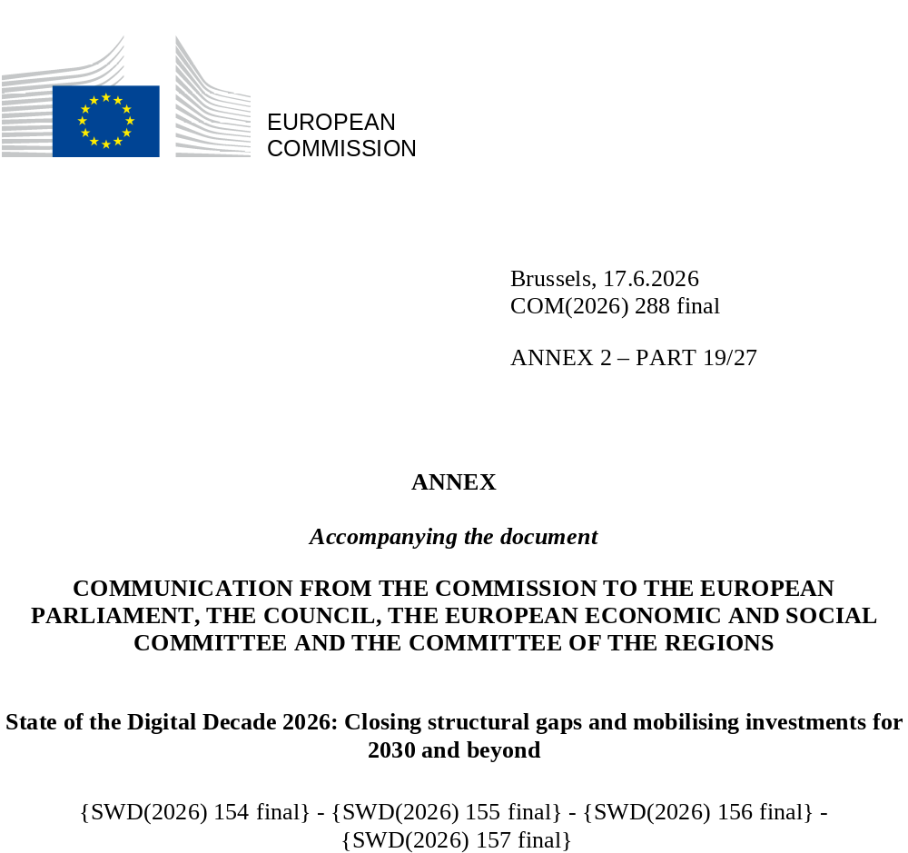

DIGITAL DECADE
SHORT COUNTRY REPORT
2026

Malta

Executive summary
Overall, Malta has strong assets in digitalisation, notably in the connectivity infrastructure and the availability of digital public services. At the same time structural weaknesses persist, particularly in relation to the shortage of ICT specialists (including low Science, Technology, Engineering and Mathematics (STEM) uptake and the representation of women in ICT), the digital skills gap among older people and people with lower levels of educational attainment and the development of cybersecurity capabilities.

The identified weaknesses in ICT specialists and digital skills constrain Malta’s competitiveness. The scarcity of specialised talent forces high-growth sectors like Fintech, Gaming and Interactive Entertainment to rely on foreign labour, which discourages long-term domestic R&D investment. Also, the significant divide in digital literacy among older people and people with lower levels of educational attainment hampers Malta’s transition to a fully inclusive knowledge-based economy. Simultaneously, high cybersecurity incident rates undermine trust in Malta as a secure digital hub, discouraging international investment in its critical tech sectors.

Regarding digital leadership assets, Malta will be launching the CALYPSO AI Factory Antenna, which provides start-ups and Small and Medium-sized enterprises (SMEs) with direct access to EuroHPC supercomputing. Also, the Malta Semiconductor Competence Centre (MSCC) supports start-ups in chip design, and Malta’s quantum landscape, through the PRISM project, aims to build a large-scale quantum-secured network in Malta, spanning the entire country. Furthermore, the Digital Innovation Hub, hosting Malta’s first High Performance Computer, grants SMEs and start-ups complimentary access to advanced AI capabilities, cloud-based tools, and data resources.

Malta in the Digital Decade
Malta shows a moderate level of ambition in its contribution to the Digital Decade having set 12 national targets (out of 14 possible), 58% of which aligned with the EU 2030 targets. In its national roadmap, Malta provided 8 trajectory points for 2025 (out of 13 analysed). The country is following them moderately well with 63% considered on track. Malta addressed 33% of the 6 recommendations issued by the Commission in 2025 by making some changes through new measures.

Malta submitted an updated national Digital Decade roadmap in January 2026. The roadmap contains 90 measures, of which 24 are new measures. The total budget is EUR 336 million (mostly coming from public budgets), corresponding to approximately 1.37% of Malta’s GDP in 2025. According to the national roadmap, by the end of 2026, 62% of the measures will come to an end. The total public budget associated to these measures is EUR 308 million, representing 91% of the total public budget outlined in the roadmap.

According to the special Eurobarometer on ‘the Digital Decade’ 2026, 91% of Maltese consider that digital policy should have a very high/high priority for the EU in shaping our future in Europe. They also think that, in the next ten years, the EU should cooperate with Member States to reinforce cybersecurity and protection from online threats (97%), promote digital education and skills programmes (95%) and strengthen the regulation of online platforms (e.g. online social networks, marketplaces, app stores, etc.) (93%). In addition, 66% of Maltese respondents think that the EU should reduce its dependencies on digital from third countries, and 88% that EU should prioritise investments in digital infrastructure and services that are developed and controlled in Europe. Meanwhile, 57% would be willing to switch to an EU-based digital service provider even if it means slightly higher costs.

Funding for digital and multi-country projects
Malta allocates 27% of its total recovery and resilience plan to digital (EUR 0.07 billion). In addition, under cohesion policy, EUR 0.1 billion, representing 14% of the country’s total cohesion policy funding, is dedicated to advancing Malta’s digital transformation.

Malta is directly participating in the IPCEI on Microelectronics and Communication Technologies (IPCEI-ME/CT) through a total capital investment of EUR 250 million. Malta is a participating state of the EuroHPC Joint Undertaking (JU) and of the Chips JU.

 | Malta |  |  |  | EU |  | Digital Decade target by 2030
Digital Decade KPI (1) | Last available data (2) | DESI 2026 (year 2025) | Annual progress | National trajectory 2025 (3) | DESI 2026 | Annual progress | MT | EU
Fixed Very High-Capacity Network (VHCN) coverage | 100.0% | 100.0% | 0.0% | - | 85.5% | 3.7% | 100.0% | 100%
Fibre to the Premises (FTTP) coverage | 86.2% | 90.4% | 4.8% | - | 74.1% | 7.1% | 100.0% | -
Overall 5G coverage | 100.0% | 100.0% | 0.0% | 100.0% | 96.8% | 2.6% | 100.0% | 100%
Edge Nodes (estimate) | - | 13 | - | - | 7451 | - | - | 10000
SMEs with at least a basic level of digital intensity * | 76.5% | 83.5% | 4.5% | 80.3% | 71.4% | 11.0% | 85.0% | 90%
Cloud * | 58.2% | 65.1% | 5.7% | 73.6% | 46.7% | 9.5% | 80.0% | 75%
Artificial Intelligence | 17.3% | 21.5% | 24.3% | 20.7% | 20.0% | 48.0% | 27.2% | 75%
Data analytics * | 35.6% | 38.9% | 4.5% | 44.6% | 39.9% | 9.5% | 51.1% | 75%
AI or Cloud or Data analytics * | 68.3% | 73.3% | 3.6% | - | 63.2% | 7.5% | - | 75%
Unicorns | 5 | 5 | 0.0% | - | 324 | 10.2% | - | 500
At least basic digital skills * | 62.8% | 66.8% | 3.2% | 66.1% | 60.4% | 4.3% | 75.0% | 80%
ICT specialists | 5.3% | 4.8% | -9.4% | 5.7% | 5.0% | 2.0% | 8.0% | ~10%
e-ID scheme notification |  | Yes
Digital public services for citizens | 99.7 | 99.1 | -0.6% | 100.0 | 84.6 | 2.8% | 100.0 | 100
Digital public services for businesses | 100.0 | 100.0 | 0.0% | - | 88.6 | 2.7% | 100.0 | 100
Access to electronic health records | 93.7 | 94.5 | 0.8% | - | 86.5 | 4.6% | 100.0 | 100
(1) Indicators full description, metadata and sources in the DESI 2026 methodological note
(2) Last available data is DESI2025 (reference year 2024) except for indicators marked with a star * for which it is DESI2024 (reference year 2023)
(3) National trajectory value for 2025, if set by the country in its Digital Decade national roadmap

A competitive, sovereign and resilient EU based on technological leadership
In connectivity, progress has been supported by ongoing fibre deployment and resilience improvements. Yet, Malta lags behind in rural fibre deployment and shows stagnation in terms of 5G coverage in the 3.4-3.8GHz band. In quantum, Malta’s quantum landscape is driven towards practical infrastructure deployment, particularly through the PRISM project. Malta’s semiconductor ecosystem has been enhanced through the launch of the Malta Semiconductor Competence Centre (MSCC).
SMEs face difficulties in digitalisation, mostly derived from the shortage and limited access to specialised talent. The same applies to the uptake of advanced technologies by businesses. Despite new initiatives, like the AI Factory Antenna, and targeted incentives for SMEs, there are still challenges in the adoption of AI and data analytics from SMEs. Malta’s start-up ecosystem has been supported through targeted national initiatives. However, challenges, like limited scale-up capital and the constraints of Malta’s small domestic market, persist.

In terms of cybersecurity, the high rates of ICT security incidents, compounded by the shortage of qualified cybersecurity professionals, highlights the country’s vulnerability to cyberattacks and undermines its resilience.

Protecting and empowering EU people and society
Despite the fact that the level of basic digital skills of the population is above the EU average, persistent bottlenecks endure due to digital skills gap among older people and people with lower levels of educational attainment. Furthermore, the share of ICT specialists is below the EU average, with under-representation of women in ICT. This leads to a shortage of specialised talent, affecting Malta’s progress in digital transformation. On digital public services, Malta is improving user-centric delivery through the redevelopment of the servizz.gov portal, the planned roll-out of Business Portal and the Malta Business Wallet, and preparations for the EUDI Wallet procurement, focusing on, trust and streamlined service journeys. Nevertheless, Malta faces several critical hurdles in the full-scale digitalisation and AI integration of its healthcare system.

Recommendations
- ICT specialists: Enhance the attractiveness of ICT careers, by implementing more effective strategies to increase participation in ICT professions, especially from women. Strengthen and expand STEM-focused educational curricula to foster greater engagement in science, technology, engineering, and mathematics (STEM) disciplines.
- Basic digital skills: Strengthen the development of basic digital skills, targeting vulnerable groups, including people with no or low formal education.
- Cybersecurity: Support the cybersecurity posture and preparedness of enterprises by promoting regular risk assessments, improving incident handling, and providing cybersecurity staff training. Focus on (i) implementing the National Cybersecurity Strategy and strengthening the technical and operational readiness of the National Coordination Centre for improved cyber incident response; (ii) expanding capacity development notably on Network and Information Systems Directive (NIS2) essential entities e.g. integrate AI into public services in line with the Malta’s Cyber and AI initiative; and (iii) intensifying international cooperation and participation in cyber exercises.
- Digitalisation of SMEs: Facilitate the digitalisation of SMEs and uptake of advanced technologies, such as AI and data analytics, also by providing support to ensure that digital intensive SMEs can scale their activities.
- Connectivity infrastructure: Promote the deployment of fibre optics in rural areas. Accelerate 5G rollout in the 3.4-3.8 GHz band. Promote the deployment of 5G SA networks while enabling advanced use cases.

