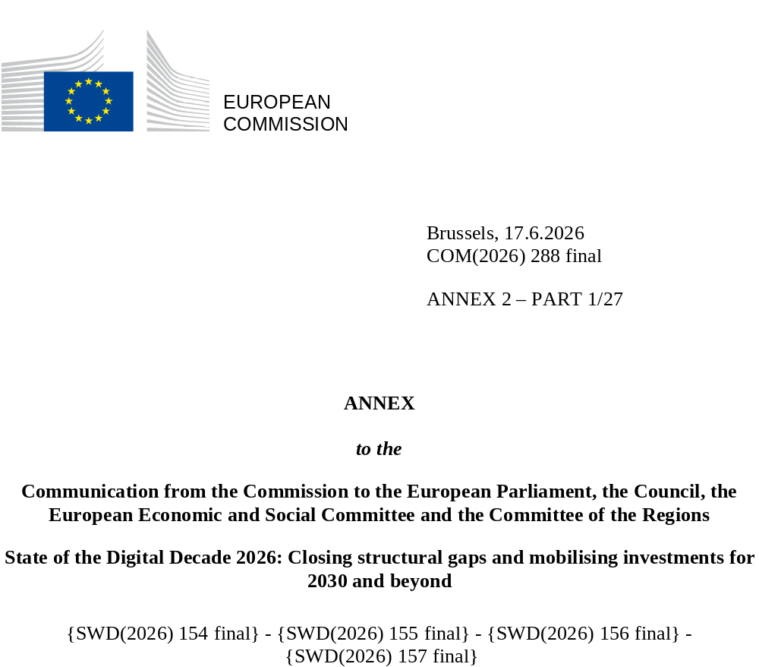

DIGITAL DECADE SHORT
COUNTRY REPORT
2026

Austria

Executive summary
Austria demonstrates solid strengths in digitalisation, with a strong digital skills base, good performance in the digitalisation of Small and Medium-Sized Enterprises (SMEs) and advanced digital public services for businesses, supported by a well-functioning digital identity ecosystem. The country also shows clear leadership in specific technological areas such as quantum and business adoption of Artificial Intelligence (AI). However, important gaps remain in the adoption of other advanced technologies like cloud and data analytics, where Austria lags behind the EU average. Connectivity deployment faces emerging structural and fiscal constraints, the growth of ICT specialists in employment remains insufficient and progress in digital public services for citizens, especially cross-border, remains slow.
These weaknesses may weigh on Austria’s competitiveness in the medium term. Lower adoption of cloud and data analytics limits productivity gains and reduces SMEs’ capacity to fully leverage digital transformation. At the same time, shortages of ICT specialists risk constraining innovation and the diffusion of advanced technologies across the economy. Meanwhile, slower progress in citizen-facing digital public services and interoperability may also limit efficiency gains in public administration and cross-border economic activity.
Nevertheless, Austria can rely on strong digital leadership assets. The country has a well-developed research and innovation ecosystem, particularly in quantum technologies, supported by sustained public investment and strong links between academia and industry. AI adoption is growing rapidly, with initiatives such as AI Factory Austria which aim to strengthen infrastructure and experimentation capacities. Austria also maintains a dynamic start-up ecosystem supported by public equity instruments, although scaling remains a challenge.

Austria in the Digital Decade
Austria shows a high level of ambition in its contribution to the Digital Decade having set 12 national targets (out of 14 possible), 92% of which aligned with the EU 2030 targets. In its national roadmap, Austria provided 12 trajectory points for 2025 (out of 13 analysed). The country is following them moderately well with 67% considered on track. Austria addressed 40% of the 5 recommendations issued by the Commission in 2025 by making some changes through new measures. According to the national roadmap, by the end of 2026, 48% of the measures will come to an end. The total public budget associated to these measures is EUR 3.36 billion, representing 83% of the total public budget outlined in the roadmap.
According to the special Eurobarometer on the Digital Decade 2026, 76% of Austrian people consider that digital policy should have a very high/high priority for the EU in shaping our future in Europe. They also think that, in the next ten years, the EU should cooperate with Member States to reinforce cybersecurity and protection from online threats (91%), promote digital education and skills programmes (85%) and strengthen regulation of online platforms such as social networks and marketplaces (81%). In addition, 86% of Austrian respondents think that the EU should reduce its dependencies on digital technologies from third countries, and 90% that the EU should prioritise investments in digital infrastructure and services that are developed and controlled in Europe. Meanwhile, 59% would be willing to switch to an EU-based digital service provider even if it means slightly higher costs.

Funding for digital and multi-country projects
Austria allocates 35% of its total recovery and resilience plan to digital (EUR 1.3 billion). In addition, under cohesion policy, EUR 0.07 billion, representing 7% of the country’s total cohesion policy funding, is dedicated to advancing Austria’s digital transformation.
Austria is directly participating in the Important Project of Common European Interest (IPCEI) on Microelectronics and Communication Technologies (IPCEI-ME/CT). Austria is a participating state of the EuroHPC Joint Undertaking (JU) and the Chips JU.

Digital Decade KPI ⁽¹⁾ | Austria |  |  |  |  | EU |  |  |  | Digital Decade target by 2030
Digital Decade KPI ⁽¹⁾ | Last available data (2) | DESI 2026 (year 2025) | Annual progress | National trajectory 2025 (3) | DESI 2026 |  | Annual progress |  | AT |  | EU
Fixed Very High Capacity Network (VHCN) coverage | 72.2% | 76.3% | 5.7% | 75.0% | 85.5% |  | 3.7% |  | 100.0% |  | 100%
Fibre to the Premises (FTTP) coverage | 44.8% | 50.9% | 13.5% | 47.0% |  | 74.1% |  | 7.1% |  | 72.0% |  | -
Basic 5G coverage | 99.5% | 99.8% | 0.3% | 99.5% |  | 96.8% |  | 2.6% |  | 100.0% |  | 100%
Edge Nodes (estimate, new methodology) | - | 210 | - | - |  | 7451 |  | - |  | - |  | 10000
SMEs with at least a basic level of digital intensity * | 57.9% | 73.0% | 12.2% | 76.0% |  | 71.4% |  | 11.0% |  | 90.0% |  | 90%
Cloud * | 35.6% | 41.7% | 8.3% | - |  | 46.7% |  | 9.5% |  | - |  | 75%
Artificial Intelligence | 20.3% | 30.0% | 47.8% | 29.1% |  | 20.0% |  | 48.0% |  | 75.0% |  | 75%
Data analytics * | 23.9% | 26.3% | 4.9% | 38.5% |  | 39.9% |  | 9.5% |  | 75.0% |  | 75%
AI or Cloud or Data analytics * | 47.0% | 58.1% | 11.2% | - |  | 63.2% |  | 7.5% |  | - |  | 75%
Unicorns | 4 | 4 | 0.0% | 5 |  | 324 |  | 10.2% |  | 10 |  | 500
At least basic digital skills * | 64.7% | 69.8% | 3.9% | 68.3% |  | 60.4% |  | 4.3% |  | 80.0% |  | 80%
ICT specialists | 5.3% | 5.4% | 1.9% | 5.9% |  | 5.0% |  | 2.0% |  | 10.0% |  | ~10%
e-ID scheme notification |  | Yes
Digital public services for citizens | 80.8 | 83.7 | 3.6% | 85.0 |  | 84.6 |  | 2.8% |  | 100.0 |  | 100
Digital public services for businesses | 87.7 | 88.8 | 1.3% | 85.0 |  | 88.6 |  | 2.7% |  | 100.0 |  | 100
Access to electronic health records | 87.0 | 89.1 | 2.4% | 97.5 |  | 86.5 |  | 4.6% |  | 100.0 |  | 100
(1) Indicators full description, metadata and sources in the DESI 2026 methodological note
(2) Last available data is DESI2025 (reference year 2024) except for indicators marked with a star * for which it is DESI2024 (reference year 2023)
(3) National trajectory value for 2025, if set by the country in its Digital Decade national roadmap

A competitive, sovereign and resilient EU based on technological leadership
Austria performs relatively well in SME digitalisation, with a share of digitally intensive SMEs above the EU average, but uptake of advanced technologies remains uneven, especially for cloud and data analytics. Connectivity coverage is progressing but may face slowing momentum due to fiscal constraints and market conditions, particularly in fibre deployment. While AI adoption is accelerating and supported by policy initiatives, broad-based diffusion across the economy is still a work in progress. Austria also benefits from a dynamic start-up ecosystem and supportive public financing instruments, but the number of unicorns has remained unchanged and scale-up financing conditions remain comparatively limited, pointing to persistent challenges in translating innovation potential into high-growth firms.

Protecting and empowering EU people and society
Austria benefits from a strong level of basic digital skills, with performance above the EU average and a relatively inclusive distribution across regions and age groups. However, the share of ICT specialists remains below EU targets and current measures focus mainly on long-term education pipelines, with more limited impact on immediate labour market needs, which may also constrain the diffusion of digital technologies across the economy.
Austria has made steady progress in digital public services, particularly for businesses, supported by a well-developed digital identity system and efficient e-government infrastructures. However, progress for citizen-facing services - especially cross-border - remains more limited due to interoperability challenges and resource constraints. Digital health services are well established through existing infrastructures, but further improvements depend on continued investments in integration and system modernisation.
Recommendations
- Connectivity: Accelerate the deployment of fibre-to-the-premises infrastructure and strengthen end-user take-up, in particular by: i) scaling up fibre rollout through coordinated funding programmes and regulatory measures at both national and regional (Länder) levels, ensuring a geographically balanced deployment that adequately covers rural and underserved areas; ii) supporting, via targeted measures and appropriate regulatory intervention, as appropriate, end-users' connections, so as to reduce the gap between fibre network availability and actual subscriber uptake; iii) foster the copper networks switch-off, in alignment with the pace of fibre rollout and with adequate consumer safeguards
- Advanced digital technologies uptake: Accelerate the adoption of cloud and data analytics, particularly among SMEs, by introducing more targeted measures that stimulate demand for cloud and data analytics solutions
- ICT specialists: Austria should complement its strong long-term education investments with more immediate actions to address persistent ICT skills shortages. This should include scaling up reskilling and upskilling programmes, promoting enterprise-based training, and facilitating the attraction of foreign ICT talent, with a particular focus on applied digital skills relevant for business adoption (e.g. data, cloud, AI).
- Digital Public Services: Austria should prioritise the modernisation and interoperability of its digital public service infrastructure to accelerate progress for citizens. Efforts should focus on scaling the once-only principle across all levels of government, addressing fragmentation and legacy systems, and ensuring full alignment with EU frameworks such as the European Digital Identity Wallet to unlock cross-border services.
- Unicorns: Austria should accelerate the implementation of measures to improve access to growth capital and support the scaling of innovative companies. While recent initiatives, including the planned Startup and Scale-up Fund, represent important progress, further efforts are needed to mobilise private investment, facilitate larger funding rounds, and improve the overall scale-up environment. This should be complemented by measures to enhance international visibility, attract foreign investors, and support the expansion of high-growth firms into global markets.

