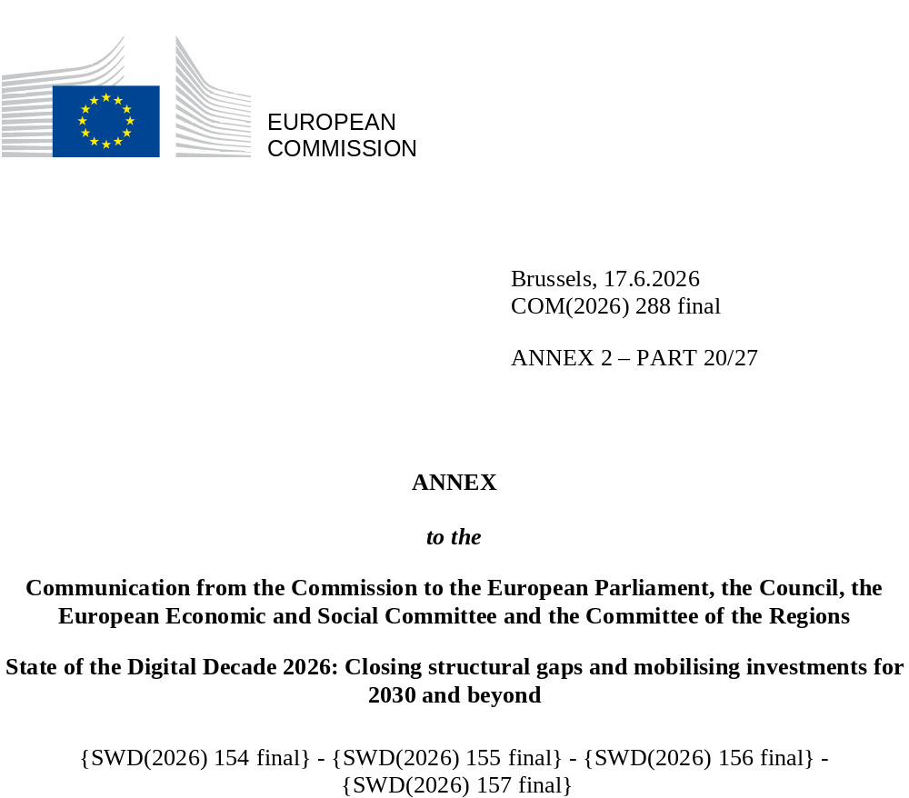

DIGITAL DECADE
SHORT COUNTRY REPORT
2026

The Netherlands

Executive summary
The Netherlands remains a leader in digitalisation, supported by excellent connectivity, a strong research base and a leading position in high-technology areas. However, these strengths are not yet widely felt across all businesses. SMEs continue to lag behind in the strategic use of advanced digital technologies, partly as a result of a lack of skills and limited financial resources, while the shortage of ICT specialists further constrains digital transformation. The tech start-up sector is also showing signs of slowing down. Digital skills, online safety and trusted public services remain important priorities. However, some structural issues continue to slow progress, including ongoing fragmentation in the delivery of public services, where government organisations operate separate systems and data infrastructures.
Overall, despite its strong technological base, the Netherlands has not fully translated its leadership in innovation into widespread productivity growth, limiting its potential to drive long-term economic development and competitiveness. The Netherlands now finds itself at a key moment of transition: its strengths and weaknesses have been clearly identified (including in Peter Wennink’s report), and a new government and several strategic initiatives provide momentum to build on them. These initiatives include the coalition agreement; the Netherlands Digitalisation Strategy (NDS), which for the first time establishes a shared whole-of-government vision for digitalisation and interoperability; a renewed industrial policy for key sectors like semiconductors and biotechnology; and a target to raise R&D investment to 3% of GDP by 2030. The key challenge now is to turn this policy momentum into economy-wide impact, while ensuring consistency across initiatives and avoiding fragmentation.
Finally, the Netherlands is a global leader in digital innovation in key high-tech areas. It has an exceptionally strong and specialised semiconductor ecosystem, built on long-standing investments and expertise that make the country a critical node in the production of advanced chips. However, these strengths are concentrated among a few players, creating strategic vulnerabilities in an increasingly fragmented geopolitical context. Recognising this, the government has repeatedly emphasised the need to maintain control over critical infrastructure to strengthen digital sovereignty – including in the December 2025 vision on digital sovereignty and in the non-paper on ‘Strengthening cloud sovereignty of public administrations’ adopted in July 2025. The government is also supporting the development of initiatives such as the Artificial Intelligence (AI) Factory in Groningen to expand access to computing power and innovation capacity for businesses.

The Netherlands in the Digital Decade
The Netherlands shows a high level of ambition in its contribution to the Digital Decade, with 10 national targets (out of 14), 90% of which are aligned with the EU 2030 targets. In its national roadmap, it provided 10 trajectory points for 2025 (out of 13 analysed). It is following these trajectories well and is on track for 80% of them. The Netherlands addressed 80% of the 5 recommendations issued by the Commission in 2025, either by implementing significant policy changes (40%) or making some changes (40%) through new measures. According to the national roadmap, 29% of the measures are set to expire by the end of 2026. The total public budget allocated to these measures is EUR 170 million, representing 3% of the total public budget outlined in the roadmap.
According to the special Eurobarometer on the Digital Decade 2026, 86% of Dutch people consider that digital policy should have a very high or high priority for the EU. They also think that, in the next 10 years, the EU should cooperate with Member States to reinforce cybersecurity and protection from online threats (95%), promote digital education and skills programmes (85%) and build an independent European digital infrastructure (broadband, 5G cloud, semiconductors) (84%). In addition, 85% of Dutch respondents think that the EU should reduce its dependence on digital technologies from third countries, and 90% think that the EU should prioritise investments in digital infrastructure and services that are developed and controlled in Europe. Meanwhile, 68% would be willing to switch to an EU-based digital service provider even if it means slightly higher costs.

Funding for digital and multi-country projects
The Netherlands allocates 28% of its total funds under the recovery and resilience plan to digital (EUR 1.1 billion). In addition, under the cohesion policy, EUR 0.2 billion is dedicated to advancing the Netherlands’ digital transformation. This represents 10% of the country’s total cohesion policy funding.
The Netherlands is a member of the ‘Alliance for Language Technologies’ European Digital Infrastructure Consortium (EDIC), the ‘Local Digital Twins towards the CitiVERSE’ EDIC, the ‘Innovative Massive Public Administration interConnected Transformation Services’ (IMPACTS) EDIC and the ‘Digital Commons’ EDIC. The Netherlands participates directly in the important project of common European interest (IPCEI) on Microelectronics and Communication Technologies and in the IPCEI on Next Generation Cloud Infrastructure and Services (IPCEI-CIS). It is also a participating state in the EuroHPC Joint Undertaking (JU) and in the Chips JU.
 | The Netherlands |  |  |  | EU |  | Digital Decade target by 2030
Digital Decade KPI (1) | Last available data (2) | DESI 2026 (year 2025) | Annual progress | National trajectory 2025 (3) | DESI 2026 | Annual progress | NL | EU
Fixed Very High-Capacity Network (VHCN) coverage | 98.4% | 98.8% | 0.3% | 98.3% | 85.5% | 3.7% | 100.0% | 100%
Fibre to the Premises (FTTP) coverage | 85.3% | 91.5% | 7.2% | - | 74.1% | 7.1% | - | -
Basic 5G coverage | 100.0% | 100.0% | 0.0% | 100.0% | 96.8% | 2.6% | 100.0% | 100%
Edge Nodes (estimate, new methodology) | - | 368 | - | - | 7 451 | - | - | 10000
SMEs with at least a basic level of digital intensity * | 82.7% | 88.8% | 3.6% | 81.7% | 71.4% | 11.0% | 95.0% | 90%
Cloud * | 60.4% | 65.8% | 4.4% | 74.0% | 46.7% | 9.5% | 85.3% | 75%
Artificial Intelligence | 23.1% | 33.2% | 44.0% | 32.0% | 20.0% | 48.0% | 85.1% | 75%
Data analytics * | 50.8% | 56.0% | 5.0% | 54.5% | 39.9% | 9.5% | 75.0% | 75%
AI or Cloud or Data analytics * | 74.6% | 79.7% | 3.3% | - | 63.2% | 7.5% | - | 75%
Unicorns | 36 | 37 | 2.8% | - | 324 | 10.2% | - | 500
At least basic digital skills * | 82.7% | 83.6% | 0.5% | 86.5% | 60.4% | 4.3% | 100.0% | 80%
ICT specialists | 7.0% | 7.2% | 2.9% | 8.0% | 5.0% | 2.0% | 9.2% | ~10%
e-ID scheme notification |  | Yes
Digital public services for citizens | 88.5 | 90.7 | 2.4% | 87.8 | 84.6 | 2.8% | 100.0 | 100
Digital public services for businesses | 88.8 | 89.4 | 0.8% | 87.8 | 88.6 | 2.7% | 100.0 | 100
Access to electronic health records | 65.2 | 69.3 | 6.4% | - | 86.5 | 4.6% | - | 100
(1) Indicators full description, metadata and sources in the DESI 2026 methodological note
(2) Last available data is DESI2025 (reference year 2024) except for indicators marked with a star * for which it is DESI2024 (reference year 2023)
(3) National trajectory value for 2025, if set by the country in its Digital Decade national roadmap

A competitive, sovereign and resilient EU based on technological leadership
The Netherlands is performing very well on connectivity, with only a few scattered rural households still lacking fibre or high-quality gigabit access. On advanced digital technologies, it is well established in semiconductors and strengthening its position in quantum technologies through continued support for research, combined with increased emphasis on practical applications and talent development via the flagship Quantum Delta NL programme. While these efforts are promising, there is currently no defined funding trajectory beyond 2028, when the programme is due to phase out. At business level, SMEs show relatively high levels of basic digitalisation compared with their EU peers, although the transition from basic use to more strategic integration of digital technologies is still a work in progress. This is particularly evident in the adoption of AI and other advanced digital technologies, where more companies are recognising the need to invest for strategic and sovereignty reasons, but continue to face constraints related to skills, resources and access to infrastructure. Existing support structures, including the European Digital Innovation Hubs (EDIHs) and the planned AI Factory in Groningen, are intended to provide access to expertise, computing capacity and support for experimentation and adoption. However, their impact is constrained by limited coordination at regional and national level. The Dutch tech ecosystem is also starting to show some structural issues, with a slowdown in new start-up creation and a decline in investment rounds. Efforts are being made to mobilise institutional capital to support scale-ups but ensuring a more stable investment environment remains a challenge. Finally, Dutch people and businesses show strong cyber awareness and preparedness. However, the increasingly complex and unpredictable cybersecurity environment is placing growing pressure on municipal budgets, while challenges remain in role allocation, information sharing and the consistent implementation of security standards across different levels of government.

Protecting and empowering EU people and society
The level of basic digital skills among the Dutch population remains generally strong, supported by efforts to introduce ‘Digital Literacy’ as a distinct area of learning in primary and secondary education. However, challenges remain in reaching low-educated individuals, older adults and young people, who are more commonly exposed to online risks. The share of ICT specialists in employment is also above the EU average, yet the labour market faces a significant supply-demand imbalance. This is due to many factors, including an ageing population, a high prevalence of part-time workers, a deterioration in the quality and funding of higher education, a lack of teachers, gender disparities and misconceptions about science, technology, engineering and mathematics (STEM) careers. These structural constraints are compounded by uneven access to talent across companies and regions, with SMEs and peripheral areas disproportionately affected. The recent coalition agreement places strong emphasis on talent development and retention, as well as lifelong learning and strengthening education and skills systems to better meet labour-market needs. It also signals measures to support the attraction of international talent and improve conditions for workers already in the labour market. These commitments reflect a focus on strengthening the ICT talent pipeline, although concrete implementation measures and funding remain to be defined. In terms of public services, the Netherlands performs strongly in digital uptake and availability, but service delivery remains fragmented as different government organisations continue to operate separate systems and data infrastructures. The Netherlands Digitalisation Strategy offers an opportunity to move towards more unified and interoperable public services. Fragmentation is also visible in healthcare digitalisation, where progress is solid but key gaps remain. These include the lack of a comprehensive national overview of which hospitals share health data and the fact that access for legal guardians, while legally provided for, is not yet technically feasible in practice.

Recommendations
- ICT specialists: Address the digital talent shortage by attracting STEM students and retaining them in the workforce. In particular: (i) enhance student participation in STEM through early, targeted career guidance in schools and measures to reduce gender imbalances; and (ii) intensify efforts and investments to attract and retain ICT specialists, particularly in sectors with high digital potential.
- Adoption of advanced digital technologies: Increase SME adoption of advanced digital technologies by strengthening the coordination and effectiveness of existing support systems. In particular: (i) expand the role of European Digital Innovation Hubs (EDIHs) beyond advisory services to help SMEs identify needs, develop practical use cases and support the full adoption process from testing to integration; and (ii) improve coordination between EDIHs, local digitalisation initiatives (e.g. the ‘Local Digital Twins in the CitiVERSE’ EDIC) and national digital infrastructure (including the AI Factory in Groningen) to enable real-world testing, scale successful solutions, avoid duplication of efforts and provide SMEs with clear and standardised access to pathways to available support and facilities.
- Digital public services and e-Health: Strengthen digital public services and e-health through coordinated governance, interoperable data systems and improved access to digital health services. In particular: (i) establish an implementation roadmap under the Netherlands Digitalisation Strategy with clear milestones and a multi-year funding framework; (ii) simplify and standardise data-sharing rules to operationalise the ‘once-only’ principle and reduce fragmentation in public service delivery, while aligning with European interoperability standards and relevant EU initiatives such as IMPACT-EDIC; and (iii) expand access to digital health services by making more types of health data available, increasing participation by healthcare providers and enabling appropriate access for patients’ legal guardians.
- Semiconductors: Strengthen the semiconductor and deep tech ecosystem by building on the Brainport Eindhoven cluster while supporting more balanced national development. In particular: (i) reinforce the innovation capacity of key semiconductor clusters, including through R&D and pilot infrastructure and by leveraging relevant EU programmes such as IPCEI on Microelectronics and Communication Technologies and the Chips Joint Undertaking; (ii) support the development of complementary regional innovation ecosystems in other parts of the country through closer cooperation between companies, universities and applied research organisations; and (iii) address skills and talent shortages by facilitating the attraction and retention of highly skilled workers in the sector.
- Quantum technologies: Consolidate the country’s leadership in quantum, including by: (i) securing public and private funding beyond the Quantum Delta NL horizon (2028) to avoid a financing cliff; (ii) strengthening support for the global scale-up of Dutch quantum start-ups; and (iii) deepening cross-border collaboration to contribute to the building of a European quantum supply chain.
- Cybersecurity: Strengthen national cybersecurity resilience by improving coordination and reducing fragmentation across responsible authorities. In particular: (i) enhance structured information-sharing between national authorities and Computer Security Incident Response Teams (CSIRTs); and (ii) ensure effective implementation of cybersecurity requirements for critical infrastructure.

