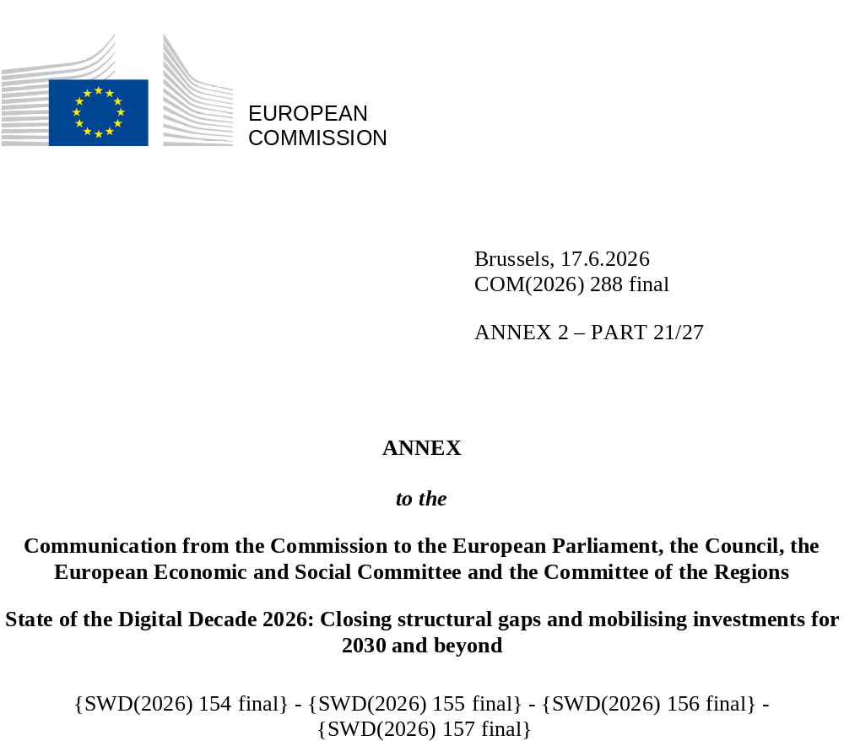

DIGITAL DECADE
SHORT COUNTRY REPORT
2026

Poland

Executive summary
Overall, Poland is making promising progress in digitalisation, particularly in continuously improving the availability of digital public services. However, it continues to lag behind in terms of business digitalisation and uptake of key technologies, especially among SMEs, in terms of the basic digital skills of the wider population and in terms of its pool of ICT specialists. While fibre coverage is above the EU average, progress appears to have slowed in recent years. The draft State Digitalisation Strategy until 2035 (Strategia Cyfryzacji Państwa do 2035), expected to be adopted in June 2026, offers a promising and comprehensive direction for Poland’s digital transformation. However, its impact will depend on the timely, well-coordinated identification and implementation of concrete measures. In this context, work is currently underway on an operational plan setting out the actions to be taken across the administration to implement the strategy.
The slow pace of digitalisation among SMEs is undermining Poland’s competitiveness, considering that SMEs account for the vast majority of firms in Poland and play a key role in value creation. Furthermore, businesses with low digital intensity are less able to realise productivity gains from both basic and advanced digital tools and to expand into new business opportunities. Moreover, limited digital literacy constrains citizens’ effective use of technology and weakens labour productivity growth, while a limited pool of ICT specialists reduces the capacity to fully leverage technological leadership assets.
In terms of digital leadership, Poland has been proactive in building quantum computing capabilities, notably through the launch of the PIAST-Q quantum computer under the EuroHPC Joint Undertaking in June 2025. It is also increasing AI capacity, with two AI Factories under development, the first of which is expected to begin offering services in 2026, while actively contributing to the European AI Gigafactory project. Poland has also developed niche expertise in certain areas of microelectronics and ranks as a highly attractive location for establishing back-end production. However, it has not yet been able to attract major investments which would enable it to develop its manufacturing capacity.

Poland in the Digital Decade
Poland shows a moderate level of ambition in its contribution to the Digital Decade having set 14 national targets (out of 14 possible), 71% of which aligned with the EU 2030 targets. In its national roadmap, Poland provided 13 trajectory points for 2025 (out of 13 analysed). The country is following them not well with only 31% considered on track. On the other hand, Poland addressed 70% of the 10 recommendations issued by the Commission in 2025 by making some changes through new measures. According to the national roadmap, by the end of 2026, 40% of the measures will come to an end. The total public budget associated to these measures is EUR 3.69 billion, representing 30% of the total public budget outlined in the roadmap.
According to the special Eurobarometer on the Digital Decade 2026, 78% of the Polish people consider that digital policy should have a very high/high priority for the EU in shaping our future in Europe. They also think that, in the next ten years, the EU should cooperate with Member States to reinforce cybersecurity and protection from online threats (87%), promote digital education and skills programs (87%) and strengthen the regulation of online platforms (e.g. online social networks, marketplaces, app stores, etc.) (85%).
In addition, 80% of Polish respondents think that the EU should reduce its dependencies on digital from third countries, and 84% that EU should prioritise investments in digital infrastructure and services that are developed and controlled in Europe. Meanwhile, 64% would be willing to switch to an EU-based digital service provider even if it means slightly higher costs.

Funding for digital and Multi-Country Projects
Poland allocates 21.3% of its total recovery and resilience plan to digital (EUR 7.3 billion). In addition, under cohesion policy, EUR 5.8 billion, representing 8% of the country’s total cohesion policy funding, is dedicated to advancing Poland’s digital transformation.
Poland is a member of the Alliance for Language Technologies EDIC, of the EUROPEUM EDIC and of the IMPACTS EDIC. Poland is directly participating in the IPCEI on Microelectronics and Communication Technologies (IPCEI-ME/CT) and in the IPCEI on Next Generation Cloud Infrastructure and Services (IPCEI-CIS). Poland is also a participating state of the EuroHPC Joint Undertaking (JU) and of the Chips JU.
Digital Decade KPI ⁽¹⁾ | Poland |  |  |  |  | EU |  |  | Digital Decade target by 2030
Digital Decade KPI ⁽¹⁾ | Last available data (2) | DESI 2026 (year 2025) | Annual progress | National trajectory 2025 (3) | DESI 2026 |  | Annual progress | PL |  | EU
Fixed Very High Capacity Network (VHCN) coverage | 83.8% | 84.1% | 0.3% | 90.0% | 85.5% |  | 3.7% | 100.0% |  | 100%
Fibre to the Premises (FTTP) coverage | 77.8% | 78.6% | 1.1% | 90.0% | 74.1% |  | 7.1% | 100.0% |  | -
Basic 5G coverage | 89.3% | 94.0% | 5.3% | 99.6% | 96.8% |  | 2.6% | 100.0% |  | 100%
Edge Nodes (estimate, new methodology) | - | 574 | - | 21 | 7451 |  | - | 370 |  | 10000
SMEs with at least a basic level of digital intensity * | 50.0% | 59.0% | 8.6% | 71.9% | 71.4% |  | 11.0% | 90.0% |  | 90%
Cloud * | 46.5% | 45.8% | -0.8% | 58.6% | 46.7% |  | 9.5% | 75.0% |  | 75%
Artificial Intelligence | 5.9% | 8.4% | 41.7% | 5.0% | 20.0% |  | 48.0% | 10.0% |  | 75%
Data analytics * | 19.3% | 24.5% | 12.6% | 23.3% | 39.9% |  | 9.5% | 35.0% |  | 75%
AI or Cloud or Data analytics * | 51.8% | 52.7% | 0.9% | - | 63.2% |  | 7.5% | - |  | 75%
Unicorns | 12 | 13 | 8.3% | 14 | 324 |  | 10.2% | 20 |  | 500
At least basic digital skills * | 44.3% | 50.4% | 6.7% | 54.5% | 60.4% |  | 4.3% | 80.0% |  | 80%
ICT specialists | 4.5% | 4.5% | 0.0% | 4.9% | 5.0% |  | 2.0% | 6.0% |  | ~10%
e-ID scheme notification |  | Yes
Digital public services for citizens | 70.7 | 83.9 | 18.7% | 88.5 | 84.6 |  | 2.8% | 100.0 |  | 100
Digital public services for businesses | 85.0 | 88.8 | 4.4% | 91.9 | 88.6 |  | 2.7% | 100.0 |  | 100
Access to electronic health records | 91.8 | 91.8 | 0.0% | 90.0 | 86.5 |  | 4.6% | 100.0 |  | 100
(1) Indicators full description, metadata and sources in the DESI 2026 methodological note
(2) Last available data is DESI2025 (reference year 2024) except for indicators marked with a star * for which it is DESI2024 (reference year 2023)
(3) National trajectory value for 2025, if set by the country in its Digital Decade national roadmap

A competitive, sovereign and resilient EU based on technological leadership
Poland’s digital connectivity performance shows a mixed picture, with its FTTP coverage above the EU average and its VHCN and 5G coverage below the EU average, particularly in the key 3.4–3.8 GHz band. To allow for further progress in broadband coverage, overcoming urban-rural and regional disparities will be crucial, as significant gaps persist in VHCN and FTTP rural coverage particularly in northern Poland, driven by the challenging terrain, low population density and dispersed housing. Moreover, by further reinforcing its backbone infrastructures, including internal country links, Poland could strengthen its role as a secure regional data hub, also in view of connectivity with neighbouring regions.
On the business side, SMEs are still lagging behind in basic digitalisation, with key bottlenecks being difficulties in accessing funding opportunities, and limited skills, awareness and internal capacity leading to piecemeal implementation of digital solutions. Uptake of advanced technologies by businesses, especially SMEs, is also subpar, with adoption rates for data analytics and AI the lowest and second lowest in the EU respectively. Recent reports suggest the primary constraint for AI adoption is not necessarily a lack of awareness, but rather the transition to deployment, with doubts about the reliability of AI outputs, concerns over data security and high implementation costs cited as the main barriers. Meanwhile, limited access to finance, including venture capital funds, continues to restrict the growth of Polish start-ups, although Poland has taken measures to address this and plans to adopt a comprehensive strategy to develop its startup ecosystem.
In the area of cybersecurity, Poland is strengthening its cybersecurity governance framework, notably through an amendment to the Act on the National Cybersecurity System as part of reforms under the Polish recovery and resilience plan (RRP). It is also implementing measures to improve cybersecurity in public administration and businesses. However, Poland’s geopolitical situation and its heightened exposure to hostile activity, including an attempt to infiltrate the country’s energy system in December 2025, as well as a growing number of cyber-related incidents being reported by Polish businesses, underscore the need to sustain efforts to reinforce resilience.

Protecting and empowering EU people and society
Despite improvement, the level of basic digital skills remains below the EU average and significant urban-rural and age-related disparities persist, with several large-scale measures (e.g. Digital Development Clubs) so far in the early stages of implementation. Amid recent targeted Foreign Information Manipulation and Interference (FIMI) linked to security incidents, Poland’s below-average performance in terms of verifying online information and its still fragmented coordination of counter-disinformation activities point to a need to strengthen efforts to foster online safety and critical-thinking skills.
The size of Poland’s pool of ICT specialists remains below the EU average and largely unchanged since 2024, potentially hindering Poland’s increased ambition to leverage its digital leadership assets in areas such as AI, quantum technologies and semiconductors. The share of women working as ICT specialists has been declining since 2023, with initiatives designed to address this showing limited results so far.
Poland has launched a number of initiatives to digitalise public services and administration, placing emphasis on digital sovereignty by developing state-owned cloud and open-source Polish LLMs, one of which is already in use for its public service app mObywatel. Poland performs at around EU average level in terms of availability of digital public services for businesses, but below the EU average in terms of availability for citizens. Nevertheless, the gap has narrowed as significant progress has been made since 2024, to a great extent thanks to investments under the Polish RRP. However, there is still room for improvement in the cross-border availability of digital public services for both citizens and businesses. Notably, the amendment to the Act on the Computerisation of the Operations of Entities Performing Public Tasks, adopted in 2025 as part of the Polish RRP reforms package, lays the groundwork for the development of solutions in the area of national and European interoperability.

Recommendations
- Digital skills: Foster digital skills and strengthen measures supporting social groups with lower digital skills, such as older adults and inhabitants of rural areas, including through raising awareness of existing and planned measures, and building on the ongoing revision of the Digital Competence Development Programme. Improve coordination and strengthen measures aimed at raising awareness of Foreign Information Manipulation and Interference (FIMI) and fostering critical thinking skills.
- Digitalisation of SMEs and uptake of advanced technologies: Strengthen the digitalisation of SMEs and accelerate the uptake of advanced technologies, such as AI, in particular by: (i) directing existing and future support towards businesses with lower levels of digital maturity, especially micro-enterprises, including through tailored advisory services, and assistance in accessing funding opportunities; (ii) supporting the deployment and effective use of AI infrastructures for businesses such as AI Factories, AI Testing and Experimentation Facilities, and European Digital Innovation Hubs; (ii) translating the revised national AI policy into concrete measures for key sectors, including via sectoral flagship initiatives of the Apply AI Strategy.
- ICT specialists: Increase the ambition of measures to expand the supply of ICT specialists, especially in key frontier technologies, in particular by: (i) strengthening the national offer of training pathways for ICT specialists and increasing participation in STEM fields in higher education; (ii) introducing incentives to attract and retain ICT specialists; (iii) taking action to reverse the decline in the share of women among ICT specialists by scaling up targeted training and mentoring schemes.
- Connectivity: Strengthen connectivity infrastructure, in particular by: (i) accelerating the rollout of gigabit coverage and strengthening focus on reducing rural-urban and regional disparities, e.g. through strengthening the role of the local authorities on the telecommunications market, (ii) building on the achievements of the National Broadband Plan (2020-2025) by swiftly adopting a post-2025 roadmap, (iii) accelerating 5G rollout in the 3.4–3.8 GHz band and promoting the deployment of 5G SA networks, while enabling advanced use cases, and taking advantage of the upcoming expiry of rights of use to negotiate pro-investment conditions, (iv) reinforcing backbone infrastructure resilience to effectively play a role as a secure regional data hub, including diversifying submarine cable routes and enhancing high-capacity terrestrial links.
- Cybersecurity: Support the public and private sector, and in particular SMEs in implementing cybersecurity measures, in particular by increasing cybersecurity awareness and the cybersecurity talent pool in order to enhance resilience and preparedness for cybersecurity incidents.
- Digitalisation of public services: Build on recent legal achievements to strengthen digital public services and improve efficiency, in particular by strengthening interoperability and practical application of the once-only principle across different levels of government, as well as by improving cross-border usability.
- Semiconductors: Invest in the development of semiconductor back-end technologies, notably heterogeneous integration and advanced packaging and support the development and retention of specialised semiconductor skills, particularly in the fields of engineering, design, research and advanced semiconductor technologies.

