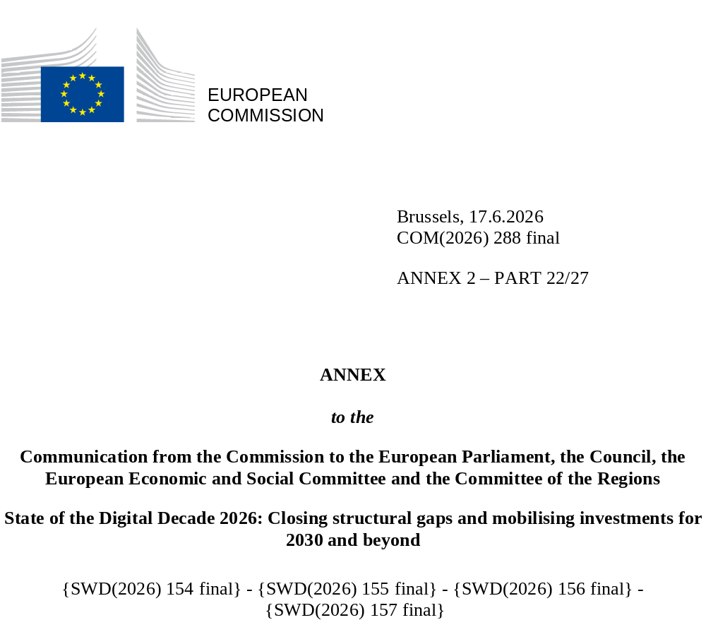

DIGITAL DECADE
SHORT COUNTRY REPORT
2026

Portugal

Executive summary
Portugal has strong assets in digitalisation, such as good connectivity infrastructure across the country and an outstanding position in digital public services for citizens and business. However, the country faces a series of challenges in achieving the successful digitalisation of businesses in advanced technologies, as it lags behind its European peers in the uptake of cloud computing and AI by enterprises. Meanwhile, Portugal has improved in overall basic digital skills more slowly than the EU average, even though the country continues to improve its share of ICT specialists.
Portugal is showing steady progress in its digital innovation and scale-up ecosystem, while also putting in place initiatives to increase its technological sovereignty. However, the efforts of the Portuguese authorities in this area may be hampered by the slow uptake of cloud technology and AI by its enterprises. This slow uptake could undermine the country’s digital competitiveness, as low digitalised enterprises cannot take advantage of the potential productivity gains brought by digital tools that allow them to access new online markets.
Portugal recently presented its 2026-2027 National Digital Strategy Action Plan as a short-term implementation instrument of the National Digital Strategy adopted in December 2024. It turned the country’s objectives into concrete measures focused on: (i) data governance and extracting value from data; (ii) digital public services; (iii) artificial intelligence (AI); (iv) cybersecurity; and (v) the strengthening of digital infrastructure. The plan prioritises a more focused set of actions compared with the plan for the previous cycle and now features greater emphasis on execution, measurable outcomes, and regulatory alignment with European frameworks. The most recent action plan also strengthens the development of sovereign digital capabilities (including cloud infrastructure, data centres, and trusted data ecosystems) and aims to enhance Portugal’s competitiveness, resilience, and technological sovereignty.

Portugal in the Digital Decade
Portugal shows a high level of ambition in its contribution to the Digital Decade having set 12 national targets (out of 14 possible), 92% of which are aligned with the EU’s 2030 targets. In its national roadmap, Portugal provided 8 trajectory points for 2025 (out of 13 analysed). The country is currently following these trajectory points very well, with 100% considered on track. Portugal addressed 89% of the 9 recommendations issued by the Commission in 2025, either by implementing significant policy changes (in 22% of cases) or making some changes (in 67% of cases) through new measures. According to the national roadmap, by the end of 2026, 62% of the measures will come to an end. The total public budget associated to these measures is EUR 1.6 billion, representing 75% of the total public budget outlined in the roadmap.
According to the special Eurobarometer on ‘the Digital Decade’ 2026, 72% of Portuguese people consider that digital policy should have a high or very high priority for the EU in shaping our future in Europe. They also think that, in the next 10 years, the EU should cooperate with Member States to reinforce security and protection from online threats (89%), promote digital education and skills programmes (86%) and strengthen the regulation of online platforms (85%). In addition, 81% of Portuguese respondents think that the EU should reduce its dependencies on digital technologies from non-EU countries, and 83% agreed that the EU should prioritise investments in digital infrastructure and services that are developed and controlled in Europe. Meanwhile, 53% of respondents said that they would be willing to switch to an EU-based digital service provider even if it means slightly higher costs.

Funding for digital and multi-country projects
Portugal allocates 21.5% of spending in its total recovery and resilience plan (RRP) to digital (EUR 4.7 billion). In addition, under cohesion policy, EUR 2.3 billion, representing 10% of the country’s total cohesion policy funding, is dedicated to advancing Portugal’s digital transformation.
Portugal is a member of both the Local Digital Twins towards the CitiVERSE EDIC and the EUROPEUM EDIC. Portuguese entities are indirect and/or associated partners in the important project of common European interest (IPCEI) on Microelectronics and Communication Technologies (IPCEI-ME/CT). Portugal is also a participating state in both the EuroHPC Joint Undertaking (JU) and the Chips JU.

Digital Decade KPI ⁽¹⁾ | Portugal |  |  |  |  | EU |  |  | Digital Decade target by 2030
Digital Decade KPI ⁽¹⁾ | Last available data (2) | DESI 2026 (year 2025) | Annual progress | National trajectory 2025 (3) | DESI 2026 |  | Annual progress | PT |  | EU
Fixed Very High Capacity Network coverage | 94.6% | 97.1% | 2.6% | 96.0% | 85.5% |  | 3.7% | 100.0% |  | 100%
Fibre to the Premises (FTTP) coverage | 93.2% | 95.5% | 2.5% | 95.0% | 74.1% |  | 7.1% | 100.0% |  | -
Basic 5G coverage | 98.7% | 99.1% | 0.4% | 98.3% | 96.8% |  | 2.6% | 100.0% |  | 100%
Edge Nodes (estimate, new methodology) | - | 150 | - | - | 7451 |  | - | - |  | 10000
SMEs with at least a basic level of digital intensity * | 53.6% | 63.9% | 9.2% | - | 71.4% |  | 11.0% | 90.0% |  | 90%
Cloud * | 32.3% | 34.1% | 2.8% | - | 46.7% |  | 9.5% | 75.0% |  | 75%
Artificial Intelligence | 8.6% | 11.5% | 33.7% | - | 20.0% |  | 48.0% | 75.0% |  | 75%
Data analytics * | 38.6% | 45.0% | 8.0% | - | 39.9% |  | 9.5% | - |  | 75%
AI or Cloud or Data analytics * | 54.4% | 58.5% | 3.7% | - | 63.2% |  | 7.5% | - |  | 75%
Unicorns | 1 | 2 | 100.0% | - | 324 |  | 10.2% | 2 |  | 500
At least basic digital skills * | 56.0% | 59.2% | 2.8% | 62.0% | 60.4% |  | 4.3% | 80.0% |  | 80%
ICT specialists | 5.2% | 5.4% | 3.8% | 5.0% | 5.0% |  | 2.0% | 7.0% |  | ~10%
e-ID scheme notification |  | Yes
Digital public services for citizens | 84.5 | 86.4 | 2.3% | 88.0 | 84.6 |  | 2.8% | 100.0 |  | 100
Digital public services for businesses | 84.3 | 90.0 | 6.8% | 87.0 | 88.6 |  | 2.7% | 100.0 |  | 100
Access to electronic health records | 88.1 | 92.2 | 4.7% | 88.1 | 86.5 |  | 4.6% | 100.0 |  | 100
(1) Indicators full description, metadata and sources in the DESI 2026 methodological note
(2) Last available data is DESI2025 (reference year 2024) except for indicators marked with a star * for which it is DESI2024 (reference year 2023)
(3) National trajectory value for 2025, if set by the country in its Digital Decade national roadmap

A competitive, sovereign and resilient EU based on technological leadership
Portugal is performing very well in connectivity, and has very high levels of broadband coverage, particularly in very high capacity networks (VHCN), fibre to the premises (FTTP), and overall 5G, with it scoring consistently better than the EU averages in these areas. In order to enhance digital innovation, competitiveness, and technological sovereignty, the 2026-2027 National Digital Strategy Action Plan strengthens Portugal’s position by advancing plans for: (i) a Sovereign Cloud Strategy to ensure secure control and processing of critical data under national and EU jurisdiction; (ii) a National Data Centre Strategy aimed at strengthening resilient, energy-efficient infrastructure capable of supporting both sovereign and commercial cloud and advanced computing services; and (iii) a National Data Policy that sets out a framework for trusted data sharing, data reuse, and extracting data from value that is aligned with the EU.
Portugal has shown progress in the digitalisation of businesses since last year, particularly in the adoption of data analytics, where it surpasses the EU average. However, in other areas (such as cloud technologies, AI, and overall digital intensity) Portugal’s enterprises lags behind the EU averages. Portugal’s growth rates in most areas of digitalisation are also lower than the EU averages, indicating that although Portugal is making progress, it is not keeping pace with broader EU trends.

Protecting and empowering EU people and society
Portugal’s digital skills profile reveals a mixed performance. While the country has strengths in digital skills among young adults and in the adoption of generative AI, it lags behind the EU average in overall rates of growth in digital skills (and in particular among women, people with low levels of education, and older adults). The country’s government has approved the Digital Skills Pact Action Plan 2026-2030, which has a budget of EUR 80 million. The plan encompasses training across basic, intermediate, advanced, and emerging digital skills and aims to be a key instrument for promoting inclusion, building skills and strengthening national competitiveness.
In the area of digital public services, Portugal makes a strong contribution to the EU’s Digital Decade targets. The country performs particularly well in digital public services for citizens and business despite differences between regions. Portugal also shows a good performance in e-Government values and access to e-Health records.

Recommendations
- Connectivity/5G: Accelerate 5G rollout of the 3.4–3.8 GHz band in rural areas and promote the deployment of 5G SA networks while enabling advanced use cases. In addition, Portugal should continue to invest in the security and resilience of its submarine cable ecosystem.
- Artificial Intelligence: Continue supporting AI take-up and thus enable innovation by enterprises, including by timely implementation of ongoing and planned measures, in particular, when revising the national AI strategy including through a stronger sectoral focus on key verticals.
- Cloud: Encourage cloud take-up, in particular implement the plans for sovereign cloud infrastructure.
- Unicorns: Accelerate efforts to improve scale-up capacity with access to financing and removing barriers to expansion.
- Basic digital skills: Continue to evaluate the take-up of the current measures and identify ways to address the remaining needs, notably to tackle the digital divide in the society.
- Cybersecurity: Continue efforts to enhance the cyberliteracy and awareness, and to consolidate the implementation of cybersecurity measures, ensuring robust supervision, mandatory risk management and incident reporting across all essential and important entities, including supply‑chain security and assessments of high‑risk ICT suppliers in line with EU standards. In addition, Portugal should update its national strategy, leveraging resilience, innovation and resource allocation, aligned with common European objectives.
- Basic digital intensity of SMEs and advanced technologies: Continue fostering the adoption of advanced digital technologies by businesses identifying support measures for the medium-term.
- eHealth: To advance the adoption and integration of AI in healthcare, Portugal should (i) define up-to-date investment roadmaps for priority use cases aligned with its national strategy, and (ii) support healthcare organisations to participate in the Network of AI-Powered Advanced Medical Centres, by establishing co-funding schemes for piloting and deploying AI solutions in clinical environments.

