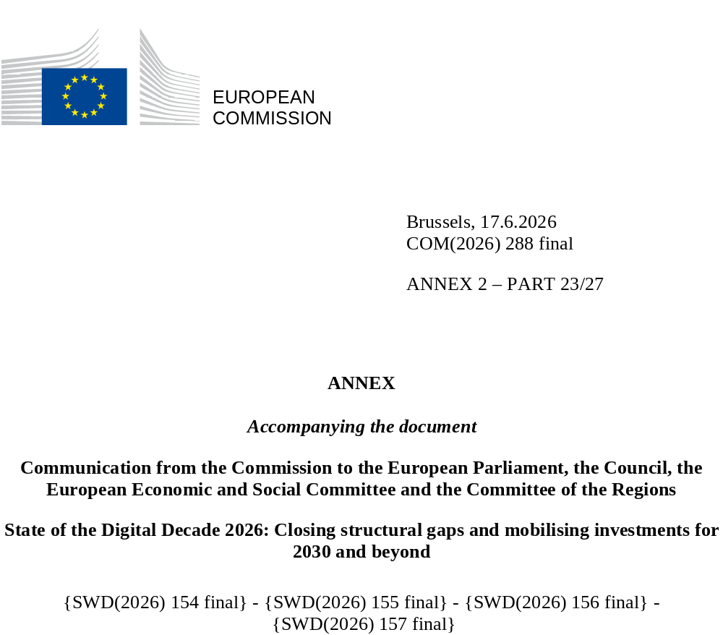

DIGITAL DECADE
SHORT COUNTRY REPORT
2026

Executive summary
Romania continues to be an EU leader in connectivity, has strengthened its position in semiconductors and is signalling its ambition to become an AI regional leader. However, limited access to finance, particularly venture capital, low research and development (R&D) spending, and a sluggish digital startups ecosystem limit its competitiveness. While digital public services have clearly progressed, the focus must now shift to delivering value-for-investment for citizens and businesses by meeting their needs for streamlined administrative procedures and continuously improved services. Despite progress, particularly for civil servants, challenges remain in tackling low-level digital skills.
The structural gaps in digital skills and the limited availability of digital public services create a competitiveness ceiling for Romania. The efforts in connectivity, AI and semiconductors may be undermined by a startup sector that struggles to grow in the absence of widespread access to finance and insufficient stimulation of home-grown innovation. To go from being a regional tech outpost to a true digital leader, Romania must bridge the gap between its infrastructure strengths and its ecosystem weaknesses. To do this, Romania requires a comprehensive digitalisation strategy, backed by strong political will, sustainable post-Recovery and Resilience Facility (RRF) funding, a coherent regulatory framework, strong ICT expertise and a well-defined governance structure.
RRF funding has been used to kickstart key high-growth sectors that could help Romania become a digital leader, such as semiconductors and AI. By modernising universities and creating industrial ecosystems linked to the country’s industrial strengths, in particular the auto industry, Romania can capitalize on key growth opportunities. The upcoming AI factory and planned Black Sea AI gigafactory could further strengthen Romania’s and the EU’s digital sovereignty.
With RRF funding winding down, Romania must define its priorities moving forward and make full use of all funding opportunities in the next Multiannual Financial Framework (MFF), in particular the national and regional partnership plans (NRPPs) and the Digital Leadership instrument.

Romania in the Digital Decade
Romania shows a low level of ambition in its contribution to the Digital Decade, having set 11 national targets (out of 14 possible), 36% of which are in line with the EU 2030 targets. In its national roadmap, Romania provided 1 trajectory point for 2025 (out of 13 analysed). The country is following it very well as it is considered on track. Romania addressed 50% of the 8 recommendations issued by the Commission in 2025 by making some changes through new measures. According to the national roadmap, by the end of 2026, 38% of the measures will come to an end. The total public budget for these measures is EUR 2.31 billion, representing 64% of the total public budget outlined in the roadmap.
Romania did not submit an update of its national Digital Decade roadmap in 2025 but is planning to do so in 2026 to take stock of performance so far and adapt its projections and targets based on national priorities.
According to the 2026 Digital Decade Eurobarometer, 59% of Romanian people think that digital policy should be a high/very high priority for the EU in shaping the future. They also think that in the next 10 years the EU should cooperate with Member States to strengthen cybersecurity and protection from online threats (74%), promote digital education and skills programmes (71%) and strengthen the regulation of online platforms (71%). In addition, 64% of Romanian respondents think that the EU should reduce its dependencies on digital from non-EU countries, and 69% agree that it should prioritise investments in digital infrastructure and services developed and controlled in Europe. Meanwhile, 49% would be willing to switch to an EU-based digital service provider even if it means slightly higher costs.

Funding for digital and multi-country projects
Romania allocates 21% of its total recovery and resilience plan to digital (EUR 4.5 billion). Under cohesion policy, EUR 3.2 billion, representing 10% of the country’s total cohesion policy funding, is also dedicated to advancing Romania’s digital transformation.
Romania is a member of the EUROPEUM EDIC. Romania is directly participating in the IPCEI on Microelectronics and Communication Technologies (IPCEI-ME/CT). Romania is also a participating state in the EuroHPC Joint Undertaking (JU) and of the Chips JU.
Digital Decade KPI ⁽¹⁾ | Romania |  |  |  | EU |  | Digital Decade target by 2030
Digital Decade KPI ⁽¹⁾ | Latest available data (2) | DESI 2026 (year 2025) | Annual progress | National trajectory 2025 (3) | DESI 2026 | Annual progress | RO | EU
Fixed very high-capacity network (VHCN) coverage | 95.9% | 96.5% | 0.6% | - | 85.5% | 3.7% | 99.0% | 100%
Fibre to the premises (FTTP) coverage | 95.7% | 96.3% | 0.5% | - | 74.1% | 7.1% | 99.0% | -
Basic 5G coverage | 46.8% | 59.3% | 26.8% | 38.0% | 96.8% | 2.6% | 62.0% | 100%
Edge nodes (estimate, new methodology) | - | 252 |  | - | 7 451 |  | - | 10 000
SMEs with at least a basic level of digital intensity | 26.8% | 44.3% | 28.7% | - | 71.4% | 11.0% | 75.0% | 90%
Cloud* | 15.5% | 22.1% | 19.4% | - | 46.7% | 9.5% | 40.0% | 75%
Artificial Intelligence | 3.1% | 5.2% | 69.7% | - | 20.0% | 48.0% | 10.0% | 75%
Data analytics* | 21.9% | 35.1% | 26.6% | - | 39.9% | 9.5% | 15.0% | 75%
AI or Cloud or Data analytics* | 28.7% | 43.6% | 23.1% | - | 63.2% | 7.5% | - | 75%
Unicorns | 0 | 0 |  | - | 324 | 10.2% | - | 500
At least basic digital skills* | 27.7% | 31.8% | 7.2% | - | 60.4% | 4.3% | 50.0% | 80%
ICT specialists | 2.8% | 2.7 | -3.6% | - | 5.0% | 2.0% | 4.0% | ~10%
e ID scheme notification |  | Yes |  |  |  |  | -
Digital public services for citizens | 62.7 | 64.2 | 2.4% | - | 84.6 | 2.8% | 100.0 | 100
Digital public services for businesses | 55.1 | 66.8 | 21.2% | - | 88.6 | 2.7% | 100.0 | 100
Access to e-Health records | 75.1 | 75.1 | 0.0% | - | 86.5 | 4.6% | - | 100
⁽¹⁾ Indicators full description, metadata and sources in the DESI 2026 methodological note
⁽²⁾ Last available data is DESI 2025 (ref year 2024) except for indicators marked with a star for which it is DESI 2024 (ref year 2023)
⁽³⁾ National trajectory value for 2025, if set by the country in its Digital Decade national roadmap

A competitive, sovereign and resilient EU based on technological leadership
Romania remains an EU leader in terms of connectivity, ranking first in the EU for fibre to the premises (FTTP) coverage for both businesses and consumers. Despite very strong year-on-year growth in 5G connectivity, Romania continues to rank last in the EU. More could be done to showcase how 5G connectivity could support manufacturing businesses and B2B interactions.
Romania has continued to strengthen its position in critical technologies. It is participating in the IPCEI on microelectronics and communication technologies. Additionally, Romania will host an AI factory and has submitted a bid to host an AI gigafactory.
Romania does not have an ICT or digital unicorn. Its startup ecosystem struggles with access to finance and the availability of risk capital. The country has a high ICT potential, which could benefit from further removal of legislative and administrative obstacles that affect rapid business development and innovation.

Protecting and empowering EU people and society
Romania has invested considerable resources in digitalising public services, so far focusing mostly on securing the necessary hardware and data centres needed for the governmental cloud. Good progress has been made on eID, digital signatures and improving overall digital interactions with the state. Next Romania must show what this high level of investment was for, by providing clear, easy-to-use digital services for companies and people. Digitalisation of the health sector remains problematic. New initiatives to digitise the activity of the Health Ministry and launch an upgraded health insurance platform are promising. These are much needed developments, as the sector lags significantly behind.
Despite progress, Romania continues to rank last in the EU for basic digital skills. Measures have been put in place to increase the advanced digital skills of public sector employees. However, support for people already employed by the private sector, remains limited. Romania has a high number of ICT graduates but continues to struggle with talent retention. The public sector struggles in engaging with the high level of ICT talent in the country. More could be done to encourage flexible cooperation between public and private sectors, including for upskilling and lifelong learning.

Recommendations
Digital public services: establish a unified multicloud ecosystem by interconnecting the Governmental cloud and sectorial cloud infrastructures. To fully implement the 'once-only' principle, the National Platform for Interoperability must be operationalized to facilitate seamless data exchange across state applications. Leverage ROePAS as the primary access point under the Single Digital Gateway Regulation. Launch the Governmental cloud marketplace in order to leverage agile private solutions to address public service needs. It should build the national EU Digital Identity wallet solution and should expand the use of advanced electronic signatures for citizens and especially SMEs for non-fiscal administrative procedures. These foundational infrastructures should be leveraged to further digitalise key sectoral domains, including tax administration, business licensing, and the judiciary.
E-health: adopt the national strategy for digital health and transform it in legally binding measures. Operationalise and adequately fund the modernised national health insurance platform (PIAS), develop a mobile application to access e-health records and establish incentives to increase the use of digital solutions in healthcare, ensuring equitable access across different socio-economic backgrounds. Make additional types of data available and improve authentication methods using a compliant eID solution. Support participation in the Network of AI-Powered Advanced Medical Centres, for example, by establishing co-funding schemes for piloting and deploying AI solutions in clinical environments, in line with existing measures in the national AI Strategy.
Skills: Boost basic digital skills as a core component of the education process, both for teachers and students. Do more to train teachers on integrating digital tools in teaching practices and explore ways of rewarding those who do using the teacher evaluation system. Continue the digital upskilling of public sector employees and make adult learning, particularly of employees in the private sector and older people, a policy priority. In this respect, Romania could look into the possibility of directly rewarding employees by means of individual learning accounts, linked to the digital wallet, with training possible only with providers certified under the Romanian Digital Competence Framework (DigCompRo). To retain skilled ICT workers and graduates, ramp up dual pathway university degrees, including by incorporating R&D into European Credit Transfer System (ECTS) credits.
Digitalisation of businesses: further strengthen support to innovative startups and scaleups via Startup Nation and the new Innovation Romania Holding Fund. Actively involve stakeholders in defining the financing priorities and performance-based milestones that will be used to measure performance under the next MFF. Identify ways of rewarding Romanian intellectual property (IP) solutions. Leverage Romanian European Digital Innovation Hubs (EDIH) capabilities to increase the digital maturity of local and regional SMEs. Define clear institutional roles in AI and leverage the upcoming AI factory and the potential AI gigafactory to pivot from outsourcing to home grown players that use AI to provide industrial scale solutions in key economic areas of strength.
Cybersecurity: provide support for all relevant entities, such as specific guidance or dedicated ICT platforms and automation tools, to ensure that cybersecurity rules are applied consistently across all sectors. Focus on helping digital public services and SMEs adopt cybersecurity measures that are effective and balanced.
5G: embed 5G regional and local connectivity targets in the new national and regional partnership plans (NRPPs). Focus on increasing 5G coverage, including in the 3.4-3.8GHz band, and spectrum assignment, subject to market demands and investment envelopes. Uphold commitments to phase out fiscal burdens on telecom operators and make information on local construction works permitting more transparent (by setting up a digital permitting portal for example). Promote the deployment of 5G standalone networks while identifying ways of stimulating demand for 5G.

