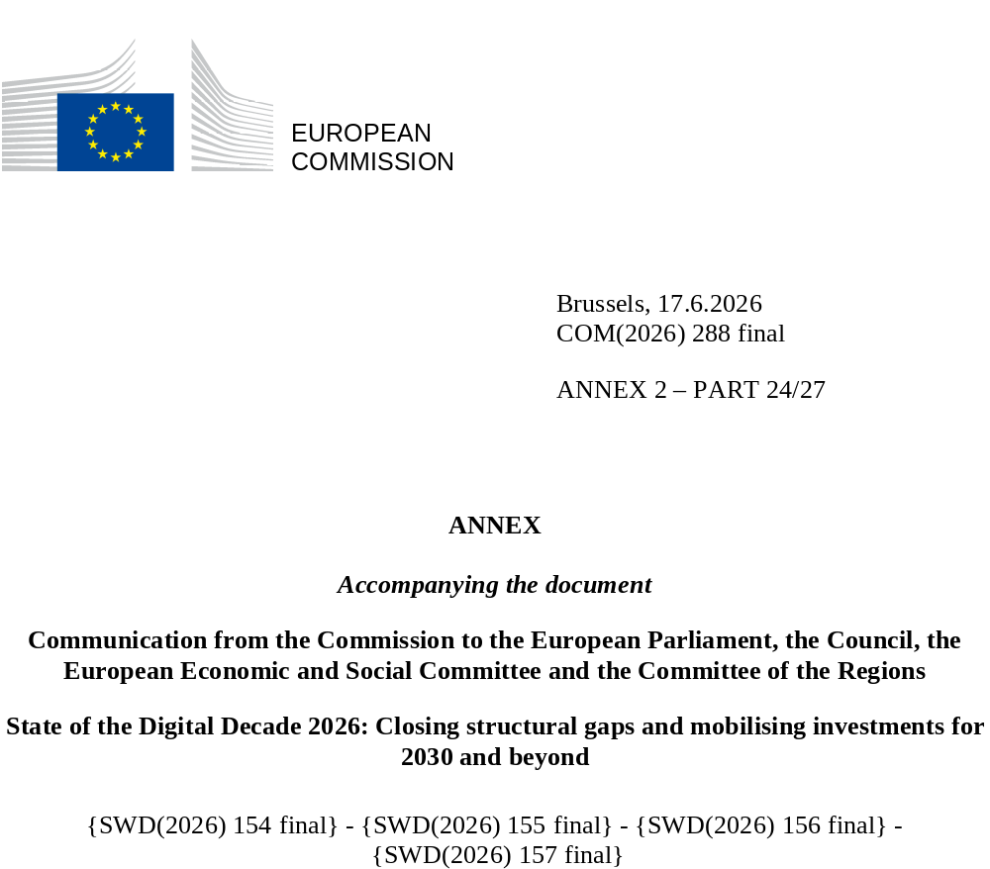

DIGITAL DECADE
SHORT COUNTRY REPORT
2026

Executive summary
Slovakia’s digital transformation is advancing, but structural weaknesses remain. A high share of young people display at least basic digital skills, but the overall proportion of individuals with at least basic digital skills is below the EU average, with particularly low levels among older groups. Small and medium sized enterprises (SMEs) are catching up in basic digitalisation and businesses are gradually increasing their use of advanced technologies, but Slovak businesses still show lower levels of digitalisation compared to their EU peers and face significant ICT specialist shortages. Connectivity infrastructure has been markedly improved, yet rural areas are still underserved by fixed gigabit networks. Overall, while Slovakia has put interlinked strategies in place to support its digital transformation, issues such as funding availability, long-term planning and investments, as well as efficient project implementation and monitoring still represent key challenges.
Existing shortcomings in Slovakia’s digital transition affect the country’s competitiveness. Persistent gaps in digital skills across the population and workforce, together with a shortage of ICT specialists, restrict the pool of workers able to support businesses’ digital transformation and slow down the adoption of tools such as cloud, data analytics and artificial intelligence (AI). Many SMEs still rely on relatively low‑tech processes and lack the managerial and technical capacity for more advanced digital investments, hampering potential gains in productivity and innovation. Digital public services also remain below the EU average, with room for improvement in terms of interoperability and user-friendliness.
Slovakia is still consolidating the strategic capabilities needed to increase its digital leadership. The frontier‑technology landscape – from deployment of advanced digital technologies at scale, to semiconductors, edge nodes, quantum technologies and a strong start‑up/scale‑up base – remains modest. Nevertheless, the ‘Vision for Artificial Intelligence in Slovakia’ and work on a national AI strategy, among other measures, signal growing ambition in AI uptake. In parallel, ongoing efforts supporting the development of a high‑performance computing (HPC) ecosystem represent an important step towards strengthening research and innovation capacity. Importantly, the success of these initiatives will depend on clear, time-bound plans and stable, long-term financing to ensure the economy can reap the benefits associated with such technologies.

Slovakia in the Digital Decade
Slovakia shows a substantial level of ambition in its contribution to the Digital Decade having set 12 national targets (out of 14 possible), 83% of which aligned with the EU 2030 targets. In its national roadmap, Slovakia provided 12 trajectory points for 2025 (out of 13 analysed). The country is following them moderately well with 58% considered on track. Slovakia addressed 56% of the nine recommendations issued by the Commission in 2025 by making some changes through new measures. According to the national roadmap, by the end of 2026, 72% of the measures will come to an end. The total public budget associated to these measures is EUR 1.63 billion, representing 72% of the total public budget outlined in the roadmap.
According to the special Eurobarometer on the Digital Decade 2026, 79% of Slovak people consider that digital policy should have a high or very high priority in shaping our future in Europe. They also think that, in the next 10 years, the EU should cooperate with Member States to reinforce cybersecurity and protection from online threats (93%), promote digital education and skills programmes (92%) and strengthen the regulation of online platforms (84%).
In addition, 79% of Slovak respondents think that the EU should reduce its dependencies on digital from non-EU countries, and 86% that EU should prioritise investments in digital infrastructure and services that are developed and controlled in Europe. Meanwhile, 54% would be willing to switch to an EU-based digital service provider even if it means slightly higher costs.
Funding for digital and multi-country projects
Slovakia allocates 21% of its total recovery and resilience plan to digital (EUR 1.2 billion). In addition, under cohesion policy, EUR 0.7 billion, representing 6% of the country’s total cohesion policy funding, is dedicated to advancing Slovakia’s digital transformation.
Slovakia is a member of the Local Digital Twins towards the CitiVERSE European Digital Infrastructure Consortium (EDIC). Slovakia directly participates in the Important Project of Common European Interest (IPCEI) on Microelectronics and Communication Technologies (IPCEI-ME/CT) and in the Tech4Cure IPCEI. Slovakia is also a participating state of the EuroHPC Joint Undertaking (JU) and of the Chips JU.
Digital Decade KPI ⁽¹⁾ | Slovakia |  |  |  |  | EU |  |  | Digital Decade target by 2030
Digital Decade KPI ⁽¹⁾ | Last available data (2) | DESI 2026 (year 2025) | Annual progress | National trajectory 2025 (3) | DESI 2026 |  | Annual progress | SK |  | EU
Fixed Very High Capacity Network (VHCN) coverage | 73.0% | 83.6% | 14.5% | 64.0% | 85.5% |  | 3.7% | 100.0% |  | 100%
Fibre to the Premises (FTTP) coverage | 67.8% | 76.0% | 12.2% | - | 74.1% |  | 7.1% | - |  | -
Basic 5G coverage | 87.9% | 93.9% | 6.7% | 85.0% | 96.8% |  | 2.6% | 98.5% |  | 100%
Edge Nodes (estimate, new methodology) | - | 107 | - | - | 7451 |  | - | - |  | 10000
SMEs with at least a basic level of digital intensity * | 42.2% | 57.1% | 16.3% | 65.0% | 71.4% |  | 11.0% | 90.0% |  | 90%
Cloud * | 30.2% | 32.9% | 4.5% | 39.0% | 46.7% |  | 9.5% | 75.0% |  | 75%
Artificial Intelligence | 10.8% | 18.0% | 67.0% | 18.0% | 20.0% |  | 48.0% | 75.0% |  | 75%
Data analytics * | 30.2% | 38.8% | 13.3% | 18.0% | 39.9% |  | 9.5% | 75.0% |  | 75%
AI or Cloud or Data analytics * | 45.8% | 55.1% | 9.8% | - | 63.2% |  | 7.5% | - |  | 75%
Unicorns | 0 | 0 |  | 1 | 324 |  | 10.2% | 3 |  | 500
At least basic digital skills * | 51.3% | 53.6% | 2.2% | 57.0% | 60.4% |  | 4.3% | 70.0% |  | 80%
ICT specialists | 4.6% | 4.4% | -4.3% | 4.0% | 5.0% |  | 2.0% | 6.0% |  | ~10%
e-ID scheme notification |  | Yes
Digital public services for citizens | 72.6 | 76.3 | 5.1% | 76.0 | 84.6 |  | 2.8% | 100.0 |  | 100
Digital public services for businesses | 73.4 | 73.9 | 0.6% | 87.0 | 88.6 |  | 2.7% | 100.0 |  | 100
Access to electronic health records | 72.0 | 72.0 | 0.0% | 55.0 | 86.5 |  | 4.6% | 100.0 |  | 100
(1) Indicators full description, metadata and sources in the DESI 2026 methodological note
(2) Last available data is DESI2025 (reference year 2024) except for indicators marked with a star * for which it is DESI2024 (reference year 2023)
(3) National trajectory value for 2025, if set by the country in its Digital Decade national roadmap

A competitive, sovereign and resilient EU based on technological leadership
Slovakia has made significant progress in deploying digital infrastructure. Very high capacity networks (VHCN) and fibre‑to‑the‑premises (FTTP) coverage experienced marked growth, while 5G networks in urban areas achieved near total coverage. However, VHCN and FTTP coverage remains significantly lower in rural areas, where low population density, high per‑premises deployment costs and complex permit procedures continue to slow roll‑out and limit commercial viability.
In the business sector, Slovakia is making efforts to address structural barriers to digitalisation, particularly among SMEs, but despite promising growth, SME basic digitalisation is still lagging behind. Ongoing support measures, such as European Digital Innovation Hubs (EDIHs) and dedicated loans, are well regarded by businesses and encourage medium‑ to long‑term planning, but the overall coverage of such initiatives is modest compared to the needs of the business population. Limited access to funding and understanding of digital technologies, as well as skills shortages within the workforce, represent underlying challenges to the digitalisation of businesses.
The uptake of advanced digital technologies has gradually improved in recent years but remains below broader EU levels. Slovakia is putting in place the policy and institutional framework to support wider adoption, with a particular focus on AI and high‑performance computing (HPC). However, progress in these areas needs to go hand-in-hand with raising the basic level of digitalisation in the business sector, as many businesses are not yet digitally mature enough to integrate advanced technologies effectively. The start‑up and scale‑up ecosystem remains relatively small and marked by structural weaknesses: venture capital activity is limited, access to first customers is difficult, and large companies are often reluctant to work with new businesses.

Protecting and empowering EU people and society
Digital skills of the population and ICT specialist availability remain bottlenecks in the digital transformation of the Slovak economy. Overall digital skills are below the EU average, with particularly low levels among older and disadvantaged population groups, despite a comparatively strong performance among young adults (16-24). A wide range of measures, including an ongoing curriculum reform, are being rolled out, but their full impact will take time to materialise. At the same time, Slovakia faces persistent shortages of ICT professionals across both public and private sectors, negatively affecting the digitalisation of the economy. Such shortages are compounded by limited opportunities and resources for upskilling and reskilling the workforce and limited participation of women in the ICT sector.
The digitalisation of the public sector is progressing but faces implementation challenges. Work on the digitalisation of 16 “priority life situations” continues, aiming to digitalise a set of key public services by 2026. However, further improvements are needed in relation to the user-friendliness, interoperability, transparency and the adoption of a uniform approach for eGovernment services across the public administration. The digitalisation of healthcare has advanced, promising time savings for the public and improved interoperability once fully implemented. However, Slovakia continues to lag behind the EU average in achieving universal public access to electronic health records (EHRs) by 2030.

Recommendations
- Digitalisation of SMEs: Strengthen and scale up the existing support framework for business digital transformation by ensuring the medium- to long-term continuity of key support structures (e.g. EDIHs) and expanding the scale and reach of existing instruments and access to finance. Improve the outreach and visibility of existing instruments, while ensuring that support measures are easy to access and do not impose an excessive administrative burden. Expand support for digital skills, managerial awareness, and digital transformation planning capacity within businesses, including by building on existing initiatives such as the “Digital Skills for a Green Future of Slovakia” project. Promote a gradual digitalisation pathway for SMEs, from basic digital foundations to the uptake of advanced technologies.
- ICT specialists: Scale up flexible, labour-market-oriented upskilling and reskilling opportunities for specialised ICT profiles in both the private and public sectors. Expand and adapt higher education and vocational ICT pathways in line with labour market needs, while strengthening measures to retain ICT graduates in Slovakia. Moreover, continue to address barriers to women’s entry, retention and progression in ICT studies and careers, for instance through targeted outreach, guidance, and support measures.
- Digital skills: Expand opportunities to acquire and regularly update digital skills, with a focus on the workforce and socio-economic groups with lower-than-average levels of digital skills, so as to better support labour market participation and businesses’ digital transformation. Moreover, further strengthen digital education across the school system, including through continued teacher training and support, as well as targeted measures for students from disadvantaged backgrounds and marginalised communities.
- Advanced digital technologies: To maximise the impact of investments in AI and HPC and promote tangible value creation for the economy, adopt a coherent national approach that supports long-term sustainability and scalability. Continue to strengthen the national AI ecosystem by building on existing national infrastructural and energy resources and expertise, and promote the integration of the Slovak AI ecosystem into the wider EU ecosystem (for instance through EDIHs, AI factories, and Technical Experimentation Facilities, as well as through greater use of sector-specific support under the Apply AI strategy).
- Digital public services: To improve user-friendliness and uptake, enhance interoperability, transparency, and consistency across digital public services, while strengthening implementation capacity of digital public service projects across the public administration, notably as regards inter-ministerial/agency coordination, monitoring and evaluation. Increase the availability of digital public services for cross-border citizens and businesses.
- Connectivity: Sustain the rollout of gigabit-capable fixed networks, prioritising the closure of gaps in rural and underserved areas, for instance by targeting public support to digital infrastructure deployment and by ensuring the coordination of funding programmes and regulatory measures at national and regional level to support balanced deployment. Foster demand and uptake, while cooperating with industry stakeholders to address deployment barriers and support timely rollout. Promote the deployment of 5G SA (standalone) networks and enable advanced use cases.
- Semiconductors: Strengthen the semiconductor ecosystem by ensuring that participation in EU semiconductor initiatives, in particular the current IPCEIs on Microelectronics and Communication Technologies (ME-CT) and on Advanced Semiconductor Technologies (AST), receive full and timely support and translate into broader domestic capability-building for relevant companies.

