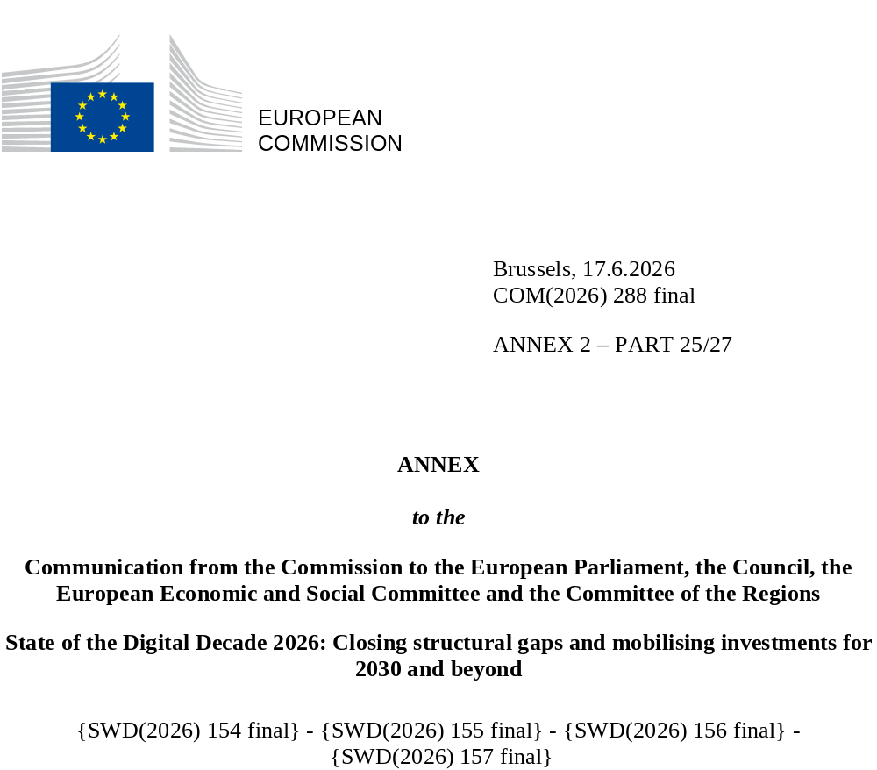

DIGITAL DECADE SHORT
COUNTRY REPORT
2026

Slovenia

Executive summary
Slovenia is very strong in some digital areas, including connectivity progress, active positioning in strategic technologies and relatively good uptake of artificial intelligence among businesses. Fibre coverage is relatively strong and 5G has progressed rapidly. However, Slovenia does not fully reap the benefits of digitalisation throughout the business world, as SMEs still lag behind in basic digitalisation and in the uptake of cloud and data analytics. Basic digital skills also remain persistently weak, the proportion of ICT specialists is below the EU average, and the start-up and scale-up ecosystem remains underdeveloped, with no unicorns.
The weaknesses identified in business digitalisation and skills hinder Slovenia’s competitiveness. Uneven digital uptake among SMEs limits productivity gains in a small, open and industrialised economy, while ICT specialist shortages constrain business transformation and the diffusion of advanced technologies. Unfavourable scale-up conditions, including continued bottlenecks in risk capital, regulatory complexity and talent attraction, further limit the growth of high-value-added firms. Broader digital skills and stronger SME digitalisation would help Slovenia translate its strong performance in certain technologies into broader economic gains.
Slovenia is taking a strong lead in a number of areas of digital technology. It is active in strategic European initiatives on semiconductors, cloud, AI and quantum technologies. Public policy has also given growing prominence to AI through the Slovenian AI Factory (SLAIF), the AI Competence Centre and related support measures as well as to quantum technologies with recently adopted National strategy for the development of quantum technologies in Slovenia up to 2035. Slovenia is also strengthening capacities in cybersecurity and advanced digital infrastructure, which provide a basis for further progress if benefits are spread more widely across the economy and across the wider business environment.

Slovenia in the Digital Decade
Slovenia is highly ambitious in its contribution to the Digital Decade, having set 14 national targets, all aligned with the EU 2030 targets. In its national roadmap, Slovenia provided 13 trajectory points for 2025, of which 46% are considered to be on track. Slovenia addressed all seven recommendations issued by the Commission in 2025 by taking new measures. According to the national roadmap, by the end of 2026, 44% of the measures will come to an end. The total public budget associated with these measures is EUR 184 million, which accounts for 33% of the total public budget outlined in the roadmap.
According to the special Eurobarometer on the Digital Decade 2026, 74% of Slovenian people consider that digital policy should be a very high/high priority for the EU in shaping our future in Europe. They also think that, in the next ten years, the EU should cooperate with Member States to reinforce cybersecurity and protection from online threats (94%), promote digital education and skills programmes (89%) and build an independent European digital infrastructure (87%). In addition, 78% of Slovenian respondents think that the EU should reduce its dependencies on digital technology from outside the EU, and 84% think that the EU should prioritise investment in digital infrastructure and services developed and controlled in Europe. Meanwhile, 51% would be willing to switch to an EU-based digital service provider even if this means slightly higher costs.

Funding for digital and multi-country projects
Slovenia allocates 244% of its total recovery and resilience plan (RRP) to digital (EUR 0.5 billion). Under cohesion policy, EUR 0.3 billion, 8% of the country’s total cohesion policy funding, is dedicated to Slovenia’s digital transformation.
Slovenia is a member of the Alliance for Language Technologies EDIC, the Local Digital Twins towards the CitiVERSE EDIC and of the EUROPEUM EDIC. Slovenia is directly participating in the Tech4Cure IPCEI. Slovenian entities are indirect and/or associated partners in the IPCEI on Microelectronics and Communication Technologies (IPCEI-ME/CT) and in the IPCEI on Next Generation Cloud Infrastructure and Services (IPCEI-CIS). Slovenia is also a participating state of the EuroHPC Joint Undertaking (JU) and of the Chips JU.
Digital Decade KPI ⁽¹⁾ | Slovenia |  |  |  |  | EU |  |  | Digital Decade target by 2030
Digital Decade KPI ⁽¹⁾ | Last available data (2) | DESI 2026 (year 2025) | Annual progress | National trajectory 2025 (3) | DESI 2026 |  | Annual progress | SI |  | EU
Fixed Very High Capacity Network (VHCN) coverage | 79.6% | 83.9% | 5.3% | 82.5% | 85.5% |  | 3.7% | 100.0% |  | 100%
Fibre to the Premises (FTTP) coverage | 79.6% | 83.9% | 5.3% | 85.0% | 74.1% |  | 7.1% | 100.0% |  | -
Basic 5G coverage | 97.7% | 99.4% | 1.7% | 78.0% | 96.8% |  | 2.6% | 100.0% |  | 100%
Edge Nodes (estimate, new methodology) | - | 48 | - | - | 7451 |  | - | 200 |  | 10000
SMEs with at least a basic level of digital intensity * | 50.4% | 65.7% | 14.2% | 61.0% | 71.4% |  | 11.0% | 90.0% |  | 90%
Cloud * | 36.0% | 43.0% | 9.2% | 52.0% | 46.7% |  | 9.5% | 75.0% |  | 75%
Artificial Intelligence | 20.9% | 21.6% | 3.4% | 40.0% | 20.0% |  | 48.0% | 75.0% |  | 75%
Data analytics * | 19.1% | 30.9% | 27.3% | 40.0% | 39.9% |  | 9.5% | 75.0% |  | 75%
AI or Cloud or Data analytics * | 44.7% | 55.3% | 11.2% | - | 63.2% |  | 7.5% | - |  | 75%
Unicorns | 0 | 0 |  | 3 | 324 |  | 10.2% | 7 |  | 500
At least basic digital skills * | 46.7% | 46.5% | -0.2% | 63.0% | 60.4% |  | 4.3% | 80.0% |  | 80%
ICT specialists | 4.3% | 4.5% | 4.7% | 6.5% | 5.0% |  | 2.0% | 10.0% |  | ~10%
e-ID scheme notification |  | Yes
Digital public services for citizens | 78.6 | 84.2 | 7.2% | 80.0 | 84.6 |  | 2.8% | 100.0 |  | 100
Digital public services for businesses | 85.0 | 86.3 | 1.5% | 92.0 | 88.6 |  | 2.7% | 100.0 |  | 100
Access to electronic health records | 87.5 | 92.6 | 5.8% | 85.0 | 86.5 |  | 4.6% | 100.0 |  | 100
(1) Indicators full description, metadata and sources in the DESI 2026 methodological note
(2) Last available data is DESI2025 (reference year 2024) except for indicators marked with a star * for which it is DESI2024
(reference year 2023)
(3) National trajectory value for 2025, if set by the country in its Digital Decade national roadmap

A competitive, sovereign and resilient EU based on technological leadership
Slovenia performs relatively well in connectivity, with high fibre coverage and rapidly improving 5G coverage. However, challenges remain in rural and hard-to-reach areas. Completing coverage in the most costly and dispersed areas, accelerating copper-to-fibre migration and translating strong coverage into more productive 5G use will help achieve the 2030 targets.
On the business side, SMEs still lag behind the EU average in basic digitalisation, despite recent progress. Uptake of advanced technologies also remains uneven: Slovenia performs comparatively well in AI adoption, but trails the EU average in cloud, data analytics and combined uptake, especially among SMEs. Policy support has become more visible through the AI Factory, the AI Competence Centre, SMASH and the European Digital Innovation Hubs (EDIHs). However, adoption remains concentrated in better-prepared firms, while SMEs still face bottlenecks relating to skills, managerial capability, access to finance and fragmented support. Scale-up conditions are unfavourable, with continued challenges in venture capital, business regulation and talent attraction.
The cybersecurity framework has become more structured, but uptake of more advanced cybersecurity measures among businesses is below the EU average. Slovenia is also building a stronger framework for using digital technologies in the green transition, although current efforts remain fragmented and not yet sufficiently systematic. The start-up and scale-up ecosystem remains underdeveloped, with no unicorns and continued challenges in venture capital, regulatory barriers and talent attraction.

Protecting and empowering EU people and society
Basic digital skills remain below the EU average, with particularly pronounced gaps among older people and low-qualified adults. The proportion of ICT specialists is also below the EU average, despite some improvement, and continues to constrain business digitalisation and innovation. In the context of labour shortages and skills mismatches, these weaknesses remain a key obstacle to wider digital transformation.
Slovenia has continued to develop digital public services from a relatively solid base, with e-Health among the stronger parts of its digital profile. However, progress is more incremental than transformative, especially in service availability, cross-border access and complex services such as judicial proceedings and the further development of access to e-Health records. At the same time, digital-safety skills remain weak and information-verification behaviour remains limited, which suggests vulnerabilities in media literacy, digital resilience and the safe use of emerging technologies.

Recommendations
- Basic digital skills: Strengthen basic digital skills across the population by embedding them in compulsory education and teacher support, expanding accessible adult training for all population, in particular for older people (55+) and low-qualified adults, improving local outreach and guidance, and reinforcing digital safety, media literacy and critical use of digital tools.
- SMEs and scale-ups: Strengthen SME digitalisation and scale-up conditions by ensuring continued support for less digitally mature SMEs, linking basic digitalisation support with cloud, data, AI, skills and finance, simplifying business-support instruments, and improving access to risk capital, administrative simplification and talent attraction, and participation in EU-level initiatives and high-tech ecosystems.
- ICT specialists: Strengthen the ICT-specialist pipeline by using labour-market intelligence to update training in AI, data, cybersecurity and semiconductor-related fields, reinforcing digital and ICT content in VET, accelerating labour-market-relevant higher-education reform and modular provision, and widening participation, especially among women and young people.
- Cybersecurity: Strengthen cybersecurity across the economy by increasing business uptake of advanced practices, especially among SMEs and critical-infrastructure entities, embedding cybersecurity in AI, data and cloud deployment, reinforcing resilience in public services, education and healthcare, and addressing cybersecurity skills shortages.
- Connectivity: Complete Slovenia’s connectivity transition by ensuring cost efficient solutions for remaining hard-to-reach areas, and fostering productive 5G use, including standalone deployment and industrial applications and making effective use of upcoming spectrum awards to develop investment and advanced 5G use cases.
- Green and digital: Strengthen the use of digital technologies for the green transition by developing interoperable environmental, climate and ESG data infrastructures, scaling digital solutions in energy, mobility, circular economy and spatial planning, supporting municipalities and smart communities, and monitoring both the footprint and emissions-reduction effects of digital technologies.
- Digital public services: Strengthen the usability and completeness of digital public services by improving cross-border access through better support for foreign digital identities, translation, interoperability and practical use of OOTS; further digitalising judicial proceedings so citizens and businesses can initiate and follow civil/commercial, administrative and criminal cases digitally and improving access to e-health records.

