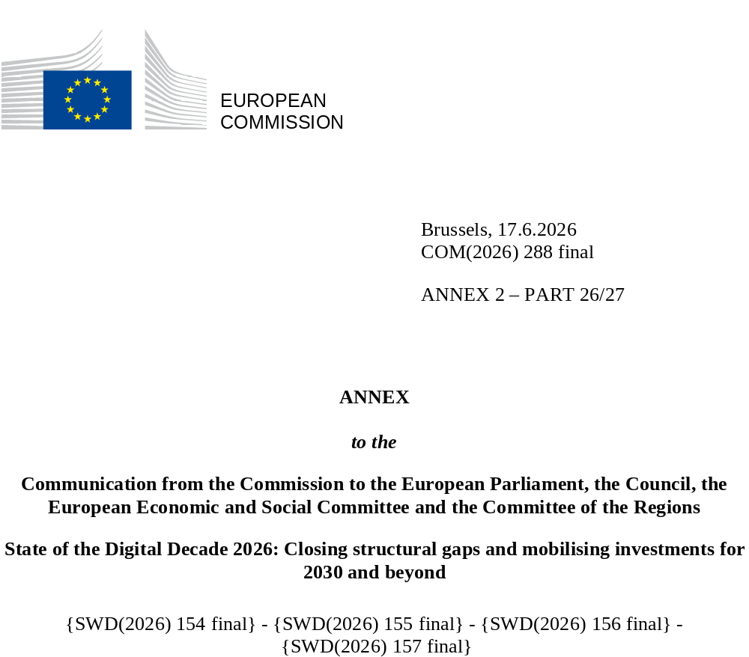

DIGITAL DECADE
SHORT COUNTRY REPORT
2026

Spain

Executive summary
Overall, Spain benefits from strong digital assets, including robust connectivity infrastructure, a digitally skilled population, and well-developed digital public services. However, the country is not yet fully capitalising on these strengths when it comes to the uptake of advanced technologies by enterprises or the share of ICT specialists within the overall labour market, despite the significant number of ICT graduates.
Some of the weaknesses affecting Spain’s competitiveness are linked to the low levels of advanced digitalisation among enterprises, particularly regarding cloud technologies, and its underdeveloped ecosystem for scale-ups and digital innovation. Increasing the share of ICT specialists in the labour market could support the further digitalisation of businesses, while improved access to funding for start-ups could help accelerate digital innovation in Spain.
Spain is also building on its progress in digitalisation to contribute to European technological sovereignty and digital leadership, notably through developing projects in quantum technologies and semiconductors. In addition, the efforts of national public authorities, supported by European funding, have played a key role in substantially digitalising public services and continuing to improve connectivity infrastructure.

Spain in the Digital Decade
Spain shows a high level of ambition in its contribution to the Digital Decade, having set 13 national targets (out of a possible 14), 92% of which aligned with the EU 2030 targets. In its national roadmap, Spain provided 13 trajectory points for 2025 (out of 13 analysed). The country is making good progress on these, with 85% considered on track. Spain addressed 33% of the six recommendations issued by the Commission in 2025 by making some changes through new measures. According to the national roadmap, by the end of 2026, 87% of the measures will come to an end. The total public budget associated with these measures is EUR 26.23 billion, representing 98% of the total public budget outlined in the roadmap.
According to the special Eurobarometer on ‘the Digital Decade’ 2026, 78% of Spanish people consider that digital policy should be a very high/high priority for the EU in shaping our future in Europe. They also think that, in the next 10 years, the EU should cooperate with Member States to reinforce security and protection from online threats (92%), promote digital education and skills programmes (88%) and strengthen regulation of online platforms (87%). In addition, 78% of Spanish respondents think that the EU should reduce its dependency on digital technology from non-EU countries, and 82% think that the EU should prioritise investments in digital infrastructure and services that are developed and controlled in Europe. Meanwhile, 54% would be willing to switch to an EU-based digital service provider even if it means slightly higher costs.

Funding for digital and multi-country projects
Spain allocates 23% of its total recovery and resilience plan to digital (EUR 22.2 billion). In addition, under cohesion policy, EUR 4.9 billion, representing 14% of the country’s total cohesion policy funding, is dedicated to advancing Spain’s digital transformation.
Spain is the host of Local Digital Twins towards the CitiVERSE EDIC, a member of the Alliance for Language Technologies EDIC, and of the EUROPEUM EDIC. Spain is directly participating in the IPCEI on Microelectronics and Communication Technologies (IPCEI-ME/CT) and in the IPCEI on Next Generation Cloud Infrastructure and Services (IPCEI-CIS). Spain is also a participating state in the EuroHPC Joint Undertaking (JU) and of the Chips JU.

Digital Decade KPI ⁽¹⁾ | Spain |  |  |  |  | EU |  |  | Digital Decade target by 2030
Digital Decade KPI ⁽¹⁾ | Last available data (2) | DESI 2026 (year 2025) | Annual progress | National trajectory 2025 (3) | DESI 2026 |  | Annual progress | ES |  | EU
Fixed Very High Capacity Network coverage | 95.0% | 96.0% | 1.1% | 98.0% | 85.5% |  | 3.7% | 100.0% |  | 100%
Fibre to the Premises (FTTP) coverage | 94.9% | 96.0% | 1.2% | 97.0% | 74.1% |  | 7.1% | 100.0% |  | -
Overall 5G coverage | 95.7% | 99.2% | 3.6% | 99.7% | 96.8% |  | 2.6% | 100.0% |  | 100%
Edge Nodes (estimate) | - | 587 | - | - | 7451 |  | - | - |  | 10000
SMEs with at least a basic level of digital intensity * | 60.5% | 75.4% | 11.6% | 63.0% | 71.4% |  | 11.0% | 90.0% |  | 90%
Cloud * | 27.3% | 37.9% | 18.0% | 36.0% | 46.7% |  | 9.5% | 75.0% |  | 75%
Artificial Intelligence | 11.3% | 20.3% | 79.2% | 13.0% | 20.0% |  | 48.0% | 75.0% |  | 75%
Data analytics * | 38.0% | 47.1% | 11.3% | 43.4% | 39.9% |  | 9.5% | 75.0% |  | 75%
AI or Cloud or Data analytics * | 49.9% | 62.4% | 11.9% | - | 63.2% |  | 7.5% | - |  | 75%
Unicorns | 11 | 12 | 9.1% | 24 | 324 |  | 10.2% | 24 |  | 500
At least basic digital skills * | 66.2% | 66.5% | 0.2% | 67.8% | 60.4% |  | 4.3% | 85.0% |  | 80%
ICT specialists | 4.7% | 4.8% | 2.1% | 5.3% | 5.0% |  | 2.0% | 8.6% |  | ~10%
e-ID scheme notification |  | Yes
Digital public services for citizens | 88.8 | 91.9 | 3.5% | 90.2 | 84.6 |  | 2.8% | 100.0 |  | 100
Digital public services for businesses | 85.1 | 95.3 | 11.9% | 96.5 | 88.6 |  | 2.7% | 100.0 |  | 100
Access to electronic health records | 88.3 | 89.6 | 1.5% | 89.4 | 86.5 |  | 4.6% | 100.0 |  | 100
(1) Indicators full description, metadata and sources in the DESI 2026 methodological note
(2) Last available data is DESI2025 (reference year 2024) except for indicators marked with a star * for which it is DESI2024 (reference year 2023)
(3) National trajectory value for 2025, if set by the country in its Digital Decade national roadmap

A competitive, sovereign and resilient EU based on technological leadership
Spain performs strongly in connectivity, consistently surpassing the EU average across all KPIs, which makes the country one of the EU’s best performers in fixed and mobile coverage. Regarding semiconductors, Spain is trying to balance the significant reduction of its flagship programme ‘PERTE Chip’ with support for the Integrated Photonics Pilot Lines and R&D programmes, while the State Society for Technological Transformation (SETT) has achieved a sustainable rhythm of project investments. The country has also approved its Spanish Quantum Technologies Strategy 2025-2030 to position Spain as a leading European actor in quantum technologies by fostering a competitive ecosystem and preparing society for the disruptive impact of these technologies.
On the business side, Spain’s businesses exhibit a commendable level of digitalisation, particularly in adopting data analytics and artificial intelligence technologies. SMEs in Spain show a robust performance in basic digital intensity, surpassing the EU average, although there is room for improvement in achieving very high digital intensity levels. Regarding the take-up of advanced technologies by business, the adoption of cloud technologies lags behind the EU average, but Spain's higher growth rates indicate a positive trend. Although the country is prioritising developing its innovative scale-up ecosystem with strategic investments aimed at fostering the growth and competitiveness of innovative enterprises, there is still untapped potential that has not yet been fully realised.

Protecting and empowering EU people and society
Spain continues to take positive steps to empower people and promote equal opportunities within the digital economy. The level of basic digital skills of the population is satisfying, above the EU average. Conversely, the share of ICT specialists remains below average leading to constraints in the ICT job market, despite a growing number of ICT graduates and an increase in ICT specialists, as this expansion has largely kept in pace with overall employment growth, resulting in only a marginal rise in their share of total employment.
In the area of Digital Public Services, Spain makes a strong contribution to the EU’s Digital Decade targets. The country performs particularly well in digital public services for citizens and business despite the differences between regions. Spain also shows a good performance in e-Government values and access to e-Health records. The Spanish authorities are also maintaining a strong focus on promoting digital rights and principles.

Recommendations
- AI, cloud and data analytics: continue the efforts to support the digitalisation of enterprises, focusing on advancing digital intensity and closing the gap in cloud adoption.
- Semiconductors and digital innovation: Spain need to foster its further development of its semiconductor industry, engaging with stakeholders and R&I, and allocating public funds.
- Quantum technologies: Spain should prioritise the development of sovereign European quantum hardware, accelerate the industrialisation and large-scale deployment, ensure rapid and secure uptake with strong intellectual property protection, attract and retain talent, align closely with EuroHPC JU governance and EU roadmaps, shift funding toward industrial scale-up ,transform HPC infrastructures into application platforms, and connect industry and research actors to Chips JU pilot lines to support end-to-end innovation and system integration.
- Unicorns: Facilitate business creation, innovation and expansion, supporting R&I investments and stronger science-business linkages improving coordination between research and universities to technology transfer centres, start-ups and scale-ups; expand access to scale-up financing; target incentives to key strategic sectors to accelerate the deployment of key digital technologies.
- Cybersecurity: Continue efforts in cybersecurity to address evolving threats, in particular, supporting enterprises and ensuring the imposition of cybersecurity measures that are necessary to enhance the cyber posture of critical infrastructure.
- ICT specialists: Spain should continue its efforts to strengthen the ICT specialist position in the labour market and retain ICT graduates. Moreover, Spain should intensify efforts to increase women’s participation in ICT studies and careers.
- Digital Public Services: Spain should improve the digitisation of public services across regions to enhance interoperability and cooperation between them and avoid regional imbalances, in particular, regarding the digitisation of the judicial system.

